6.21

#include <iostream>

using namespace std;

bool isEven(int);

int main()

{

int num;

while (cin >> num) {

//输入检查

if (num < 0) {

cout << "Illegal input!" << endl;

continue;

}

//输出

if (isEven(num))

cout << num << " is an even number." << endl;

else

cout << num << " is an odd number." << endl;

}

}

bool isEven(int i) {

return i % 2 == 0;

}

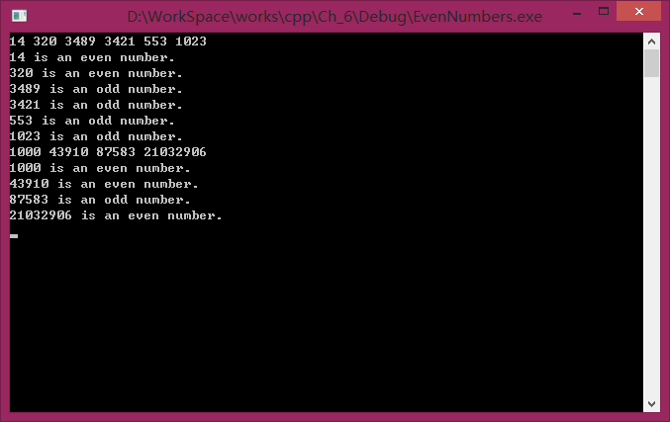

6.34

#include <iostream>

#include <cstdlib>

#include <ctime>

using namespace std;

enum Status {HIGH, LOW, CORRECT, CONTINUE, EXIT};

/\*

\* HIGH: 所猜数太高

\* LOW: 所猜数太低

\* CORRECT: 猜测正确

\* CONTINUE: 继续游戏标记

\* EXIT: 退出游戏标记

\*/

Status check(int, int);

int main() {

int target;//目标数字

int input;//用户猜数

char sign;//y/n输入

Status currentStatus = CONTINUE;//当前游戏状态

while (cin) {

if (currentStatus == EXIT)//标记为EXIT时退出游戏

break;

srand(time(0));

target = 1 + rand() % 1000;//构造待猜数

cout << "I have a number between 1 to 1000.\nCan you guess my number?\nPlease type your first guess.\n";

while (currentStatus != CORRECT) {

cin >> input;

currentStatus = check(input, target);

switch (currentStatus) {

case HIGH:

cout << "Too high! Try again.\n";

break;

case LOW:

cout << "Too low! Try again.\n";

break;

case CORRECT:

cout << "Excellent! You guess the number.\nWould you want to play again? (y or n)\n";

break;

}

}

cin >> sign;//获取y/n输入

if (sign == 'y')

currentStatus = CONTINUE;

else if (sign == 'n')

currentStatus = EXIT;

else

/\*非法输入处理\*/

break;

}

}

Status check(int input, int target) {

if (input > target)

return HIGH;

else if (input < target)

return LOW;

return CORRECT;

}

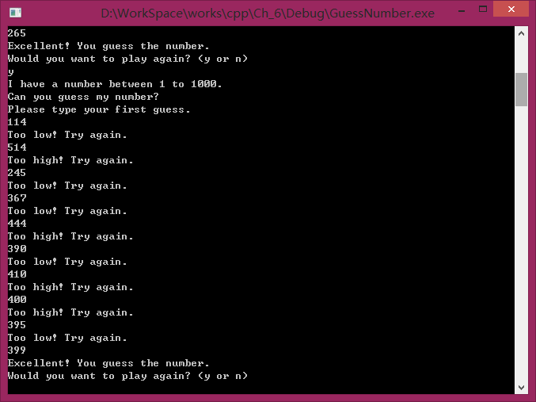

6.35

#include <iostream>

#include <cstdlib>

#include <ctime>

using namespace std;

enum Status {HIGH, LOW, CORRECT, CONTINUE, EXIT};

/\*

\*HIGH: 所猜数太高

\*LOW: 所猜数太低

\*CORRECT: 猜测正确

\*CONTINUE: 继续游戏标记

\*EXIT: 退出游戏标记

\*/

Status check(int, int);

int main() {

int target;//目标数字

int input;//用户猜数

char sign;//y/n输入

int times;//猜测次数

Status currentStatus = CONTINUE;//当前游戏状态

while (cin) {

times = 0;//初始化猜测次数

if (currentStatus == EXIT)//标记为EXIT时退出游戏

break;

srand(time(0));

target = 1 + rand() % 1000;//构造待猜数

cout << "I have a number between 1 to 1000.\nCan you guess my number?\nPlease type your first guess.\n";

while (currentStatus != CORRECT) {

cin >> input;

times++;

currentStatus = check(input, target);

switch (currentStatus) {

case HIGH:

cout << "Too high! Try again.\n";

break;

case LOW:

cout << "Too low! Try again.\n";

break;

case CORRECT:

cout << "Excellent! You guess the number.\n";

break;

}

}

//评价

cout << "\nYou guessed " << times << " times.\n";

if (times > 10)

cout << "You should be able to do better.\n";

else if (times < 10)

cout << "Either you know the secret or you got lucky!\n";

else

cout << "Ahah! You know the secret!\n";

cout << "Would you want to play again ? (y or n)\n";

cin >> sign;//获取y/n输入

if (sign == 'y')

currentStatus = CONTINUE;

else if (sign == 'n')

currentStatus = EXIT;

else

/\*非法输入处理\*/

break;

}

}

Status check(int input, int target) {

if (input > target)

return HIGH;

else if (input < target)

return LOW;

return CORRECT;

}

