Question 1:

1. Q: What payment methods are used for the automatic ticket selling?
   1. A: The payment methods used are credit card, QR code scanning, and digital wallet.
2. Q: Is there a limit to the number of tickets purchased?
   1. A: There will be no limit to the number of tickets purchased, users can buy multiple tickets at the same time.
3. Q: What happens when the user enters the wrong credit card or doesn’t confirm the ticket purchase?
   1. A: Ticket won’t be issued and users can use other payment menthods.
4. Q: Can I change my ticket when I choose the wrong destination and the ticket has already been isued?
   1. A: No, users are required to purchase a new ticket.

Question 2:

* Functional requirements:
  + System for user to choose their destination.
  + The system allows the user to choose a payment method.
  + The system displays QR code for users using e-wallets.
  + The system asks the user to confirm the purchase of the ticket to ensure that the ticket is sold.
* Non-functional requirements:
  + The system has a customer response time of no more than 5 seconds when performing the operation.
  + Each transaction is no more than 15 seconds per user.
* Domain requirements:
  + The ticket machine must execute the given transaction.
  + Ticket machines must support all predefined methods.

Question 3:

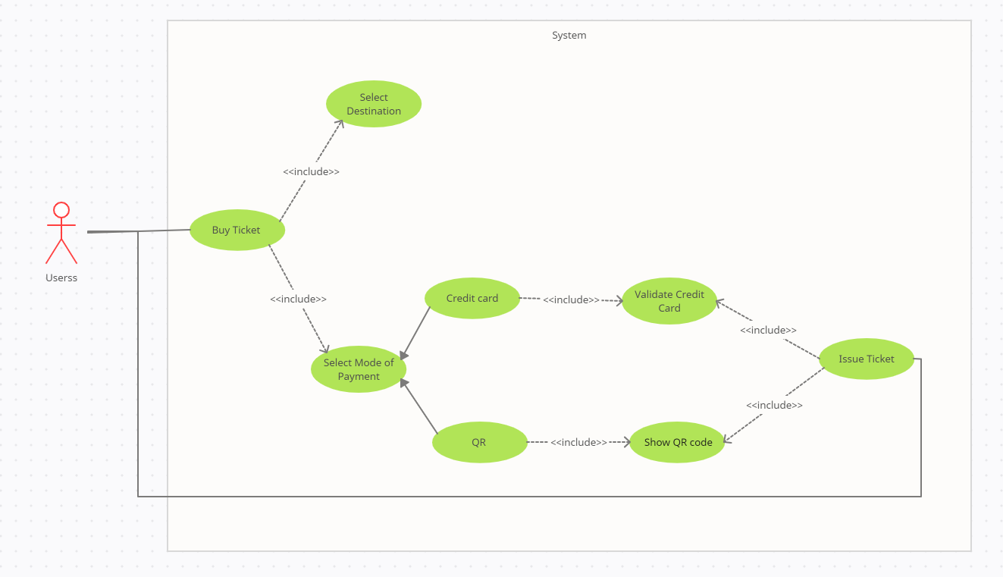

Question 4:

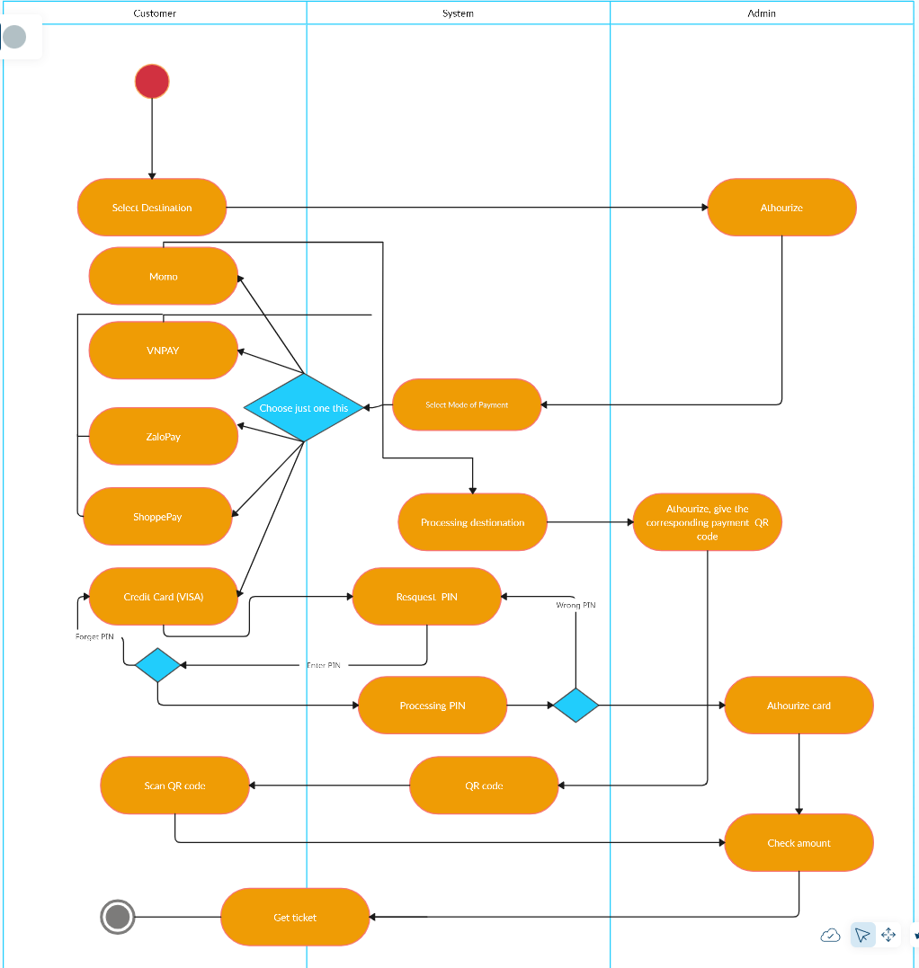

Question 5:

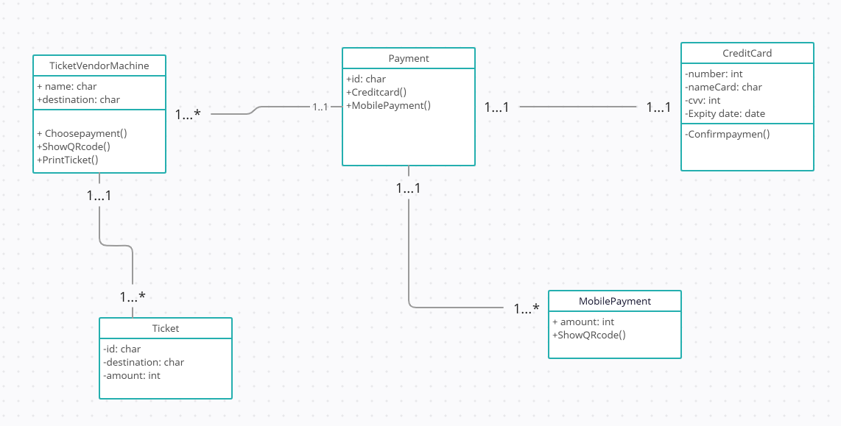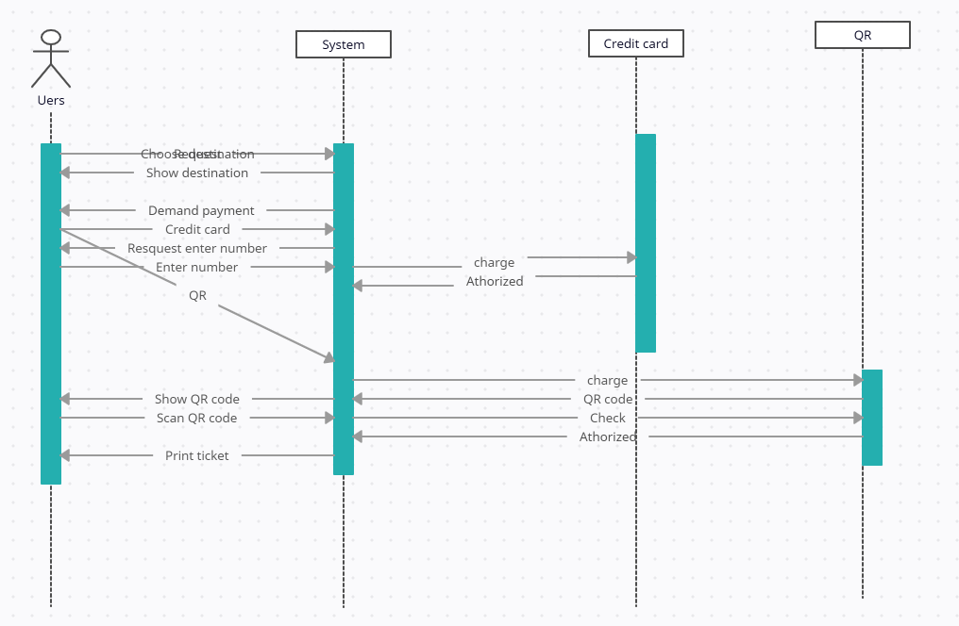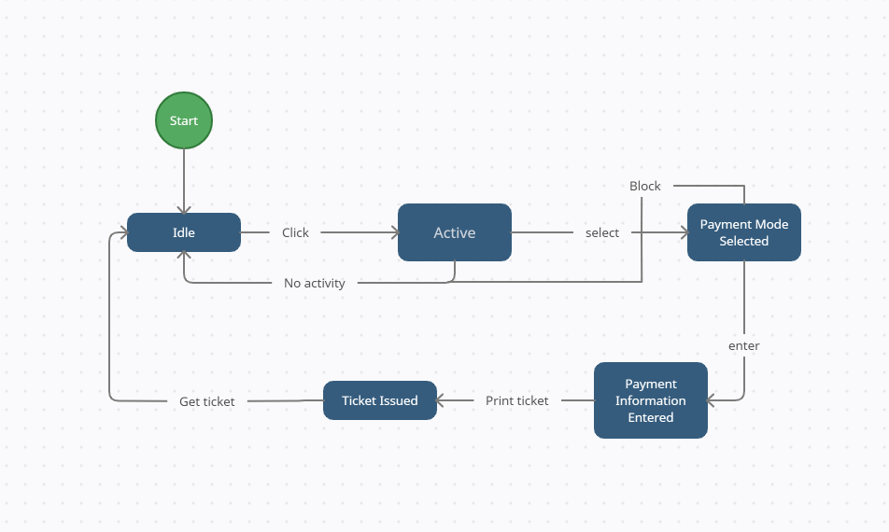

Question 8, 9:

https://github.com/Suimei1208/CNPM.git