|  |
| --- |
| Mobile Student Lookup  Domain Model  12/16/2011  Mark Vitale, Chris Gropp, Brandon Knight, and Ann Say  Campus Mail: 1200 |

Contents

Domain Model 2

The Who Done What Table: 3

# Domain Model

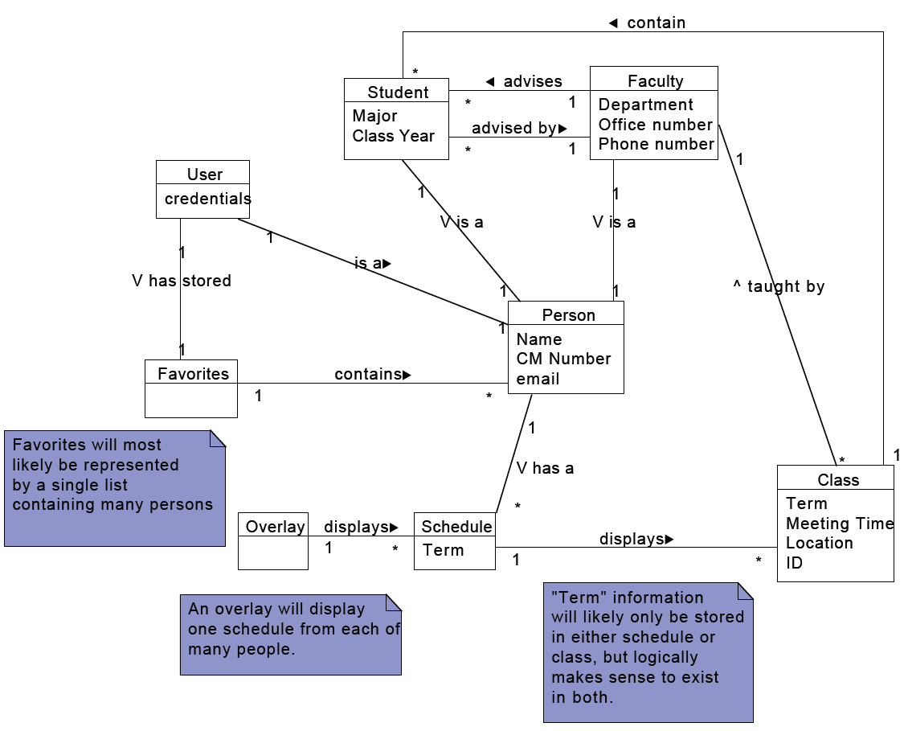

The **Student**, **Faculty**, **Person**, **Class**, and **Schedule** conceptual classes are derived from the existing Schedule Lookup Page. The features specific to the app are encapsulated in the **User**, who represents the person using the iPhone, **Favorites**, which stores the persistent data for a user’s favorites list, and **Overlay**, which generates the display for the feature of the same name.

# The Who Done What Table:

|  |  |  |  |
| --- | --- | --- | --- |
| Who Done It:  Team Member Names | Section/Part Completed | Task/Comments | # of hours effort |
| Whole Team | Domain Model | Diagrammed it on a whiteboard | 3 hours |
| Whole Team | Revised Domain Model | Revised based on comments from project manager | .5 hours |
| Mark | Compiled document | Created this document, made who done what table | 1 hour |
| Ann | Domain Model | Created the digital version of the domain model using UMLet | .5 hours |
| Chris | Domain Model Description | Added descriptive text to the domain model | .5 hours |