# GraphDB Repository and User Setup

* Download and install GraphDB desktop application

🡪 Go to [link](https://www.ontotext.com/products/graphdb/graphdb-free/)

🡪 Fill out the form and request GraphDB Free

🡪Download the installation file that was sent to you via email

🡪Run desktop installation file

🡪Open the application

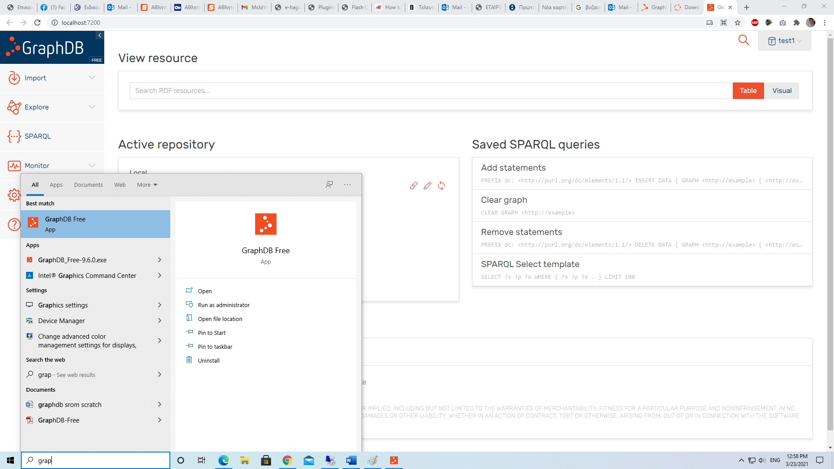

🡪 “Open GraphDB” or on browser <http://localhost:7200/>

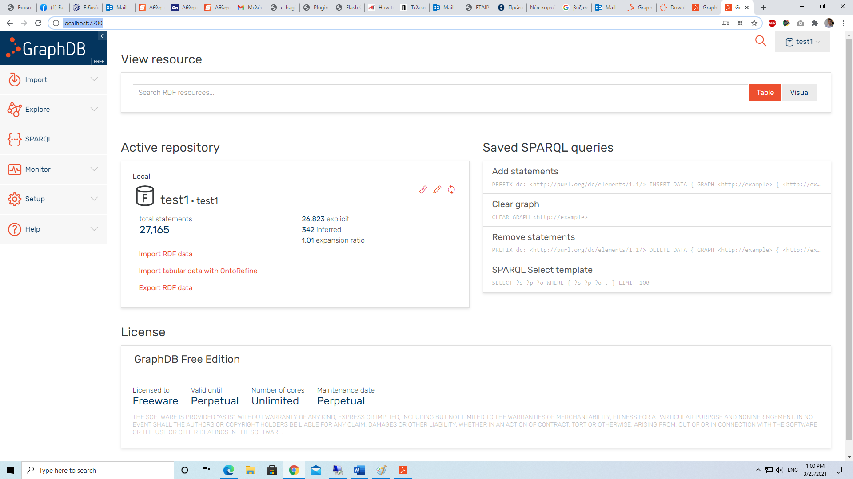

* Create repository

🡪Setup-> Repositories -> Create new

🡪Repository id🡪 test1

🡪Repository description 🡪 test1

🡪Create

* Create user for the repository
  + e.g., test_user, 12345
  + Note: credentials can changes via code (see below)

# NetBeans Project Setup and Run

🡪 Download and install Netbeans IDE 12

🡪 Open Existing Project -> go to RED

🡪 Install any plugins asked

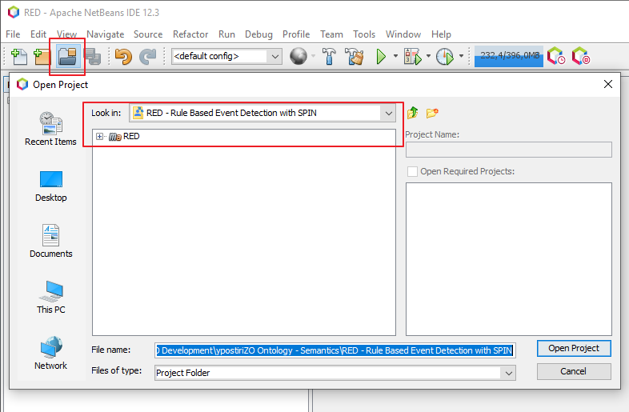

🡪 Build maven project with dependencies or Resolve Project Dependencies

* Messaging/RemoteGraphDB/CreateRemoteRepository.java
  + Configure GraphDB IP:port, (localhost or server IP)
  + Configure GraphDB username/password
  + Configure ably username/password

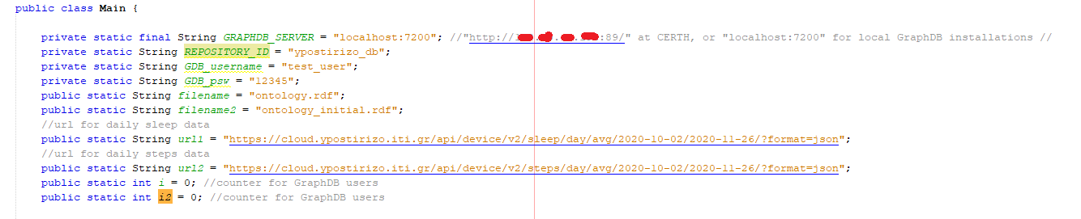

* Note that there is a .ttl configuration file that must match the repository name

🡪 Run Main.java

🡪 Build SUCCESS

**Check Data**

* Open graphDB
* Explore
  + Graphcs overview
  + Class hierarchy

