**A 32-bit CPU with RV32I ISA**

Design Specification

**Creation Date：2025.7.18**

**Version： 0406**

**University of Electronic Science and Technology of China**

**Chengdu, Sichuan**

Abstract

本文档是研究AI辅助条件下的数字IC设计环节中的设计规格说明。

设计规格说明介绍

1. 设计背景 (Context)

包括项目背景，指令集定义和设计应用场景。其中，项目背景包括架构的简单描述，为大模型指出项目的整体方向；指令集定义指出了设计的功能需求，而应用场景对设计的性能提出了更多的限制。将设计规格说明输入大模型时提供设计背景可能使其提出更加符合要求的解决方案

1. 设计内容 (Design)

设计内容包括模块的功能说明，IO说明以及架构说明

1. 验证 (Verification)
2. 工程师提供测试原理的说明，若没有提供测试原理说明则大模型提供测试原理的建议。
3. 大模型依据提供/生成的测试原理说明生成正确的testbench
4. 规格验收表 (Specification Checklist)

情况一：大模型根据“设计内容板块”提取规格要求并检验所设计电路是否满足要求

情况二：大模型根据工程师提供的设计规格表格检验所设计电路是否满足要求

# Context

## Requirements

This project aims to design a 32-bit RISC-V CPU that supports RV32I instruction set architecture (ISA). This CPU is supposed to adopt five-stage pipelining techniques and being organized in the Harvard architecture.

It is assumed that there would only be user-level instructions, which means there is no requirement for the implementation of SYSTEM instructions in RV32I ISA, such as those regarding interrupts and memory ordering. Therefore, the CPU should contain 32 registers in addition to pipeline registers and a program counter register, which can implement all the user-level instructions in RV32I ISA. The control and status registers (CSRs) are not considered since they are used by potentially privileged instructions beyond the user level.

## ISA definition

This section provides a detailed and rigorous introduction to the Instruction Set Architecture (ISA). Total of 37 instructions are included in the ISA, and they can be categorized into 5 different clusters (R-type, I-type, S-type, B-type, and U/J-type). This section introduces each instruction in the exact order.

### R-type instruction

As shown in Table 1‑1, R-type instructions perform logistic or arithmetic operations between two pieces of data in two source registers and store the result on the destination register. Each piece of data is 32 bits in length and is expected to be a signed integer.

Table 1‑1 R-type instructions

|  |  |  |  |  |  |  |  |
| --- | --- | --- | --- | --- | --- | --- | --- |
| Function [9:3] | rs2  5bits | rs1  5bits | Function  [2:0] | rd  5bits | Opcode  7bits | instruction | Assembly representation |
| 0000000 | src_2 | src_1 | 000 | R_d | 0110011 | ADD | ADD rd, rs1, rs2 |
| 0000000 | src_2 | src_1 | 010 | R_d | 0110011 | SLT | SLT rd, rs1, rs2 |
| 0000000 | src_2 | src_1 | 011 | R_d | 0110011 | SLTU | SLTU rd, rs1, rs2 |
| 0000000 | src_2 | src_1 | 111 | R_d | 0110011 | AND | AND rd, rs1, rs2 |
| 0000000 | src_2 | src_1 | 110 | R­_d | 0110011 | OR | OR rd, rs1, rs2 |
| 0000000 | src_2 | src_1 | 100 | R­_d | 0110011 | XOR | XOR rd, rs1, rs2 |
| 0000000 | src_2 | src_1 | 001 | R_d | 0110011 | SLL | SLL rd, rs1, rs2 |
| 0000000 | src_2 | src_1 | 101 | R_d | 0110011 | SRL | SRL rd, rs1, rs2 |
| 0100000 | src_2 | src_1 | 000 | R_d | 0110011 | SUB | SUB rd, rs1, rs2 |
| 0100000 | src_2 | src_1 | 101 | R_d | 0110011 | SRA | SRA rd, rs1, rs2 |

Apart from regular addition, subtraction, AND operations etc., the introduction of the R-type instruction focuses on the introduction of SLL, SRL, SRA, SLT, and SLTU, which are logistic and arithmetic shifting operations.

1. SLL or SRL: Shift-Left/Right-Logistic.
2. SRA: Shift-Right-Arithmetic.

These three instructions allow the software developers to perform both logistic and arithmetic bit-shift. It shall be noted that a leftward arithmetic shift is illegal in the current ISA since it is equivalent to the SLL.

1. SLT or SLTU: Set if Less Than/Unsigned.

The SLT instruction compares the values respectively on rs1 between rs2. If the value on rs1 is lower than that on rs2, set the value on rd to 1. However, when executing SLTU instruction, it is the absolute values are compared.

### I-type instructions

As shown in Table 1‑2, I-type instructions comprise two subtypes of instructions: 1) arithmetic and logistic operations on immediate numbers, and 2) loading immediate numbers to destination registers.

Table 1‑2 I-type instructions

|  |  |  |  |  |  |  |
| --- | --- | --- | --- | --- | --- | --- |
| I-immediate [11:0] | rs1  5bits | Function  [2:0] | rd  5bits | Opcode  7bits | instruction | Assembly representation |
| imm | src_1 | 000 | R_d | 0010011 | ADDI | ADD rd, rs1, imm |
| imm | src_1 | 010 | R_d | 0010011 | SLTI | SLT rd, rs1, imm |
| imm | src_1 | 011 | R_d | 0010011 | SLTIU | SLTU rd, rs1, imm |
| imm | src_1 | 111 | R_d | 0010011 | ANDI | AND rd, rs1, imm |
| imm | src_1 | 110 | R­_d | 0010011 | ORI | OR rd, rs1, imm |
| imm | src_1 | 100 | R­_d | 0010011 | XORI | XOR rd, rs1, imm |
| imm | src_1 | 000 | R_d | 0010011 | SLLI | SLL rd, rs1, imm |
| imm | src_1 | 001 | R_d | 0010011 | SRLI | SRL rd, rs1, imm |
| imm | src_1 | 101 | R_d | 0010011 | SRAI | SRA rd, rs1, imm |

Comparing Table 1‑2 and Table 1‑3, developers are allowed to directly write immediate numbers to participate in both numerical and logistic operations.

Table 1‑3 I-type instructions for load purpose

|  |  |  |  |  |  |  |
| --- | --- | --- | --- | --- | --- | --- |
| I-immediate [11:0] | rs1  5bits | Function  [2:0] | rd  5bits | Opcode  7bits | instruction | Assembly representation |
| imm | src_1 | 000 | R_d | 0000011 | LB | LB rd, rs1, imm |
| imm | src_1 | 010 | R_d | 0000011 | LH | LH rd, rs1, imm |
| imm | src_1 | 010 | R_d | 0000011 | LW | LW rd, rs1, imm |
| imm | src_1 | 100 | R_d | 0000011 | LBU | LBU rd, rs1, imm |
| imm | src_1 | 101 | R_d | 0000011 | LHU | LHU rd, rs1, imm |

1. LW, LH, or LB: Load-Word/Half/Byte (U: unsigned).

These instructions allow the data to be loaded from the main memory to the destination register. The address of the exact data equals to the addition of the data in rs1 and the input immediate value. The lower half/8-bit of data is loaded to the rd when using LH/LB instructions.

It shall be noticed that the immediate numbers specified in Table 1‑2 and Table 1‑3, will be sign-extended to 32bits. In addition, when executing LB/HU instruction, only the absolute value will be loaded to the register.

### S-type instructions: store operations

As shown in Table 1‑4, the S-type instructions allow the developer to store data in the main memory at a designated address.

Table 1‑4 S-type instructions

|  |  |  |  |  |  |  |  |
| --- | --- | --- | --- | --- | --- | --- | --- |
| S-imm  [11:5] | rs2  5bits | rs1  5bits | Function  [2:0] | S-imm  [4:0] | Opcode  7bits | instruction | Assembly representation |
| #imm [11:5] | src_2 | src_1 | 000 | #imm [4:0] | 0100011 | SB | SB rd, rs1, #imm |
| #imm [11:5] | src_2 | src_1 | 001 | #imm [4:0] | 0100011 | SH | SH rd, rs1, #imm |
| #imm [11:5] | src_2 | src_1 | 010 | #imm [4:0] | 0100011 | SW | SW rd, rs1, #imm |

1. SW: Store-Word
2. SH or SB: Store Half/Byte

### B-type instructions: conditional branching operations

Software developers can jump between different code blocks using conditional branching instructions. Immediate numbers in the B-type instructions are divided into two separate segments. Two pieces of data on rs1 and rs2 are the sources of the conditional operations. Once the specified condition is met, the program counter will be diverted to address PC + imm.

Table 1‑5 B-type instructions

|  |  |  |  |  |  |  |  |
| --- | --- | --- | --- | --- | --- | --- | --- |
| B-immediate [12] [10:5] | rs2  5bits | rs1  5bits | Function  [2:0] | B-imm  [4:1][11] | Opcode  7bits | instruction | Assembly representation |
| #imm [12] [10:5] | src_2 | src_1 | 000 | #imm [4:1][11] | 1100011 | BEQ | BEQ rs1, rs2, #imm |
| #imm [12] [10:5] | src_2 | src_1 | 001 | #imm [4:1][11] | 1100011 | BNE | BNE rs1, rs2, #imm |
| #imm [12] [10:5] | src_2 | src_1 | 100 | #imm [4:1][11] | 1100011 | BLT | BLT rs1, rs2, #imm |
| #imm [12] [10:5] | src_2 | src_1 | 110 | #imm [4:1][11] | 1100011 | BLTU | BLTU rs1, rs2, #imm |
| #imm [12] [10:5] | src_2 | src_1 | 101 | #imm [4:1][11] | 1100011 | BGE | BGE rs1, rs2, #imm |
| #imm [12] [10:5] | src_2 | src_1 | 111 | #imm [4:1][11] | 1100011 | BGEU | BGEU rs1, rs2, #imm |

1. BEQ or BNE: Branch-Equal/Branch-Not-Equal
2. BLT or BGT: Branch-Less/Greater-Than (U: unsigned)

In BEQ or BNE cases, if the value on rs1 is (not, in the later) equal to the value on rs2, the program counter will point to the current address plus #imm. Likewise, when performing BLT or BGT operations, the same branching operations will be executed if the value on rs1 is less/greater than that on rs2. When implementing unsigned operations, the highest positions (sign digits) are not considered. It shall be noted that one zero shall be appended to the LSB of the input immediate number otherwise, the malfunction of the PC.

### U/J -format instructions: upper immediate numbers / unconditional jump

The U/J-type instructions load/add upper 20-bit immediate numbers to the destination registers or the Program Counter. These can be used to obtain large integers or jump to another instruction.

Table 1‑6 U-type instructions

|  |  |  |  |  |
| --- | --- | --- | --- | --- |
| U-immediate  [31:12] | rd  5bits | Opcode  7bits | instruction | Assembly representation |
| #imm | R_d | 0110111 | LUI | LUI rd, #imm |
| #imm | R_d | 0100011 | AUIPC | AUIPC rd, #imm |

1. LUI: Load-Upper-Immediate.
2. AUIPC: Add-Upper-Immediate-to-PC.

Both immediate numbers specified in Table 1‑6 are extended to 32bits by adding zeros to their lower twelve digits. The LUI instruction loads the extended immediate number to the destination register. By synthesizing LUI and ADDI, developers can write 32-bit immediate numbers to a desired register. The AUIPIC instruction adds the extended number to the address on the program counter. This combination of the address and the offset immediate number will be further loaded to the destination register.

Table 1‑7 J-type instructions

|  |  |  |  |  |  |  |
| --- | --- | --- | --- | --- | --- | --- |
| J-immediate  [20] [10:1][11] [19:21] | | | rd  5bits | Opcode  7bits | Instruction | Assembly representation |
| #imm | | | R_d | 1101111 | JAL | JAL rd, #imm |
| I-immediate [11:0] | rs  5bits | Function  [2:0] | rd  5bits | Opcode  7bits | Instruction | Assembly  representation |
| #imm | src_1 | 000 | R_d | 1101111 | JALR | JALR rd, rs, #imm |

1. JAL: Jump-and-Link.
2. JALR: Jump-and-Link-Register.

The JAL instruction performs an unconditional jumping operation to the address, which equals to PC + offset (J-immediate), and saves the address of the next instruction to the rd. The JALR instruction loads the address of the next instruction to rd and executes the instruction at the rs + offset on the main memory. One zero is appended to the LSB of the J-immediate, which will be sign-extended to 32 bits.

## Application Scenarios

Figure 1‑1 shows a possible application scenario for this CPU, where it is connected to two memory modules (IMEM refers to Instruction Memory; DMEM refers to Data Memory).

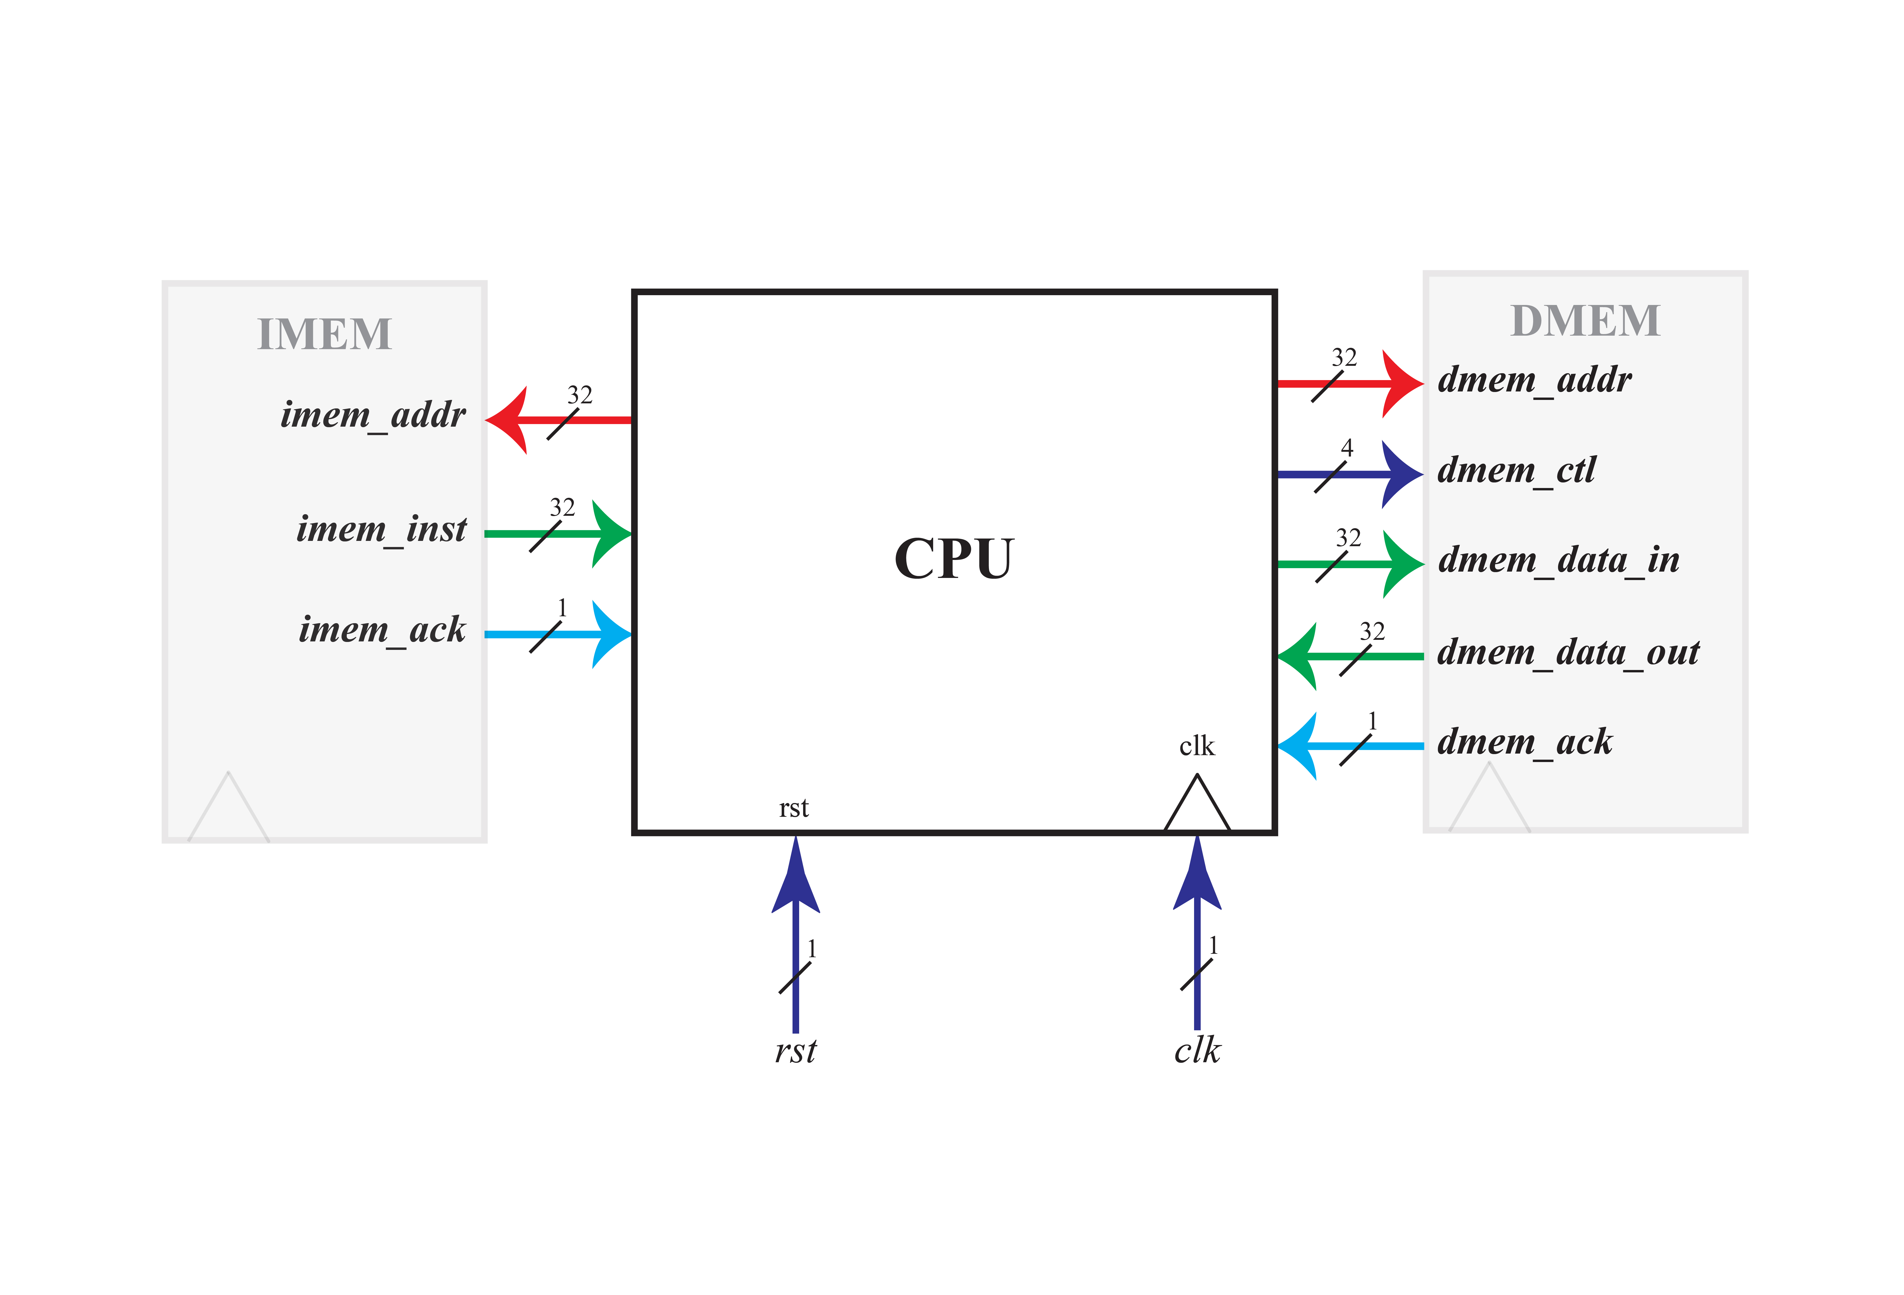

Figure 1‑1 The application scenarios diagram for the CPU

It is worth noting that the memory module shown in Figure 1‑1 can be replaced by caches or memory controllers. The DMEM module can also contain input/output ports by allocating them to different addresses.

# Design：XXXX

## Function

## Input/Output

## Architecture



# Verification

|  |  |  |  |  |  |  |  |  |
| --- | --- | --- | --- | --- | --- | --- | --- | --- |
| 测试用例名称 | |  | 测试用例标识 | |  | | | |
| 追踪关系 | |  | | | | | | |
| 测试原理 | |  | | | | | | |
| 初始化要求 | |  | | | | | | |
| 前提约束 | |  | | | | | | |
| 终止条件 | |  | | | | | | |
| 测试规程 | | | | | | | | |
| 步骤 | 输入及操作说明 | | | 预期结果 | | | | 实际结果 |
|  |  | | |  | | | |  |
|  |  | | |  | | | |  |
|  |  | | |  | | | |  |
|  |  | | |  | | | |  |
|  |  | | |  | | | |  |
| 结果评价准则 | | 如果每一步的实际结果和预期结果相符，则测试通过，否则不通过 | | | | | | |
| 测试人员 | |  | | | | 测试日期 |  | |
| 验收人员 | |  | | | | 验收日期 |  | |

# Specification Checklist

|  |  |  |  |  |  |
| --- | --- | --- | --- | --- | --- |
| SPEC No. 设计规格序号 | SPEC Name 设计规格名称 | Verification Principle 验证原理 | Termination Condition 终止条件 |  | Verification Result 测试结果 |
| 1. | XXX |  |  |  |  |
| 2. | XXX |  |  |  |  |
| 3. | XXX |  |  |  |  |