pubs.acs.org/jcim
Article
Integrating Protein Language Models and Geometric Deep Learning
for Peptide Toxicity Prediction
Yanling Wang, Na Li,* Xiao Wang, Feng Cao, Shuwen Xiong,* and Leyi Wei*
Cite This: https://doi.org/10.1021/acs.jcim.5c01073
Read Online
ACCESS
Metrics & More
Article Recommendations
*sı Supporting Information
ABSTRACT: Peptide toxicity prediction is a critical task in biomedical research, inﬂuencing drug safety and therapeutic
development. Traditional methods, relying on sequence similarity or handcrafted features, struggle to capture the complex
relationship between peptide structure and toxicity. In this study, we propose PeptiTox, an advanced deep learning framework that
integrates protein language models (PLMs) and geometric deep learning to enhance peptide toxicity prediction. Speciﬁcally, ESM2
is employed to extract sequence embeddings, while ESMFold predicts the three-dimensional (3D) peptide structure. The structural
information is then transformed into a graph representation, where residues serve as nodes, and interactions between residues form
edges. A graph neural network (GNN) is subsequently used to learn peptide representations and classify their toxicity. Experimental
results demonstrate that PeptiTox signiﬁcantly outperforms state-of-the-art models across multiple evaluation metrics. Our ﬁndings
highlight the importance of integrating sequence and structural knowledge for peptide toxicity prediction, paving the way for safer
and more eﬀective peptide-based therapeutics.
I. INTRODUCTION
homologous toxic peptides. Second, they struggle with
accuracy and eﬃciency when processing large-scale data sets.
Finally, they rely on predeﬁned threshold values, which can be
challenging to optimize in real-world scenarios.¹⁸
Peptides are short chains of amino acids linked by peptide
,2
bonds, typically consisting of 6 to 50 residues.¹ They play
crucial roles in various biological processes, including signal
To overcome these limitations, researchers have introduced
machine learning-based approaches for peptide toxicity
transduction, immune responses, and enzymatic activities.³
−6
Due to their high speciﬁcity and biocompatibility, peptides
have emerged as promising candidates for therapeutic
applications. Compared to small-molecule drugs, peptide-
based therapeutics oﬀer several advantages, including higher
prediction. Two representative models, ClanTox and Tox-
inPred,¹
9,20
utilize sequence-based features, machine learning
algorithms, and statistical techniques to classify peptides as
toxic or nontoxic.
target speciﬁcity, reduced likelihood of drug resistance, and low
With the advancements in deep learning, researchers have
developed deep learning-based models for protein toxicity
prediction, including ToxDL, ToxMVA, CSM-Toxin, and
7
immunogenicity. These attributes have driven the develop-
ment of a wide range of peptide therapeutics, particularly in
8
,9
10−13
oncology and antimicrobial therapy.
VISH-Pred.²
1−24
However, these models primarily focus on
Despite their therapeutic potential, certain peptides exhibit
toxicity, posing signiﬁcant challenges in drug development.
Therefore, accurately predicting peptide toxicity is crucial to
ensure drug safety and eﬃcacy. Traditional toxicity assessment
methods rely primarily on biological experiments, which are
time-consuming, costly, and subject to ethical constraints. To
address these limitations, computational approaches have been
developed to predict peptide toxicity eﬃciently and cost-
protein toxicity rather than peptide toxicity. Subsequently,
deep learning models speciﬁcally designed for peptide toxicity
2
5
18
prediction have been proposed, such as ATSE, ToxIBTL,
and CAPTP.²⁶ These methods leverage sequence-based feature
extraction to improve toxicity prediction accuracy. Despite
their success, current deep learning models predominantly rely
1
4
Received: May 11, 2025
eﬀectively.
Early computational methods were based on
Revised:
June 21, 2025
similarity-based approaches, which infer peptide toxicity by
comparing novel sequences with known toxic peptides using
Accepted: June 23, 2025
homology alignment or similarity scoring techniques.¹
5−17
However, these methods have several drawbacks. First, their
eﬀectiveness is limited to cases where the target peptide has
©
XXXX American Chemical Society
https://doi.org/10.1021/acs.jcim.5c01073
J. Chem. Inf. Model. XXXX, XXX, XXX−XXX
A
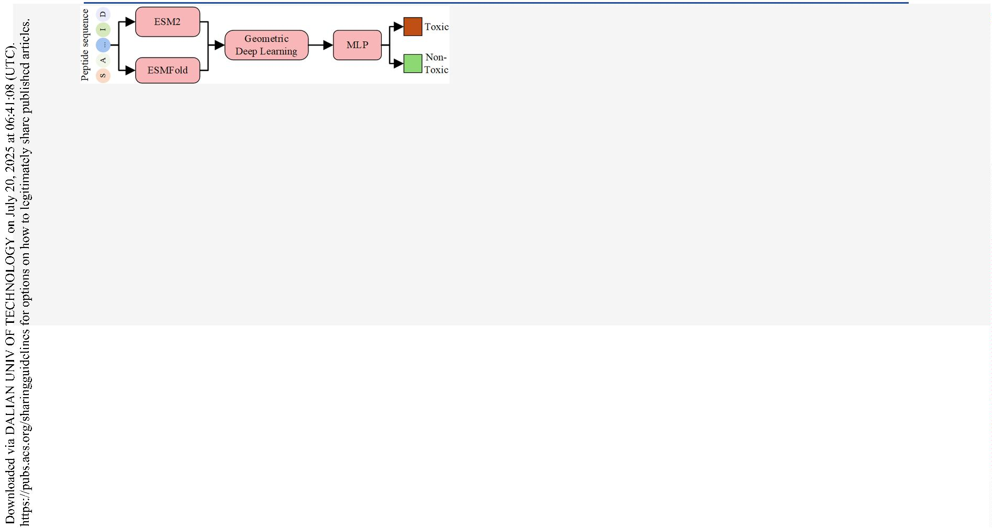

Journal of Chemical Information and Modeling
pubs.acs.org/jcim
Article
Figure 1. Framework of PeptiTox. (A) The workﬂow of PeptiTox. Given a peptide sequence, PeptiTox utilizes the pretrained protein language
model ESM2 to extract sequence-based features and employs ESMFold to predict the peptide’s 3D structure. The sequence and geometric features
are concatenated as node features and input into a graph neural network (GNN), which updates the graph representations. A readout layer
produces a graph-level embedding that is used by a classiﬁer to predict peptide toxicity. (B) The geometric featurizer. This component extracts
node features (e.g., angle, distance, direction) and edge features (e.g., angle, distance, direction) from the peptide structure
on sequence information while overlooking the three-dimen-
sional (3D) structural properties of peptides.²⁷
successfully applied to a wide range of structural biology
problems, including drug-target interaction prediction and
protein−protein interactions.
4
5,46
By representing biomole-
Given that the 3D structure is a key determinant of protein
and peptide function,²⁸ integrating structural information into
peptide toxicity prediction models is essential for enhancing
prediction accuracy and reliability. Besides, with the advent of
cules as graphs, where residues or atoms serve as nodes and
spatial or functional relationships deﬁne the edges, GNNs can
learn rich representations that complement sequence-based
features.
2
9
powerful structure prediction tools such as AlphaFold,
3
0
3
1
3
2
ESMFold,
OmegaFold
and ColabFold,
it has become
Recent advances in artiﬁcial intelligence have witnessed
remarkable progress in large language models (LLMs),
particularly within the domain of natural language processing.
Notable examples include OpenAI’s ChatGPT, Google’s
PaLM, and Meta’s LLaMA models, which demonstrate
impressive capabilities in tasks such as language generation,
feasible to obtain high-quality peptide structures directly from
sequences, enabling large-scale integration of structural
features into deep learning workﬂows. In downstream
applications, recent studies have explored how structure-
informed representations can enhance prediction in tasks
including drug−target interaction and functional site identi-
summarization, translation, and reasoning.⁴
7−49
Interestingly,
ﬁcation.
Moreover, several recently proposed models
37
�
the structural organization of proteins exhibits notable parallels
with human language, as amino acid sequences share
conceptual similarities with linguistic components. In this
context, individual amino acids can be considered analogous to
words, while complete protein sequences resemble coherent
sentences. Building upon these fundamental similarities and
the demonstrated eﬃcacy of LLMs, computational biologists
have pioneered the development of specialized protein
language models (PLMs), such as ESM, ProtBERT, ProGen,
3
3−35
3
6
−
such as MIF-ST and GearNet, as well as hybrid sequence
structure models like SaProt,
and ProSST
3
8
39
40
ESM-GearNet, ProtSSN,
�
have demonstrated that jointly leveraging
4
1
sequence and structural information can signiﬁcantly improve
performance in related tasks, including protein function
prediction and subcellular localization. These advances
motivate our proposed method, which integrates both
sequence semantics and geometric structural features into a
uniﬁed deep learning framework for improved peptide toxicity
prediction.
and ProtGPT2.³
strated signiﬁcant utility across diverse proteomic research
0,50−52
These innovative tools have demon-
applications.⁵
3−55
In parallel, graph neural networks (GNNs) have emerged as
powerful tools for modeling biomolecular structures, owing to
their ﬂexibility in representing non-Euclidean data such as
Considering the aforementioned challenges, this study
integrates protein language models with peptide structural
information to enhance the accuracy of peptide toxicity
molecules and proteins.⁴
2−44
GNN-based methods have been
B
https://doi.org/10.1021/acs.jcim.5c01073
J. Chem. Inf. Model. XXXX, XXX, XXX−XXX
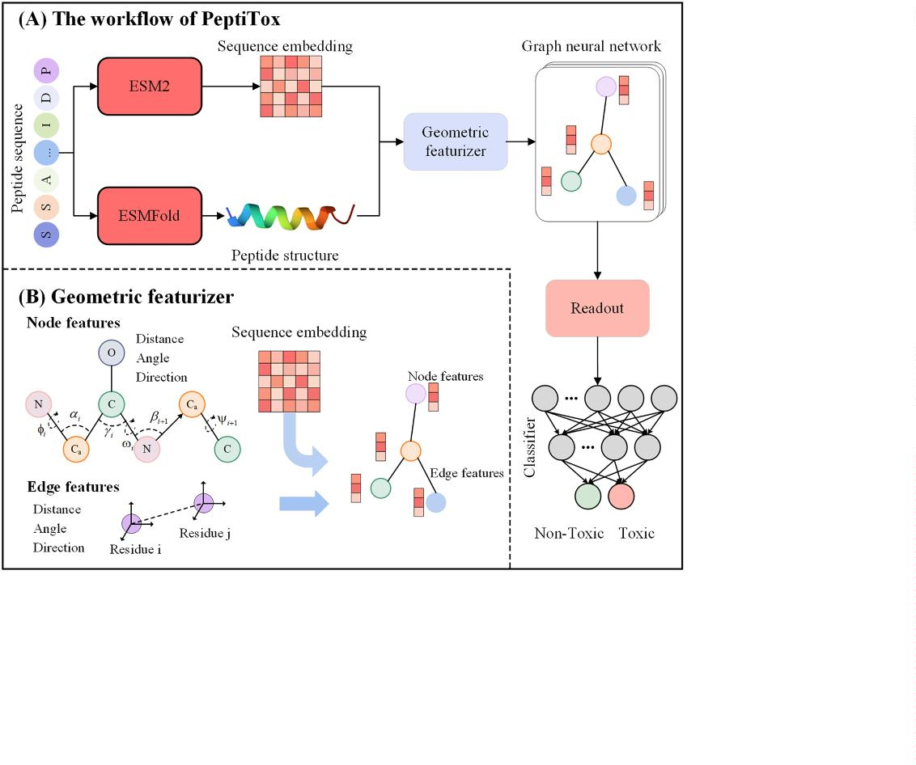

Journal of Chemical Information and Modeling
pubs.acs.org/jcim
Article
prediction, referred to as PeptiTox. Speciﬁcally, given a peptide
between atomic pairs (including the side chain centroid),
relative orientations of other internal atoms or the side chain
centroid with respect to the C atom, as well as bond and
3
0
sequence, we ﬁrst employ the ESM2 protein language model
to extract its sequence embeddings. Since experimentally
determined 3D structures are not available for all peptides, we
α
torsion angles. Similarly, geometric edge features are
3
0
utilize ESMFold to predict their 3D conformations. Next, we
constructed using the inter-residue atomic distances, relative
orientations of all atoms in adjacent residues with respect to
the central residue’s C , and the spatial transformation
construct a graph based on the predicted 3D structure and
compute residue-level geometric features. The sequence
embeddings obtained from ESM2 are then concatenated
with the geometric features as node attributes. Finally, the
model learns peptide representations through a graph neural
network, and a classiﬁer is used to determine whether the
peptide exhibits toxicity.
α
between the reference frames of neighboring residues. The
sequence features extracted by ESM2 and the geometric
features of each residue are concatenated to form the node
features of the graph. The constructed graph is then fed into a
graph neural network (GNN) module to iteratively update
node and edge representations. Finally, a graph-level
representation is obtained through a readout operation and
passed to a classiﬁer to determine whether the peptide is toxic.
III.II. The Sequence Embedding Module. Given a
II. MATERIALS
II.I. Data Preparation. The data set employed in this study
1
8
was derived from the work ToxIBTL developed by Wei et al.
3
0
peptide sequence, we utilize ESM2 to extract the sequence
Positive samples consist of experimentally validated toxic
peptides collected from three publicly available databases:
embeddings. Let L represent the sequence length of the
peptide, the resulting feature matrix can be denoted as X
ESM
∈
5
6
57
58
ConoServer,
ArachnoServer,
and SwissProt.
In the
L×D
R
, where D denotes the feature dimension of each residue,
SwissProt database, toxic peptides were identiﬁed using the
which is 1280 in this study. ESM-2 is a Transformer-based
protein language model developed by Meta and trained on the
keyword ″KW-0800″. These toxic peptides range in length
1
9
from 10 to 50 amino acids. After removing duplicate sequences
across the three databases, a total of 3992 toxic peptides were
obtained. For negative samples, experimentally veriﬁed non-
toxic peptides were retrieved from the SwissProt database
using the keywords ″NOT KW-0800″ and ″NOT KW-0020.″
To mitigate potential model bias caused by sequence length
variations, nontoxic peptide sequences were also restricted to a
length range of 10−50 amino acids, yielding a total of 7009
nontoxic peptides. To further reduce model bias caused by
6
0
UniRef50 data set. It employs a masked language modeling
(MLM) strategy, predicting the identity of amino acids masked
at random within a sequence:
L_{MLM}
=
log p(x|x )
\M
i
(1)
i
M
where M denotes a randomly selected subset containing 15%
of sequence positions, and the model learns to infer the
masked amino acids x based on the context information x ,
5
9
high sequence similarity, CD-HIT was employed to remove
i
\M
6
1
excluding the masked positions. This pretraining objective
enables ESM2 to capture contextual dependencies between
amino acids eﬀectively. Notably, the parameters of the ESM2
model were kept ﬁxed throughout the training process to
preserve its pretrained representations and reduce computa-
tional overhead.
sequences with more than 90% similarity within both the toxic
and nontoxic peptide sets. This process resulted in a ﬁnal set of
1
932 toxic peptides as positive samples. To maintain a
balanced data set, 1932 nontoxic peptides were randomly
selected from the nontoxic set as negative samples. The ﬁnal
data set comprises 3854 peptide sequences. Of these, 85%
were randomly allocated to the training set, while the
remaining 15% were reserved as the test set. To further
provide an intuitive understanding of the distribution of
positive and negative samples in the data set, we visualized the
peptide length distribution and amino acid frequency
distribution, as shown in Figure S1. The distributions of
toxic and nontoxic peptides are generally consistent, and it is
worth noting that the data set contains only 20 standard amino
acids, with no inclusion of nonstandard amino acids.
III.III. The Structure Prediction and Preprocessing
Module. Given a peptide sequence, we utilize ESMFold to
predict its 3D structure. ESMFold is a state-of-the-art, end-to-
end protein folding model built upon the ESM-2 backbone.
Unlike alignment-based methods, ESMFold achieves compa-
rable accuracy without requiring multiple sequence alignments
(MSAs) or external database lookups, signiﬁcantly reducing
inference time compared to AlphaFold2. Once the tertiary
structure is predicted, we extract the 3D coordinates of key
atomic positions, including the N, C , C, O, and the centroid
α
of the heavy side chain atoms. The ﬁnal 3D structure of a
III. THE ARCHITECTURE OF THE PROPOSED MODEL
peptide is represented as a coordinate matrix M ∈ R^{n}
×5×3
,
III.I. Overview of the Model. As illustrated in Figure 1,
where n denotes the number of residues in the peptide, 5
represents the selected atomic positions, and 3 corresponds to
the spatial coordinates (x, y, z) in 3D space. To construct the
connectivity of the peptide graph, we compute the pairwise
distance between the C atoms of all residues. If the distance
given a peptide sequence, PeptiTox ﬁrst employs the
3
0
pretrained protein language model ESM2 to extract sequence
features. Additionally, the structure prediction model ESM-
3
0
Fold is used to predict the 3D structure of the peptide. From
α
the predicted structure, the 3D coordinates of key atomic
between two residues’ C atoms is less than 15 Å, an edge is
α
positions�including the N, C , C, O, and the centroid of the
established between them. A peptide graph can be represented
α
heavy side chain atoms�are extracted. Based on the structural
information, the peptide is represented as a graph, where each
node corresponds to an amino acid residue, and edges
represent interactions between residues. Notably, edges are
established by calculating the distance between the C atoms
as G(A,X,E), where A ∈ R^{n} (binary) denotes the adjacency
×
n
matrix, X ∈ R^{n}
×
d
represents the node feature matrix, and E
∈
node
R^{m}
×
d
denotes the edge feature matrix. Here, n and m
edge
correspond to the number of nodes and edges, respectively,
while d
node
and d represent the dimensionality of node and
edge
α
of two residues. Furthermore, geometric features of each
edge features, respectively. We construct a local coordinate
residue are computed, which include intramolecular distances
system Q = [b , n , b × n ] for each residue, where
i
i
i
i
i
C
https://doi.org/10.1021/acs.jcim.5c01073
J. Chem. Inf. Model. XXXX, XXX, XXX−XXX
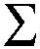

Journal of Chemical Information and Modeling
pubs.acs.org/jcim
Article
residues serve as edges. Node features include ESM2 features
and geometric characteristics of the residues, and edge features
represent the interactions between residues. The resulting
graph is then input into a graph neural network to update the
node and edge features.
Node Update: Given a pair of residues i and j, the node
features are updated using a multihead attention mechanism,
with the following computation formula:
u_{i} = C
N_{i}, v_{i}
i
=
=
C_{iui}
C , b
i
v
i
^{i} , n
i
u
i
v
i
u × v
=
i
i
u_{i} × v_{i}
(2)
C , N , and C denote the coordinates of the α carbon (C ),
α
i
i
α
^{h}i^{l+1}
= h +
i
l
a (W h + W e )
j
l
i
V
l
j
l
E
l
j
l
i
i
nitrogen (N), and carbon (C) atoms of the ith residue,
j
NB_{i}
i
(5)
respectively.
III.IV. The Geometric Featurizer Module. To compre-
hensively capture the structural characteristics of peptides, we
constructed a geometric feature extractor inspired by the works
_{e}w^{l}
ji
^{l} =
ji
_{ew}l
ki
6
2
63
k
NB_{l}
i
(6)
(7)
of Gao et al. and Song et al. This extractor encodes key
geometric properties at both the residue and edge levels.
Speciﬁcally, for each residue, it extracts features related to
distance, angle, and direction information. Similarly, for each
edge, it encodes geometric attributes, including inter-residue
distances, directional vectors, and angular relationships.
III.IV.I. Geometric Node Features. Given the 3D structure of
a peptide sequence, represented as the previously extracted
coordinate matrix, the distance feature between two speciﬁed
atoms, I and J, within residue i is computed using the following
formula:
(W hl)T (W h + W e )
l
l
l
j
l
l
Q
i
K
E ji
w =
l
ji
d
where h_{i}
^{l} represents the node features at the lth layer, and e^{l}
ji
α_{l} denotes the
represents the edge features at the lth layer.
ji
attention weight, while W
^{l} , W^{l} , and W^{l} are the weight
Q
K
V
matrices corresponding to the query, key, and value vectors,
respectively. W
^{l} represents the weight associated with the edge
E
features. NB denotes the neighboring nodes of node i.
i
Edge update: The edge information is updated through
distance = RBF( I
J )
(3)
neighboring nodes, as shown in the following formula:
where, RBF(·) represents the radial basis function, and I, J ∈
^{l+1} = ^{l} +
l+1
^{EdgeMLP(h}j
^{h}il+1₎
l
e
e
e
ji
ji
ji
(8)
{
C , C , N , O , R } with I ≠ J, where R denotes the centroid of
α
i
i
i
i
i
where EdgeMLP( ) represents the multilayer perceptron used
for edge features, and || denotes the concatenation operation.
Global Attention: To eﬀectively capture global information
that is beneﬁcial for peptide toxicity prediction, a global
attention mechanism is employed. To reduce the computa-
tional complexity of global attention, the global context vector
is computed before being used for node representations with
gate attention. The computation formula is as follows:
·
the heavy side chain atoms.
The directional features are obtained by computing the
relative orientation of other atoms within residue i with respect
to the C atom. This is calculated using the following equation:
α
I
I
C
C
direction = Q
T
i
i
i
(4)
where I ∈ {C , N , O , R }.
i
i
i
i
n
1
l+1
h
In addition, we also incorporate the sine and cosine values of
_{c}l ₌
k₌0
n
k
the bond angles (α , β , γ ) and torsion angles(φ , ψ , ω ) as
(9)
i
i
i
i
i
i
node features. The angles α , β , and γ represent the bond
i
i
i
angles formed by N − C − C , C
− N − C , and C − C
l
+
1
=
l
+
1
(GateMLP(c^{l}))
h
h
i
α
i
i
i−1
i
α
i
α
i
i
i
i
i
(10)
−
N , respectively. Similarly, the dihedral angles φ , ψ , and ω
i+1
i
i
where n denotes the number of residues in the peptide
correspond to the torsion angles deﬁned by N − C , C − C ,
i
α
i
i
α
i
sequence,
σ represents the sigmoid activation function, and ⊙
and C − N , respectively.
i+1
indicates element-wise multiplication. GateMLP( ) refers to
the multilayer perceptron (MLP) with gate attention.
·
i
III.IV.II. Geometric Edge Features. Similarly, we construct
geometric features between adjacent residues as edge features,
including distance, direction, and angle. Given two residues i
and j, their distance feature is computed using the radial basis
function (RBF) as RBF(∥I-J∥) where I ∈ {N , C , C , O , R }
III.VI. The Classiﬁcation Module.
Finally, the output of
the GNN block is subjected to average pooling to obtain
sequence-level features, which are then input into the classiﬁer
to categorize the peptide sequence as toxic or nontoxic. The
computational formula is as follows:
i
α
i
i
i
i
and J ∈ {N , C , C , O , R }. The direction features are
j
α
i
j
j
j
calculated by determining the relative direction of all atoms in
=
^{X}Seq
^{Pool}Avg^{(X)}
(11)
J
C
T
i
j
∈
residue j to C using the formula Q
, where J
{N_{j},
α
i
|J C _{j}|
=
y
softmax(MLP(X_{Seq}))
(12)
C , C , O , R }. The rotational angle between two residues is
αj
j
j
j
represented by the feature q(Q^{T} Q ), where q(·) is a quaternion
where ŷrepresents the probability predicted by the model, with
a range of [0, 1]. A larger ŷvalue indicates a higher likelihood
of the peptide being an antimicrobial peptide, and vice versa.
III.VII. The Objective Function. To train the deep
learning model for peptide toxicity prediction, we use the
binary cross-entropy loss function, which is designed for binary
i
j
encoding function that represents the three-dimensional
6
4
rotation matrix as a quaternion vector.
III.V. The Graph Neural Network Module. After the
above steps, a peptide sequence is represented as graph-
structured data, where residues are nodes, interactions between
D
https://doi.org/10.1021/acs.jcim.5c01073
J. Chem. Inf. Model. XXXX, XXX, XXX−XXX
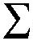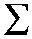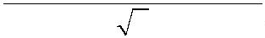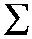

Journal of Chemical Information and Modeling
pubs.acs.org/jcim
Article
Figure 2. Performance comparison with baselines on peptide toxicity prediction. This ﬁgure displays the performance of PeptiTox and other
baseline methods on the test set across ﬁve metrics, including Sensitivity, Speciﬁcity, FDR, Accuracy and MCC. (A-E) Bar plots show the
performance of each method in Sensitivity, Speciﬁcity, FDR, Accuracy and MCC, respectively. (F) A Radar chart summarizes the overall
performance of all methods across all metrics.
classiﬁcation tasks. Given the predicted label ŷand the true
label y, the binary cross-entropy loss is computed as
TP
+
sensitivity(recall) =
TP
FN
(17)
L(y, y) = [(y log(y) + (1
y)log(1
y))]
(13)
MCC =
TP × TN
FP × FN
The model’s training objective is to minimize this loss cross all
training samples:
(TP + FN)(TP + FP)(TN + FP)(TN + FN)
N
(18)
(19)
1
N
L_{total}
=
L(y, y )
i
i
i=1
(14)
FP
TP + FP
FDR =
where N is the number of peptide sequences in a batch, y is
the true label for sequence i, and y is the model’s predicted
probability for sequence i to be toxic.
i
i
where True Positive (TP) refers to the number of samples that
are actually positive and correctly predicted as positive by the
model. True Negative (TN) denotes the number of samples
that are actually negative and correctly predicted as negative.
False Positive (FP) indicates the number of samples that are
actually negative but incorrectly predicted as positive. False
Negative (FN) represents the number of samples that are
actually positive but incorrectly predicted as negative. The
Sensitivity metric evaluates the predictor’s ability to identify
positive samples, while the Speciﬁcity metric assesses its ability
to identify negative samples. False Discovery Rate (FDR)
measures the proportion of incorrect predictions among the
positive samples. Accuracy (ACC) and Matthews Correlation
Coeﬃcient (MCC) are employed to assess the overall
performance of the predictor.
III.VIII. Evaluation Metrics. To evaluate the performance
of the proposed model on the peptide toxicity prediction task,
the metrics Sensitivity, Speciﬁcity, False Discovery Rate
(FDR), Accuracy, and Matthews Correlation Coeﬃcient
(MCC) were utilized to compare the proposed model with
6
5−68
baseline models.
follows:
The formulas for these metrics are as
69
TP + TN
accuracy =
TP + TN + FP + FN
(15)
(16)
TN
specificity =
TN + FP
E
https://doi.org/10.1021/acs.jcim.5c01073
J. Chem. Inf. Model. XXXX, XXX, XXX−XXX
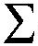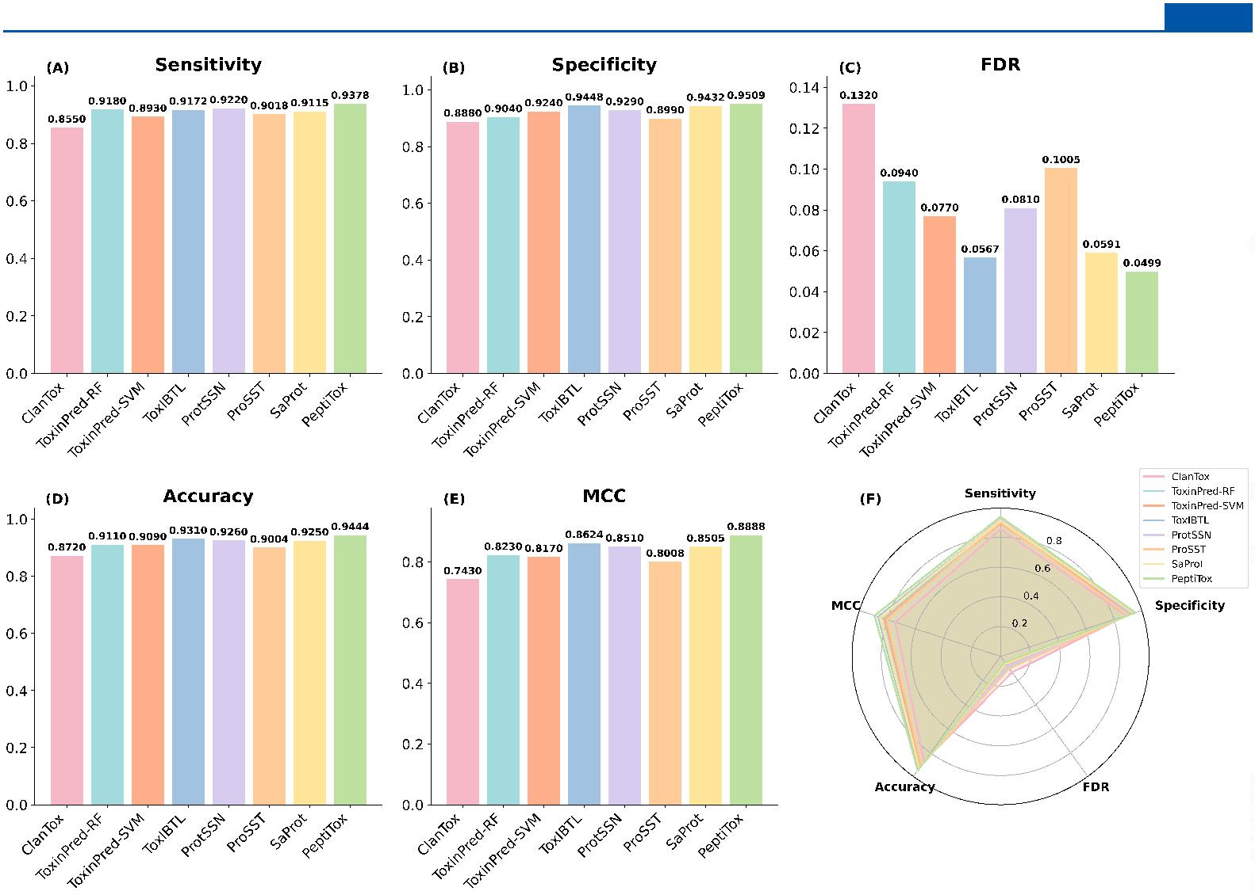

Journal of Chemical Information and Modeling
pubs.acs.org/jcim
Article
Table 1. Performance Comparison of PeptiTox and Its Variants
variants
w/o ESM2
w/o geometric features
w/o structure
accuracy
F1
MCC
sensitivity
speciﬁcity
FDR
0.9009
0.9286
0.9218
0.9444
0.8993
0.9278
0.9215
0.9439
0.8023
0.8574
0.8438
0.8888
0.8856
0.9177
0.9177
0.9378
0.9162
0.9394
0.926
0.0863
0.0619
0.0746
0.0499
PeptiTox
0.9509
III.IX. Experimental Setup. All experiments were con-
PeptiTox consistently occupied the outermost region of the
chart (except for FDR), indicating its superior performance in
all metrics.
ducted on a system equipped with an NVIDIA GeForce GTX
4
090 GPU (24GB) running Ubuntu 20.04. The deep learning
models were implemented using PyTorch 2.4.1 with Python
.12, and PyTorch Geometric 2.6.1. Model training was
performed using the Adam optimizer with a learning rate of 1
10⁻⁴. The binary cross-entropy loss (BCELoss) function was
employed to optimize classiﬁcation performance. Dropout was
In conclusion, the proposed model exhibits a signiﬁcant
performance advantage over existing methods, making it a
promising approach for peptide toxicity prediction.
3
×
IV.II. Ablation Study on the Architectural Compo-
nents of PeptiTox. To explore the optimal architecture of
our model and demonstrate that each module is both eﬀective
and nonredundant, we conducted ablation experiments. In
these experiments, we systematically removed or replaced one
module at a time while keeping the rest of the model
unchanged. Speciﬁcally, we performed the following experi-
ments: (1) To evaluate the contribution of the ESM2 model,
we constructed a model variant termed w/o ESM2, in which
the ESM2 module was removed from the architecture,
retaining only the peptide’s 3D structure and geometric
features. (2) To assess the importance of geometric features,
we implemented a model variant termed w/o geometric
features, in which node representations were constructed using
only the sequence features extracted by ESM2, while all
geometric information was omitted. (3) To examine the role of
structural information, we designed another variant, referred to
as w/o structure, where the structural input was removed and
only sequence features from ESM2 were utilized. To maintain
model functionality in the absence of structural data, we
replaced the graph neural network with LSTM and CNN
layers. We evaluated the performance of the proposed model
and its variants across six metrics: Accuracy, F1-score, MCC,
Sensitivity, Speciﬁcity, and FDR. The experimental results are
presented in Table 1. From the experimental results, we can
observe that the removal of the ESM2 model leads to a
substantial decline in performance across all six evaluation
metrics. Speciﬁcally, Accuracy drops from 0.9444 to 0.9009 (a
decrease of 4.6%), F1-score from 0.9439 to 0.8993 (4.7%),
MCC from 0.8888 to 0.8023 (9.7%), Sensitivity from 0.9378
to 0.8856 (5.6%), Speciﬁcity from 0.9509 to 0.9162 (3.6%),
and FDR increases from 0.0499 to 0.0863 (73%). These results
highlight the critical role of the pretrained protein language
model in capturing sequence information and signiﬁcantly
improving the model’s ability to distinguish between toxic and
nontoxic peptides. Similarly, removing structural information
results in a performance degradation, with Accuracy reducing
to 0.9218 (2.4% decrease), F1-score to 0.9215 (2.4%
decrease), and MCC to 0.8438 (5.1% decrease). This indicates
that structural information plays a crucial role in peptide
toxicity prediction, reinforcing the idea that peptide con-
formation signiﬁcantly impacts biological activity. Further-
more, when geometric features are removed, the model’s
performance also declines, albeit to a lesser extent than the
removal of the ESM2 embeddings and structure information,
suggesting that geometric features contribute to predictive
performance but are less inﬂuential than sequence-based
representations and structure information. Comparing the
performance drop across diﬀerent model variants, we observe
set to 0.2, weight decay to 1 × 10 , and the graph neural
−
3
network consisted of four layers. The batch size was set to 128,
and the learning rate was dynamically adjusted using the
ExponentialLR scheduler.
IV. RESULTS
IV.I. Comparative Evaluation of PeptiTox for Peptide
Toxicity Prediction. To validate the eﬀectiveness of the
proposed model for peptide toxicity prediction, we compared
the performance of PeptiTox with four existing methods:
2
0
19
ClanTox,
ToxinPred-RF, ToxinPred-SVM,
and Tox-
1
8
IBTL. Furthermore, to further validate the eﬀectiveness of
our proposed integration of sequence and structural
information, we conducted a comparative analysis against
three representative state-of-the-art sequence−structure hybrid
3
8
40
41
models, namely SaProt,
ProtSSN,
and ProSST.
The
evaluation metrics included Sensitivity, Speciﬁcity, False
Discovery Rate (FDR), Accuracy, and Matthews Correlation
Coeﬃcient (MCC). The experimental results are presented in
Figure 2.
As shown in Figure 2A−E, PeptiTox outperforms all
baseline methods across all ﬁve evaluation metrics. Speciﬁcally,
it achieves a Sensitivity of 0.9378, a Speciﬁcity of 0.9509, an
FDR of 0.0499, an Accuracy of 0.9444, and an MCC of 0.8888.
Compared to the second-best method, ToxIBTL, PeptiTox
improves Sensitivity, Speciﬁcity, FDR, Accuracy, and MCC by
2
.25, 0.65, 11.99, 1.44, and 3.06%, respectively. In addition, the
results demonstrated that PeptiTox achieved superior overall
performance compared to SaProt, ProtSSN, and ProtSST.
ProtSSN and SaProt exhibited performance comparable to
PeptiTox, suggesting that these models are also capable of
eﬀectively utilizing sequence−structure information for peptide
toxicity prediction. In contrast, the performance of ProtSST
was slightly lower, which may be attributed to the model being
less well-suited to the speciﬁc characteristics of this prediction
task. This superior performance highlights the eﬀectiveness of
our proposed strategy for integrating sequence and structural
information, underscoring its potential advantages in peptide
toxicity prediction. The high Sensitivity and Speciﬁcity of
PeptiTox indicates its superior ability to distinguish toxic and
nontoxic peptides compared to baseline methods. Moreover,
its lower FDR suggests a reduced false positive rate, which is
crucial in avoiding the misclassiﬁcation of potential therapeutic
peptide candidates. Additionally, PeptiTox achieves the highest
MCC, demonstrating its overall classiﬁcation eﬀectiveness. The
radar chart in Figure 2F provides a comprehensive visualization
of the overall performance of each method across all metrics.
F
https://doi.org/10.1021/acs.jcim.5c01073
J. Chem. Inf. Model. XXXX, XXX, XXX−XXX

Journal of Chemical Information and Modeling
pubs.acs.org/jcim
Article
Table 2. Performance Comparison of Transformer-GNN and Baseline GNNs
variants
GCN
ChebConv
GraphSAGE
GraphConv
GAT
accuracy
F1
MCC
sensitivity
speciﬁcity
FDR
0.9244
0.9301
0.9299
0.5709
0.9208
0.9444
0.924
0.8492
0.8604
0.8602
0.1473
0.8422
0.8888
0.9203
0.9229
0.9208
0.6848
0.9275
0.9378
0.9286
0.9374
0.9389
0.457
0.9141
0.9509
0.0719
0.0635
0.0618
0.4395
0.0843
0.0499
0.9296
0.9292
0.613
0.9213
0.9439
PeptiTox
Figure 3. Comparison of pLDDT distribution for ColabFold, Omegafold and ESMFold.
that sequence information contributes the most to model
performance, followed by structural information, and ﬁnally
geometric features. This hierarchical importance suggests that
while peptide sequence embeddings provide a fundamental
representation, structural and geometric attributes further
reﬁne toxicity prediction.
metrics. One striking observation is the poor performance of
GraphConv, which achieves Accuracy (0.5709), MCC
(0.1473), and FDR (0.4395)�substantially worse than all
other GNN variants, suggesting that it may not be well-suited
for this speciﬁc task.
Overall, the results demonstrate that our Transformer-based
approach eﬀectively captures structural and sequential depend-
encies, leading to more accurate and reliable predictions
compared to traditional GNN architectures.
These ﬁndings demonstrate that a comprehensive repre-
sentation incorporating sequence, structural, and geometric
features leads to optimal peptide toxicity prediction. The
ESM2 model provides essential sequence-level embeddings,
while structural and geometric features enhance the model’s
ability to capture spatial properties.
IV.IV. Investigating the Impact of Diﬀerent Structure
Predictors on Toxicity Prediction. With the development
of various protein structure prediction models, it is important
to assess how structural diﬀerences generated by diﬀerent
models may inﬂuence downstream peptide toxicity prediction.
To this end, we employed three representative structure
IV.III. Performance Comparison of Transformer-GNN
and Baseline GNNs. To validate the eﬀectiveness of the
proposed Transformer-based graph neural network, we
compared its performance against ﬁve commonly used GNN
prediction tools�ESMFold, OmegaFold, and ColabFold�to
generate peptide structures for comparison. ColabFold was
used in place of the original AlphaFold due to the high
computational requirements of AlphaFold, making ColabFold
a more accessible alternative with similar predictive capa-
bilities. To provide a visual comparison of the predicted
structure quality, we calculated the average pLDDT scores for
each peptide structure generated by ColabFold, OmegaFold,
and ESMFold, and presented the results as violin plots (Figure
3). As shown, ColabFold produced peptide structures with the
highest predicted quality, followed by OmegaFold, and then
ESMFold. All generated structures were then input into our
established PeptiTox framework for toxicity classiﬁcation. The
7
0
71
ChebConv,
72
GraphSAGE,
architectures: GCN,
Graph-
Conv, and GAT.⁷⁴ Table 2 summarizes the performance of
these models across six evaluation metrics.
73
From the results, it is evident that our proposed Trans-
former-based model consistently outperforms all baseline
GNN models across all six metrics. Among the baseline
GNNs, ChebConv and GraphSAGE exhibit relatively strong
performance, with accuracy values of 0.9301 and 0.9299,
respectively. However, their FDR values (0.0635 and 0.0618)
remain higher than the proposed model, indicating a higher
rate of incorrect positive predictions. While GCN and GAT
achieve competitive results, they still lag behind PeptiTox in all
G
https://doi.org/10.1021/acs.jcim.5c01073
J. Chem. Inf. Model. XXXX, XXX, XXX−XXX
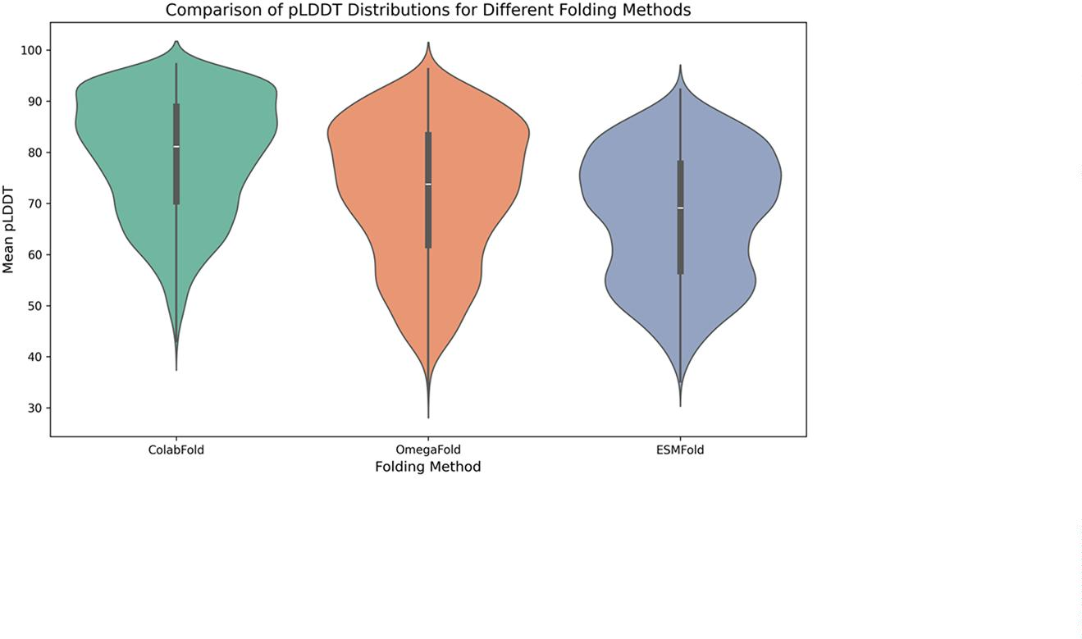

Journal of Chemical Information and Modeling
pubs.acs.org/jcim
Article
Table 3. Performance Comparison of Diﬀerent Structure Predictors
methods
accuracy
F1
MCC
sensitivity
speciﬁcity
FDR
OmegaFold
ColabFold
ESMFold
0.9317
0.9306
0.9444
0.9315
0.9311
0.9439
0.8634
0.8615
0.8888
0.9296
0.9374
0.9378
0.9337
0.9239
0.9509
0.0665
0.075
0.0499
Figure 4. Feature visualization of peptide representations across diﬀerent learning stages. This ﬁgure displays the visualization of the 2D t-SNE
projections of the feature embedding across the diﬀerent stages. (A) Features encoded by ESM2; (B) Features after concatenating ESM2 and
geometric features; (C−F) Features progressively reﬁned through four layers of a graph neural network. Dark blue represents nontoxic peptides,
and light blue represents toxic peptides.
detailed results are summarized in Table 3. Despite noticeable
diﬀerences in predicted structural quality, all three structure
prediction models achieved comparably high performance in
toxicity classiﬁcation, with only minor variations across
diﬀerent evaluation metrics. These results suggest that
structural representations generated by ESMFold, OmegaFold,
and ColabFold are all suitable for downstream peptide toxicity
prediction, exhibiting overall similar predictive performance.
Interestingly, ESMFold consistently outperformed the other
two models across all evaluation metrics, which appears
contradictory to its relatively lower predicted structural quality
shown in Figure 3. We hypothesize that this phenomenon may
be attributed to the inherent compatibility between ESMFold
and ESM2, as both models originate from the Meta family.
The structural features produced by ESMFold, although of
lower predicted quality, may oﬀer more complementary
information to the sequence embeddings generated by
ESM2, thereby facilitating more eﬀective feature learning by
the downstream toxicity prediction model. Moreover, peptide
toxicity is a complex property that may depend not only on
precise global structural accuracy but also on various other
factors, including critical local structural features. Therefore,
although ColabFold generates structures with higher predicted
global quality, these structures may not capture the subtle
structural determinants directly associated with peptide toxicity
as eﬀectively as those predicted by ESMFold. Based on these
results and analyses, we selected ESMFold as the ﬁnal structure
prediction tool in our framework.
IV.V. Visualization of Feature Learning Dynamics for
Peptide Toxicity Prediction. To intuitively understand the
learning process of the model and evaluate its ability to capture
peptide toxicity-related features, we conducted a visualization
analysis of the extracted features at diﬀerent learning stages.
Speciﬁcally, we ﬁrst extracted features from peptide sequences
encoded by ESM2, features obtained by concatenating ESM2
and geometric features, and features learned progressively
through four layers of graph neural networks. Subsequently, we
applied t-SNE⁷⁵ for dimensionality reduction, projecting the
high-dimensional features into a two-dimensional space and
selecting the two most important dimensions for analysis.
H
https://doi.org/10.1021/acs.jcim.5c01073
J. Chem. Inf. Model. XXXX, XXX, XXX−XXX
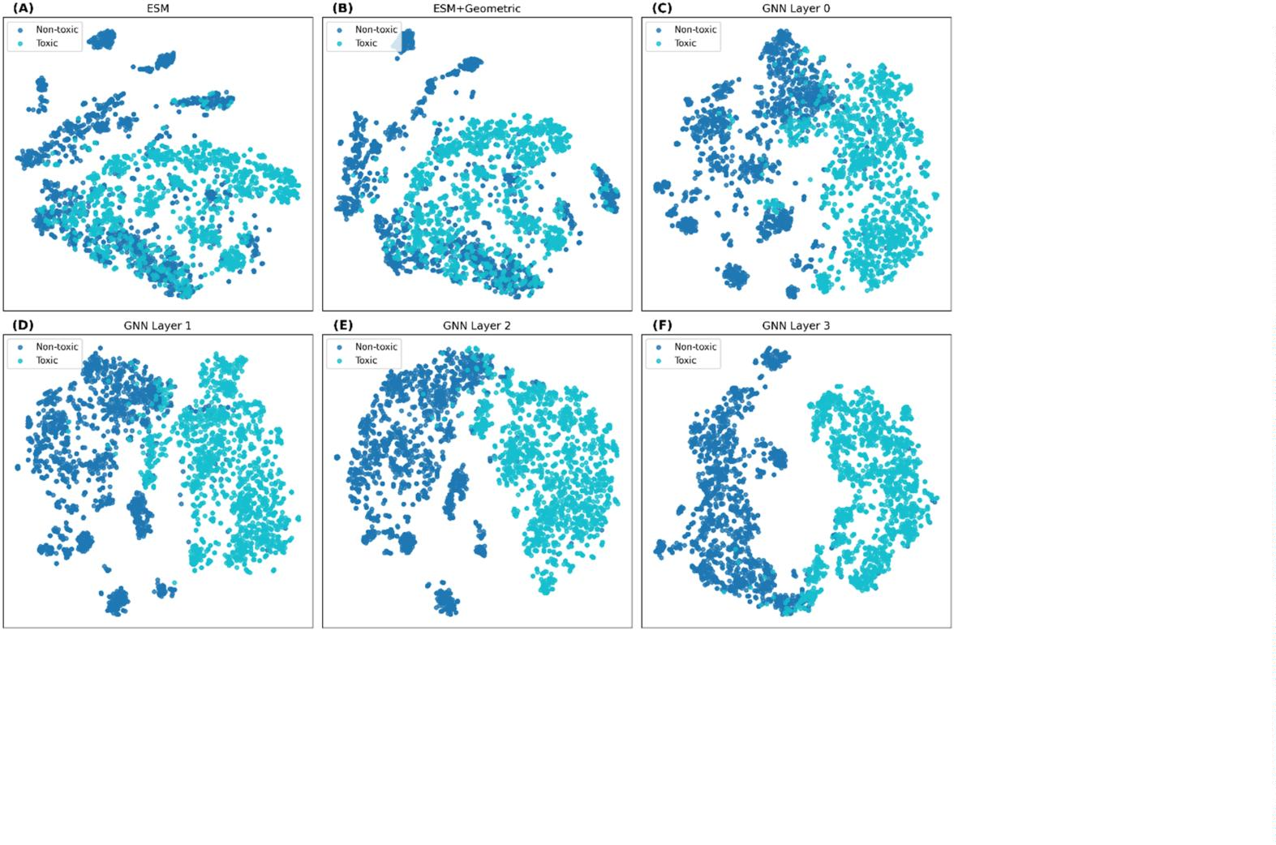

Journal of Chemical Information and Modeling
pubs.acs.org/jcim
Article
Table 4. Performance Comparison of Diﬀerent ESM2 Model Scales on Peptide Toxicity Prediction
variants
accuracy
F1
MCC
sensitivity
speciﬁcity
FDR
params
ESM2_t6_8M_UR50D
ESM2_t12_35M_UR50D
ESM2_t30_150M_UR50D
ESM2_t33_650M_UR50D
ESM2_t36_3B_UR50D
ProtBert-BFD
0.9234
0.9117
0.9237
0.9444
0.9275
0.8577
0.9327
0.9222
0.9109
0.9231
0.9439
0.9281
0.8527
0.9329
0.8474
0.8237
0.8476
0.8888
0.8553
0.7172
0.8655
0.9089
0.9027
0.9156
0.9378
0.9348
0.8245
0.9353
0.9379
0.9208
0.9317
0.9509
0.9203
0.8908
0.9301
0.0637
0.0807
0.0692
0.0499
0.0784
0.1166
0.0694
8M
35M
150M
650M
3B
420M
3B
ProtT5-XL-UniRef50
Finally, we visualized the reduced features as scatter plots, as
shown in Figure 3.
still slightly lags behind the ESM2 model with 650 M
parameters.
As observed in Figure 4A, after encoding with ESM2, the
features of toxic and nontoxic peptides remain highly mixed,
making it diﬃcult to establish a clear separation boundary.
This indicates that ESM2 alone fails to fully capture toxicity-
related feature representations. After incorporating geometric
features (Figure 4B), while the data distribution remains
somewhat mixed, certain regions exhibit a preliminary degree
of separation compared to using ESM2 alone. As features are
learned progressively through the GNN layers (Figure 4C−F),
the distribution of toxic and nontoxic peptides gradually
exhibits a more pronounced separation trend. Notably, after
the third (Figure 4E) and fourth GNN layers (Figure 4F), the
two feature groups become almost entirely distinct. This
suggests that the GNN eﬀectively captures crucial toxicity-
related feature patterns through multilayer feature aggregation.
These results validate the eﬀectiveness of the proposed model,
demonstrating that it can learn important representations that
enable accurate identiﬁcation of toxic peptides.
Overall, the ESM2_t33_650M_UR50D model achieves the
best performance across all evaluation metrics, striking an
optimal balance between model accuracy, parameter size, and
inference eﬃciency. Consequently, we selected
ESM2_t33_650M_UR50D as the pretrained feature extractor
for our ﬁnal model.
V. CONCLUSIONS
In this study, we introduced PeptiTox, a novel deep learning-
based framework that integrates protein language models and
geometric deep learning for peptide toxicity prediction. Our
results demonstrate that incorporating both sequence embed-
dings from ESM2 and structural information from ESMFold
leads to superior predictive performance compared to existing
methods. Ablation experiments further conﬁrm that sequence,
structural, and geometric features collectively contribute to
model performance, with sequence embeddings playing a
dominant role. Additionally, our comparison of diﬀerent graph
neural network architectures highlights the eﬀectiveness of
Transformer-based GNNs in capturing intricate peptide
relationships.
In summary, the proposed model eﬀectively learns the
distinguishing features of toxic and nontoxic peptides and
progressively enhances its discrimination ability through
hierarchical learning.
Despite the promising performance of our approach, there is
still room for improvement. First, the model lacks interpret-
ability, making it unclear which speciﬁc patterns in peptide
sequences contribute to their toxicity. Second, our study
focuses solely on peptide toxicity prediction and does not
extend to other properties such as biological activity. In future
work, we will enhance the model’s interpretability by
identifying key sequence patterns associated with toxicity.
Additionally, we will expand the model’s capabilities to enable
multiattribute prediction, allowing for a more comprehensive
assessment of peptide properties.
IV.VI. Performance Comparison of Protein Language
Models in Peptide Toxicity Prediction. To investigate the
eﬀect of diﬀerent model sizes on peptide toxicity prediction,
we conducted experiments using ﬁve diﬀerent parameter scales
of the ESM2 protein language model: 8M, 35M, 150M, 650M,
and 3B. Due to GPU memory limitations (NVIDIA RTX
4
090, 24GB), we were unable to evaluate the 15B model in
this study. Table 4 presents the performance of each ESM2
variant across six metrics.
■
From the table, we observe a general upward trend in model
performance for peptide toxicity prediction as the pretrained
model size increases from 8 to 650 M, although some
ﬂuctuations occur across speciﬁc metrics. Interestingly, when
scaling up from 8 to 35 M, the model exhibits a performance
drop, suggesting that the 35 M variant may not be as eﬀective
in capturing relevant sequence features. Moreover, when the
pretrained model size increases to 3B, the performance starts
to decline. This may be attributed to the excessive complexity
introduced by a large number of parameters, combined with
the relatively short peptide sequences and limited data set size.
Furthermore, considering the widespread application of
existing protein language models such as ProtBert-BFD and
ProtT5-XL-UniRef50, we compared these models with ESM2.
The experimental results demonstrate that models with various
parameter sizes of ESM2 consistently outperform ProtBert-
BFD. ProtT5-XL-UniRef50 achieves results comparable to
those of ESM2 models with 650 M and 3B parameters, yet it
ASSOCIATED CONTENT
Data Availability Statement
The data used in this study and the source code are openly
available for those interested at https://github.com/WYLqlit/
PeptiTox
*
_{sı} Supporting Information
The Supporting Information is available free of charge at
https://pubs.acs.org/doi/10.1021/acs.jcim.5c01073.
The statistical information of the data set (Figure S1)
(PDF)
■
AUTHOR INFORMATION
Corresponding Authors
Na Li − School of Intelligent Manufacturing and Control
Engineering, Qilu Institute of Technology, Jinan 250200,
China; Email: nli@qlit.edu.cn
I
https://doi.org/10.1021/acs.jcim.5c01073
J. Chem. Inf. Model. XXXX, XXX, XXX−XXX

Journal of Chemical Information and Modeling
pubs.acs.org/jcim
Article
Shuwen Xiong − Faculty of Applied Sciences, Macao
Language Models. J. Chem. Inf. Model. 2025, 65, 3789⁻3799,
DOI: 10.1021/acs.jcim.4c02365.
(10) Chung, C.-R.; Kuo, T.-R.; Wu, L.-C.; Lee, T.-Y.; Horng, J.-T.
Characterization and identification of antimicrobial peptides with
different functional activities. Briefings Bioinf. 2020, 21 (3), 1098−
Polytechnic University, Macao 999078, China;
orcid.org/
0
000-0002-0935-9787; Email: shuwenx@foxmail.com
Leyi Wei − Faculty of Applied Sciences, Macao Polytechnic
University, Macao 999078, China; orcid.org/0000-0003-
444-190X; Email: weileyi@sdu.edu.cn
1
114.
1
(11) Thakur, A.; Sharma, A.; Alajangi, H. K.; et al. In pursuit of next-
generation therapeutics: Antimicrobial peptides against superbugs,
their sources, mechanism of action, nanotechnology-based delivery,
and clinical applications. Int. J. Biol. Macromol. 2022, 218, 135−156.
(12) Zhang, W.; Xu, Y.; Wang, A.; Chen, G.; Zhao, J. Fuse feeds as
one: cross-modal framework for general identification of AMPs.
Briefings Bioinf. 2023, 24 (6), No. bbad336.
Authors
Yanling Wang − School of Intelligent Manufacturing and
Control Engineering, Qilu Institute of Technology, Jinan
2
50200, China
Xiao Wang − School of Intelligent Manufacturing and Control
Engineering, Qilu Institute of Technology, Jinan 250200,
China
(13) Yan, K.; Guo, Y.; Liu, B. PreTP-2L: identification of therapeutic
peptides and their types using two-layer ensemble learning framework.
Bioinformatics 2023, 39 (4), No. btad125.
Feng Cao − School of Intelligent Manufacturing and Control
Engineering, Qilu Institute of Technology, Jinan 250200,
China
(14) Liu, M.; Li, C.; Chen, R.; Cao, D.; Zeng, X. Geometric deep
learning for drug discovery. Expert Syst. Appl. 2024, 240, No. 122498.
(15) Altschul, S. F.; et al. Gapped BLAST and PSI-BLAST: a new
generation of protein database search programs. Nucleic Acids Res.
Complete contact information is available at:
https://pubs.acs.org/10.1021/acs.jcim.5c01073
1
997, 25 (17), 3389 3402.
−
(16) Negi, S. S.; Schein, C. H.; Ladics, G. S.; et al. Functional
classification of protein toxins as a basis for bioinformatic screening.
Sci. Rep. 2017, 7 (1), No. 13940.
Author Contributions
Y.W.: conceptualization, methodology. N.L.: programming
and reviewing, X.W.: data curation, F.C.: validation and
(17) Meng, Q.; Guo, F.; Tang, J. Improved structure-related
prediction for insufficient homologous proteins using MSA enhance-
ment and pre-trained language model. Briefings Bioinf. 2023, 24 (4),
No. bbad217, DOI: 10.1093/bib/bbad217.
supervision, Y.W.: writing�original draft preparation, S.X.:
visualization and data analysis. L.W.: writing�reviewing and
editing.
Funding
(18) Wei, L.; Ye, X.; Sakurai, T.; Mu, Z.; Wei, L. ToxIBTL:
prediction of peptide toxicity based on information bottleneck and
This work was supported by the National Natural Science
Foundation of China (No. 62322112), the Internal Research
Grants of Macao Polytechnic University (No. RP/CAI02/
023), the Science and Technology Development Fund of
Macao (No. 0177/2023/RIA3).
−
transfer learning. Bioinformatics 2022, 38 (6), 1514 1524.
(19) Gupta, S.; Kapoor, P.; Chaudhary, K.; et al. In silico approach
for predicting toxicity of peptides and proteins. PLoS One 2013, 8 (9),
No. e73957.
2
(20) Naamati, G.; Askenazi, M.; Linial, M. ClanTox: a classifier of
short animal toxins. Nucleic Acids Res. 2009, 37 (suppl\_2), W363−
W368.
(21) Mall, R.; Singh, A.; Patel, C. N.; Guirimand, G.; Castiglione, F.
VISH-Pred: an ensemble of fine-tuned ESM models for protein
toxicity prediction. Briefings Bioinf. 2024, 25 (4), No. bbae270.
(22) Pan, X.; Zuallaert, J.; Wang, X.; et al. ToxDL: deep learning
using primary structure and domain embeddings for assessing protein
toxicity. Bioinformatics 2021, 36 (21), 5159−5168.
(23) Shi, H.; Li, Y.; Chen, Y.; et al. ToxMVA: An end-to-end multi-
view deep autoencoder method for protein toxicity prediction.
Comput. Biol. Med. 2022, 151, No. 106322.
(24) Morozov, V.; Rodrigues, C. H. M.; Ascher, D. B. CSM-Toxin: a
web-server for predicting protein toxicity. Pharmaceutics 2023, 15 (2),
Notes
The authors declare no competing ﬁnancial interest.
■
REFERENCES
(1) Guntuboina, C.; Das, A.; Mollaei, P.; Kim, S.; Barati Farimani, A.
Peptidebert: A language model based on transformers for peptide
property prediction. J. Phys. Chem. Lett. 2023, 14 (46), 10427−10434.
(2) Yan, K.; LV, H.; Shao, J.; Chen, S.; Liu, B. TPpred-SC: multi-
functional therapeutic peptideprediction based on multi-label super-
visedcontrastive learning. Sci. China Inf. Sci. 2024, 67 (11),
No. 212105, DOI: 10.1007/s11432-024-4147-8.
(3) Sundaram, B.; Pandian, N.; Mall, R.; et al. NLRP12-
PANoptosome activates PANoptosis and pathology in response to
heme and PAMPs. Cell 2023, 186 (13), 2783−2801.
(4) Karki, R.; Lee, S.; Mall, R.; et al. ZBP1-dependent inflammatory
cell death, PANoptosis, and cytokine storm disrupt IFN therapeutic
efficacy during coronavirus infection. Sci. Immunol. 2022, 7 (74),
No. eabo6294.
(5) Alshawwa, S. Z.; Kassem, A. A.; Farid, R. M.; Mostafa, S. K.;
Labib, G. S. Nanocarrier drug delivery systems: characterization,
limitations, future perspectives and implementation of artificial
intelligence. Pharmaceutics 2022, 14 (4), 883.
4
31.
(25) Wei, L.; Ye, X.; Xue, Y.; Sakurai, T.; Wei, L. ATSE: a peptide
toxicity predictor by exploiting structural and evolutionary informa-
tion based on graph neural network and attention mechanism.
Briefings Bioinf. 2021, 22 (5), No. bbab041.
(26) Jiao, S.; Ye, X.; Sakurai, T.; Zou, Q.; Liu, R. Integrated
convolution and self-attention for improving peptide toxicity
prediction. Bioinformatics 2024, 40 (5), No. btae297.
(27) Zulfiqar, H.; et al. Deep-STP: a deep learning-based approach
to predict snake toxin proteins by using word embeddings. Front. Med.
2024, 10, No. 1291352, DOI: 10.3389/fmed.2023.1291352.
(28) Prabantu, V. M.; Yazhini, A.; Srinivasan, N. Manoeuvring
protein functions and functional levels by structural excursions.
(6) Yan, K.; Lv, H.; Guo, Y.; Peng, W.; Liu, B. sAMPpred-GAT:
Prediction of Antimicrobial Peptide by Graph Attention Network and
Predicted Peptide Structure. Bioinformatics 2023, 39 (1), No. btac715.
(7) Baig, M. H.; Ahmad, K.; Saeed, M.; et al. Peptide based
therapeutics and their use for the treatment of neurodegenerative and
other diseases. Biomed. Pharmacother. 2018, 103, 574−581.
(8) Chiangjong, W.; Chutipongtanate, S.; Hongeng, S. Anticancer
peptide: Physicochemical property, functional aspect and trend in
clinical application. Int. J. Oncol. 2020, 57 (3), 678−696.
Phenotypic Switching 2020, 77 104, DOI: 10.1016/B978-0-12-
−
817996-3.00006-2.
(29) Abramson, J.; Adler, J.; Dunger, J.; et al. Accurate structure
prediction of biomolecular interactions with AlphaFold 3. Nature
2024, 630 (8016), 493
−
500.
(30) Lin, Z.; Akin, H.; Rao, R.; et al. Evolutionary-scale prediction of
atomic-level protein structure with a language model. Science 2023,
379 (6637), 1123−1130.
(9) Xiong, S.; Cai, J.; Shi, H.; Cui, F.; Zhang, Z.; Wei, L. UMPPI:
Unveiling Multilevel Protein−Peptide Interaction Prediction via
J
https://doi.org/10.1021/acs.jcim.5c01073
J. Chem. Inf. Model. XXXX, XXX, XXX−XXX

Journal of Chemical Information and Modeling
pubs.acs.org/jcim
Article
(31) Wu, R.et al. High-resolution de novo structure prediction from
primary sequence. BioRxiv, p. 2022.07. 21.500999, 2022.
(32) Mirdita, M.; Schütze, K.; Moriwaki, Y.; Heo, L.; Ovchinnikov,
S.; Steinegger, M. ColabFold: making protein folding accessible to all.
Nat. Methods 2022, 19 (6), 679−682.
(54) Schmirler, R.; Heinzinger, M.; Rost, B. Fine-tuning protein
language models boosts predictions across diverse tasks. Nat.
Commun. 2024, 15 (1), No. 7407.
(55) Zhang, Q.; Chen, W.; Qin, M.; et al. Integrating protein
language models and automatic biofoundry for enhanced protein
evolution. Nat. Commun. 2025, 16 (1), No. 1553.
(56) Kaas, Q.; Yu, R.; Jin, A.-H.; Dutertre, S.; Craik, D. J.
ConoServer: updated content, knowledge, and discovery tools in the
conopeptide database. Nucleic Acids Res. 2012, 40 (D1), D325−D330.
(57) Wood, D. L.; Cai, R.; Kaas, E.; Herzig, W.; King, G. F.
ArachnoServer: a database of protein toxins from spiders. BMC
Genomics 2009, 10 (1), No. 375.
(58) Apweiler, R.; et al. UniProt: the universal protein knowledge-
base. Nucleic Acids Res. 2004, 32 (suppl\_1), D115−D119.
(59) Li, W.; Godzik, A. Cd-hit: a fast program for clustering and
comparing large sets of protein or nucleotide sequences. Bio-
informatics 2006, 22 (13), 1658−1659.
(60) Coudert, E.; Gehant, S.; de Castro, E.; et al. Annotation of
biologically relevant ligands in UniProtKB using ChEBI. Bioinfor-
matics 2023, 39 (1), No. btac793.
(33) Gligorijevic,́V.; Renfrew, P. D.; Kosciolek, T.; et al. Structure-
based protein function prediction using graph convolutional networks.
Nat. Commun. 2021, 12 (1), No. 3168.
(34) Mitra, R.; Li, J.; Sagendorf, J. M.; et al. Geometric deep learning
of protein−DNA binding specificity. Nat. Methods 2024, 21 (9),
1
674−1683.
(35) van der Weg, K.; Merdivan, E.; Piraud, M.; Gohlke, H. TopEC:
prediction of Enzyme Commission classes by 3D graph neural
networks and localized 3D protein descriptor. Nat. Commun. 2025, 16
(1), No. 2737.
(36) Yang, K. K.; Zanichelli, N.; Yeh, H. Masked inverse folding with
sequence transfer for protein representation learning. Protein Eng.,
Des. Sel. 2023, 36, No. gzad015.
(37) Zhang, Z.et al. Protein representation learning by geometric
structure pretraining. arXiv:2203.06125. arXiv.org e-Print archive
https://arxiv.org/abs/2203.06125. 2022.
(38) Su, J.; Han, C.; Zhou, Y.; Shan, J.; Zhou, X.; Yuan, F. Saprot:
Protein language modeling with structure-aware vocabulary.bioRxiv, p.
(61) Devlin, J.; Chang, M.-W.; Lee, K.; Toutanova, K.Bert: Pre-
training of deep bidirectional transformers for language under-
standing. In Proceedings of the 2019 Conference of the North American
Chapter of the Association for Computational Linguistics: Human
Language Technologies, volume 1 (long and shortpapers) 2019; pp
2
023.10. 01.560349, 2023.
(39) Zhang, Z.; Xu, M.; Lozano, A.; Chenthamarakshan, V.; Das, P.;
Tang, J. Enhancing protein language model with structure-based
encoder and pre-training. In ICLR 2023-Machine Learning for Drug
Discovery workshop, 2023.
4
171−4186.
(62) Gao, Z.; Tan, C.; Chacn, P.; Li, S. Z. Pifold: Toward eﬀective
and eﬃcient protein inverse folding. arXiv:2209.12643. arXiv.org e-
Print archive. https://arxiv.org/abs/2209.12643. 2022.
(40) Tan, Y.; Zhou, B.; Zheng, L.; Fan, G.; Hong, L. Semantical and
geometrical protein encoding toward enhanced bioactivity and
thermostability. Elife 2025, 13, No. RP98033.
(41) Li, M.et al. Prosst: Protein language modeling with quantized
structure and disentangled attention. bioRxiv, 2024.
(42) Wang, Y.; Wang, J.; Cao, Z.; Barati Farimani, A. Molecular
contrastive learning of representations via graph neural networks. Nat.
Mach. Intell. 2022, 4 (3), 279−287.
(43) Corso, G.; Stark, H.; Jegelka, S.; Jaakkola, T.; Barzilay, R. Graph
neural networks. Nat. Rev. Methods Primers 2024, 4 (1), No. 17.
(44) Xiong, J.; Xiong, Z.; Chen, K.; Jiang, H.; Zheng, M. Graph
neural networks for automated de novo drug design. Drug Discovery
Today 2021, 26 (6), 1382−1393.
(45) Zhang, Z.; Chen, L.; Zhong, F.; et al. Graph neural network
approaches for drug-target interactions. Curr. Opin. Struct. Biol. 2022,
(63) Song, Y.; Yuan, Q.; Chen, S.; Zeng, Y.; Zhao, H.; Yang, Y.
Accurately predicting enzyme functions through geometric graph
learning on ESMFold-predicted structures. Nat. Commun. 2024, 15
(1), No. 8180.
(64) Huynh, D. Q. Metrics for 3D rotations: Comparison and
analysis. J. Math. Imaging Vision 2009, 35, 155 164.
−
(65) Zhu, H.; Hao, H.; Yu, L. Identification of microbe disease
signed associations via multi-scale variational graph autoencoder
based on signed message propagation. BMC Biol. 2024, 22 (1),
No. 172.
−
(66) Guo, X.; Huang, Z.; Ju, F.; Zhao, C.; Yu, L. Highly Accurate
Estimation of Cell Type Abundance in Bulk Tissues Based on Single-
Cell Reference and Domain Adaptive Matching. Adv. Sci. 2024, 11
(7), No. 2306329.
(67) Huang, Z.; Guo, X.; Qin, J.; et al. Accurate RNA velocity
estimation based on multibatch network reveals complex lineage in
batch scRNA-seq data. BMC Biol. 2024, 22 (1), No. 290.
(68) Li, H.-L.; Pang, Y.; Liu, B. BioSeq-BLM: a platform for
analyzing DNA, RNA, and protein sequences based on biological
language models. Nucleic Acids Res. 2021, 49 (22), No. e129.
(69) Zou, X.; Ren, L.; Cai, P.; et al. Accurately identifying
hemagglutinin using sequence information and machine learning
methods. Front. Med. 2023, 10, No. 1281880.
(70) Kipf, T. N.; Welling, M. Semi-supervised classiﬁcation with
graph convolutional networks. arXiv:1609.02907. arXiv.org e-Print
archive. https://arxiv.org/abs/1609.02907. 2016.
(71) Deﬀerrard, M.; Bresson, X.; Vandergheynst, P. Convolutional
neural networks on graphs with fast localized spectral ﬁltering Adv.
Neural Inf. Process Syst. 2016; Vol. 29.
7
3, No. 102327.
(46) Li, R.; Yuan, X.; Radfar, M.; et al. Graph signal processing,
graph neural network and graph learning on biological data: a
systematic review. IEEE Rev. Biomed. Eng. 2023, 16, 109−135.
(47) Brown, T.; et al. Language models are few-shot learners. Adv.
Neural Inf. Process Syst. 2020, 33, 1877−1901.
(48) Chowdhery, A.; et al. Palm: Scaling language modeling with
pathways. J. Mach. Learn. Res. 2023, 24 (240), 1−113.
(49) Touvron, H.et al. Llama: Open and eﬃcient foundation
language models. arXiv:2302.13971. arXiv.org e-Print archive.
https://arxiv.org/abs/2302.13971. 2023.
(50) Elnaggar, A.; Heinzinger, M.; Dallago, C.; et al. Prottrans:
Toward understanding the language of life through self-supervised
learning. IEEE Trans. Pattern Anal. Mach. Intell. 2022, 44 (10), 7112−
(72) Hamilton, W.; Ying, Z.; Leskovec, J. Inductive representation
learning on large graphs Adv. Neural Inf. Process Syst. 2017; Vol. 30.
(73) Morris, C.; Ritzert, M.; Fey, M.et al.Weisfeiler and leman go
neural: Higher-order graph neural networks. In Proceedings of the
AAAI Conference on Artiﬁcial Intelligence 2019; Vol. 33, pp 4602−4609
.
7
127.
(51) Madani, A.; Krause, B.; Greene, E. R.; et al. Large language
models generate functional protein sequences across diverse families.
Nat. Biotechnol. 2023, 41 (8), 1099−1106.
(52) Ferruz, N.; Schmidt, S.; Höcker, B. ProtGPT2 is a deep
unsupervised language model for protein design. Nat. Commun. 2022,
(74) Velickovic, P. et al. Graph attention networks Stat, 2017 1050
1
3 (1), No. 4348.
2
010-48550.
(53) Guan, C.; Fernandes, F. C.; Franco, O. L.; de la Fuente-Nunez,
C. Leveraging large language models for peptide antibiotic design. Cell
Rep. Phys. Sci. 2025, 6 (1), No. 102359, DOI: 10.1016/
j.xcrp.2024.102359.
(75) Van der Maaten, L.; Hinton, G. Visualizing data using t-SNE. J.
Mach. Learn. Res. 2008, 9 (11), 2579−2605.
K
https://doi.org/10.1021/acs.jcim.5c01073
J. Chem. Inf. Model. XXXX, XXX, XXX−XXX

