Page 1 of 20
Bioinformatics
1
2
3
4
5
6
7
8
9
Bioinformatics, YYYY, 0–0
doi: 10.1093/bioinformatics/xxxxx
Advance Access Publication Date: DD Month YYYY
Manuscript Category
Sequence Analysis
1
1
1
1
1
1
1
1
1
1
2
2
2
2
2
2
2
2
2
2
3
3
3
3
3
3
3
3
3
3
4
4
4
4
4
4
4
4
4
4
5
5
5
5
5
5
5
5
5
5
6
0
1
2
3
4
5
6
7
8
9
0
1
2
3
4
5
6
7
8
9
0
1
2
3
4
5
6
7
8
9
0
1
2
3
4
5
6
7
8
9
0
1
2
3
4
5
6
7
8
9
0
An innovative peptide toxicity prediction model based on
multi-scale convolutional neural network and residual
connection
Shengli Zhang^{1,*}, Jingyi Ren¹ and Yunyun Liang²
1
School of Mathematics and Statistics, Xidian University, Xi’an 710071, P. R. China
²School of Science, Xi’an Polytechnic University, Xi’an 710048, P. R. China
*To whom correspondence should be addressed.
Associate Editor: XXXXXXX
Received on XXXXX; revised on XXXXX; accepted on XXXXX
Abstract
Motivation: Peptide toxicity is a critical concern in the development of peptide-based therapeutics, as
toxic peptides can lead to severe side effects, including organ damage, immune reactions, and
cytotoxicity. Predicting peptide toxicity accurately is essential to ensure the safety and efficacy of these
drugs.
Results: In this study, we propose a novel model, ToxMSRC, to predict peptide toxicity using a
combination of the continuous bag of words (CBOW) method from word2vec, synthetic minority over-
sampling technique (SMOTE), multi-scale convolutional neural networks (CNN), and bidirectional long
short-term memory (BiLSTM). This approach addresses the challenge of data imbalance by
augmenting positive samples and improves feature extraction through multi-scale convolution.
Furthermore, the model incorporates a residual connection that helps prevent overfitting and enhances
generalization ability, improving classification performance. The model is evaluated on benchmark and
independent test sets, achieving BACC scores of 92.17% on independent test1 and 86.89% on
independent test2, outperforming existing state-of-the-art models. Additionally, ToxMSRC provides
valuable insights into the relationship between peptide toxicity and amino acid sequences,
demonstrating its potential and practical value in peptide-based drug development.
Availability: The complete datasets, source code, and pre-trained models are made available at
https://github.com/Renjingyi123/ToxMSRC and https://doi.org/10.5281/zenodo.15668530.
Contact: shengli0201@163.com
Supplementary information: Supplementary data are available at Bioinformatics online.
can exert on living organisms (Harris et al. 2015, Khan et al. 2018), which
can manifest in various forms, including cytotoxicity, hemolysis, or
immune responses (Cardozo et al. 2007). These toxic effects (Semwal et
al. 2022, Zhang et al. 2024) can result from several factors (Lee et al. 2020,
Lie et al. 2005), such as the peptide’s structure, its interaction with cellular
membranes (Chen et al. 2020, Lushchak et al. 2018), or its ability to
trigger unwanted immune reactions (Saar-Dover et al. 2013). Toxic
peptides may not only impair the function of healthy cells (Saar-Arruda et
al. 2013) but can also lead to serious side effects, including organ damage
or even failure, which can be detrimental to the therapeutic potential of
peptide-based drugs (Bhol et al. 2024, Kanekura et al. 2018). Given the
1
Introduction
Peptides, as promising therapeutic agents, have garnered significant
attention due to their ability to target specific biological pathways with
high precision (Rossino et al. 2023). They offer advantages over
traditional small molecules, such as fewer side effects and more
predictable pharmacokinetics (Wang et al. 2022). However, despite their
potential, peptide-based drugs are not without risks, with toxicity being
one of the most critical concerns in their development and application
(Fetse et al. 2023). Peptide toxicity refers to the harmful effects peptides
©
The Author(s) 2025. Published by Oxford University Press.
This is an Open Access article distributed under the terms of the Creative Commons Attribution License
(http://creativecommons.org/licenses/by/4.0/), which permits unrestricted reuse, distribution, and reproduction in any medium,
provided the original work is properly cited.

Bioinformatics
Page 2 of 20
Zhang et al.
1
2
3
4
5
6
7
8
9
1
1
1
1
1
1
1
1
1
1
2
2
2
2
2
2
2
2
2
2
3
3
3
3
3
3
3
3
3
3
4
4
4
4
4
4
4
4
4
4
5
5
5
5
5
5
5
5
5
5
6
complexity and variability of peptide toxicity, developing reliable and
robust prediction models has become a key challenge.
positive and negative samples. To facilitate a better comparison of the
performance of ToxMSRC, we use the same dataset as the CAPTP model.
First, the datasets from CSM-Toxin, ToxinPred2 (Sharma et al. 2022), and
ATSE are merged, and sequences with a length greater than 50 amino
acids are removed. Next, in the UniProt (Consortium et al. 2019) database,
non-toxic peptide data is selected using the keywords “NOT KW-0800
AND NOT KW-0020 AND reviews: true.” and sequences containing non-
standard amino acids or with a length exceeding 50 amino acids are
excluded. The non-toxic peptides are then integrated with data from the
three sources, and conflicting label samples are removed. Redundancy is
eliminated using CD-HIT (Fu et al. 2012) software with a similarity
threshold of 0.9 to remove redundant sequences, resulting in 2138 positive
samples and 5375 negative samples. We use 85% of the data as the
benchmark dataset and 15% as independent test1. As shown in Table 1,
the final training set consists of 1818 positive samples and 4569 negative
samples, while independent test1 contains 320 positive samples and 806
negative samples. To further evaluate the model’s classification accuracy,
an additional independent test2 introduced, with 46 positive samples and
536 negative samples.
Traditional experimental methods for peptide toxicity include in vitro
cytotoxicity assays, acute toxicity testing (Garle
et
al. 1994),
hematological and biochemical assays (Sirin
et
al. 2019), and
immunotoxicity testing (Nagarkatti et al. 2010). These methods can
effectively assess the toxicity of peptides on cells, tissues, and the entire
organism (Gupta et al. 2013). However, they are often time-consuming,
costly, and may involve animal experiments. Therefore, in recent years,
machine learning-based prediction models have emerged as
a
0
1
2
3
4
5
6
7
8
9
0
1
2
3
4
5
6
7
8
9
0
1
2
3
4
5
6
7
8
9
0
1
2
3
4
5
6
7
8
9
0
1
2
3
4
5
6
7
8
9
0
complementary approach to these traditional methods, providing faster
and more accurate toxicity predictions. In 2021, Wei et al. constructed
ATSE (Wei et al. 2021), using graph neural networks and deep learning
networks to process peptide sequence data in parallel, with the processed
data being input as different heads into a multi-head attention mechanism
for classification. Wei et al. constructed the ToxIBTL (Wei et al. 2022),
which first pre-trained protein data using BLOSUM62. convolutional
neural network (CNN), and bidirectional gated recurrent unit (BiGRU) for
data processing. Additionally, calculating graphical features, amino acid
composition (AAC) and dipeptide composition (DPC) were used to
process the data, which were then concatenated into new features. The
features processed by both methods were combined for classification to
build the model, which was further fine-tuned using peptide sequences in
Table 1. Description of the benchmark dataset and independent dataset.
2
022. In 2013, Morozov et al. constructed the CSM-Toxin (Morozov et
al. 2023) model, which uses a protein pre-training model to predict peptide
sequences. In 2024, Rathore et al. proposed ToxinPred3.0 (Rathore et al.
2024), integrating motif-based, machine learning, and deep learning
methods to improve the prediction of peptide toxicity, achieving
promising results. Wang et al. constructed a model named ToxTeller
(Wang et al. 2024), which includes four machine learning models for
peptide toxicity prediction, namely logistic regression (LR), support
vector machine (SVM), random forest (RF), and extreme gradient
boosting (XGBoost). Jiao et al. integrated convolutional networks and
Transformer models, and used a contrastive loss function to construct
CAPTP (Jiao et al. 2024) for predicting peptide toxicity. The existing
model, although already employing deep learning algorithms, still exhibits
issues such as overfitting to some extent, resulting in relatively low
recognition accuracy. Therefore, a combined approach incorporating
residual connections, multi-scale CNN, and SMOTE is proposed to
address these problems and improve accuracy.
In this study, we develop a new model framework, named ToxMSRC,
which uses the continuous bag of words (CBOW) model from word2vec
in the sequence feature encoding part. Unlike traditional handcrafted
features and natural language processing methods, the word2vec-based
approach can better learn the relationships between amino acids that are
spaced apart. The encoded amino acid sequences are processed using
synthetic minority over-sampling technique (SMOTE) to handle positive
samples in imbalanced data, doubling the dataset size to reduce overfitting
to negative samples during subsequent learning. The processed sequences
are then input into the multi-scale CNN to extract features at different
scales, thereby reducing information loss. The extracted features are
subsequently fed into a bidirectional long short-term memory (BiLSTM)
to feature extraction further. Finally, the features extracted from both the
CNN and BiLSTM are combined through a residual connection. This
residual connection effectively prevents overfitting. Finally, the features
are input into a fully connected layer for classification, resulting in
improved classification performance. The existing model, although
already employing deep learning algorithms, still exhibits issues such as
overfitting to some extent, resulting in relatively low recognition accuracy.
Therefore, a combined approach incorporating residual connections,
multi-scale CNN, and SMOTE is proposed to address these problems and
improve accuracy.
2
.2
Model architecture
The ToxMSRC is comprised of six main modules: word2vec module,
SMOTE module, multi-scale CNN module, BiLSTM module,
classification module, and Figure 1 shows the architecture of ToxMSRC.
In the feature representation phase, we employ the CBOW method from
word2vec to represent the amino acid sequences. The amino acid sequence
is treated as a sentence, with adjacent pairs of amino acids considered as
words for training, resulting in a feature matrix. Subsequently, the positive
sample matrix is augmented using SMOTE to double the number of toxic
peptide samples. In the feature extraction phase, the augmented positive
and negative samples are input into a multi-scale CNN with kernel sizes
of 3, 5, and 7 to extract information at different scales. The extracted
features are then fed into a bidirectional long short-term memory
(BiLSTM) for further feature extraction. The features output by both the
multi-scale CNN and BiLSTM are combined through
a
residual
connection and then input into a fully connected layer for classification,
enabling the differentiation of toxic and non-toxic peptide sequences.
During training, we set the learning rate (lr) to 0.0001 with 100 epochs
and a batch size of 32. To prevent overfitting, we implement early
stopping that terminates training when the validation metric fails to
improve for 10 consecutive epochs. The training process of the parameters
of the main layers are shown in Table 2.
2
Materials and methods
Figure 1.ꢀ The overview of the ToxMSRC framework.
2
.1 Data description
2
.3 Word2vec module
Benchmark dataset plays a critical role in shaping the training outcomes
and predictive performance of deep learning models. A high-quality
dataset not only enables the model to learn more informative and robust
features but also enhances its ability to accurately differentiate between
Word2vec (Mikolov et al. 2013) introduced by Mikolov et al. in 2013, is
a natural language processing technique that transforms words into dense
vector representations within
a
continuous vector space, where
semantically similar words are mapped to nearby points. The core concept
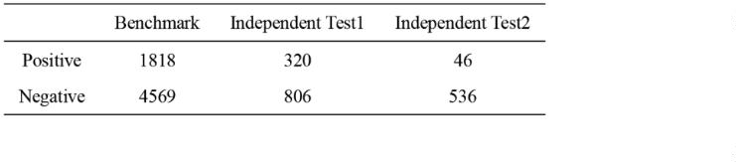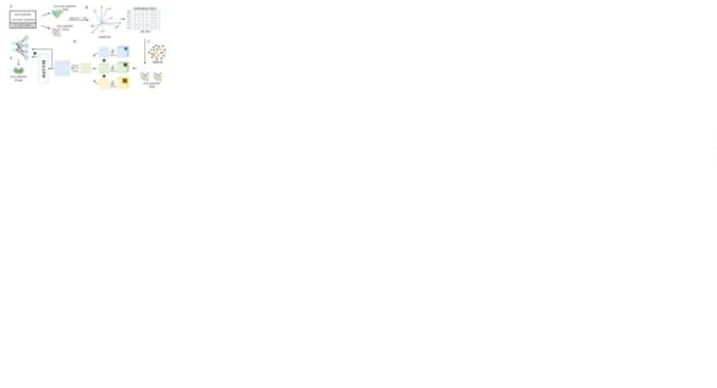

Page 3 of 20
An end-to-end model for peptide toxicity
Bioinformatics
1
2
3
4
5
6
7
8
9
1
1
1
1
1
1
1
1
1
1
2
2
2
2
2
2
2
2
2
2
3
3
3
3
3
3
3
3
3
3
4
4
4
4
4
4
4
4
4
4
5
5
5
5
5
5
5
5
5
5
6
of Word2Vec is to capture the semantic and syntactic relationships
1818, while the number of non-toxic peptide samples is 4569. Without
balancing the dataset, the model would likely learn more from the non-
toxic peptide samples, leading to a reduced accuracy on positive samples.
To prevent this issue, we apply SMOTE to handle the toxic peptide
samples. For each sample, three nearest neighbors were calculated, and
one is randomly selected to be added to the training set. As a result, during
model training, the number of positive and negative samples is 3636 and
4569. The visualization in Figure 2 confirms the robustness of our
approach: while introducing some noise, SMOTE effectively preserves
sample distribution patterns and boosts classifier accuracy.
between words by utilizing the context in which they appear. Word2Vec
consists of two model architectures: the CBOW model and the Skip-gram
model. The CBOW model predicts a target word based on a context of
surrounding words, while the Skip-gram model does the reverse,
predicting the surrounding context words given a target word. Both
models aim to optimize the same objective function, which is to maximize
the likelihood of predicting context words from the target word. In this
study, we select the CBOW model, as shown in Figure 1B, treating each
amino acid sequence as a sentence and considering each adjacent pair of
amino acids as a word for model input. Since the peptide sequences in this
study vary in length from 11 to 50 amino acids, all sequences are first
padded with ‘X’ to a length of 50 before being input to word2vec. For
example, the sequence ‘DCCIIAGCPFGCTICC’ is padded to
0
1
2
3
4
5
6
7
8
9
0
1
2
3
4
5
6
7
8
9
0
1
2
3
4
5
6
7
8
9
0
1
2
3
4
5
6
7
8
9
0
1
2
3
4
5
6
7
8
9
0
‘DCCIIAGCPFGCTICCX...X’, and then divided into [DC, CC, CI, ...,
XX] for feature representation. Each word is represented as a 96-
dimensional vector, so each amino acid sequence is represented as a (49,
96) feature matrix.
Let the word vectors of the context words be represented by
^{vw}tk ^{,K vw}_{tk} , where vw is the vector representation of word w _{. The}
Figure 2.ꢀ Visualization of positive Samples and SMOTE-sampled samples before and
after training
process is as follows:
1
tk

jtk
(1)
(2)
^{v}c 
v_{wj}
2k
2
.5 Multi-scale CNN module
^{exp(vcT v}w_{t}
)
p(w_{t} w_{tk} ,K w_{tk} ^{) } 
Fukushima proposed the concepts of convolutional and pooling layers in
980. Subsequently, in 1998, LeCun et al. introduced the earliest deep
exp(v^{T} v )
wV
c
w
1
where v_{c} is the averaged context vector, v_{w} is the word vector of the
convolutional neural network, LeNet-5 (LeCun
et
al. 1998), for
t
handwritten digit recognition. In 2017, Krizhevsky et al. proposed
AlexNet (Krizhevsky et al. 2017), which achieved groundbreaking results
in large-scale image classification tasks through deep convolutional neural
networks. CNN are composed of convolutional layers, pooling layers, and
fully connected layers, with the convolutional layers being the primary
component that extracts spatial features. The key advantages of CNN
include parameter sharing, local connectivity, and the ability to learn
multi-level feature representations, which enhance their efficiency and
robustness in various machine learning tasks. In this study, the feature
matrices trained by word2vec are input into convolutional layers with
kernel sizes of 3, 5, and 7. Each convolutional layer is followed by a Batch
Normalization (BN) layer and a dropout layer with a dropout rate of 0.2.
The outputs of the convolutional layers are then summed to form a multi-
scale convolutional layer. The features extracted by different kernel sizes
vary in terms of receptive field size and the range of features captured.
Smaller kernels focus more on local details, while larger kernels capture
broader patterns and structural information. Therefore, utilizing multi-
scale convolutions helps reduce information loss. Subsequently, the
extracted features are passed through a max-pooling layer to highlight the
most significant features and accelerate network training. The formula is
as follows:
^{target word w}t . V is the vocabulary of all words.
Table 2. The parameters of ToxMSRC.
X_{o}^{C}_{u}º_{t}^{nv3}  ReLU(Dropout(BN(Conv3(X ))))
(3)
X_{o}^{C}_{u}º_{t}^{nv5}  ReLU(Dropout(BN(Conv5(X ))))
X_{o}^{C}_{u}º_{t}^{nv7}  ReLU(Dropout(BN(Conv7(X ))))
X  X ^{Conv3}  X ^{Conv5}  X ^{Conv7}
out
out
out
out
X ^{Conv}  ReLU(Conv3(Dropout(Maxpool(X ))))
Each epoch takes an average of 28 seconds.
out
out
where X represents the output of the feature by word2vec.
2
.4 SMOTE module
2
.6 BiLSTM module
SMOTE (Chawla et al. 2002) introduced by Chawla et al. in 2002, is a
technique designed to address the issue of class imbalance in datasets. In
many classification tasks, particularly when one class has significantly
fewer samples than the other, models tend to bias their predictions towards
the majority class, leading to poor performance on the minority class.
SMOTE works by generating synthetic samples for the minority class
rather than simply duplicating existing samples. It achieves this by
selecting a minority class sample and finding its nearest neighbors, then
creating new synthetic samples through interpolation between the original
sample and its neighbors in the feature space. This process increases the
diversity of the minority class and helps improve model performance on
imbalanced datasets. In this study, the number of toxic peptide samples is
BiLSTM (Schuster et al. 1997), proposed by Schuster and Paliwal in 1997,
is an extension of traditional LSTM networks designed to capture
dependencies in sequential data by processing the input in both forward
and backward directions. While a standard LSTM only considers past
information (from left to right in the case of text or time series data),
BiLSTM processes data in two passes one from left to right and the other
from right to left allowing it to capture both past and future context. This
bidirectional approach enhances the model’s ability to understand
complex patterns and relationships in sequential data, making BiLSTM
particularly effective in tasks such as speech recognition, machine
translation, and sentiment analysis. The formula is as follows:
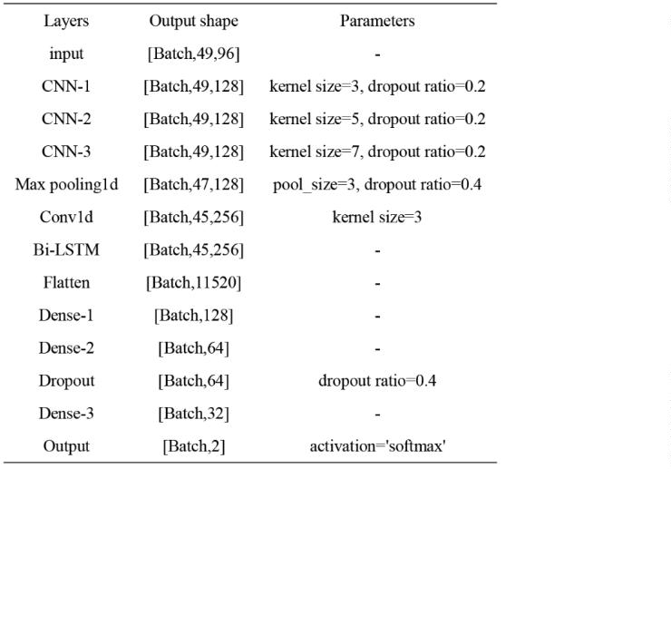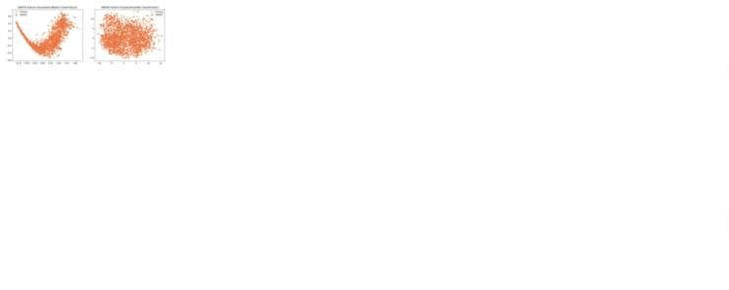

Bioinformatics
Page 4 of 20
Zhang et al.
1
2
3
4
5
6
7
8
9
1
1
1
1
1
1
1
1
1
1
2
2
2
2
2
2
2
2
2
2
3
3
3
3
3
3
3
3
3
3
4
4
4
4
4
4
4
4
4
4
5
5
5
5
5
5
5
5
5
5
6
h^{f}  LSTM (x ,h^{f} )
t1
(4)
(5)
peptides are more uniformly distributed. In the independent test sets, we
find that the sequence length distribution in independent test1 is similar to
t
f
t
h^{b}  LSTM (x ,h^{b} )
t1
that in the training set, while the toxic peptide sequences in independent
test2 tend to be shorter. As shown in the results in Table 3, we attribute
the relatively better performance of the model on independent test1 to the
high similarity in sequence length distribution between this test set and the
training set.
Table 3. Performance comparison of ToxMSRC with other state-of-the-
arts models.
t
b
t
where x_{t} is the input at the time step t , h_{t}^{f} and h_{t}^{b} are the hidden states
of the forward and backward LSTM at the times step t respectively.
LSTM
and LSTM_{b} are the forward and backward LSTM operations.
f
Finally, the output of the BiLSTM at each time step is the concatenation
of the forward and backward hidden states:
(6)
X^{BiLSTM} h [h^{f} ,h^{b}]
0
1
2
3
4
5
6
7
8
9
0
1
2
3
4
5
6
7
8
9
0
1
2
3
4
5
6
7
8
9
0
1
2
3
4
5
6
7
8
9
0
1
2
3
4
5
6
7
8
9
0
out
t
t
t
2
.7 Residual connection
Residual connection is a widely used technique in deep neural networks,
introduced to address challenges such as vanishing or exploding gradients
in deep networks. The core idea is to add skip connections between layers,
allowing the output of a layer to be directly added to its input. This
approach helps alleviate the issue of diminishing gradients during
backpropagation, as it provides a direct path for the gradient to flow
through. Residual connection enhances training by enabling information
to flow more easily through deep networks, improving both training speed
and model performance, particularly in architectures such as ResNet (He
et al. 2016) and DenseNet (Huang et al. 2022). In this study, to prevent
overfitting, we apply a residual connection between the output of the
BiLSTM layer and the output of the convolutional layer. The formula is
as follows:
In this study, to demonstrate the higher usability of the model, we
compare several state-of-the-art models, as shown in Table 3. Given the
significant imbalance between the positive and negative samples in the
data, BACC and MCC provide a more reliable evaluation of the model’s
performance. ToxMSRC achieves BACC and MCC scores of 92.17% and
0.852 on independent test1, outperforming the other models by at least
0.18% and 0.041, respectively. On independent test2, ToxMSRC achieves
BACC and MCC scores of 86.89% and 0.655, surpassing the other models
by at least 3.94% and 0.13%, respectively. Moreover, ToxMSRC also
shows slightly higher performance than other models in terms of ACC,
AUC, and SP, further proving the superior usability of our model. To
provide an intuitive comparison of performance differences between
ToxMSRC and other models, we conduct statistical analyses using
Wilcoxon signed rank tests and Friedman tests to examine both pairwise
differences between ToxMSRC and individual models as well as overall
differences. On independent test1, the p-values between ToxMSRC and
the other four models are 0.03125, 0.15625, 0.03125, and 0.03125
respectively, with an overall model p-value of 0.0118. On independent
test2, the p-values compare with the other two models are both 0.03125,
with an overall p-value of 0.0174. These results demonstrate the superior
classification performance of our model.
(7)
^{X}out
 X^{BiLSTM}  X^{Conv}
out out
2
.8 Performance measures
In order to access the predictive capability of ToxMSRC, we use six
evaluation metrics for evaluating the performance of the prediction model,
including accuracy (ACC), sensitivity (SN), specificity (SP), balanced
accuracy (BACC), area under the ROC curve (AUC) and Matthew’s
correlation coefficient (MCC). The formulas are as follows:
TP TN
ACC 
BACC 
SN 
100%
TP TN  FP  FN
1
TP
TN
(8)
(

)100%
2 TP  FN TN  FP
TP
100%
TP  FN
TN
SP 
100%
TN  FP
TPTN  FP FN
MCC 
(TP  FP)(TP  FN)(TN  FP)(TN  FN)
where TN (True Negative) and TP (True Positive) represent the number
of correctly identified non-toxic and toxic peptide sequences, FN (False
Negative) and FP (False Positive) represent the number of non-toxic and
toxic peptide sequences, that are incorrectly identified. Since the training
and testing datasets in this study are imbalanced, BACC and MCC are
effective in evaluating the performance of imbalanced data. SN and SP
refer to the accuracy of identifying all positive samples and the accuracy
of identifying all negative samples, respectively. These evaluation metrics
contribute to a better interpretability of the model in this study.
Figure 3.ꢀ The overview of the ToxMSRC framework. Data analysis and performance of
the ToxMSRC model on the benchmark dataset. (A) Peptide sequence length distribution
of positive and negative samples in the benchmark dataset and two independent test sets.
(B) Comparison and analysis of the 2-10 fold cross-validation results of the ToxMSRC
model with the 5-fold cross-validation results from the CAPTP. (C) Visualization of PCA
and t-SNE dimensionality reduction methods before and after training.
Furthermore, as shown in Figure 3(B), the green line represents the
training results of ToxMSRC on the benchmark dataset using 2-10 fold
cross-validation, with the light pink line indicating the average cross-
validation result of 0.9546. In contrast, the red dot represents the result of
the currently best-performing model, after 5-fold cross-validation, which
is 0.9252, significantly lower than the performance of our model. Figure
3(C) shows the visualization of the benchmark dataset after
dimensionality reduction using PCA (Alain et al. 2022) and t-SNE (Van
et al. 2008). It can be observed that the clustering effect of the data before
and after classification is evident, demonstrating how the model’s feature
extraction and classification process influences the separability of the data.
3
Results and discussion
3
.1 Performance
comparison
of
ToxMSRC
with
other
models and model analysis
To evaluate the performance and generalization ability of the ToxMSRC
model, we perform analysis and testing on both the benchmark dataset and
the independent test sets. In the data analysis section, as shown in Figure
3
(A), the length distribution of toxic and non-toxic peptide sequences
across different datasets is illustrated. From Figure 3(A), we can observe
that in the benchmark dataset, the lengths of toxic peptide sequences
predominantly range from 25 to 40, while the lengths of non-toxic
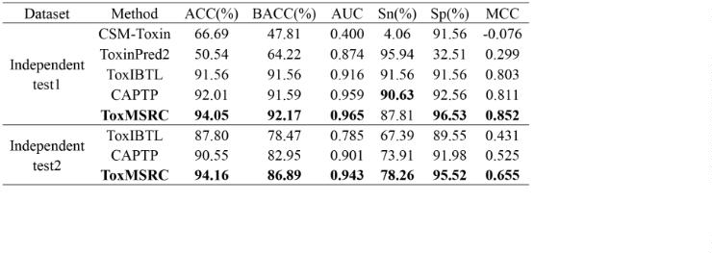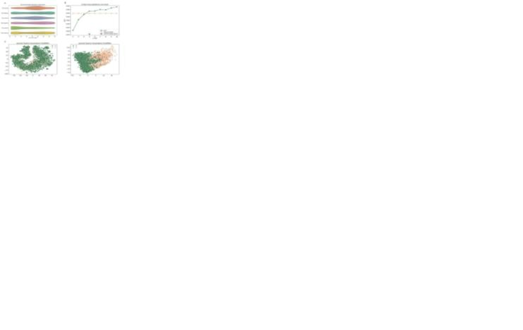

Page 5 of 20
An end-to-end model for peptide toxicity
Bioinformatics
1
2
3
4
5
6
7
8
9
1
1
1
1
1
1
1
1
1
1
2
2
2
2
2
2
2
2
2
2
3
3
3
3
3
3
3
3
3
3
4
4
4
4
4
4
4
4
4
4
5
5
5
5
5
5
5
5
5
5
6
3
.2 Exploration of the optimal architecture of ToxMSRC
GAN generated samples, especially in terms of BACC, where SMOTE
outperforms GAN by over 2%.
Table 5. Comparison of different imbalance handling methods.
To ensure that the methods used in our model are optimal, we conduct
further analysis on the word2vec, multi-scale CNN, and residual
connection in the model.
Table 4. Comparison of model performance with different data handling
methods.
0
1
2
3
4
5
6
7
8
9
0
1
2
3
4
5
6
7
8
9
0
1
2
3
4
5
6
7
8
9
0
1
2
3
4
5
6
7
8
9
0
1
2
3
4
5
6
7
8
9
0
In selecting convolutional kernel sizes for multi-scale convolution,
we conduct a variety of analyses. As shown in Figures 5(A-F), we
compare the ACC, SN, and MCC when using a single convolutional
kernel size without multi-scale convolution. Additionally, we analyze the
effects of combinations of kernel sizes 3 and 5, 3 and 7, and 5 and 7 on
the two independent test sets. The results indicate that none of these
combinations perform better than the combination of kernel sizes 3, 5, and
7
. We believe that different convolutional kernel sizes extract features
over different ranges: smaller kernels extract finer-grained features over
smaller ranges, while larger kernels extract coarser features over broader
ranges. When the peptide sequence length is shorter, smaller kernel sizes
yield better results. For example, in independent test2, where toxic peptide
samples are predominantly short sequences, the SN gradually decreases as
the kernel size increases, as shown in Figure 5(E). In independent test1,
where toxic peptides tend to have medium lengths, the SN is higher with
a kernel size of 5, as shown in Figure 5(B). When combining different
kernel sizes to form multi-scale convolution, our model selects kernel
sizes that capture both fine details and broader features between amino
acids, enabling the extraction of more comprehensive information. In
addition, we also consider the impact of the method used to combine
different scale convolutions on the model’s classification performance.
Figure 5(G) shows that the outer ring represents the method of combining
the multi-scale convolution output features using matrix splicing, while
the inner ring represents the method of adding corresponding elements of
the output feature matrices, similar to a residual connection. From the
accuracy shown in the figure, the latter method achieves an accuracy
improvement of 4.97% and 6.53% over the former.
In word2vec, we compare different lengths of amino acids as a word,
as shown in Figure 4(A-B). We consider using three and four adjacent
amino acids as one word for feature representation, resulting in feature
matrices with dimensions of (48, 96) and (47, 96), respectively. From
Figure 4(A-B), it is evident that as the number of amino acids represented
by each word increases, all evaluation metrics gradually decrease. We
believe that the short peptide sequence lengths and small dataset,
especially the limited number of toxic peptides, contribute to this decline.
A larger number of amino acids per word leads to less precise
representation of each word’s features, resulting in poorer performance.
Therefore, using two amino acids as a word is the most reasonable choice
for this study. Since the number of non-toxic peptides in our dataset is
more than twice that of toxic peptides, we consider using SMOTE to
augment the toxic peptide samples, ensuring that the model can adequately
learn the information from the toxic peptide samples during the training
process. To ensure the optimality of the augmentation quantity, Table 4
shows a comparison between doubling the data, not using SMOTE, and
balancing the dataset. It is evident that when no balancing is performed,
the accuracy of the negative samples is higher than that of the positive
samples, indicating that the model has learned more features of the
negative samples. When balancing is applied, although the accuracy of the
positive samples increases significantly, the negative sample accuracy
decreases notably due to SMOTE selecting nearby samples. We believe
this is because when some samples select two nearby samples, the amount
of similar data increases, which leads to a reduction in the accuracy of the
negative samples. Therefore, doubling the positive samples is the optimal
choice.
Figure 4.ꢀ Comparison of different amino acid counts as words and the impact of residual
connections.
Generative adversarial networks (GAN) help address imbalanced
sequence data by generating realistic samples for the minority class,
improving data balance and model performance (Andresini et al. 2021).
To better demonstrate the effectiveness of choosing SMOTE, we conduct
a comparative analysis between samples generated by GAN and those
generated by SMOTE. As shown in Table 5, the performance metrics on
the training set and two independent test sets are consistently lower for
Figure 5.ꢀ The impact of different convolutional kernel sizes on performance. (A-F) The
ACC, SN, and MCC results of the multi-scale convolutional layer using only kernel sizes
of 3, 5, 7, and combinations of 3 and 5, 3 and 7, 5 and 7 are presented on independent test1
and independent test2. (G) Comparison of ACC between matrix splicing and element-wise
matrix addition in the final splicing part of the multi-scale convolution on independent test1
and independent test2.
In Figure 4(C-D), we analyze the importance of the residual
connection in the model. Whether or not the residual connection is used,
the model’s accuracy and cross-validation results during training are quite
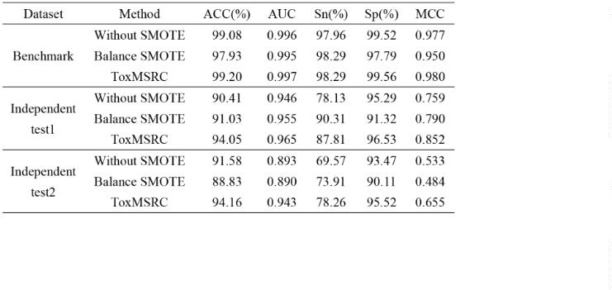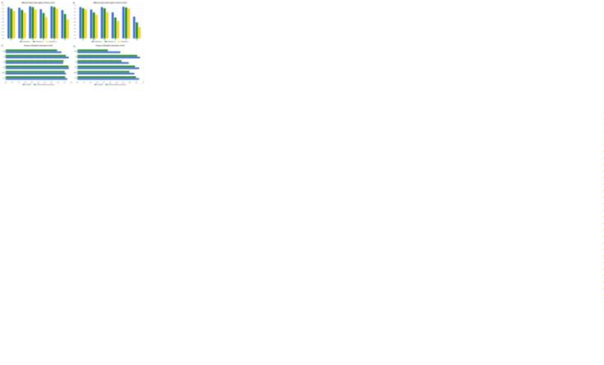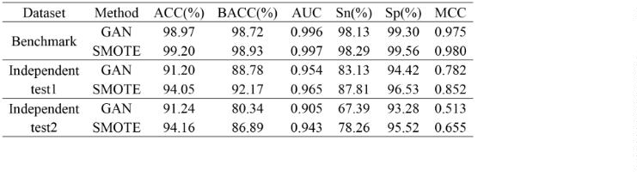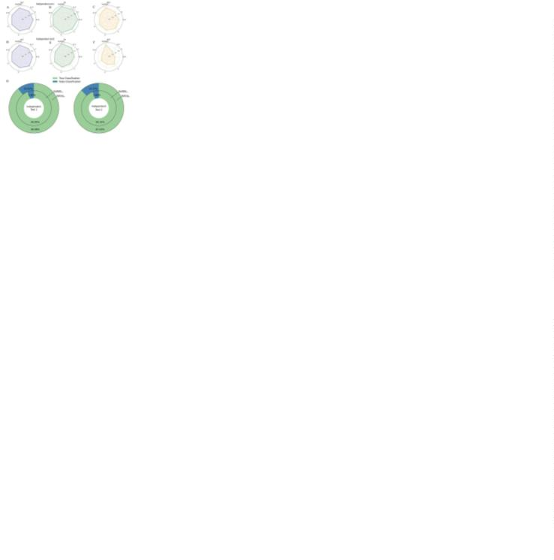

Bioinformatics
Page 6 of 20
Zhang et al.
1
2
3
4
5
6
7
8
9
1
1
1
1
1
1
1
1
1
1
2
2
2
2
2
2
2
2
2
2
3
3
3
3
3
3
3
3
3
3
4
4
4
4
4
4
4
4
4
4
5
5
5
5
5
5
5
5
5
5
6
similar. However, on the two independent test sets, it is evident that the
classification performance with the residual connection is higher than that
without it. This indicates that by using the residual connection to input the
data from the BiLSTM layer together with the previous data into the fully
connected layer, the occurrence of overfitting in the model is significantly
alleviated.
in toxic sequences is more than twice that in non-toxic sequences in the
training data. After mutation, the number of sequences with Glycine (G)
at the first position predicted as toxic by the model exceeds the number of
non-toxic sequences by more than twice, indicating that the model has
effectively learned the sequence differences. Additionally, sequences with
Cysteine (C) at positions 2, 3, 6, or 9 demonstrate a similar pattern. In the
training data, Cysteine (C) rarely appears at these positions. Therefore, the
mutated sequences have a much higher probability of being predicted as
positive samples. Glycine (G) at position 6 occurs more frequently in toxic
peptides than in non-toxic peptides in the training data. Consequently,
after mutation, the predicted number of toxic sequences with Glycine (G)
at position 6 follows the same trend observed in the training data.
Because these mutated samples are derived from toxic peptide
sequences and each mutation only alters one amino acid, the model does
not classify sequences based solely on one amino acid. Therefore, when
training data contains amino acids that are more likely to appear in non-
toxic sequences, the mutation of these amino acids may lead to less distinct
classification differences. For instance, at positions 2 and 11, Lysine (K)
is much more likely to appear in non-toxic peptides than in toxic peptides.
At position 11, the occurrence probability is approximately the same for
both toxic and non-toxic peptides. In the mutated data, the distribution of
counts shows that at position 2, the number of non-toxic predictions for
Lysine (K) exceeds the number of toxic predictions, although the
difference insignificant. At position 11, the number of positive samples
exceeds that of negative samples. This further demonstrates the model’s
accuracy in feature extraction.
3
.3 Performance
methods
comparison
of
ToxMSRC
with
other
0
1
2
3
4
5
6
7
8
9
0
1
2
3
4
5
6
7
8
9
0
1
2
3
4
5
6
7
8
9
0
1
2
3
4
5
6
7
8
9
0
1
2
3
4
5
6
7
8
9
0
Different methods extract different information and features. In this paper,
we compare BiLSTM, multi-head attention (Vaswani et al. 2017), and
temporal convolutional network (TCN) (Wan et al. 2022). As shown in
Figure 6, the area under the ROC curve (AUC) indicates model
performance. The closer the ROC curve is to the top-left corner, the better
the model’s performance. Similarly, the closer the PR curve is to the top-
right corner, the better the model’s performance. The ROC and PR curves
of these three methods indicate that the BiLSTM model selected at the end
of this paper performs better.
Figure 6.ꢀ ROC and PR curves of different deep learning methods on independent test1
and independent test2.
3
.4 Exploring the sequential characteristic of toxic peptides
by using ToxMSRC
We use a computational approach similar to in silico mutagenesis (ISM)
(Nair et al. 2022) to analyze the sequence features of peptide toxicity
further. ISM is employed to determine the impact of each amino acid in
the input sequence on the model’s prediction. This method has been
widely applied in the sequence analysis of amino acids.
Figure 7.ꢀ The result of exploring the sequential characteristics of toxic peptides using
ToxMSRC. (A) The distribution of the proportion of amino acid counts at positions 1-11
for toxic peptides and non-toxic peptides. (B) The heatmap of the distribution of all amino
acids for positive and negative samples in the benchmark dataset. (C) Prediction of toxic
and non-toxic sequences for fixed amino acids at specific positions after 20 amino acid
mutations (Positions 1-11) in toxic peptide sequences from independent test2.
Figure 7(A) shows the visualization of the amino acid frequency at
positions 1-11 for toxic and non-toxic peptides in the benchmark dataset,
while Figure 7(B) displays the amino acid occurrence probabilities across
all positions for both toxic and non-toxic peptides. It can be observed that,
in positive samples, the amino acids Glycine (G) and Cysteine (C) appear
more frequently. From the heatmap, it is evident that Cysteine (C) has the
highest probability of occurrence at almost every position. In contrast, in
negative samples, Methionine (M) predominantly appears at the first
position, while the distribution of amino acids is almost uniform across
other positions. During the model training process, these features are
heavily utilized, ensuring the accuracy of the model’s classification.
In Figure 7(C), these findings are further validated. Figure 6(C)
illustrates the mutation of 20 amino acids at positions 1-11 in 46 toxic
peptide sequences from independent test2. This mutation results in a new
dataset consisting of 10120 amino acid sequence data points. By selecting
a fixed position and a fixed amino acid, the sequences are input into the
model to predict whether they are toxic or non-toxic, allowing us to track
the counts of each classification. As shown in the figure, when the first
amino acid in the sequence is Methionine (M), the model predicts a higher
number of non-toxic sequences compared to toxic ones. When the first
amino acid in the sequence is Glycine (G), the frequency of Glycine (G)
3
.5 Limitations and Future Directions
Although ToxMSRC demonstrates excellent performance in peptide
toxicity prediction, it still has some limitations. Firstly, the model only
applies to peptide sequences with lengths between 11-50 amino acids, and
its generalization capability is limited to shorter or longer sequences.
Additionally, the Word2Vec feature representation may not fully capture
long-range dependencies. Future research could optimize the ToxMSRC
model in several directions. On the one hand, more advanced data
balancing techniques and feature extraction methods could be explored,
such as using DeepInsight (Sharma et al. 2019) to convert sequence data
into image data, in order to enhance the model's robustness and prediction
accuracy while extending its applicability to a wider range of peptide
sequence lengths. On the other hand, developing an online prediction tool
would facilitate the practical application of the model in peptide-based
drug development, thereby advancing the field of precision medicine.
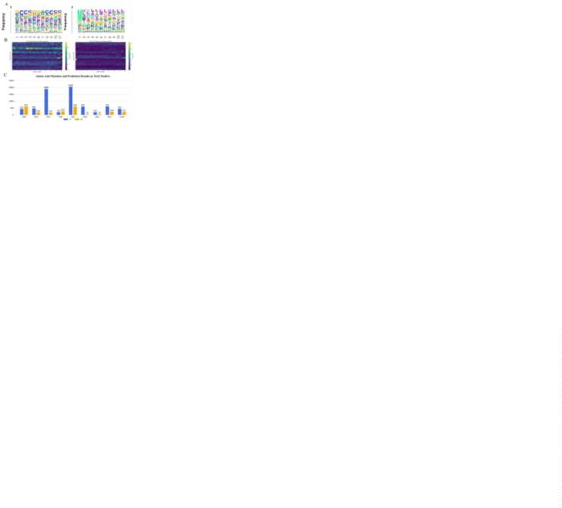

Page 7 of 20
An end-to-end model for peptide toxicity
Bioinformatics
1
2
3
4
5
6
7
8
9
1
1
1
1
1
1
1
1
1
1
2
2
2
2
2
2
2
2
2
2
3
3
3
3
3
3
3
3
3
3
4
4
4
4
4
4
4
4
4
4
5
5
5
5
5
5
5
5
5
5
6
4
Conclusions
Huang G, Liu Z, Pleiss G, Maaten LV, Weinberger KQ. Convolutional Networks
IEEE
with Dense Connectivity.
2022;44(12):8704-8716.
Trans
Pattern
Anal
Mach
Intell
ToxMSRC provides an advanced and reliable solution to the critical
challenge of predicting peptide toxicity, a primary concern developing
peptide-based therapeutics. Given the significant risks associated with
toxic peptides, such as organ damage, immune reactions, and cytotoxicity,
accurately predicting toxicity is vital for ensuring the safety of peptide
drugs. The model integrates several innovative techniques, including the
word2vec-based encoding method for capturing amino acid relationships,
SMOTE for augmenting positive samples, and multi-scale CNN for
Jiao S, Ye X, Sakurai T, Zou Q, Liu R. Integrated convolution and self-attention for
improving peptide toxicity prediction. Bioinformatics 2024;40(5):btae297.
Kanekura K, Harada Y, Fujimoto M, Yagi T, Hayamizu Y, Nagaoka K, Kuroda M.
Characterization of membrane penetration and cytotoxicity of C9orf72-encoding
arginine-rich dipeptides. Sci Rep 2018;8(1):12740.
Khan F, Niaz K, Abdollahi M. Toxicity of Biologically Active Peptides and Future
Safety Aspects: An Update. Curr Drug Discov Technol 2018;15(3):236-242.
Krizhevsky A, Sutskever I, Hinton GE. ImageNet classification with deep
convolutional neural networks. Commun ACM 2017;60(6):84-90.
Lee S, Choi MC, Al Adem K, Lukman S, Kim TY. Aggregation and Cellular
Toxicity of Pathogenic or Non-pathogenic Proteins. Sci Rep 2020;10(1):5120.
LeCun Y, Bottou L, Bengio Y, Haffner P. Gradient-based learning applied to
document recognition. Proc IEEE 1998;86(11):2278-2324.
Liebler DC, Guengerich FP. Elucidating mechanisms of drug-induced toxicity. Nat
Rev Drug Discov 2005;4(5):410-20.
Lushchak VI, Matviishyn TM, Husak VV, Storey JM, Storey KB. Pesticide toxicity:
a mechanistic approach. EXCLI J 2018;17:1101-1136.
Mikolov T, Chen K, Corrado G, Dean J. Efficient Estimation of Word
Representations in Vector Space. arXiv, arXiv:1301.3781, 2013, preprint: not
peer reviewed.
Morozov V, Rodrigues CHM, Ascher DB. CSM-Toxin: A Web-Server for Predicting
Protein Toxicity. Pharmaceutics 2023;15(2):431.
Nagarkatti M, Rieder SA, Vakharia D, Nagarkatti PS. Evaluation of apoptosis in
immunotoxicity testing. Methods Mol Biol 2010;598:241-57.
Nair S, Shrikumar A, Schreiber J, Kundaje A. fastISM: performant in silico
saturation mutagenesis for convolutional neural networks. Bioinformatics
2022;38(9):2397-2403.
Rathore AS, Choudhury S, Arora A, Tijare P, Raghava GPS. ToxinPred 3.0: An
improved method for predicting the toxicity of peptides. Comput Biol Med
2024;179:108926.
Rossino G, Marchese E, Galli G, Verde F, Finizio M, Serra M, Linciano P, Collina
S. Peptides as Therapeutic Agents: Challenges and Opportunities in the Green
Transition Era. Molecules 2023;28(20):7165.
Saar-Dover R, Ashkenazi A, Shai Y. Peptide interaction with and insertion into
membranes. Methods Mol Biol 2013;1033:173-183.
Schuster M, Paliwal KK. Bidirectional recurrent neural networks. IEEE Trans Signal
Process 1997;45(11):2673-2681.
Semwal R, Semwal RB, Lehmann J, Semwal DK. Recent advances in
immunotoxicity and its impact on human health: causative agents, effects and
existing treatments. Int Immunopharmacol 2022;108:108859.
0
1
2
3
4
5
6
7
8
9
0
1
2
3
4
5
6
7
8
9
0
1
2
3
4
5
6
7
8
9
0
1
2
3
4
5
6
7
8
9
0
1
2
3
4
5
6
7
8
9
0
comprehensive feature extraction. Moreover, including
a
residual
connection enhances model performance by reducing overfitting and
improving generalization. The model’s outstanding performance on
benchmark and independent test sets underscores its potential for guiding
the design of safer peptide drugs. Additionally, the study incorporates a
detailed analysis of amino acid sequence features and the role of mutations
in toxicity prediction. Through computational approaches, such as ISM,
the model’s ability to identify key sequence features contributing to
toxicity was demonstrated. This further reinforces the potential of
ToxMSRC in uncovering the underlying patterns in peptide toxicity.
Ultimately, the model offers valuable insights for peptide drug
development, highlighting the importance of accurate prediction models
in mitigating toxicity risks and optimizing peptide-based therapeutic
discoveries.
Funding
This work was supported by the National Natural Science Foundation of China
(No.12101480), the Natural Science Basic Research Program of Shaanxi (No.
2
024JC-YBMS-004) and Xidian University Specially Funded Project for
Interdisciplinary Exploration (No. TZJH2024028).
Conflict of Interest: none declared.
References
Alain B, Sylvie VP. Principal components analysis and cyclostationarity. J Multivar
Anal 2022;189:104875.
Andresini G, Appice A, De Rose L, Malerba D. GAN augmentation to deal with
imbalance in imaging-based intrusion detection. FGCS 2021;123:108-127.
Arruda VR, Favaro P, Finn JD. Strategies to Modulate Immune Responses: A New
Frontier for Gene Therapy. Mol Ther 2009;17(9):1492-1503.
Bhol NK, Bhanjadeo MM, Singh AK, Dash UC, Ojha RR, Majhi S, Duttaroy AK,
Jena AB. The interplay between cytokines, inflammation, and antioxidants:
mechanistic insights and therapeutic potentials of various antioxidants and anti-
cytokine compounds. Biomed Pharmacother 2024;178:117177.
Cardozo AK, Buchillier V, Mathieu M, Chen J, Ortis F, Ladrière L, Allaman-Pillet
N, Poirot O, Kellenberger S, Beckmann JS, Eizirik DL, Bonny C, Maurer F.
Cell-permeable peptides induce dose- and length-dependent cytotoxic effects.
Biochim Biophys Acta 2007;1768(9):2222-2234
Sharma A, Vans E, Shigemizu D, Boroevich KA, Tsunoda T. DeepInsight: A
methodology to transform a non-image data to an image for convolution neural
network architecture. Sci Rep. 2019;9(1):11399.
Sharma N, Naorem LD, Jain S, Raghava GPS. ToxinPred2: an improved method for
predicting toxicity of proteins. Brief Bioinform 2022;23(5):bbac174.
Sirin MC, Cicioglu Aridogan B, Sesli Cetin E, Sirin FB. Evaluation of biochemical,
hematological, RIBA and PCR assays in predicting viremia in anti-HCV positive
patients. J Infect Dev Ctries 2019;13(8):736-743.
Chawla NV, Bowyer KW, Hall LO. SMOTE: Synthetic Minority Over-sampling
Technique. J Artif Intell Res 2002;16(0):321-357.
Chen CH, Melo MC, Berglund N, Khan A, de la Fuente-Nunez C, Ulmschneider JP,
Ulmschneider MB. Understanding and modelling the interactions of peptides
with membranes: from partitioning to self-assembly. Curr Opin Struct Biol
UniProt Consortium. UniProt: a worldwide hub of protein knowledge. Nucleic Acids
Res 2019;47(D1):D506-D515.
Van der Maaten L, Hinton G. Visualizing data using t-SNE. J Mach Learn Res
2
008;9(86):2579-2605.
Vaswani A, Shazeer N, Parmar N, Uszkoreit J, Jones L, Gomez AN, Kaiser L,
Polosukhin I. Attention Is All You Need. arXiv, arXiv:1706.03762, 2017,
preprint: not peer reviewed.
Wan R, Tian C, Zhang W, Deng W, Yang F. A Multivariate Temporal Convolutional
Attention Network for Time-Series Forecasting. Electronics 2022;11(10):1516.
Wang JH, Sung TY. ToxTeller: Predicting Peptide Toxicity Using Four Different
Machine Learning Approaches. ACS Omega 2024;9(29):32116-32123.
Wang L, Wang N, Zhang W, Cheng X, Yan Z, Shao G, Wang X, Wang R, Fu C.
Therapeutic peptides: current applications and future directions. Signal
Transduct Target Ther 2022;7(1):48.
2
020;61(0):160-166.
Fetse J, Kandel S, Mamani UF, Cheng K. Recent advances in the development of
therapeutic peptides. Trends Pharmacol Sci 2023;44(7):425-441.
Fu L, Niu B, Zhu Z, Wu S, Li W. CD-HIT: accelerated for clustering the next-
generation sequencing data. Bioinformatics 2012;28(23):3150-3152.
Garle MJ, Fentem JH, Fry JR. In vitro cytotoxicity tests for the prediction of acute
toxicity in vivo. Toxicol In Vitro 1994;8(6):1303-1312.
Gupta S, Kapoor P, Chaudhary K, Gautam A, Kumar R, Open Source Drug
Discovery Consortium, Raghava GP. In silico approach for predicting toxicity
of peptides and proteins. PLoS One 2013;8(9):e73957.
Harris KD, Barzilai A, Zahavi A. An evolutionary perspective on signaling peptides:
toxic peptides are selected to provide information regarding the processing of the
propeptide, which represents the phenotypic state of the signaling cell. F1000Res
Wei L, Ye X, Xue Y, Sakurai T, Wei L. ATSE: a peptide toxicity predictor by
exploiting structural and evolutionary information based on graph neural
network and attention mechanism. Brief Bioinform 2021;22(5):bbab041.
Wei L, Ye X, Sakurai T, Mu Z, Wei L. ToxIBTL: prediction of peptide toxicity based
2
He KM, Zhang XY, Ren SQ, Sun J. Deep Residual Learning for Image Recognition.
015;4:512.
on information bottleneck and transfer learning.
2022;38(6):1514-1524.
Bioinformatics
Proc IEEE Conf Comput Vis Pattern Recognit (CVPR) 2016;770-778.

Bioinformatics
Page 8 of 20
Zhang et al.
1
2
3
4
5
6
7
8
9
1
1
1
1
1
1
1
1
1
1
2
2
2
2
2
2
2
2
2
2
3
3
3
3
3
3
3
3
3
3
4
4
4
4
4
4
4
4
4
4
5
5
5
5
5
5
5
5
5
5
6
Hai-Na Z, Jun-Jie J, Guang-Meng X. Peptides derived from growth factors:
Exploring their diverse impact from antimicrobial properties to neuroprotection.
Biomed Pharmacother 2024;176:116830.
0
1
2
3
4
5
6
7
8
9
0
1
2
3
4
5
6
7
8
9
0
1
2
3
4
5
6
7
8
9
0
1
2
3
4
5
6
7
8
9
0
1
2
3
4
5
6
7
8
9
0

Page 9 of 20
Bioinformatics
1
2
3
4
5
6
7
8
9
1
1
1
1
1
1
1
1
1
1
2
2
2
2
2
2
2
2
2
2
3
3
3
3
3
3
3
3
3
3
4
4
4
4
4
4
4
4
4
4
5
5
5
5
5
5
5
5
5
5
6
0
1
2
3
4
5
6
7
8
9
0
1
2
3
4
5
6
7
8
9
0
1
2
3
4
5
6
7
8
9
0
1
2
3
4
5
6
7
8
9
0
1
2
3
4
5
6
7
8
9
0
Figure 1. The overview of the ToxMSRC framework.
196x105mm (300 x 300 DPI)


Bioinformatics
Page 10 of 20
1
2
3
4
5
6
7
8
9
1
1
1
1
1
1
1
1
1
1
2
2
2
2
2
2
2
2
2
2
3
3
3
3
3
3
3
3
3
3
4
4
4
4
4
4
4
4
4
4
5
5
5
5
5
5
5
5
5
5
6
0
1
2
3
4
5
6
7
8
9
0
1
2
3
4
5
6
7
8
9
0
1
2
3
4
5
6
7
8
9
0
1
2
3
4
5
6
7
8
9
0
1
2
3
4
5
6
7
8
9
0
Figure 2. Visualization of positive Samples and SMOTE-sampled samples before and after training.
3
10x121mm (300 x 300 DPI)


Page 11 of 20
Bioinformatics
1
2
3
4
5
6
7
8
9
1
1
1
1
1
1
1
1
1
1
2
2
2
2
2
2
2
2
2
2
3
3
3
3
3
3
3
3
3
3
4
4
4
4
4
4
4
4
4
4
5
5
5
5
5
5
5
5
5
5
6
0
1
2
3
4
5
6
7
8
9
0
1
2
3
4
5
6
7
8
9
0
1
2
3
4
5
6
7
8
9
0
1
2
3
4
5
6
7
8
9
0
1
2
3
4
5
6
7
8
9
0
Figure 3. The overview of the ToxMSRC framework. Data analysis and perfor-mance of the ToxMSRC model
on the benchmark dataset. (A) Peptide sequence length distribution of positive and negative samples in the
benchmark dataset and two independent test sets. (B) Comparison and analysis of the 2-10 fold cross-
validation results of the ToxMSRC model with the 5-fold cross-validation results from the CAPTP. (C)
Visualization of PCA and t-SNE dimensionality reduction methods before and after training.
4
84x304mm (300 x 300 DPI)
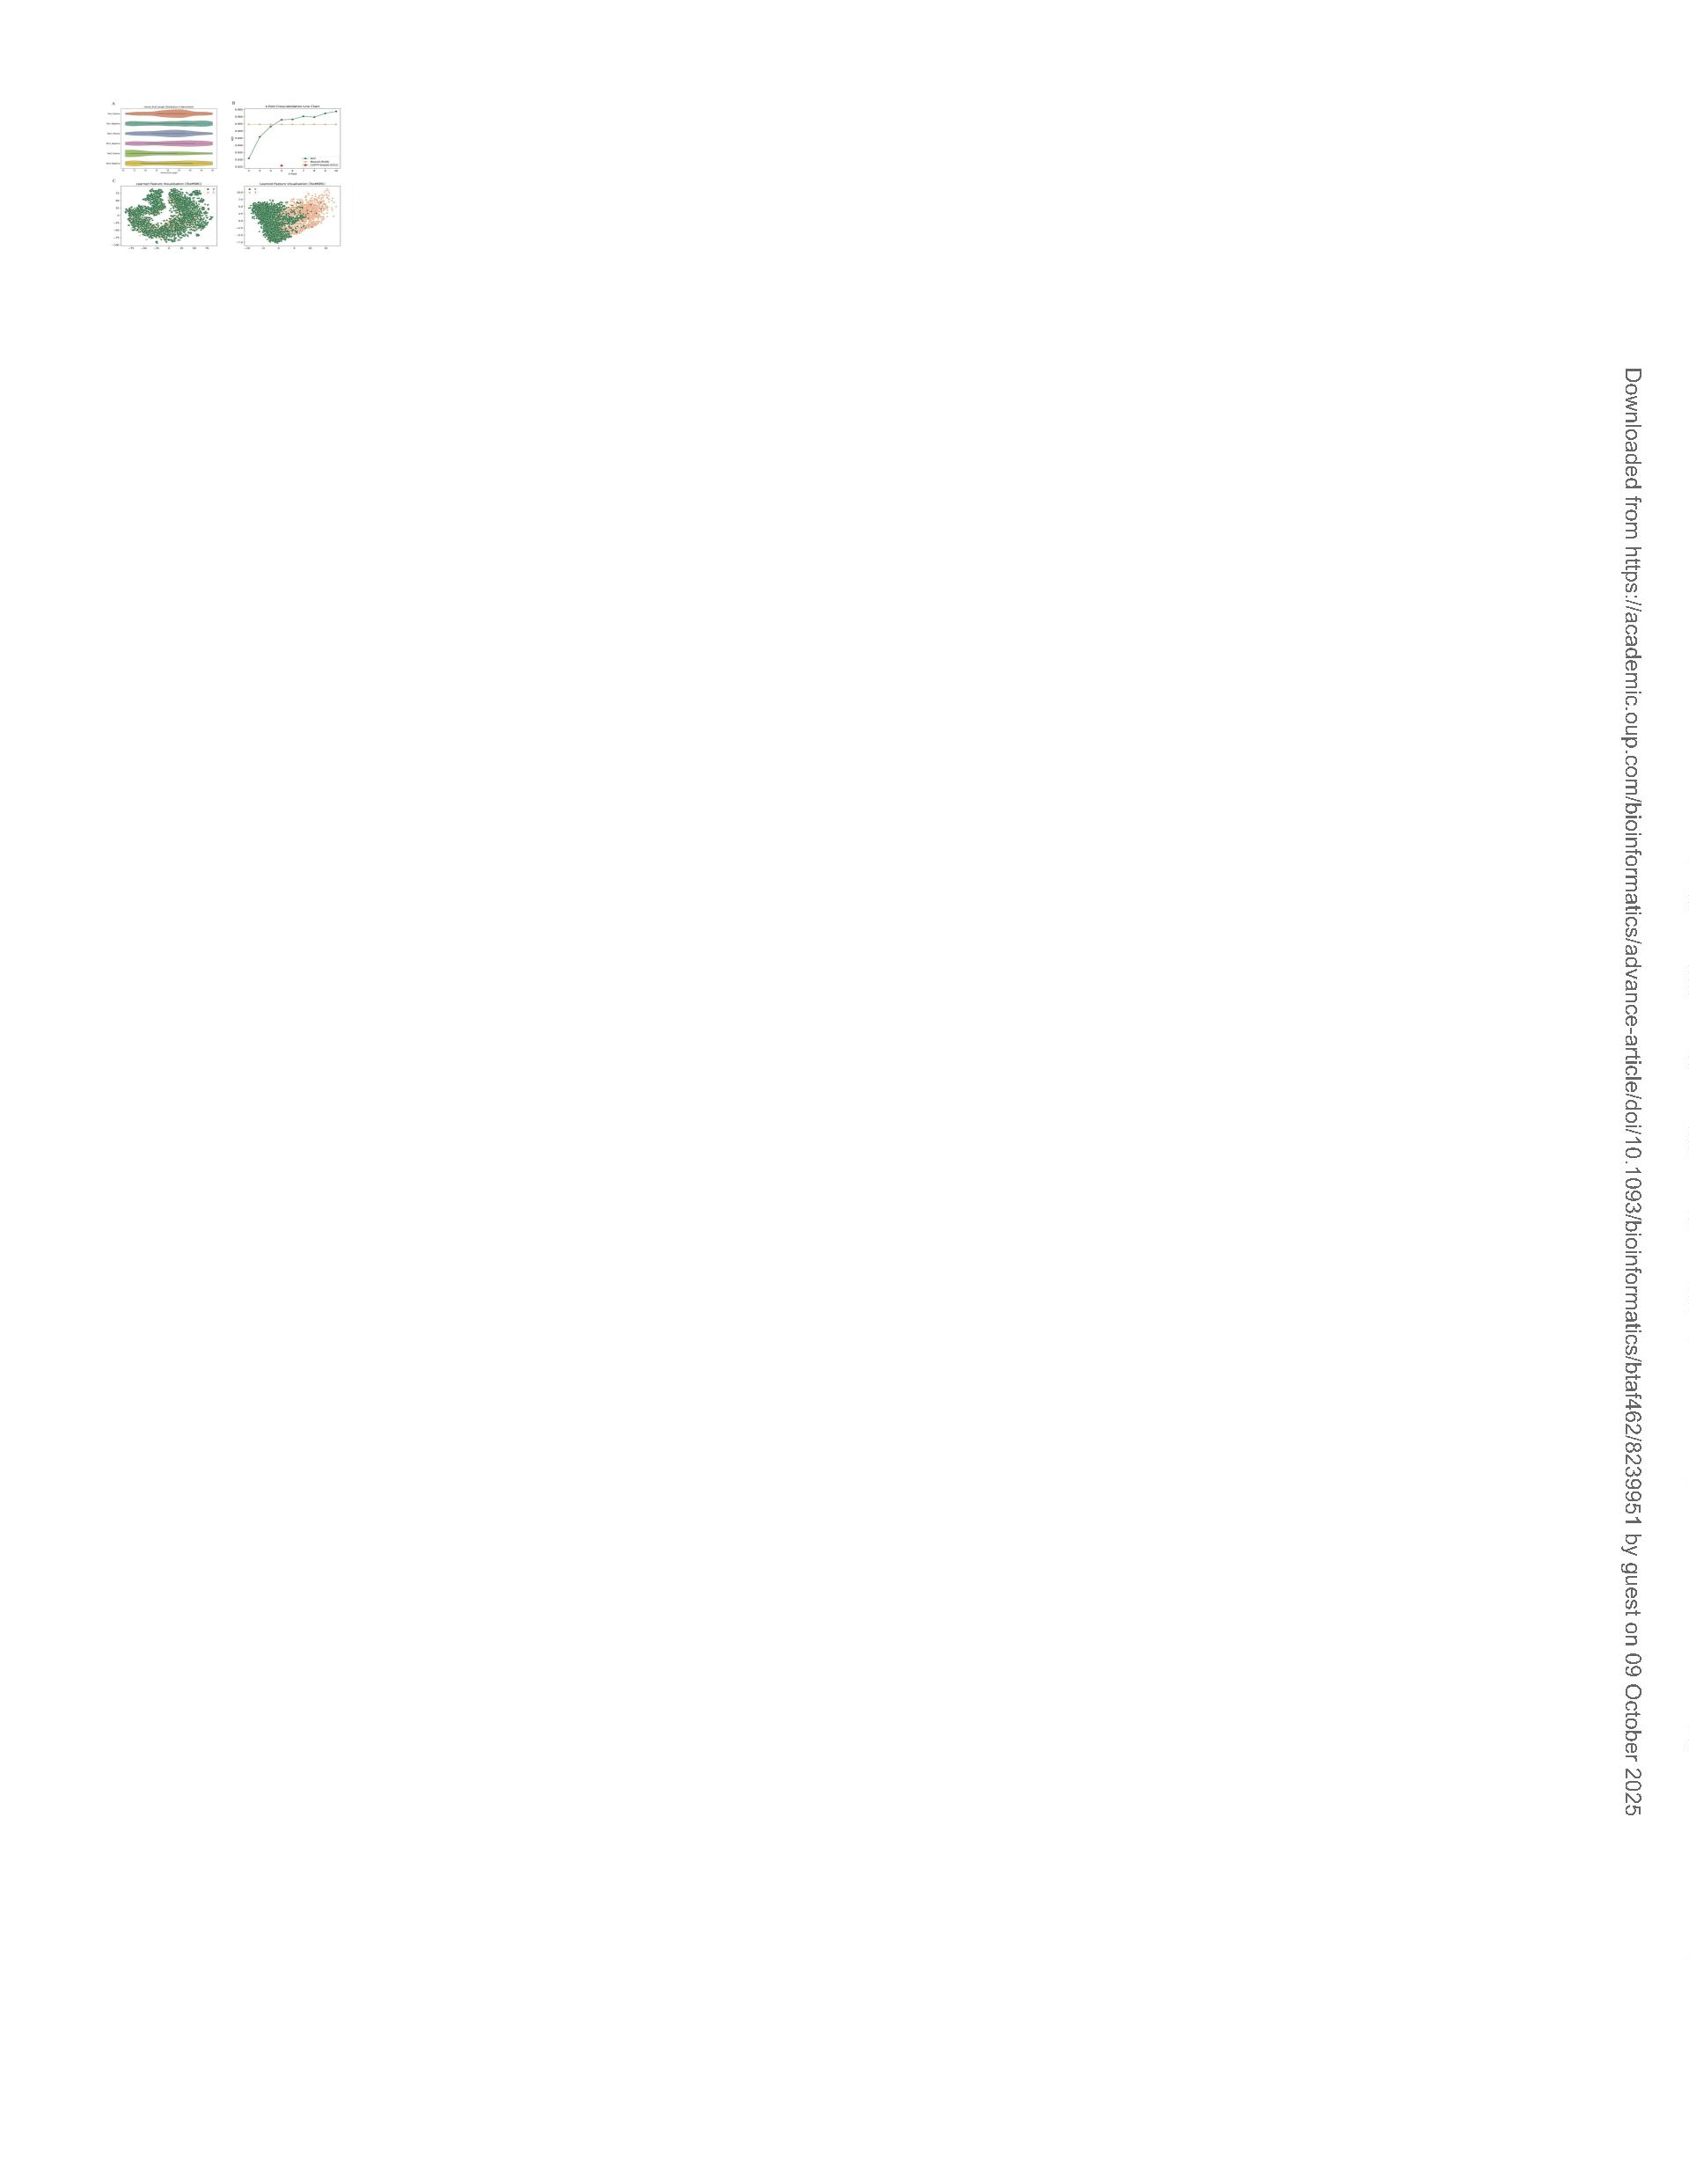

Bioinformatics
Page 12 of 20
1
2
3
4
5
6
7
8
9
1
1
1
1
1
1
1
1
1
1
2
2
2
2
2
2
2
2
2
2
3
3
3
3
3
3
3
3
3
3
4
4
4
4
4
4
4
4
4
4
5
5
5
5
5
5
5
5
5
5
6
0
1
2
3
4
5
6
7
8
9
0
1
2
3
4
5
6
7
8
9
0
1
2
3
4
5
6
7
8
9
0
1
2
3
4
5
6
7
8
9
0
1
2
3
4
5
6
7
8
9
0
Figure 4. Comparison of different amino acid counts as words and the impact of residual connections.
508x304mm (300 x 300 DPI)
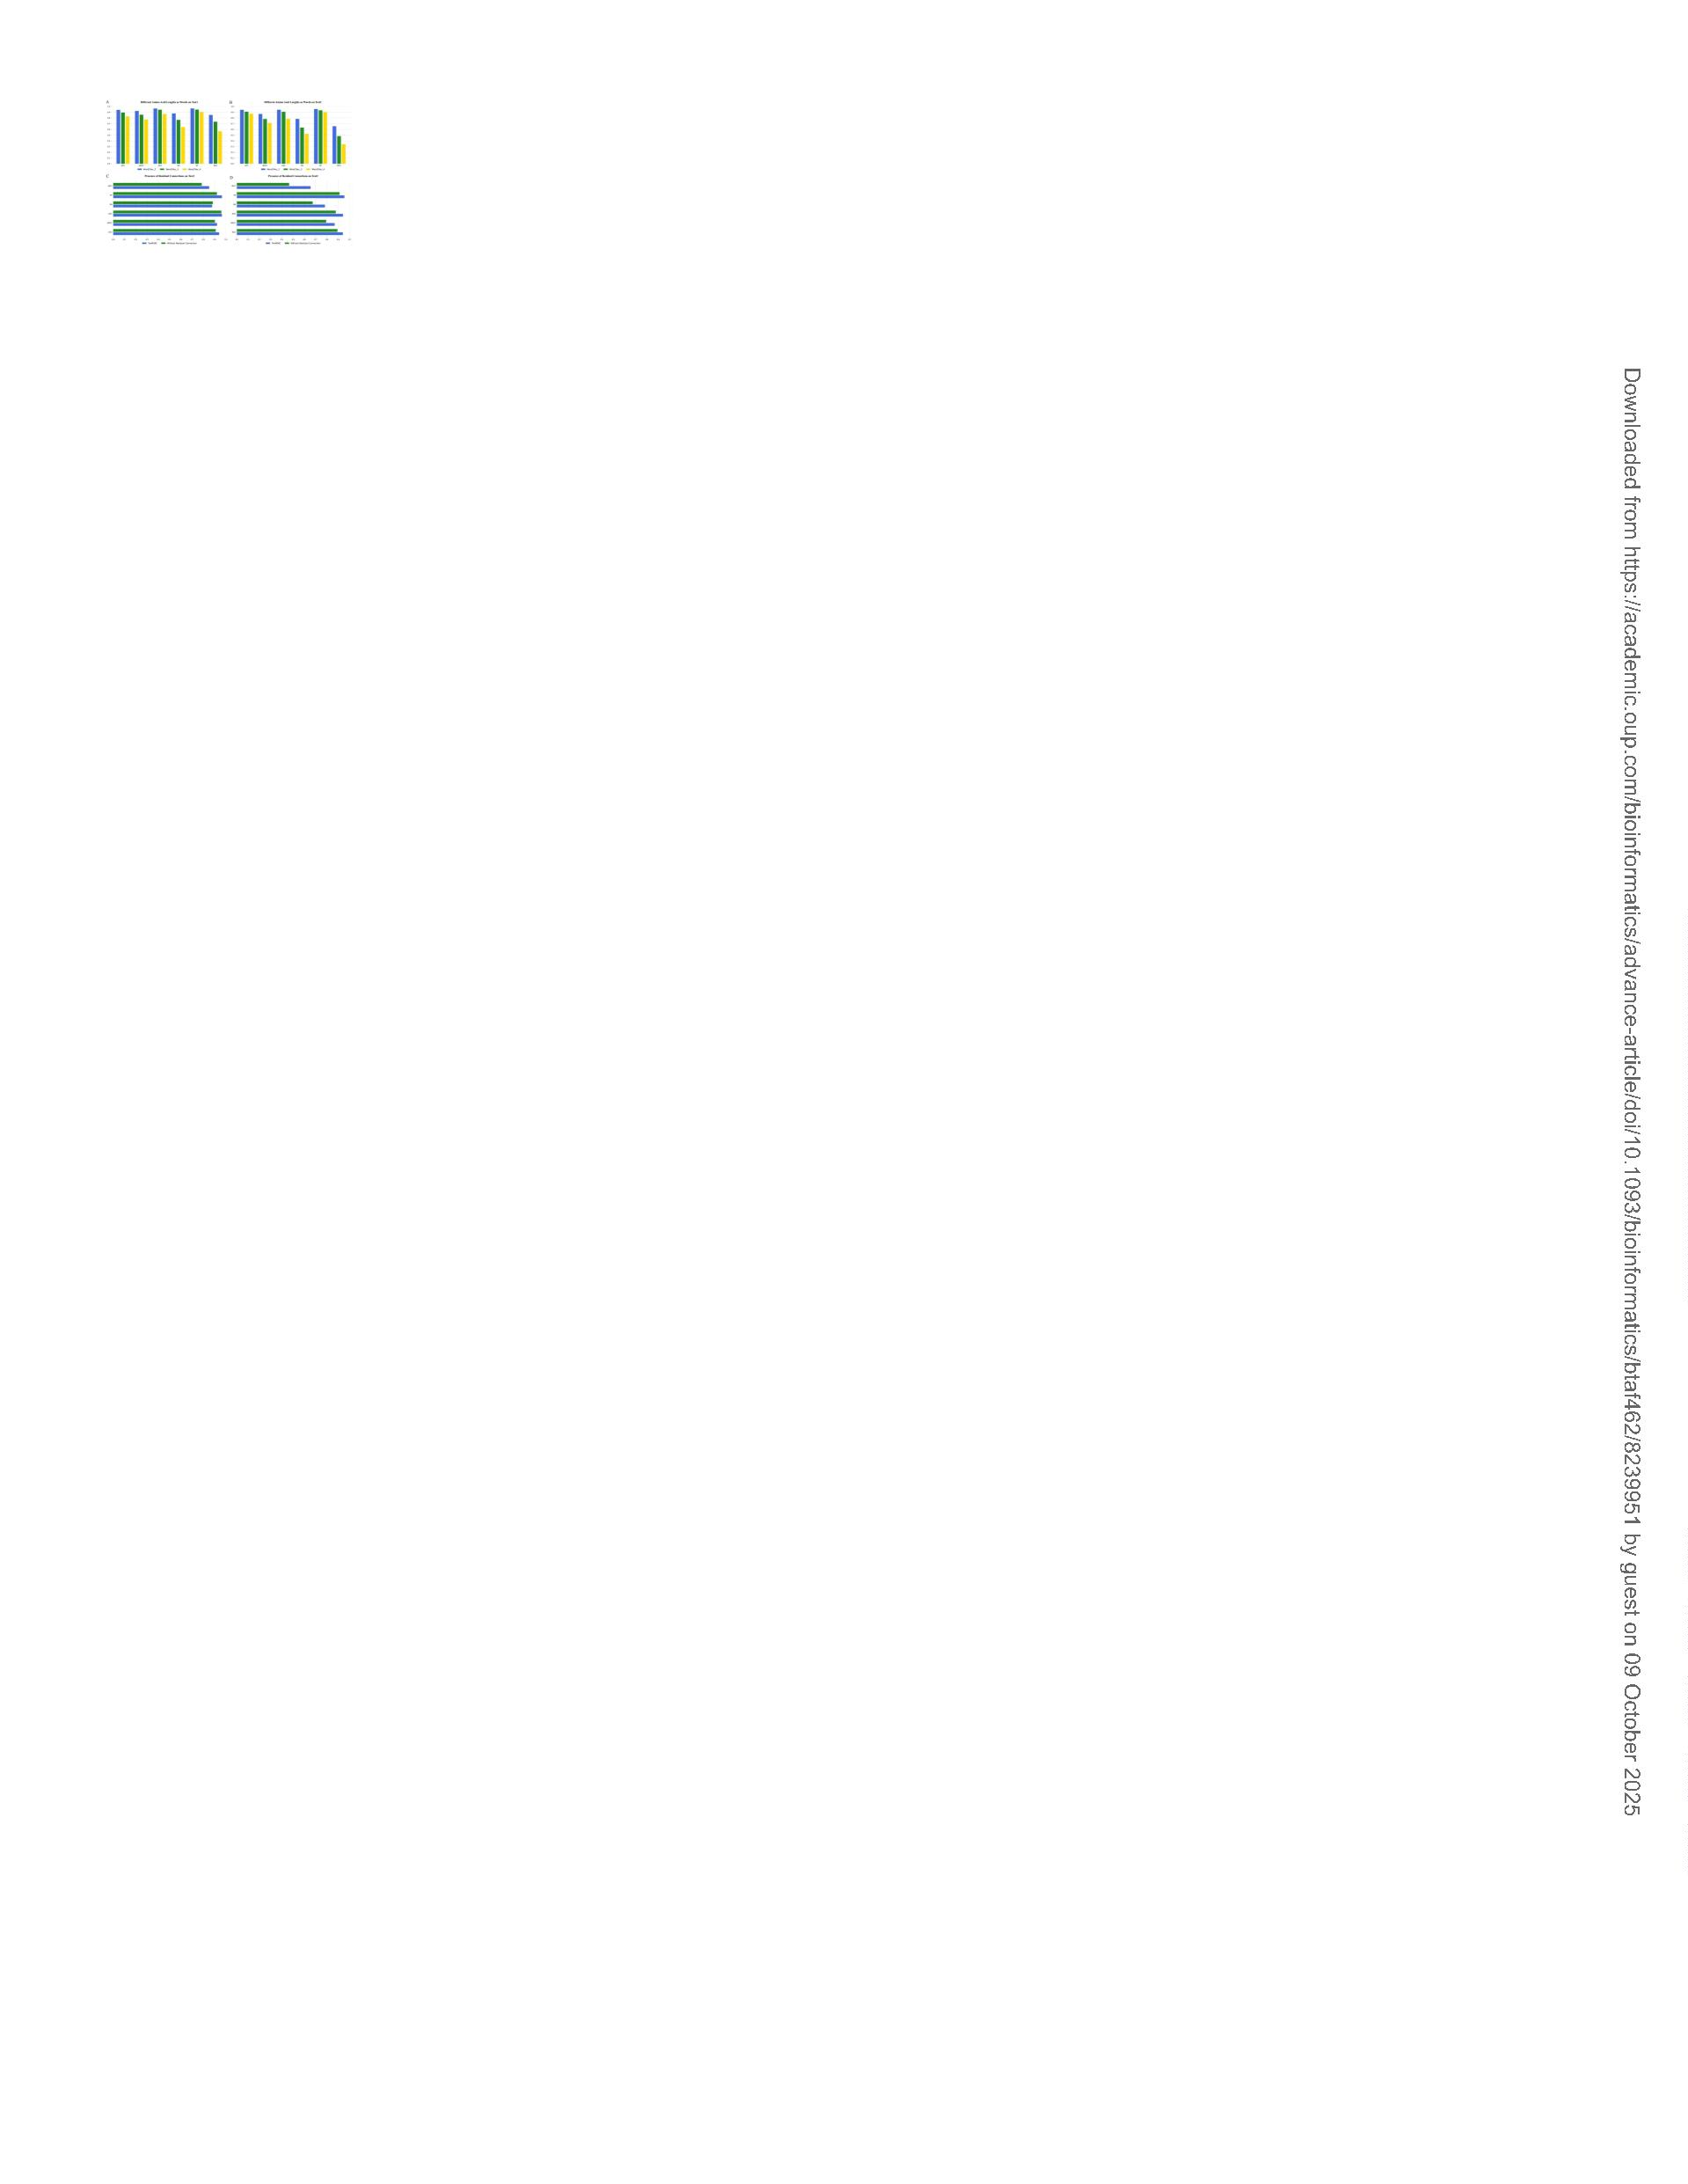

Page 13 of 20
Bioinformatics
1
2
3
4
5
6
7
8
9
1
1
1
1
1
1
1
1
1
1
2
2
2
2
2
2
2
2
2
2
3
3
3
3
3
3
3
3
3
3
4
4
4
4
4
4
4
4
4
4
5
5
5
5
5
5
5
5
5
5
6
0
1
2
3
4
5
6
7
8
9
0
1
2
3
4
5
6
7
8
9
0
1
2
3
4
5
6
7
8
9
0
1
2
3
4
5
6
7
8
9
0
1
2
3
4
5
6
7
8
9
0
Figure 5. The impact of different convolutional kernel sizes on performance. (A-F) The ACC, SN, and MCC
results of the multi-scale convolutional layer using only kernel sizes of 3, 5, 7, and combinations of 3 and 5,
3
and 7, 5 and 7 are presented on independent test1 and independent test2. (G) Comparison of ACC
between matrix splicing and element-wise matrix addition in the final splicing part of the multi-scale
convolution on independent test1 and independent test2.
4
32x436mm (300 x 300 DPI)
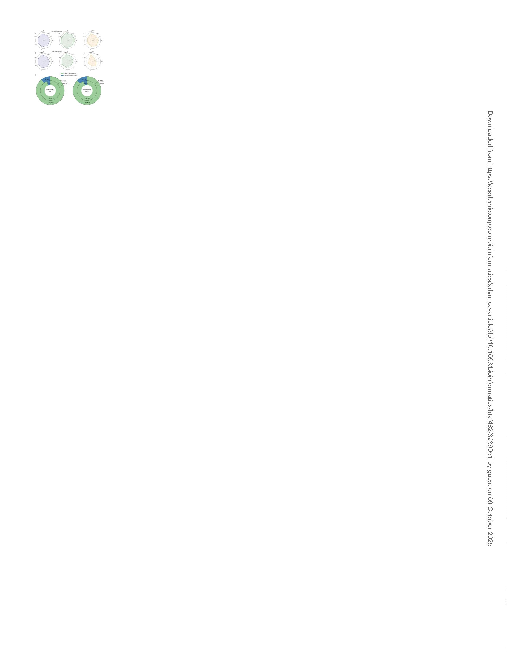

Bioinformatics
Page 14 of 20
1
2
3
4
5
6
7
8
9
1
1
1
1
1
1
1
1
1
1
2
2
2
2
2
2
2
2
2
2
3
3
3
3
3
3
3
3
3
3
4
4
4
4
4
4
4
4
4
4
5
5
5
5
5
5
5
5
5
5
6
0
1
2
3
4
5
6
7
8
9
0
1
2
3
4
5
6
7
8
9
0
1
2
3
4
5
6
7
8
9
0
1
2
3
4
5
6
7
8
9
0
1
2
3
4
5
6
7
8
9
0
Figure 6. ROC and PR curves of different deep learning methods on independent test1 and independent
test2.
3
25x243mm (300 x 300 DPI)


Page 15 of 20
Bioinformatics
1
2
3
4
5
6
7
8
9
1
1
1
1
1
1
1
1
1
1
2
2
2
2
2
2
2
2
2
2
3
3
3
3
3
3
3
3
3
3
4
4
4
4
4
4
4
4
4
4
5
5
5
5
5
5
5
5
5
5
6
0
1
2
3
4
5
6
7
8
9
0
1
2
3
4
5
6
7
8
9
0
1
2
3
4
5
6
7
8
9
0
1
2
3
4
5
6
7
8
9
0
1
2
3
4
5
6
7
8
9
0
Figure 7. The result of exploring the sequential characteristics of toxic peptides using ToxMSRC. (A) The
distribution of the proportion of amino acid counts at positions 1-11 for toxic peptides and non-toxic
peptides. (B) The heatmap of the distribution of all amino acids for positive and negative samples in the
benchmark dataset. (C) Prediction of toxic and non-toxic sequences for fixed amino acids at specific
positions after 20 amino acid mutations (Positions 1-11) in toxic peptide sequences from independent test2.
304x275mm (300 x 300 DPI)
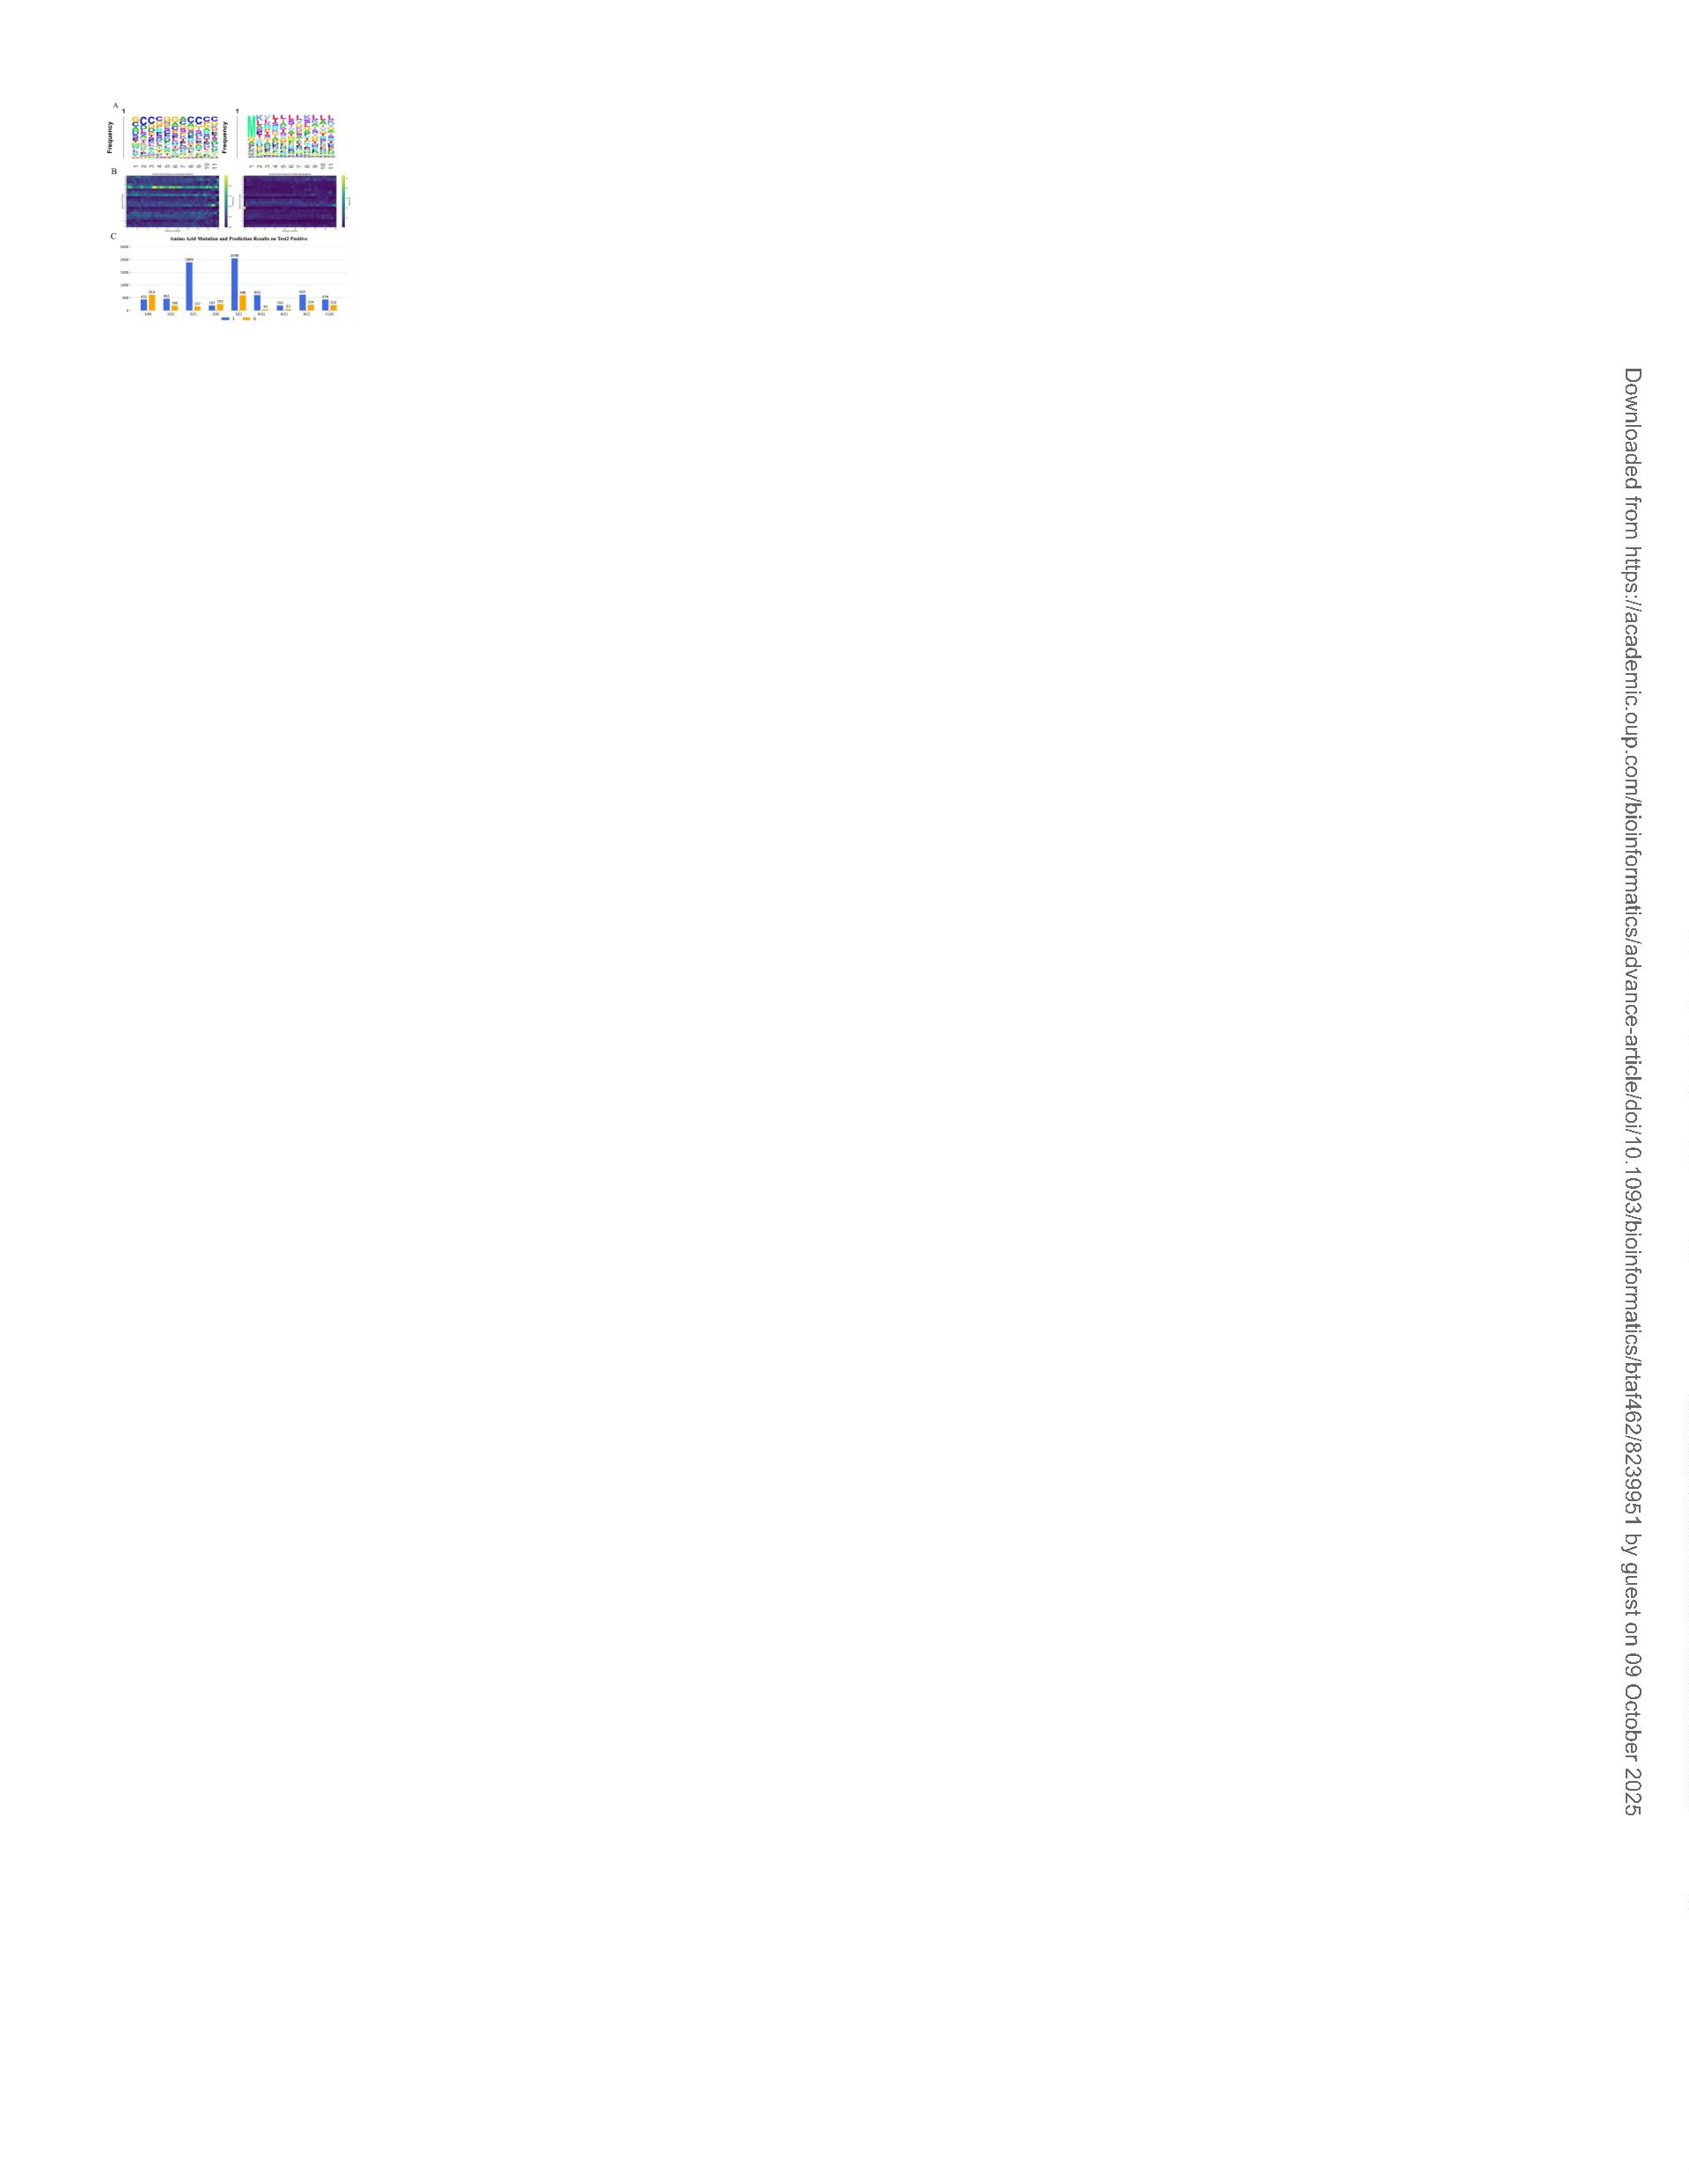

Bioinformatics
Page 16 of 20
1
2
3
4
5
6
7
8
9
1
1
1
1
1
1
1
1
1
1
2
2
2
2
2
2
2
2
2
2
3
3
3
3
3
3
3
3
3
3
4
4
4
4
4
4
4
4
4
4
5
5
5
5
5
5
5
5
5
5
6
Benchmark
1818
Independent Test1
Independent Test2
Positive
320
806
46
Negative
4569
536
0
1
2
3
4
5
6
7
8
9
0
1
2
3
4
5
6
7
8
9
0
1
2
3
4
5
6
7
8
9
0
1
2
3
4
5
6
7
8
9
0
1
2
3
4
5
6
7
8
9
0

Page 17 of 20
Bioinformatics
1
2
3
4
5
6
7
8
9
Layers
input
Output shape
[Batch,49,96]
[Batch,49,128]
[Batch,49,128]
[Batch,49,128]
[Batch,47,128]
[Batch,45,256]
[Batch,45,256]
[Batch,11520]
[Batch,128]
Parameters
-
CNN-1
kernel size=3, dropout ratio=0.2
CNN-2
kernel size=5, dropout ratio=0.2
CNN-3
kernel size=7, dropout ratio=0.2
1
1
1
1
1
1
1
1
1
1
2
2
2
2
2
2
2
2
2
2
3
3
3
3
3
3
3
3
3
3
4
4
4
4
4
4
4
4
4
4
5
5
5
5
5
5
5
5
5
5
6
0
1
2
3
4
5
6
7
8
9
0
1
2
3
4
5
6
7
8
9
0
1
2
3
4
5
6
7
8
9
0
1
2
3
4
5
6
7
8
9
0
1
2
3
4
5
6
7
8
9
0
Max pooling1d
Conv1d
Bi-LSTM
Flatten
pool_size=3, dropout ratio=0.4
kernel size=3
-
-
Dense-1
Dense-2
Dropout
Dense-3
Output
-
[Batch,64]
-
[Batch,64]
dropout ratio=0.4
-
[Batch,32]
[Batch,2]
activation='softmax'

Bioinformatics
Page 18 of 20
1
2
3
4
5
6
7
8
9
1
1
1
1
1
1
1
1
1
1
2
2
2
2
2
2
2
2
2
2
3
3
3
3
3
3
3
3
3
3
4
4
4
4
4
4
4
4
4
4
5
5
5
5
5
5
5
5
5
5
6
Dataset
Method
CSM-Toxi
n
ACC(%) BACC(%) AUC Sn(%) Sp(%)
MCC
6
6.69
47.81
0.400
4.06
91.56
-0.076
Independent ToxinPred2
50.54
91.56
92.01
94.05
87.80
90.55
94.16
64.22
91.56
91.59
92.17
78.47
82.95
86.89
0.874
0.916
0.959
0.965
0.785
0.901
0.943
95.94
91.56
90.63
87.81
67.39
73.91
78.26
32.51
91.56
92.56
96.53
89.55
91.98
95.52
0.299
0.803
0.811
0.852
0.431
0.525
0.655
test1
ToxIBTL
CAPTP
0
1
2
3
4
5
6
7
8
9
0
1
2
3
4
5
6
7
8
9
0
1
2
3
4
5
6
7
8
9
0
1
2
3
4
5
6
7
8
9
0
1
2
3
4
5
6
7
8
9
0
ToxMSRC
ToxIBTL
CAPTP
Independent
test2
ToxMSRC

Page 19 of 20
Bioinformatics
1
2
3
4
5
6
7
8
9
Dataset
Method
ACC(%)
99.08
97.93
99.20
90.41
91.03
94.05
91.58
88.83
94.16
AUC
0.996
0.995
0.997
0.946
0.955
0.965
0.893
0.890
0.943
Sn(%)
97.96
98.29
98.29
78.13
90.31
87.81
69.57
73.91
78.26
Sp(%)
99.52
97.79
99.56
95.29
91.32
96.53
93.47
90.11
95.52
MCC
0.977
0.950
0.980
0.759
0.790
0.852
0.533
0.484
0.655
Without SMOTE
Balance SMOTE
ToxMSRC
Benchmark
Without SMOTE
Balance SMOTE
ToxMSRC
Independent
test1
1
1
1
1
1
1
1
1
1
1
2
2
2
2
2
2
2
2
2
2
3
3
3
3
3
3
3
3
3
3
4
4
4
4
4
4
4
4
4
4
5
5
5
5
5
5
5
5
5
5
6
0
1
2
3
4
5
6
7
8
9
0
1
2
3
4
5
6
7
8
9
0
1
2
3
4
5
6
7
8
9
0
1
2
3
4
5
6
7
8
9
0
1
2
3
4
5
6
7
8
9
0
Without SMOTE
Balance SMOTE
ToxMSRC
Independent
test2

Bioinformatics
Page 20 of 20
1
2
3
4
5
6
7
8
9
1
1
1
1
1
1
1
1
1
1
2
2
2
2
2
2
2
2
2
2
3
3
3
3
3
3
3
3
3
3
4
4
4
4
4
4
4
4
4
4
5
5
5
5
5
5
5
5
5
5
6
Dataset
Method ACC(%) BACC(%) AUC Sn(%) Sp(%) MCC
GAN
SMOTE
GAN
98.97
99.20
91.20
94.05
91.24
94.16
98.72
98.93
88.78
92.17
80.34
86.89
0.996
0.997
0.954
0.965
0.905
0.943
98.13
98.29
83.13
87.81
67.39
78.26
99.30
99.56
94.42
96.53
93.28
95.52
0.975
0.980
0.782
0.852
0.513
0.655
Benchmark
Independent
test1
SMOTE
GAN
0
1
2
3
4
5
6
7
8
9
0
1
2
3
4
5
6
7
8
9
0
1
2
3
4
5
6
7
8
9
0
1
2
3
4
5
6
7
8
9
0
1
2
3
4
5
6
7
8
9
0
Independent
test2
SMOTE

