Computational and Structural Biotechnology Journal 27 (2025) 2347–2358
Contents lists available at ScienceDirect
Computational and Structural Biotechnology Journal
journal homepage: www.elsevier.com/locate/csbj
Software/Web server Article
ToxiPep: Peptide toxicity prediction via fusion of context-aware
representation and atomic-level graph
Jiahui Guan _{a 1}, Peilin Xie _{b 1}, Dian Meng _{a}
_{,1}, Lantian Yao _{b,} , Dan Yu _{a,}
,
,
,
,
Ying-Chih Chiang _{b}
∗, Tzong-Yi Lee _{c ∗}, Junwen Wang _{a ∗}
,
,
,
,
ª Division of Applied Oral Sciences and Community Dental Care, Faculty of Dentistry, The University of Hong Kong, Hong Kong, China
^{b} Kobilka Institute of Innovative Drug Discovery, School of Medicine, The Chinese University of Hong Kong, Shenzhen, 2001 Longxiang Road, 51872, Shenzhen, China
^{c} Center for Intelligent Drug Systems and Smart Bio-devices (IDS2B), National Yang Ming Chiao Tung University, Hsinchu, 300, Taiwan
A R T I C L E
I N F O
A B S T R A C T
Keywords:
Peptide-based therapeutics have emerged as a promising avenue in drug development, oﬀering high biocom-
patibility, speciﬁcity, and eﬃcacy. However, the potential toxicity of peptides remains a signiﬁcant challenge,
necessitating the development of robust toxicity prediction methods. In this study, we introduce ToxiPep, a novel
dual-model framework for peptide toxicity prediction that integrates sequence-based contextual information with
atomic-level structural features. This framework combines BiGRU and Transformer to capture local and global
sequence dependencies while leveraging multi-scale CNNs to extract reﬁned structural features from molecu-
lar graphs derived from peptide SMILES representations. A cross-attention mechanism aligns and fuses these
two feature modalities, enabling the model to capture intricate relationships between sequence and structural
information. ToxiPep outperforms several state-of-the-art tools, including ToxinPred2, CSM-Toxin, PepNet, and
ToxinPred3, on both internal and independent test sets. Additionally, interpretability analyses reveal that ToxiPep
identiﬁes key amino acids along with their structural features, providing insights into the molecular mechanisms
of peptide toxicity. To facilitate broader accessibility, we have also developed a web server for convenient user
access. Overall, this framework has the potential to accelerate the identiﬁcation of safer therapeutic peptides,
oﬀering new opportunities for peptide-based drug development in precision medicine.
Peptide bioactivity prediction
Sequence modeling
Drug discovery
Deep learning
1
. Introduction
ies, in vitro haemolytic and cytotoxicity assays are routinely employed
to evaluate membrane disruption and cell viability [11,12], oﬀering
In recent years, peptide-based therapeutics have garnered signiﬁ-
faster and more economical read-outs during early discovery [13]. How-
ever, both in vivo and in vitro assays are time-consuming and labor-
intensive, which has spurred the development of computational predic-
tion tools for high-throughput screening [14,15]. These approaches can
be broadly categorized into similarity-based and artiﬁcial intelligence-
based methods. Similarity-based methods, such as BLAST, rely on lo-
cal or global sequence alignments to predict peptide toxicity [16,17].
However, these methods are limited by their reliance on homologous
toxic peptides and their ineﬃciency when dealing with large datasets.
Moreover, determining an appropriate sequence similarity threshold is
challenging, potentially aﬀecting prediction accuracy.
cant attention from academia and the pharmaceutical industry due to
their unique bioactivity, speciﬁcity, and potential eﬃcacy in treating
various diseases such as diabetes, cancer, and infectious diseases [1–3].
Peptides are characterized by their high biocompatibility and low im-
munogenicity [4]. Additionally, compared to traditional small-molecule
drugs and large protein-based therapeutics, peptides exhibit superior tis-
sue penetration and lower production costs [5]. However, despite their
advantages in bioactivity and selectivity, challenges such as toxicity,
immunogenicity, and in vivo stability remain major barriers to their
clinical application [6,7]. Thus, ensuring low toxicity and high safety is
crucial in peptide drug development [8].
Traditional toxicity assessment methods, such as animal testing, can
provide accurate toxicity measurements [9,10]. Alongside in vivo stud-
In contrast, machine learning and deep learning methods have
proven more eﬃcient by leveraging features from both toxic and non-
*
1
Corresponding authors.
E-mail addresses: chiangyc@cuhk.edu.cn (Y.-C. Chiang), leetzongyi@nycu.edu.tw (T.-Y. Lee), junwen@hku.hk (J. Wang).
These authors contributed equally to this work.
https://doi.org/10.1016/j.csbj.2025.05.039
Received 27 February 2025; Received in revised form 22 May 2025; Accepted 23 May 2025
Available online 28 May 2025
2
001-0370/© 2025 The Authors. Published by Elsevier B.V. on behalf of Research Network of Computational and Structural Biotechnology. This is an open access
article under the CC BY license (http://creativecommons.org/licenses/by/4.0/).


J. Guan, P. Xie, D. Meng et al.
Computational and Structural Biotechnology Journal 27 (2025) 2347–2358
Fig. 1. Framework of the ToxiPep. The model fuses sequence-based contextual representations and atomic-level structural features for enhanced peptide classiﬁcation.
Sequence embeddings are processed by BiGRU and Transformer encoder, while SMILES-derived graph features are reﬁned via multi-scale convolutions. Cross-attention
aligns both modalities, and an MLP classiﬁer generates the ﬁnal prediction.
toxic peptides to build predictive models [18,19]. For instance, Naamati
et al. developed ClanTox, a machine learning tool for predicting animal
toxins using boosted stump classiﬁers [20]. Following this, Gupta et al.
introduced ToxinPred, which utilized sequence-based descriptors such
as amino acid composition, dipeptide composition, and sequence mo-
tifs, signiﬁcantly improving prediction accuracy [21]. Building on these
approaches, deep learning methods have demonstrated considerable ad-
vancements in recent years. For example, Wei et al. proposed the ATSE
model based on graph neural networks, integrating structural and evo-
lutionary information for improved performance [22]. Similarly, Pan et
al. developed ToxDL, which employed convolutional neural networks
(CNNs) to encode protein sequences and incorporated Skip-gram em-
beddings for toxicity prediction [23]. Expanding on these innovations,
Jiao et al. developed CAPTP, which combines CNN and self-attention
mechanisms to eﬃciently extract features from amino acid sequences,
achieving outstanding performance in toxicity prediction [24]. Most
recently, Rathore et al. introduced ToxinPred3, an advanced computa-
tional tool that enhances reliability and accuracy by integrating multiple
models through ensemble learning [25].
computational safety scores [29], and AI-screened K4F4 lipopeptides
required further haemolytic testing to conﬁrm low cytotoxicity [30].
These ﬁndings indicate that experimentally validated test sets are im-
portant for evaluating model generalization.
In this study, we developed ToxiPep, a dual-model framework for
peptide toxicity prediction that integrates context-aware representations
and atomic-level graph features to enhance prediction accuracy and ro-
bustness. The framework, as shown in Fig. 1, begins by sequence embed-
dings, which are processed through a bidirectional GRU (BiGRU) layer
and Transformer encoder blocks to capture both local and global depen-
dencies. Simultaneously, atomic-level graph features are extracted from
the SMILES representation of peptides by constructing molecular graphs.
These features are further reﬁned through multiple 2D convolutional
layers (Multi-scale CNN) to produce a detailed structural representa-
tion. The context-aware representations and atomic-level graph features
are then fused through a cross-attention mechanism, aligning relevant
information between the two modalities. The fused representation is
passed through a multi-layer perceptron (MLP) classiﬁer to predict pep-
tide toxicity. This hybrid approach eﬀectively leverages both contextual
and structural information, providing a powerful computational tool for
peptide toxicity prediction. Additionally, we developed a web server
to facilitate user-friendly access to ToxiPep, allowing researchers to ef-
ﬁciently predict peptide toxicity through an intuitive online platform,
available at https://awi.cuhk.edu.cn/~dbAMP/ToxiPep/.
Despite signiﬁcant advancements in peptide toxicity prediction,
there are still notable limitations. First, most models are not speciﬁcally
designed for short peptides, which are critical in many applications.
For instance, peptides with a length of 10-50 amino acids often ex-
hibit higher bioactivity and tissue penetration capabilities, while their
lower molecular weight reduces immunogenicity and enhances drug
targeting speciﬁcity [26,27]. Furthermore, the length range of these
peptides facilitates the formation of stable secondary structures, which
are closely associated with their biological functions [28]. Second, many
current toxicity prediction methods primarily rely on sequence-based
features, such as amino acid composition or sequence motifs, while
neglecting molecular structural information, potentially limiting their
ability to capture key toxicity-related mechanisms. Third, existing mod-
els often lack suﬃcient interpretability, making it challenging to derive
insights into the underlying mechanisms of peptide toxicity. By integrat-
ing both sequence and structural features, a deeper understanding of the
mechanisms of peptide toxicity could be achieved, leading to improved
predictive reliability and broader applicability. Moreover, recent studies
have shown that some models may fail to generalize beyond the training
data, resulting in inconsistent or inaccurate predictions when applied to
newly designed peptides. For example, Chenopodin-derived peptides
exhibited negligible haemolysis in in vitro assays despite favorable
Overall, this framework not only improves predictive accuracy and
robustness but also deepens the understanding of the molecular mech-
anisms underlying peptide toxicity. The insights gained from this study
have the potential to positively inﬂuence peptide-based therapeutic de-
sign, enabling the identiﬁcation of safer and more eﬀective therapeutic
peptides.
2
. Materials and methods
2.1. Dataset preparation
Constructing a well-curated dataset is essential for training a robust
and reliable model. In this study, we integrated both newly curated
and previously validated data sources. Toxic peptides were sourced
from multiple well-established datasets, including ToxinPred3 [25] and
ATSE [22], which have been widely used in peptide toxicity studies.
2
348
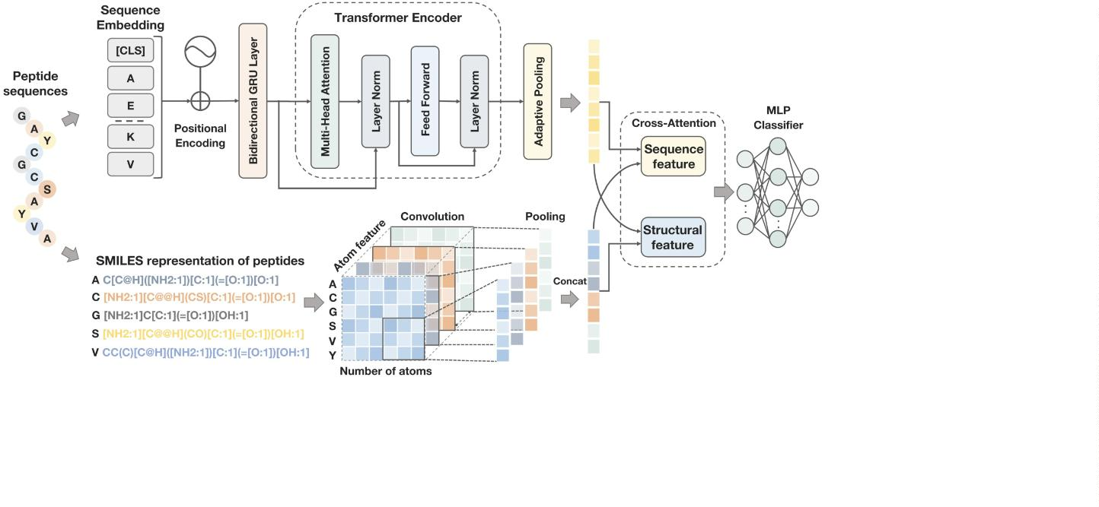

J. Guan, P. Xie, D. Meng et al.
Computational and Structural Biotechnology Journal 27 (2025) 2347–2358
Furthermore, we incorporated additional reviewed toxic peptides from
the latest versions of DRAMP4.0 [31] and dbAMP3.0 [32].
Table 1
Overview of the dataset under two diﬀerent CD-HIT clustering thresholds, which
summarizes the number of toxic and non-toxic peptide samples used in the train-
ing and testing sets.
For non-toxic peptides, peptide sequences were retrieved from
UniProt [33] using the query “NOT toxin NOT toxic AND reviewed:
yes”, and from SwissProt [34] database using the query “NOT KW-
CD-HIT Threshold Training data
Testing data
0
800 AND NOT KW-0020”, which speciﬁcally targets entries that are
Toxic Non-Toxic Total Toxic Non-Toxic Total
manually curated and reviewed. This strategy is consistent with the pre-
viously established protocols for constructing reliable non-toxic peptide
datasets [22,25].
0
.9
.8
3528
2772
3528
2772
7056 883
5544 694
883
694
1766
1388
0
To reduce redundancy within and across both positive and negative
datasets, we applied the CD-HIT clustering algorithm [35] with two se-
quence similarity thresholds. A threshold of 0.9, which is commonly
employed in previous studies, was applied to ensure comparability with
existing benchmarks. Additionally, a more stringent threshold of 0.8 was
used to train models under reduced sequence similarity for more rig-
orous performance evaluation. After reducing redundancy, we further
optimized the selection of negative samples to reduce distributional bias
between positive and negative sets [36,37]. Speciﬁcally, for each posi-
tive sample pos , we computed a combined similarity measure with each
partic acid (D) are mapped to indices 3, 4, and 5, respectively [43]. The
token embedding of an amino acid ꢆ is deﬁned as:
ꢀ
ꢇ ꢆ
(
) = Index from Vocabulary(ꢆꢀ)
(3)
ꢈ
ꢀ
Additionally, the positional information of each amino acid is captured
with a learnable positional encoding matrix, ensuring the model con-
siders sequence order. The positional embedding for the ꢀ-th residue is
given by:
ꢀ
candidate negative sample neg , deﬁned as:
Positional Encoding_{(ꢀ)}
(4)
^{ꢇ}ꢉ^{(ꢀ) =}
ꢁ
ꢂ_{combined}(pos ,neg ) = |ꢃ_{pos} − ꢃ_{neg} | + Euclidean(ꢄpos ,ꢄ_{neg} )
(1)
The complete embedding of each amino acid, denoted ꢊ , is the sum of
ꢀ
ꢁ
ꢀ
ꢀ
ꢁ
ꢀ
ꢁ
its token and positional embeddings:
where ꢃ denotes sequence length and ꢄ the normalized 20-dimensional
amino acid composition vector. The Euclidean distance component is
given by:
ꢊ = ꢇ (ꢋ ) + ꢇ (ꢀ), ∀ꢀ ∈ {1,2,…,ꢃ}
(5)
emb
ꢀ
ꢈ
ꢀ
ꢉ
where ꢃ is the length of the protein sequence. The resulting matrix ꢊ
√
√
√
∑²⁰
constitutes the sequence embedding of the protein.
√
Euclidean(ꢄ_{posꢀ} ,ꢄ_{negꢁ} ) =
(ꢄ_{posꢀ,ꢅ − ꢄnegꢁ,ꢅ} )²
(2)
ꢅ=1
2.2.2. Context-aware sequence processing architecture
This matching approach ensures that the selected non-toxic peptides
are comparable to the toxic peptides in terms of amino acid composition
and sequence length distribution, thereby mitigating artiﬁcial separabil-
ity due to trivial sequence-level diﬀerences and reducing selection bias
in model training.
The embedding matrix
ꢊemb
is processed through a deep learning
architecture that captures both local patterns and global dependencies.
First, the embedding matrix
ꢊemb
is passed through a BiGRU
layer [44], which learns dependencies in both forward and backward
directions:
To avoid potential data leakage, especially among short peptides
where homology can be subtle yet signiﬁcant, we partitioned the dataset
into training and testing sets using Levenshtein distance-based cluster-
ing [38,39]. Peptides were grouped based on sequence similarity, and
clusters were then split such that 80% of the data formed the training
set and 20% formed a testing set. This strategy ensures that sequences
in the test set are not overly similar to those in the training set, thereby
supporting a more realistic evaluation of model generalization in bio-
logical scenarios. As a complementary reference, Table S1 compares our
dataset with those used in ATSE [22], CAPTP [24], and ToxinPred3 [25],
highlighting diﬀerences in design and preprocessing. The detailed com-
position of the dataset is shown in Table 1.
ꢊGRU
=
BiGRU(ꢊ_{emb})
(6)
where ꢊ
represents the sequence with bidirectional contextual in-
GRU
formation integrated.
Next, the output ꢊ
is fed into a series of Transformer encoder
GRU
blocks [45], each employing multi-head self-attention and feedforward
layers to model both short- and long-range dependencies:
ꢊ_{trans} =
TransformerEncoder_{ꢌ(ꢊGRU)}
(7)
To generate a ﬁxed-size feature vector, we apply an adaptive max pool-
ing operation on the transposed sequence representation:
In addition to the above data construction and evaluation strategy,
we included an independent test set to further evaluate the generaliz-
ability of the model on experimentally validated peptide toxicity data.
The independent test set consists of 479 toxic peptides retrieved from the
DBAASP database [40], all of which possess experimentally measured
hemolytic activity. These peptides were labeled as toxic based on hemol-
ysis thresholds established in previous studies [41,42]. The negative
samples were curated from reviewed UniProt [33] and SwissProt [34]
entries with exclusion of toxin-associated annotations, using the same
review-based strategy as applied during training dataset construction.
In addition, to prevent data leakage, all sequences in this dataset were
ensured to have no overlap with any peptides in the training set.
ꢊ_{seq} = AdaptiveMaxPool1d(ꢊ⊤
)
(8)
captures the most informative features,
trans
The resulting pooled vector
ꢊseq
yielding a compact representation suitable for downstream tasks.
2
.2.3. Structural encoding
Structural encoding methods based on SMILES representations have
previously achieved signiﬁcant success in peptide function predic-
tion [46]. Building on this foundation, peptide sequences are trans-
formed into numerical representations by incorporating their molec-
ular structure and physicochemical properties. Each peptide is ﬁrst
converted into its corresponding SMILES representation [47], and 2D
molecular graphs are generated for each amino acid:
2.2. Framework of the ToxiPep
ꢍ({ꢆ ,…,ꢆ }) → {ꢏ ,…,ꢏ }
(9)
where is the peptide sequence, represents individual amino acids,
1
ꢎ
1
ꢎ
2
.2.1. Sequence embedding
ꢍ
ꢆ
ꢀ
To transform protein sequences into numerical representations, we
and
denotes the molecular graph of each amino acid.
ꢏ
ꢀ
employ a combination of token and positional embeddings. Each amino
For each atom in the molecular graph, a comprehensive set of 21
features is extracted to represent its structural and physicochemical con-
text [48]. These features are grouped as follows:
acid ꢆ in the sequence is assigned a unique numerical index from a
ꢀ
predeﬁned vocabulary. For example, Alanine (A), Cysteine (C), and As-
2
349

J. Guan, P. Xie, D. Meng et al.
Computational and Structural Biotechnology Journal 27 (2025) 2347–2358
1
. Atomic type: The type of atom (C, N, O, or S), encoded using one-hot
ꢔ_{concat} = Concat(ꢔ_{pool,1},…,ꢔ_{pool,ꢌ})
The concatenated output is passed through a fully connected layer:
ꢊ_{struct} = ReLU(Linear(ꢔ_{concat})) (16)
(15)
encoding.
2
. Degree: The number of atoms directly bonded to the atom.
. Total hydrogen count: The number of hydrogen atoms attached to
the atom, including both explicit and implicit hydrogens.
. Implicit valence: The estimated valence of the atom based on its
bonding conﬁguration.
3
4
5
6
7
8
2
.2.5. Cross-attention fusion
To integrate sequence-level and structural features eﬀectively, a
. Aromaticity: A binary value indicating whether the atom is part of
an aromatic ring.
cross-attention mechanism aligns relevant information from both rep-
resentations [52,53].
. Ring size: Two binary values indicating whether the atom is part of
a ﬁve- or six-membered ring.
In the ﬁrst cross-attention step, sequence features attend to structural
features:
. Hybridization type: An integer from 1 to 7 representing the hy-
bridization state.
ꢕseq,ꢖstruct,ꢗ_{struct} = ꢊseq,ꢊstruct,ꢊstruct
(17)
(18)
. Gasteiger charges: A single ﬂoat value representing the partial
atomic charge, estimated by an iterative algorithm that approx-
imates electron distribution based on atom electronegativity and
bonding environment.
(
)
ꢕ_{seq}ꢖs⊤truct
ꢑ_{seq} = Softmax
ꢗstruct
√
ꢓ
Similarly, structural features attend to sequence-level information:
Together, these features oﬀer a structured and informative repre-
ꢕstruct,ꢖseq,ꢗ_{seq} = ꢊstruct,ꢊseq,ꢊseq
(19)
(20)
sentation of each atom, forming the basis for atomic-level graph con-
struction. Here, the term atomic-level refers to the granularity of the
molecular graph, where each node corresponds to an individual atom.
This representation enables the model to incorporate local chemical en-
vironments of each residue within peptide structures.
(
)
ꢕstructꢖ
⊤
seq
ꢑ_{struct}
=
Softmax
√
ꢗ_{seq}
ꢓ
The outputs are concatenated:
Each atomic feature vector within an amino acid graph is propa-
gated through the local molecular structure by multiplication with the
normalized adjacency matrix:
ꢊ_{fusion}
=
Concat(ꢑ_{seq},ꢑ_{struct})
(21)
The fused representation is then passed through a fully connected layer
for classiﬁcation:
= ̂
ꢐꢀ′ ꢑ ⋅ ꢐ
(10)
ꢀ
^{logits = Linear(ꢊ}fusion⁾
This cross-attention fusion mechanism ensures that both sequence em-
beddings ꢊ and structural features ꢊ contribute eﬀectively to
(22)
where ꢐ denotes the feature vector of atom ꢀ, and ꢑ̂ is the normalized
ꢀ
adjacency matrix deﬁned as:
−0.5
seq
the ﬁnal prediction.
struct
̂
ꢑ
=
ꢂ^{−0.5(}ꢑ ꢒ ꢂ
+
)
(11)
with ꢂ being the degree matrix and ꢒ the identity matrix. This operation
allows each atom to aggregate feature information from its neighbors,
enhancing the representation with local chemical context.
For each amino acid, the propagated atomic features are stacked into
a matrix of shape ꢏ × ꢓ, where ꢏ is the maximum number of atoms
allowed per residue and ꢓ = 21 is the feature dimension. These matri-
ces are then assembled along the sequence axis to construct the ﬁnal
structural tensor:
2
.3. Evaluation metrics
In this study, we utilized Accuracy, Sensitivity, Speciﬁcity, and
Matthews correlation coeﬃcient (MCC) to evaluate the performance of
the presented method [54]. They are deﬁned as follows:
ꢔ ꢜ + ꢔ ꢌ
ꢔ ꢜ + ꢔ ꢌ + ꢝꢜ + ꢝꢌ
ꢑꢘꢘꢙꢚꢆꢘꢛ =
(23)
(24)
(25)
(26)
ꢔ ꢜ
ꢔ ꢜ + ꢝꢌ
ꢔ ꢌ
_{∈ ℝ}ꢃ×ꢏ×ꢓ
(12)
=
^{ꢔ}ꢍ
ꢍꢞꢎꢟꢀꢈꢀꢠꢀꢈꢛ
where ꢃ is the maximum peptide length. This tensor ꢔ encodes atom-
ꢍ
ꢍꢉꢞꢘꢀꢐꢀꢘꢀꢈꢛ =
level structural information in a residue-wise manner and serves as the
input to the subsequent 2D convolutional layers.
+
ꢔ ꢌ ꢝꢜ
ꢔ ꢜ ꢔ ꢌ ꢝꢜ ꢝꢌ
(ꢔ ꢜ + ꢝꢜ)(ꢔ ꢜ + ꢝꢌ)(ꢔ ꢌ + ꢝꢜ)(ꢔ ꢌ + ꢝꢌ)
×
−
×
ꢏꢄꢄ = √
While the 2D representation captures local chemical environments,
it does not model full 3D peptide conformations. Experimental struc-
tures are scarce, and predicted models (e.g., AlphaFold, ESMFold) may
introduce noise [49], especially in imbalanced datasets. In contrast,
where TP, TN, FP and FN denote true positives, true negatives, false
positives and false negatives, respectively.
2
D graphs oﬀer computational eﬃciency and scalability for large-scale
3
. Results and discussion
screening [50,51].
3
.1. Amino acid composition analysis of toxic and non-toxic peptides
2
.2.4. Atomic-level graph processing architecture
The peptide graphs are processed through Multi-scale CNN to cap-
To investigate the diﬀerences in amino acid composition between
ture both local and global dependencies among atomic features. For the
toxic and non-toxic peptides, we performed a comparative analysis
based on two datasets clustered at CD-HIT thresholds of 0.9 (Fig. 2)
and 0.8 (Figure S1). Panel A in both ﬁgures shows the mean amino
acid composition (AAC) of toxic and non-toxic peptides, with amino
acids grouped by physicochemical properties. Panels B and C present
the Bonferroni-corrected ꢉ-values [55] derived from Wilcoxon rank-sum
tests [56] and the corresponding − log -transformed values [57,58],
ꢀ
-th convolutional layer, the operation is:
ꢔ_{conv,ꢀ} = ReLU(Conv2D(ꢔ ,ꢐ ))
(13)
ꢍ
ꢀ
where ꢐ is the size of the convolution ﬁlter. The output from each con-
ꢀ
volutional layer is pooled to reduce dimensionality:
ꢔ_{pool,ꢀ} = AdaptiveAvgPool2D(ꢔ_{conv,ꢀ})
The pooled features are concatenated:
(14)
10
respectively, which quantify the statistical signiﬁcance of amino acid
composition diﬀerences between toxic and non-toxic peptides.
2
350

J. Guan, P. Xie, D. Meng et al.
Computational and Structural Biotechnology Journal 27 (2025) 2347–2358
baselines include classical machine learning algorithms, standard deep
learning architectures, and recent large-scale pretrained protein lan-
guage models.
For the machine learning baselines, we utilized feature combina-
tions such as Amino Acid Composition, Dipeptide Composition, Pseudo-
Amino Acid Composition, Composition of k-Spaced Amino Acid Pairs,
and Composition of k-Spaced Amino Acid Group Pairs [59]. The models
employed included Random Forest, Extra Trees [60], Gradient Boost-
ing [61], AdaBoost [62], and K-Nearest Neighbors [63]. For the deep
learning baselines, we encoded protein sequences using one-hot encod-
ing and adopted Gated Recurrent Unit (GRU), Long Short-Term Memory
(LSTM), Convolutional Neural Network (CNN), and Multi-Layer Per-
ceptron (MLP) architectures [64,65]. In addition, we incorporated two
state-of-the-art pretrained protein language models, ESM [66] and Prot-
BERT [67], which generate contextual embeddings directly from raw
protein sequences. These models have been extensively validated in a
variety of protein classiﬁcation tasks and are considered baselines for
sequence-based representation learning.
As shown in Fig. 3, we compare the performance of our proposed
model, ToxiPep, with a series of classical machine learning models,
deep learning baselines, and pretrained protein language models using
the dataset clustered at a CD-HIT threshold of 0.9. Panel A presents
the comparison with machine learning classiﬁers using handcrafted fea-
tures, with detailed results provided in Table S2. ToxiPep shows the best
overall performance across most metrics, with an accuracy of 0.850,
sensitivity of 0.827, speciﬁcity of 0.873, MCC of 0.701, and AUC of
0
.919. While KNeighbors yields a slightly higher sensitivity of 0.853,
ToxiPep demonstrates a more balanced performance across all metrics,
particularly in terms of MCC and AUC. Panel B shows the performance
comparison against deep learning models, with numerical results listed
in Table S3. ToxiPep consistently outperforms GRU, LSTM, CNN, and
MLP models across all metrics, reﬂecting its advantage in both sequence
modeling and structural integration. Panel C and Table S4 present the
comparison between ToxiPep and two large-scale pretrained protein lan-
guage models, ESM and ProtBERT. While both pretrained models deliver
competitive results, ToxiPep achieves higher accuracy, MCC, and AUC,
indicating that the incorporation of chemically informed structural rep-
resentations provides additional discriminative power beyond that of
sequence-based embeddings.
3
.2.2. ToxiPep surpasses state-of-the-art toxicity prediction tools
Fig. 2. Amino acid composition diﬀerences between toxic and non-toxic pep-
tides (CD-HIT threshold = 0.9) and their statistical signiﬁcance. (A) Mean amino
acid composition of toxic and non-toxic peptides. (B) Bonferroni-corrected ꢉ-
values based on Wilcoxon rank-sum tests of amino acid composition diﬀerences.
(C) Log-transformed corrected ꢉ-values representing the level of statistical sig-
niﬁcance for each amino acid.
To assess the robustness and generalizability of our model, we com-
pared ToxiPep with several state-of-the-art protein toxicity prediction
tools, including ToxinPred2 [68], CSM-Toxin [69], PepNet [70], and
ToxinPred3 [25]. We evaluated these methods on both the internal
testing sets (constructed under CD-HIT thresholds of 0.8 and 0.9) and
independent test set. Speciﬁcally, for ToxinPred3, as a substantial por-
tion of the test sets overlapped with its training data, we removed the
overlapping entries to ensure a fair comparison.
Across both datasets, the composition of aspartic acid (D), histi-
dine (H), lysine (K), asparagine (N), and serine (S) does not diﬀer
signiﬁcantly between the two peptide classes (corrected ꢉ ꢡ 0.05), in-
dicating that these residues are compositionally stable regardless of
peptide toxicity. In contrast, cysteines (C) exhibit the most signiﬁcant
enrichment in toxic peptides, with corrected ꢉ-values approaching zero
(− log ꢉ ꢡ 280), underscoring a strong association with toxicity. Ad-
As shown in Table 2, ToxiPep demonstrates consistently higher per-
formance than existing methods on the test sets constructed under both
CD-HIT thresholds. Under the threshold of 0.9, ToxiPep attains an ac-
curacy of 0.850 and an MCC of 0.701, outperforming PepNet, which
achieves an accuracy of 0.794 and an MCC of 0.605, as well as Toxin-
Pred2(Hybrid), which yields an accuracy of 0.619 and an MCC of 0.340.
Under the threshold of 0.8, ToxiPep maintains comparable performance,
with an accuracy of 0.840 and an MCC of 0.680. These results indi-
cate that ToxiPep remains eﬀective across varying levels of sequence
redundancy control. Table 3 shows the results of comparisons with Tox-
inPred3 after removing overlapping sequences between its training data
and the test sets. Under the threshold of 0.9, ToxiPep achieves an accu-
racy of 0.885 and an MCC of 0.769, surpassing ToxinPred3(ML), which
obtains an accuracy of 0.827 and an MCC of 0.654, and ToxinPred3(Hy-
brid), which reports an accuracy of 0.750 and an MCC of 0.532. Under
the threshold of 0.8, ToxiPep yields an accuracy of 0.850 and an MCC
of 0.701, in contrast to ToxinPred3(ML) with an accuracy of 0.817 and
1
0
ditionally, several hydrophobic residues, including leucines (L), valines
(V), and isoleucines (I), consistently show higher abundance in non-
toxic peptides across both datasets, suggesting a potential protective or
structural role.
3
.2. ToxiPep achieves superior performance compared with baseline models
.2.1. Comparison with classical machine learning, deep learning, and
3
pretrained language models
To comprehensively evaluate the performance of our proposed
model, we compared it with various baseline models that have demon-
strated excellent performance in protein function prediction tasks. These
2
351
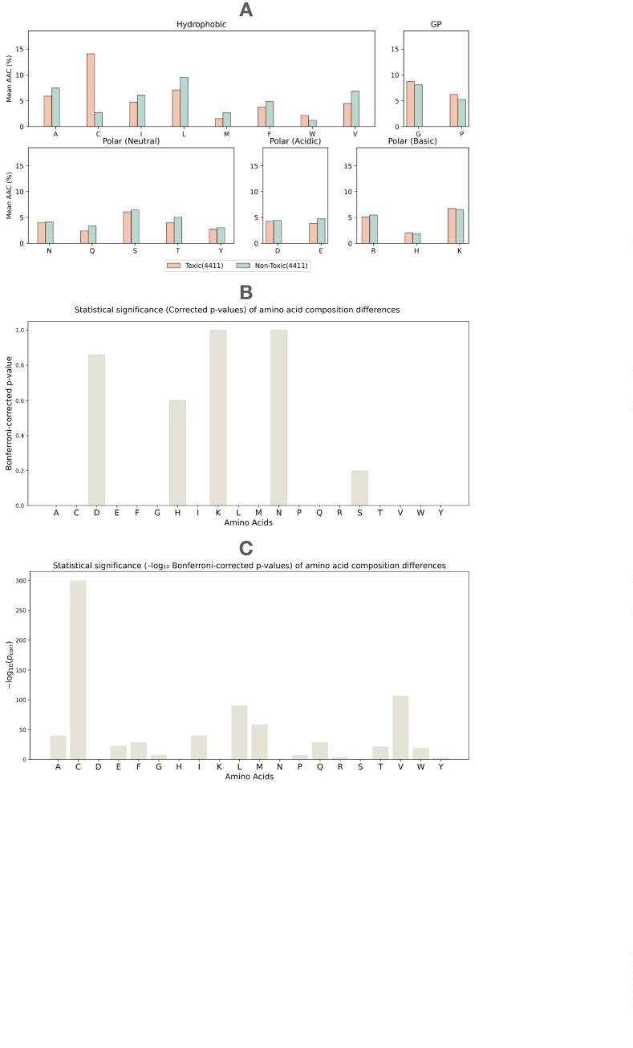

J. Guan, P. Xie, D. Meng et al.
Computational and Structural Biotechnology Journal 27 (2025) 2347–2358
Fig. 3. Performance comparison with machine learning and deep learning baseline models. Panels A–C present radar plots comparing the proposed model ToxiPep
with three categories of baseline methods: (A) machine learning models using handcrafted features, (B) deep learning architectures trained on one-hot encoded
sequences, and (C) pretrained protein language models.
Table 2
Performance comparison with existing methods on testing datasets, which includes multiple evaluation metrics and sta-
tistical signiﬁcance tests under diﬀerent CD-HIT thresholds.
CD-HIT Threshold Method
ToxinPred2(RF)
Accuracy Sensitivity Speciﬁcity MCC
Paired ꢈ-test ꢜ
Wilcoxon ꢜ
0.596
0.974
0.975
0.062
0.680
0.827
0.217
0.264
0.949
0.909
0.873
0.293
0.340
0.025
0.605
0.701
<0.001
<0.001
<0.001
<0.001
–
<0.001
<0.001
<0.001
<0.001
–
ToxinPred2(Hybrid) 0.619
0
.9
.8
CSM-Toxin
PepNet
0.506
0.794
0.850
ToxiPep
ToxinPred2(RF)
0.598
0.977
0.980
0.048
0.684
0.826
0.219
0.269
0.950
0.899
0.854
0.300
0.354
<0.001
<0.001
<0.001
<0.001
<0.001
–
ToxinPred2(Hybrid) 0.625
<0.001
0
CSM-Toxin
PepNet
0.499
0.792
0.840
-0.007 <0.001
0.598
0.680
<0.001
ToxiPep
–
Table 3
Performance comparison with ToxinPred3 on testing datasets after removing overlapping data, which includes multiple
evaluation metrics and statistical signiﬁcance tests under diﬀerent CD-HIT thresholds.
CD-HIT Threshold Method
Accuracy Sensitivity Speciﬁcity MCC
Paired ꢈ-test ꢜ
0.654 <0.001
0.532 <0.001
0.769
Wilcoxon ꢜ
<0.001
<0.001
–
ToxinPred3(ML)
0.827
0.845
0.568
0.879
0.810
0.927
0.890
0.9
ToxinPred3(Hybrid) 0.750
ToxiPep
0.885
0.817
–
ToxinPred3(ML)
0.835
0.505
0.854
0.800
0.902
0.847
0.635 <0.001
<0.001
<0.001
–
0.8
ToxinPred3(Hybrid) 0.708
0.445 <0.001
ToxiPep
0.850
0.701
–
an MCC of 0.635, and ToxinPred3(Hybrid) with an accuracy of 0.708
and an MCC of 0.445.
each baseline under both the internal and independent test sets. All tests
resulted in -values below 0.001, indicating that the performance im-
ꢉ
To further evaluate generalization capability, all models were as-
sessed on an independent test set. As summarized in Table S5, ToxiPep
shows higher accuracy and MCC across both CD-HIT thresholds com-
pared to all baseline methods. In contrast, models such as PepNet and
ToxinPred2(Hybrid) yield substantially lower values across the same
metrics. Furthermore, Table S6 presents results on the independent test
set after excluding sequences overlapping with the training data of Tox-
inPred3. In this setting, ToxiPep achieves an accuracy of up to 0.828
and an MCC of 0.578, again exceeding the performance of both Toxin-
Pred3(ML) and ToxinPred3(Hybrid). These ﬁndings support the general-
ization capacity of ToxiPep across non-redundant and externally sourced
data.
provements observed for ToxiPep are statistically signiﬁcant.
The superior performance of our model can be attributed to two key
factors: First, we integrated context-aware features and atomic-level fea-
tures, providing a multidimensional representation of protein sequence
order and chemical properties. Second, we employed a cross-attention
mechanism to fuse sequence and structure features, eﬀectively capturing
and integrating complementary information between these two feature
types.
3.3. Ablation study reveals the importance of cross-attention and
multi-modal fusion
To quantify the statistical signiﬁcance of these performance diﬀer-
ences, we conducted paired t-tests and Wilcoxon tests across evaluation
metrics [71,72]. Comparisons were performed between ToxiPep and
To evaluate the contribution of each module in our framework, we
conducted an ablation study using the dataset clustered at a CD-HIT
threshold of 0.9. This study included diﬀerent feature extraction and
2
352
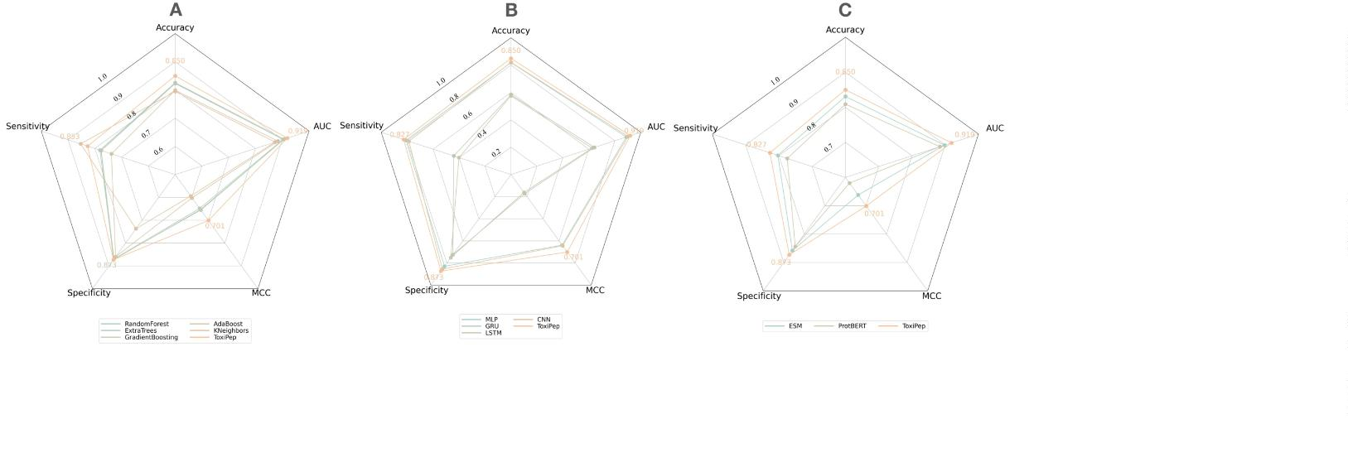

J. Guan, P. Xie, D. Meng et al.
Computational and Structural Biotechnology Journal 27 (2025) 2347–2358
Fig. 4. Performance comparison in ablation analysis. (A) and (B) Performance of ToxiPep compared with diﬀerent ablation models, including Transformer, GRU +
Transformer, Atomic-level graph with multi-scale CNN, Concatenation fusion, and Late fusion.
fusion strategies, comprising Transformer alone, GRU combined with
Transformer, atomic-level graph with multi-scale CNN, as well as two
commonly used fusion methods: feature concatenation and late fusion.
The results are presented in Fig. 4 and Table S7.
structures in the embedding space. The corresponding silhouette scores
range from 0.32 to 0.34, indicating an improvement in class separation
due to the modeling of sequential dependencies. Similarly, the output
of atomic-level graph encoding via Multi-scale CNN (Fig. 5 D and Fig-
ure S2 D) demonstrates more distinct clusters, suggesting that structural
features are also informative for classiﬁcation. However, due to the in-
herent complexity of molecular graph topology at the atomic level, the
projections are more dispersed. The silhouette scores remain within the
0.32–0.34 range across seeds, consistent with sequence-based modeling.
By concatenating sequence and structure-based features (Fig. 5 E and
Figure S2 E), the separation between classes further improves. However,
the projections tend to align along speciﬁc dimensions, forming thin,
partially overlapping lines, which indicates a lack of deep integration
between the two modalities. The silhouette scores rise slightly, ﬂuctu-
ating between 0.41 and 0.43.
It is observed that the addition of GRU after the Transformer mod-
ule leads to consistent improvements in classiﬁcation performance. The
Transformer model produces an accuracy of 0.788 and an MCC of 0.577,
while the GRU-enhanced model achieves an accuracy of 0.816 and an
MCC of 0.632. This suggests that incorporating contextual dependencies
into sequence representation contributes positively to predictive perfor-
mance. Further improvements are observed when combining sequence
and structural features. The concatenation fusion model achieves an ac-
curacy of 0.837 and an MCC of 0.674, whereas the late fusion model
reaches an accuracy of 0.830 and an MCC of 0.660. These results indi-
cate the beneﬁt of integrating complementary information from multi-
ple modalities.
Finally, when applying a cross-attention mechanism to fuse sequence
and structural representations (Fig. 5 F and Figure S2 F), the UMAP visu-
alization reveals the clearest separation with moderate dispersion. This
suggests that cross-attention eﬀectively captures complementary infor-
mation between semantic and physicochemical features, enhancing the
model’s ability to discriminate toxic from non-toxic peptides. The silhou-
ette scores for this conﬁguration range from 0.42 to 0.45, representing
the highest clustering quality among all tested modules.
ToxiPep integrates sequence and structure representations through
a cross-attention mechanism. This design results in more balanced and
consistently higher values across evaluation metrics, with an accuracy
of 0.850, sensitivity of 0.827, speciﬁcity of 0.873, and MCC of 0.701.
This advantage is further reﬂected in the ROC analysis. As shown
in Fig. 4 B, ToxiPep achieves an AUC of 0.919, which is the high-
est among all compared models. The AUC scores for the fusion-based
models are 0.912 for concatenation fusion and 0.904 for late fusion.
Among the other baselines, GRU combined with Transformer yields an
AUC of 0.888, and the atomic-level graph with multi-scale CNN reaches
3.5. Residue-level interpretation of model predictions reveals features
relevant to peptide toxicity
0
.901. These results suggest that cross-attention facilitates more eﬀec-
tive modeling of the interactions between sequence-level semantics and
structural features.
To gain a deeper understanding of the key features learned by the
model in predicting toxic and non-toxic peptides, we conducted a multi-
faceted interpretability analysis.
3
.4. Representation space analysis demonstrates the eﬀectiveness of
First, the attention mechanism in the Transformer provided key in-
terpretability for the amino acids in peptide sequences. By visualizing
the attention weights of each amino acid, we identiﬁed which residues
the model focuses on more prominently. As shown in Fig. 6 A, for a rep-
resentative toxic peptide, amino acids such as S (Serine), I (Isoleucine),
C (Cysteine), and G (Glycine) exhibited signiﬁcantly higher attention
weights at speciﬁc positions in the sequence. This suggests that the
model tends to focus on these amino acids when capturing features as-
sociated with toxic peptides, which may be related to their chemical
properties and roles in toxicity-related functions.
cross-modal feature fusion
To comprehensively assess the classiﬁcation performance of the dif-
ferent modules and their advantages in feature representation, we em-
ployed Uniform Manifold Approximation and Projection (UMAP) to vi-
sualize how each model processes positive and negative samples [73].
To reduce the bias introduced by random initialization, UMAP was run
with multiple random seeds, and clustering quality was quantitatively
evaluated using silhouette scores [74], where higher scores indicate bet-
ter intra-class compactness and inter-class separation, and scores near
zero suggest overlapping or poorly separated clusters.
Second, through Class Activation Mapping (CAM) analysis [75],
which provides interpretability at the residue level, we visualized the
decision-making process of the CNN model. By generating heatmaps
with diﬀerent convolutional kernel sizes (Fig. 6 B–E), we observed the
model’s varying attention to speciﬁc amino acids and atoms across dif-
ferent scales. For instance, with smaller convolutional kernels (e.g.,
3×3), the model focuses more on local features, while larger kernels
(e.g., 9×9) capture more global patterns. This multi-scale analysis re-
As shown in Fig. 5 A–B and Figure S2 A-B, both the initial sequence
embedding and structural encoding appear relatively disordered and
mixed distributions, with silhouette scores consistently close to 0 across
random seeds. After applying the GRU+Transformer for context-aware
sequence modeling, the distinction between toxic and non-toxic pep-
tides becomes evident (Fig. 5 C and Figure S2 C), forming clearer linear
2
353
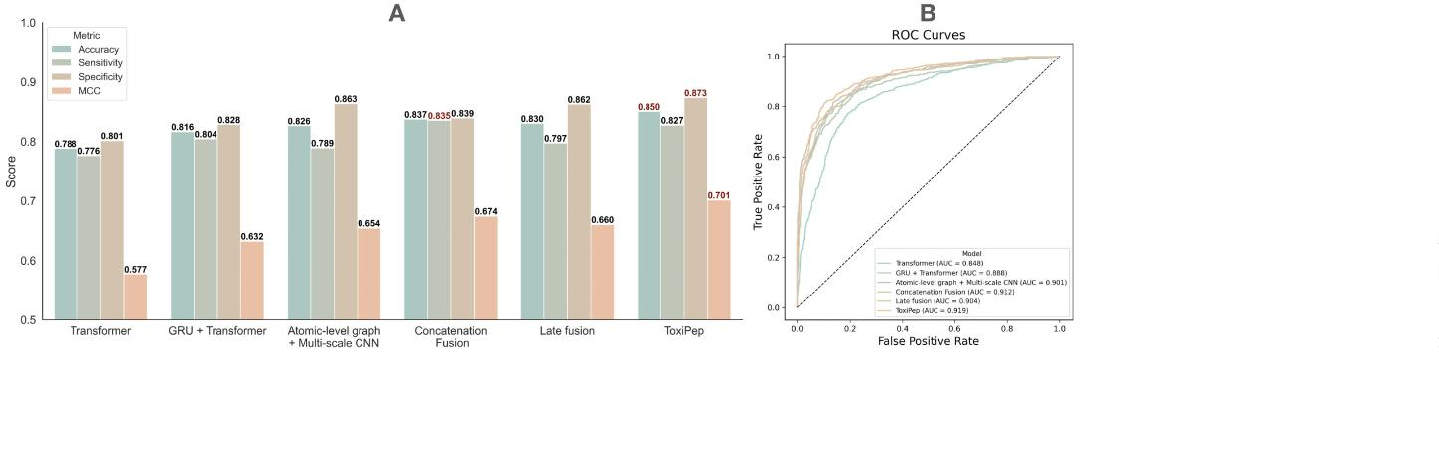

J. Guan, P. Xie, D. Meng et al.
Computational and Structural Biotechnology Journal 27 (2025) 2347–2358
Fig. 5. UMAP visualizations of feature representations derived from diﬀerent model modules under a single random seed. (A) Sequence embedding (silhouette =
0
.00). (B) Structural encoding (silhouette = 0.00). (C) Context-aware sequence processing (silhouette = 0.33). (D) Atomic-level graph processing (silhouette =
.34). (E) Without cross-attention fusion (silhouette = 0.41). (F) ToxiPep (silhouette = 0.44).
0
veals the model’s sensitivity to diﬀerent features and provides deeper
insights into its decision-making mechanism.
tural features for peptide toxicity prediction. ToxiPep demonstrated su-
perior performance over existing methods across multiple benchmark
datasets, achieving state-of-the-art accuracy and MCC scores. Inter-
pretability analysis further revealed the model’s ability to highlight key
amino acid residues and structural motifs associated with toxicity. To fa-
cilitate practical use, we have developed a web server that allows users
to rapidly assess the toxicity potential of peptides through an intuitive
online interface. This provides a scalable and user-friendly platform for
the early-stage screening of therapeutic peptides.
Finally, combining CAM with molecular structure analysis, we fur-
ther investigated the role of key amino acids in the model. As shown in
Fig. 6 F–I, the molecular structures of Serine, Isoleucine, Cysteine, and
Glycine were highlighted to emphasize their critical atoms. These analy-
ses indicate that the model not only focuses on speciﬁc amino acids, but
also on important atoms in their molecular structure. This interpretabil-
ity analysis helps further elucidate how the model captures features of
toxic peptides through speciﬁc atoms or chemical groups to make accu-
rate predictions.
Despite the promising results, several limitations should be acknowl-
edged. First, the current study focuses on algorithmic development and
benchmarking, and does not yet include experimental validation of
model predictions. Nonetheless, we recognize the critical role of in vitro
testing in conﬁrming peptide toxicity and reﬁning model outputs. In fu-
ture work, we plan to conduct cell-based viability assays on selected
peptides predicted by the model across nanomolar to micromolar con-
centrations [76]. Our goal is to identify candidates with a wide therapeu-
tic window and minimal oﬀ-target cytotoxicity [77,78]. These results
will not only help validate the practical utility of ToxiPep but also sup-
port iterative model improvement through data feedback.
In summary, these analyses show that the model can eﬀectively iden-
tify key amino acids and their molecular characteristics when predicting
toxic and non-toxic peptides, verifying its ability to capture diﬀerent
types of features.
3.6. ToxiPep web server for fast and accessible toxicity prediction
For user convenience, our framework is implemented as a user-
friendly web interface (Fig. 7), freely accessible at https://awi.cuhk.
edu.cn/~dbAMP/ToxiPep/. Users can start by clicking the “Start Pre-
diction” button, which opens a page to input peptide sequences directly
or upload a text ﬁle containing multiple sequences. Upon submission,
the system processes the input and displays the predicted toxicity re-
sults, including toxicity classiﬁcation and conﬁdence scores from the
model in an intuitive format. The web server is capable of predicting 10
peptide sequences in an average of 5.4 seconds and supports batch sub-
missions of up to 1,000 sequences, enabling eﬃcient high-throughput
analysis.
Second, our study focuses on binary classiﬁcation of peptides as toxic
or non-toxic, rather than estimating toxicity potency in a continuous
manner (e.g., IC values). The toxicity labels were assigned based on
5
0
curated annotations in established databases such as DRAMP4.0 and
dbAMP3.0, which reﬂect experimental observations or literature-based
classiﬁcation, rather than uniformly deﬁned potency thresholds. There-
fore, the model is not designed to predict or classify peptides based on
IC cutoﬀs.
5
0
Third, the peptides in our dataset were not screened using a standard-
ized experimental setup or cell line. Since the sequences were collected
from various sources, the original toxicity annotations are derived from
diverse biological contexts, organisms, and assay protocols. The absence
of a uniﬁed screening system may introduce latent biases, potentially fa-
voring certain cell types or assay conditions. We acknowledge that this
4
. Conclusion
In this study, we proposed ToxiPep, a deep learning framework that
integrates context-aware sequence embeddings with atomic-level struc-
2
354
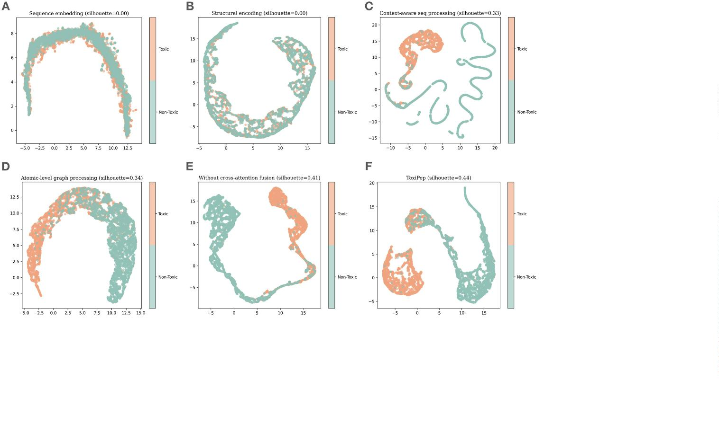

J. Guan, P. Xie, D. Meng et al.
Computational and Structural Biotechnology Journal 27 (2025) 2347–2358
Fig. 6. Interpretability analysis of the model in predicting toxic peptides. (A) Attention weights of amino acids in a representative toxic peptide sequence. (B–E)
Heatmaps generated by CAM analysis for CNN. (F–I) Molecular structure analysis of key amino acids.
Fig. 7. Demonstration of the ToxiPep web interface for peptide toxicity prediction. (1) Starting the Prediction: Users initiate the process by clicking the “Start
Prediction” button, which opens a dedicated page for sequence input. (2) Input protein sequence: On the new page, users can enter peptide sequences directly into
the text box or upload a ﬁle containing multiple sequences using the “Upload” button. This ﬂexible input option supports both single and batch predictions. (3)
Running the Prediction: After inputting the sequences, users click the “Start Prediction” button to submit them for analysis. (4) Results Panel: The results page
presents the prediction outcomes, including the toxicity classiﬁcation for each peptide and conﬁdence scores from the model, displayed in an intuitive format.
2
355
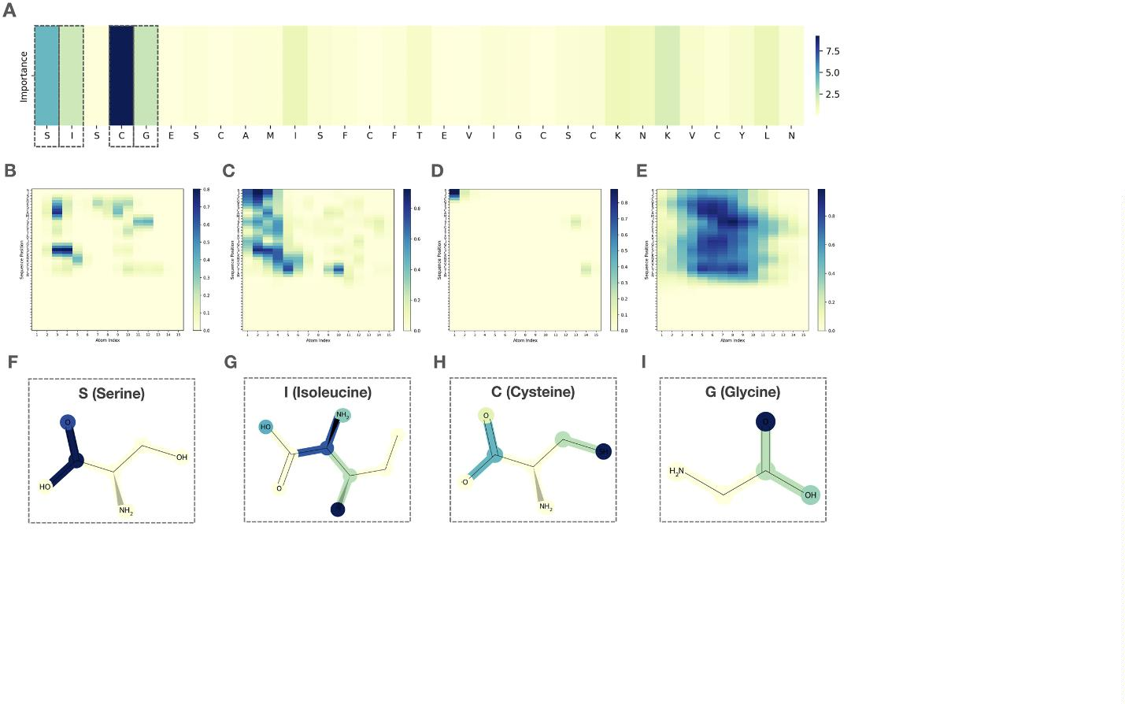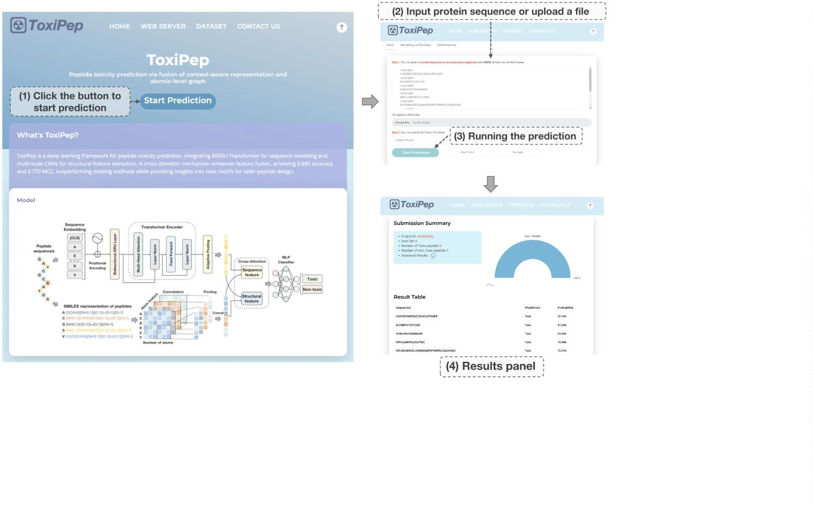

J. Guan, P. Xie, D. Meng et al.
Computational and Structural Biotechnology Journal 27 (2025) 2347–2358
heterogeneity limits the granularity and consistency of toxicity labels,
and future dataset reﬁnement using cell-speciﬁc or assay-speciﬁc anno-
tations may further improve model reliability.
in Taiwan and The National Health Research Institutes (NHRI-EX114-
11320BI) in Taiwan.
In addition, the modular nature of ToxiPep allows for potential ex-
tension beyond general toxicity prediction. One promising direction
is the identiﬁcation of peptides that bind to GM1 gangliosides, which
mediate cellular internalization via endocytic pathways [79]. Such pep-
tides may serve as Trojan horse vectors for blood–brain barrier (BBB)
crossing, a mechanism exploited by toxins such as Vibrio cholerae and
Bordetella pertussis [80]. With appropriate training data, our frame-
work could be adapted via transfer learning to support GM1-targeting
peptide design.
Declaration of competing interest
The authors have declared no conﬂict of interest.
Acknowledgements
The authors sincerely appreciate the Faculty of Dentistry, the Univer-
sity of Hong Kong, the “Center for intelligent Drug Systems and Smart
Biodevices” from The Featured Areas Research Center Program within
the framework of the Higher Education Sprout Project by the Ministry
of Education in Taiwan, and the Kobilka Institute of Innovative Drug
Discovery, The Chinese University of Hong Kong (Shenzhen).
In conclusion, ToxiPep oﬀers an accurate, interpretable, and ex-
tensible framework for peptide toxicity prediction. By integrating
multi-modal information through advanced representation learning, the
model provides a powerful tool for peptide safety assessment and lays
the foundation for future developments in therapeutic peptide discov-
ery, targeted delivery, and translational bioinformatics.
Appendix A. Supplementary material
Supplementary material related to this article can be found online at
https://doi.org/10.1016/j.csbj.2025.05.039.
5
. Key points
•
•
In this study, we developed a dual-model framework, ToxiPep, for
peptide toxicity prediction, integrating context-aware sequence rep-
resentations and atomic-level structural features.
Availability and implementation
Code and datasets of this study are available at https://github.com/
GGCL7/ToxiPep. Web server is available at https://awi.cuhk.edu.cn/
A cross-attention mechanism is employed to align and fuse sequence-
based and structural features, enhancing the model’s ability to cap-
ture complex interrelationships and improving predictive accuracy
and robustness.
~dbAMP/ToxiPep/.
References
•
•
Comprehensive evaluations reveal that ToxiPep outperforms exist-
ing methods in peptide toxicity prediction, achieving superior per-
formance across multiple metrics.
[
1] Craik David J, Fairlie David P, Liras Spiros, Price David. The future of peptide-based
drugs. Chem Biol Drug Des 2013;81(1):136–47.
Interpretability analyses demonstrate that the model can eﬀectively
identify key amino acids and their structural characteristics, pro-
viding valuable insights into the molecular mechanisms underlying
peptide toxicity.
[
2] Rastogi Shruti, Shukla Shatrunajay, Kalaivani M, Singh Gyanendra Nath. Peptide-
based therapeutics: quality speciﬁcations, regulatory considerations, and prospects.
Drug Discov Today 2019;24(1):148–62.
[3] Cicero Arrigo FG, Fogacci Federica, Colletti Alessandro. Potential role of bioactive
peptides in prevention and treatment of chronic diseases: a narrative review. Br J
Pharmacol 2017;174(11):1378–94.
•
We developed a web server to provide a user-friendly platform,
enabling researchers to conveniently utilize ToxiPep for peptide tox-
icity prediction.
[
[
[
4] Wagner Angela M, Gran Margaret P, Peppas Nicholas A. Designing the new gen-
eration of intelligent biocompatible carriers for protein and peptide delivery. Acta
Pharm Sin B 2018;8(2):147–64.
5] Haggag Yusuf A, Donia Ahmed A, Osman Mohamed A, El-Gizawy Sanaa A. Pep-
tides as drug candidates: limitations and recent development perspectives. Biomed
J 2018;1(3).
CRediT authorship contribution statement
Jiahui Guan: Methodology, Formal analysis, Data curation, Con-
ceptualization. Peilin Xie: Validation, Methodology, Formal analysis,
Data curation. Dian Meng: Validation, Formal analysis. Lantian Yao:
Supervision, Project administration. Dan Yu: Formal analysis. Ying-
Chih Chiang: Supervision, Project administration, Funding acquisition.
Tzong-Yi Lee: Supervision, Project administration, Funding acquisi-
tion. Junwen Wang: Supervision, Project administration, Methodology,
Funding acquisition.
6] Raﬀerty John, Nagaraj Hema, McCloskey Alice P, Huwaitat Rawan, Porter Si-
mon, Albadr Alyaa, et al. Peptide therapeutics and the pharmaceutical industry:
barriers encountered translating from the laboratory to patients. Curr Med Chem
2016;23(37):4231–59.
[
7] Wang Lei, Wang Nanxi, Zhang Wenping, Cheng Xurui, Yan Zhibin, Shao Gang, et al.
Therapeutic peptides: current applications and future directions. Signal Transduct
Targeted Ther 2022;7(1):48.
[8] Muttenthaler Markus, King Glenn F, Adams David J, Alewood Paul F. Trends in
peptide drug discovery. Nat Rev Drug Discov 2021;20(4):309–25.
[
9] Robles-Loaiza Alberto A, Pinos-Tamayo Edgar A, Mendes Bruno, Ortega-Pila Josse-
lyn A, Proaño-Bola nos Carolina, Plisson Fabien, et al. Traditional and computational
screening of non-toxic peptides and approaches to improving selectivity. Pharmaceu-
ticals 2022;15(3):323.
Funding
The work was funded by collaborative research fund of Hong Kong
RGC (C7015-23G), seed funding for collaborative research (2207101590)
from the University of Hong Kong to J Wang. This work was sup-
ported by Shenzhen Science and Technology Innovation Commission
(JCYJ20230807114206014), Guangdong Province Basic and Applied
Basic Research Fund (2025A1515011753), and the Kobilka Institute
of Innovative Drug Discovery, The Chinese University of Hong Kong,
Shenzhen, China. This work was also ﬁnancially supported by the Cen-
ter for Intelligent Drug Systems and Smart Biodevices (IDS2B) from
The Featured Areas Research Center Program within the framework of
the Higher Education Sprout Project and Yushan Young Fellow Pro-
gram (114C51N039) by the Ministry of Education (MOE) and National
Science and Technology Council (NSTC 113-2321-B-A49-025, 114-
[10] Marquis Bryce J, Love Sara A, Braun Katherine L, Haynes Christy L. Analytical meth-
ods to assess nanoparticle toxicity. Analyst 2009;134(3):425–39.
[
11] Markides Han, Rotherham M, El Haj AJ. Biocompatibility and toxicity of magnetic
nanoparticles in regenerative medicine. J Nanomater 2012;2012(1):614094.
[
12] Greco Ines, Molchanova Natalia, Holmedal Elin, Jenssen Håvard, Hummel Bernard
D, Watts Jeﬀrey L, et al. Correlation between hemolytic activity, cytotoxicity and sys-
temic in vivo toxicity of synthetic antimicrobial peptides. Sci Rep 2020;10(1):13206.
13] Chi Yulang, Peng Yunhui, Zhang Shikun, Tang Sijia, Zhang Wenzhou, Dai Congjie,
et al. A rapid in vivo toxicity assessment method for antimicrobial peptides. Toxics
[
[
[
2024;12(6):387.
14] Wu Xinyi, Lin Huitian, Bai Renren, Duan Hongliang. Deep learning for advancing
peptide drug development: tools and methods in structure prediction and design.
Eur J Med Chem 2024:116262.
15] Sangaraju Vinoth Kumar, Pham Nhat Truong, Wei Leyi, Yu Xue, Manavalan Bal-
achandran. Macppred 2.0: stacked deep learning for anticancer peptide predic-
tion with integrated spatial and probabilistic feature representations. J Mol Biol
2024;436(17):168687.
2
634-F-039-001, 113-2221-E-A49-160-MY3 and 112-2740-B-400-005)
2
356

J. Guan, P. Xie, D. Meng et al.
Computational and Structural Biotechnology Journal 27 (2025) 2347–2358
[
[
[
16] Altschul Stephen F, Madden Thomas L, Schäﬀer Alejandro A, Zhang Jinghui,
Zhang Zheng, Miller Webb, et al. Gapped blast and psi-blast: a new generation of
protein database search programs. Nucleic Acids Res 1997;25(17):3389–402.
17] Negi Surendra S, Schein Catherine H, Ladics Gregory S, Mirsky Henry, Chang Peter,
Rascle Jean-Baptiste, et al. Functional classiﬁcation of protein toxins as a basis for
bioinformatic screening. Sci Rep 2017;7(1):13940.
[44] Liu Bin, Gao Xin, Zhang Hanyu. Bioseq-analysis2. 0: an updated platform for ana-
lyzing dna, rna and protein sequences at sequence level and residue level based on
machine learning approaches. Nucleic Acids Res 2019;47(20):e127.
[45] Nambiar Ananthan, Heﬂin Maeve, Liu Simon, Maslov Sergei, Hopkins Mark,
Ritz Anna. Transforming the language of life: transformer neural networks for pro-
tein prediction tasks. In: Proceedings of the 11th ACM international conference on
bioinformatics, computational biology and health informatics; 2020. p. 1–8.
[46] Wang Ding, Jin Junru, Li Zhongshen, Wang Yu, Fan Mushuang, Liang Sirui, et al.
Structuraldppiv: a novel deep learning model based on atom structure for predicting
dipeptidyl peptidase-iv inhibitory peptides. Bioinformatics 2024;40(2):btae057.
18] Vishnoi Shubham, Matre Himani, Garg Prabha, Pandey Shubham Kumar. Artiﬁcial
intelligence and machine learning for protein toxicity prediction using proteomics
data. Chem Biol Drug Des 2020;96(3):902–20.
[
[
[
19] Rezaee Khosro, Eslami Hossein. Bridging machine learning and peptide design for
cancer treatment: a comprehensive review. Artif Intell Rev 2025;58(5):1–59.
20] Naamati Guy, Askenazi Manor, Linial Michal. Clantox: a classiﬁer of short animal
toxins. Nucleic Acids Res 2009;37(suppl_2):W363–8.
[
[
[
47] Capecchi Alice, Reymond Jean-Louis. Peptides in chemical space. Med Drug Discov
2021;9:100081.
48] Landrum Greg, et al. Rdkit: A software suite for cheminformatics, computational
chemistry, and predictive modeling. Greg Landrum, 2013;8(31.10):5281.
49] Akdel Mehmet, Pires Douglas EV, Pardo Eduard Porta, Jänes Jürgen, Zalevsky Arthur
O, Mészáros Bálint, et al. A structural biology community assessment of alphafold2
applications. Nat Struct Mol Biol 2022;29(11):1056–67.
21] Gupta Sudheer, Kapoor Pallavi, Chaudhary Kumardeep, Gautam Ankur, Ku-
mar Rahul, Open Source Drug Discovery Consortium, et al. In silico approach for
predicting toxicity of peptides and proteins. PLoS ONE 2013;8(9):e73957.
22] Wei Lesong, Ye Xiucai, Xue Yuyang, Sakurai Tetsuya, Wei Leyi. Atse: a peptide toxi-
city predictor by exploiting structural and evolutionary information based on graph
neural network and attention mechanism. Brief Bioinform 2021;22(5):bbab041.
23] Pan Xiaoyong, Zuallaert Jasper, Wang Xi, Shen Hong-Bin, Campos Elda Posada,
Marushchak Denys O, et al. Toxdl: deep learning using primary structure and domain
embeddings for assessing protein toxicity. Bioinformatics 2020;36(21):5159–68.
24] Jiao Shihu, Ye Xiucai, Sakurai Tetsuya, Zou Quan, Liu Ruijun. Integrated convo-
lution and self-attention for improving peptide toxicity prediction. Bioinformatics
[
[
[
[
[
[
50] Duvenaud David K, Maclaurin Dougal, Iparraguirre Jorge, Bombarell Rafael,
Hirzel Timothy, Aspuru-Guzik Alán, et al. Convolutional networks on graphs for
learning molecular ﬁngerprints. Adv Neural Inf Process Syst 2015;28.
51] Yang Kevin, Swanson Kyle, Jin Wengong, Coley Connor, Eiden Philipp, Gao Hua, et
al. Analyzing learned molecular representations for property prediction. J Chem Inf
Model 2019;59(8):3370–88.
[
[
52] Li Hui, Wu Xiao-Jun. Crossfuse: a novel cross attention mechanism based infrared
and visible image fusion approach. Inf Fusion 2024;103:102147.
2024;40(5):btae297.
[
53] Liu Tianyuan, Huang Junyang, Luo Delun, Ren Liping, Ning Lin, Huang Jian, et
al. Cm-sirpred: predicting chemically modiﬁed sirna eﬃciency based on multi-view
learning strategy. Int J Biol Macromol 2024;264:130638.
25] Rathore Anand Singh, Choudhury Shubham, Arora Akanksha, Tijare Purva,
Raghava Gajendra PS. Toxinpred 3.0: an improved method for predicting the toxicity
of peptides. Comput Biol Med 2024;179:108926.
[54] Chicco Davide, Jurman Giuseppe. The advantages of the Matthews correlation co-
eﬃcient (mcc) over f1 score and accuracy in binary classiﬁcation evaluation. BMC
Genomics 2020;21:1–13.
26] Papagianni Maria. Ribosomally synthesized peptides with antimicrobial prop-
erties: biosynthesis, structure, function, and applications. Biotechnol Adv
2003;21(6):465–99.
[55] Dunn Olive Jean. Multiple comparisons among means.
J
Am Stat Assoc
[
[
[
27] Sitaram Narasimhaiah, Nagaraj Ramakrishnan. Host-defense antimicrobial peptides:
1961;56(293):52–64.
importance of structure for activity. Curr Pharm Des 2002;8(9):727–42.
[
56] Wilcoxon Frank. Individual comparisons by ranking methods. In: Breakthroughs in
statistics: methodology and distribution. Springer; 1992. p. 196–202.
28] Powers Jon-Paul S, Hancock Robert EW. The relationship between peptide structure
and antibacterial activity. Peptides 2003;24(11):1681–91.
[57] Armstrong Richard A. When to use the Bonferroni correction. Ophthalmic Physiol
Opt 2014;34(5):502–8.
29] Feijoo-Coronel Marcia L, Mendes Bruno, Ramírez David, Peña-Varas Carlos, de Los
Monteros-Silva Nina QE, Proaño-Bola nos Carolina, et al. Antibacterial and antiviral
properties of chenopodin-derived synthetic peptides. Antibiotics 2024;13(1):78.
30] Mendes Bruno, Edwards-Gayle Charlotte, Barrett Glyn. Peptide lipidation and
shortening optimises antibacterial, antibioﬁlm and membranolytic actions of
an amphiphilic polylysine-polyphenyalanine octapeptide. Curr Res Biotechnol
[58] Heskes Tom, Eisinga Rob, Breitling Rainer. A fast algorithm for determining bounds
and accurate approximate p-values of the rank product statistic for replicate experi-
ments. BMC Bioinform 2014;15:1–11.
[
[59] Yao Lantian, Guan Jiahui, Li Wenshuo, Chung Chia-Ru, Deng Junyang, Chiang Ying-
Chih, et al. Identifying antitubercular peptides via deep forest architecture with
eﬀective feature representation. Anal Chem 2024;96(4):1538–46.
2024;8:100240.
[31] Ma Tianyue, Liu Yanchao, Yu Bingxin, Sun Xin, Yao Huiyuan, Hao Chen, et al. Dramp
[60] Chang Kuan Y, Yang Je-Ruei. Analysis and prediction of highly eﬀective antiviral
peptides based on random forests. PLoS ONE 2013;8(8):e70166.
4
.0: an open-access data repository dedicated to the clinical translation of antimi-
crobial peptides. Nucleic Acids Res 2024:gkae1046.
[61] Guan Jiahui, Yao Lantian, Chung Chia-Ru, Chiang Ying-Chih, Lee Tzong-Yi. Stackth-
pred: identifying tumor-homing peptides through gbdt-based feature selection with
stacking ensemble architecture. Int J Mol Sci 2023;24(12):10348.
[
32] Yao Lantian, Guan Jiahui, Xie Peilin, Chung Chia-Ru, Zhao Zhihao, Dong Danhong, et
al. Dbamp 3.0: updated resource of antimicrobial activity and structural annotation
of peptides in the post-pandemic era. Nucleic Acids Res 2024:gkae1019.
33] UniProt Consortium. Uniprot: a worldwide hub of protein knowledge. Nucleic Acids
Res 2019;47(D1):D506–15.
[
[
[
[
[
[
[
62] Bhattarai Sadik, Kim Kyu-Sik, Tayara Hilal, Chong Kil To. Acp-ada: a boosting
method with data augmentation for improved prediction of anticancer peptides. Int
J Mol Sci 2022;23(20):12194.
[
[
63] Zhang Wenyu, Ding Yijie, Wei Leyi, Guo Xiaoyi, Ni Fengming. Therapeutic pep-
tides identiﬁcation via kernel risk sensitive loss-based k-nearest neighbor model and
multi-laplacian regularization. Brief Bioinform 2024;25(6):bbae534.
34] Boeckmann Brigitte, Bairoch Amos, Apweiler Rolf, Blatter Marie-Claude, Estre-
icher Anne, Gasteiger Elisabeth, et al. The Swiss-prot protein knowledgebase and
its supplement trembl in 2003. Nucleic Acids Res 2003;31(1):365–70.
35] Li Weizhong, Godzik Adam. Cd-hit: a fast program for clustering and comparing
large sets of protein or nucleotide sequences. Bioinformatics 2006;22(13):1658–9.
36] Veltri Daniel, Kamath Uday, Shehu Amarda. Deep learning improves antimicrobial
peptide recognition. Bioinformatics 2018;34(16):2740–7.
64] Yang Xuetong, Jin Junru, Wang Ruheng, Li Zhongshen, Wang Yu, Wei Leyi. Cacpp:
a contrastive learning-based Siamese network to identify anticancer peptides based
on sequence only. J Chem Inf Model 2023;64(7):2807–16.
[
[
[
65] Zhang Xin, Wei Lesong, Ye Xiucai, Zhang Kai, Teng Saisai, Li Zhongshen, et al.
Siamesecpp: a sequence-based Siamese network to predict cell-penetrating peptides
by contrastive learning. Brief Bioinform 2023;24(1):bbac545.
37] Li Jiawei, Pu Yuqian, Tang Jijun, Zou Quan, Guo Fei. Deepavp: a dual-channel deep
neural network for identifying variable-length antiviral peptides. IEEE J Biomed
Health Inform 2020;24(10):3012–9.
66] Lin Zeming, Akin Halil, Rao Roshan, Hie Brian, Zhu Zhongkai, Lu Wenting, et
al. Evolutionary-scale prediction of atomic-level protein structure with a language
model. Science 2023;379(6637):1123–30.
[
[
[
38] Berger Bonnie, Waterman Michael S, Yu Yun William. Levenshtein distance,
sequence comparison and biological database search. IEEE Trans Inf Theory
67] Elnaggar Ahmed, Heinzinger Michael, Dallago Christian, Rehawi Ghalia, Wang Yu,
Jones Llion, et al. Prottrans: toward understanding the language of life through self-
supervised learning. IEEE Trans Pattern Anal Mach Intell 2021;44(10):7112–27.
68] Sharma Neelam, Naorem Leimarembi Devi, Jain Shipra, Raghava Gajendra PS. Tox-
inpred2: an improved method for predicting toxicity of proteins. Brief Bioinform
2
020;67(6):3287–94.
39] Yu Zilan, Jiang Mengnan, Lan Xun. Heterotcr:
a
heterogeneous graph neu-
ral network-based method for predicting peptide-tcr interaction. Commun Biol
2024;7(1):684.
40] Pirtskhalava Malak, Amstrong Anthony A, Grigolava Maia, Chubinidze Mindia, Al-
imbarashvili Evgenia, Vishnepolsky Boris, et al. Dbaasp v3: database of antimicro-
bial/cytotoxic activity and structure of peptides as a resource for development of
new therapeutics. Nucleic Acids Res 2021;49(D1):D288–97.
2022;23(5):bbac174.
[
69] Morozov Vladimir, Rodrigues Carlos HM, Ascher David B. Csm-toxin: a web-server
for predicting protein toxicity. Pharmaceutics 2023;15(2):431.
[
70] Han Jiyun, Kong Tongxin, Liu Juntao. Pepnet: an interpretable neural network for
anti-inﬂammatory and antimicrobial peptides prediction using a pre-trained protein
language model. Commun Biol 2024;7(1):1198.
[
[
[
41] Gautam Ankur, Chaudhary Kumardeep, Singh Sandeep, Joshi Anshika, Anand Priya,
Tuknait Abhishek, et al. Hemolytik:
a
database of experimentally determined
hemolytic and non-hemolytic peptides. Nucleic Acids Res 2014;42(D1):D444–9.
42] Rathore Anand Singh, Kumar Nishant, Choudhury Shubham, Mehta Naman Kumar,
Raghava Gajendra PS. Prediction of hemolytic peptides and their hemolytic concen-
tration. Commun Biol 2025;8(1):176.
[71] Demšar Janez. Statistical comparisons of classiﬁers over multiple data sets. J Mach
Learn Res Jan 2006;7:1–30.
[72] Dietterich Thomas G. Approximate statistical tests for comparing supervised classi-
ﬁcation learning algorithms. Neural Comput 1998;10(7):1895–923.
[73] McInnes Leland, Healy John, Melville James. Umap: uniform manifold approxi-
mation and projection for dimension reduction. arXiv preprint. arXiv:1802.03426,
2018.
43] Su Jianlin, Ahmed Murtadha, Lu Yu, Pan Shengfeng, Bo Wen, Liu Yunfeng. Ro-
former: enhanced transformer with rotary position embedding. Neurocomputing
2024;568:127063.
2
357

J. Guan, P. Xie, D. Meng et al.
Computational and Structural Biotechnology Journal 27 (2025) 2347–2358
[
74] Rousseeuw Peter J. Silhouettes: a graphical aid to the interpretation and validation
of cluster analysis. J Comput Appl Math 1987;20:53–65.
[78] Wang Qifei, Yang Junlin, Xing Malcolm, Li Bingyun. Antimicrobial peptide identiﬁed
via machine learning presents both potent antibacterial properties and low toxicity
toward human cells. Microorganisms 2024;12(8):1682.
[
75] Zhou Bolei, Khosla Aditya, Lapedriza Agata, Oliva Aude, Torralba Antonio. Learning
deep features for discriminative localization. In: Proceedings of the IEEE conference
on computer vision and pattern recognition; 2016. p. 2921–9.
[79] Georgieva Julia V, Hoekstra Dick, Zuhorn Inge S. Smuggling drugs into the brain: an
overview of ligands targeting transcytosis for drug delivery across the blood–brain
barrier. Pharmaceutics 2014;6(4):557–83.
[
76] Malinowski Piotr, Skała Klaudia, Jabłońska-Trypuć Agata, Koronkiewicz Agata,
Wołejko Elżbieta, Wydro Urszula, et al. Comparison of the usefulness of mtt and
celltiterglo tests applied for cytotoxicity evaluation of compounds from the group of
polyphenols. Proc Environ Sci 2022;18(1):9.
[80] Chen Yan, Liu Lihong. Modern methods for delivery of drugs across the blood–brain
barrier. Adv Drug Deliv Rev 2012;64(7):640–65.
[77] Peternel Luka, Kotnik Miha, Preželj Andrej, Urleb Uroš. Comparison of 3 cytotoxicity
screening assays and their application to the selection of novel antibacterial hits.
SLAS Discov 2009;14(2):142–50.
2
358

