Level 1

addXvaluesExactCrossings.m
3 tests as shown in Figure 1.
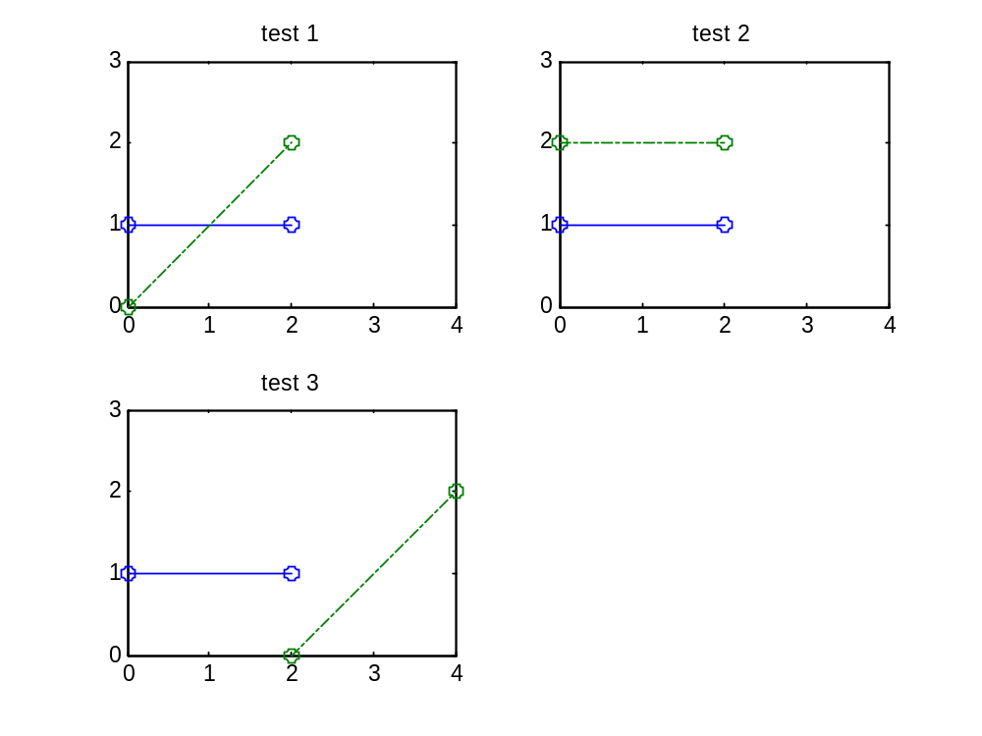
Figure 1 Tests for addXvaluesExactCrossings.m

findCrossings.m
For 3 tests as shown in Figure 1, test both options for ‘flag’:
- 'synchronizegrids' add crossings and synchronize grids
- 'keeporiginalgrid' add crossings only

roundoff.m
rounding π at -1:1:5 digits
test ‘floor’ and ‘ceil’ functionalities

getCumVolume.m
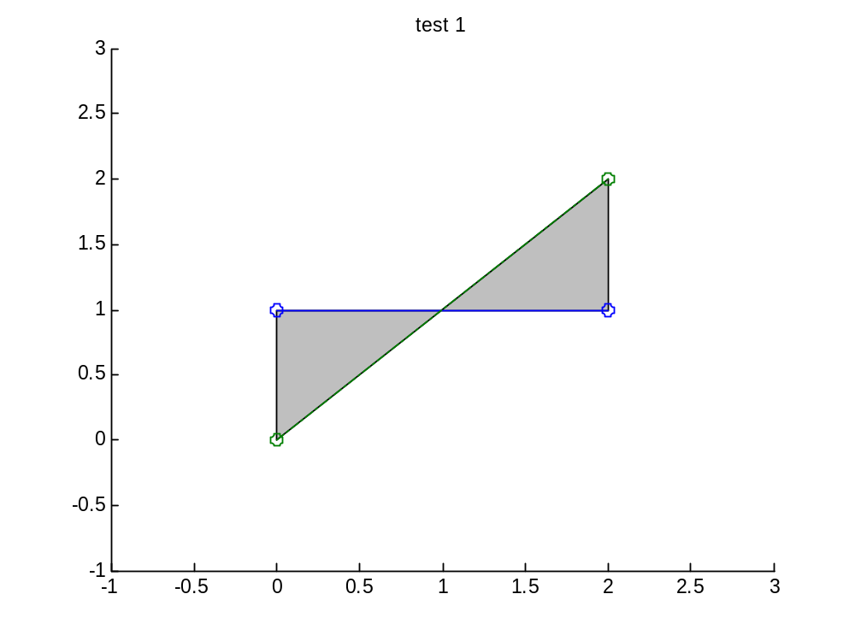
Figure 2 Test for getCumVolume.m
The cumulative volume of the patch in Figure 2 should be zero.

getFallVelocity.m
- coefficients a,b,c default and D50 = 150:25:300 µm
- several values for coefficients a,b,c

getG.m
- Bend = 1:5:26
input => output

getBoundaryProfile.m
input => ouput (eventually plot)

defaultDESettings.m
No test

createEmptyDurosResult.m
No test

getParabolicProfile.m
- derive xmax (input argument x = [])
- plot parabolic profile of old routine together with the new ones
- volume under parabolic profile as function of the number of gridpoints, to show the validity of our choise for a minimum dx of 1/20 of the horizontal length of the parabolic part.

getVolumeCorrection
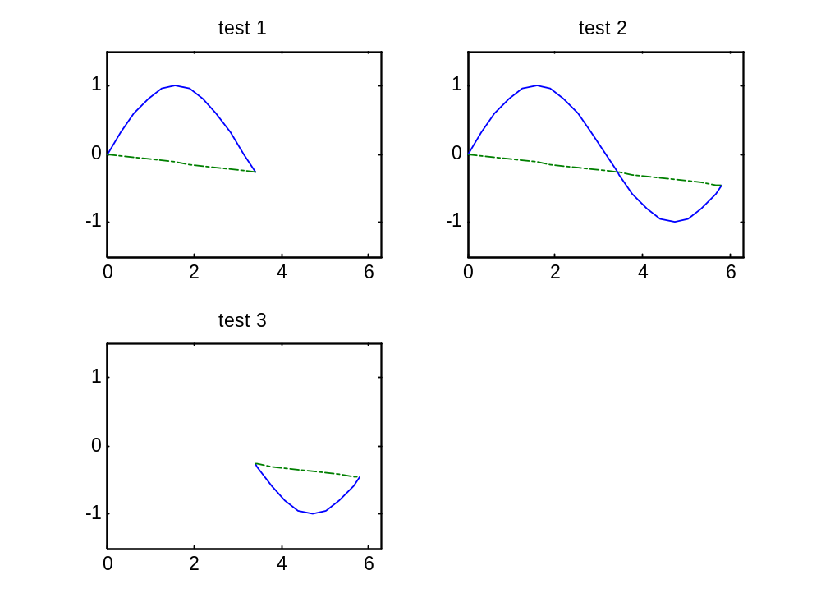
Figure 3 Test for getVolumeCorrection.m
- test 1 should result in: volume = 0
- test 2 should only erode a part of the big hump
- test 3 should determine the total volume between the two profiles

Level 2

getIterationBoundaries
- Normal situation with standard (simplified) cross-shore profile
- Situation with total profile below water level
- Message about the ‘reason’ of the boundary
  - Landward, based on:
    - crossing of lowest point of parabolic profile with initial profile
    - ‘raakpunt’ of parabolic profile with initial profile
    - the lack of data at landward side
  - Seaward, based on:
    - crossing of highest point of parabolic profile with initial profile
    - 1:12.5 slope, i.e. non-erodible channel slope
    - the lack of data at seaward side

getSteeppoints.m
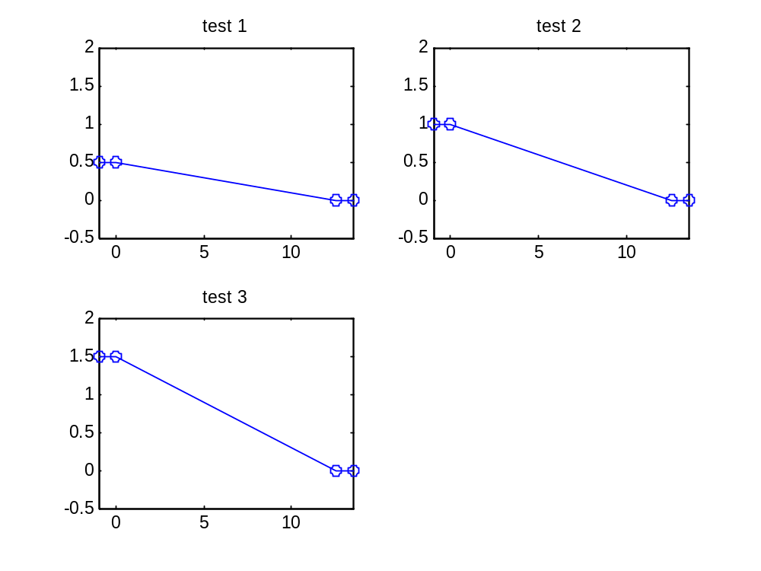
Figure 4 Tests for getSteeppoints.m
For gradmax = -1/12,5
- test 1: no steep point
- test 2: steep point
- test 3: steep point
- plot a ‘real’ profile with 1 or more steep points

getVolume.m
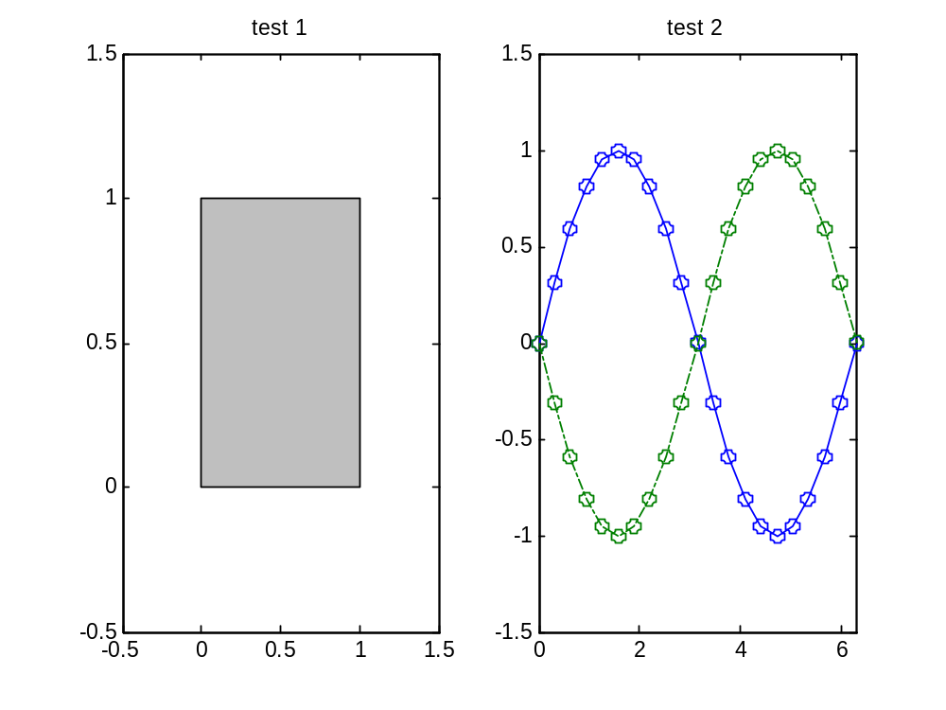
Figure 5 Tests for getVolume.m
- test 1: should result in volume = 1
- test 2: erosion volume should be equal to accretion, volume should be 0
- run getVolume with a ‘real’ profile without defining the boundaries, check whether these are OK

getDurosProfile.m
plot initial profile together with DUROS profile for:
- complete profile, consisting of 1:1 dune face, parabolic part, and 1:12.5 toe slope
- situation without toe slope
- situation without dune face
- situation with only parabolic part

Level 3

getDuneErosion_additional.m
Make plot and show the precision for:
- Normal situation where additional volume easily fits (precision should be sufficient)
- Situation with more than 1 dune row (exeptions occur)
- Situation where the volume does not fit

fitBoundaryProfile.m
Similar tests like in getDuneErosion_additional

DuneErosionSettings.m
Test the ‘get’ functionality for the logicals

optimiseDUROS.m
- Standard (simplified) cross-shore profile
- Channel / no channel (plot)
- Volume correction / no volume correction (plot, check difference)
- ‘Virtual erosion point’, dune breach

Level 4

getDuneErosion
Dealing with errors

