Directory structure
1. Use Right Click → Tortoise SVN → Repo-browser to browse the repository

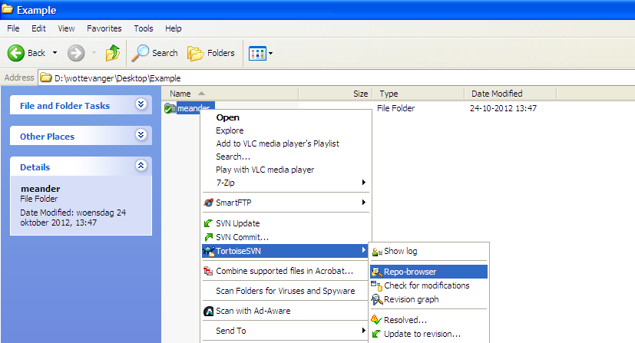
2. We have created the following directory structure
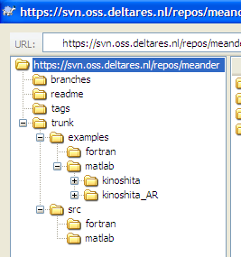
The trunk is the main line of development in a SVN repository.
The readme contains some useful information related to the code as well as the repository.
A branch is a side-line of development created to make larger, experimental or disrupting work without annoying users of the trunk version. Also, branches can be used to create development lines for multiple versions of the same product, like having a place to backport bugfixes into a stable release.
Finally, tags are markers to highlight notable revisions in the history of the repository, usually things like "this was released as 1.0".
In the trunk directory we have two sub directories examples and src.
The src contains the source code and the examples contains some examples for running the source code.

The folders matlab are for matlab source and examples whereas the fortran folders are for the combined BERM and non-linear flow model and the example files.

matlab/kinoshita contains the hydrodynamic simulation for the Kinoshita flume, matlab/kinoshita_AR contains the combined hydro-morphodynamic simulation for the Kinoshita flume. You may experiment with the variable approxlev to test the degree to which you want to account for the non-linear bed adaptation equation.

For more information contact:

Willem Ottevanger: w.ottevanger@tudelft.nl
Dong Chen: dchen@igsnrr.ac.cn
Yun Zhang: zyaj@stanford.edu
…

