Downloading the source code
1. Create a folder “meander”
2. Install the a subversion client (e.g. http://tortoisesvn.net/ is the one I work with, so therefore the guide will be based on that)
3. Right click on the folder “meander” and goto SVN Checkout …

You will probably be asked to log in. In this case supply your username and password.

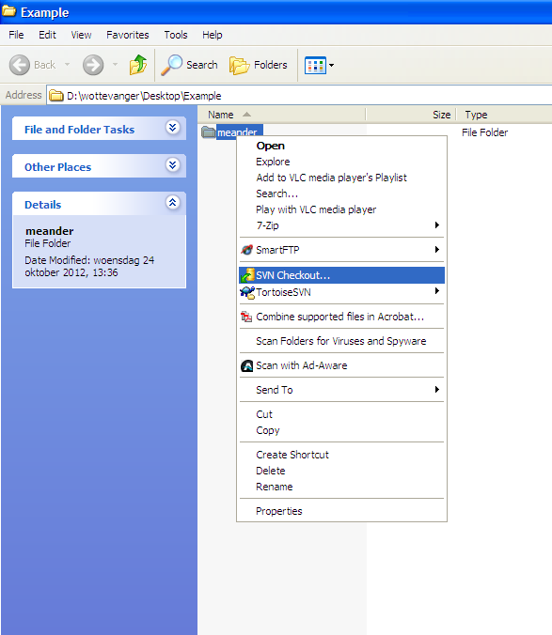

4. Enter the URL of repository “https://svn.oss.deltares.nl/repos/meander” .
Checout directory : “(your path)\meander”
Click OK
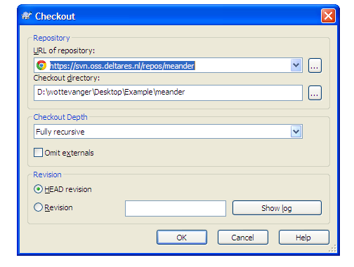

5. Download starts 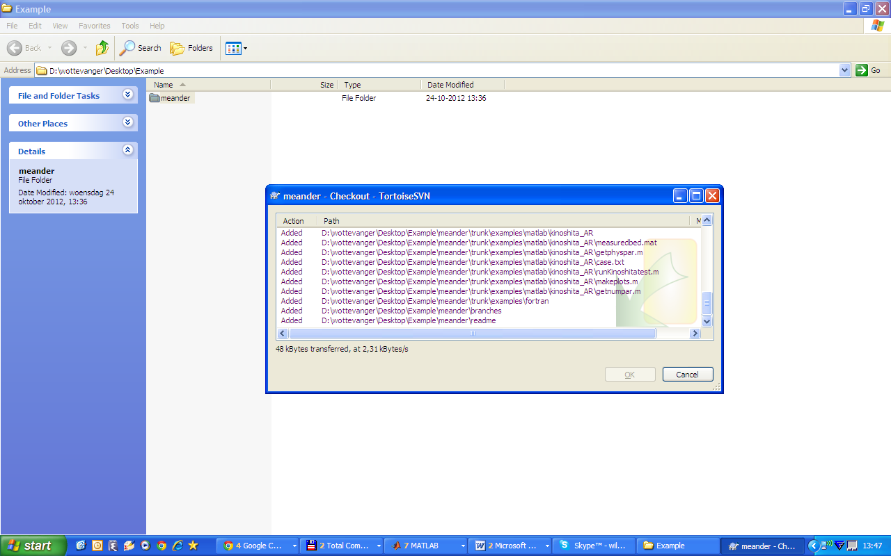

6. Hit refresh ‘F5’ and you should see a green tick on the folder.
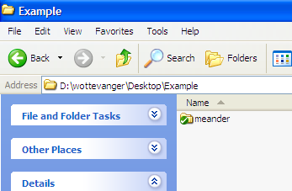

To add a file or folder to the repository:

1. Right click the file or folder →TortoiseSVN→Add

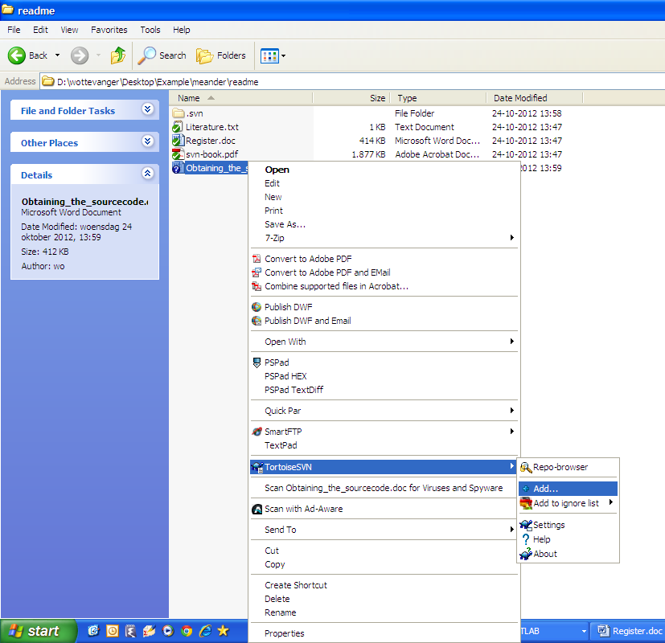
2. A blue + should appear
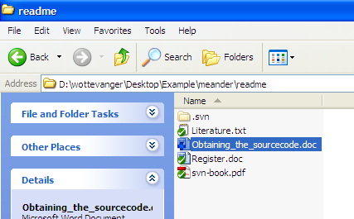

3. Next right click and SVN Commit …

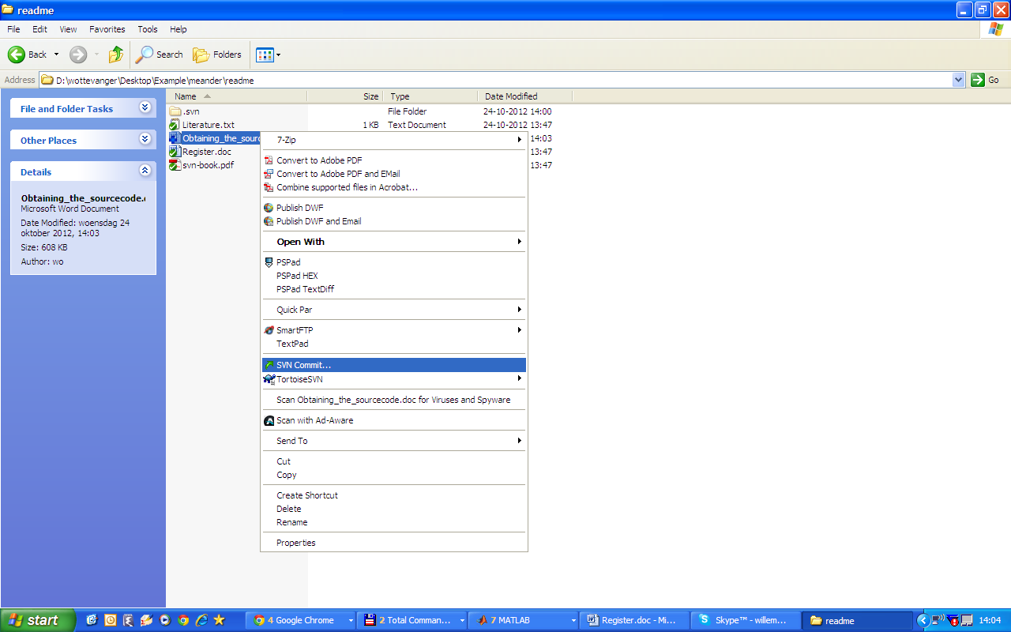

4. Hit OK
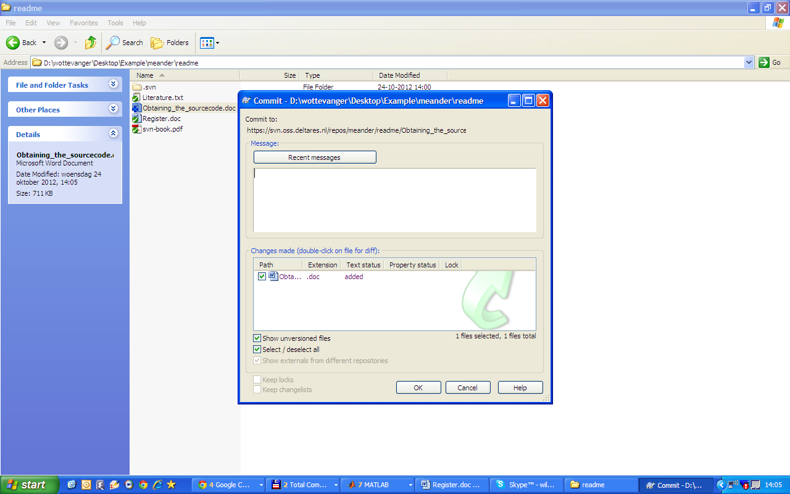

5. Uploading
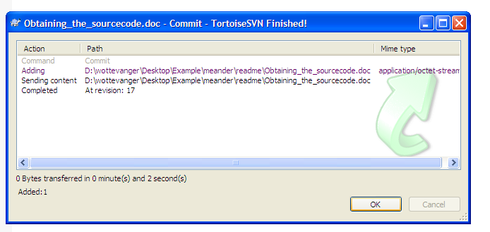
6. Hit refresh (F5) and you will see a green tick

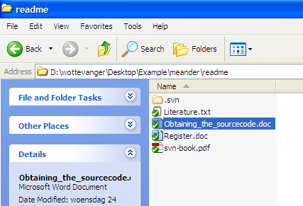

7. You’re done

Updating changes / Reverting to old version
Suppose you have made some changes to the file a red exclamation mark appears indicating your file is not up to date.
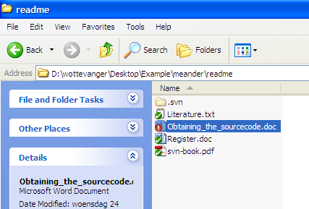
14. To add these changes to the repository click SVN Commit
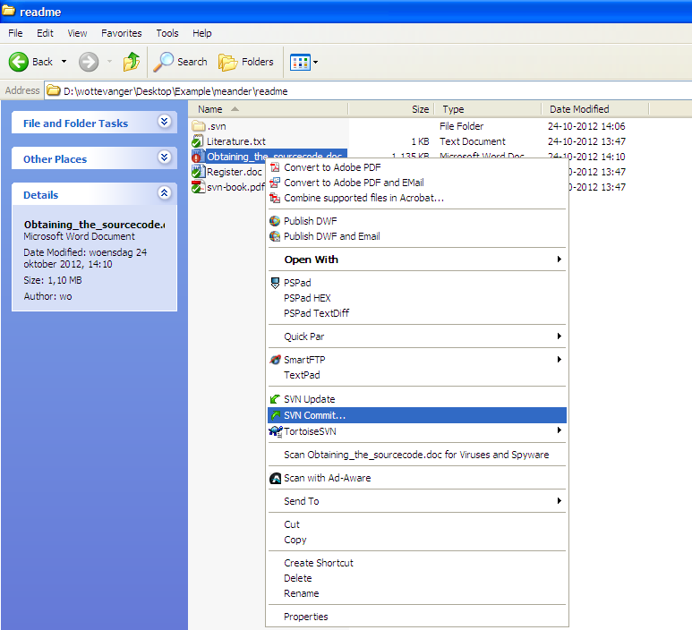

15. To instead revert to the previously downloaded version from the server
Use TortoiseSVN →Revert …
