1. Visit http://oss.deltares.nl
2. Click on ‘Register’ (top right hand corner of the screen)

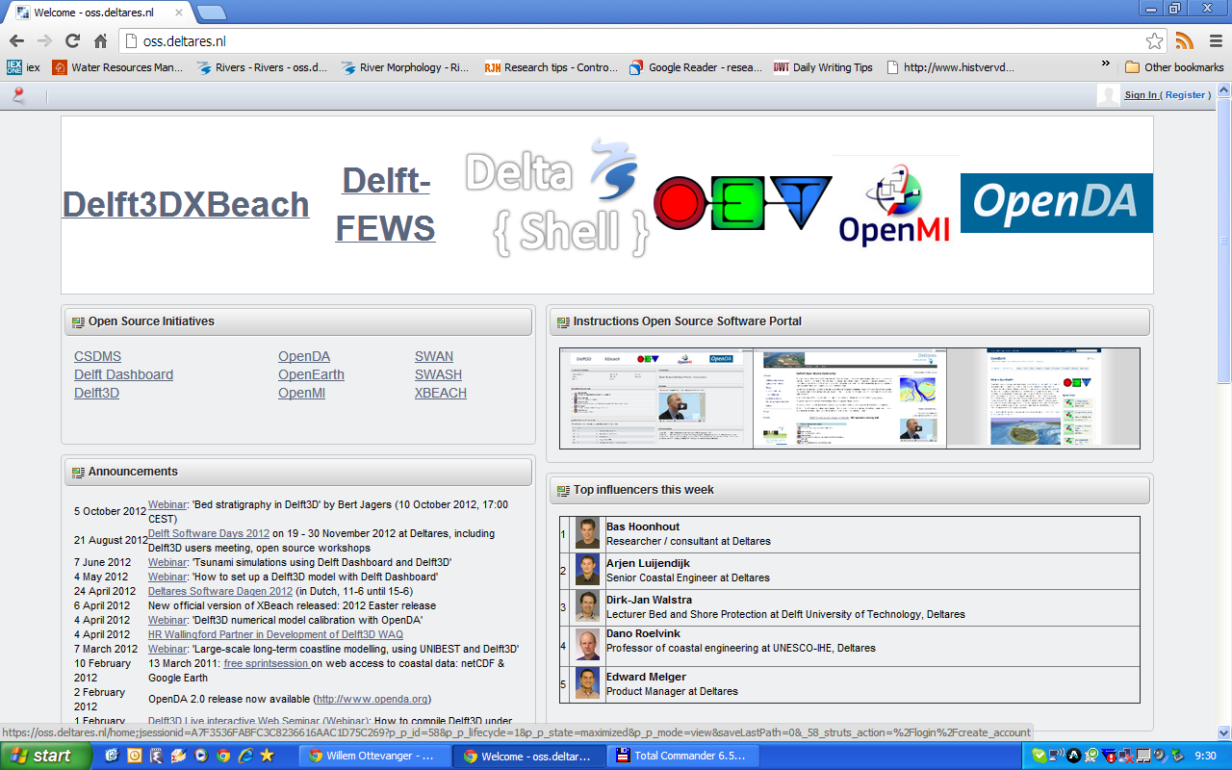

3. Fill in your details
4. Finally select ‘OpenDelft3D’
(incidently, this allows you to download the open source Delft3D code to which you may also make contributions)
5. Role as ‘Community contributor’

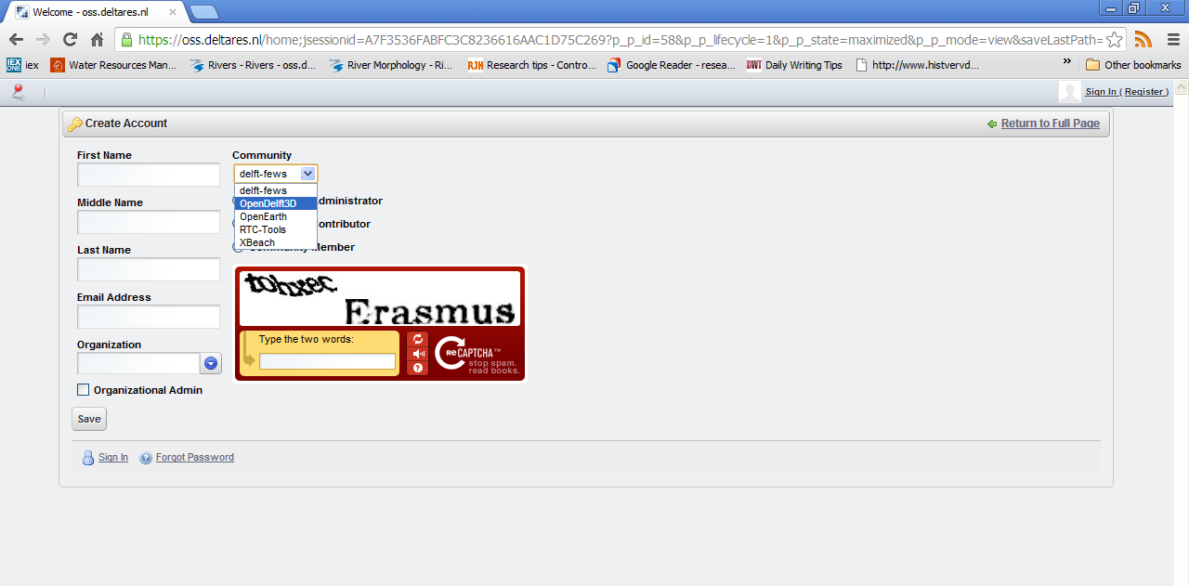
6. Send me your username, and I will take care of the rest
7. Our code will reside at http://oss.deltares.nl/repos/meander and using Tortoise SVN you can upload/download changes and updates

