A Colormap for Effective Black and White Rendering of Color Scale Images

Carey Rappaport
Northeastern University
Boston, MA 02115

Abstract—Default colormaps on color images often reproduce to confusing grayscale images. The proposed colormap maintains an aesthetically pleasing color image that automatically reproduces to a monotonic grayscale with discrete, quantifiable saturation levels.
Index Terms—Color graphics, Rendering (computer graphics), Computer graphics software

It is quite informative to display intensity information in terms of color levels in a graphic image. While the default mapping of intensity values to color (the “colormap”) in commercial software, such as Matlab™ gives a visually pleasing and quantitatively useful graphic, much of this information is often lost when the original color image is printed or photocopied in black and white. This is due to the mapping of different colors to the same shade of gray, often resulting in both the maximum and the minimum intensity values ending up as black. To maintain high quality black and white images, the author generating the image is forced to use a grayscale colormap, and lose the attractive color option on his computer screen and his presentation images, or generate two separate renderings of the same information, one in black and white and one in color (or pay the particular journal’s expensive color printing charges).

Rather than sacrifice the pretty colors, we devised a colormap that preserves colors, but mixes the color components so that the back and white rendering of the colormap produces a grayscale representation that is monotonic with intensity. Thus the color images photocopy and print to effective black and white images suitable for journal printing. In addition, we divided the continuously variable color scale into nine discrete levels. Though variations in color are easy to see and quantify, continuously varying grayscale is quite difficult to interpret quantitatively. With nine discrete levels, the color representation more effectively maps to a quantifiable grayscale with enough levels to capture most of the fine scale intensity variation while maintaining enough difference between levels to be discernable.

Assuming the intensity of a color in an image is given in terms a triplet of the intensity of red, green, and blue light, each varying form 0.0 to 1.0, with 0.0 being completely unsaturated (absent), and 1.0 being completely saturated, the colormap is given by:

CMRmap = [0.00 0.00 0.00;
0.15 0.15 0.50;
0.30 0.15 0.75;
0.60 0.20 0.50;
1.00 0.25 0.15;
0.90 0.50 0.00;
0.90 0.75 0.10;
0.90 0.90 0.50;
1.00 1.00 1.00 ]
This map is implemented in Matlab™, for example with the command:

colormap(CMRmap)
The essential issue in developing this map is that blue values have very little effect on the black and white rendering of the color images. Thus the first two elements of the colormap triplet must monotonically increase with intensity, but the third element can be adjusted for best color aesthetics. On some monitor settings the darker values may become hard to separate visually. It has been found, however, that the hardcopy printed versions of these images show the differences appropriately.

As an example, the rendering of Fig. 1 is the original color image; Fig. 2 is what would be printed on a black and white printer or photocopier. Note the confusion of the black color level. The rendering of Fig. 3 is the grayscale colormap, which does not ever use color. Although this grayscale image eliminates the black level ambiguity, it is still hard to precisely determine which level of gray is a given intensity (e.g. where is level “7”?).

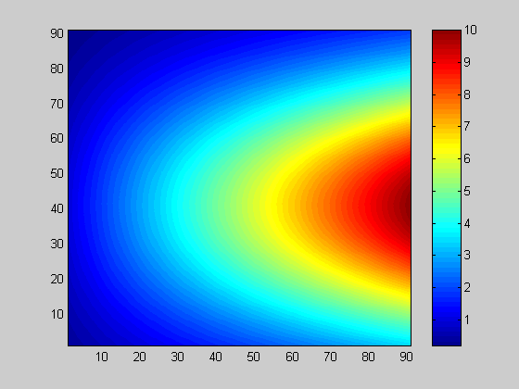

Figure 1: Original color rendering Figure 2: B&W rendering of color image

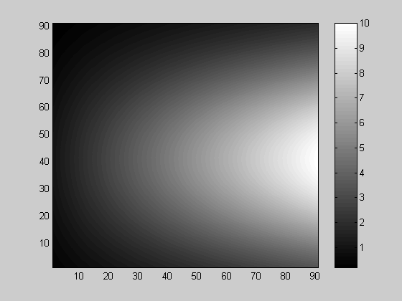

Figure 3: Grayscale rendering

The remapped color image is presented in Fig. 4, while Fig. 5 is the black and white rendering of Fig 4, which would be observed when the image of Fig. 4 was printed. The levels of darkness monotonically decrease with intensity, and the nine levels are clearly distinguished and identified.
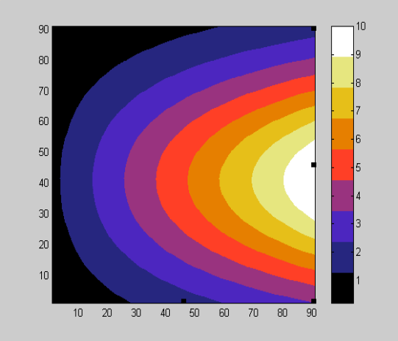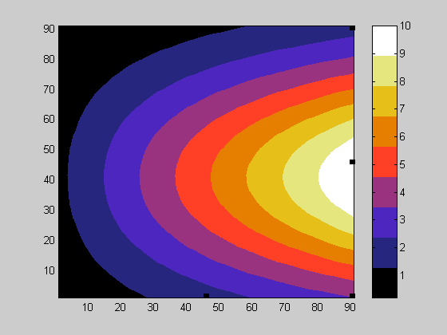

Figure 4: CMRmap rendering Figure 5: B&W CMRmap rendering

The basic color gradations can be retained without the limitation of only nine discrete levels by spline fitting each column of the colormap. For example, if 64 intensity levels are desired, the Matlab™ code:

x = 1:8/63:9; % 64 color levels instead of 9
x1 = 1:9
for i = 1:3
sCMRmap(:,i) = spline(x1,CMRmap(:,i),x)'; % spline fit intermediate values
end
sCMRmap = abs(sCMRmap/max(max(sCMRmap))); % eliminate spurious values outside of range

could be used. This colormap results in Figure 6 and 7. The black and white rendering of this more continuous intensity variation is quite similar to the grayscale image of Figure 3.

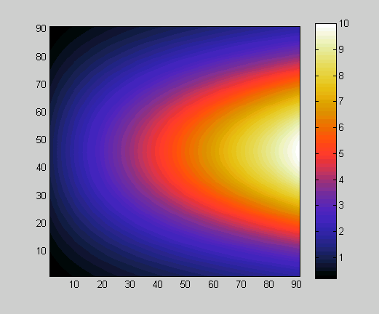

Figure 6: 64 level sCMRmap rendering Figure 7: 64 level B&W sCMRmap rendering

