Notes

. I do not have Ubuntu/Linux installed, I recently moved to Mac and thought of not spending lot of time on Ubuntu/Linux installation because I already had spent time installing Qt on Mac.

* It took a while for me to understand why my UI designer changes were not getting compiled. I was not cleaning/rebuilding/saving all each time I would do a change.
* Qt Creator was often crashing on Mac in design mode giving following error.

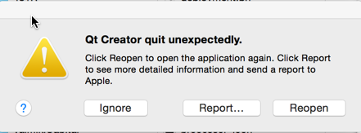

* This was the the first time I installed it an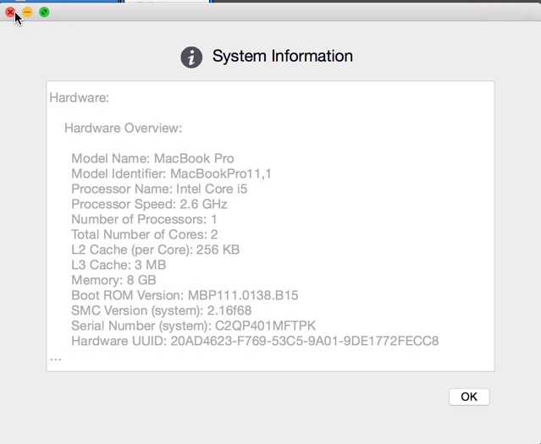d used it but I think there is some wrong setup either in my program or installation. I used following link to configure the environment

http://doc.qt.io/qt-4.8/install-mac.html

* I spent lot of time trying to use Foundation/NSProcessinfo.h “NSProcessInfo” class but was not successful in that. I need to spend more time to understand this.
* As far as UI is concerned I was unable to do the design I planned to do as today was the first time I used Qt Creator. Current UI looks really simple.