Name Sujal das
Regno : 24BCA0150
Big Data lab

Question 1
Basic Arithmetic Operations
a<-9
b<- 3
sum<- a+b
product <- a*b
diff<- a-b
div <-a/b
print(sum)
print(diff)
print(div)
print(product)

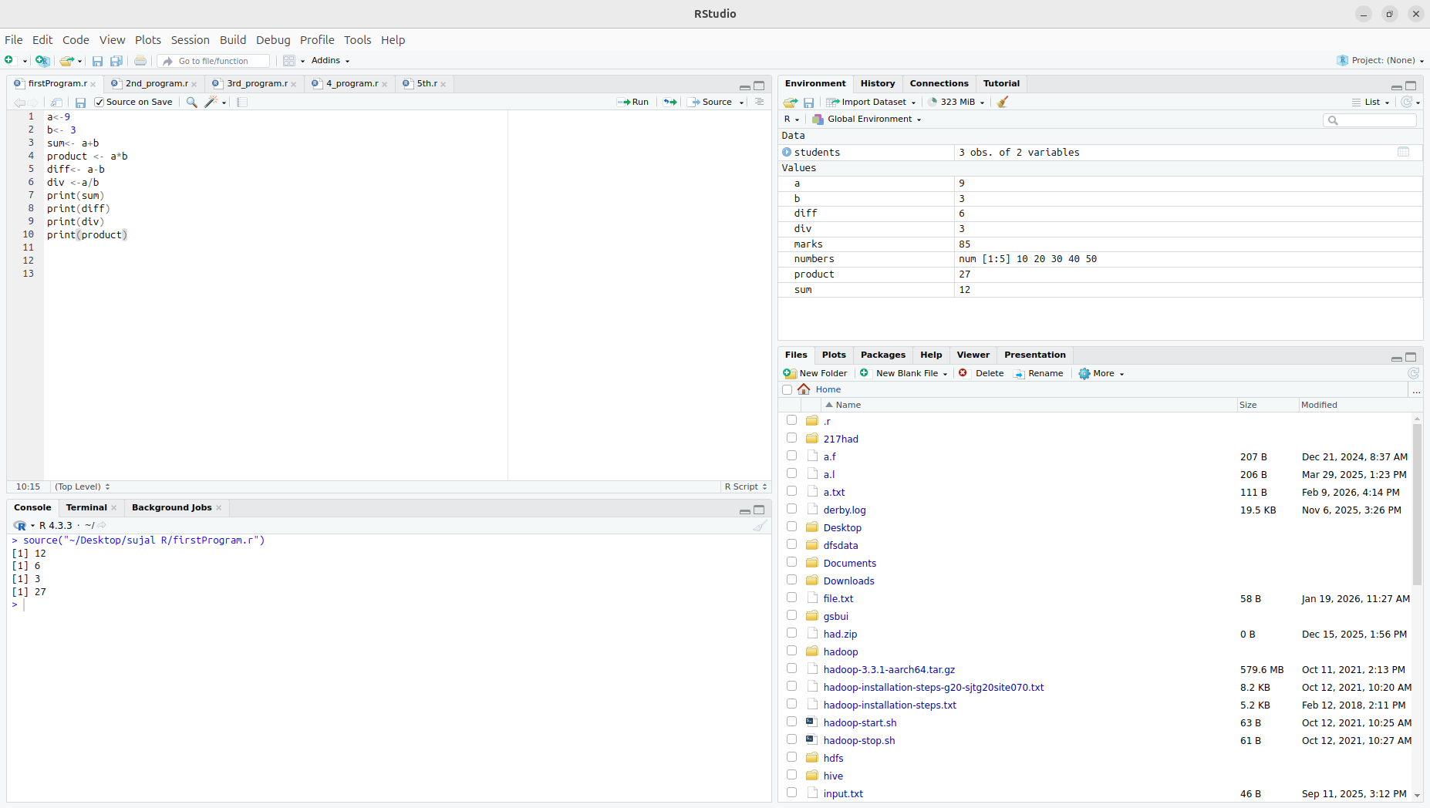
question 2)
Working with Vectors

numbers<- c(10,20,30,40,50)
print(numbers)
print(mean(numbers))
print(sum(numbers))
print(max(numbers))
print(min(numbers))
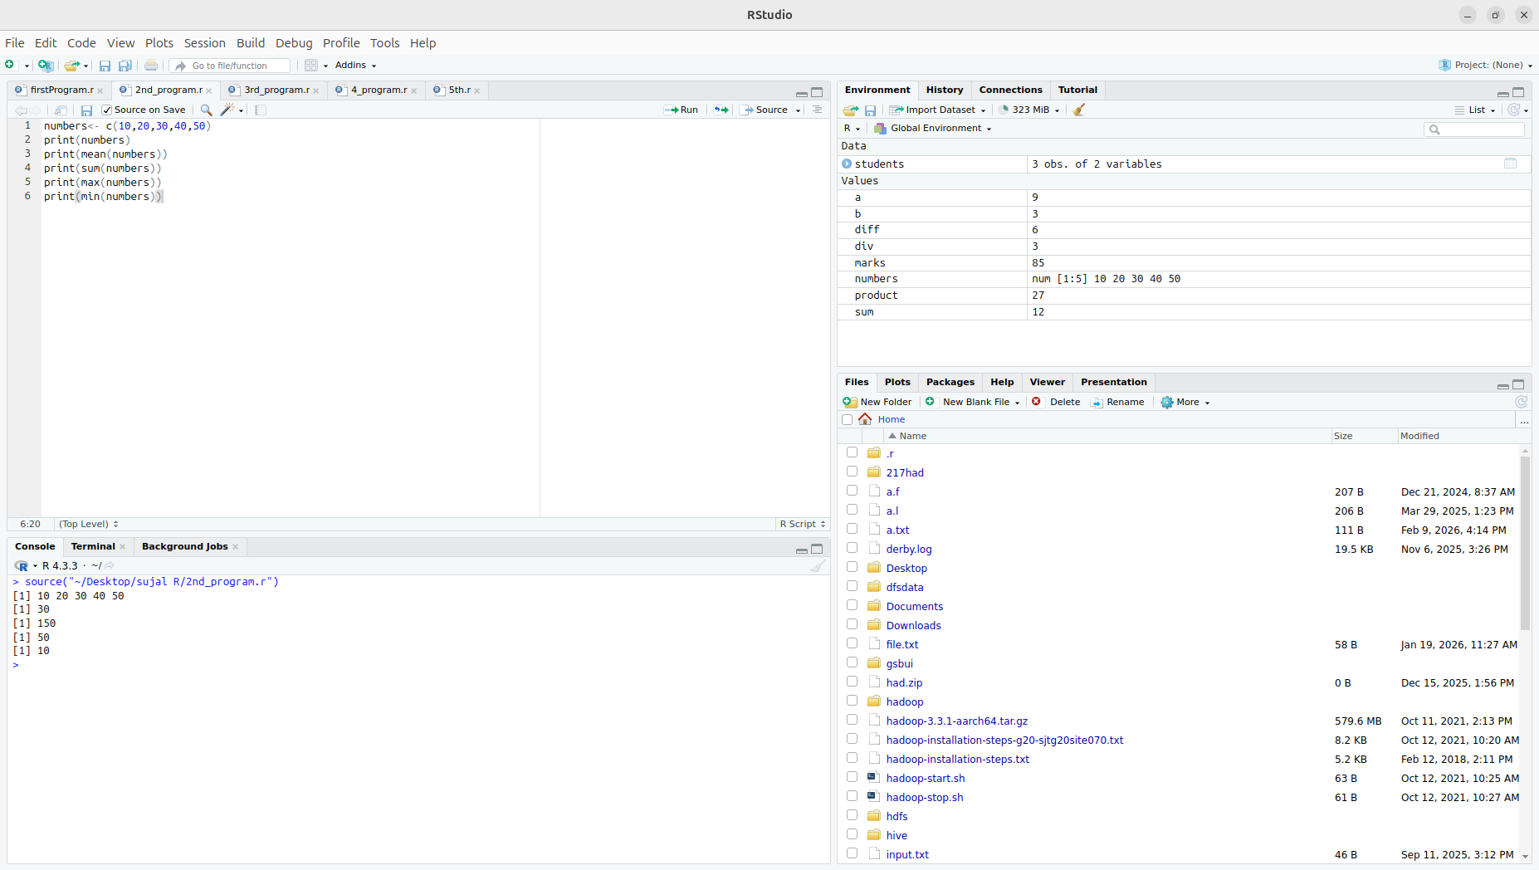

Question 3) : Conditional Statement (If-Else)

marks <- 85
if (marks >= 80) {
print("Grade A")
} else if (marks >= 60) {
print("Grade B")
} else {
print("Grade C")
}

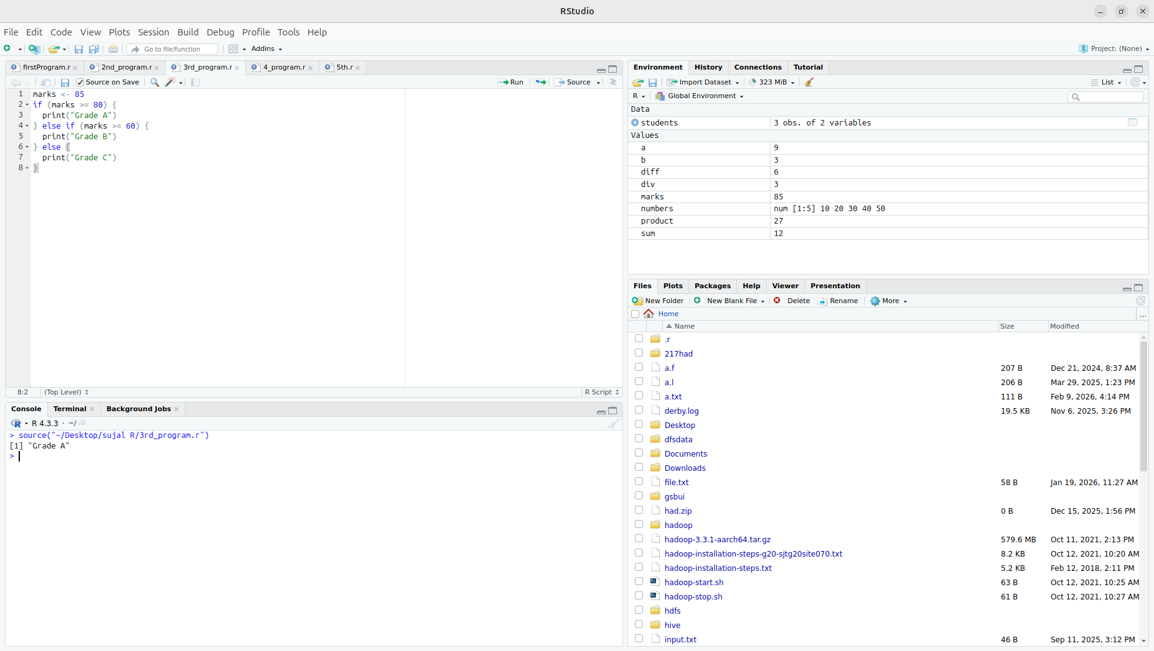

Question 4) : Data Frame Creation
students<-data.frame(name=c("A","B","C"), marks=c(80,89,56))
print(students)
print(students$marks)

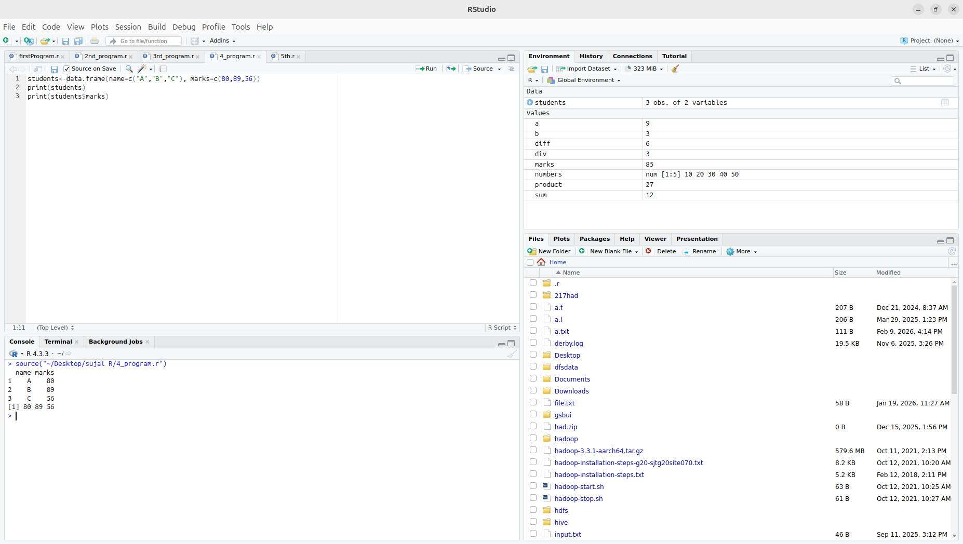

Question 5: Visualization

data preparation

set.seed(123)
sales_data <- data.frame(
CustomerID = 1:1000,
Age = sample(18:60, 1000, replace = TRUE),
Gender = sample(c("Male", "Female"), 1000, replace = TRUE),
Region = sample(c("North", "South", "East", "West"), 1000, replace = TRUE),
PurchaseAmount = round(rnorm(1000, mean = 5000, sd = 1500), 2),
AdvertisementSpend = round(rnorm(1000, mean = 2000, sd = 500), 2)
)
head(sales_data)
summary(sales_data)

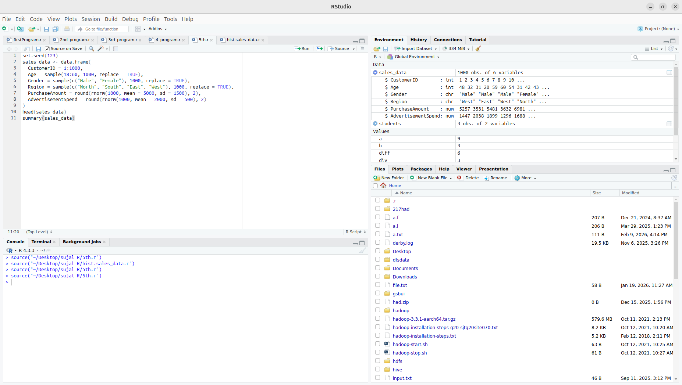

histogram

hist(sales_data$PurchaseAmount,
main = "Distribution of Purchase Amount",
xlab = "Purchase Amount")

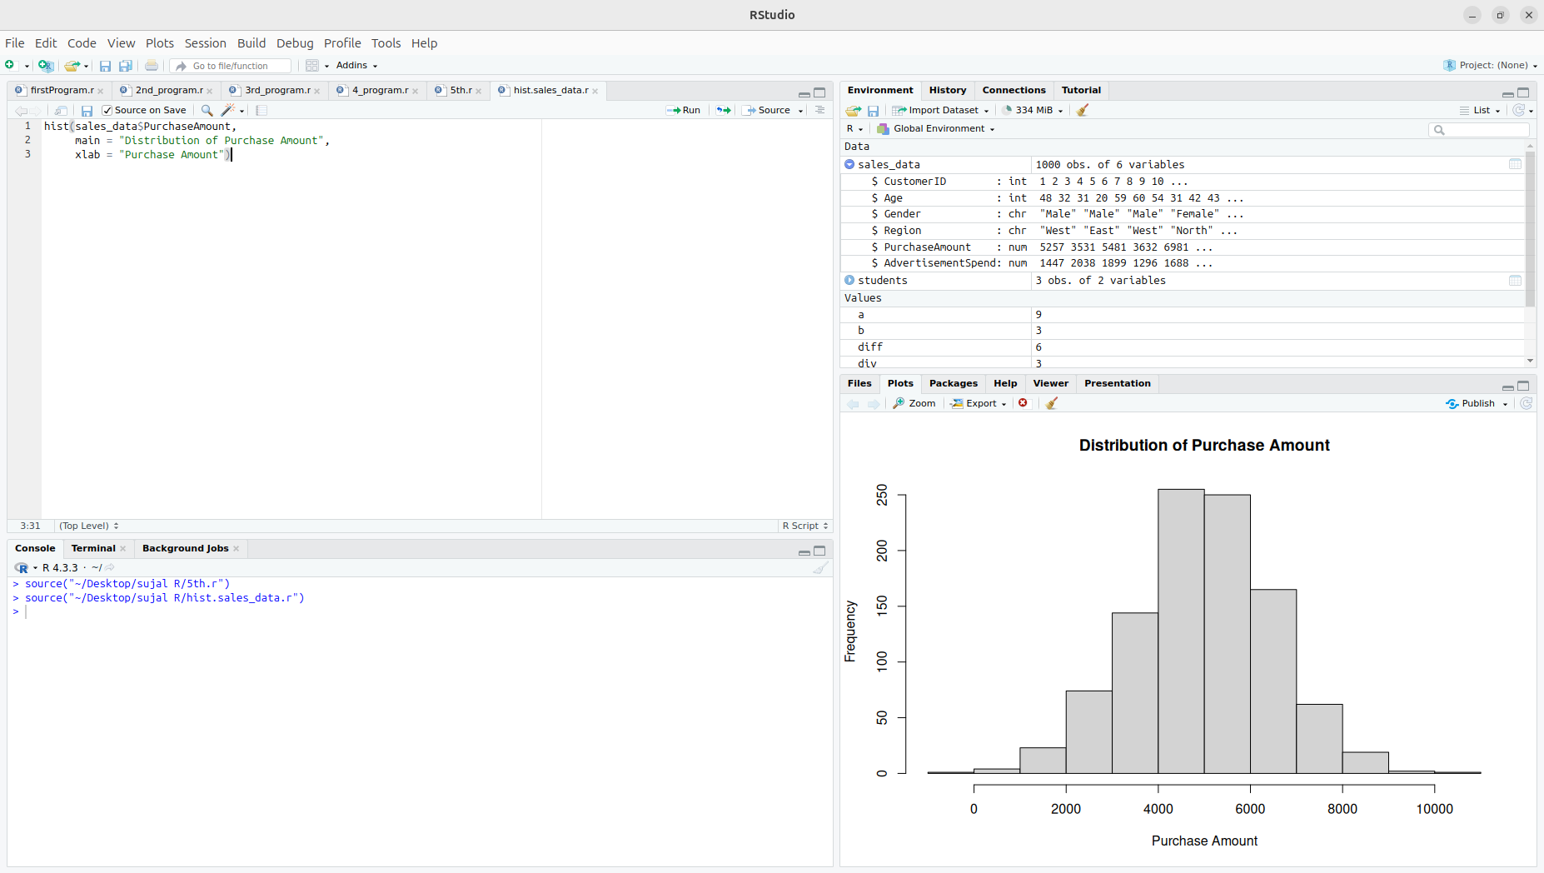

bar plot
boxplot(PurchaseAmount ~ Region,
data = sales_data,
main = "Purchase Amount by Region",
xlab = "Region",
ylab = "Purchase Amount")

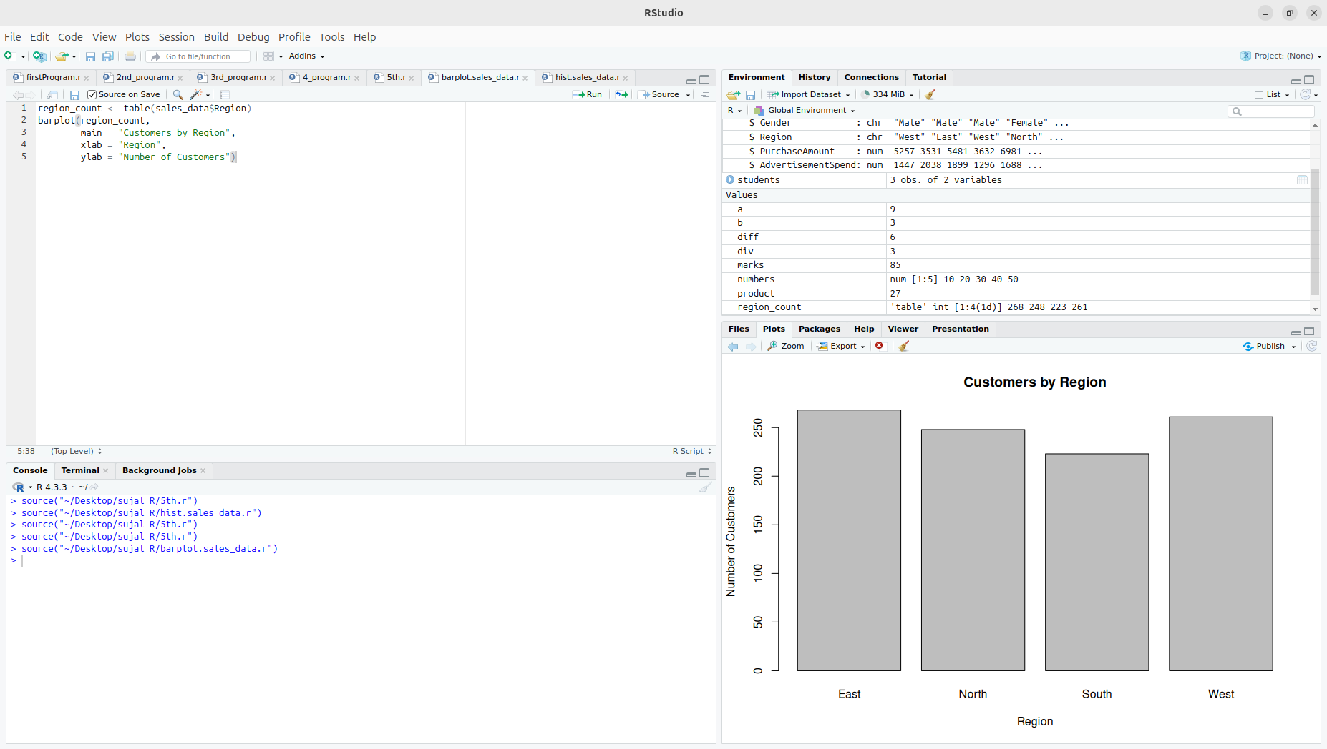
Pie Chart
region_count <- table(sales_data$Region)
pie(region_count,
main = "Customer Distribution by Region")
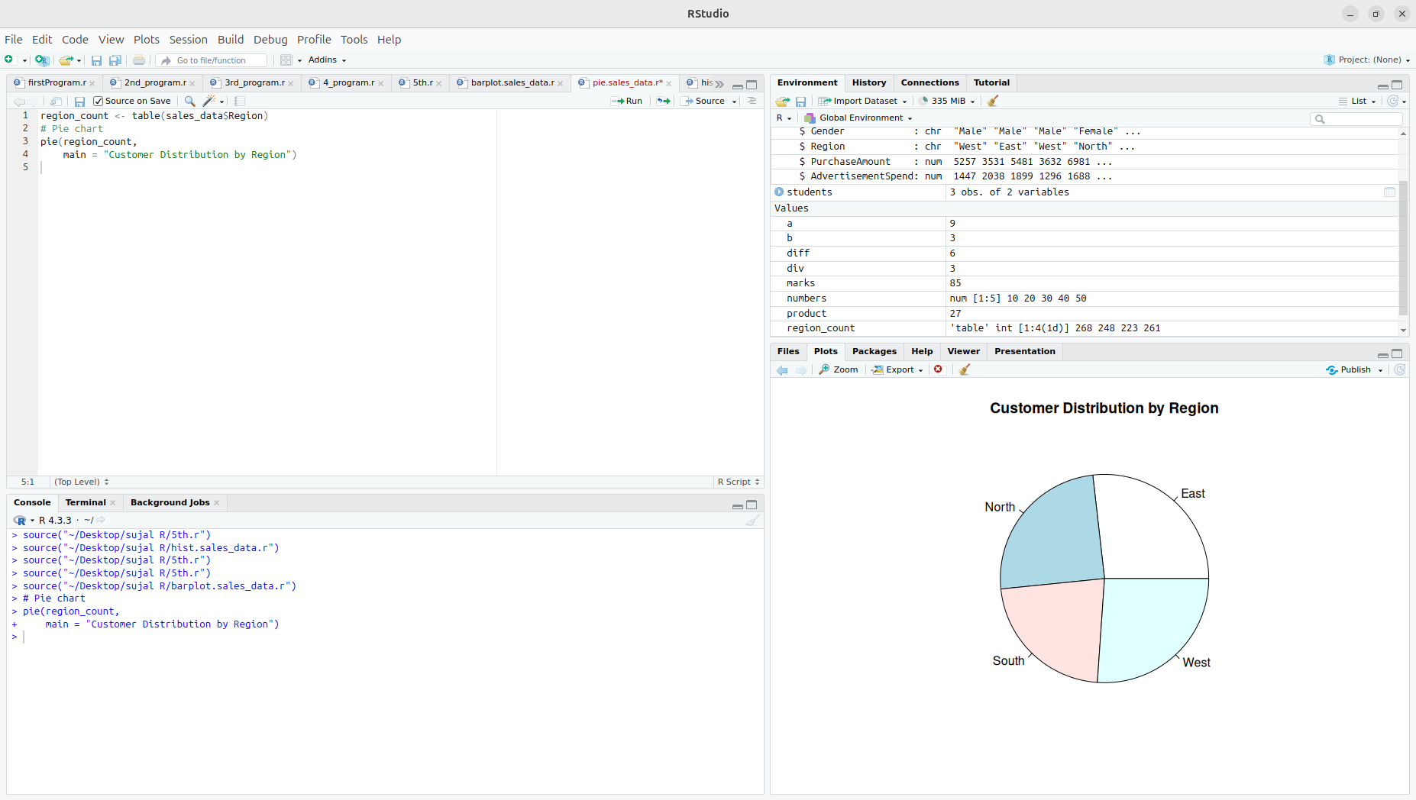
Scatter plot
plot(sales_data$AdvertisementSpend, sales_data$PurchaseAmount,
main = "Advertisement Spend vs Purchase Amount",
xlab = "Advertisement Spend",
ylab = "Purchase Amount")
cor(sales_data$AdvertisementSpend, sales_data$PurchaseAmount)
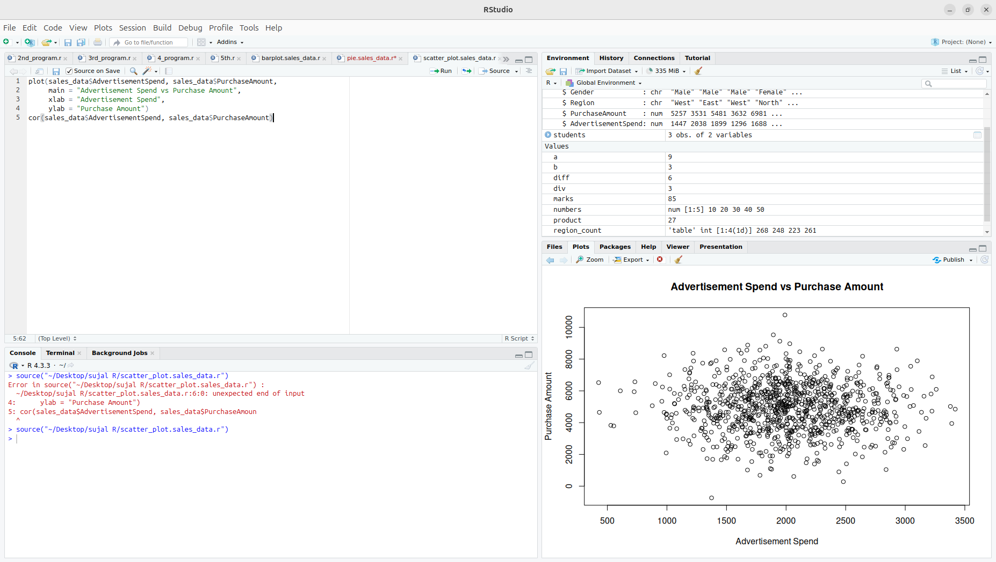
box plot
boxplot(PurchaseAmount ~ Region,
data = sales_data,
main = "Purchase Amount by Region",
xlab = "Region",
ylab = "Purchase Amount")
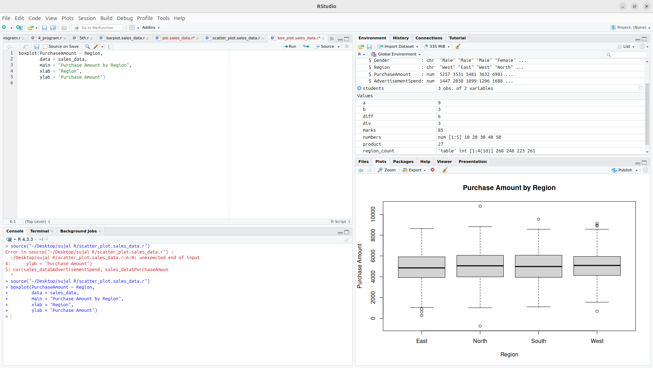

Question 6)
Importing and loading Dataset
#load the csv
adm_data <- read.csv('/home/hduser/Downloads/adm_data.csv')
head(adm_data)
str(adm_data)
summary(adm_data)
dim(adm_data)

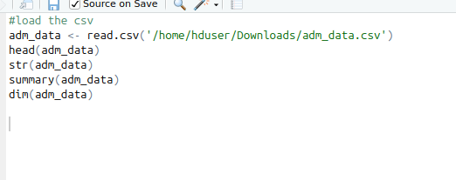

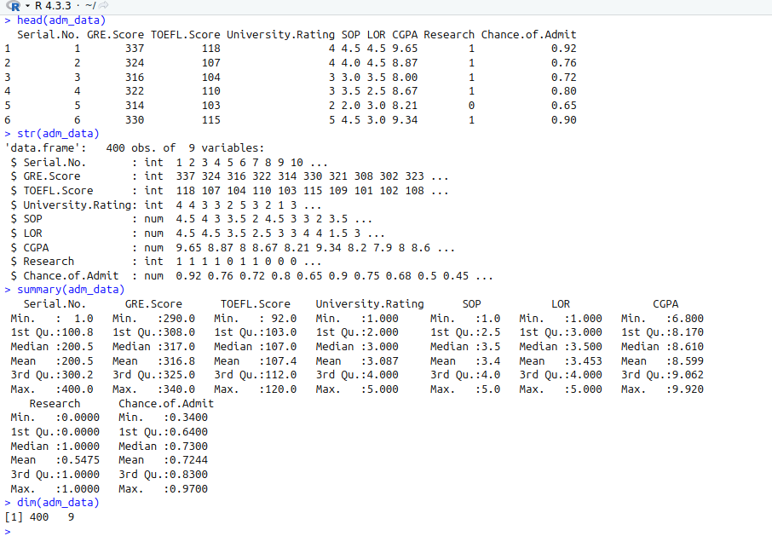
Bar Graph Visualization

CODE:

barplot(table(adm_data$Research),
col = c('skyblue','orange'),
main = "bar plot of research participant",
xlab = 'Research (0 = No 1 = yes)',
ylab = 'count')

output:
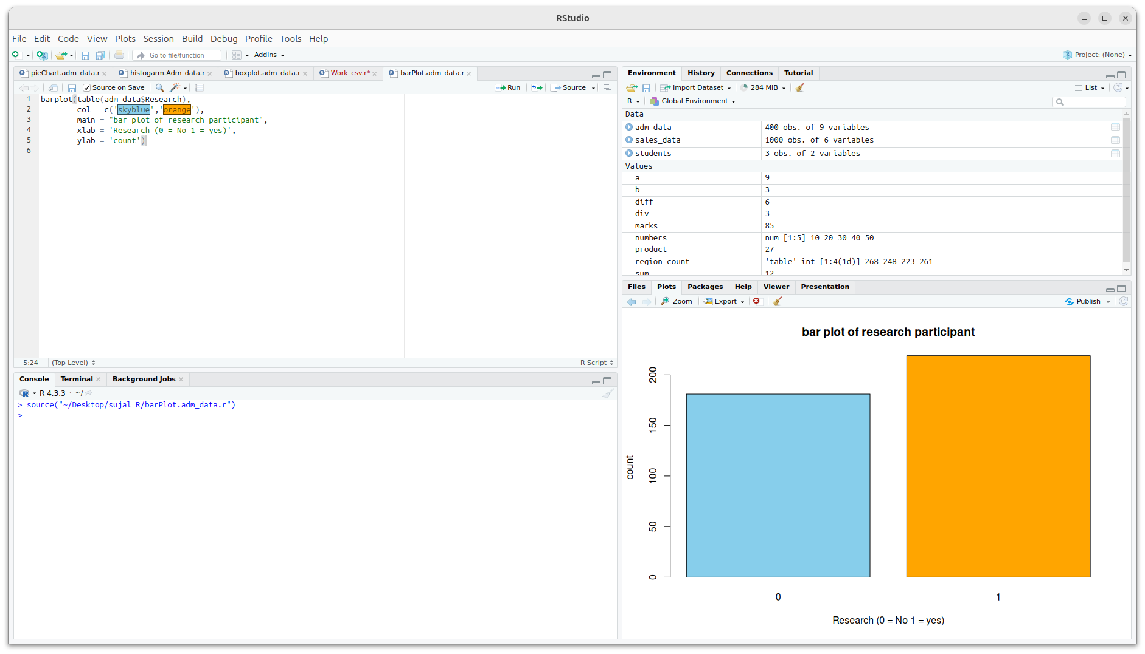

Pie Chart Analysis

pie(table(adm_data$University.Rating),
col = rainbow(length(unique(adm_data$University.Rating))),
main = "pie chart representation")

Output:

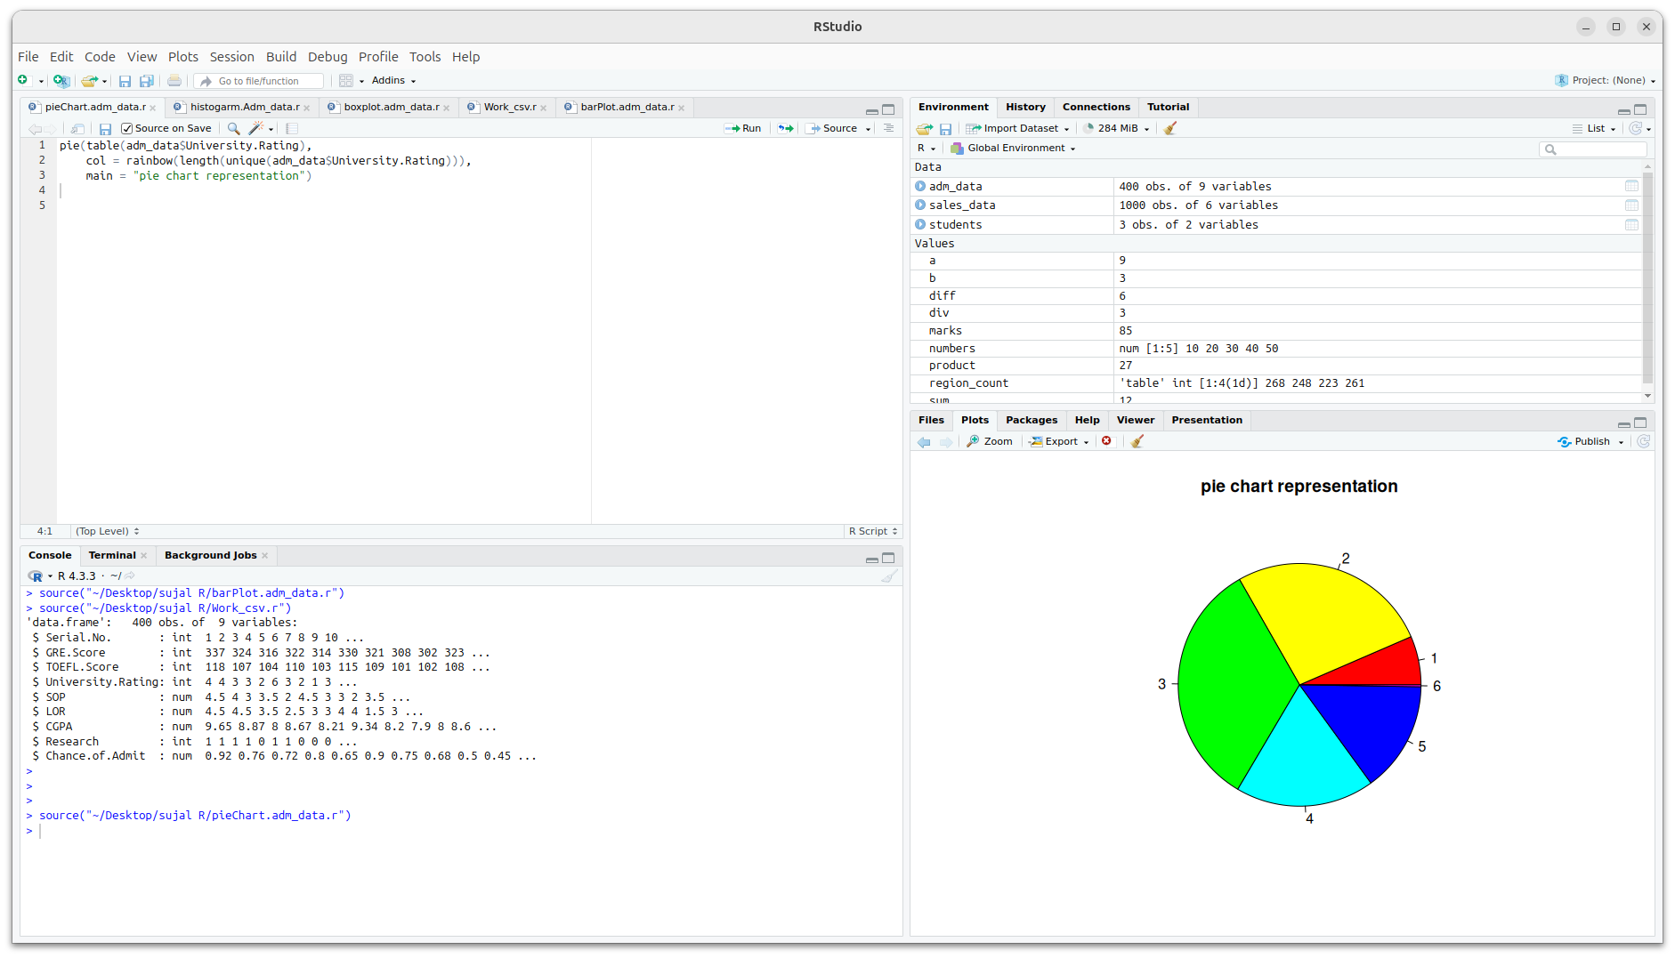

Histogram

Code:
hist(adm_data$GRE.Score,
col = "lightgreen",
border = "black",
main = "Histogram of GRE Scores",
xlab = "GRE Score",
ylab = "Frequency")

output:
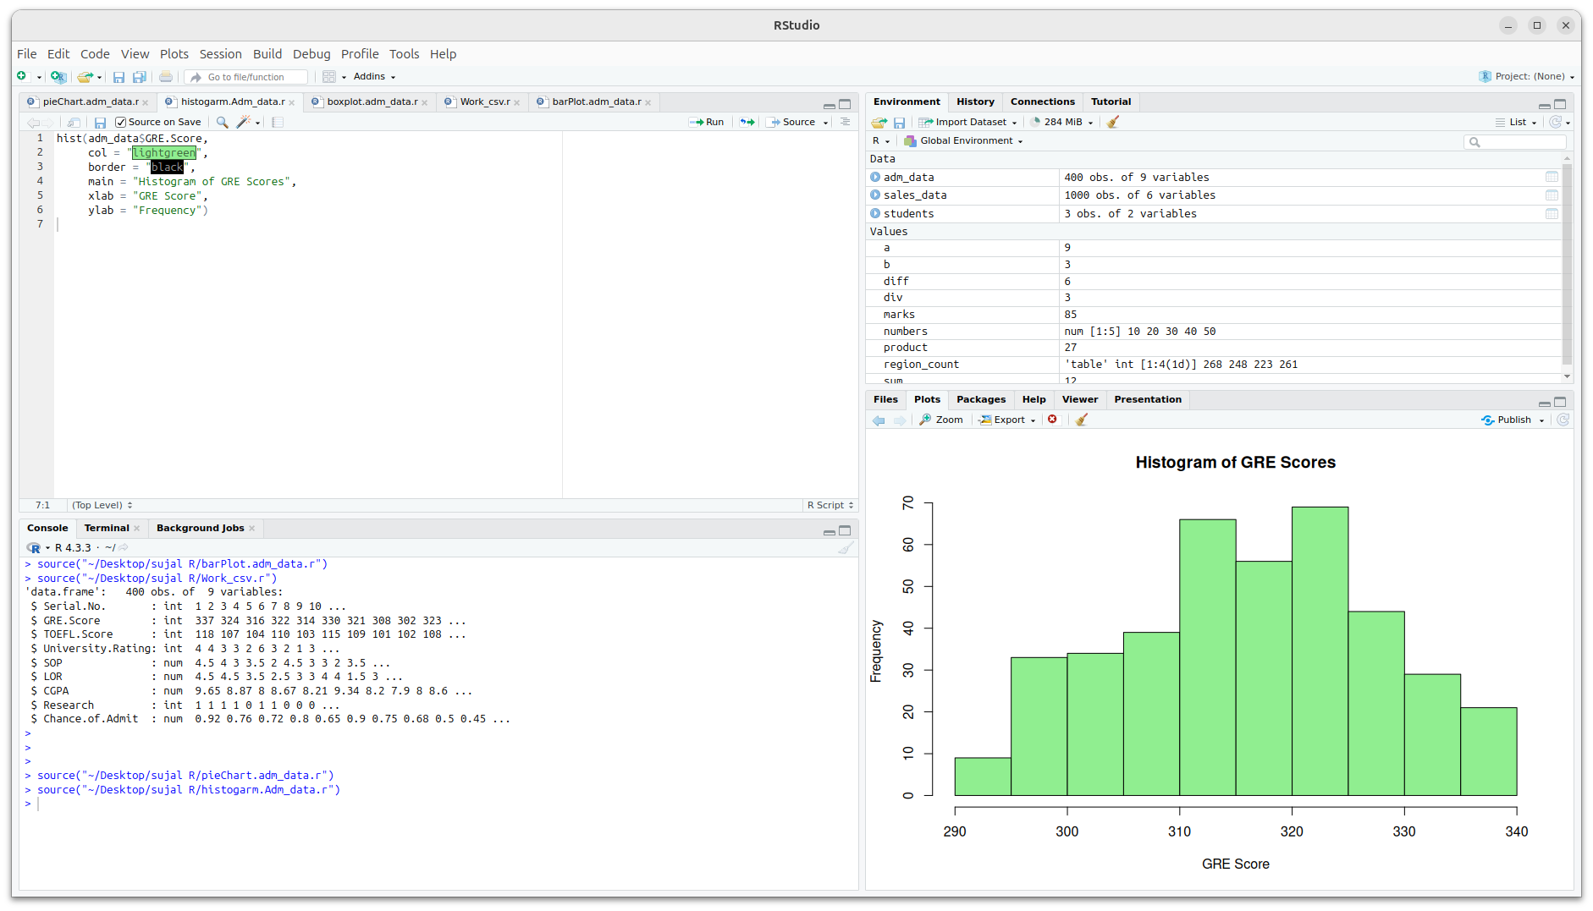

Box Plot Visualization

Code:

boxplot(adm_data$CGPA,
col = "purple",
main = "Boxplot of CGPA",
ylab = "CGPA")

Output:
