Objective: Practise essential Linux command-line operations — file and directory management, viewing files, searching, archiving, downloading, permissions, and environment variables.

1. Creating and Renaming Files/Directories
1. Create a directory named test_dir using mkdir.
2. Inside test_dir, create an empty file called example.txt.
3. Rename example.txt to renamed_example.txt using mv.

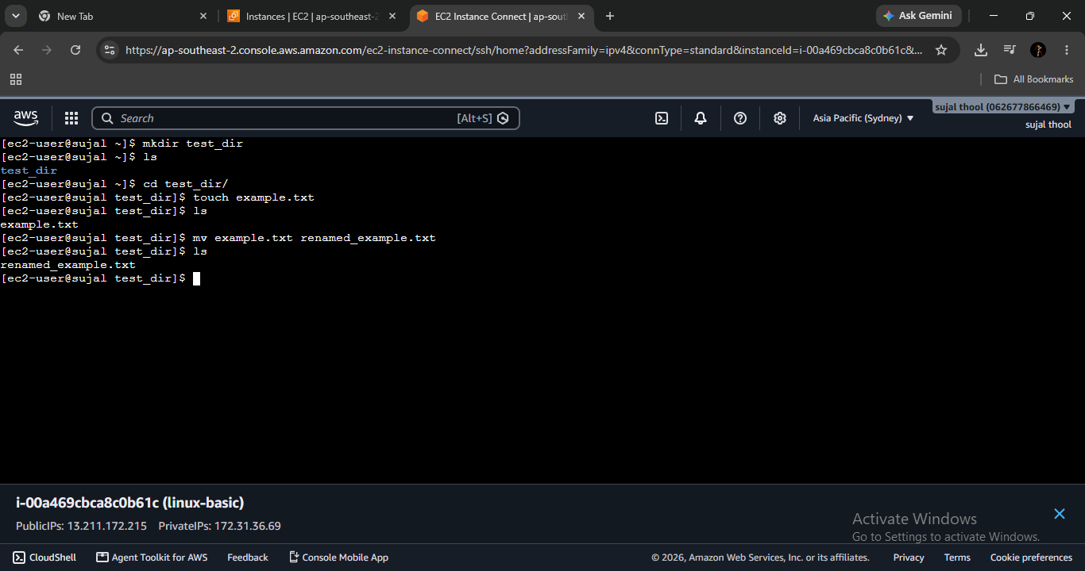

Mkdir test_dir
touch test_dir/example.txt
mv test_dir/example.txt test_dir/renamed_example.txt

2. Viewing File Contents
4. Use cat to display the contents of /etc/passwd.
5. Display only the first 5 lines of /etc/passwd using head.
6. Display only the last 5 lines of /etc/passwd using tail.

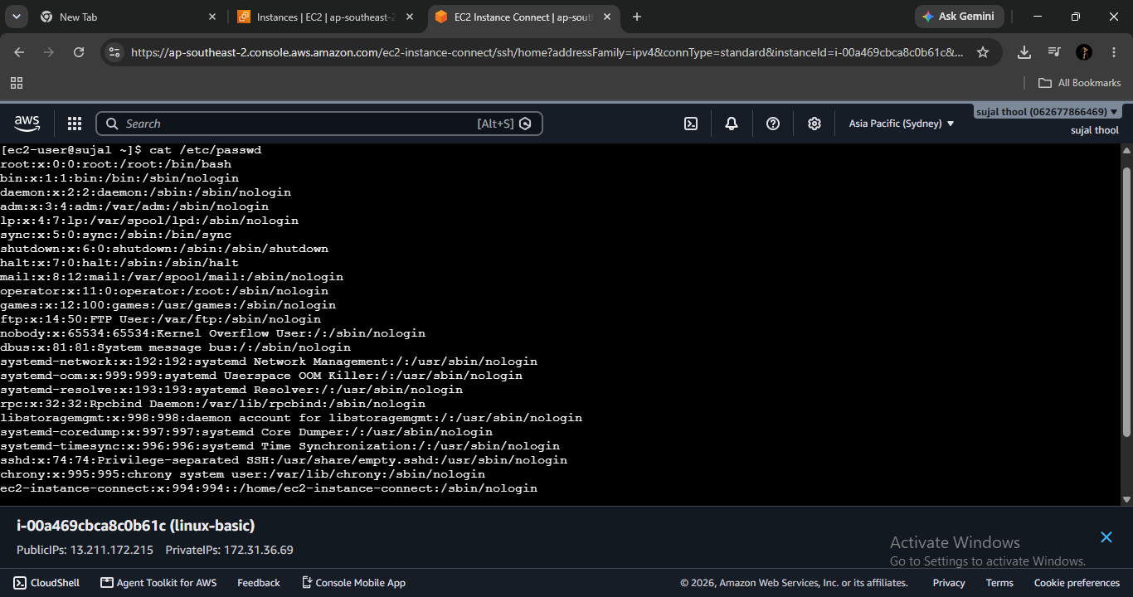

cat /etc/passwd
head -n 5 /etc/passwd
tail -n 5 /etc/passwd
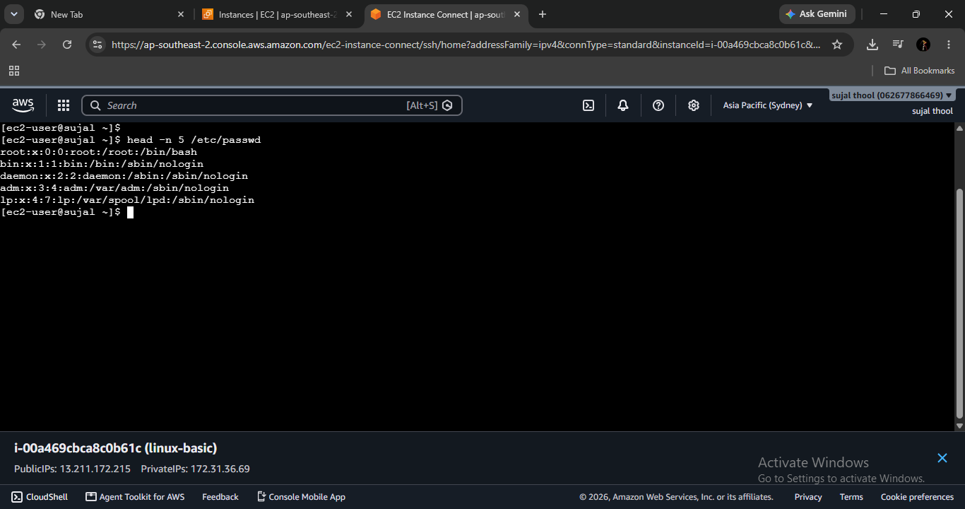

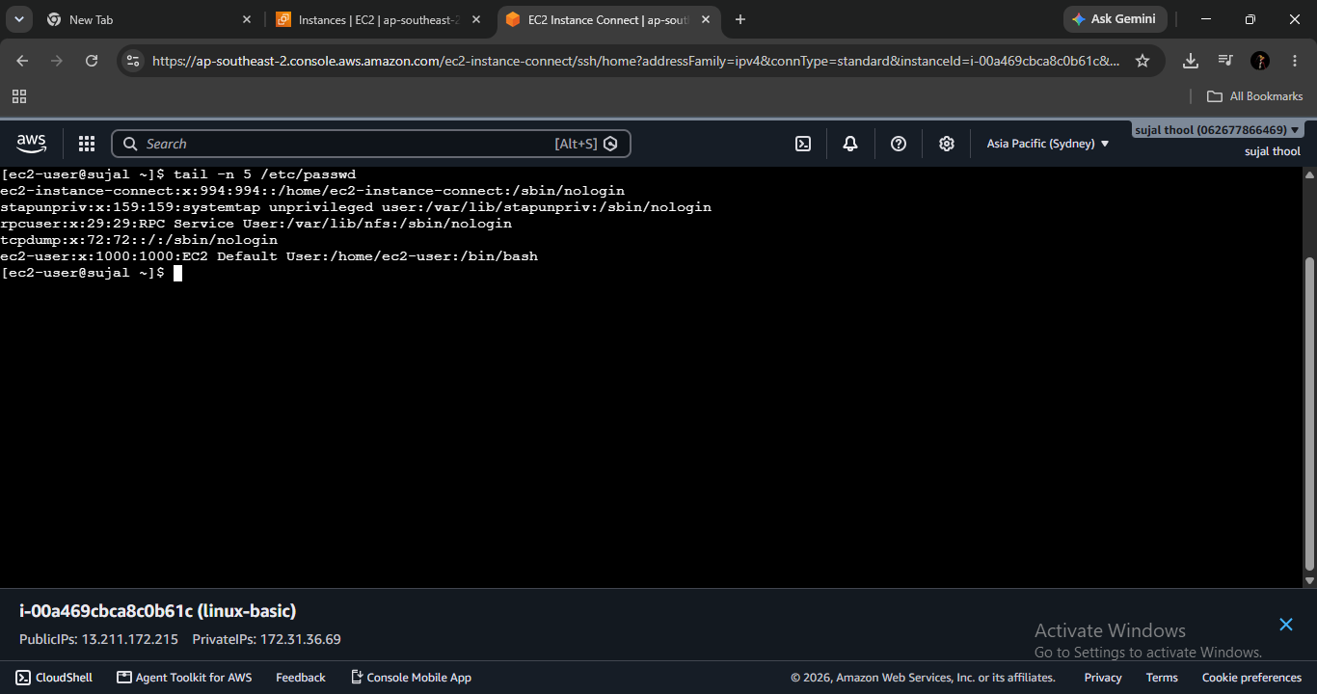

3. Searching for Patterns
7. Use grep to find all lines containing the word “root” in /etc/passwd.

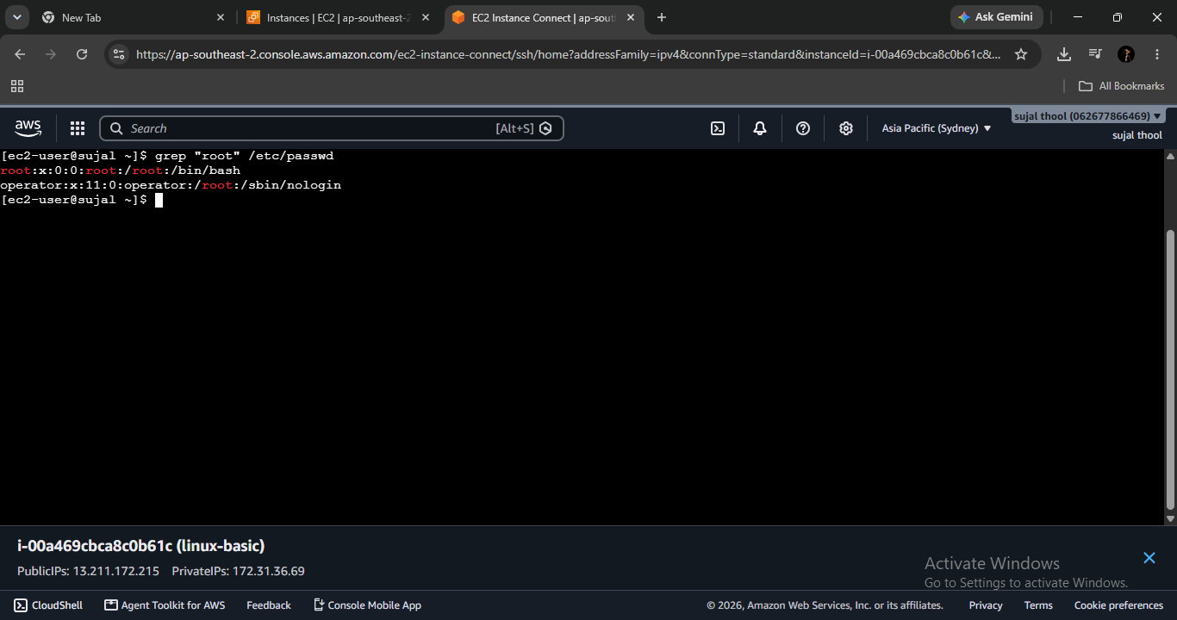

grep "root" /etc/passwd

4. Zipping and Unzipping
8. Compress the test_dir directory into a file named test_dir.zip using zip.
9. Unzip test_dir.zip into a new directory named unzipped_dir.

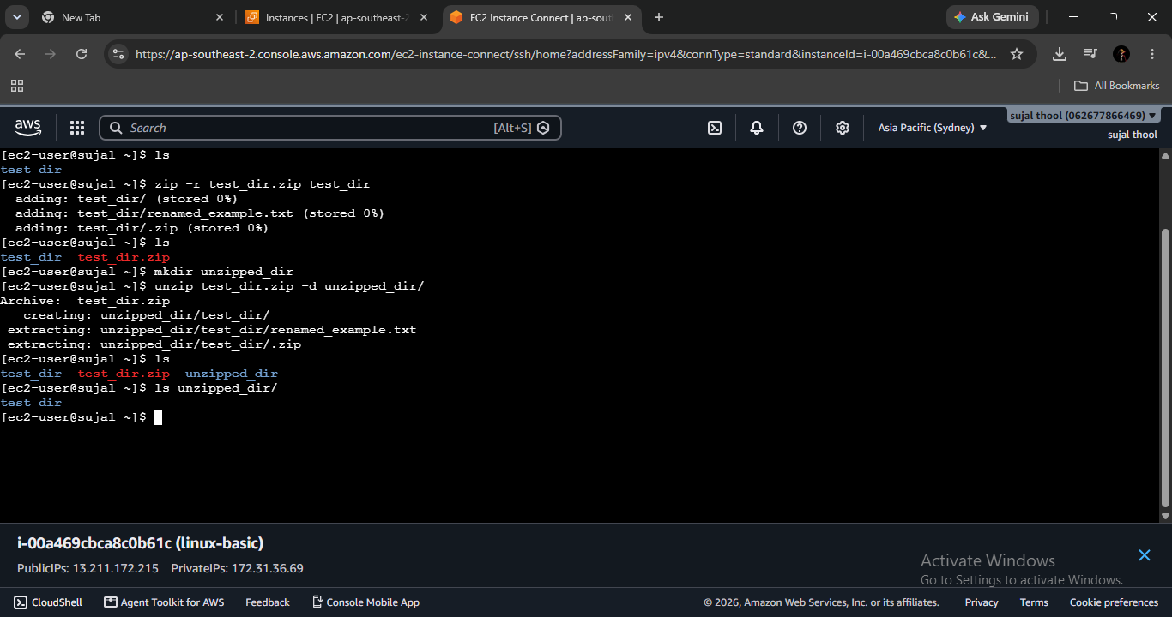

zip -r test_dir.zip test_dir
mkdir unzipped_dir
unzip test_dir.zip -d unzipped_dir

5. Downloading Files

10. Use wget to download a file from a URL (e.g., https://example.com/sample.txt).
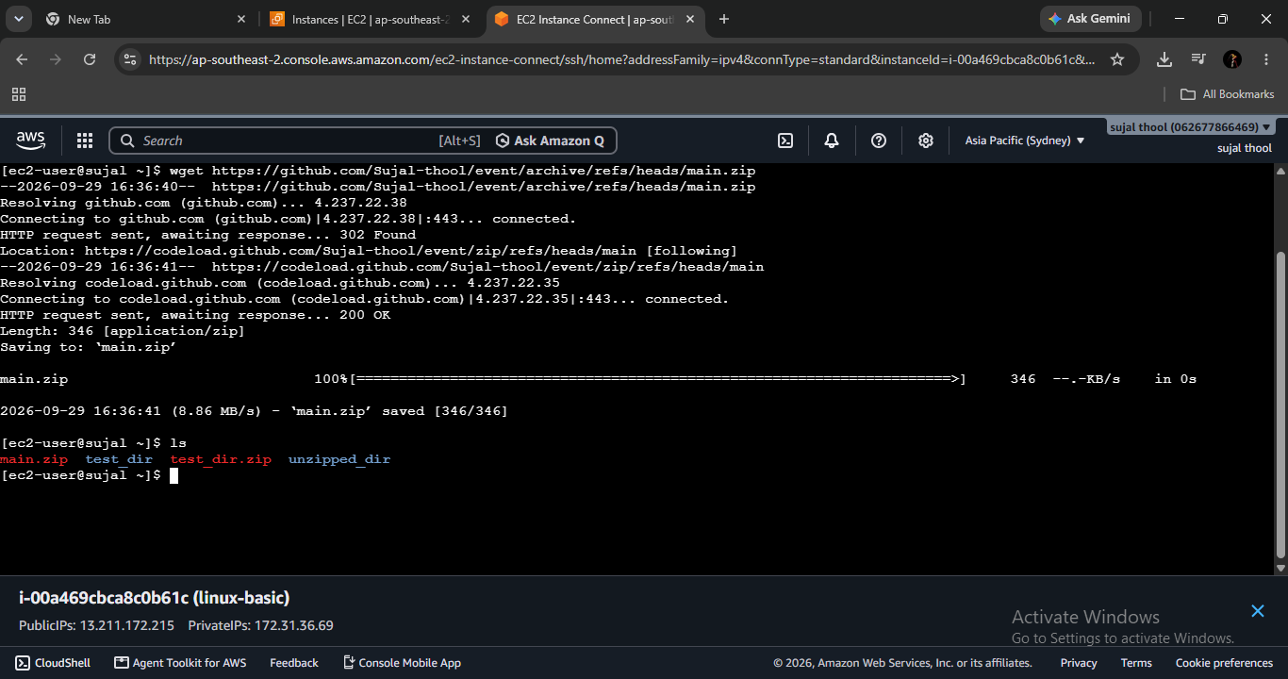

wget https://github.com/Sujal-thool/event/archive/refs/heads/main.zip

6. Changing Permissions
11. Create a file named secure.txt and change its permissions to read-only for everyone using chmod.
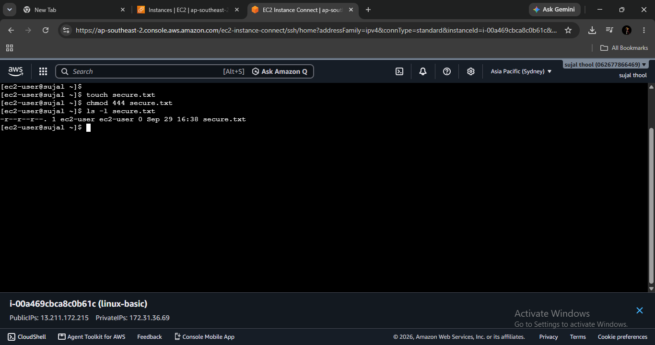

touch secure.txt
chmod 444 secure.txt
ls -l secure.txt

7. Working with Environment Variables

12. Use export to set a new environment variable called MY_VAR with the value “Hello, Linux!”.

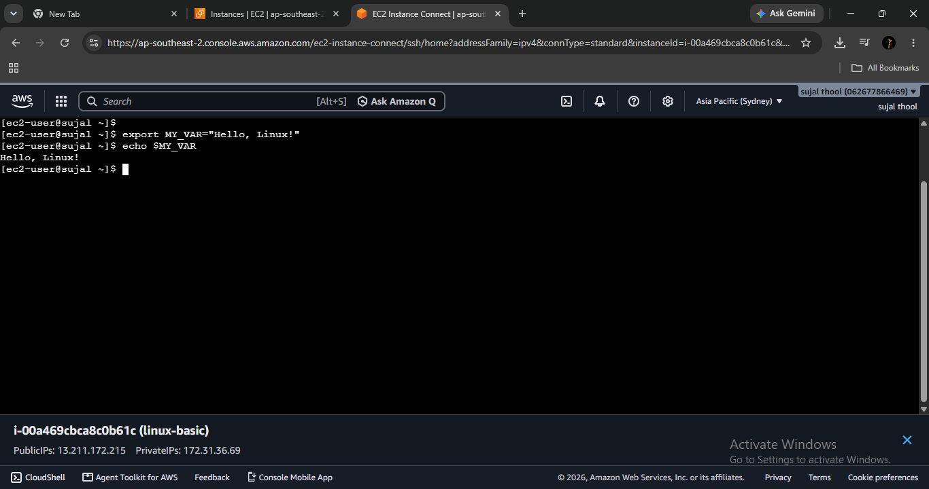

export MY_VAR="Hello, Linux!"
echo $MY_VAR

