Week 1 Task
Data Acquisition and Preliminary Analysis in E-Governance
Dataset: UN E-Government Development Index (EGDI) 2024 | Tool: R (readr, dplyr, ggplot2)

1. Introduction and Objective
E-governance is the use of digital technologies by governments to deliver services, share information and involve citizens in decision making. To judge whether a country is succeeding at this, researchers need comparable, measurable indicators. The objective of this task is to simulate the first stage of a real data science project in this sector: identify a relevant, publicly available dataset, import it into R, clean it, run exploratory data analysis (EDA), and document every decision along the way.
This report follows the same order as the workflow: dataset selection, import and cleaning, exploratory analysis with visualizations, and finally a reflection on challenges, decisions and next steps. All R code used is embedded in the report and is also provided as a stand-alone script (egov_analysis.R).

2. Dataset Selection and Rationale

2.1 The dataset
The dataset is the United Nations E-Government Development Index (EGDI) 2024, published by the UN Department of Economic and Social Affairs (UN DESA) in the UN E-Government Survey. It is free to access from the UN Data Center (publicadministration.un.org/egovkb/Data-Center) using the "Download 2024 Data in Excel/CSV format" option. It covers all 193 UN Member States, and for each one it provides the following fields:
Column | Meaning | Type
Country | UN Member State name | Text
Group | EGDI level: LEGDI (low), MEGDI (middle), HEGDI (high), VHEGDI (very high) | Categorical
Rating Class | Finer 16-level class inside each group (e.g. V3, H3, M1) | Categorical
Rank 2024 | Global rank, 1 = best | Integer
EGDI 2024 | Composite score between 0 and 1 | Numeric
MSQ | Member State Questionnaire flag ("No*" or blank) | Text / flag

2.2 Why this dataset is relevant to e-governance
The EGDI is the most widely used international benchmark of digital government. It is a weighted average of three normalised components: the Online Service Index (scope and quality of online government services), the Telecommunication Infrastructure Index (connectivity) and the Human Capital Index (education and skills). It therefore captures government performance, the digital services offered to citizens, and the conditions needed for citizens to actually use them.
Insights this dataset can reveal include: how digital government capability is distributed across countries, how large the gap is between leaders and laggards, where a particular country (here, India) stands relative to the world, and whether some data-quality or reporting patterns (such as the questionnaire response flag) are linked to performance. It is also a good starting point because the same survey publishes the three sub-indices and earlier years (2003 to 2022), which allows a deeper follow-up analysis later.

3. Data Import and Cleaning

3.1 Setup and import
The file was saved as data/egdi_2024_raw.csv in the same layout as the UN download. It was imported with readr::read_csv(), and glimpse() was used to inspect column names, types and the first values.
R code
library(readr)
library(dplyr)
library(ggplot2)

dir.create("figures", showWarnings = FALSE)

# ---------- 1. DATA IMPORT ----------
egdi_raw <- read_csv("data/egdi_2024_raw.csv", show_col_types = FALSE)

glimpse(egdi_raw)
cat("Rows:", nrow(egdi_raw), " Columns:", ncol(egdi_raw), "\n")

R output
Rows: 193
Columns: 6
$ Country <chr> "Denmark", "Estonia", "Singapore", "Republic of Korea",~
$ Group <chr> "VHEGDI", "VHEGDI", "VHEGDI", "VHEGDI", "VHEGDI", "VHEG~
$ `Rating Class` <chr> "VH", "VH", "VH", "VH", "VH", "VH", "VH", "VH", "VH", "~
$ `Rank 2024` <dbl> 1, 2, 3, 4, 5, 6, 7, 8, 9, 10, 11, 12, 13, 14, 15, 16, ~
$ `EGDI 2024` <dbl> 0.9847, 0.9727, 0.9691, 0.9679, 0.9671, 0.9602, 0.9577,~
$ MSQ <chr> NA, NA, NA, NA, "No*", NA, NA, "No*", NA, "No*", NA, NA~

The import confirmed 193 rows, which matches the number of UN Member States, and 6 columns. The numeric columns (rank and EGDI) were read as numbers automatically, so no type conversion was needed for them.

3.2 Cleaning steps and how missing or inconsistent data was handled
The data is already well structured, so cleaning focused on making it analysis-ready and on testing its quality rather than repairing large errors. Four issues were dealt with:
- Awkward column names. Names such as "Rank 2024" and "EGDI 2024" contain spaces, which makes code harder to write. They were renamed to rank and egdi using rename().
- Missing values in the MSQ column. 83 of 193 rows are blank (NA) in MSQ, while the rest contain "No*". These blanks are not errors; they are how the UN table marks countries without the flag. Dropping them would have removed 43% of the data, so instead the column was recoded into an explicit two-level variable (msq_response). The reading used here is that "No*" marks countries that did not respond to the Member State Questionnaire, and this assumption is stated again in the limitations section.
- Inconsistent country naming. The UN table uses "Georgia (Country)" to avoid confusion with the US state. This was recoded to "Georgia". Whitespace was trimmed with trimws() to prevent matching errors. Other long official names, for example "United Kingdom of Great Britain and Northern Ireland", were kept as published so that the data still joins to other UN sources.
- Categorical variables stored as text. Group and Rating Class were converted to ordered factors (Low < Middle < High < Very High) so that charts and tables sort logically instead of alphabetically.
R code
# 2a. Standardise column names
egdi <- egdi_raw %>%
rename(country = Country, group = Group, rating_class = `Rating Class`,
rank = `Rank 2024`, egdi = `EGDI 2024`, msq = MSQ)

# 2b. Missing / inconsistent values
cat("\nMissing values per column:\n")
print(colSums(is.na(egdi)))

# MSQ is blank for some countries and "No*" for others -> recode to explicit labels
egdi <- egdi %>%
mutate(
msq_response = if_else(is.na(msq), "Responded / not flagged", "No response (No*)"),
country = trimws(country),
country = recode(country, "Georgia (Country)" = "Georgia")
)

# 2c. Correct data types and ordered factors
egdi <- egdi %>%
mutate(
group = factor(group, levels = c("LEGDI", "MEGDI", "HEGDI", "VHEGDI"),
labels = c("Low", "Middle", "High", "Very High")),
rating_class = factor(rating_class,
levels = c("L1","L2","L3","LM","M1","M2","M3","MH",
"H1","H2","H3","HV","V1","V2","V3","VH")),
msq_response = factor(msq_response)
) %>%
select(-msq)

R output
Missing values per column:
country group rating_class rank egdi msq
0 0 0 0 0 83

3.3 Validation checks
Before analysis, four validation checks were run: duplicate countries, scores outside the valid 0 to 1 range, tied scores, and whether the UN "group" label agrees with the official EGDI thresholds (Low < 0.25, Middle 0.25 to 0.50, High 0.50 to 0.75, Very High 0.75 and above).
R code
# 2d. Validation checks
stopifnot(!any(duplicated(egdi$country))) # no duplicate countries
stopifnot(all(egdi$egdi >= 0 & egdi$egdi <= 1)) # EGDI must be in [0, 1]
cat("\nDuplicate countries:", sum(duplicated(egdi$country)), "\n")
cat("EGDI outside [0,1]:", sum(egdi$egdi < 0 | egdi$egdi > 1), "\n")

# Tied scores share a different 'rank' in the UN table -> check
ties <- egdi %>% group_by(egdi) %>% filter(n() > 1) %>% arrange(desc(egdi))
cat("\nCountries with tied EGDI scores:\n")
print(ties %>% select(country, rank, egdi), n = 20)

# Does the UN 'group' agree with the official EGDI thresholds?
egdi <- egdi %>%
mutate(group_check = cut(egdi, breaks = c(0, 0.25, 0.50, 0.75, 1),
labels = c("Low","Middle","High","Very High"),
include.lowest = TRUE, right = FALSE))
cat("\nGroup vs threshold mismatches:", sum(egdi$group != egdi$group_check), "\n")
print(egdi %>% filter(group != group_check) %>% select(country, egdi, group, group_check))

R output
Duplicate countries: 0
EGDI outside [0,1]: 0

Countries with tied EGDI scores:
country rank egdi
1 United Kingdom of Great Britain and Northern Ireland 7 0.958
2 Australia 8 0.958
3 Jamaica 96 0.668
4 India 97 0.668
5 Kiribati 147 0.457
6 Iraq 148 0.457
7 Micronesia (Federated States of) 167 0.324
8 Madagascar 168 0.324

Group vs threshold mismatches: 0

There are no duplicates, no out-of-range scores and no mismatches between group labels and thresholds. Four pairs of countries share the same 4-decimal score but have different ranks. This happens because the UN ranks on the unrounded score. It is worth knowing about because ranks should not be read as meaning that one country is clearly ahead of the other in these pairs.

4. Exploratory Data Analysis

4.1 Summary statistics
R code
# ---------- 3. SUMMARY STATISTICS ----------
cat("\n--- Summary of EGDI ---\n")
print(summary(egdi$egdi))
cat("SD:", round(sd(egdi$egdi), 4), " IQR:", round(IQR(egdi$egdi), 4), "\n")

group_stats <- egdi %>%
group_by(group) %>%
summarise(countries = n(),
mean = round(mean(egdi), 3),
median = round(median(egdi), 3),
sd = round(sd(egdi), 3),
min = min(egdi), max = max(egdi))
cat("\n--- EGDI by group ---\n")
print(group_stats)

msq_stats <- egdi %>%
group_by(msq_response) %>%
summarise(countries = n(), mean = round(mean(egdi), 3), median = round(median(egdi), 3))
cat("\n--- EGDI by questionnaire response status ---\n")
print(msq_stats)

# Where does India stand?
india <- egdi %>% filter(country == "India")
cat("\nIndia -> rank:", india$rank, " EGDI:", india$egdi, " group:", as.character(india$group), "\n")
cat("India percentile (share of countries scoring lower):",
round(mean(egdi$egdi < india$egdi) * 100, 1), "%\n")
cat("Global mean EGDI:", round(mean(egdi$egdi), 4), "\n")

R output
--- Summary of EGDI ---
Min. 1st Qu. Median Mean 3rd Qu. Max.
0.0947 0.4757 0.6678 0.6382 0.8415 0.9847
SD: 0.2279 IQR: 0.3658

--- EGDI by group ---
group countries mean median sd min max
1 Low 11 0.185 0.208 0.05 0.0947 0.248
2 Middle 44 0.38 0.396 0.078 0.251 0.492
3 High 62 0.624 0.632 0.069 0.500 0.744
4 Very High 76 0.865 0.862 0.064 0.751 0.985

--- EGDI by questionnaire response status ---
msq_response countries mean median
1 No response (No*) 110 0.562 0.553
2 Responded / not flagged 83 0.74 0.8

India -> rank: 97 EGDI: 0.6678 group: High
India percentile (share of countries scoring lower): 49.7 %
Global mean EGDI: 0.6382

Interpretation. The global mean EGDI is 0.638 and the median is 0.668, so the distribution is slightly left-skewed: a long tail of low-scoring countries pulls the mean below the median. The standard deviation of 0.228 is large for an index bounded between 0 and 1, which signals a wide digital divide. The gap between the highest (Denmark, 0.985) and lowest (Central African Republic, 0.095) scores is roughly ten to one. Most countries sit in the upper two groups: 76 are Very High and 62 are High, compared with 44 Middle and just 11 Low.

4.2 Visualization 1: distribution of EGDI
R code
p1 <- ggplot(egdi, aes(x = egdi)) +
geom_histogram(binwidth = 0.05, fill = "#2c5aa0", colour = "white") +
geom_vline(xintercept = mean(egdi$egdi), linetype = "dashed", colour = "#d95f02") +
labs(title = "Distribution of E-Government Development Index (2024)",
subtitle = "Dashed line = global mean", x = "EGDI score", y = "Number of countries")
ggsave("figures/fig1_histogram.png", p1, width = 7, height = 4.2, dpi = 200, bg = "white")

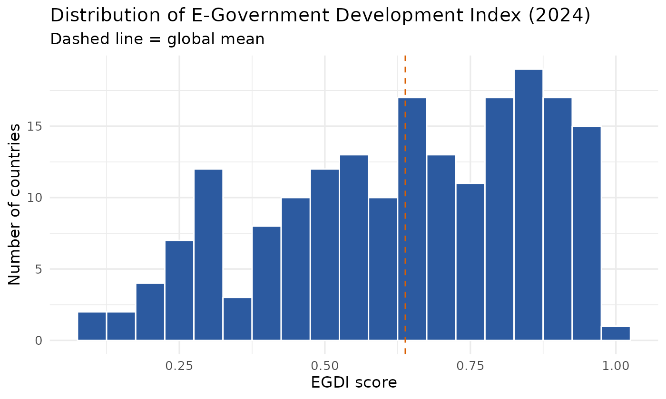
Figure 1. Histogram of EGDI scores for 193 countries (2024).
The histogram is not a single symmetric bell shape. The largest concentration of countries is between 0.80 and 0.95, there is a second, flatter cluster between roughly 0.45 and 0.70, and a thin tail of low scores below 0.35. The global mean (dashed line) sits in the middle of the distribution where relatively few countries are digitally mature and few are at the bottom, so a single average hides the difference between leaders and countries still building foundations.

4.3 Visualization 2: countries per EGDI group
R code
# 4.2 Countries per EGDI group
p2 <- ggplot(egdi, aes(x = group, fill = group)) +
geom_bar(show.legend = FALSE) +
geom_text(stat = "count", aes(label = after_stat(count)), vjust = -0.4) +
scale_fill_manual(values = pal) +
labs(title = "Number of countries in each EGDI group (2024)", x = NULL, y = "Countries")
ggsave("figures/fig2_groups.png", p2, width = 7, height = 4.2, dpi = 200, bg = "white")

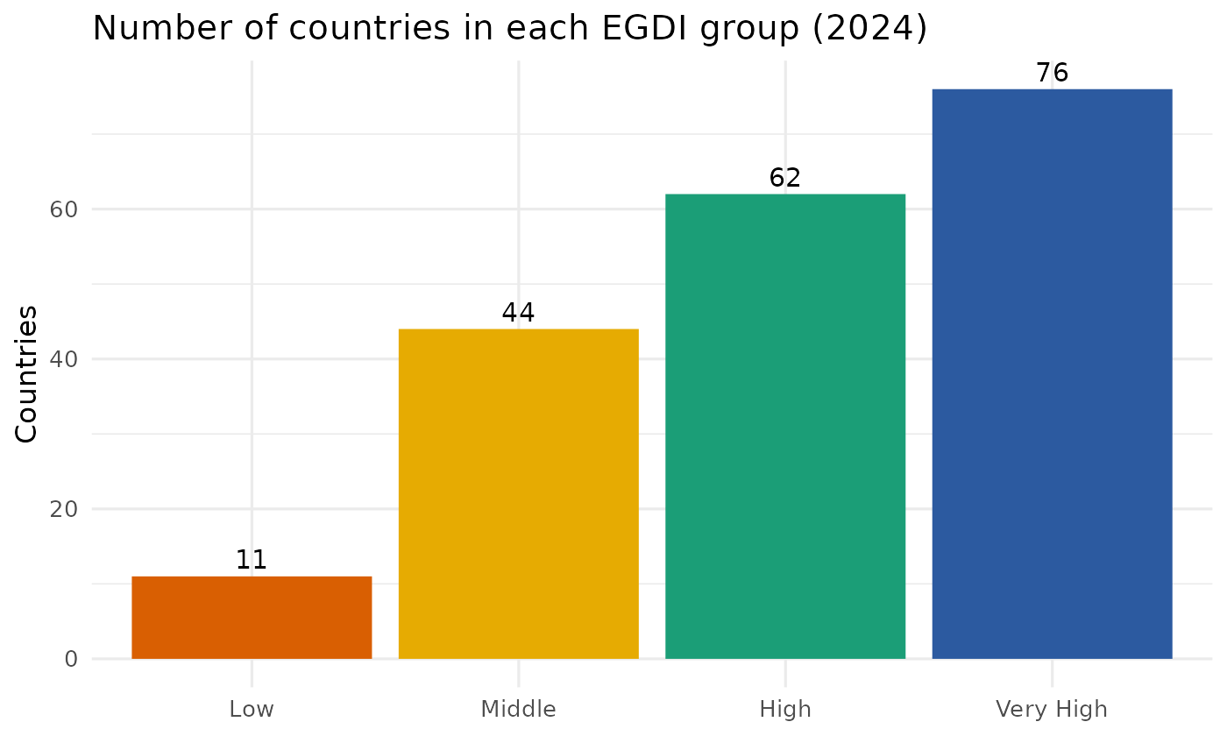
Figure 2. Number of countries in each EGDI group.
The counts confirm that digital government capability is now the norm rather than the exception: 138 of 193 countries (71.5%) are in the High or Very High groups. The challenge is concentrated in the 55 Middle and Low countries.

4.4 Visualization 3: score against rank, with India highlighted
R code
# 4.4 Scatter: rank vs score, India highlighted
p4 <- ggplot(egdi, aes(x = rank, y = egdi, colour = group)) +
geom_point(size = 2, alpha = 0.8) +
geom_point(data = india, colour = "black", size = 4, shape = 1, stroke = 1.2) +
annotate("text", x = india$rank + 6, y = india$egdi + 0.06, label = "India", fontface = "bold") +
scale_colour_manual(values = pal, name = "EGDI group") +
labs(title = "EGDI score against global rank (2024)", x = "Rank (1 = best)", y = "EGDI score")
ggsave("figures/fig4_rank_scatter.png", p4, width = 7, height = 4.2, dpi = 200, bg = "white")

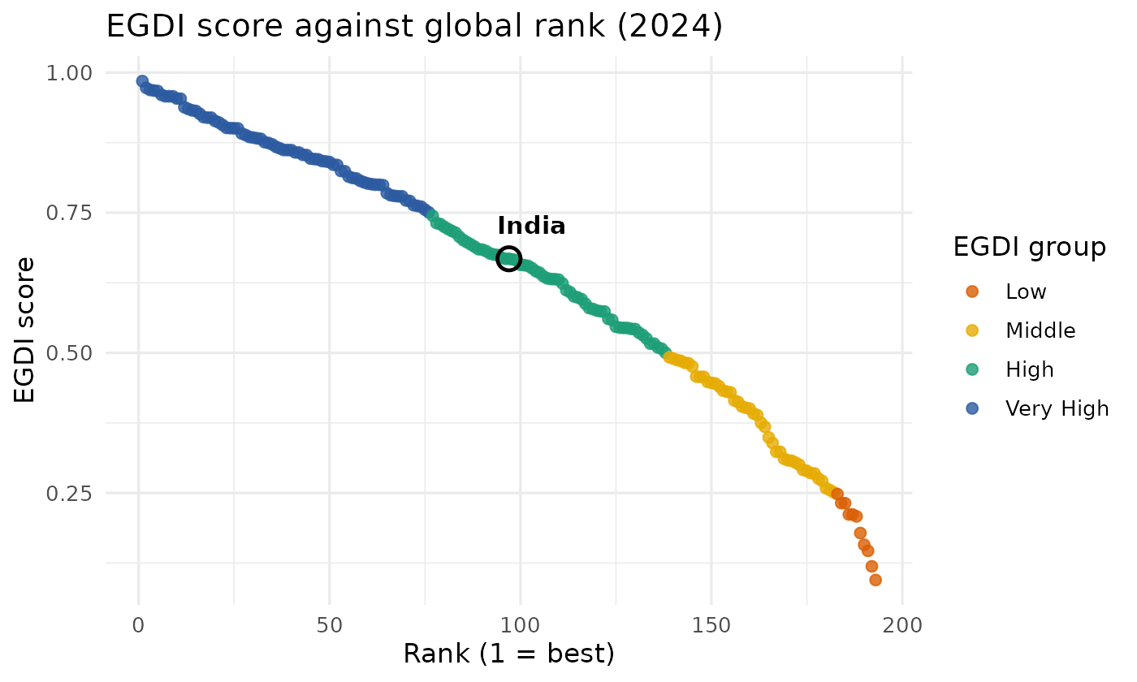
Figure 3. EGDI score against global rank, coloured by group. India is circled.
The curve is nearly linear through the top 75 or so ranks and then falls away steeply in the last 40. This means that moving up one rank is cheap in the middle of the table but each rank gained near the bottom corresponds to a large jump in score. India has an EGDI of 0.6678 (rank 97, High group), almost exactly at the global median (49.7% of countries score lower) and slightly above the global mean of 0.638.

4.5 Visualization 4: top 10 and bottom 10
R code
# 4.5 Top 10 and bottom 10
extremes <- bind_rows(
egdi %>% slice_min(rank, n = 10) %>% mutate(end = "Top 10"),
egdi %>% slice_max(rank, n = 10) %>% mutate(end = "Bottom 10")
) %>% mutate(end = factor(end, levels = c("Top 10", "Bottom 10")))

p5 <- ggplot(extremes, aes(x = reorder(country, egdi), y = egdi, fill = end)) +
geom_col(show.legend = FALSE) +
coord_flip() +
facet_wrap(~end, scales = "free_y") +
scale_fill_manual(values = c("#2c5aa0", "#d95f02")) +
scale_x_discrete(labels = function(x) stringr::str_wrap(x, 22)) +
labs(title = "Highest and lowest EGDI scores (2024)", x = NULL, y = "EGDI score")
ggsave("figures/fig5_top_bottom.png", p5, width = 9, height = 4.8, dpi = 200, bg = "white")

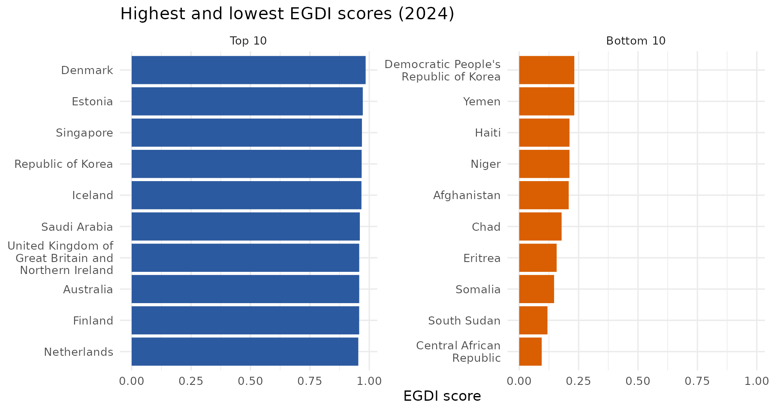
Figure 4. Ten highest and ten lowest EGDI scores.
The top ten is led by Denmark, Estonia, Singapore, the Republic of Korea and Iceland, with scores that are separated by less than 0.04. The bottom ten, from the Democratic People's Republic of Korea to the Central African Republic, are far more spread out. The leaders are tightly bunched at the ceiling of the index, while the laggards are not.

4.6 Visualization 5: questionnaire response status and EGDI
R code
# 4.3 Boxplot of EGDI by questionnaire response
p3 <- ggplot(egdi, aes(x = msq_response, y = egdi, fill = msq_response)) +
geom_boxplot(show.legend = FALSE, alpha = 0.8) +
scale_fill_manual(values = c("#9ecae1", "#fdae6b")) +
labs(title = "EGDI by Member State Questionnaire (MSQ) status",
x = NULL, y = "EGDI score")
ggsave("figures/fig3_msq_boxplot.png", p3, width = 7, height = 4.2, dpi = 200, bg = "white")

# ---------- 5. SIMPLE STATISTICAL TEST ----------
# Do countries that did not respond to the MSQ score differently?
wt <- wilcox.test(egdi ~ msq_response, data = egdi)
print(wt)

R output
Wilcoxon rank sum test with continuity correction

data: egdi by msq_response
W = 2450.5, p-value = 3.744e-08
alternative hypothesis: true location shift is not equal to 0

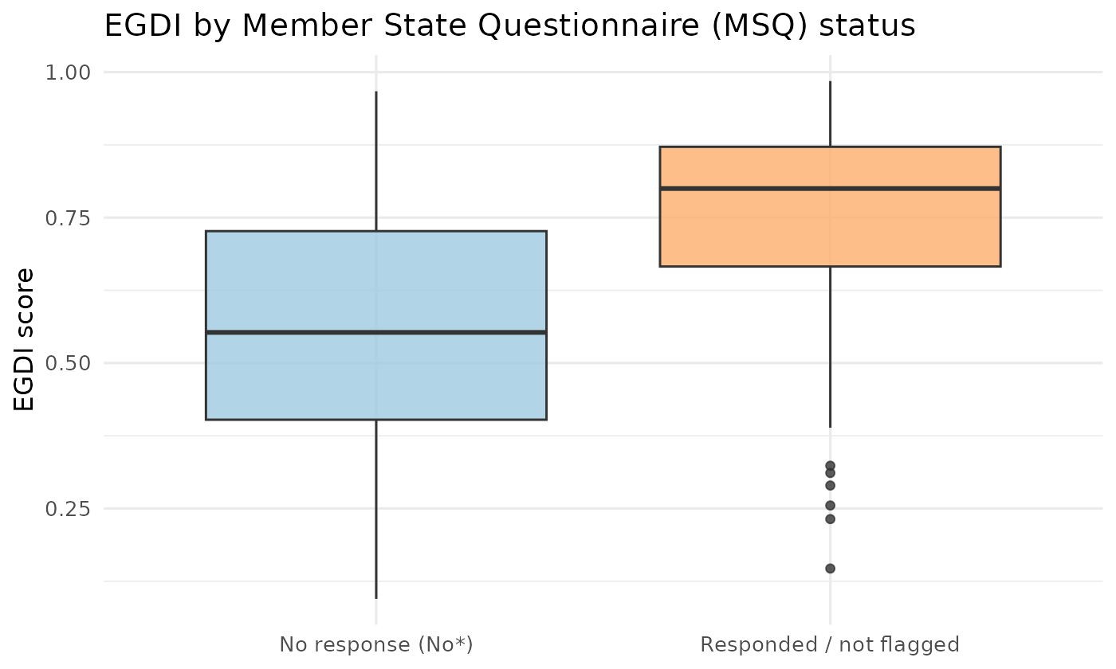
Figure 5. EGDI by Member State Questionnaire (MSQ) status.
Countries flagged "No*" have a lower median EGDI (0.553) than the others (0.800), and a Wilcoxon rank-sum test (chosen because the scores are not normally distributed) gives p < 0.001. This is an association only; it does not show that failing to respond causes a lower score. A more plausible explanation is that countries with weaker institutions and fewer digital resources find it harder to complete international surveys.

5. Process Overview: Challenges, Decisions and Next Steps

5.1 Challenges encountered
- The UN table is designed for display on a web page. It contains a flag column that is blank for some countries and "No*" for others, which looks like missing data but is actually meaningful.
- The public table contains only the overall EGDI score, group, class and rank. The three sub-indices (OSI, TII, HCI) and the region of each country are published separately in the Survey annexes, so they could not be analysed in this first pass.
- Rank ties on rounded scores (four pairs of countries) could be mistaken for data errors if not examined.
- The EGDI is a relative index, not an absolute measure. A country can improve its services and still fall in rank if others improve faster, so the scores must be interpreted with care.

5.2 Key decisions made
- Chose a composite, internationally recognised index over a narrow dataset, because it allows comparison across all countries and links to later weeks of the project.
- Recoded rather than deleted blank MSQ values, to avoid losing 43% of the rows and to keep an analytically interesting variable.
- Kept official UN country names (except Georgia) to preserve compatibility with other UN datasets.
- Used a non-parametric test (Wilcoxon) because the distribution is multi-peaked and left-skewed, which violates the normality assumption of a t-test.
- Wrote all steps in a single reproducible R script so that the full analysis can be re-run by changing only the input file.

5.3 Limitations
- The meaning of the "No*" flag is interpreted as "no questionnaire response" based on the column name and the layout of the UN table. This should be confirmed against the UN technical notes before drawing firm conclusions.
- Only one year (2024) was analysed, so no trends can be claimed.

5.4 Potential next steps for in-depth analysis
- Add the three sub-indices (OSI, TII, HCI) and study which component drives each country's score. In the 2022 UN Survey, for example, India recorded a very high Online Service Index (0.79) despite a much lower Telecommunication Infrastructure Index (0.40), which shows why the components matter.
- Add EGDI data from earlier editions (2003 to 2022) to analyse trends and identify the fastest improvers.
- Merge with World Bank indicators such as GDP per capita, internet users and mobile subscriptions, then fit a regression to test how much income explains e-government performance.
- Compare India with its regional peers (South Asia) and with similar-income countries.
- Add the E-Participation Index to look specifically at citizen feedback and engagement.

6. Conclusion
This preliminary analysis shows that the UN EGDI 2024 is a clean and well-structured dataset that is suitable for e-governance analytics. Digital government capability is broadly strong worldwide (71.5% of countries are in the High or Very High group), but the distribution is uneven and the gap between leaders and laggards is large. India sits at the global median with a score of 0.668 and a rank of 97. The dataset passed all validation checks, and the main data quality point is a flag column that is blank for 43% of countries. The next stage should bring in the sub-indices, earlier years and socio-economic indicators to move from description towards explanation.

Appendix A. Data Saving and Reproducibility
R code
# ---------- 6. SAVE CLEAN DATA ----------
write_csv(egdi %>% select(-group_check), "data/egdi_2024_clean.csv")
cat("\nDone. Clean file and figures saved.\n")

Files delivered with this report: egov_analysis.R (full script), data/egdi_2024_raw.csv (input), data/egdi_2024_clean.csv (cleaned output), and the five PNG figures in the figures folder.

Appendix B. Source
United Nations Department of Economic and Social Affairs, Division for Public Institutions and Digital Government. UN E-Government Survey 2024 and E-Government Knowledgebase Data Center: https://publicadministration.un.org/egovkb/Data-Center

