Week 3 Task
Data Visualization and Reporting for Digital Services
A mini case study: what the UN E-Government Development Index 2024 tells digital service planners | Package: ggplot2

1. Introduction and Objective
Numbers in a table rarely persuade anyone; a well-built chart can. In digital government, visualizations are used to brief ministers, justify budgets and show citizens how their country compares. The goal of this task is to use R and ggplot2 to turn the transformed EGDI 2024 dataset from Week 2 into a small set of clear, honest and decision-oriented visuals, and to explain what each one means for digital service strategy.
The report is written as a mini case study built around one question: Where should digital government effort and support go next, and where does India stand?

2. Data and Visual Exploration
The data comes from the Week 2 pipeline: 193 countries, 18 variables including region, peer group, gap to the Very High threshold and a policy priority tier, plus three summary tables. Week 1 had already shown that scores are widely spread (mean 0.638, standard deviation 0.228) and that the distribution is uneven. The visual exploration therefore looked for where the differences come from, and looked at four levels: regions, countries within regions, India and its peers, and countries close to a classification threshold.
Question | Chart type chosen | Why this chart type
How do regions compare on average? | Ordered horizontal bar with benchmark line | Ranking and exact values are the message
How different are countries inside a region? | Box plot with individual points | Shows spread, outliers and each country
What is the make-up of each region? | 100% stacked bar | Compares shares when regions have different sizes
How does India compare with its neighbours? | Highlighted bar with two reference lines | Draws the eye to India without hiding peers
Who is close to the next level? | Lollipop to a threshold | Distance to a target is the message
Where is support most needed? | Stacked bar by policy tier | Counts per tier and region, for budgeting
Is reporting linked to performance? | Bubble scatter by region | Two numeric variables plus group size

3. Design Choices Applied to Every Chart
Before drawing any chart I fixed a small set of design rules so that the figures look like one report and are easy to read:
- Colour-blind-safe palette. One colour per EGDI group (orange, amber, green, blue), reused in every chart so that readers learn the meaning once. India always appears in magenta.
- Titles that state the finding, not just the topic, with a subtitle that says exactly what is measured, and a source line.
- Direct labels instead of legends wherever possible (values on bars, "India" next to its dot).
- Reference lines (world mean, Very High threshold) so that each value can be judged against something.
- One reusable theme, theme_egov(), so that every change to fonts or spacing is made once.
R code
# ---------- 1. LOAD TRANSFORMED DATA ----------
egdi <- read_csv("data/egdi_2024_transformed.csv", show_col_types = FALSE) %>%
mutate(group = factor(group, levels = c("Low", "Middle", "High", "Very High")))
reg_sum <- read_csv("data/region_summary.csv", show_col_types = FALSE)
reg_grp <- read_csv("data/region_group_long.csv", show_col_types = FALSE) %>%
mutate(group = factor(group, levels = c("Low", "Middle", "High", "Very High")))

global_mean <- mean(egdi$egdi)
region_order <- reg_sum$region # already sorted by mean EGDI (high -> low)

# ---------- 2. SHARED DESIGN CHOICES ----------
# Colour-blind-safe palette, one colour per EGDI group, reused in every chart
pal_group <- c("Low" = "#D55E00", "Middle" = "#E69F00", "High" = "#009E73", "Very High" = "#0072B2")
india_col <- "#CC0066"

theme_egov <- function() {
theme_minimal(base_size = 12) +
theme(plot.title = element_text(face = "bold", size = 14),
plot.title.position = "plot", plot.caption.position = "plot",
plot.subtitle = element_text(colour = "grey35"),
plot.caption = element_text(colour = "grey45", size = 8),
panel.grid.minor = element_blank(),
legend.position = "bottom")
}
src <- "Source: UN E-Government Survey 2024 (EGDI). Regions per UN DESA."

4. Visualizations and Interpretation

4.1 Iteration: from default chart to communication chart
The first version of the regional comparison used ggplot2 defaults. It is technically correct, but it does not help a reader: bars are in alphabetical order, there is no benchmark, no values and no message. I improved it in five steps and kept the final version.
R code
# ---------- 3. ITERATION 1 vs 2: REGIONAL AVERAGES ----------
# Version 1: ggplot defaults (no ordering, no labels, no context)
v1 <- ggplot(reg_sum, aes(region, mean_egdi)) + geom_col()
ggsave("figures/w3_regional_v1_default.png", v1, width = 7, height = 4, dpi = 200, bg = "white")

# Version 2: ordered, labelled, global benchmark, horizontal for readability
v2 <- ggplot(reg_sum, aes(x = reorder(region, mean_egdi), y = mean_egdi)) +
geom_col(fill = "#0072B2", width = 0.65) +
geom_text(aes(label = sprintf("%.3f", mean_egdi)), hjust = -0.15, size = 4) +
geom_hline(yintercept = global_mean, linetype = "dashed", colour = "#D55E00") +
annotate("text", x = 0.55, y = global_mean + 0.01, label = sprintf("World mean %.3f", global_mean),
hjust = 0, vjust = 0, colour = "#D55E00", size = 3.6) +
coord_flip(ylim = c(0, 1)) +
labs(title = "Europe leads digital government;\nAfrica has the most ground to cover",
subtitle = "Mean EGDI by region, 2024 (0 = lowest, 1 = highest)",
x = NULL, y = "Mean EGDI score", caption = src) +
theme_egov()
ggsave("figures/w3_regional_v2_refined.png", v2, width = 7, height = 4, dpi = 200, bg = "white")

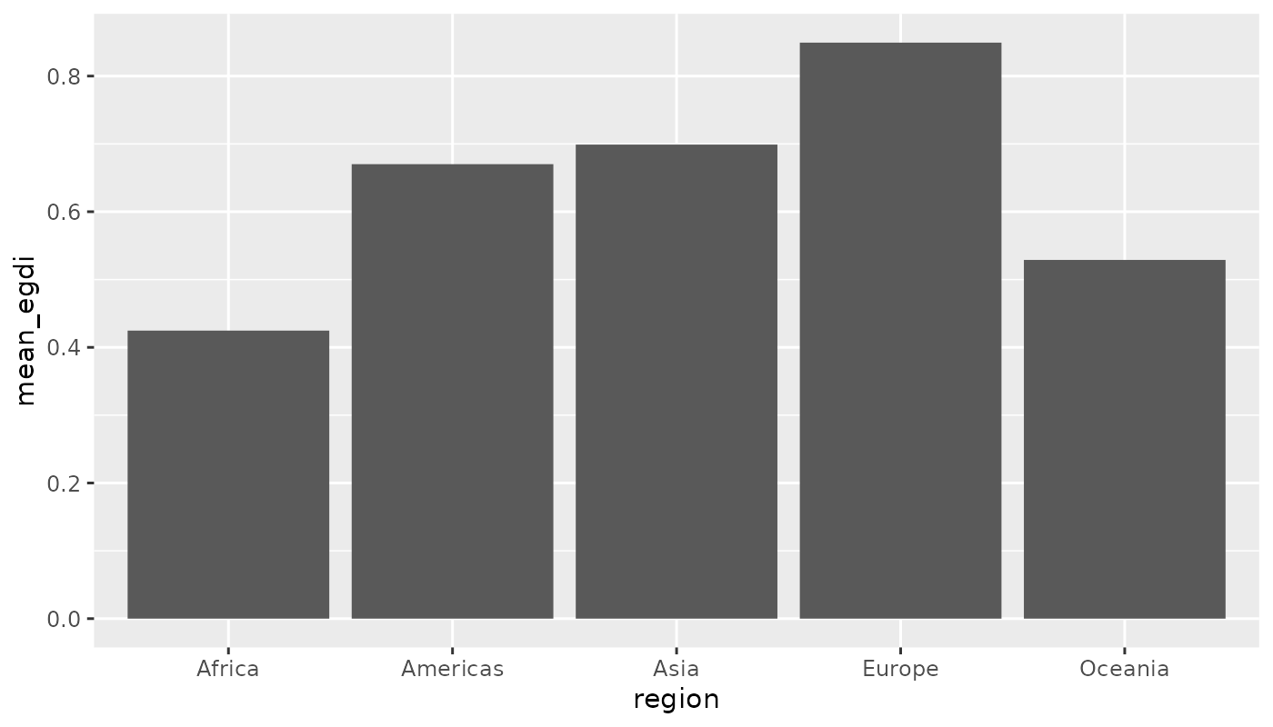
Figure 1a. Version 1: ggplot2 defaults.
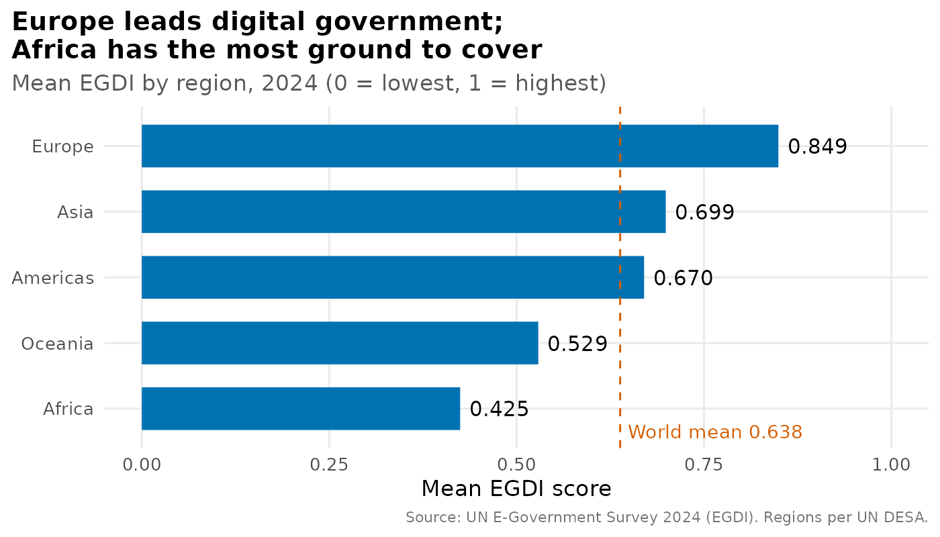
Figure 1b. Version 2: refined chart that states the finding.
Improvement | Reason
Sorted bars by value with reorder() | Alphabetical order hides the ranking
Added value labels | Readers do not have to estimate from the axis
Added dashed world-mean line | Gives a benchmark; shows Asia and Europe above and the others below
Flipped to horizontal bars | Easier to read category names and rank from top to bottom
Replaced default grey with palette colour, removed grey panel, added finding-style title and source | Cleaner look and a clear message

Interpretation. Europe has a mean EGDI of 0.849, followed by Asia (0.699) and the Americas (0.670). Only these three regions are above the world mean of 0.638. Oceania (0.529) and Africa (0.425) are below it. Africa's average is about half of Europe's.
Implication for digital service strategy. Global averages hide very different starting points. Programmes and donor funding should be designed regionally: Europe is competing on advanced services, while Africa still needs infrastructure and skills.

4.2 Variation inside regions
R code
# ---------- 4. SPREAD WITHIN REGIONS (box + jitter, India labelled) ----------
egdi <- egdi %>% mutate(region = factor(region, levels = region_order))
india <- egdi %>% filter(country == "India")

p_spread <- ggplot(egdi, aes(x = region, y = egdi)) +
geom_boxplot(outlier.shape = NA, fill = "grey92", colour = "grey40", width = 0.55) +
geom_jitter(aes(colour = group), width = 0.12, size = 1.8, alpha = 0.8) +
geom_point(data = india, shape = 21, size = 4.5, stroke = 1.3, colour = india_col, fill = NA) +
annotate("text", x = as.numeric(india$region) + 0.38, y = india$egdi, label = "India",
colour = india_col, fontface = "bold", size = 4) +
scale_colour_manual(values = pal_group, name = "EGDI group") +
labs(title = "Asia and Oceania hide the widest gaps\nbetween countries",
subtitle = "EGDI of every country, by region (each dot = one country)",
x = NULL, y = "EGDI score", caption = src) +
theme_egov()
ggsave("figures/w3_regional_spread.png", p_spread, width = 8, height = 4.8, dpi = 200, bg = "white")

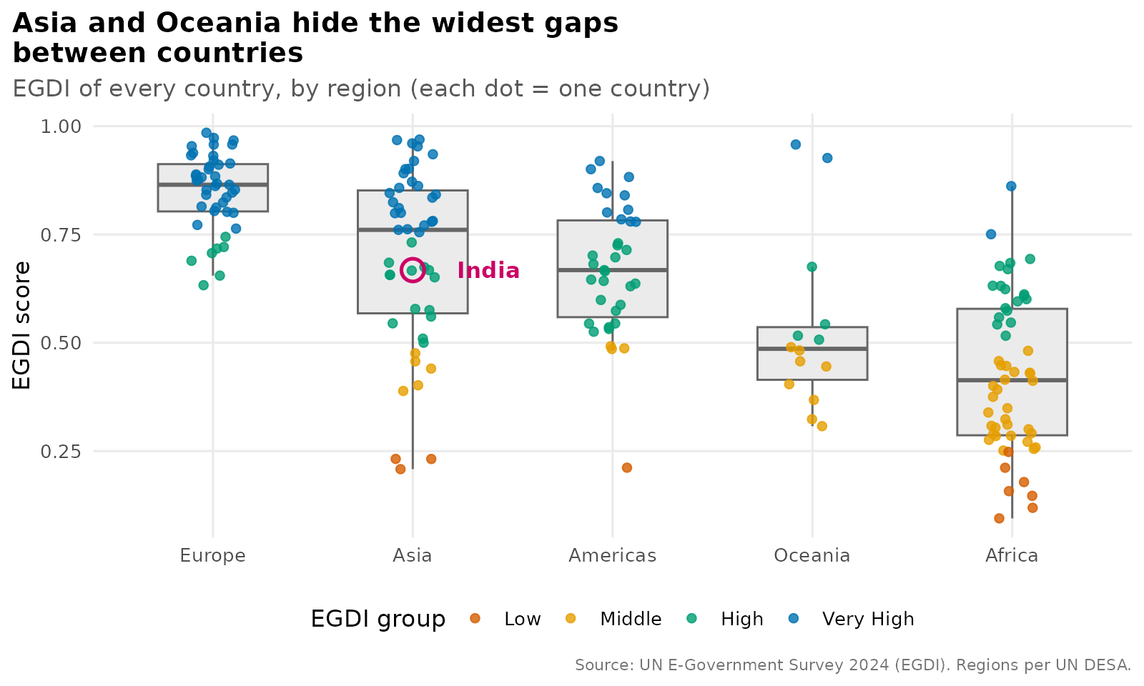
Figure 2. EGDI of every country, by region. India is circled.
Interpretation. The averages in Figure 1 hide large differences. Europe is tightly clustered (standard deviation 0.088), while Asia (0.204) and Oceania (0.199) are the most spread out: Asia contains world leaders such as Singapore and the Republic of Korea but also countries with scores near 0.2. Africa is spread too (0.179), though almost entirely in the lower half. India (circled) sits just below the middle of the Asian box and clearly below the Asian median of 0.761.
Implication. Regional peer learning is more realistic than global comparison. A high-scoring Asian country can serve as a peer model for a low-scoring neighbour, while a regional average would suggest all are similar.

4.3 Composition of each region
R code
# ---------- 5. COMPOSITION: SHARE OF COUNTRIES BY GROUP (100% stacked) ----------
p_share <- reg_grp %>%
mutate(region = factor(region, levels = rev(region_order))) %>%
ggplot(aes(x = region, y = share, fill = group)) +
geom_col(width = 0.7, colour = "white") +
geom_text(aes(label = ifelse(share >= 6, paste0(round(share), "%"), "")),
position = position_stack(vjust = 0.5), colour = "white", size = 3.6, fontface = "bold") +
scale_fill_manual(values = pal_group, name = "EGDI group", breaks = names(pal_group)) +
scale_y_continuous(labels = label_percent(scale = 1)) +
coord_flip() +
labs(title = "Every European country is High or Very High;\nonly 19 of 54 African countries are",
subtitle = "Share of countries in each EGDI group, by region (2024)",
x = NULL, y = "Share of countries", caption = src) +
theme_egov()
ggsave("figures/w3_group_share.png", p_share, width = 8, height = 4.5, dpi = 200, bg = "white")

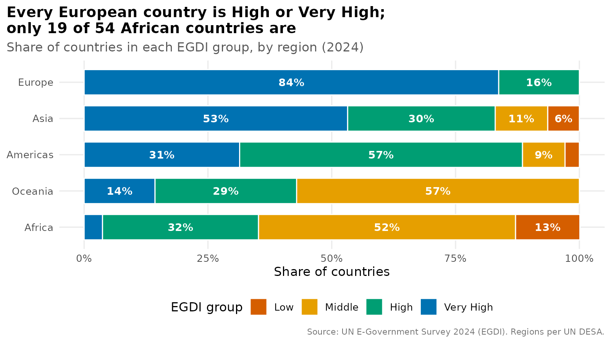
Figure 3. Share of countries in each EGDI group, by region.
Interpretation. Using shares rather than counts makes regions of different sizes comparable. All 43 European countries are High or Very High (84% Very High). In Asia 83% are High or Very High, in the Americas 89%. In Oceania the figure is 43% and in Africa only 35% (19 of 54 countries). More than half of Africa (52%) and of Oceania (57%) is in the Middle group, and 13% of African countries are in the Low group.
Implication. The digital divide is regional and concentrated. Strategies for "the Middle group" are in practice strategies for Africa and Oceania, and these countries are often small, island or low-income states with limited capacity of their own.

4.4 India and its South Asian peers
R code
# ---------- 6. INDIA vs SOUTH ASIA PEERS ----------
sa <- egdi %>% filter(peer_group != "Other countries") %>%
mutate(is_india = country == "India")
sa_mean <- mean(sa$egdi)

p_sa <- ggplot(sa, aes(x = reorder(country, egdi), y = egdi, fill = is_india)) +
geom_col(width = 0.7, show.legend = FALSE) +
geom_text(aes(label = sprintf("%.3f (rank %d)", egdi, rank)), hjust = -0.05, size = 3.6) +
geom_hline(yintercept = global_mean, linetype = "dashed", colour = "#D55E00") +
geom_hline(yintercept = sa_mean, linetype = "dotted", colour = "grey30") +
annotate("text", x = 8.6, y = global_mean, label = " World mean", hjust = 0, vjust = 0,
colour = "#D55E00", size = 3.4) +
annotate("text", x = 8.6, y = sa_mean, label = "South Asia mean ", hjust = 1, vjust = 0,
colour = "grey30", size = 3.4) +
scale_fill_manual(values = c("FALSE" = "#7FB3D5", "TRUE" = india_col)) +
coord_flip(ylim = c(0, 0.95), clip = "off") +
labs(title = "India ranks second in South Asia,\njust behind the Maldives",
subtitle = "EGDI 2024 for SAARC member states; India highlighted",
x = NULL, y = "EGDI score", caption = src) +
theme_egov()
ggsave("figures/w3_south_asia.png", p_sa, width = 8, height = 4.5, dpi = 200, bg = "white")

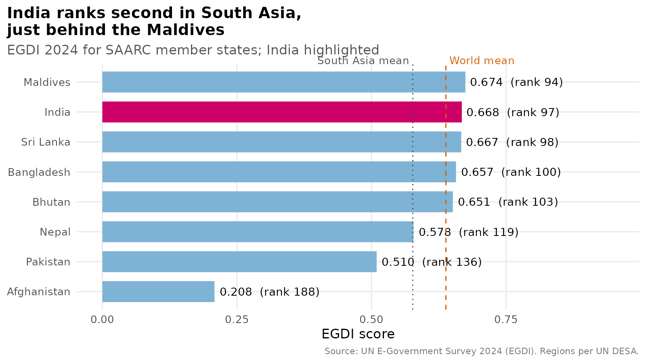
Figure 4. EGDI of SAARC member states; India highlighted.
Interpretation. India (0.668, global rank 97) is second in South Asia, narrowly behind the Maldives (0.674, rank 94) and just ahead of Sri Lanka (0.667), Bangladesh (0.657) and Bhutan (0.651). All five are in the High group and sit within 0.025 of each other, so small changes could reorder them. India is slightly above the world mean (0.638). Nepal (0.578) and Pakistan (0.510) are in the High group but lower, and Afghanistan (0.208) is in the Low group. This one country pulls the South Asia mean down to 0.577; without it the mean is 0.629.
Implication. India's peers are close competitors, not distant ones, so progress in rank will depend on relative improvement. The wide gap to Afghanistan also suggests a role for regional cooperation and knowledge transfer.

4.5 Who is close to the next level?
R code
# ---------- 7. DECISION VIEW: COUNTRIES CLOSEST TO THE VERY HIGH THRESHOLD ----------
near <- egdi %>% filter(group == "High") %>% arrange(gap_to_very_high) %>% slice_head(n = 12)
near <- bind_rows(near, india %>% filter(!country %in% near$country)) %>%
mutate(country = stringr::str_wrap(country, 24), is_india = country == "India")

p_near <- ggplot(near, aes(x = reorder(country, -gap_to_very_high), y = egdi)) +
geom_segment(aes(xend = country, y = egdi, yend = 0.75), colour = "grey60", linewidth = 1) +
geom_point(aes(colour = is_india), size = 4, show.legend = FALSE) +
geom_hline(yintercept = 0.75, colour = "#0072B2", linewidth = 1) +
annotate("text", x = 1, y = 0.752, label = "Very High threshold (0.75)", hjust = 0, vjust = -0.5,
colour = "#0072B2", size = 3.6) +
scale_colour_manual(values = c("FALSE" = "#009E73", "TRUE" = india_col)) +
coord_flip(ylim = c(0.64, 0.81)) +
labs(title = "Belarus is within 0.006 of Very High; India needs +0.082",
subtitle = "High-group countries closest to the Very High threshold (India added for reference)",
x = NULL, y = "EGDI score", caption = src) +
theme_egov()
ggsave("figures/w3_near_threshold.png", p_near, width = 8, height = 5, dpi = 200, bg = "white")

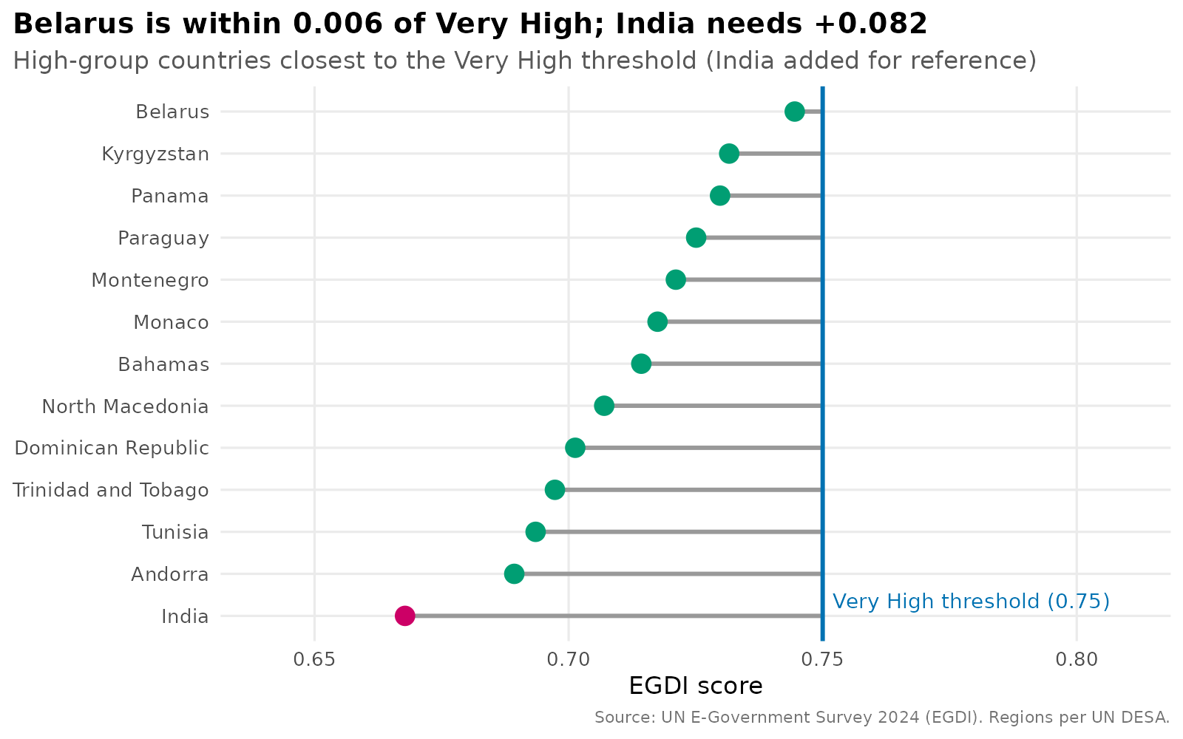
Figure 5. High-group countries closest to the Very High threshold (0.75). India added for reference.
Interpretation. Belarus is only 0.006 below the Very High threshold, and nine High-group countries are within 0.05 of it. India, at 0.668, needs a gain of 0.082 to reach the same level, which is larger than the gap of any country shown above it. The lollipop format makes the remaining distance visible, whereas a ranked table would show only the order.
Implication. This is the kind of chart that supports target setting. Countries near the line can reach the next category with focused effort on their weakest component, while countries farther away, such as India, need sustained, multi-cycle investment. Because the EGDI is relative, targets should be set on the score and not only on the rank.

4.6 Where is support needed? Priority tiers
R code
# ---------- 8. PRIORITY TIERS BY REGION (from Week 2 case_when) ----------
tier_cols <- c("Tier 1: Leader (maintain)" = "#0072B2", "Tier 2: Consolidate" = "#009E73",
"Tier 3: Accelerate" = "#E69F00", "Tier 4: Foundational support" = "#D55E00")
p_tier <- egdi %>% count(region, priority_tier) %>%
ggplot(aes(x = region, y = n, fill = priority_tier)) +
geom_col(colour = "white", width = 0.7) +
geom_text(aes(label = n), position = position_stack(vjust = 0.5), colour = "white",
fontface = "bold", size = 3.6) +
scale_fill_manual(values = tier_cols, name = NULL) +
labs(title = "Where support is needed: 55 countries sit\nin the two lowest priority tiers",
subtitle = "Number of countries per policy priority tier, by region",
x = NULL, y = "Number of countries", caption = src) +
theme_egov() + theme(legend.text = element_text(size = 9))
ggsave("figures/w3_priority_tiers.png", p_tier, width = 8, height = 4.8, dpi = 200, bg = "white")

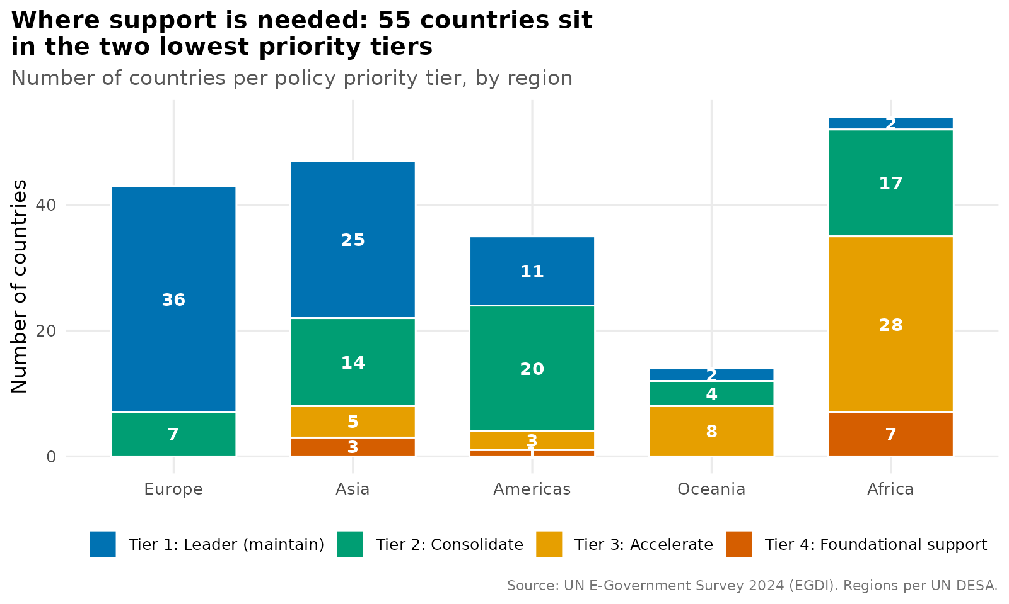
Figure 6. Number of countries per policy priority tier, by region.
Interpretation. The priority tiers created in Week 2 are shown by region. Of the 55 countries in Tier 3 (Accelerate) or Tier 4 (Foundational support), 35 are in Africa (28 + 7), 8 in Oceania, 8 in Asia and 4 in the Americas. Europe has none. The 11 Tier 4 countries are 7 in Africa, 3 in Asia and 1 in the Americas.
Implication. For funding agencies and development partners, the chart is a ready-made allocation view: roughly two thirds of countries needing the most support are in one region, but support is also needed in specific countries elsewhere, so a purely regional approach would miss them.

4.7 Reporting and performance
R code
# ---------- 9. OPEN-DATA PARTICIPATION: QUESTIONNAIRE RESPONSE vs SCORE ----------
p_msq <- ggplot(reg_sum, aes(x = msq_response_rate, y = mean_egdi, label = region)) +
geom_point(aes(size = countries), colour = "#0072B2", alpha = 0.8) +
geom_text(vjust = -1.4, size = 3.8) +
scale_size_continuous(range = c(4, 12), name = "Countries") +
scale_x_continuous(limits = c(10, 75), labels = label_percent(scale = 1)) +
scale_y_continuous(limits = c(0.35, 0.92)) +
labs(title = "Questionnaire response and EGDI tend to rise\ntogether (Europe is the exception)",
subtitle = "Regional response rate to the UN Member State Questionnaire vs mean EGDI",
x = "Share of countries with a questionnaire response", y = "Mean EGDI", caption = src) +
theme_egov()
ggsave("figures/w3_msq_vs_egdi.png", p_msq, width = 8, height = 4.8, dpi = 200, bg = "white")

cat("All figures saved.\n")

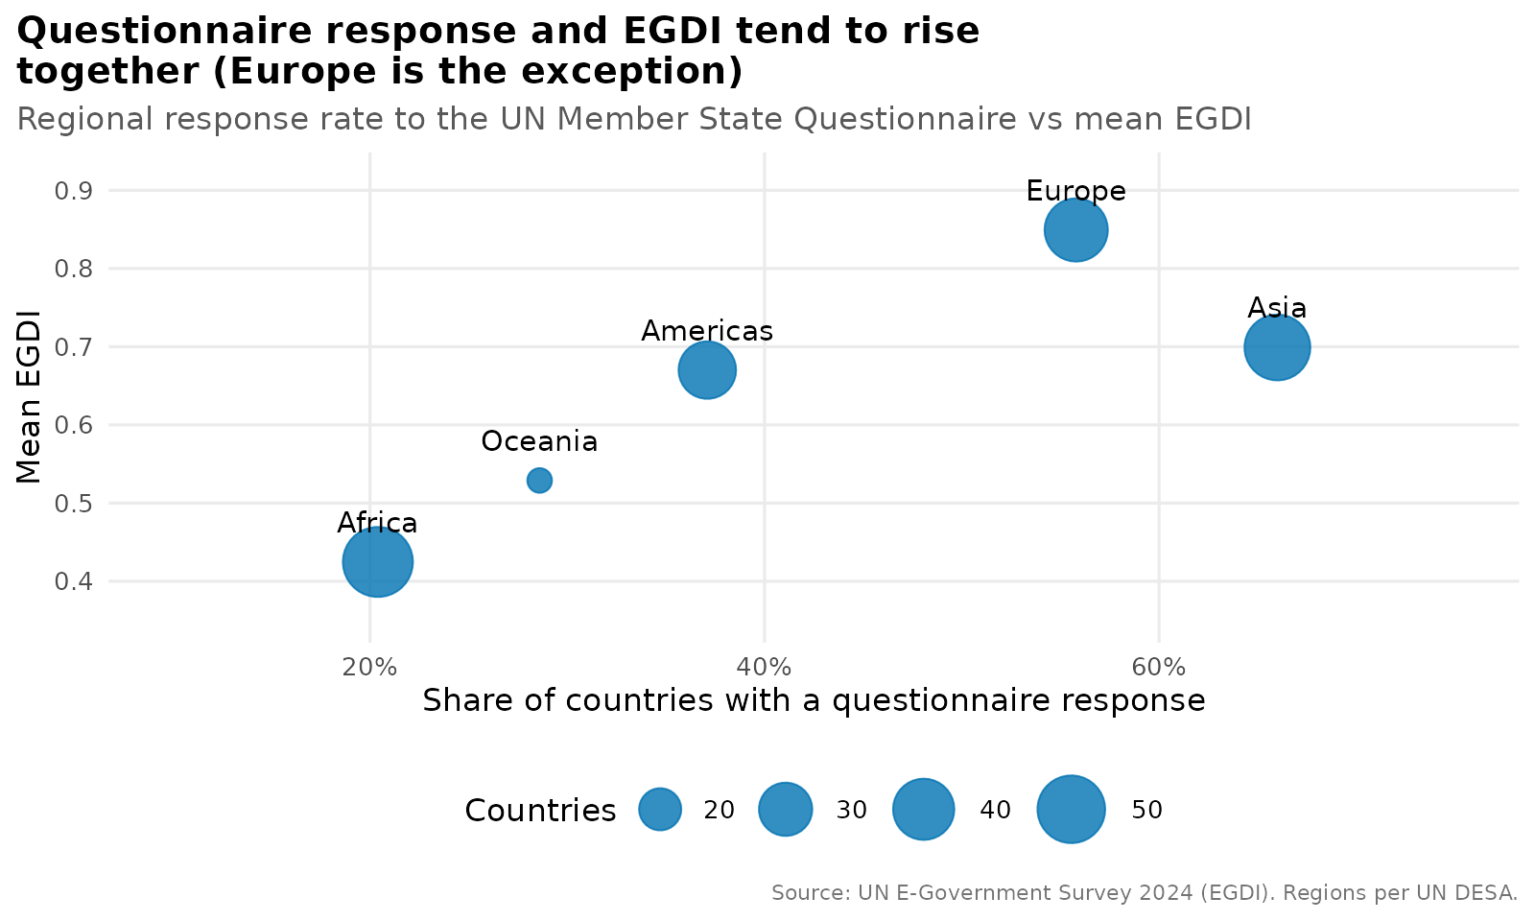
Figure 7. Questionnaire response rate and mean EGDI by region (bubble size = number of countries).
Interpretation. Regions with higher questionnaire response rates tend to have higher mean EGDI: Africa (20% response, 0.425) and Oceania (29%, 0.529) are at the bottom left, and Asia (66%, 0.699) is at the right. Europe is the exception, with a score of 0.849 on a response rate of 56%. With only five regions this is a pattern to note, not proof of a relationship, and the meaning of the "No*" flag should be confirmed with the UN documentation.
Implication. If non-response reflects limited administrative capacity, then the survey itself may under-measure the countries that need the most help. Better data collection support should be treated as part of digital government capacity building.

5. Summary of Insights and Their Uses
Visual | Key insight | How it can inform digital service strategy
Regional means (Fig. 1) | Europe 0.849 vs Africa 0.425; only three regions above the world mean | Design programmes and benchmarks by region
Spread (Fig. 2) | Asia and Oceania are the most unequal regions | Use regional peer learning, not global averages
Composition (Fig. 3) | 100% of Europe vs 35% of Africa in High or Very High | Target support at Middle and Low groups
South Asia (Fig. 4) | India second to the Maldives; five peers within 0.025 | Set targets on relative improvement
Threshold (Fig. 5) | Nine countries within 0.05 of Very High; India needs +0.082 | Prioritise near-threshold countries for quick wins
Priority tiers (Fig. 6) | 35 of 55 highest-need countries are in Africa | Allocate capacity-building funds
Reporting (Fig. 7) | Response rate and score rise together, except Europe | Treat data capacity as part of the programme

6. Reflection: Iteration and Learnings
- Message first. The biggest improvement came from asking what each chart should make the reader do, then writing that into the title. A chart title that states the finding turned decorative charts into arguments.
- Check every claim against the data. While writing titles I found three statements that were wrong when checked against the data (for example, I had assumed India led South Asia, but the Maldives is ahead). I corrected the titles and always verify numbers in titles before saving.
- Fix text clipping and overlap. Long titles were cut off at the plot edge, and a threshold label was clipped. I solved these with left-aligned plot titles, manual line breaks, and wider axis limits.
- Keep encodings consistent. Reusing the same colours for the same groups across charts meant the reader did not need to relearn the legend.
- Limits of the data. Only one survey year is used, so no trends can be shown, and region-level comparisons rely on five points. These limits are noted next to the relevant findings.

Possible extensions
- A world choropleth map of EGDI (needs a country-code join to a map file, which is a good use of the join skills from Week 2).
- Time-series charts of EGDI change when earlier survey years are added.
- Component breakdown charts (OSI, TII, HCI) to show which dimension holds a country back.
- An interactive dashboard (Shiny or plotly) so that policy teams can filter by region or income group.

7. Conclusion
The visualizations show that digital government progress is broad but uneven. Most of the world is at least at the High level, yet the remaining gap is concentrated in Africa and Oceania, and very large differences exist inside Asia. India is a mid-table, High-group country, second in its neighbourhood, and about 0.08 away from the Very High level. When charts state their finding, give a benchmark and keep a consistent design, they move from describing data to guiding decisions about where to invest, which countries to learn from and which to support.

Appendix: Files and Source
week3_visualize.R (script); figures/w3_*.png (seven finished charts and the default version used in the iteration). Source: UN DESA E-Government Survey 2024, https://publicadministration.un.org/egovkb/Data-Center

