Week 4 Task
Statistical Analysis and Predictive Modeling in E-Governance
Does national income explain digital government performance, and can we predict it? | UN EGDI 2024 + World Bank GDP and population | R

1. Introduction and Objective
Governments increasingly need to know not only how well they are doing in digital services but also what level of performance is realistic given their circumstances, and which countries are doing better or worse than expected. This task applies statistical analysis and predictive modeling in R to answer those questions with the UN E-Government Development Index (EGDI) 2024, combined with World Bank economic data.
Research questions
- Q1. Do regions differ in e-government performance, and how precisely can we estimate the averages?
- Q2. How strongly is EGDI related to national income (GDP per capita)?
- Q3. Can a model predict a country's EGDI from GDP per capita, region, population and survey participation, and how accurate is it on countries it has not seen?
- Q4. Can a logistic model predict which countries reach the "Very High" EGDI level (0.75 or above)?
- Q5. Which countries, including India, perform above or below what the model predicts?

2. Data Selection and Preprocessing

2.1 Datasets
Dataset | Content | Source
egdi_2024_transformed.csv | 193 countries: EGDI score, group, rank, region, questionnaire flag (output of Week 2) | UN DESA E-Government Survey 2024
wb_gdp_raw.csv | GDP in current US$, by country and year, to 2023 | World Bank data (GitHub "datasets" mirror)
wb_pop_raw.csv | Population by country and year | World Bank data (GitHub "datasets" mirror)
wb_name_map.csv | Lookup from UN country names to World Bank names (25 differences) | Compiled by me

Statistical and predictive work needs explanatory variables, which the EGDI table alone does not have. GDP per capita is the most widely used measure of national resources and is available for almost every country, which makes it a sensible first predictor. Population is added because the size of a country affects administrative scale, and the questionnaire flag is kept because Week 1 showed it was associated with score.

2.2 Preprocessing steps
R code
# ---------- 1. LOAD AND PREPARE DATA ----------
egdi <- read_csv("data/egdi_2024_transformed.csv", show_col_types = FALSE)
gdp <- read_csv("data/wb_gdp_raw.csv", show_col_types = FALSE) %>%
rename(wb_name = `Country Name`, iso3 = `Country Code`, year = Year, gdp_usd = Value)
pop <- read_csv("data/wb_pop_raw.csv", show_col_types = FALSE) %>%
select(iso3 = `Country Code`, year = Year, population = Value)
name_map <- read_csv("data/wb_name_map.csv", show_col_types = FALSE) # EGDI name -> World Bank name

# Keep the latest GDP value per country, but only if it is recent (2019-2023)
indicators <- gdp %>%
filter(year >= 2019, year <= 2023, !is.na(gdp_usd)) %>%
group_by(iso3) %>% slice_max(year, n = 1) %>% ungroup() %>%
left_join(pop, by = c("iso3", "year")) %>% # population for the SAME year
mutate(gdp_pc = gdp_usd / population) %>%
select(wb_name, iso3, wb_year = year, gdp_pc, population)

full <- egdi %>%
left_join(name_map, by = "country") %>%
left_join(indicators, by = "wb_name")

cat("Countries in EGDI:", nrow(full), "\n")
cat("Missing GDP per capita or population:", sum(is.na(full$gdp_pc) | is.na(full$population)), "\n")
print(full %>% filter(is.na(gdp_pc) | is.na(population)) %>% select(country, region, egdi) %>% arrange(desc(egdi)), n = 30)
cat("Data year used (World Bank):\n"); print(table(full$wb_year, useNA = "ifany"))

# Analysis table: complete cases, log-transformed predictors, binary outcome
df <- full %>%
filter(!is.na(gdp_pc), !is.na(population)) %>%
mutate(log_gdp = log10(gdp_pc), log_pop = log10(population),
region = relevel(factor(region), ref = "Africa"),
responded = factor(ifelse(msq_responded, "Yes", "No"), levels = c("No", "Yes")),
very_high = as.integer(egdi >= 0.75))
n <- nrow(df); cat("\nCountries in the analysis:", n, "\n")
india <- df %>% filter(country == "India")

R output
Countries in EGDI: 193
Missing GDP per capita or population: 5
country region egdi
1 Venezuela Americas 0.536
2 Democratic People's Republic of Korea Asia 0.232
3 Yemen Asia 0.232
4 Eritrea Africa 0.158
5 South Sudan Africa 0.119

Data year used (World Bank):
2020 2021 2022 2023 <NA>
1 2 7 178 5

Countries in the analysis: 188

- Matching names. Country names differ between sources (for example "Republic of Korea" and "Korea, Rep."). A lookup table fixed 25 differences. Population is joined by ISO country code and year, which also resolved cases such as Somalia where the name differs again.
- Using one consistent, recent year. For each country the latest GDP value between 2019 and 2023 was used, and population for the same year. 178 of 188 countries use 2023. Older values (for example Venezuela 2014, Eritrea 2011) were not used because they would mix very different economic periods.
- Handling missing data. Five countries (Venezuela, North Korea, Yemen, Eritrea, South Sudan) have no recent GDP data and were excluded, leaving 188. They are all lower scoring countries, so this may make the sample look slightly better than the world; this is noted as a limitation.
- Creating GDP per capita. GDP divided by population.
- Log transformation. GDP per capita and population are extremely right-skewed (skewness 3.5 and 8.1). A log10 transformation makes them nearly symmetric (skewness -0.03 and -0.57) and means that each unit in the model is a tenfold change, which is the natural way to compare rich and poor countries.
- Recoding variables. Region is a factor with Africa as the reference group; the questionnaire flag is a Yes/No factor; "very_high" is a 0/1 outcome equal to 1 when EGDI is at least 0.75.
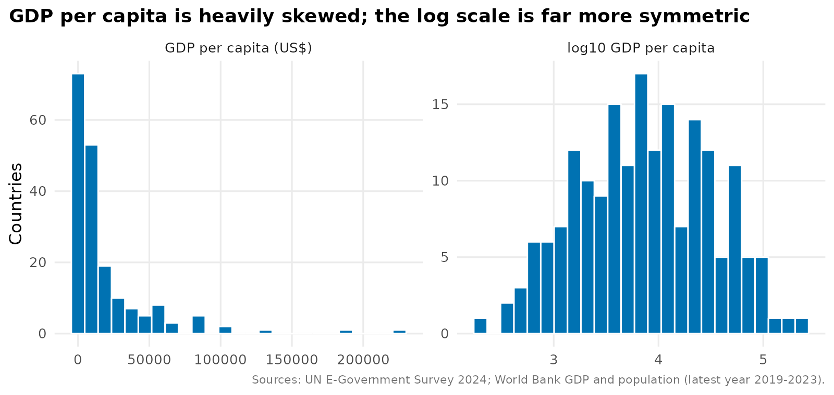
Figure 1. GDP per capita before and after the log10 transformation.

3. Exploratory Statistical Analysis

3.1 Descriptive statistics
R code
# ---------- 2. DESCRIPTIVE STATISTICS ----------
skew <- function(x) mean((x - mean(x))^3) / sd(x)^3
desc <- tibble(variable = c("EGDI", "GDP per capita (US$)", "log10 GDP per capita", "Population", "log10 Population"),
mean = c(mean(df$egdi), mean(df$gdp_pc), mean(df$log_gdp), mean(df$population), mean(df$log_pop)),
median = c(median(df$egdi), median(df$gdp_pc), median(df$log_gdp), median(df$population), median(df$log_pop)),
sd = c(sd(df$egdi), sd(df$gdp_pc), sd(df$log_gdp), sd(df$population), sd(df$log_pop)),
skewness = c(skew(df$egdi), skew(df$gdp_pc), skew(df$log_gdp), skew(df$population), skew(df$log_pop)))
print(desc %>% mutate(across(where(is.numeric), ~ signif(.x, 4))), width = Inf)

Variable | Mean | Median | SD | Skewness
EGDI | 0.648 | 0.672 | 0.221 | -0.41
GDP per capita (US$) | 18,910 | 7,154 | 30,000 | 3.50
log10 GDP per capita | 3.86 | 3.86 | 0.636 | -0.03
Population | 42.1 million | 9.0 million | 152.1 million | 8.07
log10 Population | 6.79 | 6.96 | 0.983 | -0.57

The median EGDI (0.672) is above the mean (0.648) and skewness is negative, meaning a tail of low-scoring countries. GDP per capita has a mean more than twice its median (US$18,910 against US$7,154), which confirms that a few very rich countries pull the average up and justifies the log transformation.

3.2 Confidence intervals
R code
# ---------- 3. CONFIDENCE INTERVALS ----------
ci_mean <- function(x) { m <- mean(x); se <- sd(x) / sqrt(length(x)); tq <- qt(0.975, length(x) - 1)
c(mean = m, lower = m - tq * se, upper = m + tq * se) }
cat("\n95% CI for mean EGDI (all countries):\n"); print(round(ci_mean(df$egdi), 4))
region_ci <- df %>% group_by(region) %>%
summarise(n = n(), mean = mean(egdi), lower = ci_mean(egdi)[2], upper = ci_mean(egdi)[3], .groups = "drop") %>%
arrange(desc(mean))
print(region_ci %>% mutate(across(where(is.numeric), ~ round(.x, 3))))

# Bootstrap CI for the median EGDI (no distribution assumption)
boot_med <- replicate(5000, median(sample(df$egdi, replace = TRUE)))
cat("\nBootstrap 95% CI for median EGDI:", round(quantile(boot_med, c(0.025, 0.975)), 4), "\n")

R output
95% CI for mean EGDI (all countries):
mean lower upper
0.6484 0.6166 0.6801

region n mean lower upper
1 Europe 43 0.849 0.822 0.877
2 Asia 45 0.72 0.665 0.774
3 Americas 34 0.674 0.622 0.726
4 Oceania 14 0.529 0.414 0.644
5 Africa 52 0.436 0.388 0.484

Bootstrap 95% CI for median EGDI: 0.6322 0.7193

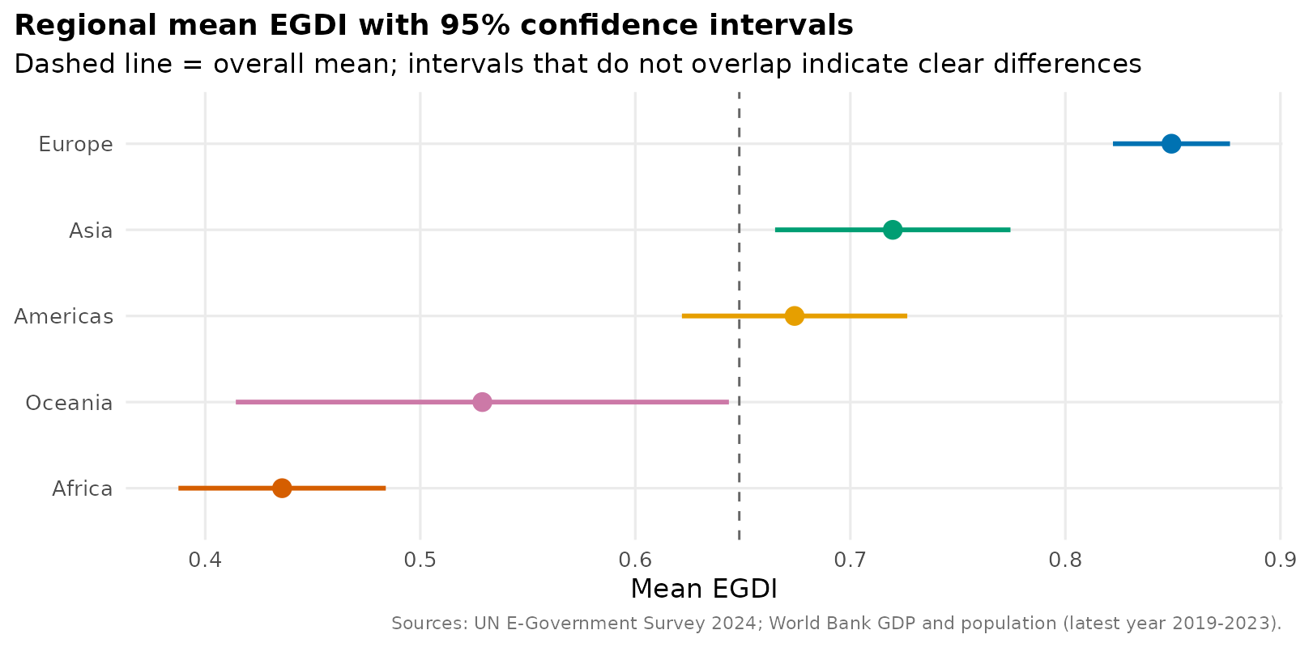
Figure 2. Mean EGDI by region with 95% confidence intervals.
Interpretation. We are 95% confident that the true mean EGDI of countries like those studied lies between 0.617 and 0.680. The regional intervals show clear separation between Europe (0.822 to 0.877) and Africa (0.388 to 0.484), with no overlap. Asia and the Americas overlap, so their difference is not clear. Oceania has the widest interval (0.414 to 0.644) because it has only 14 countries, so its average is the least certain. The bootstrap interval for the median does not assume any distribution and gives a consistent answer (0.632 to 0.719).

3.3 Hypothesis tests
R code
# ---------- 4. HYPOTHESIS TESTS ----------
# 4.1 Do regions differ? ANOVA (+ Tukey) and the non-parametric Kruskal-Wallis
aov1 <- aov(egdi ~ region, data = df); print(summary(aov1))
cat("Kruskal-Wallis:\n"); print(kruskal.test(egdi ~ region, data = df))
tuk <- TukeyHSD(aov1)$region; cat("\nTukey HSD (adjusted p < 0.05 shown):\n")
print(round(tuk[tuk[, "p adj"] < 0.05, ], 4))
eta2 <- summary(aov1)[[1]]$`Sum Sq`[1] / sum(summary(aov1)[[1]]$`Sum Sq`)
cat("Eta-squared (share of EGDI variance explained by region):", round(eta2, 3), "\n")

# 4.2 Do countries that responded to the questionnaire score differently? (Welch t-test + effect size)
tt <- t.test(egdi ~ responded, data = df); print(tt)
sp <- sqrt(((table(df$responded)[1] - 1) * var(df$egdi[df$responded == "No"]) +
(table(df$responded)[2] - 1) * var(df$egdi[df$responded == "Yes"])) / (n - 2))
cat("Cohen's d:", round((mean(df$egdi[df$responded == "Yes"]) - mean(df$egdi[df$responded == "No"])) / sp, 2), "\n")

# 4.3 Is region associated with EGDI group? (chi-square with simulated p because of small counts)
print(chisq.test(table(df$region, df$egdi >= 0.75), simulate.p.value = TRUE, B = 5000))

# 4.4 Normality of EGDI within regions (checks the ANOVA assumption)
print(df %>% group_by(region) %>% summarise(shapiro_p = round(shapiro.test(egdi)$p.value, 3), .groups = "drop"))

R output
Df Sum Sq Mean Sq F value Pr(>F)
region 4 4.539 1.135 45.39 <2e-16 ***
Residuals 183 4.575 0.025

Kruskal-Wallis chi-squared = 92.994, df = 4, p-value < 2.2e-16
Eta-squared (share of EGDI variance explained by region): 0.498

Welch Two Sample t-test (EGDI by questionnaire response)
t = -5.8792, df = 183.53, p-value = 1.91e-08
95 percent confidence interval: -0.2311751 -0.1150034
mean in group No 0.5729 mean in group Yes 0.7460
Cohen's d: 0.85

Pearson's Chi-squared test with simulated p-value
X-squared = 71.529, p-value = 2e-04

Test | Question | Result | Conclusion
One-way ANOVA | Do mean EGDI scores differ across regions? | F(4,183) = 45.4, p < 0.001; eta-squared = 0.50 | Yes. Region alone explains about half of the variation
Kruskal-Wallis | Same question without assuming normality | chi-squared = 93.0, df = 4, p < 0.001 | Confirms ANOVA
Tukey HSD | Which regions differ? | Europe-Africa +0.414; Asia-Africa +0.284; Americas-Africa +0.238; Europe-Americas +0.175; Europe-Asia +0.130; Oceania below Americas, Asia and Europe | Asia vs Americas and Oceania vs Africa are not significantly different
Welch t-test | Do questionnaire responders score differently? | t = -5.88, p < 0.001; difference 0.17 (95% CI 0.12 to 0.23); Cohen's d = 0.85 | Yes, a large difference (but see Section 4.3)
Chi-square (simulated p) | Is region associated with reaching Very High? | X-squared = 71.5, p < 0.001 | Yes, strongly associated

Assumption check. A Shapiro-Wilk test of EGDI within each region gave p-values of 0.23 (Africa), 0.20 (Americas), 0.08 (Europe), 0.03 (Asia) and 0.01 (Oceania). Normality is therefore questionable for Asia and Oceania, which is why the non-parametric Kruskal-Wallis test was run alongside ANOVA. Both agree. The chi-square test used a simulated p-value because several region-by-group counts are small, which would make the standard approximation unreliable.

3.4 Correlation analysis
R code
# ---------- 5. CORRELATION ANALYSIS ----------
ct_p <- cor.test(df$egdi, df$log_gdp); print(ct_p)
ct_s <- cor.test(df$egdi, df$log_gdp, method = "spearman", exact = FALSE); cat("Spearman rho:", round(ct_s$estimate, 3), "\n")
cat("Correlation EGDI vs raw GDP per capita (not logged):", round(cor(df$egdi, df$gdp_pc), 3), "\n")
cat("Correlation EGDI vs log10 population:", round(cor(df$egdi, df$log_pop), 3), "\n")

R output
Pearson r = 0.8165, 95% CI 0.7625 to 0.8592 (t = 19.288, df = 186, p < 2.2e-16)
Spearman rho: 0.826
Correlation EGDI vs raw GDP per capita (not logged): 0.504
Correlation EGDI vs log10 population: 0.11

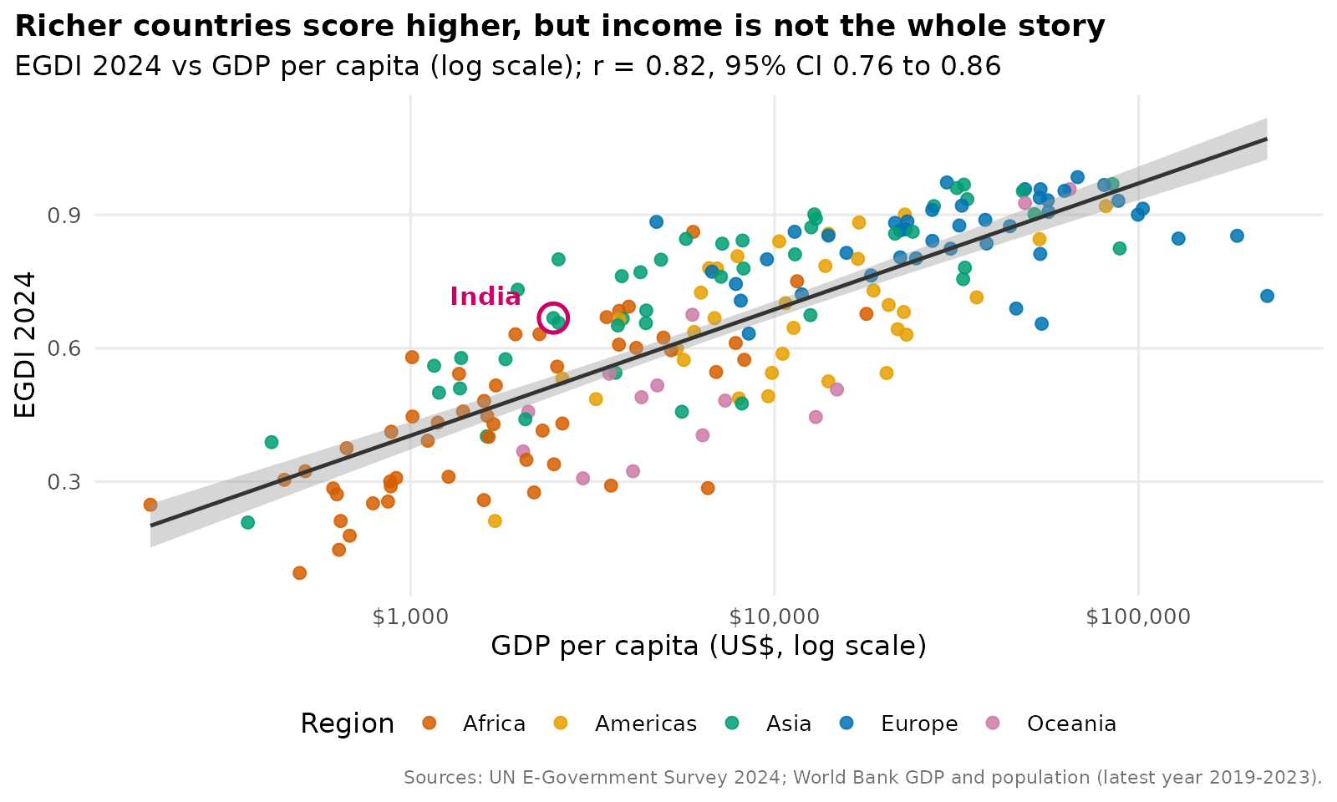
Figure 3. EGDI against GDP per capita (log scale), with regression line and 95% band.
Interpretation. EGDI and log GDP per capita are strongly and positively correlated (r = 0.82, 95% CI 0.76 to 0.86); the rank-based Spearman correlation (0.83) agrees, so the result is not driven by a few outliers. Using raw GDP per capita would have understated the relationship (r = 0.50), because the relationship is proportional (rich versus poor in percentage terms) rather than linear in dollars. Population is only weakly correlated with EGDI on its own (r = 0.11). The scatter around the line is wide: countries with similar income can have EGDI scores more than 0.3 apart, which motivates the multiple-variable models that follow.

4. Predictive Modeling

4.1 Choice of models and assumptions
EGDI is a continuous score between 0 and 1, so linear regression is the natural starting model. It is interpretable, which matters for government audiences, and it gives confidence and prediction intervals. Three models of increasing complexity were compared:
Model | Formula | Idea
M1 | EGDI ~ log10 GDP per capita | Income only
M2 | EGDI ~ log10 GDP + region + questionnaire response + log10 population | Adds context
M3 | As M2 but with a quadratic term for log10 GDP | Allows the curve to bend

Assumptions of linear regression: (1) a linear relationship between predictors and outcome (after transformation); (2) independent observations; (3) residuals that are approximately normal; (4) constant residual variance (homoscedasticity); (5) no severe multicollinearity; and (6) no single observation with unreasonable influence. Each is checked in Section 4.4. Independence is a reasonable but imperfect assumption here, since neighbouring countries may influence each other.
A time-series forecasting model was considered but is not possible because only a single survey year is used. For this reason the task's "prediction" is cross-sectional: predicting the EGDI that would be expected for a country given its characteristics.

4.2 Model comparison with cross-validation
R code
# 6.1 Model comparison data: simple, multiple and non-linear linear models
m1 <- lm(egdi ~ log_gdp, data = df)
m2 <- lm(egdi ~ log_gdp + region + responded + log_pop, data = df)
m3 <- lm(egdi ~ poly(log_gdp, 2) + region + responded + log_pop, data = df)
forms <- list("M1 GDP only" = egdi ~ log_gdp,
"M2 GDP + region + response + pop" = egdi ~ log_gdp + region + responded + log_pop,
"M3 as M2 with quadratic GDP" = egdi ~ poly(log_gdp, 2) + region + responded + log_pop)

# 10-fold cross-validation (RMSE and MAE), repeated 5 times
cv_lm <- function(formula, data, k = 10, reps = 5) {
res <- replicate(reps, { f <- sample(rep(1:k, length.out = nrow(data))); pr <- numeric(nrow(data))
for (i in 1:k) { fit <- lm(formula, data[f != i, ]); pr[f == i] <- pmin(pmax(predict(fit, data[f == i, ]), 0), 1) }
c(rmse = sqrt(mean((data$egdi - pr)^2)), mae = mean(abs(data$egdi - pr))) })
rowMeans(res) }
cv <- t(sapply(forms, cv_lm, data = df))
fits <- list(m1, m2, m3)
comparison <- tibble(model = names(forms), adj_r2 = sapply(fits, function(m) summary(m)$adj.r.squared),
aic = sapply(fits, AIC), cv_rmse = cv[, "rmse"], cv_mae = cv[, "mae"])
cat("\nMODEL COMPARISON\n"); print(comparison %>% mutate(across(where(is.numeric), ~ round(.x, 4))))
cat("Baseline RMSE (predict the mean for everyone):", round(sd(df$egdi), 4), "\n")

Model | Adjusted R-squared | AIC | CV RMSE | CV MAE
M1: GDP only | 0.665 | -236 | 0.127 | 0.104
M2: + region, response, population | 0.797 | -324 | 0.102 | 0.081
M3: M2 with quadratic GDP | 0.819 | -345 | 0.097 | 0.075
Baseline: predict the mean | - | - | 0.221 | -

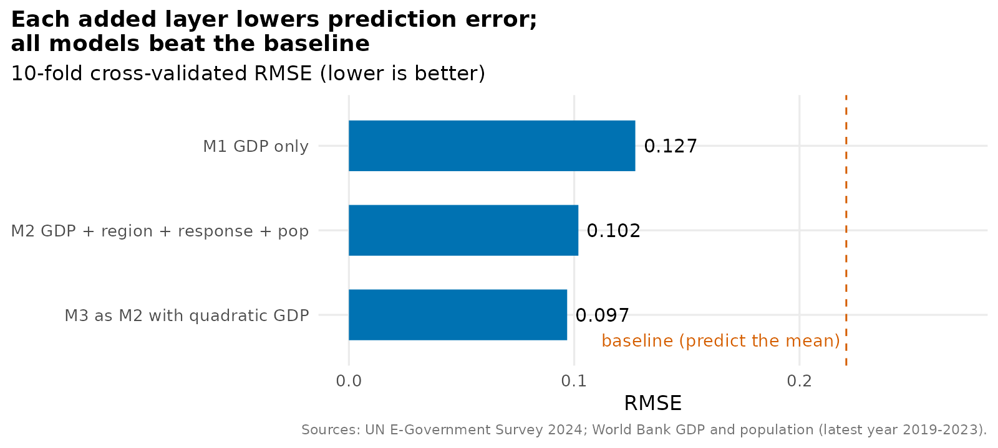
Figure 4. Ten-fold cross-validated RMSE for each model (repeated five times).
Interpretation. Cross-validation estimates error on countries a model has not seen, which protects against overfitting. All three models beat the baseline of predicting the mean for everyone (RMSE 0.221). Adding region, questionnaire response and population (M2) reduces the error from 0.127 to 0.102, and the quadratic term (M3) reduces it a little more to 0.097. M3 is best on every criterion. I kept M2 as the main model because it is easier to explain and its coefficients can be read directly, while noting that M3 is the better choice if prediction accuracy is the only goal. The difference between M2 and M3 (0.005 EGDI points) is small in practical terms.

4.3 The chosen model (M2): coefficients and interpretation
R code
# 6.2 Chosen model: M2 (summary, CIs)
print(summary(m2)); cat("\n95% CI for coefficients:\n"); print(round(confint(m2), 4))
cat("\nEffect of a 10% rise in GDP per capita (model M2):",
round(coef(m2)["log_gdp"] * log10(1.10), 4), "EGDI points\n")
cat("Effect of a 10-fold rise in GDP per capita (model M2):", round(coef(m2)["log_gdp"], 4), "\n")

Term | Estimate | 95% CI | p-value
Intercept | -0.852 | -1.033 to -0.672 | < 0.001
log10 GDP per capita (10x) | 0.262 | 0.229 to 0.296 | < 0.001
Americas (vs Africa) | 0.050 | -0.001 to 0.100 | 0.052
Asia (vs Africa) | 0.102 | 0.056 to 0.148 | < 0.001
Europe (vs Africa) | 0.093 | 0.036 to 0.151 | 0.002
Oceania (vs Africa) | 0.032 | -0.034 to 0.098 | 0.342
Responded to questionnaire | 0.040 | 0.009 to 0.072 | 0.013
log10 population (10x) | 0.061 | 0.044 to 0.078 | < 0.001

Model fit: R-squared 0.805, adjusted R-squared 0.797, residual standard error 0.0995, F(7, 180) = 105.8, p < 0.001.
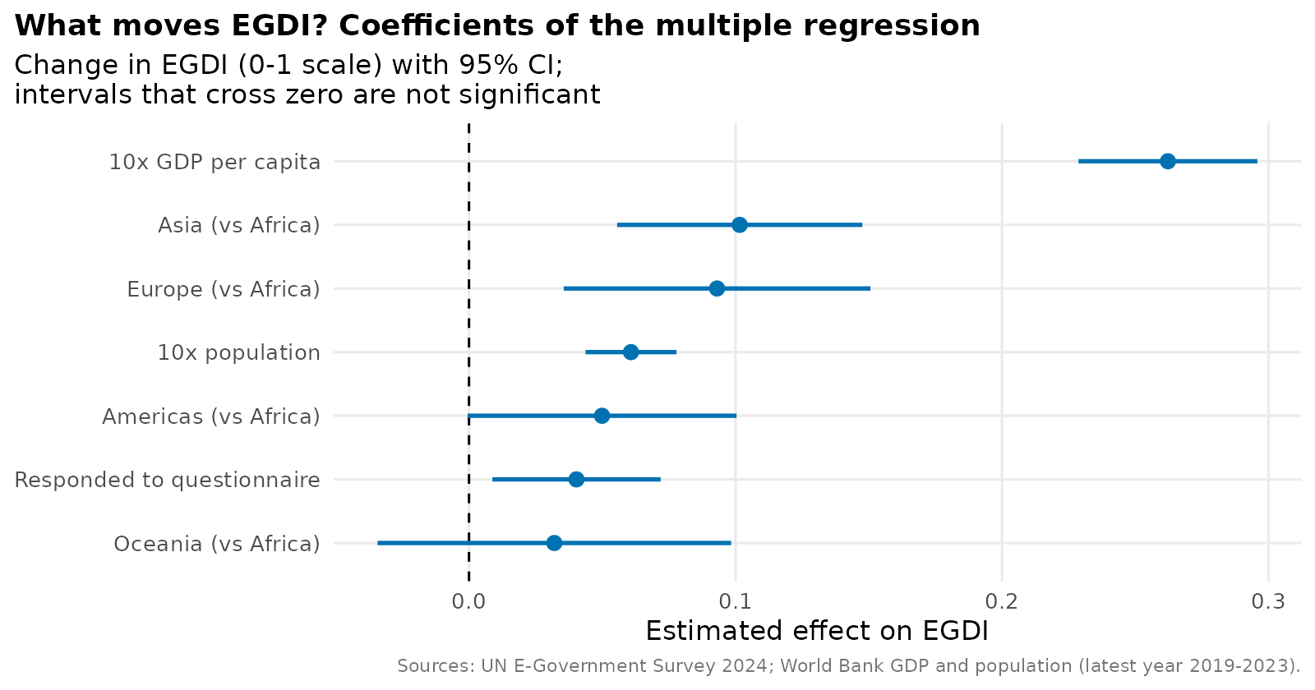
Figure 5. Coefficients of model M2 with 95% confidence intervals.
- Income. Holding other variables constant, a tenfold increase in GDP per capita is associated with an EGDI that is 0.26 higher (95% CI 0.23 to 0.30). A 10% increase is associated with a gain of about 0.011.
- Region. After accounting for income, Asia and Europe score about 0.09 to 0.10 higher than Africa. The raw gap between Europe and Africa (0.41) shrinks to 0.09 once income is considered: most of the difference between regions is explained by income, not by region itself. The Americas and Oceania are not clearly different from Africa at the same income.
- Questionnaire response. The raw difference between responders and non-responders was 0.17 (Cohen's d = 0.85). Once income, region and population are held constant it falls to 0.04. This shows confounding: non-responders tend to be poorer countries, and income, not non-response itself, explains most of the gap.
- Population. At the same income, larger countries score slightly higher (0.06 per tenfold increase). This is an association, and could reflect scale advantages, larger administrations or fixed costs of digital systems being spread across more people; the data cannot say which.

4.4 Validation on unseen data
R code
# 6.3 Hold-out validation (80% train / 20% test)
idx <- sample(seq_len(n), size = round(0.8 * n))
train <- df[idx, ]; test <- df[-idx, ]
m2_tr <- lm(formula(m2), data = train)
test$pred <- pmin(pmax(predict(m2_tr, test), 0), 1)
rmse <- sqrt(mean((test$egdi - test$pred)^2)); mae <- mean(abs(test$egdi - test$pred))
r2_test <- 1 - sum((test$egdi - test$pred)^2) / sum((test$egdi - mean(test$egdi))^2)
cat("\nHOLD-OUT TEST (n =", nrow(test), "): RMSE", round(rmse, 4), " MAE", round(mae, 4), " R2", round(r2_test, 3), "\n")
cat("Share of test countries predicted within 0.10 of actual:", round(mean(abs(test$egdi - test$pred) <= 0.10) * 100, 1), "%\n")

R output
HOLD-OUT TEST (n = 38 ): RMSE 0.1101 MAE 0.0906 R2 0.723
Share of test countries predicted within 0.10 of actual: 63.2 %

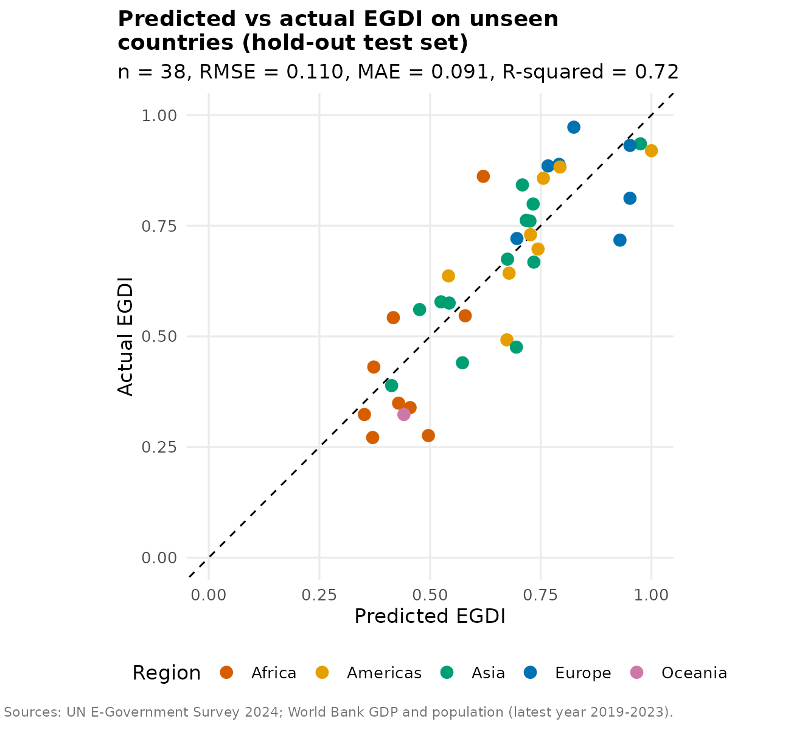
Figure 6. Predicted vs actual EGDI for 38 countries not used to fit the model.
Interpretation. The model was fitted on a random 80% of countries (150) and tested on the remaining 20% (38). On those unseen countries the typical error (RMSE) is 0.110 and the model explains 72% of the variance. 63% of countries are predicted within 0.10 of their true score. The points follow the diagonal, but there is visible scatter, so the model is useful for benchmarking and planning, not for precise prediction of one country's score. The hold-out RMSE (0.110) is a little higher than the cross-validated one (0.102), as expected for a single small test set.

4.5 Checking the regression assumptions
R code
# 6.4 Assumption checks for M2
df$fitted <- fitted(m2); df$resid <- resid(m2); df$rstud <- rstudent(m2); df$cooks <- cooks.distance(m2)
cat("\nShapiro-Wilk test of residuals: p =", round(shapiro.test(df$resid)$p.value, 3), "\n")
aux <- summary(lm(I(resid^2) ~ fitted, data = df))$r.squared # Koenker (studentised) Breusch-Pagan
bp_p <- pchisq(n * aux, df = 1, lower.tail = FALSE); cat("Breusch-Pagan (Koenker) test for constant variance: p =", round(bp_p, 3), "\n")
X <- model.matrix(m2)[, -1]
vif <- sapply(seq_len(ncol(X)), function(j) 1 / (1 - summary(lm(X[, j] ~ X[, -j]))$r.squared))
names(vif) <- colnames(X); cat("Variance inflation factors:\n"); print(round(vif, 2))
cat("Observations with Cook's distance > 4/n:", sum(df$cooks > 4 / n), "\n")
cat("Observations with |studentised residual| > 2:", sum(abs(df$rstud) > 2), "\n")

R output
Shapiro-Wilk test of residuals: p = 0.147
Breusch-Pagan (Koenker) test for constant variance: p = 0.06
Variance inflation factors:
log_gdp regionAmericas regionAsia regionEurope regionOceania
2.21 1.84 1.88 2.85 1.48
respondedYes log_pop
1.19 1.37
Observations with Cook's distance > 4/n: 10
Observations with |studentised residual| > 2: 11

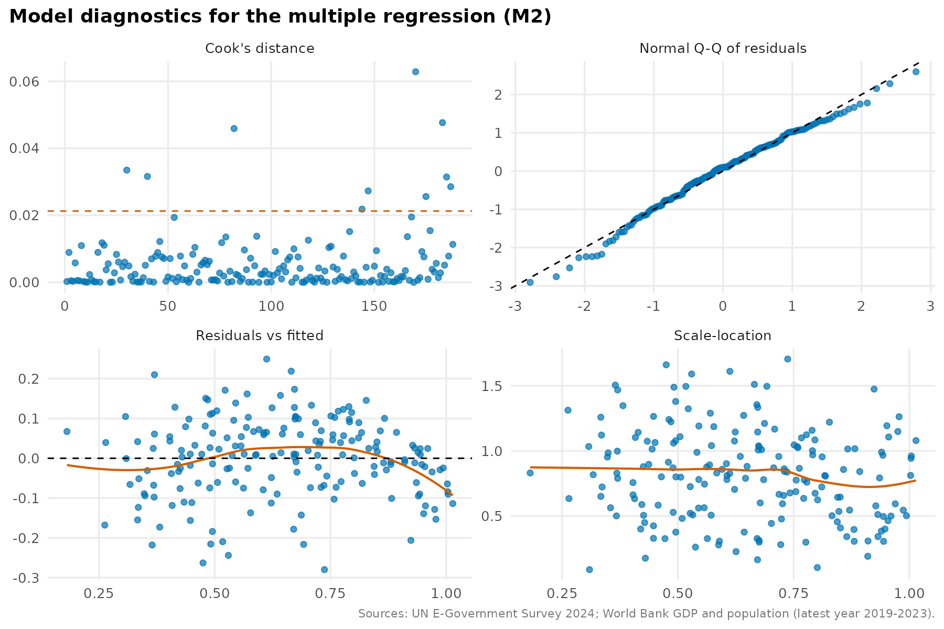
Figure 7. Diagnostic plots for model M2.
Assumption | Evidence | Verdict
Normal residuals | Q-Q plot follows the line; Shapiro-Wilk p = 0.147 | Met
Constant variance | Scale-location plot is flat; Breusch-Pagan p = 0.06 | Borderline; not rejected at 5%
Linearity | Residuals vs fitted show a mild inverted-U pattern | Slight curvature, which is why the quadratic M3 fits better
No multicollinearity | All VIF values are below 3 | Met
No undue influence | 10 observations above the 4/n Cook's distance guide; maximum around 0.06 | No single country dominates
Outliers | 11 of 188 (5.9%) have |studentised residual| above 2 | About what chance alone would give (5%)

4.6 Predicting India and finding over- and under-performers
R code
# 6.5 Prediction for India and the largest over/under performers
india <- df %>% filter(country == "India") # refresh so India carries fitted values and residuals
india_pred <- predict(m2, india, interval = "prediction", level = 0.95)
cat("\nIndia actual EGDI:", india$egdi, "| predicted:", round(india_pred[1], 3),
"| 95% prediction interval:", round(india_pred[2], 3), "to", round(india_pred[3], 3), "\n")
cat("India GDP per capita (US$):", round(india$gdp_pc), " (year", india$wb_year, ")\n")
over <- df %>% arrange(desc(resid)) %>% slice_head(n = 8) %>% select(country, region, gdp_pc, egdi, fitted, resid)
under <- df %>% arrange(resid) %>% slice_head(n = 8) %>% select(country, region, gdp_pc, egdi, fitted, resid)
cat("\nOver-performers (EGDI higher than model predicts):\n"); print(over %>% mutate(across(where(is.numeric), ~ round(.x, 3))))
cat("\nUnder-performers (EGDI lower than model predicts):\n"); print(under %>% mutate(across(where(is.numeric), ~ round(.x, 3))))
cat("Rank of India's residual among", n, "countries (1 = largest positive):", which(df$country[order(-df$resid)] == "India"), "\n")

R output
India actual EGDI: 0.6678 | predicted: 0.736 | 95% prediction interval: 0.534 to 0.937
India GDP per capita (US$): 2469 (year 2023 )
Rank of India's residual among 188 countries (1 = largest positive): 145

Over-performers: Under-performers:
South Africa 0.862 vs 0.612 (+0.249) Iraq 0.457 vs 0.737 (-0.280)
Ukraine 0.884 vs 0.665 (+0.219) Haiti 0.212 vs 0.475 (-0.263)
Rwanda 0.580 vs 0.370 (+0.210) Equatorial Guinea 0.286 vs 0.530 (-0.244)
Mongolia 0.846 vs 0.672 (+0.173) Somalia 0.147 vs 0.365 (-0.218)
Tunisia 0.694 vs 0.522 (+0.171) Turkmenistan 0.476 vs 0.692 (-0.216)
Kyrgyzstan 0.732 vs 0.570 (+0.162) Sudan 0.276 vs 0.491 (-0.216)
Uzbekistan 0.800 vs 0.642 (+0.158) Papua New Guinea 0.308 vs 0.517 (-0.210)
Kenya 0.631 vs 0.481 (+0.151) Monaco 0.718 vs 0.924 (-0.206)

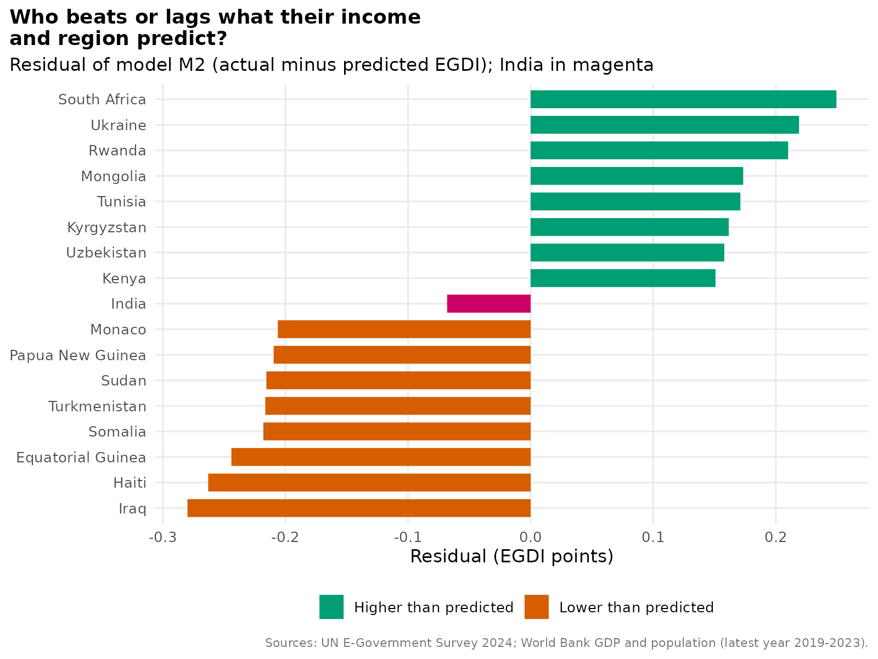
Figure 8. Largest positive and negative residuals of M2 (actual minus predicted EGDI). India in magenta.
India. With a GDP per capita of about US$2,469 (2023), the model predicts an EGDI of 0.736 for India (95% prediction interval 0.534 to 0.937). India's actual score is 0.668, about 0.07 below the prediction but well inside the interval, so India is not an unusual case. It ranks 145th of 188 for its residual, meaning most countries perform further from the model. In other words, India scores in the High group, about what its income would suggest, and a little lower than the model expects because the model credits India for its large population and Asian location.
Over- and under-performers. South Africa, Ukraine, Rwanda, Mongolia, Tunisia, Kyrgyzstan, Uzbekistan and Kenya score 0.15 to 0.25 above the model, which makes them useful case studies of how modest incomes can still produce strong digital government. Iraq, Haiti, Equatorial Guinea, Somalia, Turkmenistan, Sudan and Papua New Guinea score 0.2 to 0.3 below, which may reflect conflict, governance or connectivity constraints rather than income. Monaco (GDP per capita over US$225,000) is a statistical outlier because it is far outside the income range of the other countries.

4.7 Logistic regression: predicting Very High status
For planning, a yes/no question is often more useful than a score: will a country be in the Very High group (EGDI 0.75 or above)? Logistic regression models the probability of a binary outcome and gives odds ratios that are easy to interpret. Its assumptions are independent observations, a linear relationship between the predictors and the log-odds, and enough cases of each outcome (here 76 Very High countries in the full set of 193; the model uses 188).
R code
# ---------- 7. LOGISTIC REGRESSION: PREDICT "VERY HIGH" STATUS ----------
lg <- glm(very_high ~ log_gdp + region + responded, data = df, family = binomial)
print(summary(lg))
or <- exp(cbind(OR = coef(lg), confint.default(lg))); cat("\nOdds ratios with 95% CI (Wald):\n"); print(round(or, 3))
lg_tr <- glm(formula(lg), data = train, family = binomial)
test$p_vh <- predict(lg_tr, test, type = "response"); test$pred_vh <- as.integer(test$p_vh >= 0.5)
cm <- table(Actual = test$very_high, Predicted = test$pred_vh); print(cm)
cat("Hold-out accuracy:", round(mean(test$very_high == test$pred_vh), 3),
" | Baseline (always predict majority):", round(max(table(test$very_high)) / nrow(test), 3), "\n")
auc <- function(y, p) { r <- rank(p); n1 <- sum(y == 1); n0 <- sum(y == 0); (sum(r[y == 1]) - n1 * (n1 + 1) / 2) / (n1 * n0) }
cat("Hold-out AUC:", round(auc(test$very_high, test$p_vh), 3), "\n")
df$p_vh_all <- predict(lg, df, type = "response")
cat("India probability of Very High (model):", round(df$p_vh_all[df$country == "India"], 3), "\n")

# 10-fold cross-validated accuracy and AUC for the logistic model
f <- sample(rep(1:10, length.out = n)); cvp <- numeric(n)
for (i in 1:10) cvp[f == i] <- predict(glm(formula(lg), data = df[f != i, ], family = binomial), df[f == i, ], type = "response")
cat("10-fold CV accuracy:", round(mean((cvp >= 0.5) == df$very_high), 3), " AUC:", round(auc(df$very_high, cvp), 3), "\n")

Predictor | Odds ratio | 95% CI (Wald) | Reading
log10 GDP per capita (10x) | 29.1 | 7.9 to 107.9 | Tenfold higher income multiplies the odds of Very High by about 29
Asia (vs Africa) | 9.3 | 1.6 to 53.2 | Significant after income
Europe (vs Africa) | 6.7 | 1.0 to 46.6 | Borderline (interval touches 1)
Americas (vs Africa) | 1.5 | 0.2 to 9.6 | Not significant
Oceania (vs Africa) | 0.7 | 0.1 to 8.6 | Not significant
Responded to questionnaire | 3.0 | 1.2 to 7.7 | Three times the odds, after other factors

R output
Predicted
Actual 0 1
0 19 5
1 4 10
Hold-out accuracy: 0.763 | Baseline (always predict majority): 0.632
Hold-out AUC: 0.839
10-fold CV accuracy: 0.84 AUC: 0.903
India probability of Very High (model): 0.329

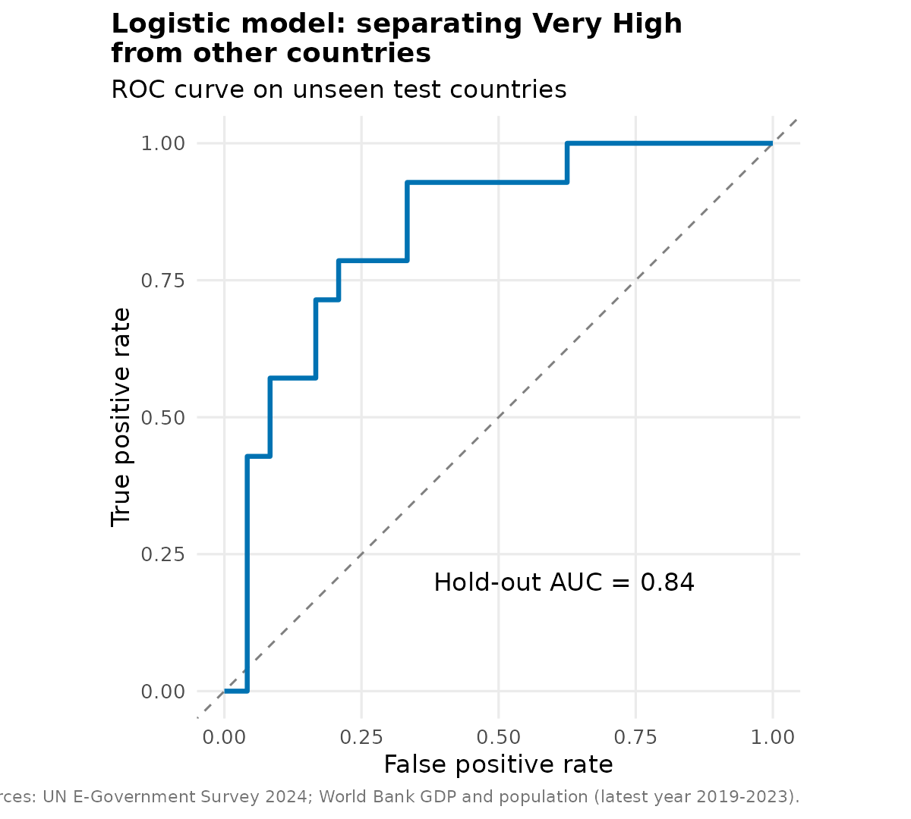
Figure 9. ROC curve of the logistic model on the hold-out test set.
Interpretation. On the 38 test countries the model classifies 76% correctly (29 of 38), against 63% for always guessing the majority class. It finds 10 of 14 Very High countries (sensitivity 71%) and correctly rules out 19 of 24 others (specificity 79%). The AUC of 0.84 on the test set (0.90 in 10-fold cross-validation) means that, given one Very High and one other country, the model ranks the Very High one higher about 84 to 90% of the time. For India the model gives a 33% probability of being Very High, which is consistent with its actual High classification and with its being 0.082 short of the threshold.

5. Discussion

5.1 Main findings
- Regions differ strongly in e-government performance (ANOVA F = 45.4, eta-squared 0.50), with Europe clearly ahead and Africa clearly behind.
- Income is the single strongest predictor: r = 0.82 between EGDI and log GDP per capita, and a tenfold rise in income is associated with +0.26 in EGDI after accounting for region, population and survey response.
- Most of the regional gap is an income gap. Once income is controlled for, the Europe-Africa difference drops from 0.41 to 0.09, and the effect of questionnaire non-response drops from 0.17 to 0.04.
- A multiple regression predicts unseen countries to within about 0.10 EGDI points (RMSE 0.11, R-squared 0.72), and a logistic model identifies Very High countries with an accuracy of 76% to 84%.
- Income is not destiny. Many countries are more than 0.15 above or below the model, and these gaps are where policy choices matter.

5.2 Implications for public services
- Realistic target setting. A model-based expected score gives a country a benchmark that accounts for its means. A target such as "reach the expected EGDI for our income, then exceed it" is fairer than a target to match Denmark.
- Resource planning. The coefficient implies that sustained economic growth is accompanied by about 0.011 EGDI per 10% income growth, but because the over-performers show that policy can do much more, spending on digital services should not wait for income to rise.
- Learning partners. Over-performers such as Rwanda, Kenya, Kyrgyzstan and Uzbekistan achieve strong digital government at low income and are natural study cases for countries like India that are in the same income band.
- Targeted support. Under-performers relative to income, such as Iraq, Haiti and Equatorial Guinea, may need targeted governance and connectivity support rather than general economic aid.
- Better measurement. Non-response to the UN questionnaire largely reflects income. Capacity support for reporting would improve the quality of the data on which these decisions rest.

5.3 Challenges encountered
- Different country names across sources required a lookup table, and some names differed again between the GDP and population files, which was solved by joining on ISO codes.
- Five low-scoring countries had no recent GDP data and had to be excluded, which creates a mild selection effect.
- GDP and population are extremely skewed, and the first correlation on raw values (0.50) badly understated the relationship until the log transformation was applied.
- The raw questionnaire effect looked large but mostly disappeared after controlling for income, which shows why a multiple regression is needed before drawing conclusions.
- The model-comparison chart title I first wrote ("a curve adds little") was contradicted by the cross-validation result and was corrected, which is a reminder to write interpretations after reading the numbers.

5.4 Limitations
- The analysis is cross-sectional and shows associations, not causes. Higher income may enable better digital services, better digital services may raise income, or both may follow from governance quality.
- The EGDI is a relative index; scores depend partly on how other countries do.
- GDP values come from years 2020 to 2023 and EGDI from 2024, and the GDP data are from a GitHub mirror of World Bank data rather than the World Bank website directly.
- The Breusch-Pagan result (p = 0.06) is borderline and the residual plot shows slight curvature, so intervals should be treated as approximate.
- The hold-out set is only 38 countries, so its metrics are noisy; cross-validation figures are more stable.

5.5 Recommendations for further analysis
- Assemble EGDI for 2003 to 2024 and fit panel models or time-series forecasts of each country's EGDI path (for example ARIMA or growth models), which is the true forecasting task for resource planning.
- Add the sub-indices (Online Service, Telecommunication Infrastructure and Human Capital) and indicators such as internet use, education spending and governance quality to understand why countries over- or under-perform.
- Try regularised or tree-based models (lasso, random forest) and compare them with the linear models using the same cross-validation.
- Use a beta regression or logit transformation of EGDI to respect its 0 to 1 limits, and a mixed-effects model with region as a random effect.
- Compare India with peers over time using the model, to check whether its residual has narrowed.

6. Conclusion
Statistical analysis shows that digital government performance differs sharply between regions and is strongly linked to national income. Predictive models built in R can estimate a country's expected EGDI from GDP per capita, region, population and survey participation with a typical error of about 0.10, and can classify Very High countries with 76% to 84% accuracy. The most valuable output is not the prediction itself but the residual: the difference between actual and expected performance, which separates what income explains from what policy and implementation can change. India sits close to its expected level, with an actual score of 0.668 compared with a predicted 0.736, and has room to move towards the Very High group.

Appendix: Files and Sources
week4_modeling.R (script); data/egdi_2024_transformed.csv, data/wb_gdp_raw.csv, data/wb_pop_raw.csv, data/wb_name_map.csv (inputs); data/egdi_model_data.csv (model output); figures/w4_*.png (nine charts). Sources: UN DESA E-Government Survey 2024 (https://publicadministration.un.org/egovkb/Data-Center); World Bank GDP (current US$) and population data, accessed through the GitHub "datasets" repositories (github.com/datasets/gdp and github.com/datasets/population).

