KENZO ONEERP (KORE) - ARCHITECTURE & DIAGRAMS HANDBOOK
Complete Collection of Visual System Architecture, DFD Level 1, ERD Schema, RBAC Pyramid, and Theme Engine Diagrams
1. Full-Stack System Architecture Diagram
Explains the end-to-end data flow from Client Browser -> Next.js App Router -> Session Auth -> Prisma ORM -> Neon PostgreSQL DB & Cloudinary CDN.
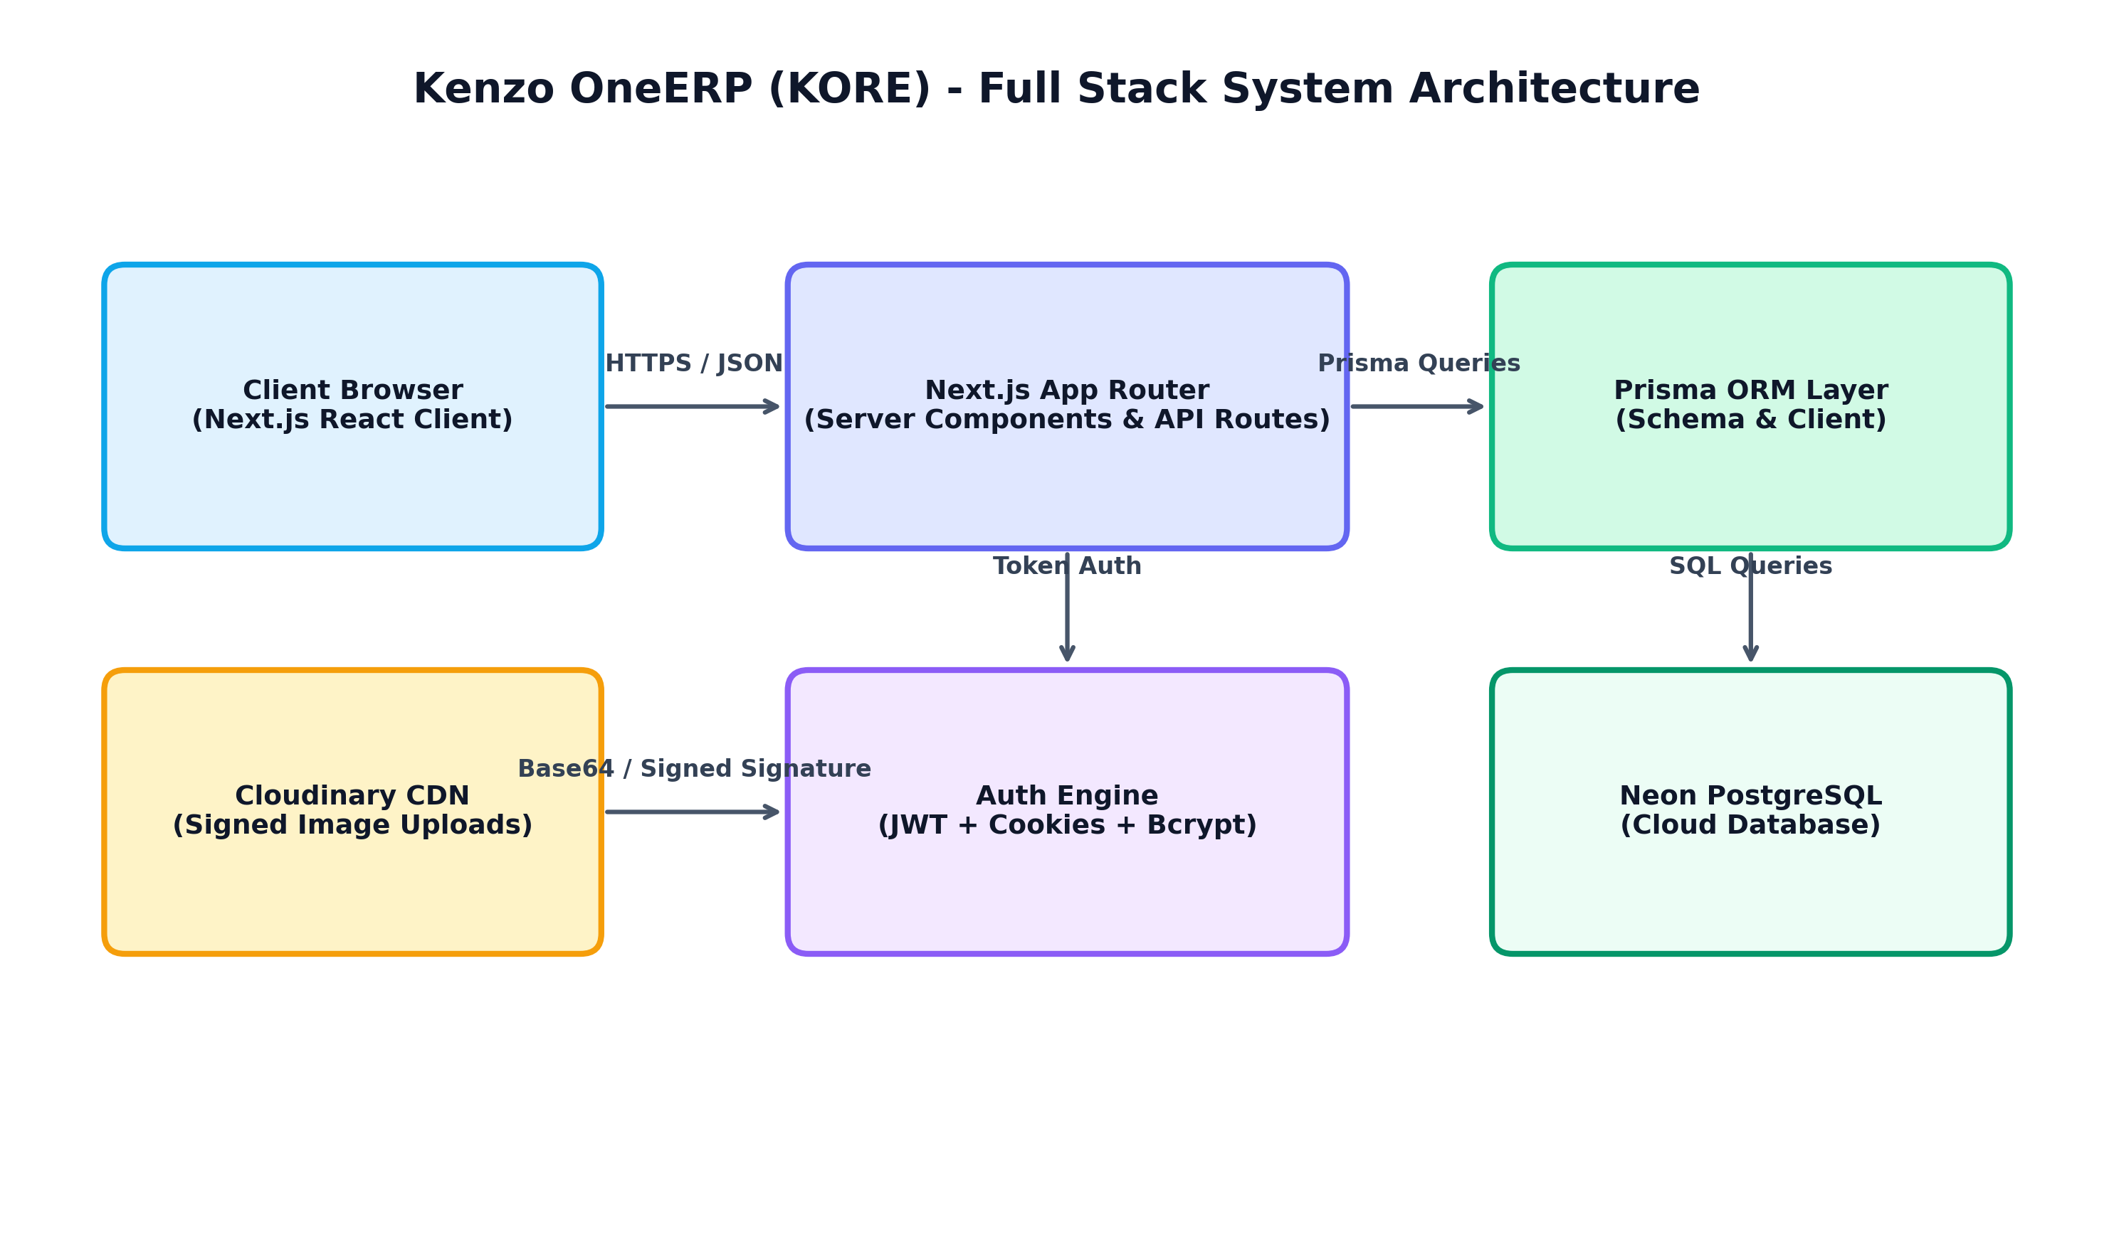

2. Data Flow Diagram (DFD Level 1)
Illustrates the real-time submission of leave applications, database write locks, and real-time polling/notifications on Admin/CEO/HR dashboards.
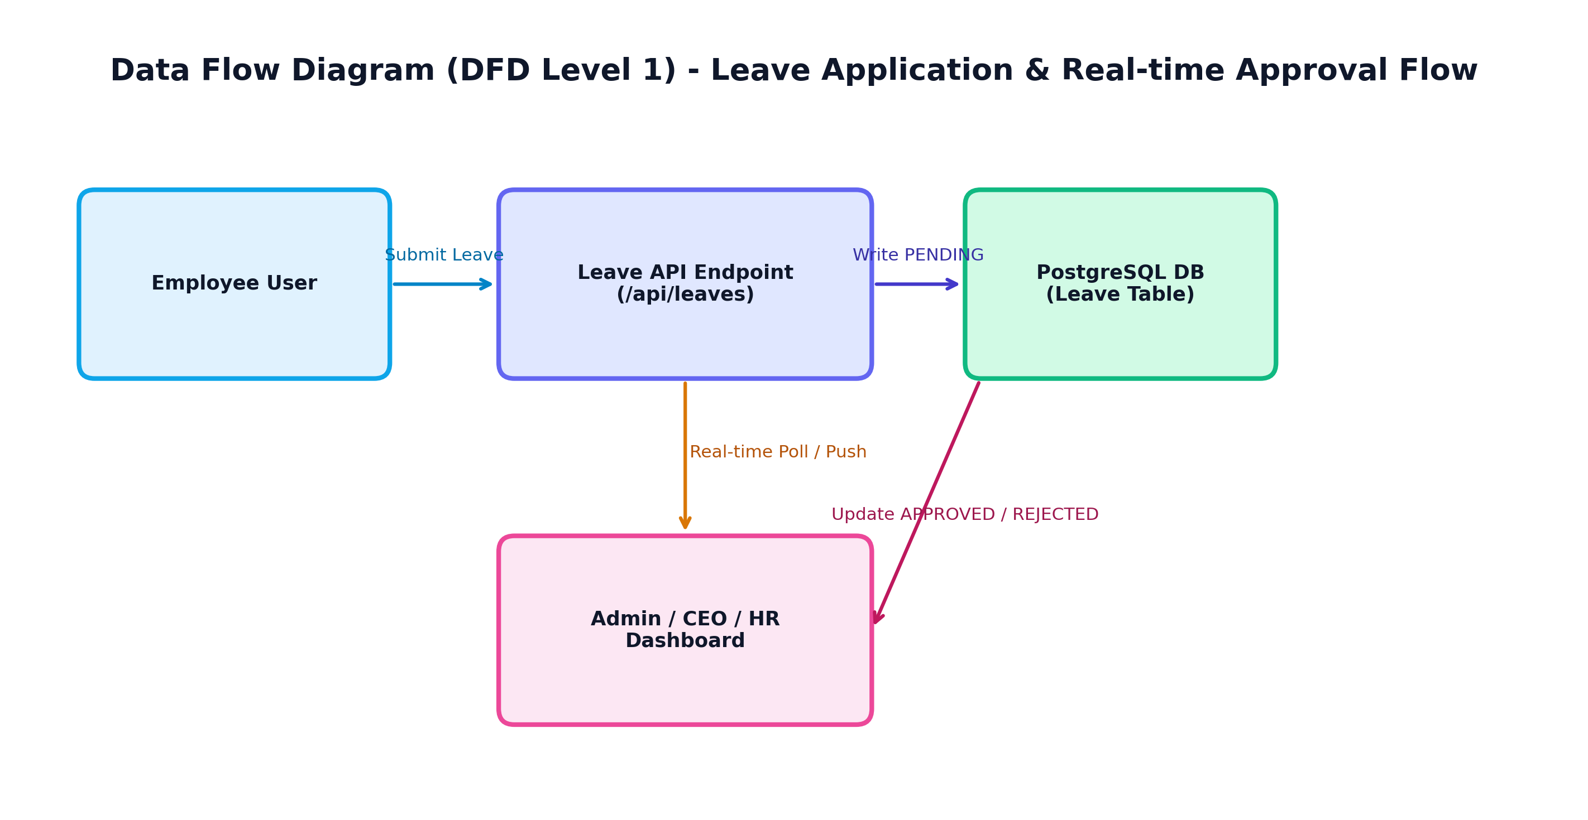

3. Leave State Lifecycle & Isolation Workflow
Details the 4-step leave lifecycle: Employee submission, tenant-scoped PENDING status, role-based visibility filter, and APPROVED/REJECTED status update.
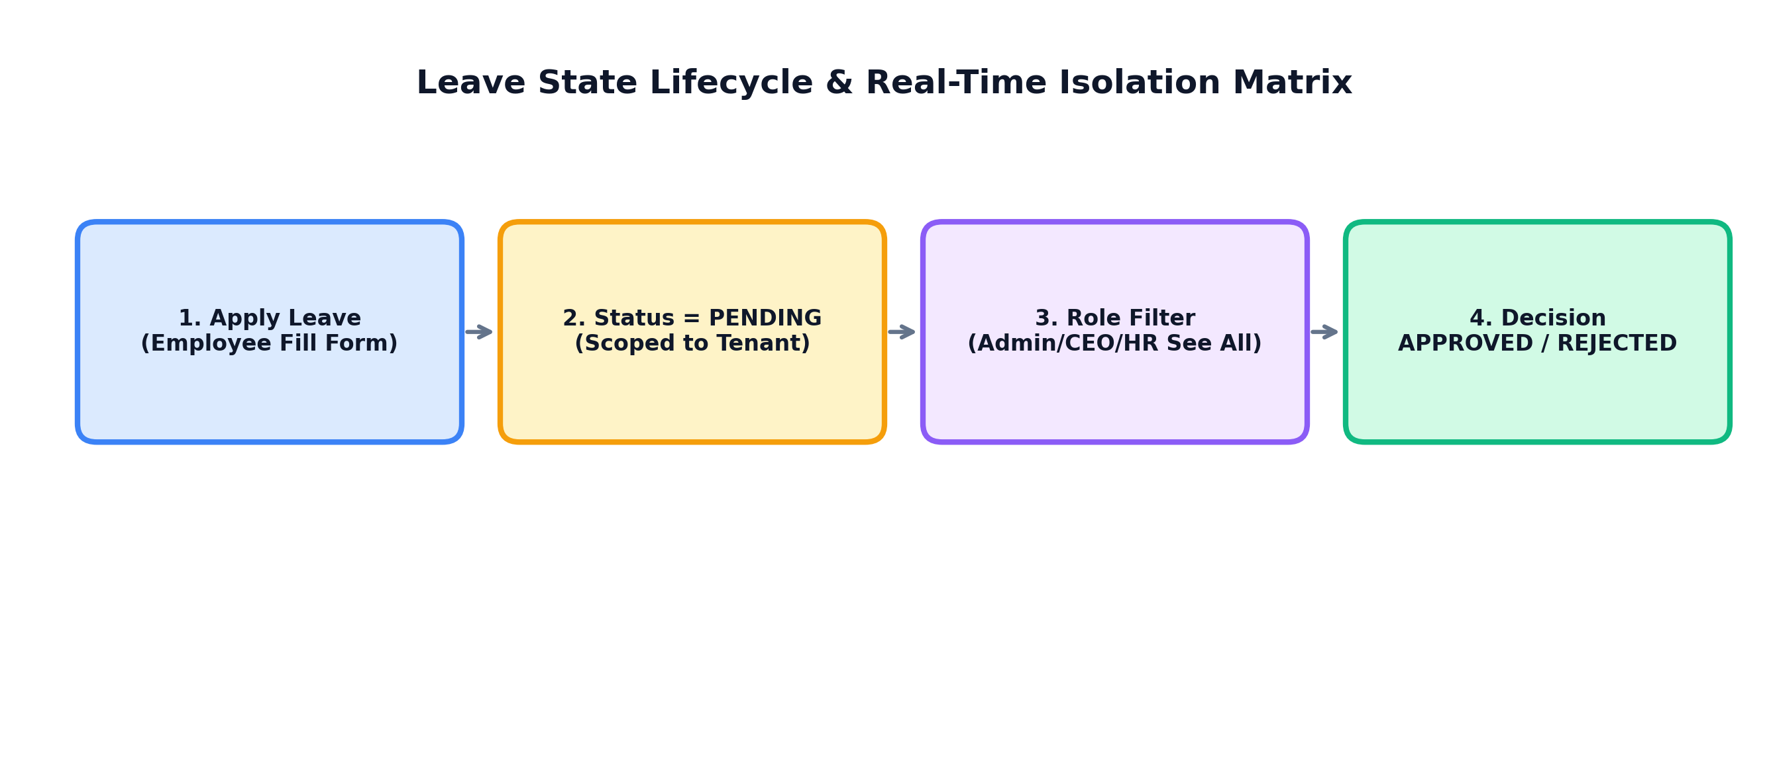

4. Database Entity Relationship Diagram (ERD)
Visualizes Prisma ORM relational database models: Tenant, User, Employee, Attendance, Leave, Project, Task, Invoice, Expense.
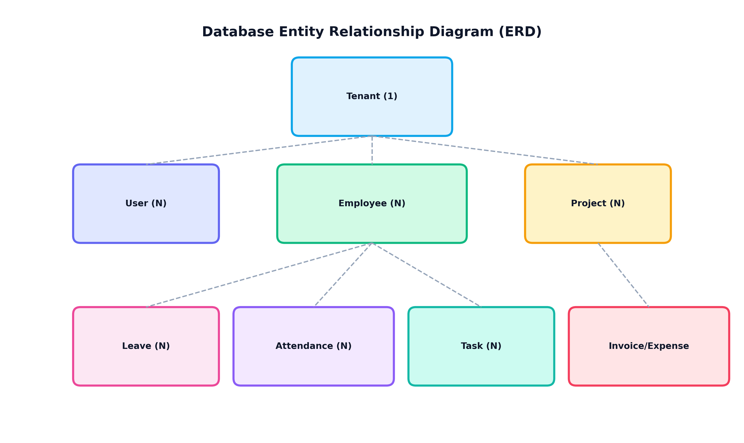

5. Role-Based Access Control (RBAC) Hierarchy
Pyramid breakdown of user roles from SUPER_ADMIN & COMPANY_ADMIN down to CEO/CTO, HR/FINANCE, and DEVELOPER/EMPLOYEE levels.
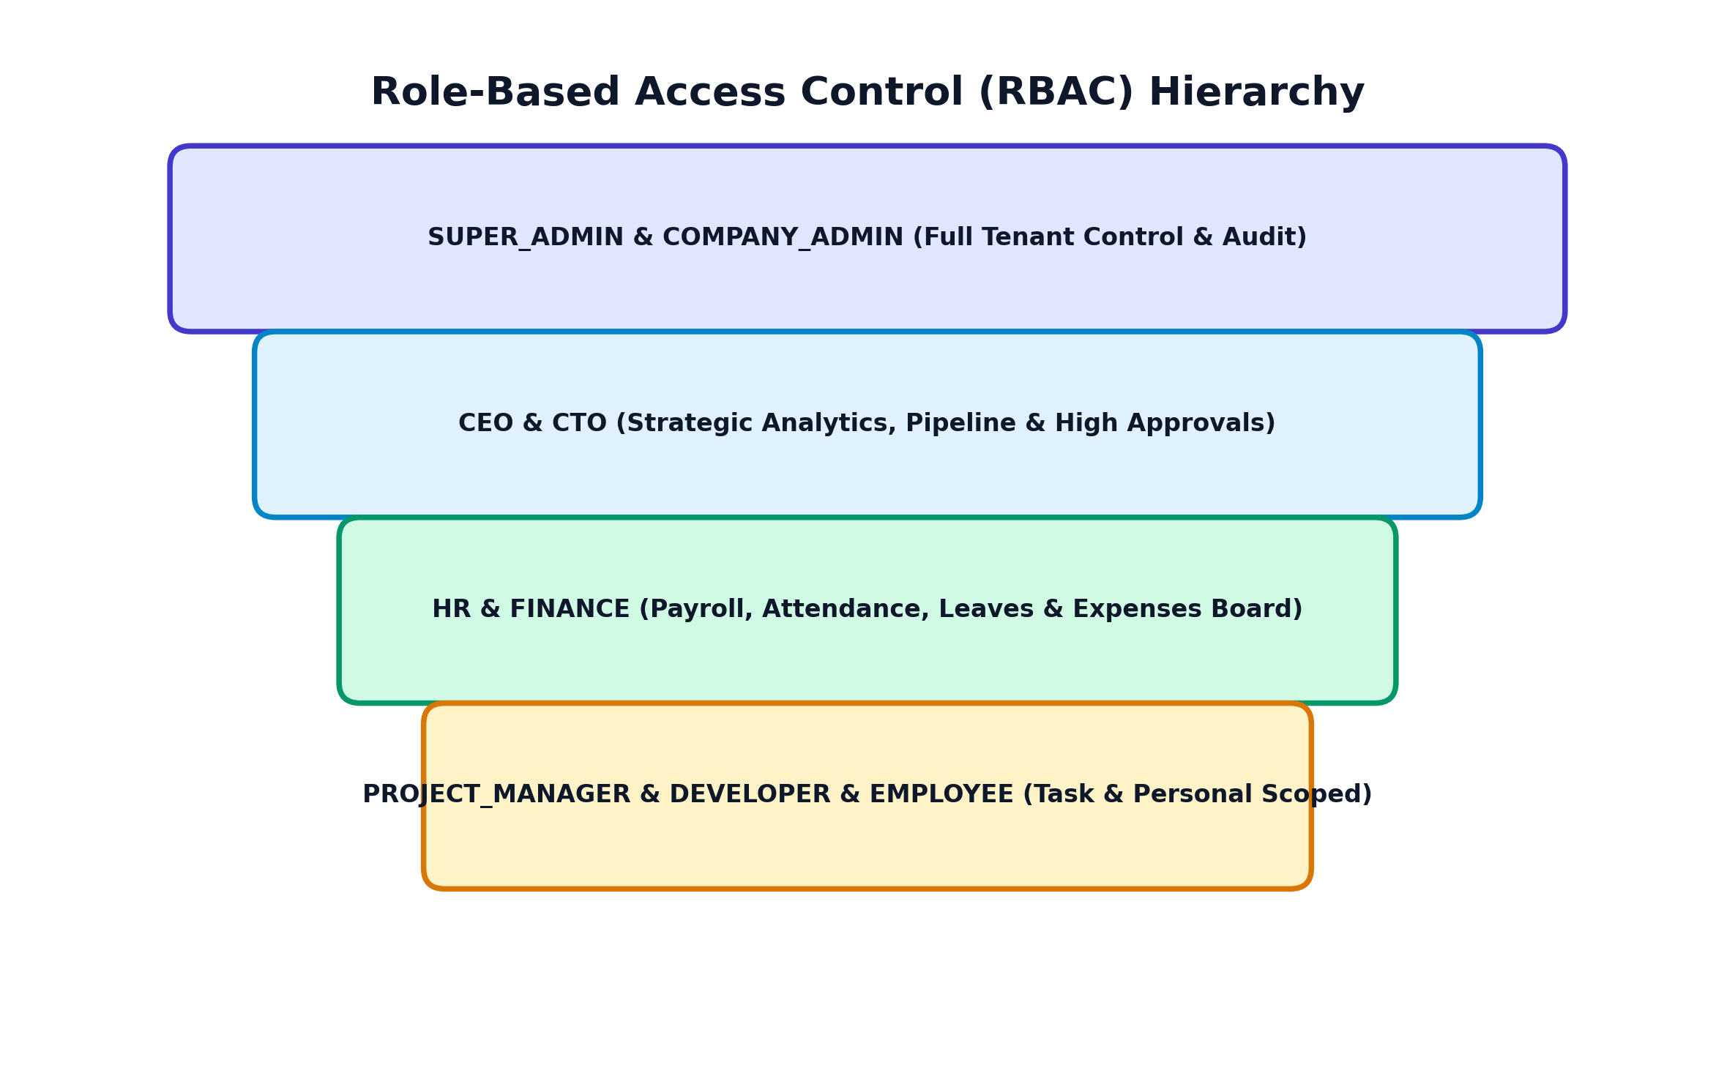

6. Theme Engine & Text Contrast Architecture
Shows how CSS contrast variables manage Light Mode (#0f172a text) vs Dark Mode (#ffffff text) and fixed modal styling (.profile-modal-dark).
