SAAR
Technical Design Specification v1.0
Implementation blueprint: architecture → database → APIs → events → AI → security → CI/CD
Co-founder: Sujal Kumar | Strategic / Technical M.D.: GPT | Status: Draft for implementation

1. Purpose
This specification converts the SAAR Product Requirements Document into an implementation-level technical blueprint. "
"It is intentionally opinionated: the first release should be modular, secure, observable, testable and capable of evolving from an MVP into a multi-region consumer product without rewriting its core domain model.
Primary product loop:
- Current You → Desired You → Gap → Action → Behavior → Evidence → Insight → Adaptation → Repeat.
- SAAR is not a generic task manager. The technical architecture must preserve longitudinal behavioral context and turn it into explainable, bounded interventions.
- AI is an orchestration layer over trusted application data—not the source of truth.

2. Architecture Principles
- Modular monolith first: keep domain boundaries strict while avoiding premature microservice complexity.
- API-first: mobile/web clients consume stable versioned contracts.
- PostgreSQL is the system of record; Redis is acceleration/state, never authoritative business storage.
- Event-driven side effects: reminders, analytics, AI analysis and weekly reports are asynchronous.
- AI never mutates critical user state directly. It proposes actions; policy + domain services validate and commit them.
- Privacy by design: collect the minimum data necessary, make sensitive features opt-in, support export/delete.
- Every important behavioral event is timestamped and attributable to a device/session/source.
- Observability is a feature: every workflow must be diagnosable with correlation IDs.
- Feature flags protect risky releases and permit controlled experiments.
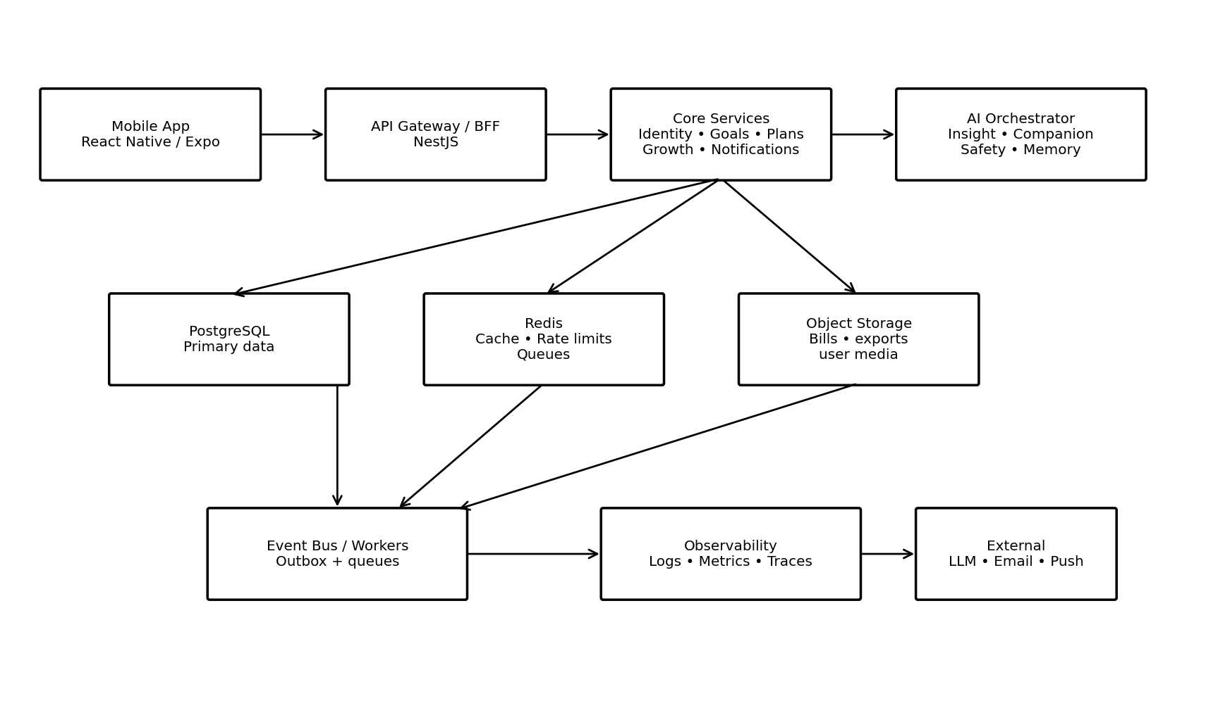
Figure 1 — Recommended SAAR logical architecture.

3. Recommended Technology Baseline
Layer | Recommended choice | Reason
Mobile | React Native + Expo | Fast cross-platform iteration; native capabilities for notifications, biometrics and sensors.
Web/Admin | Next.js | Marketing site, account/settings, internal operations and future web client.
Backend | NestJS + TypeScript | Strong modular architecture, DI, validation, guards, background integrations.
Database | PostgreSQL | Transactional integrity, JSONB where useful, mature indexing and analytics support.
ORM | Prisma | Fast developer workflow and typed schema access; raw SQL allowed for tuned queries.
Cache/Jobs | Redis + BullMQ | Rate limits, short-lived cache, delayed jobs, queues.
Object storage | S3-compatible storage | Encrypted attachments/media with signed URLs.
Auth | OIDC/OAuth + email/password | Flexible sign-in with MFA/passkeys later; server-side authorization.
AI gateway | Provider-agnostic internal adapter | Avoid hard coupling to one model vendor.
Observability | OpenTelemetry + structured logs | Trace requests and asynchronous workflows end-to-end.
CI/CD | GitHub Actions + preview/staging/prod | Branch protection, automated checks and controlled releases.

4. Repository / Monorepo Structure
saar/
├─ apps/
│ ├─ mobile/ # React Native / Expo client
│ ├─ web/ # Next.js marketing + authenticated web
│ └─ api/ # NestJS application
├─ packages/
│ ├─ contracts/ # OpenAPI-generated types / DTO contracts
│ ├─ domain/ # Pure domain types, rules, scoring
│ ├─ config/ # Typed environment/config package
│ ├─ ui/ # Shared design system where applicable
│ ├─ analytics/ # Event names + schemas
│ └─ ai-core/ # Prompt templates, tool schemas, AI adapters
├─ infra/
│ ├─ docker/
│ ├─ terraform/ # Optional after MVP infrastructure stabilizes
│ └─ scripts/
├─ prisma/
│ ├─ schema.prisma
│ ├─ migrations/
│ └─ seed/
├─ docs/
│ ├─ adr/
│ ├─ api/
│ ├─ security/
│ └─ runbooks/
├─ .github/workflows/
├─ turbo.json
└─ package.json

5. Domain Modules
Module | Owns | Key rule
Identity | users, sessions, credentials, devices | Authentication is separate from authorization.
Profile | preferences, timezone, locale, notification settings | User controls what is collected and used.
Future Self | vision, life areas, targets, values | Desired state must be measurable where possible.
Goals | goals, milestones, metrics | Goals have lifecycle and evidence.
Planning | tasks, routines, schedules, time blocks | Planner is not the source of truth for historical behavior.
Behavior | events, completions, skips, snoozes, interventions | Immutable event history; corrections are compensating events.
Growth Engine | scores, gaps, recommendations, experiments | Recommendations are explainable and versioned.
Daily Growth | check-ins, daily review, reflection | User-owned reflections; sensitive content needs strict access control.
Companion | conversations, summaries, approved memories | AI context is scoped; no unrestricted database access.
Notifications | templates, preferences, delivery attempts | Respect quiet hours and consent.
Analytics | product events, aggregates, experiments | Do not expose raw sensitive content to product analytics.
Safety | risk signals, escalation policy, audit trail | High-risk outputs must follow predefined safety policy.

6. Database Design
Core relational entities:
Entity | Important fields | Indexes / constraints
users | id, email, status, timezone, created_at | unique email; status index
user_profiles | user_id, display_name, locale, preferences_json | 1:1 user
devices | id, user_id, platform, push_token, last_seen_at | user + active index
life_areas | id, user_id, type, title, target_state | user + type
goals | id, user_id, life_area_id, title, status, target_date | user + status; target date
goal_metrics | id, goal_id, metric_type, target_value, unit | goal index
plans | id, user_id, date, generated_by | unique user/date
tasks | id, plan_id, goal_id, title, due_at, status, priority | user + due_at/status
routines | id, user_id, recurrence_rule, active | user + active
behavior_events | id, user_id, event_type, occurred_at, source, metadata_json | user + occurred_at; event_type
checkins | id, user_id, date, mood, energy, notes | unique user/date
insights | id, user_id, type, evidence_json, recommendation_json, confidence, expires_at | user + created_at
interventions | id, user_id, insight_id, action_type, status | user + status
conversations | id, user_id, created_at | user index
messages | id, conversation_id, role, content_ref, created_at | conversation + created_at
memories | id, user_id, type, summary, source_refs, consent_status | user + type
notifications | id, user_id, type, scheduled_at, status | user + scheduled_at
audit_logs | id, user_id, actor_type, action, entity_type, entity_id, created_at | entity + created_at
Recommended event model:
BehaviorEvent {
id: UUID
userId: UUID
eventType: string
occurredAt: timestamptz
source: mobile | web | system | integration
entityType?: string
entityId?: UUID
metadata: JSONB
schemaVersion: integer
}

7. Data Architecture
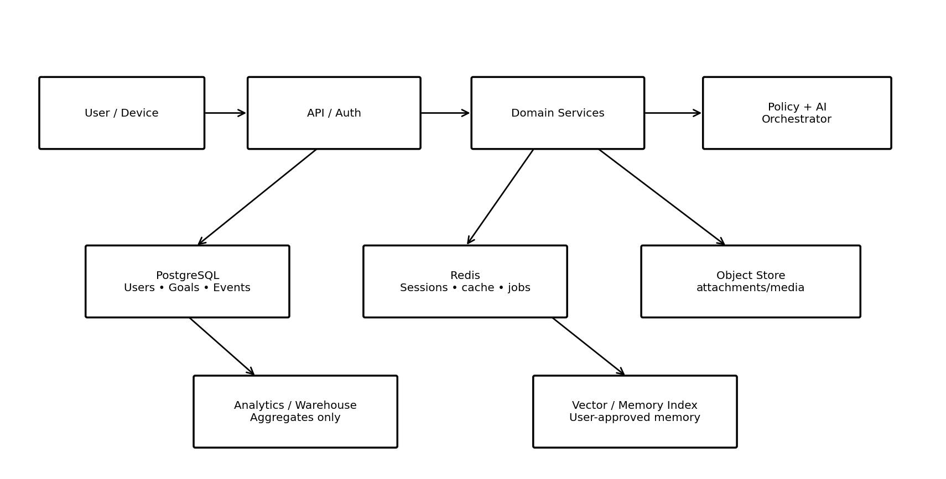
Figure 2 — Data ownership and storage boundaries.

8. API Architecture
All authenticated APIs are versioned under /api/v1. Use REST for transactional operations and server-sent events/websockets only where real-time UX materially benefits.
Area | Representative endpoints | Notes
Auth | POST /auth/register, /login, /refresh, /logout | Short-lived access token + rotating refresh token.
Profile | GET/PATCH /me | Never expose internal/security fields.
Future Self | GET/POST/PATCH /future-self | Version target changes.
Goals | GET/POST/PATCH /goals | Validate ownership and life-area membership.
Plans | GET /plans/:date, POST /plans/generate | Generated plans require idempotency.
Tasks | POST /tasks, PATCH /tasks/:id | Completion creates behavior event.
Behavior | POST /behavior-events, GET /behavior/timeline | Write path should be cheap and append-oriented.
Growth | GET /growth/dashboard, /growth/gaps, /growth/insights | Read models can be cached.
Daily Growth | GET /daily-growth/session, POST /daily-growth/checkin | Session is user-timezone aware.
Companion | POST /companion/conversations, POST /companion/messages | AI calls go through policy/orchestrator.
Notifications | GET /notifications/preferences, PATCH /notifications/preferences | No silent override of user settings.
Privacy | GET /privacy/export, POST /privacy/delete-request | Deletion is asynchronous and auditable.

9. Authentication & Authorization
- Use short-lived access tokens and rotating refresh tokens stored in secure platform storage.
- Device/session records enable revocation and anomaly detection.
- Authorization must be server-side on every protected resource.
- Use RBAC internally (user/admin/support) but keep domain ownership checks mandatory.
- Prepare for passkeys and MFA; do not hard-code password-only assumptions.
- Never trust client-provided user_id, role, organization_id or ownership fields.
- Rate-limit login, OTP, password reset, companion messaging and expensive AI endpoints.
- Sensitive operations require step-up authentication when appropriate.

10. AI Architecture
The AI layer is a controlled decision-support system with four stages:
- Context Builder: retrieves only the minimum approved context needed for the task.
- Policy Engine: checks permissions, safety, privacy, age/eligibility and tool constraints.
- Model Router: selects model/provider based on task complexity, latency and cost.
- Action Validator: converts AI output into a strict schema and allows only whitelisted mutations.
AI tools should be explicit, typed and permission-scoped, for example:
get_today_plan()
get_recent_behavior(days)
get_goal_progress(goal_id)
get_balance_snapshot()
create_task(proposed_task) # requires user confirmation for sensitive changes
reschedule_task(task_id, new_time) # policy checked
create_insight(insight_payload)
save_memory(memory_payload) # explicit memory policy / consent
Do not expose a generic SQL tool or unrestricted application database to the model.

11. Growth / Gap Engine
Reference pipeline:
Observed State
↓
Normalize events
↓
Build behavior features
↓
Compare with Desired State
↓
Detect gaps
↓
Rank gaps by impact + confidence + user preference
↓
Generate candidate interventions
↓
Policy / feasibility validation
↓
Explainable recommendation
↓
Measure outcome
Signal | Example feature | Use
Consistency | completion_rate_7d | Detect routine stability.
Timing | success_by_hour | Adaptive scheduling.
Load | planned_minutes vs available_minutes | Life trade-off engine.
Recovery | sleep/recovery inputs if explicitly connected | Avoid overloading user.
Mood/energy | self-reported trend | Contextual recommendations, not diagnosis.
Goal trajectory | actual pace vs target pace | Detect stalled goals.
Friction | snooze/skip/failure patterns | Change task design/time rather than guilt user.

12. Life Trade-off Engine
SAAR must treat time and attention as constrained resources. A recommendation that improves one life area while repeatedly damaging another is not automatically a good recommendation.
- Represent daily capacity as available time blocks rather than assuming unlimited availability.
- Maintain life-area weights selected by the user.
- Detect overload: planned effort > estimated capacity.
- Detect displacement: adding work consistently removes sleep, exercise, relationships or personal time.
- Recommend trade-offs explicitly: reduce, move, delegate, defer or drop.
- Never optimize a single score at the expense of the user's stated values.

13. Adaptive Scheduling
- Store intended time and actual completion time.
- Calculate success rates by time window, day-of-week, context and task type.
- Require a minimum evidence threshold before moving a recurring routine automatically.
- Propose changes first; optionally enable auto-rescheduling for low-risk routines.
- Respect fixed commitments and user-defined no-move windows.
- Every adaptation is logged so the user can understand why the schedule changed.

14. Daily Growth Session
Trigger: user's configured local time
1. Lock daily snapshot
2. Collect plan + completed/failed behavior
3. Run feature aggregation
4. Calculate goal/gap changes
5. Generate 3–5 concise insights
6. Ask mood/energy/reflection questions
7. Recommend tomorrow's top actions
8. Save session summary
9. Schedule next-day reminders
10. Record outcome events
Performance target: render the session quickly from precomputed aggregates; never wait for a full LLM analysis before showing basic progress.

15. Companion Conversation Flow
- User message enters API → authentication → rate limit → safety classifier → context selection.
- Context Builder retrieves relevant recent conversation, goals, behavior summaries and user-approved memories.
- Prompt is assembled from versioned templates.
- Model returns structured response plus optional action proposals.
- Schema validator rejects malformed tool/action outputs.
- Policy layer decides whether confirmation is required.
- Response is stored with a redacted/structured audit record where appropriate.
- Sensitive raw conversation should not automatically enter analytics or long-term memory.

16. Memory Model
Memory class | Examples | Retention
Preference | prefers morning workouts | Until user changes/deletes.
Goal context | wants to run 10K by a date | Until goal expires or user deletes.
Behavioral pattern | usually completes exercise before 9 AM | Derived; recompute periodically.
Reflection | user-authored life reflection | User controlled; sensitive.
Companion context | recurring topic user asked to remember | Explicit opt-in / visible management.
Memory is not a dump of chat history. Store compact, explainable facts with source references, timestamps and retention rules.

17. Notification / Alarm System
- Notification scheduling service stores intended notifications and delivery state.
- Client handles platform-specific local alarm behavior where OS capabilities are stronger.
- Server remains authoritative for schedule and recurring rules.
- Alarm dismissal actions are modeled as events.
- Behavioral alarms may require a configurable action (e.g., scan/step/task), but provide accessibility and emergency bypasses.
- Never use coercive or unsafe mechanics. The goal is accountability, not punishment.

18. Event-Driven Processing
Transactional request
↓
DB transaction
├─ write business state
└─ write outbox event
↓
Outbox publisher
↓
Queue
├─ analytics worker
├─ notification worker
├─ growth feature worker
└─ AI insight worker
Use the transactional outbox pattern so important domain changes are not committed without their corresponding event.

19. Idempotency & Reliability
- All write endpoints that may be retried accept an idempotency key.
- Workers must be safe to retry.
- Use exponential backoff and dead-letter queues for persistent failures.
- Every job has status, attempts, started_at, finished_at and error metadata.
- External provider calls use timeouts and circuit-breaking where appropriate.
- User-visible operations should return a correlation ID for support/debugging.

20. Security Architecture
- TLS everywhere; HSTS on web.
- Secrets only in managed secret storage/environment configuration; never commit secrets.
- Encrypt data at rest using platform/database/object-store encryption.
- Signed, short-lived object URLs for private files.
- Strict CORS and CSRF strategy based on auth mechanism.
- Content validation and malware scanning for uploads.
- PII/sensitive-content classification at schema level.
- Audit logs for authentication, privacy actions, role changes and critical account changes.
- Dependency scanning, secret scanning, SAST and container scanning in CI.
- Threat-model high-risk flows before launch.

21. Privacy & Data Lifecycle
- Explicitly explain why each sensitive permission/data source is requested.
- Default to minimal collection.
- Allow users to disable optional integrations.
- Provide export and deletion workflows.
- Separate operational data from product analytics where possible.
- Define retention periods per data class.
- Use data minimization in AI context retrieval.
- Never sell or share personal growth data as a default business model.

22. Observability
Signal | Examples | Alert
Logs | request_id, user-safe context, error code | 5xx spike; worker failures
Metrics | API latency, queue depth, AI latency, notification success | SLO breach
Traces | API → DB → queue → AI provider | Slow path / bottleneck
Business metrics | daily session completion, recommendation acceptance | Product regression
Cost metrics | AI tokens/call, storage, push/email volume | Budget anomaly

23. Testing Strategy
- Unit tests for domain rules, scoring and scheduling.
- Integration tests for API + PostgreSQL + Redis.
- Contract tests for API schemas and mobile/web clients.
- End-to-end tests for onboarding, planning, daily session, companion and privacy deletion.
- Security tests for authorization bypass, IDOR, rate limits, token handling and upload paths.
- AI evaluation suite with deterministic test cases, safety cases and regression prompts.
- Load tests for daily-session spikes and notification jobs.
- Migration tests before production database changes.

24. CI/CD Pipeline
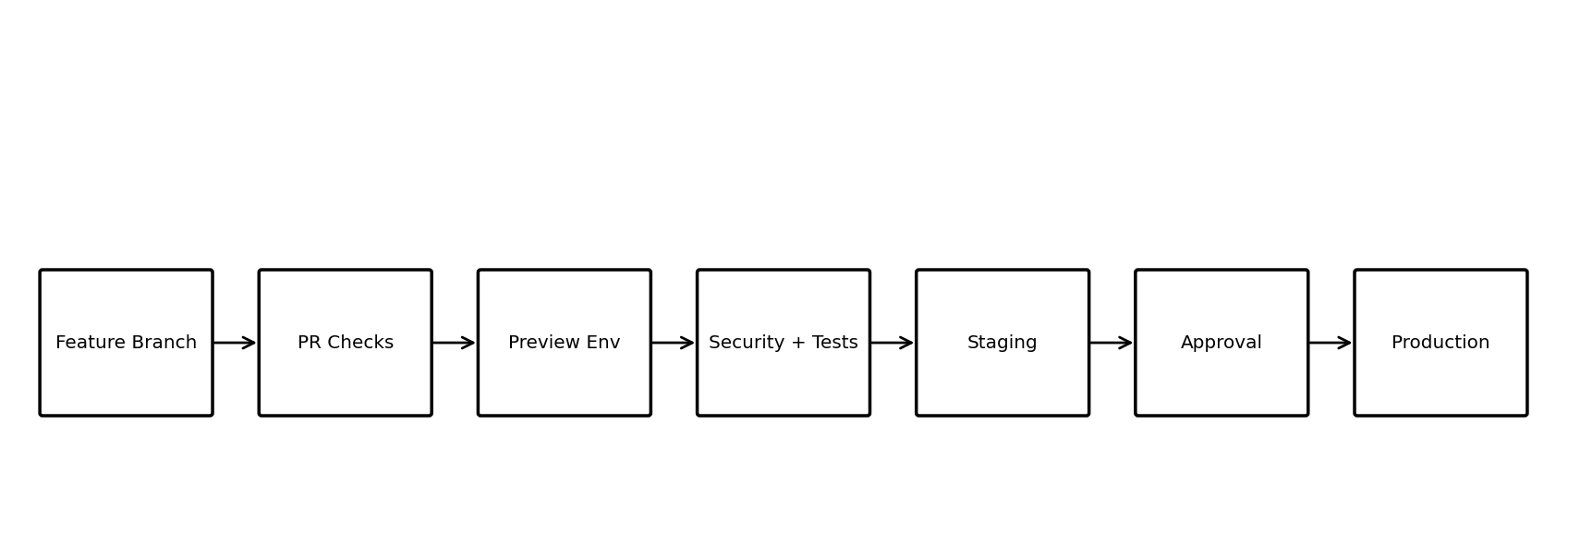
Figure 3 — Recommended branch-to-production pipeline.
- feature/* → pull request → lint/typecheck/unit/security checks.
- Preview deployment for frontend/API changes where practical.
- Integration/e2e suite → staging deployment.
- Manual approval for production for the initial release.
- Database migrations run as controlled release steps, never ad hoc from a developer laptop.
- Production rollback plan tested before launch.
- Main branch is protected; direct pushes disabled.

25. Environments
Environment | Purpose | Data
Local | Developer work | Synthetic/local only.
Preview | PR validation | Ephemeral/synthetic.
Staging | Release candidate | Synthetic or anonymized test data.
Production | Real users | Strict access, backups, monitoring.

26. SLO / NFR Targets for MVP
Area | Initial target
API availability | ≥ 99.5% monthly, excluding planned maintenance
Typical API p95 | < 500 ms for non-AI CRUD endpoints
Basic dashboard load | < 2 s from warm API/cache target
AI response | stream first useful response when possible; target < 5 s median
Notification job reliability | ≥ 99% successful/accepted by provider
Data backup | Automated daily backups + tested restore
Crash-free mobile sessions | Target ≥ 99.5% after stabilization

27. Analytics & Product Events
app_opened
onboarding_completed
future_self_created
goal_created
task_completed
task_skipped
task_snoozed
alarm_dismissed
daily_growth_started
daily_growth_completed
insight_viewed
insight_accepted
insight_dismissed
recommendation_followed
recommendation_failed
companion_message_sent
memory_saved
notification_opened
subscription_started
subscription_cancelled
Event payloads must use schema versions and must not contain raw sensitive conversation text.

28. Billing / Monetization Architecture
- Separate entitlement state from payment provider implementation.
- Maintain subscription, plan, entitlement and provider-event tables.
- Use provider webhooks as the source of truth for payment state.
- Gate premium capabilities server-side.
- Support grace periods and failed-payment states.
- Do not make safety-critical or basic privacy controls paywalled.

29. Feature Flag Architecture
- Flags are server-evaluated for entitlement/security-sensitive behavior.
- Support user cohort, percentage rollout and environment targeting.
- Every flag has owner, purpose, created date and expiry date.
- Remove stale flags; do not accumulate permanent branches.

30. Implementation Phases
Phase | Deliverables | Exit criteria
0 — Foundation | monorepo, environments, CI, auth skeleton, DB, observability | PR pipeline green; deployable skeleton.
1 — Core Life Model | profile, life areas, Future Self, goals | CRUD + authorization + tests.
2 — Planning | tasks, routines, schedules, notifications | Reliable planner and event tracking.
3 — Behavior Engine | events, aggregates, daily check-in | Behavior timeline and metrics work.
4 — Growth Engine | gap detection, trade-offs, adaptive scheduling | Explainable insights from real data.
5 — Daily Growth | daily session, weekly report | End-to-end growth loop works.
6 — Companion | conversation, context builder, safety, memory | Bounded AI assistant with evaluations.
7 — Monetization | entitlements, subscriptions, billing webhooks | Premium gating + billing reconciliation.
8 — Hardening | security review, load testing, backup restore, app-store readiness | Launch checklist passed.

31. Definition of Done
- Feature works on supported clients.
- Database migrations are versioned.
- API contract documented and tested.
- Authorization tests cover owner/non-owner cases.
- Telemetry exists for success and failure.
- Errors are actionable and do not leak sensitive data.
- Performance is measured.
- Feature flag/rollback exists for risky features.
- User-facing privacy implications are documented.
- CI passes before merge; production changes are traceable to a reviewed PR.

32. Major Technical Risks
Risk | Why it matters | Mitigation
Overbuilding microservices | Solo developer velocity collapses. | Modular monolith until scale proves otherwise.
AI hallucination | Bad advice damages trust. | Grounded context, structured outputs, policy checks, evaluations.
Privacy breach | Product handles intimate life data. | Minimization, encryption, scoped context, audit, deletion.
Notification fatigue | Users disable the app. | Adaptive frequency and user controls.
Gamification addiction | Growth becomes another source of pressure. | No compulsive streak mechanics as core.
Cold start | AI has little behavioral data initially. | User-defined Future Self + simple check-ins + explicit goals.
Cost explosion | AI usage can scale faster than revenue. | Model routing, caching, summaries, budgets and quotas.
Feature sprawl | Product becomes another bloated Life OS. | Every feature must strengthen the growth loop.

33. Initial Security Threat Model
Threat | Control
Account takeover | MFA/passkeys roadmap, secure sessions, rate limits, anomaly detection.
IDOR / cross-user access | Ownership checks + authorization tests.
Token theft | Short-lived tokens, rotation, secure storage, revocation.
Prompt injection | Treat retrieved content as untrusted; tool allowlists; no unrestricted tools.
Sensitive data leakage to AI provider | Context minimization, provider policy review, redaction where feasible.
Malicious uploads | MIME validation, size limits, scanning, isolated processing.
Abusive automation | Rate limits, quotas, bot detection where necessary.
Insider access | Least privilege, audit logs, production access controls.

34. ADRs to Create Before Coding
- ADR-001: Modular monolith vs microservices.
- ADR-002: Authentication/session strategy.
- ADR-003: PostgreSQL/Prisma data ownership rules.
- ADR-004: Event/outbox architecture.
- ADR-005: AI provider abstraction and data handling.
- ADR-006: Memory retention and user control.
- ADR-007: Notification/alarm platform strategy.
- ADR-008: Subscription/entitlement model.
- ADR-009: Observability and incident response.
- ADR-010: Production deployment and rollback.

35. Claude Code / Antigravity Execution Contract
Agents should implement one bounded phase at a time. They must inspect the existing repository before changing architecture, preserve working behavior, write tests for critical paths, update documentation, and never silently introduce infrastructure or dependency choices.
For every implementation task:
1. Inspect current repository and identify affected modules.
2. State assumptions and risks.
3. Produce a short implementation plan.
4. Implement in small reviewable commits.
5. Add/update tests.
6. Run lint, typecheck, unit/integration tests.
7. Check authorization and failure paths.
8. Update API/schema/docs.
9. Report files changed, migrations, env vars and rollback steps.
10. Do NOT modify unrelated modules.

36. First Engineering Sprint
Order | Task | Output
1 | Initialize monorepo/workspaces | apps + packages + tooling
2 | API bootstrap | NestJS health/readiness endpoints
3 | PostgreSQL + Prisma | Initial schema + migration
4 | Auth foundation | Register/login/refresh/logout + session model
5 | Observability | structured logs + request correlation
6 | CI | lint/typecheck/test/security checks
7 | Mobile shell | navigation + secure session handling
8 | Design system | tokens + core components
9 | Future Self domain | schema + API + tests
10 | Goal domain | schema + API + tests

37. Final Technical Contract
SAAR v1 should be built as a privacy-first, modular, event-aware application whose source of truth is deterministic application data and whose AI layer is bounded, explainable and replaceable. "
"The architecture deliberately optimizes for a solo/small engineering team: strong module boundaries, one deployable backend initially, PostgreSQL as the durable core, Redis for acceleration, asynchronous workers for expensive work, and strict CI/CD. "
"The product's technical moat is not the chat model; it is the longitudinal behavioral model, the gap engine, adaptive interventions and trusted user-controlled memory.

38. Next Deliverable
The next artifact after this specification should be the SAAR Database & API Contract Pack: complete Prisma schema, ERD, OpenAPI endpoint definitions, request/response DTOs, error model, event catalog, RBAC matrix and seed data. This becomes the direct execution source for Claude Code / Antigravity.

Appendix A — Naming Conventions
- TypeScript: camelCase variables/functions, PascalCase classes/types.
- Database: snake_case tables/columns.
- API: kebab-case resource paths where appropriate.
- Events: lowercase dot notation, e.g. task.completed.
- IDs: UUIDv7 or equivalent time-sortable UUID strategy.
- Timestamps: UTC in storage; render in user's timezone.

Appendix B — Environment Variable Categories
DATABASE_URL
REDIS_URL
AUTH_SECRET / provider configuration
OBJECT_STORAGE_*
PUSH_PROVIDER_*
EMAIL_PROVIDER_*
AI_PROVIDER_*
BILLING_PROVIDER_*
OTEL_*
SENTRY_* (if selected)
Never place real secrets in the repository. Commit only a validated .env.example with placeholders.

