SSC CHSL – Data Interpretation Question Bank
Graph-based questions (Bar, Pie, Line, Double Bar, Stacked Bar) | 5 Questions
Q1. Study the bar graph and answer the question.
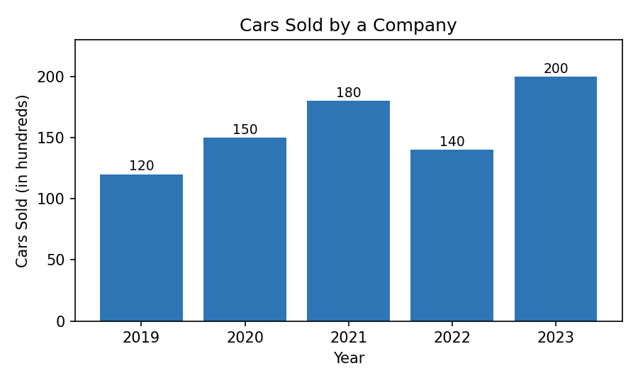
Image URL: https://claude.ai/artifact/VsVbHef315AkcYedwpwcQf
What is the average number of cars sold per year during the period 2019–2023?
(A) 148 hundred
(B) 158 hundred
(C) 160 hundred
(D) 168 hundred
Answer: B
Explanation: Total = 120+150+180+140+200 = 790 hundred; average = 790 ÷ 5 = 158 hundred.
Q2. Study the pie chart and answer the question.
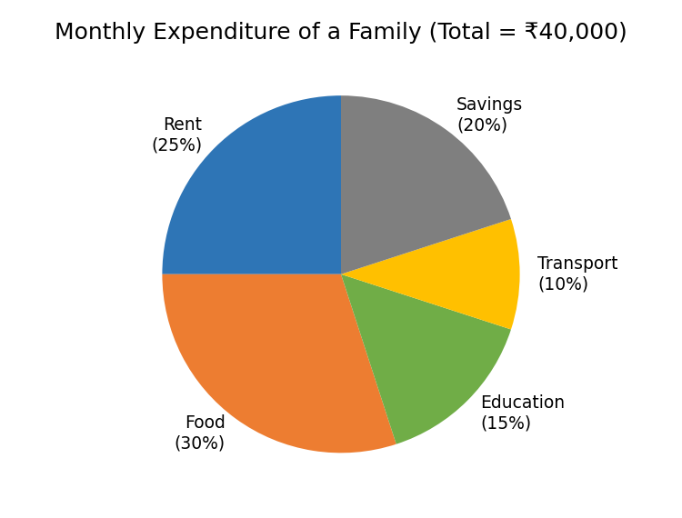
Image URL: https://claude.ai/artifact/LtrkgWzP73kUtmCJrEHupM
How much money is spent on Food and Transport together?
(A) ₹12,000
(B) ₹14,000
(C) ₹16,000
(D) ₹18,000
Answer: C
Explanation: Food (30%) + Transport (10%) = 40% of ₹40,000 = ₹16,000.
Q3. Study the line graph and answer the question.
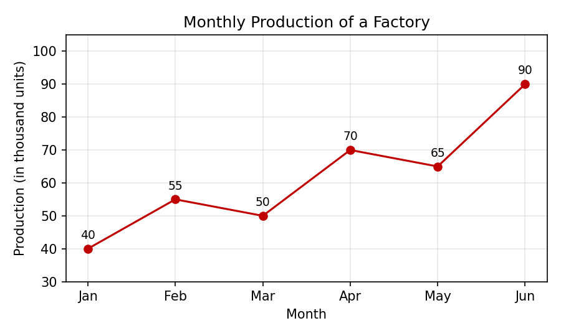
Image URL: https://claude.ai/artifact/5FXhTGeqL7bA938Cj2mSsy
What is the difference between the highest and the lowest monthly production?
(A) 40 thousand units
(B) 45 thousand units
(C) 50 thousand units
(D) 55 thousand units
Answer: C
Explanation: Highest = 90 (June), lowest = 40 (January); difference = 50 thousand units.
Q4. Study the double bar graph and answer the question.
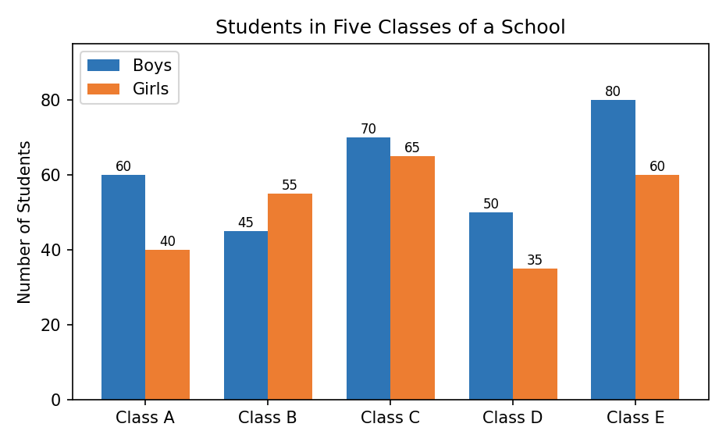
Image URL: https://claude.ai/artifact/PkeJ3LpsTQo2nDQu9FtJha
In which class is the ratio of boys to girls the highest?
(A) Class A
(B) Class B
(C) Class C
(D) Class D
Answer: A
Explanation: Boys:Girls – A 60:40 = 1.5, B 45:55 ≈ 0.82, C 70:65 ≈ 1.08, D 50:35 ≈ 1.43; Class A is highest.
Q5. Study the stacked bar graph and answer the question.
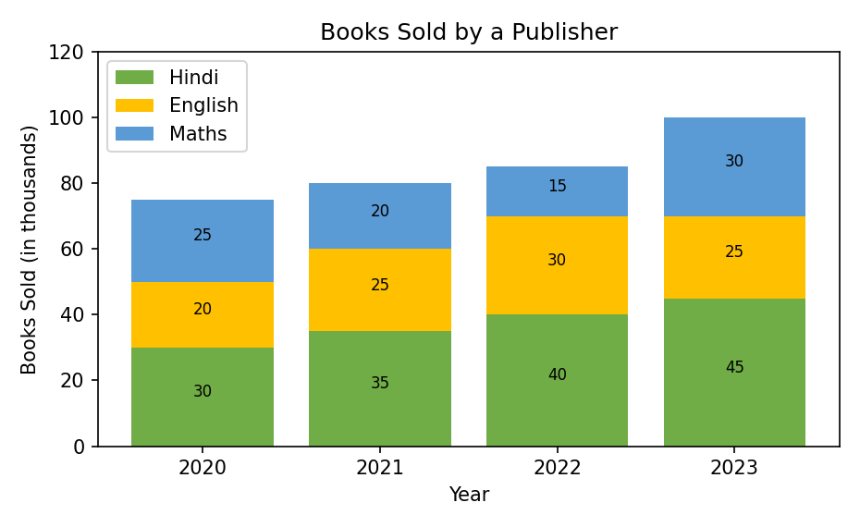
Image URL: https://claude.ai/artifact/K9ve5KcVNQCsTCrhyE7pL5
In 2023, the number of Hindi books sold was what percent of the total books sold in that year?
(A) 40%
(B) 42%
(C) 45%
(D) 48%
Answer: C
Explanation: 2023 total = 45+25+30 = 100 thousand; Hindi = 45 thousand, so 45/100 × 100 = 45%.

Answer Key
Q1: Option (B)
Q2: Option (C)
Q3: Option (C)
Q4: Option (A)
Q5: Option (C)

