**Tutorial – 1(Sub Query)**

Q1 **Find the name of the department where 'Jane Smith' works**

Ans : **select DepartmentName from Departments_a where DepartmentID = (select DepartmentID from Employees where FirstName = 'Jane' and LastName = 'Smith');**

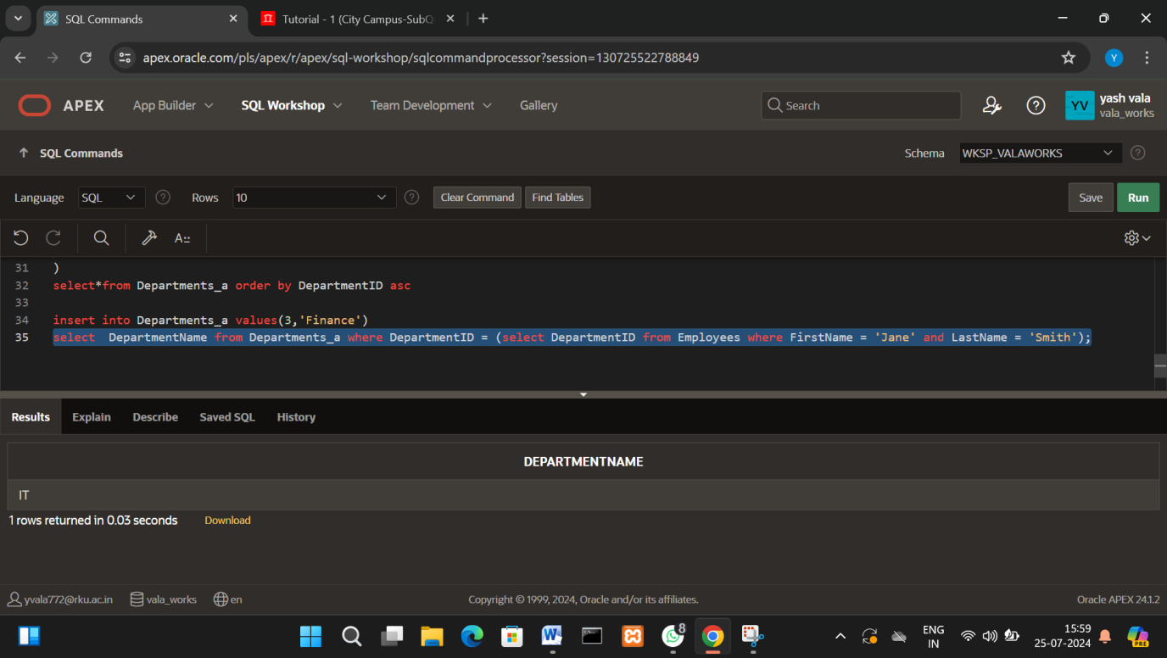

**Q2 List all employees who work in the 'Finance' department**

**Ans : select FirstName,LastName from Employees where DepartmentID = (select DepartmentID from Departments_a where DepartmentName = 'Finance');**

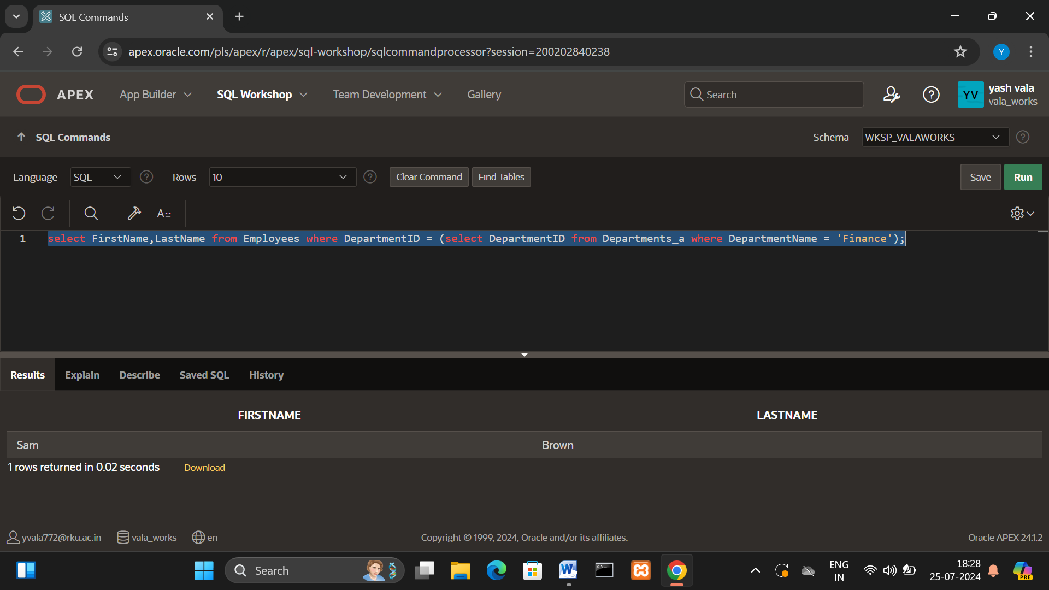

**Q3 Find the highest salary in the 'IT' department**

**Ans : select max(salary)AS HighestSalary from Employees where DepartmentID = (select DepartmentID from Departments_a where DepartmentName = 'IT');**

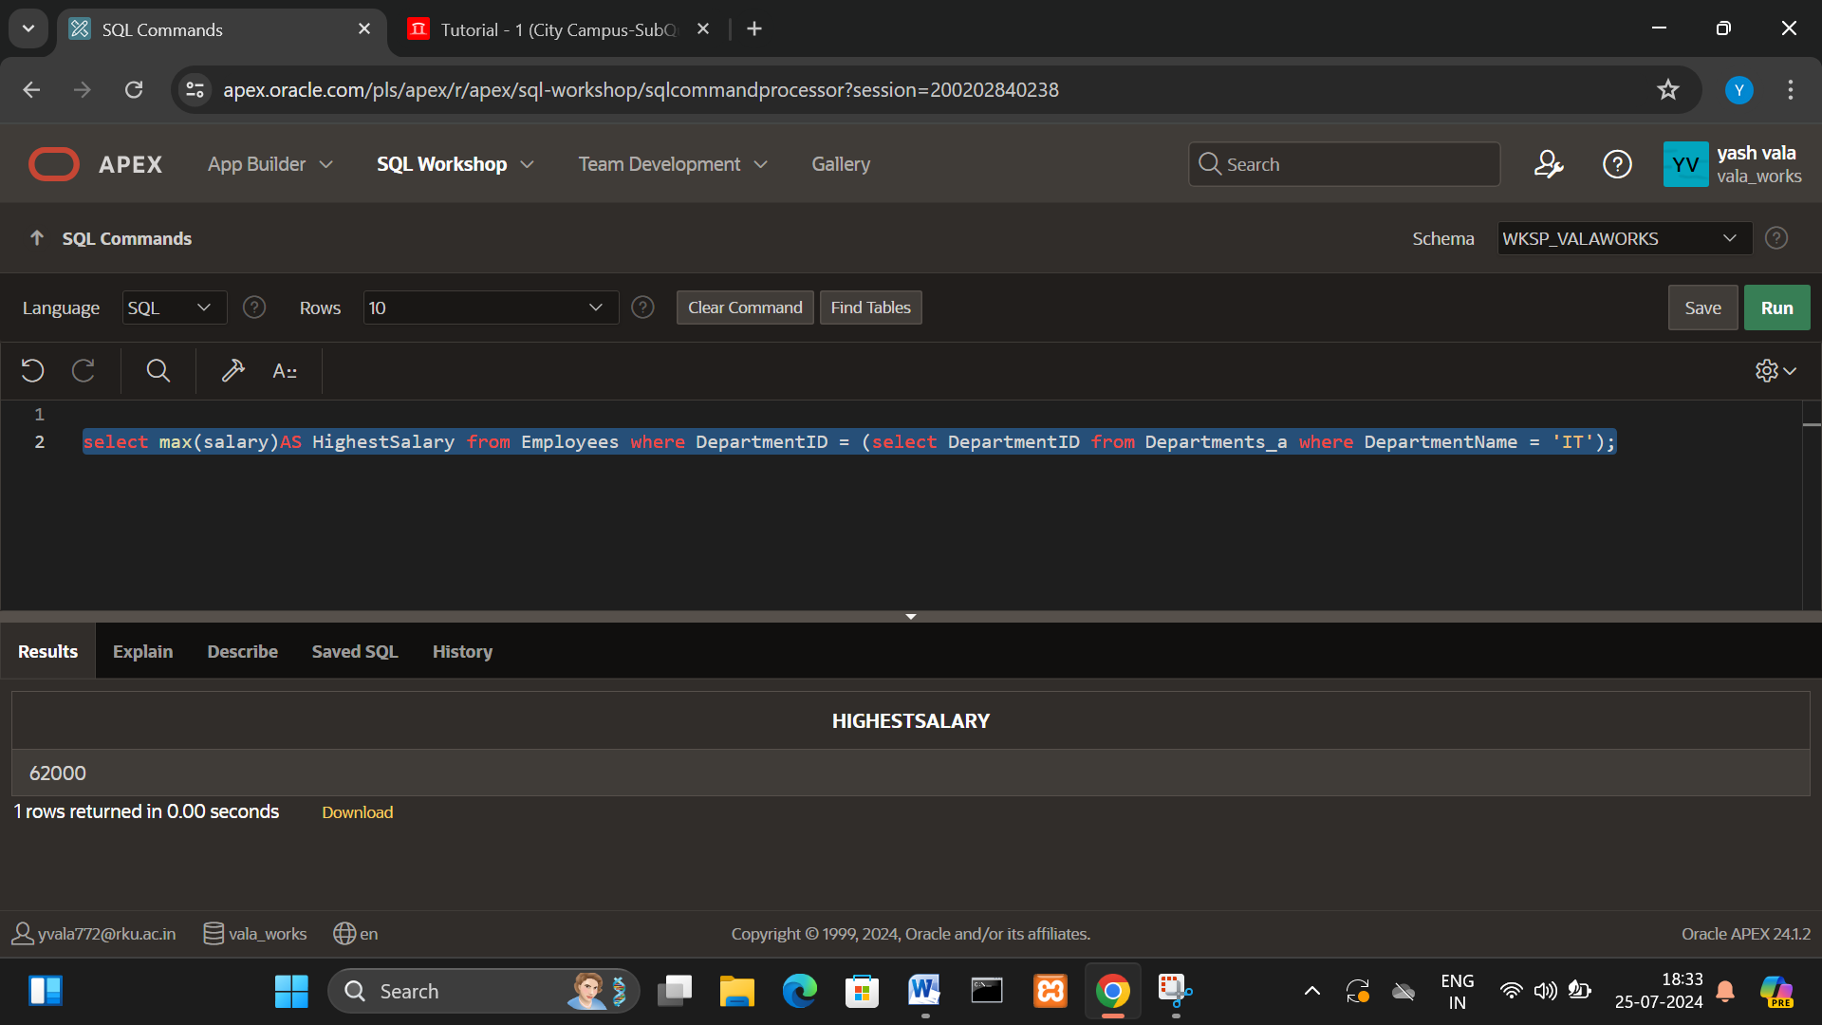

**Q-4 List the names of employees who earn more than 'John Doe'.**

Ans : select FirstName,LastName from Employees where Salary>(select Salary from Employees where FirstName = 'John' and LastName = 'Doe')

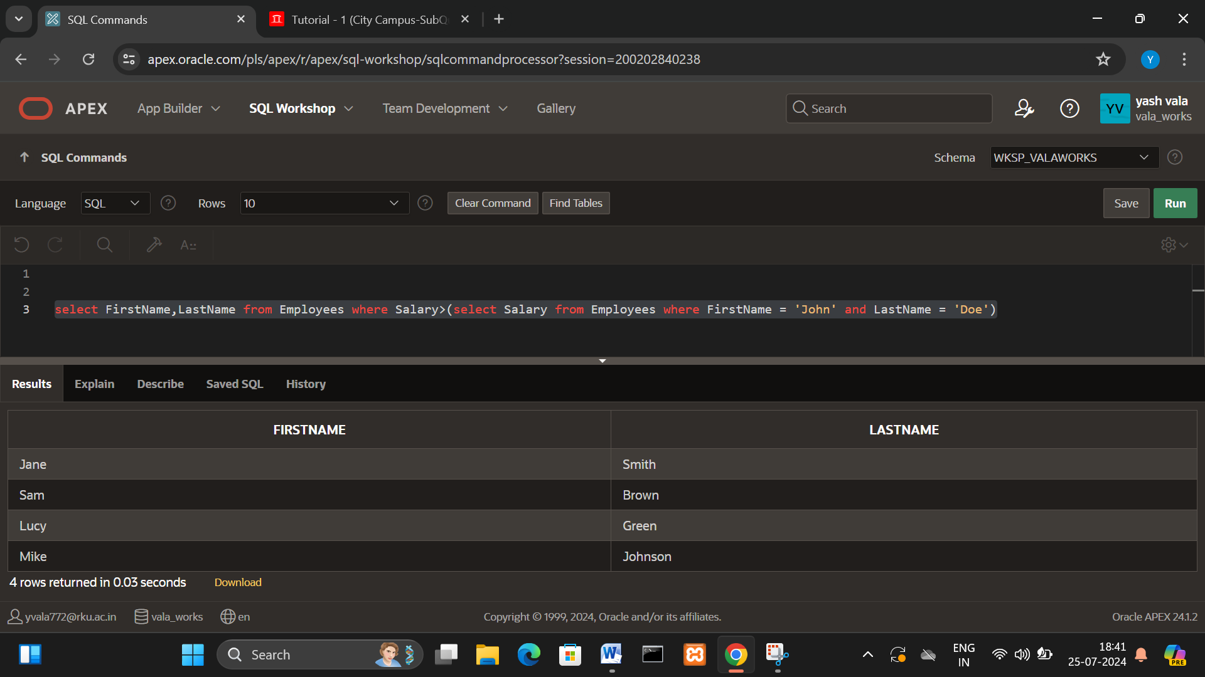

**Q-5 Find the average salary of employees in the 'HR' department**

**Ans : select avg(Salary) AS AverageSalary from Employees where DepartmentID = (select DepartmentID from Departments_a where DepartmentName = 'HR')**

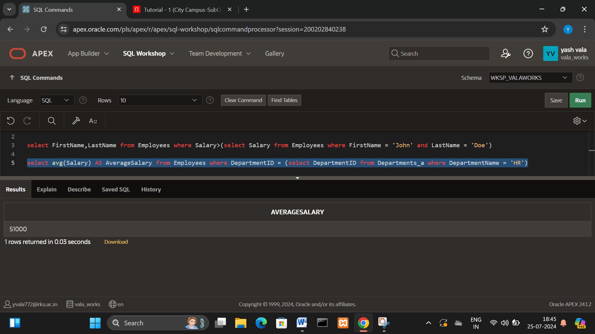

**Q-6 List the departments that have at least one employee with a salary greater than 55,000**

**Ans : select DepartmentName from Departments_a where exists(select 1 from Employees where Employees.DepartmentID = Departments_a.DepartmentID and Salary>55000)**

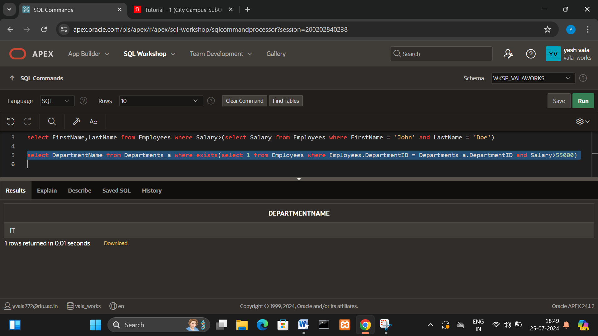

**Q-7 Find the names of employees who work in the same department as 'Lucy Green'**

**Ans : select FirstName,LastName from Employees where DepartmentID = (select DepartmentID from Employees where FirstName = 'Lucy' and LastName = 'Green')and (FirstName!='Lucy'OR LastName ! ='Green')**

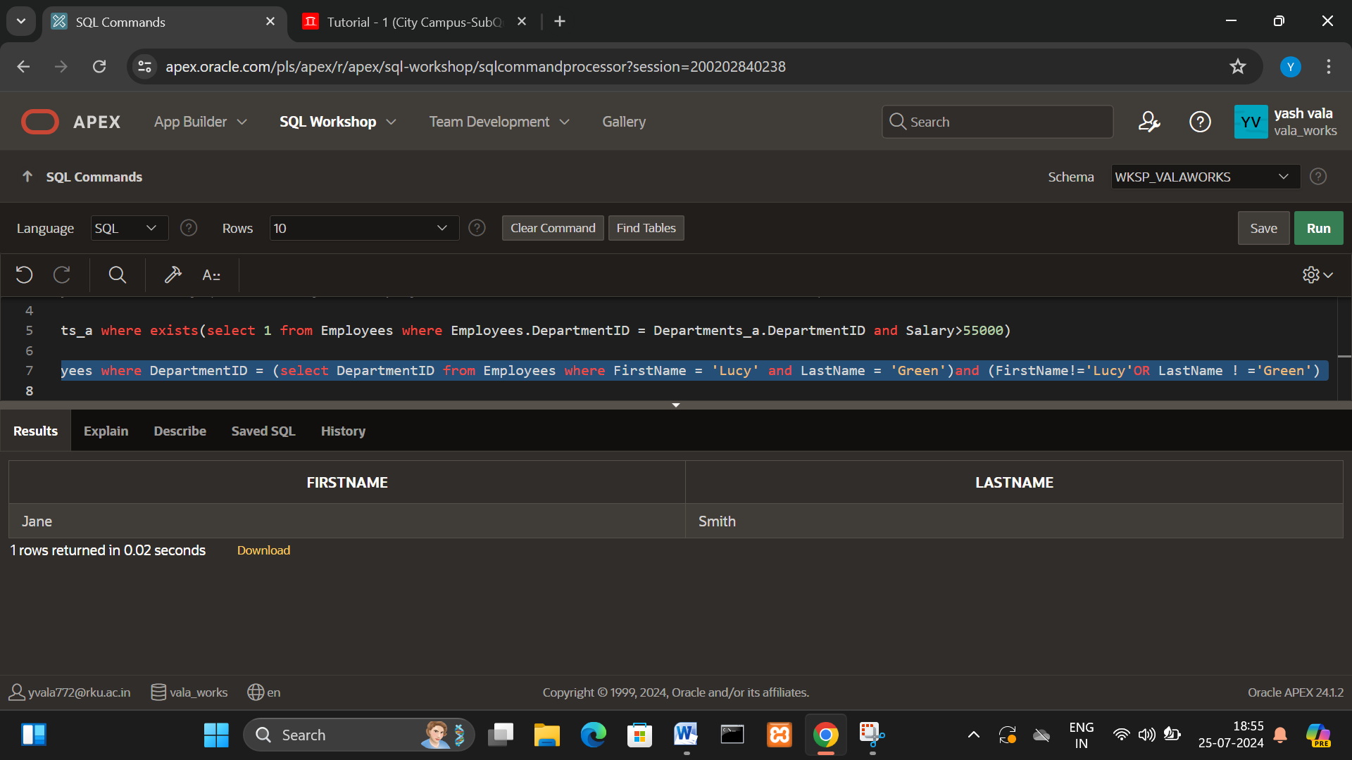

**Q-8 List the departments with no employees**

**Ans : select DepartmentID,DepartmentName from Departments_a where DepartmentID not in(select DepartmentID from Employees)**

