**Shoppers Point – Project Proposal**

**App Name:** Shoppers Point

**Team Members-**

|  |
| --- |
| Sujal Sutariya, ID-101410300, CRN-58079 |
| Aditya Suri, ID-101410341, CRN-58079 |
| Leela Krishna Reddy, ID-10396586, CRN-50492 |

**Course:** COMP3097 – Mobile App Development II

**Application Description**

**Overview**

Shoppers Point is a shopping list application meant to assist individuals in keeping track of their shopping items effectively. The application categorizes items, determines applicable tax amounts, and enables individuals to create and edit various shopping lists. The objective is to simplify the process of shopping and assist users in maintaining lists of must-haves while giving a convenient user interface. With an easy-to-use interface, users are able to switch between sections with ease and utilize advanced features for a hassle-free shopping experience. The app seeks to reduce missed purchases, offer cost estimation via tax calculation, and provide other convenience features like barcode scanning and product categorization.

The users will be able to save repeat buys, have separate shopping lists for different stores, and even exchange lists with housemates or relatives for group shopping. The app will also incorporate a budget option where the user can input how much they would like to spend and monitor what they spend along the way when shopping.

**Application Functionality & Screens**

**1. Launch Screen**

* Displays the app name and team member names.
* Provides a brief loading animation before redirecting users to the home screen.

**2. Home Screen**

* Lists added shopping items with categories such as:
  + Fruits
  + Dairy
  + Coffee, Tea & Cocoa
  + Pharmacy
  + Personal Care & Beauty
* Users can add, edit, or delete items.
* Users can sort items by category, price, or alphabetical order.
* Includes a search bar for quick access to specific products.

**3. Product Details Screen**

* Displays details of an individual product:
  + Name
  + Quantity
  + Price
  + Category
* Allows users to modify item details or mark them as "To Buy Later."
* Provides an estimated total cost preview including tax.
* Suggests similar products based on previous purchases.

**4. Tax Calculator Screen**

* Calculates the total cost, including applicable taxes, based on item categories.
* Users can select different tax rates based on location.
* Provides an option to split the bill among multiple people.

**5. Additional Features (Optional Enhancements)**

* **Push Notifications:** Alerts for expiring groceries or shopping reminders.
* **Barcode Scanner:** Allows users to scan product barcodes for quick addition.
* **Multiple Lists:** Users can maintain separate lists for different stores or occasions.
* **Budget Tracking:** Allows users to set a spending limit and track expenses.
* **List Sharing:** Enables real-time collaboration with family or roommates.

**User Flow Explanation**

1. **User Opens the App:** Sees the launch screen with app branding and a brief loading animation.
2. **Navigates to Home Screen:** Views a categorized shopping list and can filter items as needed.
3. **Adds a Product:** Selects a category, enters details, and saves the product.
4. **Views/Edits a Product:** Clicks on an item to modify details, mark it "To Buy Later," or check similar product suggestions.
5. **Calculates Total Cost:** Navigates to the tax calculator to get the final price with tax, choose tax rates, and split the bill.
6. **Optional Features:** Uses barcode scanning, budget tracking, push notifications, and list sharing for enhanced usability.

**Data Storage**

* **Data Stored:** Shopping items, categories, prices, tax calculations, user preferences, shared lists.
* **Storage Method:**
  + **Core Data** (For offline local persistence).
  + **Firebase** (For cloud synchronization and cross-device access).
* **Reason:** Ensures data persistence, enhances user experience, and provides scalability. Storing data in Firebase allows multiple users to access shared lists in real time, ensuring seamless collaboration. Core Data helps keep local data secure and accessible even when offline.

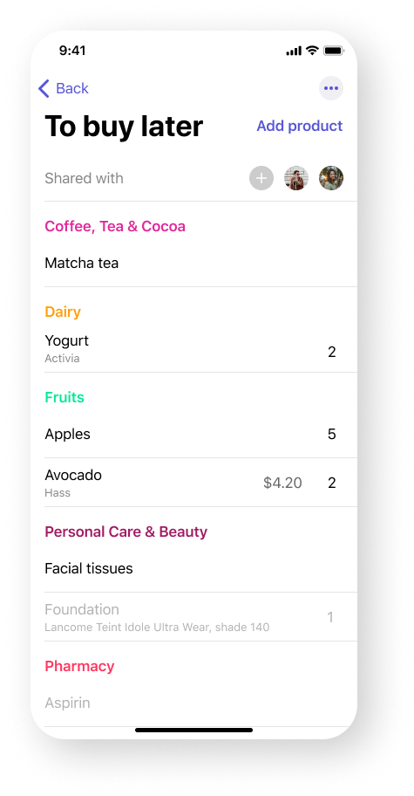**Technology Stack**

* **Programming Language:** Swift
* **Frameworks:** SwiftUI, UI Kit
* **Database:** Core Data / Firebase
* **Development Tools:** Xcode

**GUI Mockups/Wireframes**

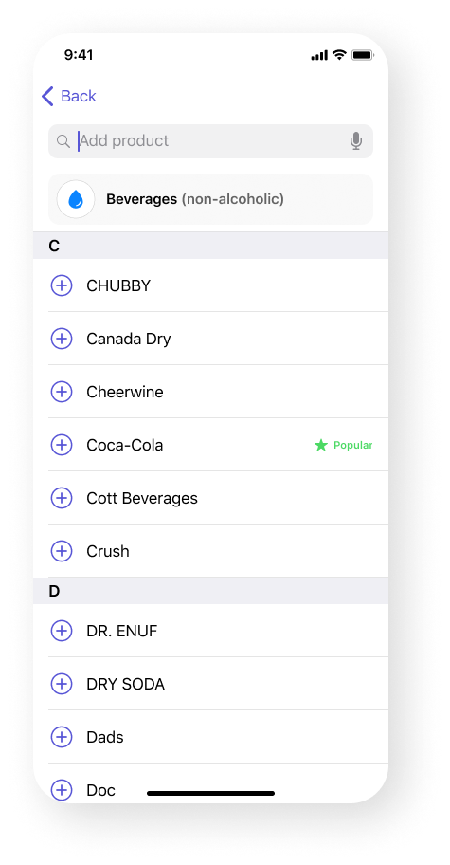

**Conclusion**

Shoppers Point is designed to be a simple yet powerful shopping assistant. With categorized lists, tax calculation, and future enhancements like barcode scanning, budgeting, and push notifications, this app will help users streamline their shopping experience. The integration of shared lists and collaborative shopping further enhances its utility, making it a great tool for households and groups.

This project will provide an intuitive, seamless, and user-friendly experience while also encouraging smarter spending and better organization. The combination of local storage and cloud sync ensures accessibility and data security, making Shoppers Point a reliable shopping companion.