MERN Final:

Requirements:
- NodeJS
- MongoDB
- Postman

Packages:
- ExpressJS
- MongoDB
- Nodemon
- Here, we are using the `vite` for the React
Now, here is the directories structure for the better understanding:
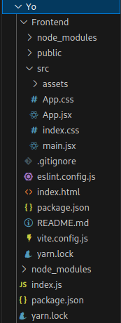

First create one directory with named as the "yo"
mkdir yo
Now, initialize the "yarn"
yarn init
Now, create a index.js file
touch index.js
After that install the required the packages:
yarn add express
yarn add mongodb
yarn add nodemon
After that create simple backend code in the "index.js"
const express = require('express')
const app = express()
app.get("/", async (req, resp) => {
resp.send("App is wokring...")
})
app.listen(4500, (err) => {
if (err) {
console.error("Error found ", err)
}
else {
console.log("Port is running on the 4500")
}
})
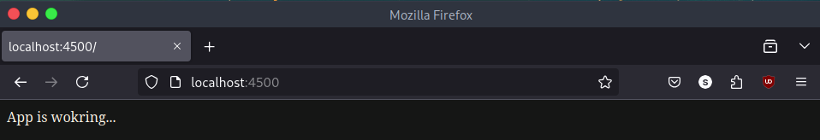
Now, create a react's vite's file:
yarn create vite Backend
Choose the framework: react
Choose the language: Javascript
After that, check by running the project:
cd Backend
yarn
yarn run dev
Now,
Change the code in the `app.jsx` file's
import './App.css'
function App() {
return (
<>
<h1>This is just an example</h1>
</>
)
}
export default App
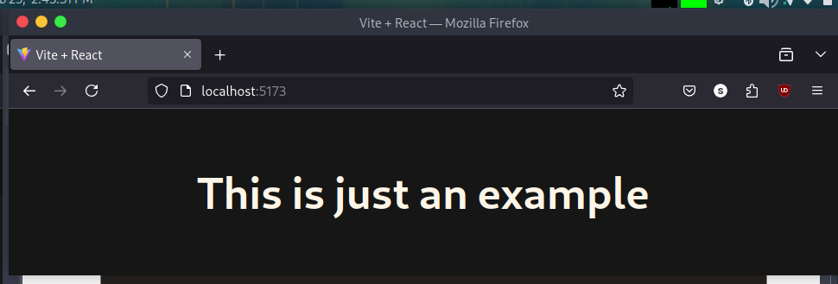
- This is how we setup the frontend and the backend.

Now, we are adding the routing the "React.js":
Install the react-router-dom
yarn add react-router-dom
Now, here is the navbar.jsx's code:
import React from 'react'
// Now, we are using the "Links" for routing the pages.
// Here, we are not using the "anchor tag" <a href=""> </a>. This is because it refreshes the page.
import { Link } from 'react-router-dom'
function Nav() {
return (
<>
<div className="nav">
<ul className="Nav">
<li><Link to="/">Home</Link></li>
<li><Link to="/add">Add Product</Link></li>
<li><Link to="/update">Update Product</Link></li>
<li><Link to="/logout">Logout</Link></li>
<li><Link to="/profile">Profile</Link></li>
<li><Link to="/error">Error Page</Link></li>
</ul>
</div>
</>
)
}
export default Nav
- For handling these routes we are creating the components.
Now,
here is proper routing after adding the components:
import Nav from "./Components/navbar"
import './App.css'
import { BrowserRouter, Routes, Route } from "react-router-dom"
function App() {
return (
<>
<BrowserRouter>
<Nav />
<Routes>
<Route path="/" element={<h1>Here, we are adding the different Components</h1>} />
<Route path="/add" element={<h1>Here, we are adding Product Components</h1>} />
<Route path="/update" element={<h1>Here, we are adding Update Components</h1>} />
<Route path="/logout" element={<h1>Here, we are adding Logout Components</h1>} />
<Route path="/profile" element={<h1>Here, we are adding Profile Components</h1>} />
<Route path="/*" element={<h1>Here, we are adding ErrorPage Components</h1>} />
</Routes>
</BrowserRouter>
</>
)
}
export default App
- In the element's section we are adding the files from the component and executing those pages.

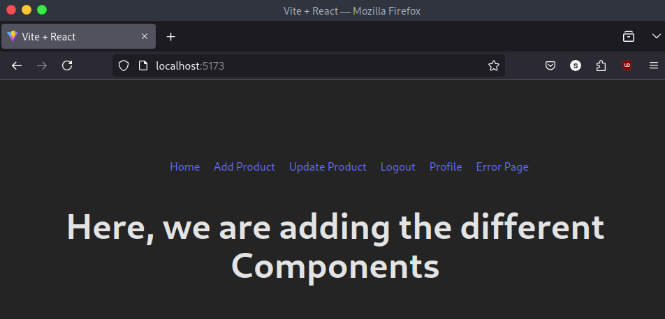
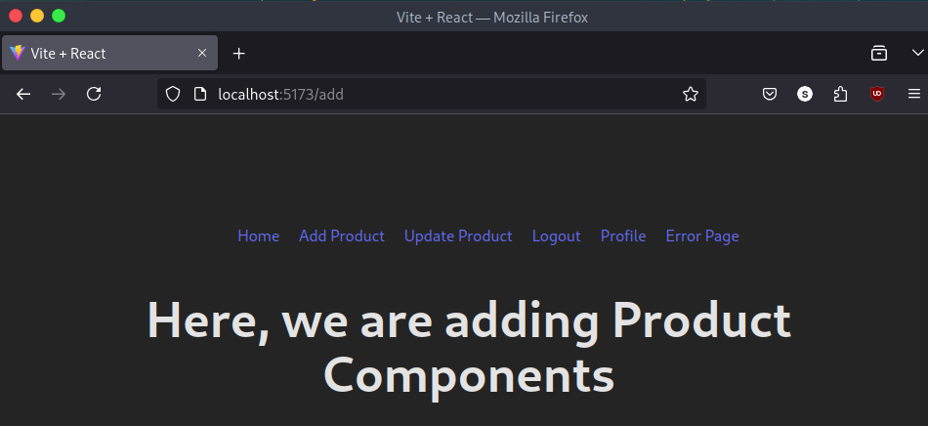
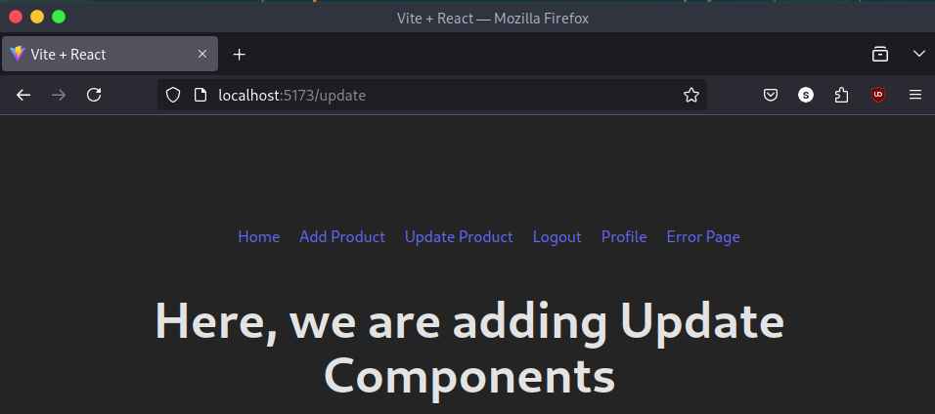
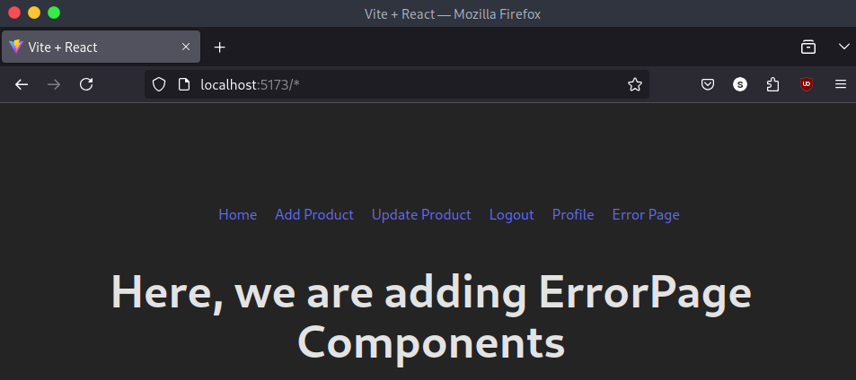
- Here, proper routing has been done. Now, we are creating the separate component for an element's section to render.

Now, we are adding the Navbar component and Footer component's:
Navbar already added. Now, we are adding just footer componnet:
import React from 'react'
function Footer() {
return (<>
<div className="footer">
<h3>E-com dashboard</h3>
</div>
</>)
}
export default Footer
And, new CSS's file:
#root {
text-align: center;
}
.nav Nav li{
border-radius: 10px;
}
.Nav li {
display: inline-block;
padding: 10px;
margin: 0px;
background-color: hsl(208, 100%, 97%);
text-align: center;
}

.Nav li a {
color: hsl(231, 47%, 14%);
padding: 5px;
text-decoration: none;
}
.footer {
position: absolute;
bottom: 0;
text-align: center;
width: 100%;
background: hsl(197, 17%, 29%);
}
- Now, here is an output:
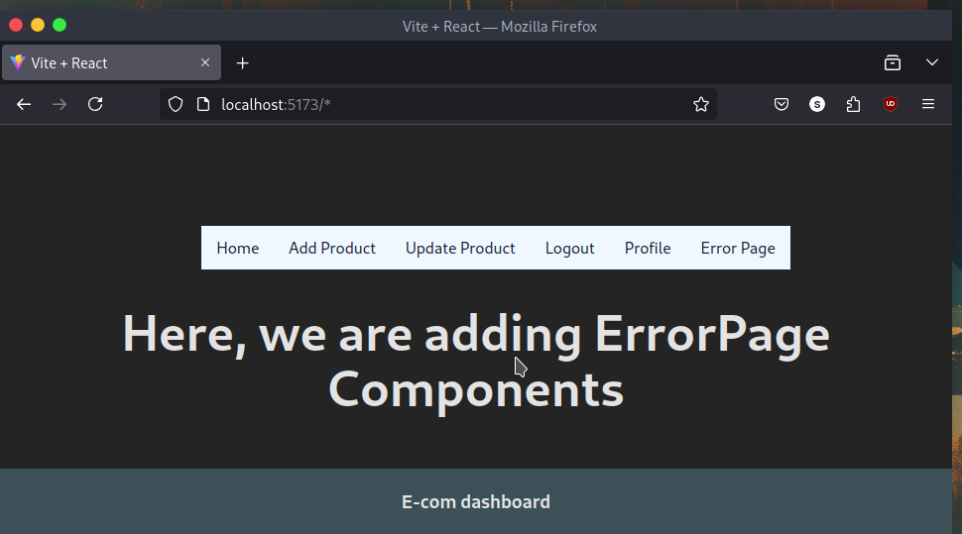
- Here, you can see the output.

Now, here we are working on the Sign Up Page’s layout:

Signup.jsx:
import React, { useState } from "react";
function Signup() {
const [name, setName] = useState("");
const [email, setEmail] = useState("");
const [password, setPassword] = useState("");

const collectData = () => {
console.log(name, email, password);
};
return (
<div className="register">
<h2>This is a sign up menu</h2>
<input
className="InputBox"
type="text"
value={name}
onChange={(e) => setName(e.target.value)}
placeholder="Enter Name"
/>
<input
className="InputBox"
type="email"
value={email}
onChange={(e) => setEmail(e.target.value)}
placeholder="Enter Email"
/>
<input
className="InputBox"
type="password"
value={password}
onChange={(e) => setPassword(e.target.value)}
placeholder="Enter Password"
/>
<button type="button" onClick={collectData} className="appButton">
Sign up
</button>
</div>
);
}
export default Signup;
- Here, we have added the Sign Up's page.
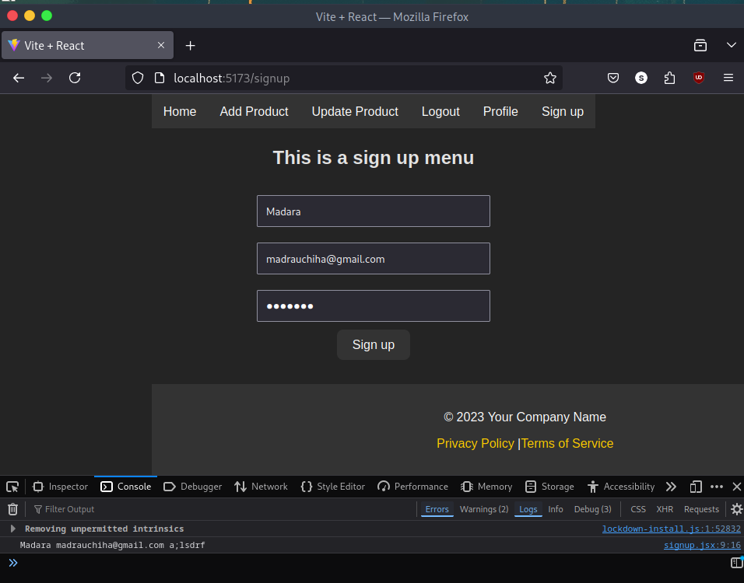
- Here, we are taking an input from the user and then executing that input in the `console section`.

Now, we are setting up the MongoDB:
- Click here for the MongoDB's section.
Now, we are connecting the MongoDB with the ReactJS's frontend project.
yarn add mongoose
Code in the index.js:
const mongoose = require('mongoose')
const connectDB = async () => {
mongoose.connect('mongodb://localhost:27017/Marc')
// Now, we are creating the schema:
const productSchema = new mongoose.Schema({})
const prodcut = mongoose.model('product', productSchema)
const data = await prodcut.find();
console.log(data)
}
connectDB()
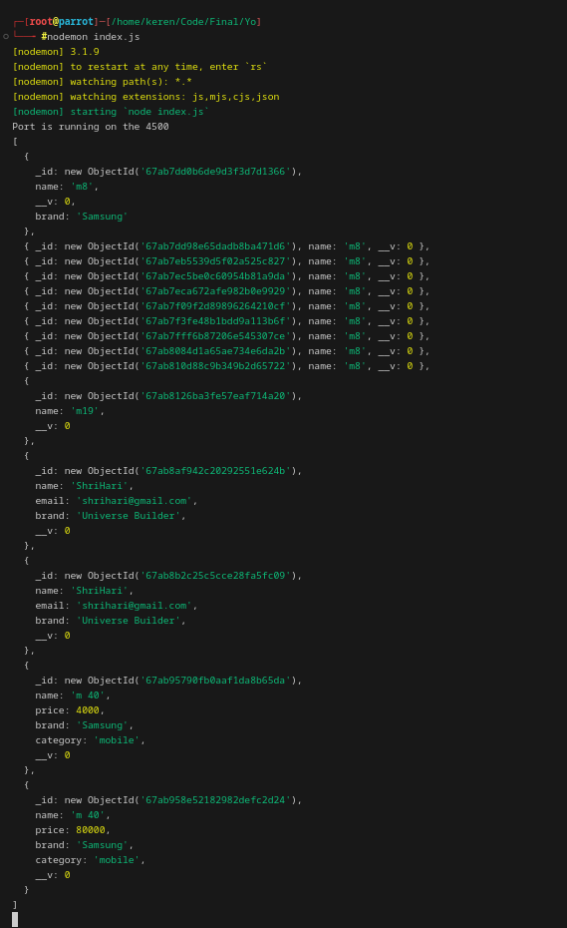

SignUp API:
- Now, we are creating a separate directory for the MongoDB's config file:
mkdir Components
Now, create a config file:
touch DB_Config.js
Code:
const mongoose = require('mongoose')
mongoose.connect('mongodb://localhost:27017/Marc')
And, another users.js file for storing the data:
const mongoose = require('mongoose')
// Here, we are defining the schema's:
const userSchema = new mongoose.Schema({
name: String,
email: String,
password: String
})
module.exports = mongoose.model("users",userSchema)
// Here, one is the collections name and another is the set of Rules for that Schema.
Now, come to the index.js file and create a "post" request for testing and even import other config's file:
require("./Components/DB_Config")
const Users = require("./Components/users")
app.post("/register", (req, resp) => {
resp.send("Api in progress")
})
- Now, go to the Postman for the testing:
- Before that run the program:
nodemon index.js
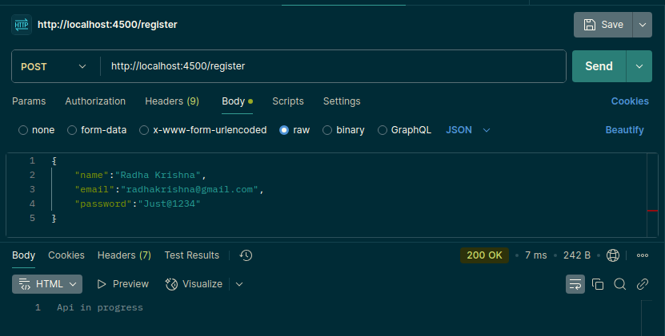
- Now, we want to show the inserted data as a true.
// Here, we are adding the middleware for controlling the data
app.use(express.json())
app.post("/register", (req, resp) => {
resp.send(req.body)
})
Now, post the data and you can see the output in the console of the POSTMAN's side's.

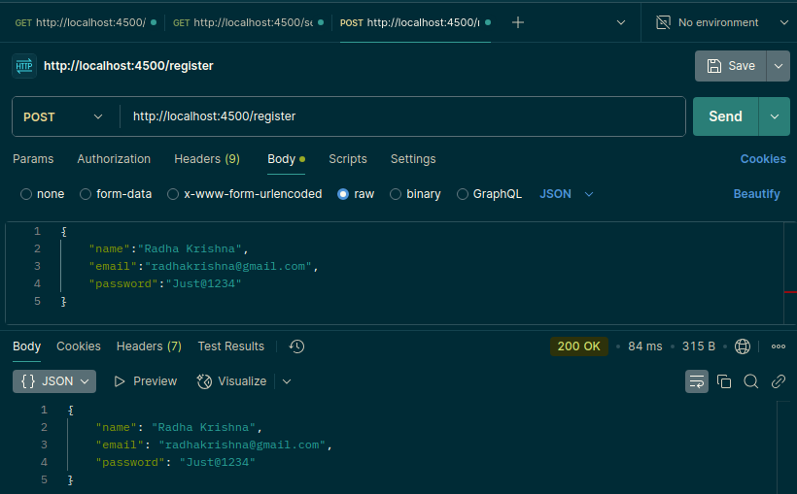
- Now, we are transferring this data into the `mongodb's database`.
Code of inserting the data into the `mongod `.
app.use(express.json())
app.post("/register", async (req, resp) => {
let user = new Users(req.body)
let result = await user.save()
resp.send(result)
})

- Here, you can see that data is getting inserted.
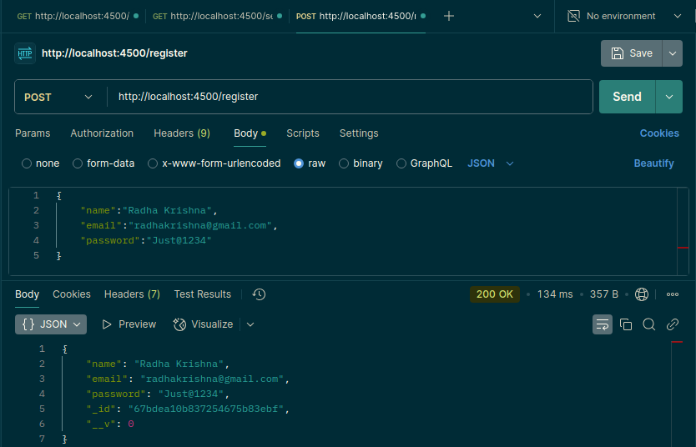
- Here, an Obj _id: is the "67bdea10b837254675b83ebf"
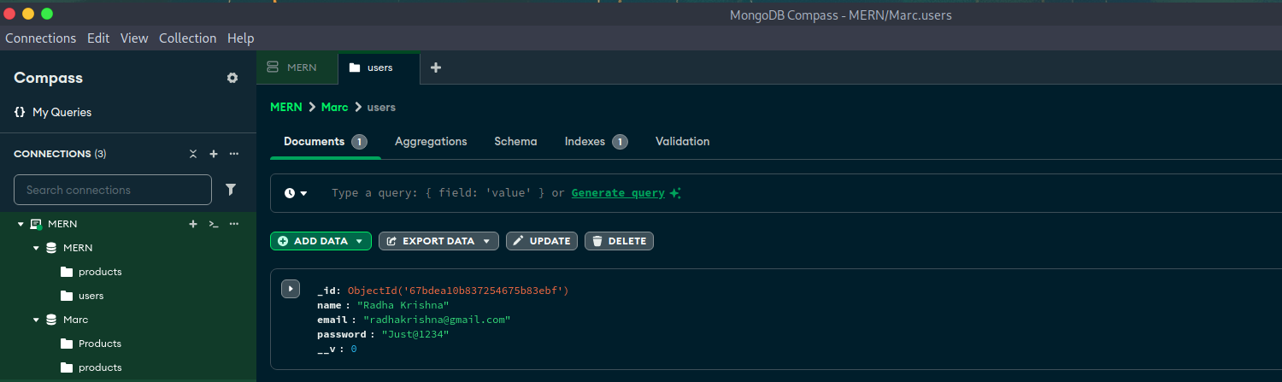
- Here, you can see that our object id same.

Fix "cors" issue:
- Generally developer thinks that this was an issue of the "frontend's" not "backend's".
- And this issue never found you on the POSTMAN but found on the browsers
- It thinks request comes from the different PORTS like frontend runs on the different domain and backend runs on the different domain.
yarn add cors
Add, the give below code in the backend of the project's "index.js" file:
const cors = require('cors')
app.use(cors())

- This will solve your error of the cors and give an output as a 200 OK.

Integrate SignUp API in React:
- There is one more module to fetch the API and that is the "axios". It's a third party package on the yarn
- Instead of that we are using the JavaScript's inbuilt function – "fetch"
Now, the final code for the SignUP API is the:

index.js:
const express = require('express')
const app = express()
require("./Components/DB_Config")
const cors = require('cors')
const Users = require("./Components/users")
// Here, we are adding the middleware for controlling the data
app.use(express.json())
app.use(cors())
app.post("/register", async (req, resp) => {
let user = new Users(req.body)
let result = await user.save()
resp.send(result)
})
app.listen(4500, (err) => {
if (err) {
console.error("Error found ", err)
}
else {
console.log("Port is running on the 4500")
}
})

- Now, the code of the signup.jsx's file's
import React, { useState } from "react";
function Signup() {
const [name, setName] = useState("");
const [email, setEmail] = useState("");
const [password, setPassword] = useState("");
const collectData = async () => {
console.log(name, email, password);
let result = await fetch('http://localhost:4500/register',
{
method: 'post',
body: JSON.stringify({ name, email, password }),
headers: {
'Content-type': 'application/json'
}
})
result = await result.json()
console.warn(result)
}
return (
<div className="register">
<h2>This is a sign up menu</h2>
<input
className="InputBox"
type="text"
value={name}
onChange={(e) => setName(e.target.value)}
placeholder="Enter Name"
/>
<input
className="InputBox"
type="email"
value={email}
onChange={(e) => setEmail(e.target.value)}
placeholder="Enter Email"
/>
<input
className="InputBox"
type="password"
value={password}
onChange={(e) => setPassword(e.target.value)}
placeholder="Enter Password"
/>
<button type="button" onClick={collectData} className="appButton">
Sign up
</button>
</div>
);
}
export default Signup;
- Here, you can see that our 200's request is OK.
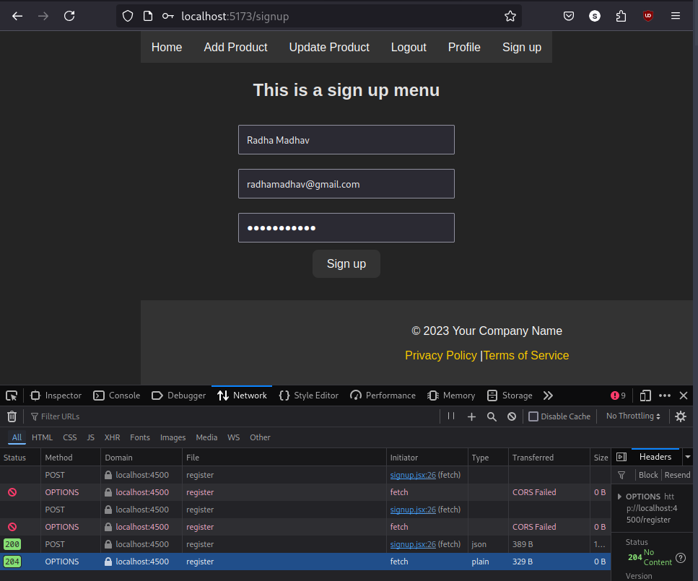

- Now, you can see the result in the MongoDB's section:
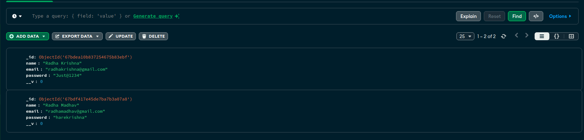
- Now, we are redirecting to the main page after "registeration"
adding one more hook in the signup file:
useNavigate

Code:
import React, { useState } from "react";
import { useNavigate } from "react-router-dom"
function Signup() {
const [name, setName] = useState("");
const [email, setEmail] = useState("");
const [password, setPassword] = useState("");
const navigate = useNavigate()
const collectData = async () => {
console.log(name, email, password);
let result = await fetch('http://localhost:4500/register',
{ //Here, fetch takes 1st inupt as an URL and second as set of data and method
method: 'post', body: JSON.stringify({ name, email, password }),
headers: {
'Content-type': 'application/json'
}
})
result = await result.json()
console.warn(result)
if (result) {
navigate("/")
}
}
- After adding the bold code. You'll get an output.
And it will redirect you to main page.
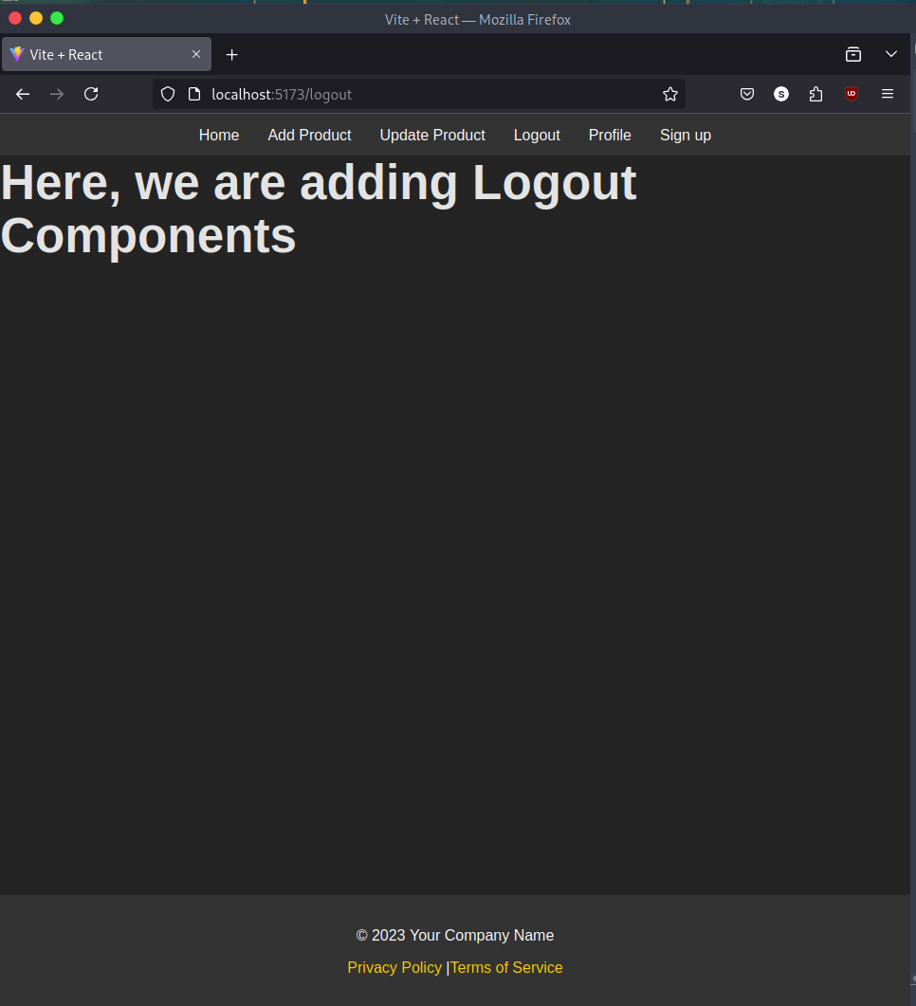
- Here, even though I am not logged in still it shows me the logout's button. And, we should have to fix that.
- If someone logined then they won't be show SignUp button and if they opened the some navbar link in other tab still it should be logined.
- Even if I try to change the URL forcefully. Still, it won't show me that page. Until I logged out.

Complete SignUp Flow:
- Keep user data in Local Storage
- Make private Component
- Handle Signup page with Local Storage
- Update Navbar with Logout and SignUP Menu

- Here, is the Local Storage:
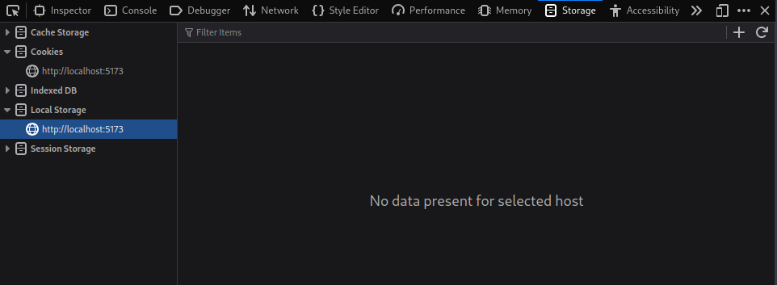
- Here, it stores the data for the Longterm until or unless you won't clean here.

Code:
// To store the data in the localstorage we have to convert that into the stringify
localStorage.setItem("user", JSON.stringify(result))
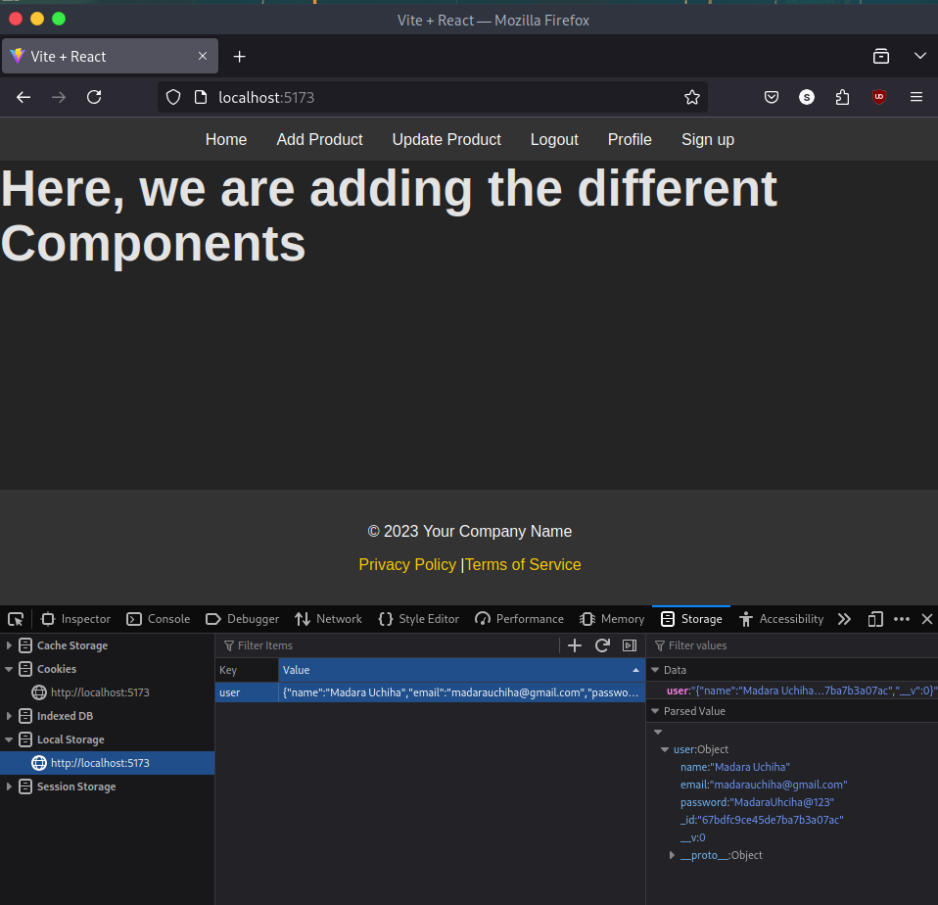
- Add this code in the if(result)'s section

- Now, we are making a Private Component:
- It's like I don't want to expose some of the data until the user login
- So, to solve this we are making a Private Component.
- Make a new file in the directory of the Component ("./yo/Frontend/src/Component")
touch PrivateComponent.jsx

PrivateComponent.jsx
import React from "react"
import { Navigate, Outlet } from "react-router-dom"
function PrivateComonent() {
const auth = localStorage.getItem('user')
return (<>
auth?<Outlet />: <Navigate to="/signup" />
</>)
}
export default PrivateComonent
- After, adding this we can see that if you are logged in then you'll able to access other routes, otherwise it says that. First Login and then continue.
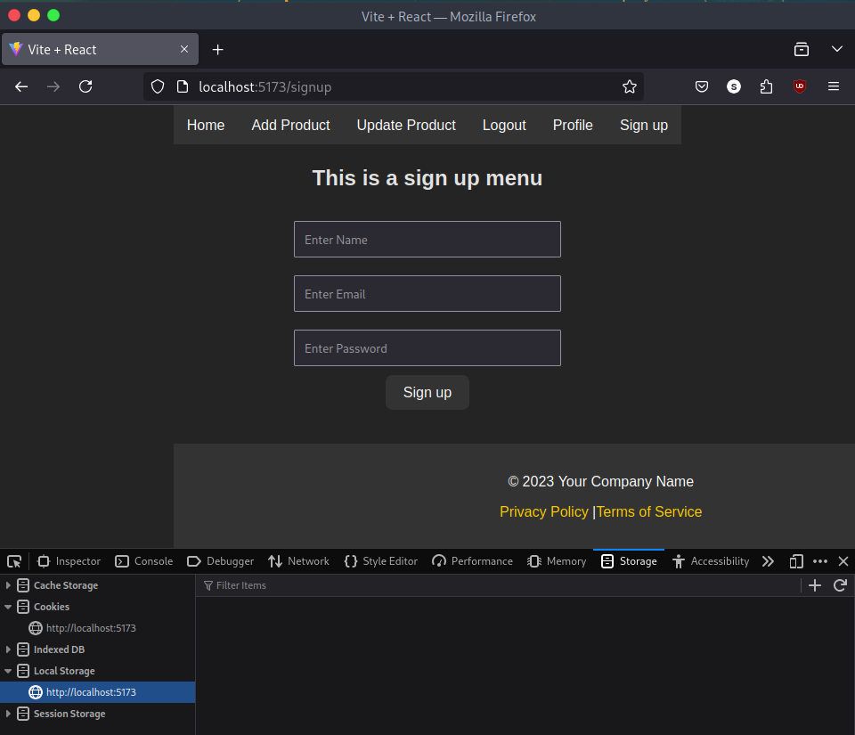
- Here, you can see that after deleting the user from the – Local Storage. We are not able to access the other pages.
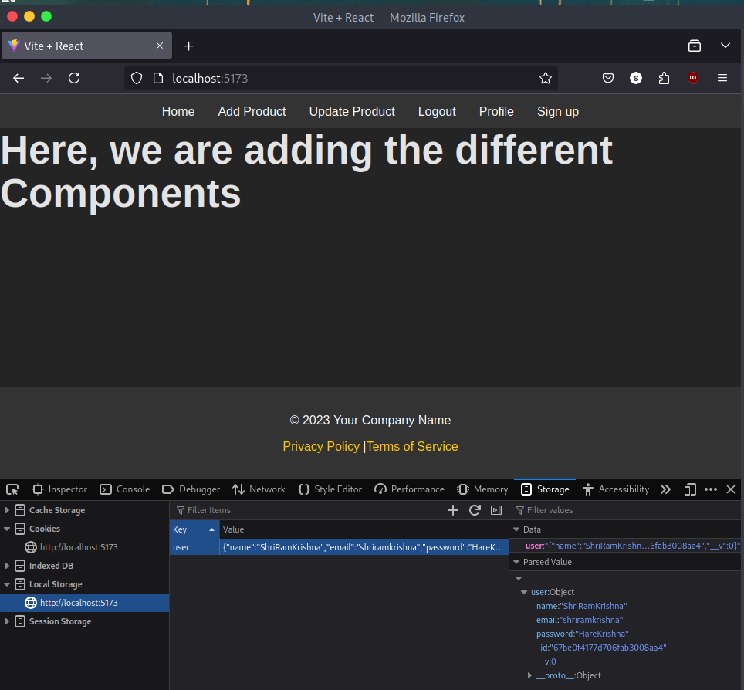
- Here, after adding the user in the Local Storage. We are able to access the other components.
- Now, after login still it shows the Sign Up's button and now, we are hiding that one and if we are logged in then we can't again login.

SignUp.jsx
import React, { useState, useEffect } from "react";
import { useNavigate } from "react-router-dom";
function Signup() {
const [name, setName] = useState("");
const [email, setEmail] = useState("");
const [password, setPassword] = useState("");
const navigate = useNavigate();
useEffect(() => {
const auth = localStorage.getItem('user');
if (auth) {
navigate('/');
}
}, [navigate]); // Add navigate as a dependency
const collectData = async () => {
try {
console.log(name, email, password);
let result = await fetch('http://localhost:4500/register', {
method: 'post',
body: JSON.stringify({ name, email, password }),
headers: {
'Content-type': 'application/json'
}
});
result = await result.json();
localStorage.setItem("user", JSON.stringify(result));
console.warn(result);
if (result) {
navigate("/");
}
} catch (error) {
console.error("Error during registration:", error);
}
};
return (
<div className="register">
<h2>This is a sign up menu</h2>
<input
className="InputBox"
type="text"
value={name}
onChange={(e) => setName(e.target.value)}
placeholder="Enter Name"
/>
<input
className="InputBox"
type="email"
value={email}
onChange={(e) => setEmail(e.target.value)}
placeholder="Enter Email"
/>
<input
className="InputBox"
type="password"
value={password}
onChange={(e) => setPassword(e.target.value)}
placeholder="Enter Password"
/>
<button type="button" onClick={collectData} className="appButton">
Sign up
</button>
</div>
);
}
export default Signup;
- After adding this you can't again go into the Sign Up's section. You have to delete the user or log out the user to enter into the page.
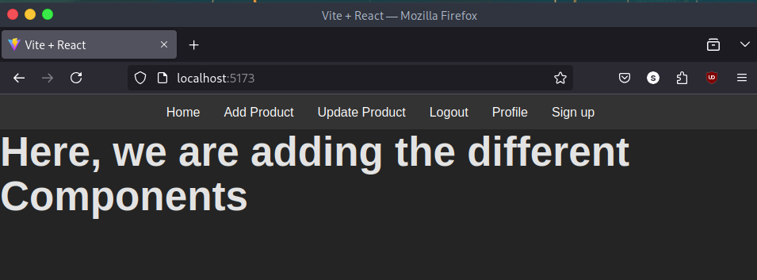
- Here, you can see that there is still "Sign Up". Now, we are choosing one buttone between the "Sign Up" and "Log Out".
- If he is logged in then we will show the Log Out's button. And if it's not logged in then it shows the "Sign Up's" Section.
Here, is the new code just insert in the "navbar.jsx"
import React from 'react'
import { Link } from 'react-router-dom'
function Nav() {
const auth = localStorage.getItem('user')
return (
<>
<div className="nav">
<ul className="Nav">
<li><Link to="/">Home</Link></li>
<li><Link to="/add">Add Product</Link></li>
<li><Link to="/update">Update Product</Link></li>
<li><Link to="/profile">Profile</Link></li>
<li>{auth ? <Link to="/logout">Logout</Link> : <Link to="/signup">Sign up</Link>}</li>
</ul>
</div>
</>
)
}
export default Nav
- Here, you can see that we have added the "auth" inside the web. Now, are adding the condition of the if else's.
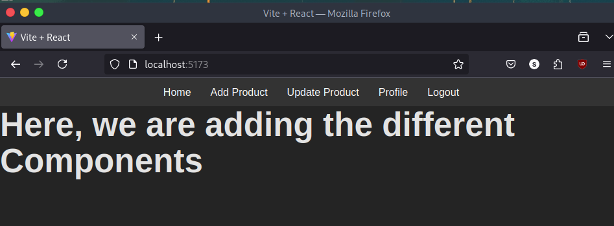
- Here, you can see that there is a "Log Out" section instead of the "Sign Up's" Section.

Logout Section:
- Make a function for Log Out
- Clear the Local Storage
- Redirect User to Sign Up

navbar.jsx
import React from 'react'
import { Link, useNavigate } from 'react-router-dom'
function Nav() {
const auth = localStorage.getItem('user')
const navigate = useNavigate() //This re-render the function without refreshing an elements
const logout = async () => {
localStorage.clear()
navigate('/signup')
}
return (
<>
<div className="nav">
<ul className="Nav">
<li><Link to="/">Home</Link></li>
<li><Link to="/add">Add Product</Link></li>
<li><Link to="/update">Update Product</Link></li>
<li><Link to="/profile">Profile</Link></li>
<li>{auth ? <Link to="/signup" onClick={logout}>Logout</Link> : <Link to="/signup">Sign up</Link>}</li>
</ul>
</div>
</>
)
}
export default Nav
- Here, is an output of the Code:

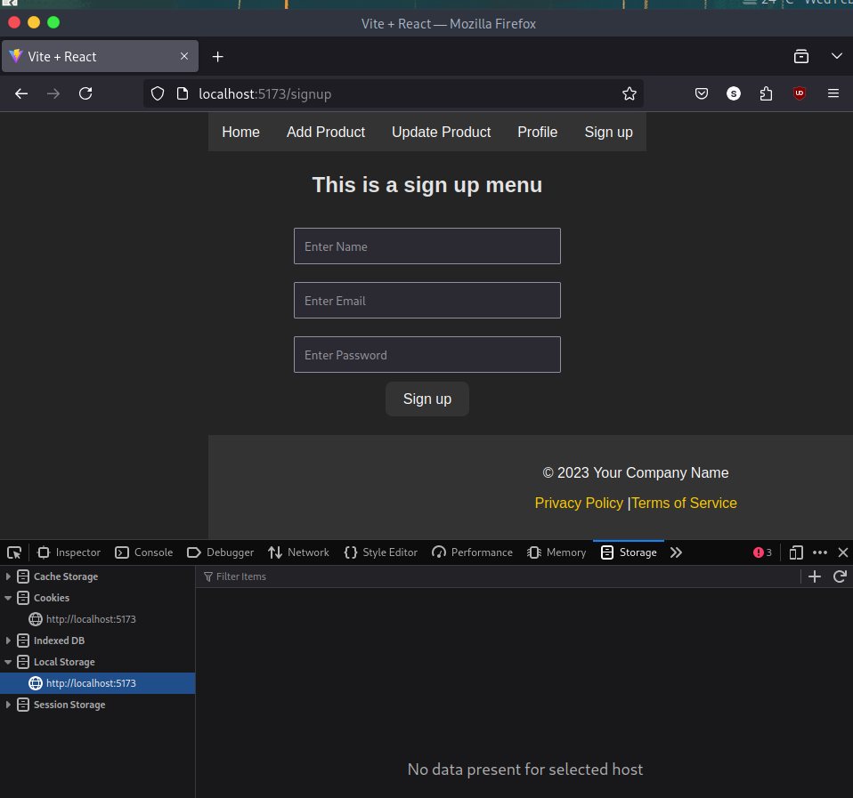
- It deletes the data after Log Out. And redirect us to the Sign Up page.
- And by adding the useNavigate Hook, we don't need to render the page again. It automatically renders the page.

Login API in Node JS:
- Make Route for API
- Pass data from POSTMAN
- Fetch Result from DB
- Remove password from Register and Login API
- Test Flow

index.js:
// Here, we are making the Login's API for log in.
app.post("/login", async (req, resp) => {
// resp.send(req.body)
// Here, we are using the - "Users" because it has already data.
let user = await Users.findOne(req.body)
resp.send(user)
})
Now, we are getting this given below as an outupt:
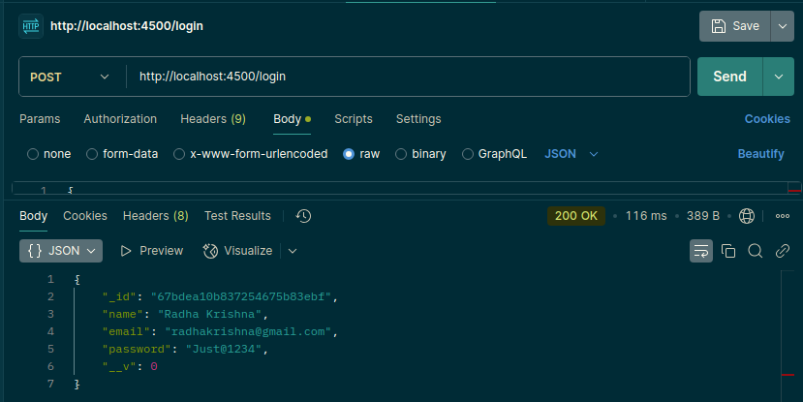
- We don't need the password. That's why we are using the given below code:
let user = await Users.findOne(req.body).select("-password")

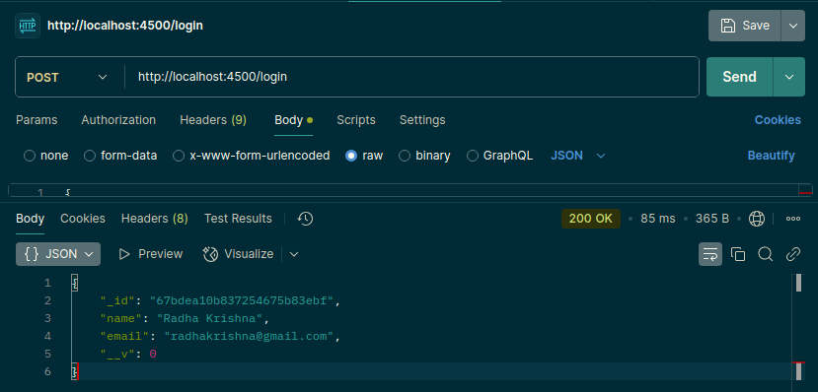
- This is how it removes some specific details from the fetching the data from the database.
- Here, we are adding the "user's" existings condition.
app.post("/login", async (req, resp) => {
let user = await Users.findOne(req.body).select("-password")
if (user) {
resp.send(user)
}
else {
resp.send({ result: 'No user found' })
}
})
- This will check that – if the user's data in the Database, then it will show the output. Otherwise, it won't show an output.
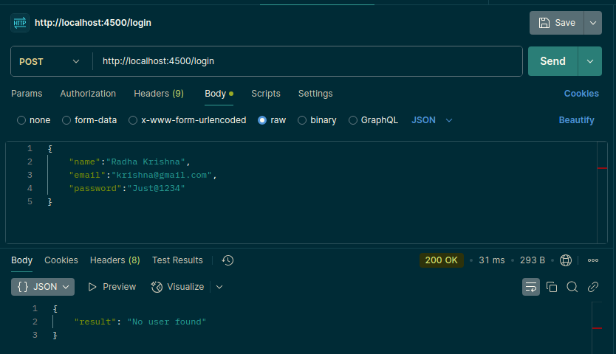
- Here, you can see that output of the above input. It gives an result as no user found.
- After adding the given below code in the Login API, then it will that what input has been given by the user.
console.log(req.body)

- Output:
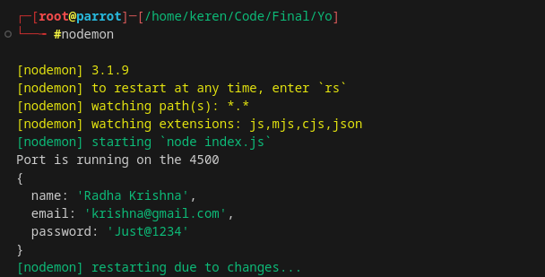
- Now, here is the password and email's condition API:
// Here, we are making the Login's API for log in.
app.post("/login", async (req, resp) => {
console.log(req.body)
if (req.body.password && req.body.email) {
let user = await Users.findOne(req.body).select("-password")
// Now, we are checking that Password and Email sends and if they both gets "True" then we will execute the command otherwise. We won't execute.
if (user) {
resp.send(user)
}
else {
resp.send({ result: 'No user found' })
}
} else {
resp.send({ result: "No user found" })
}
})
- Here, is the input that we have given in the POSTMAN and it gives a same output as we input the text inside the body:
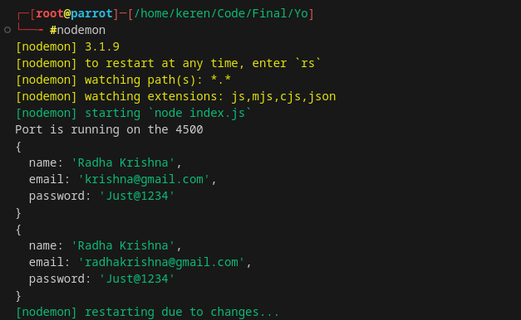
- Second one true and first one is false:
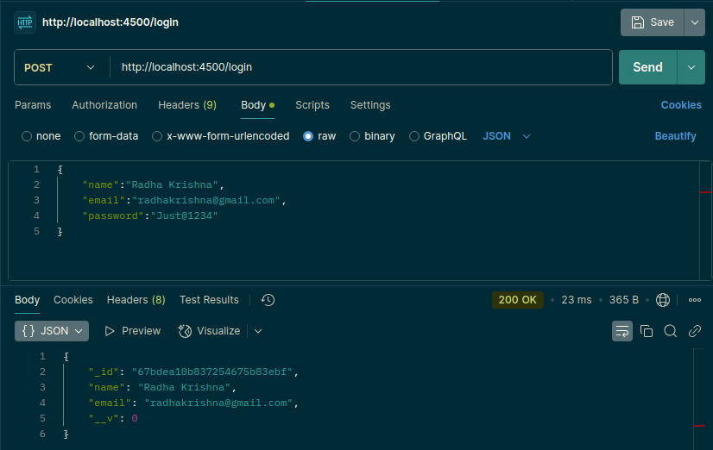
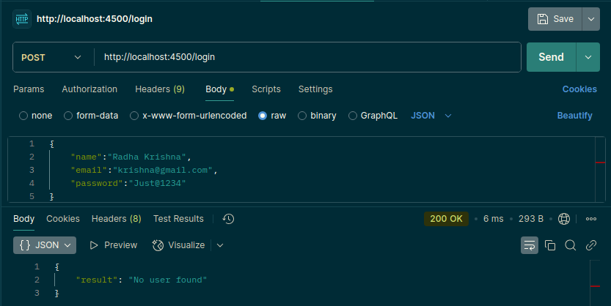
- Here, are two input's images.
- If we try to remove some of the input's details like password or email then also it gives an error.

- Password even won't come to our POSTMAN's response. It's not a good practice.
So,
In the "/register" API we have to make the changes after saving the user.
Code of the "/register" API:
app.post("/register", async (req, resp) => {
let user = new Users(req.body)
let result = await user.save()
result = result.toObject() //Here, we are creating an Object and storing that after that we are deleting the password
delete result.password
resp.send(result)
})
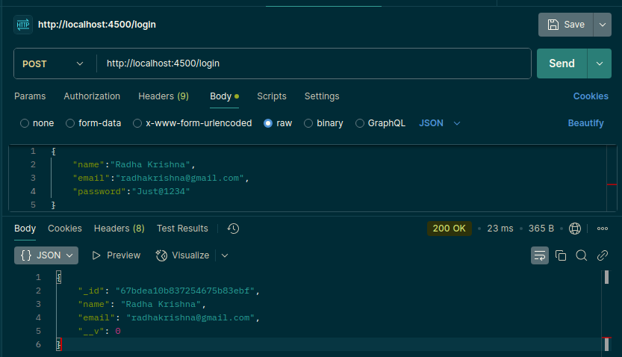
- Here, all the things are correct. Still it doesn't show us the Password.

Our email should be unique. So, for that we are working on that.
- Here, we are making some changes in the login.jsx’s file:
import React, { useState } from "react"
function Login() {
const [email, setEmail] = React.useState('')
const [password, setPassword] = React.useState('');
const handleLogin = () => {
console.log(email, password)
}
return (<>
<h1>Login Page</h1>
<div className="login">
<input className="InputBox" type="text" onChange={(e) => setEmail(e.target.value)} value={email} placeholder="Enter email" />
<input className="InputBox" type='password' onChange={(e) => setPassword(e.target.value)} value={password} placeholder="Enter password" />
<button onClick={handleLogin} className="appButton" type="button">Login</button>
</div>
</>)
}
export default Login
- Here, we have done some changes inside the file. For the login button.
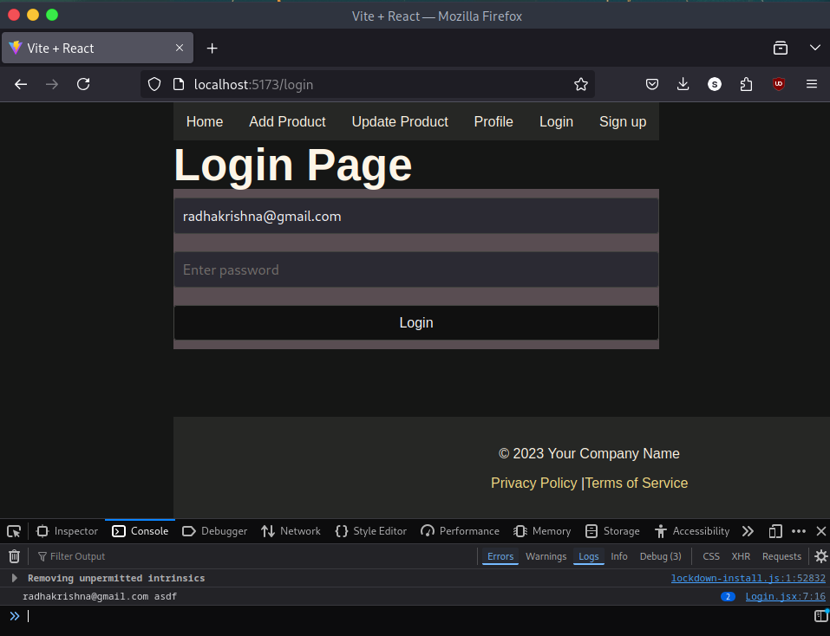

Login API Integration:
- Before integrating an API inside the Program. Check that is it perfectly works inside the POSTMAN's app.
- Here, is the code of working state inside the "index.js"
app.post("/login", async (req, resp) => {
console.log(req.body)
if (req.body.password && req.body.email) {
let user = await Users.findOne(req.body).select("-password")
// Now, we are checking that Password and Email sends and if they both gets "True" then we will execute the command otherwise. We won't execute.
if (user) {
resp.send(user)
}
else {
resp.send({ result: 'No user found' })
}
} else {
resp.send({ result: "No user found" })
}
})
- And, here is an output of an App.
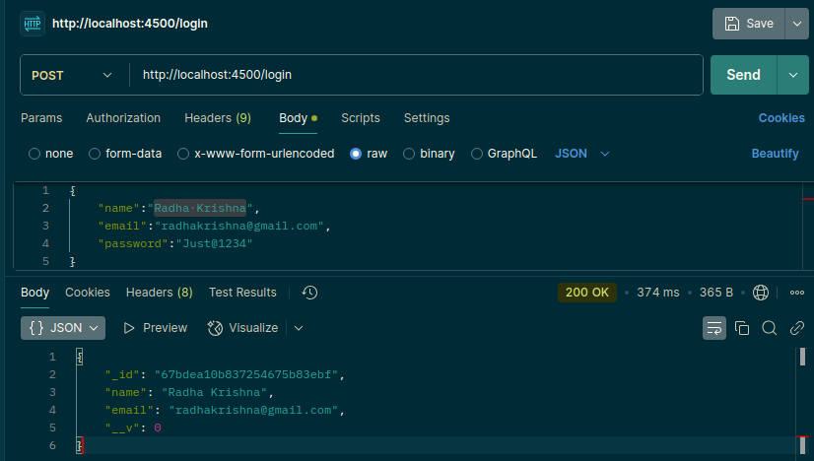
- And one more output from the nodemon's terminal:
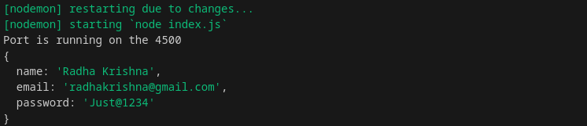
- Code in the login.jsx's file:
const handleLogin = async () => {
console.log(email, password)
// Here, we are integrating an API for the working model
let result = await fetch('http://localhost:4500/login', {
method: 'post',
body: JSON.stringify({ email, password }),
headers: {
'Content-Type': "application/json"
}
})
result = await result.json()
console.log(result)
}
- This input takes from the MongoDB's and it executed successfully:
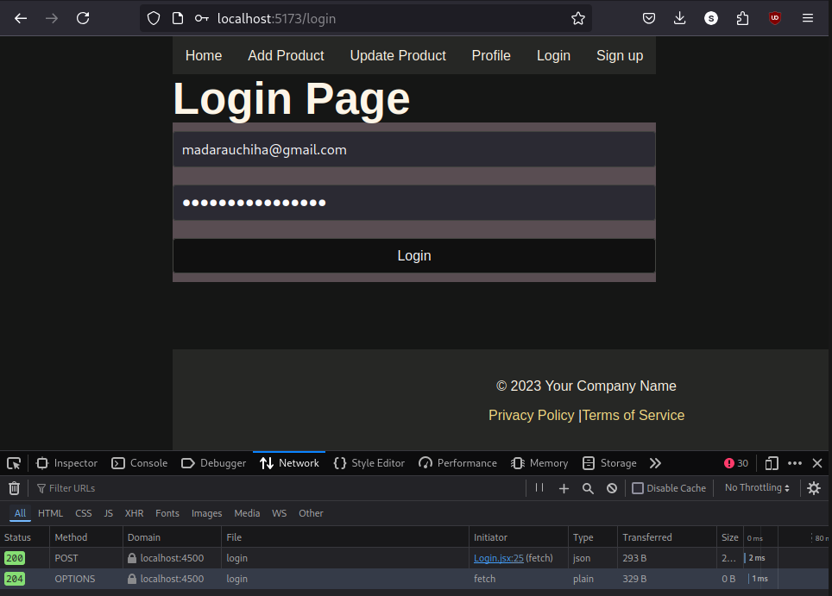
- Here, we even get an output in the terminal:
Now, the final code of the Login.jsx's files:
import React, { useState } from "react"
import { useNavigate } from "react-router-dom";
function Login() {
const [email, setEmail] = React.useState('')
const [password, setPassword] = React.useState('');
const naviage = useNavigate();

const handleLogin = async () => {
console.log(email, password)
// Here, we are integrating an API for the working model
let result = await fetch('http://localhost:4500/login', {
method: 'post',
body: JSON.stringify({ email, password }),
headers: {
'Content-Type': "application/json"
}
})
result = await result.json()
console.log(result)
if (result.name) {
// For storing the data in the Local storage
localStorage.setItem('user', JSON.stringify(result))
naviage("/")
}
else {
alert("Please enter correct details")
}
}
return (<>
<h1>Login Page</h1>
<div className="login">
<input className="InputBox" type="text" onChange={(e) => setEmail(e.target.value)} value={email} placeholder="Enter email" />
<input className="InputBox" type='password' onChange={(e) => setPassword(e.target.value)} value={password} placeholder="Enter password" />
<button onClick={handleLogin} className="appButton" type="button">Login</button>
</div>
</>)
}
export default Login

- And, the output of the session is:
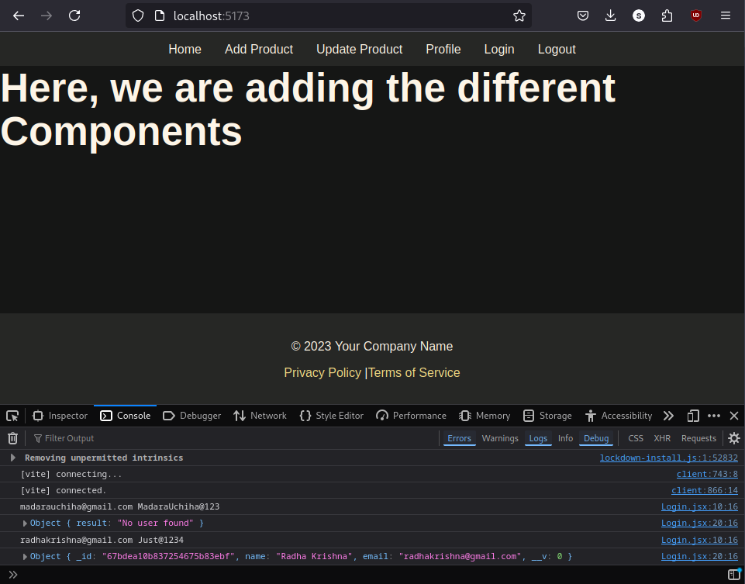
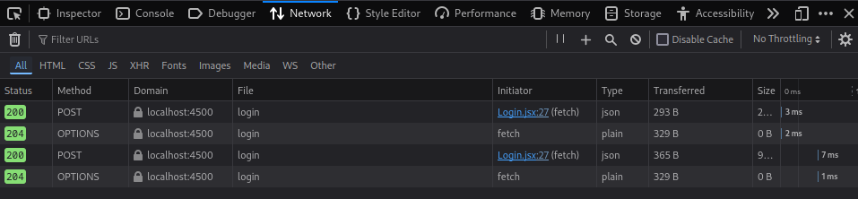
- This is one is like an API:

- This is a Local Storage:
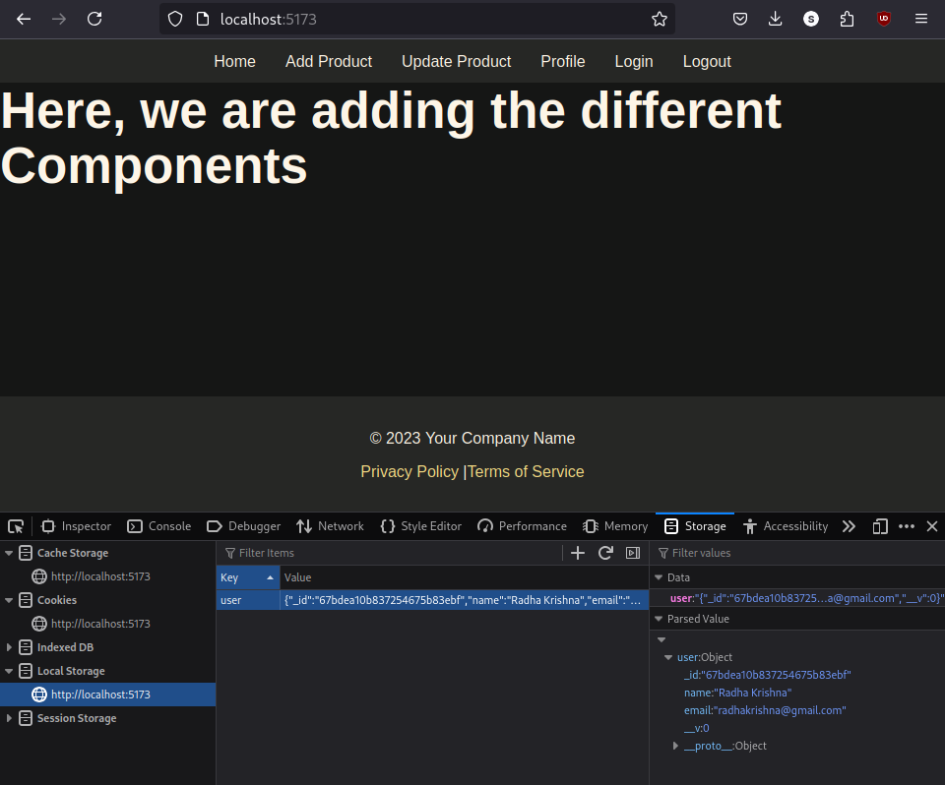
Now, we are working on the buttons from the above like we only want a "logout" button after Log in, and after Sign Up we don't want a Log in button also.

Navbar.jsx:
import React from 'react'
import { Link, useNavigate } from 'react-router-dom'

function Nav() {
const auth = localStorage.getItem('user')
const navigate = useNavigate()
const logout = async () => {
localStorage.clear()
navigate('/signup')
}
return (
<>
<div className="nav">
<ul className="Nav">
<li><Link to="/">Home</Link></li>
<li><Link to="/add">Add Product</Link></li>
<li><Link to="/update">Update Product</Link></li>
<li><Link to="/profile">Profile</Link></li>
{/* <li><Link to="/login">Login</Link></li>
<li>{auth ? <Link to="/signup" onClick={logout}>Logout</Link> : <Link to="/signup">Sign up</Link>}</li> */}

{/* Here, we are creating some different code for Using all the things at a time */}

{
auth ? <li><Link to="/signup" onClick={logout}> Logout </Link></li> :
<>
<li><Link to="/signup">Sign up</Link></li>
<li><Link to="/login">Login</Link></li>
</>
}
</ul>
</div>
</>
)
}
export default Nav\
- The highlighted part is edited. After that you can see only there are two butons before Sign Up to the websites. After that we can only see the one button.
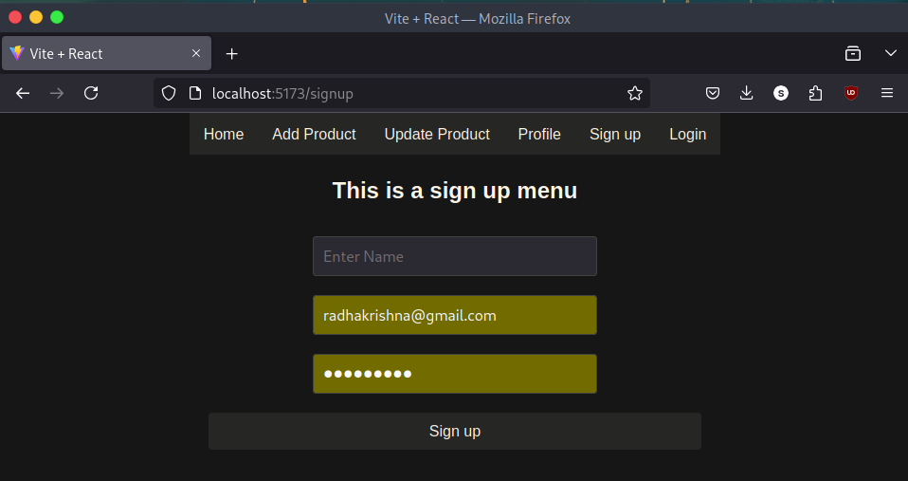
- Here, you can see that there two buttons and after login you can see below:
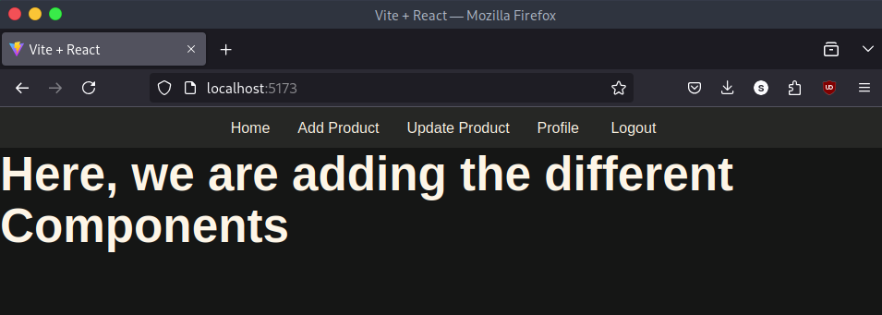
- Here, there is only one button. Which is of the "logout's".

- There is one issue that after login into you can see that you can directly access the "url's section of the login" by just adding the "/login" at the end.
- To solve this we have to add one more property in the Login.jsx's files:
// Here, we are adding the property of not adding the url by manually after log in. And it is specifically for the Login and the Sign Up.
const auth = localStorage.getItem('user')
useEffect(() => {
if (auth) {
naviage('/')
}
})
- Add this code in the Login().
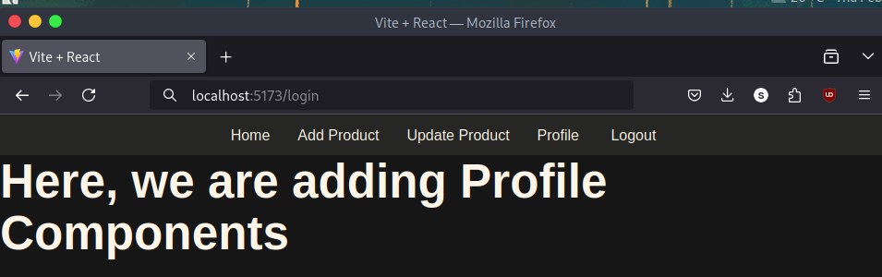
- After adding this and entereing the enter. Still, we won't get into the login's section.

- And it shows the given below content:
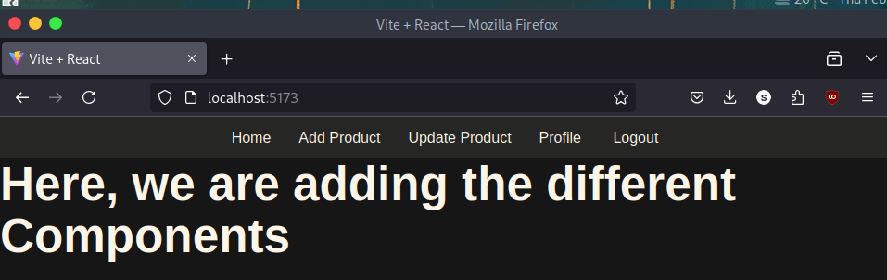

Update Navbar
- Hide Products Menu before Login
- Show Logged – in user name
- Add Logo and Style
Add the given blow return function into the code of the navbar.jsx's files:
return (
<>
<div className="nav">
{auth ?
<ul className="Nav">
<li><Link to="/">Home</Link></li>
<li><Link to="/add">Add Product</Link></li>
<li><Link to="/update">Update Product</Link></li>
<li><Link to="/profile">Profile</Link></li>
<li><Link onClick={logout} to="/logout">logout</Link></li>

</ul> :
<ul className='Nav nav-right'>
<li><Link to="/signup">Sign up</Link></li>
<li><Link to="/login">Login</Link></li>
</ul>
}
</div >
</>
)

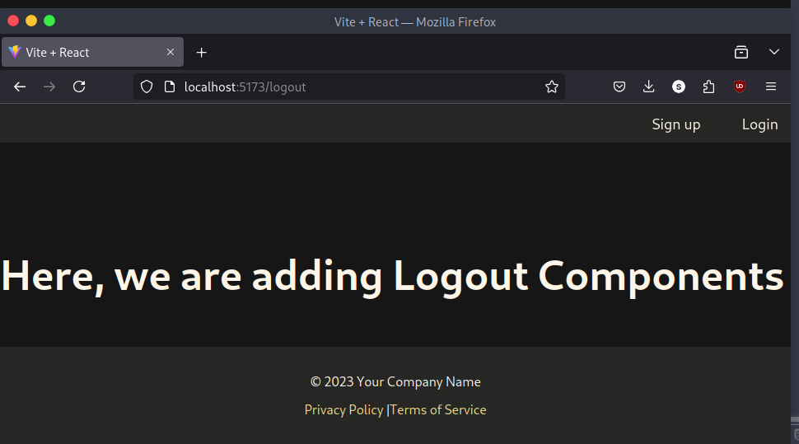
- Here, you can see the page after logout. We have only two links to enter:
Sign up and Login:
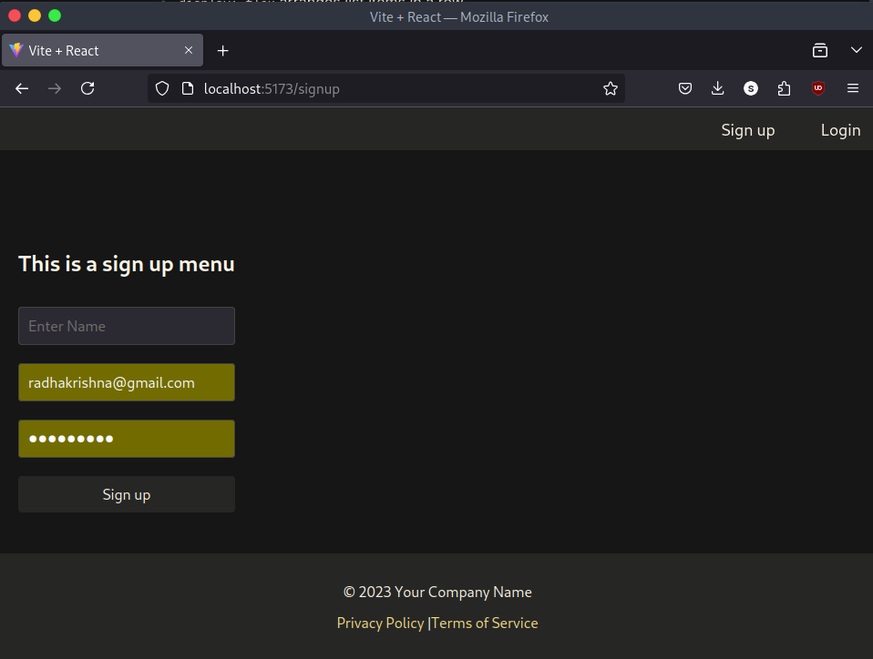
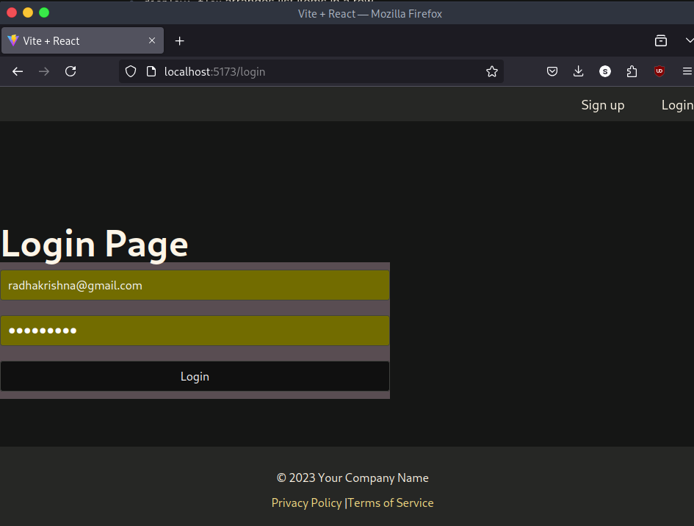

- It looks like this. We can center the content.

- Here is the CSS's file's code:
* {
margin: 0;
padding: 0;
box-sizing: border-box;
}

.nav {
position: fixed;
top: 0;
width: 100%;
background-color: #333;
display: flex;
justify-content: center;
align-items: center;
padding: 10px 0;
z-index: 1000;
}

.Nav {
list-style-type: none;
display: flex;
gap: 20px;
}

.Nav li a {
text-decoration: none;
color: white;
font-size: 18px;
padding: 10px 15px;
transition: background-color 0.3s ease;
}

.Nav li a:hover {
background-color: #555;
border-radius: 5px;
}

.nav-right {
margin-left: auto;
}

.register {
position: absolute;
top: 50%;
left: 50%;
transform: translate(-50%, -50%);
background-color: #f9f9f9;
padding: 40px;
border-radius: 8px;
box-shadow: 0 4px 8px rgba(0, 0, 0, 0.1);
width: 300px;
text-align: center;
}

.register h2 {
margin-bottom: 20px;
font-size: 22px;
color: #333;
}

.InputBox {
width: 100%;
padding: 10px;
margin: 10px 0;
border: 1px solid #ccc;
border-radius: 4px;
font-size: 16px;
}

.appButton {
width: 100%;
padding: 10px;
margin-top: 20px;
border: none;
border-radius: 4px;
background-color: #007bff;
color: white;
font-size: 16px;
cursor: pointer;
transition: background-color 0.3s ease;
}

.appButton:hover {
background-color: #0056b3;
}

footer {
background-color: #333;
color: #fff;
text-align: center;
padding: 20px 0;
position: fixed;
width: 100%;
bottom: 0;
}

footer p {
margin: 10px 0;
}

footer a {
color: #ffcc00;
text-decoration: none;
}

footer a:hover {
text-decoration: underline;
}

/* Here, is the Login page's CSS */
.login {
position: absolute;
top: 50%;
left: 50%;
transform: translate(-50%, -50%);
background-color: white;
padding: 40px;
border-radius: 8px;
box-shadow: 0 4px 8px rgba(0, 0, 0, 0.1);
width: 300px;
text-align: center;
}

.login h1 {
margin-bottom: 20px;
font-size: 24px;
color: #333;
}

.InputBox {
width: 100%;
padding: 10px;
margin: 10px 0;
border: 1px solid #ccc;
border-radius: 4px;
font-size: 16px;
}

.appButton {
width: 100%;
padding: 10px;
margin-top: 20px;
border: none;
border-radius: 4px;
background-color: #28a745;
color: white;
font-size: 16px;
cursor: pointer;
transition: background-color 0.3s ease;
}
.appButton:hover {
background-color: #218838;
}
- Now, we are adding the Name of the user after logged in.
Go to the navbar.jsx's file:
Code paste inside the <div> </div> section
<img className="logo" alt="logo" src="https://cdnb.artstation.com/p/assets/images/images/055/228/903/large/chadrixy-randomlogo2.jpg?1666435943" />
And, here is the CSS's code. Paste it in the App.css's file:
.logo {
width: 45px;
float: left;
border-radius: 50%;
margin-top: 3px;
margin-left: 20px;
display: block;
transition: transform 0.3s ease;
}
.logo:hover {
transform: scale(1.05);
}
- And, here is an output:
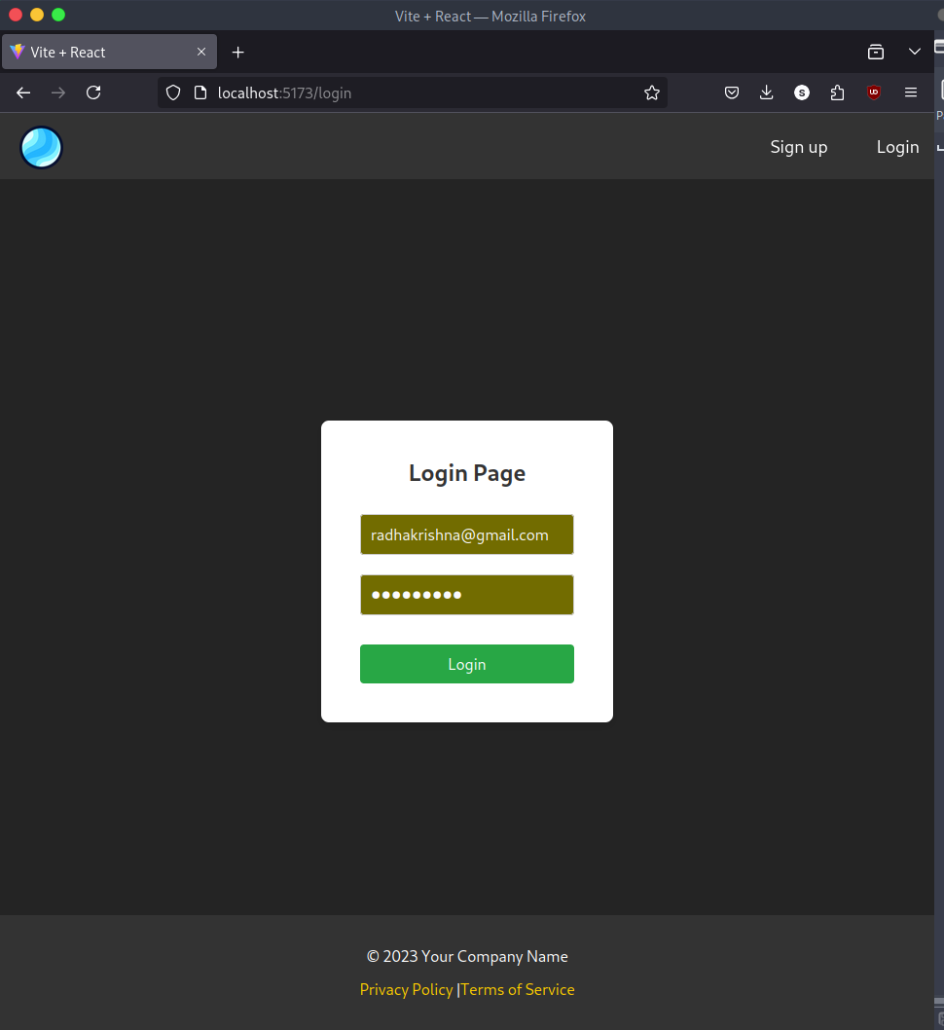

Add Product API:
- Create a collection inside the MongoDB.
Craete a collection with the "products" name.
Now, create a file inside the Backend's Component directory with named as the "products.js".
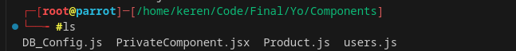
- Now, here is the code to put in that file.

Product.js's code:
const mongoose = require('mongoose')
const productSchema = new mongoose.Schema({
name: String,
price: String,
category: String, //For category
userId: String, //Who is adding that product
company: String //
})
module.exports = mongoose.model("poducts", productSchema)
- Now, we are importing this file in the "index.js's" file.
// Now, this is for the adding the Product // Now, we are working with the Products API:
const Product = require('./Components/Product')
app.post("/add", async (req, resp) => {
// resp.send("Hello wordl")
let product = new Product(req.body)
let result = await product.save()
resp.send(result)
})
- After this try to run the code with the, "nodemon index.js" and then go to the POSTMAN for the API testing.

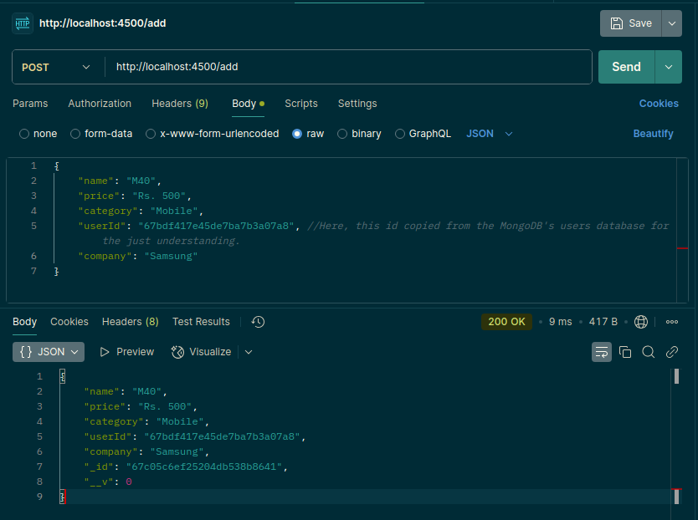

- Here, you can see that we have send the request successfully. Now, we can see the data inside the database.
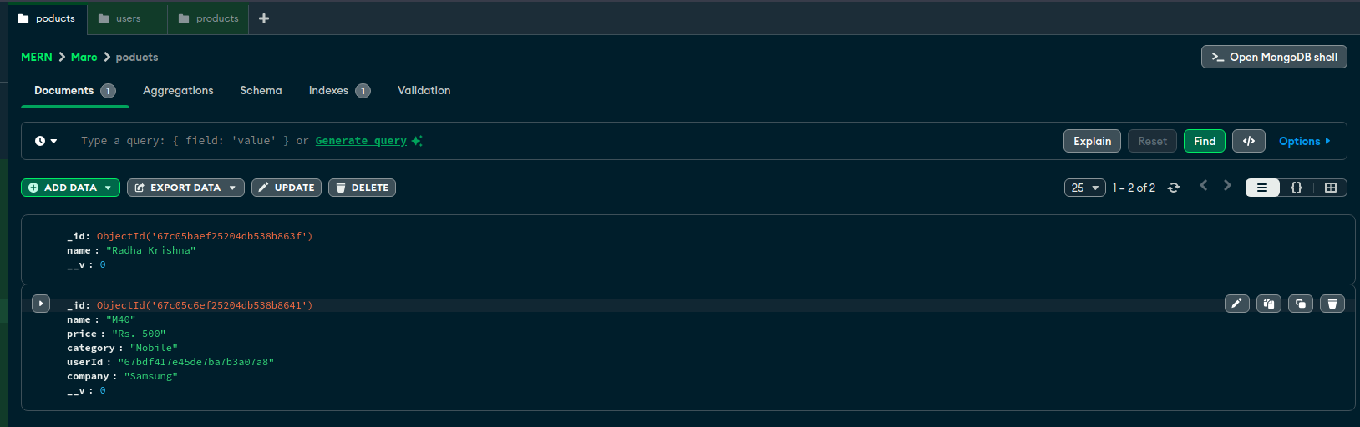
- Here, you can see the entry of the data.

Add Product Component:
- Now, we are integrating this API in the "add-product's" page.

AddProduct.jsx:
import React, { useState } from "react"
function AddProduct() {
const [name, setName] = useState('')
const [price, setPrice] = useState('')
const [category, setCategory] = useState('')
const [company, setCompany] = useState('')

const addProduct = () => {
console.log(name, price, category, company)
}
return (<>
<div className="product">
<input className="InputBox"
type="text"
onChange={(e) => setName(e.target.value)}
value={name}
placeholder="Enter product name" />
<input className="InputBox"
type="text"
onChange={(e) => setPrice(e.target.value)}
value={price}
placeholder="Enter product price" />
<input className="InputBox"
type="text"
onChange={(e) => setCategory(e.target.value)}
value={category}
placeholder="Enter product category" />
<input className="InputBox"
type="text"
onChange={(e) => setCompany(e.target.value)}
value={company}
placeholder="Enter product company" />
<button className="appButton"
type="button"
onClick={addProduct}
>Add Product</button>
</div>
</>)
}
export default AddProduct=
- Here, is an Output of the above code. And don't forget to import this function in the App.jsx's file.

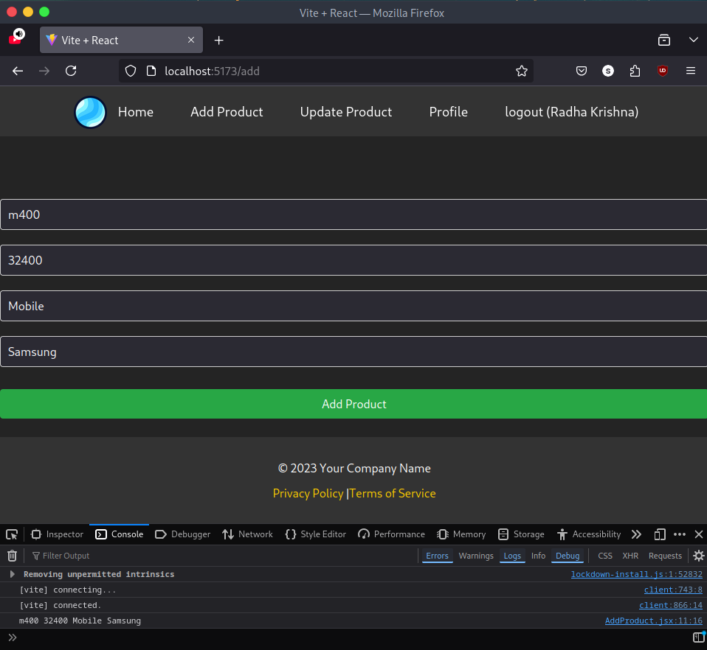

- After successfully product added. We are now connecting the API with this one.

Call API for Add Product:
- Get use id from local storage
- Call API to Add product
- Get the result and test flow.
- Here, is an integrationn of the API call code inside the addProduct.jsx:
const addProduct = async () => {
console.log(name, price, category, company)
// Now, we are adding the userId in the given list:, the give commented code is for testing the code
// const userId = JSON.parse(localStorage.getItem("user"))._id
// console.log(userId)
// Now, we are fetching the API's url
let result = await fetch("http://localhost:4500/add", {
method: "post",
body: JSON.stringify({ name, price, category, company }),
headers: {
"Content-Type": "application/json"
}
})
result = await result.json()
console.log(result)
}

- Now, you can see that we have added the call api here successfully.

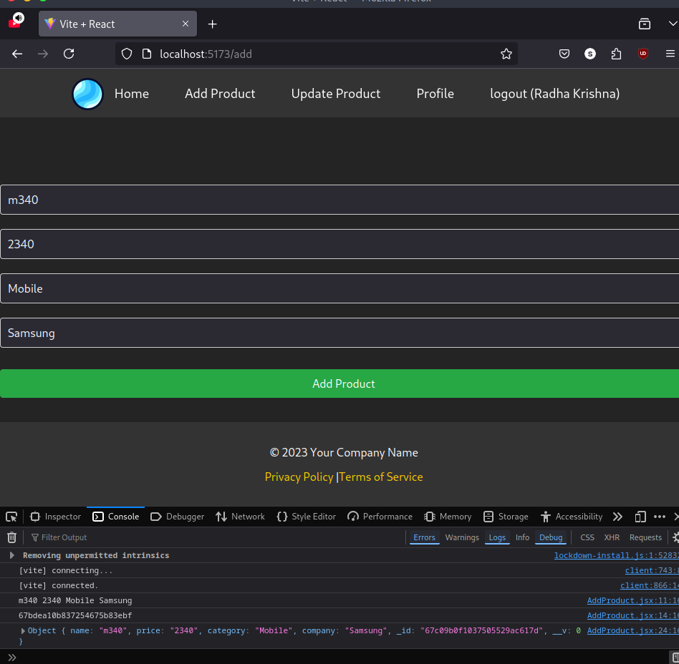
- Now, the screenshot of the Network sider;
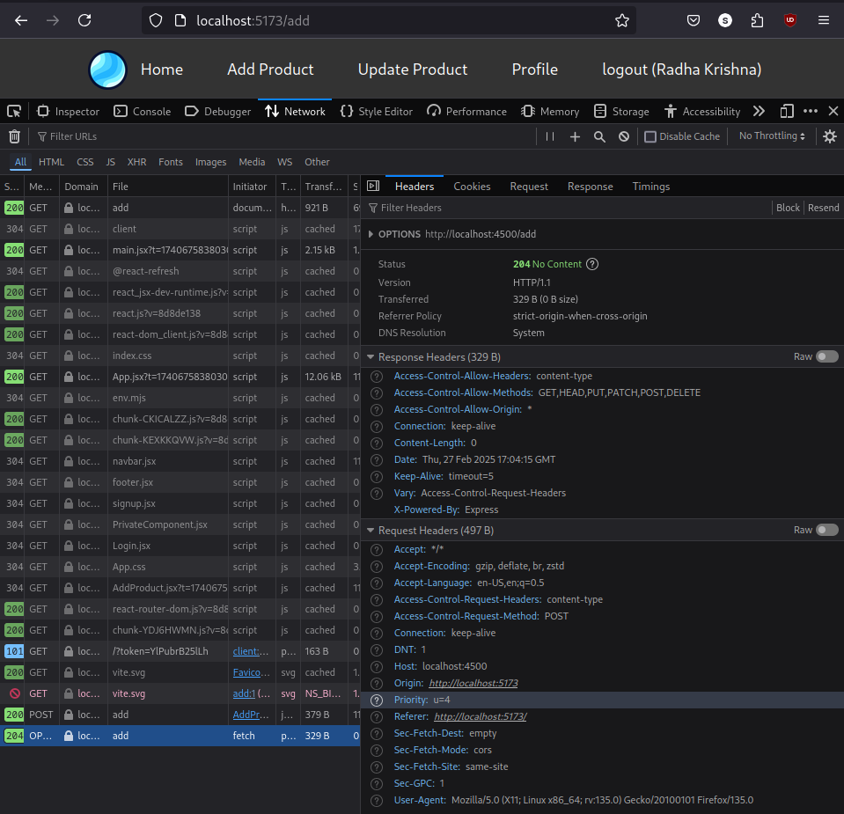
- And data is even added in the MongoDB.

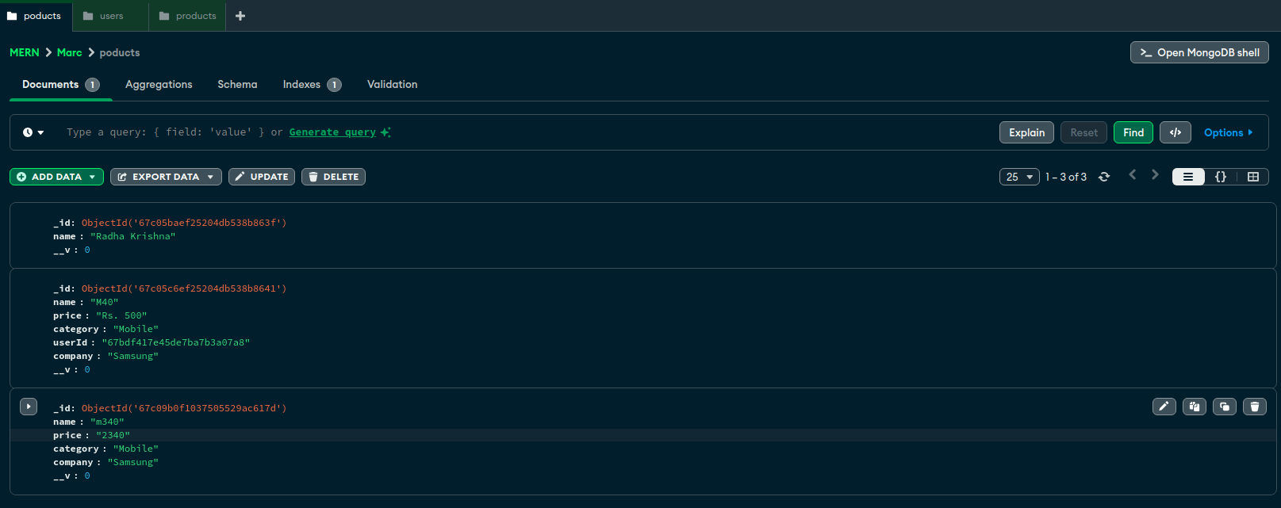
- Here, last one is added in the data.

Simple Form Validation:
- Here, we are adding the some new highlighted part in the AddProduct.jsx's file:
import React, { useState } from "react";

function AddProduct() {
const [name, setName] = useState('');
const [price, setPrice] = useState('');
const [category, setCategory] = useState('');
const [company, setCompany] = useState('');
const [error, setError] = useState(false);

const addProduct = async () => {
// Check if any field is empty
if (!name || !price || !category || !company) {
setError(true);
return;
}

setError(false); // Reset error state if all fields are valid

console.log(name, price, category, company);

try {
const userId = JSON.parse(localStorage.getItem("user"))._id;
console.log(userId);

let result = await fetch("http://localhost:4500/add", {
method: "post",
body: JSON.stringify({ name, price, category, company, userId }),
headers: {
"Content-Type": "application/json"
}
});

result = await result.json();
console.log(result);
} catch (error) {
console.error("Error adding product:", error);
}
};

return (
<div className="products">
<input
className="InputBoxs"
type="text"
onChange={(e) => setName(e.target.value)}
value={name}
placeholder="Enter product name"
/>
{error && !name && <span className="invalidInput">Enter valid name</span>}

<input
className="InputBoxs"
type="text"
onChange={(e) => setPrice(e.target.value)}
value={price}
placeholder="Enter product price"
/>
{error && !price && <span className="invalidInput">Enter valid price</span>}

<input
className="InputBoxs"
type="text"
onChange={(e) => setCategory(e.target.value)}
value={category}
placeholder="Enter product category"
/>
{error && !category && <span className="invalidInput">Enter valid category</span>}

<input
className="InputBoxs"
type="text"
onChange={(e) => setCompany(e.target.value)}
value={company}
placeholder="Enter product company"
/>
{error && !company && <span className="invalidInput">Enter valid company</span>}

<button className="appButtons" type="button" onClick={addProduct}>
Add Product
</button>
</div>
);
}
export default AddProduct

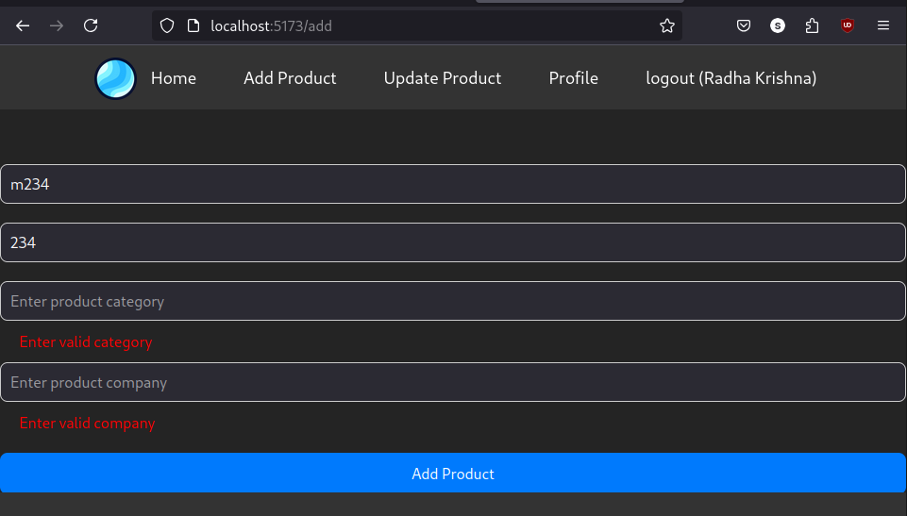
- Here, you can see that we will get an output. If we don't provide all the data.

Product List API
- Create an API in the "index.js" file;
// Here, we are calling the Product's list:
app.get("/products", async (req, resp) => {
let products = await Product.find()
if (products.length > 0) {
resp.send(products)
} else {
resp.send({ result: "No products found" })
}
})
- Now, run with the "nodemon"
- Now, open the Postman and then try to run an API:
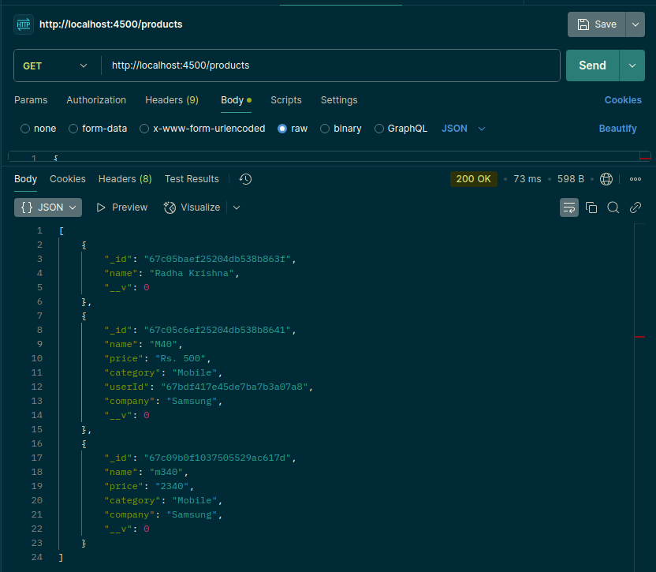
- Here, we get all the details of the products.
- After that we will filter the products according to an "User" or "_id":

Integrate Product List API:
- Make function and define state
- Call API for Product list
- Make static list
- Render Product list

StaticProduct.jsx’s code:
import React, { useEffect, useState } from "react";
import "./CSS File/products.css"; // Import the CSS fi
function StaticProduct() {
const [products, setProducts] = useState([]);
useEffect(() => {
getProducts();
}, []);
// This is for the API calling
const getProducts = async () => {
try {
let result = await fetch("http://localhost:4500/products");
result = await result.json();
setProducts(result);
} catch (error) {
console.error("Error fetching products:", error);
}
};
return (
<div className="sunny">
<div className="products">
<h3>Product List</h3>
<ul className="product-header">
<li>S. No</li>
<li>Name</li>
<li>Price</li>
<li>Category</li>
<li>Company</li>
</ul>
{
products.map((product, index) => (
<ul key={index} className="product-item">
<li>{index + 1}</li>
<li>{product.name}</li>
<li>{product.price}</li>
<li>{product.category}</li>
<li>{product.company}</li>
</ul>
))
}
</div>
</div>
);
}
export default StaticProduct;
- Here, you can see the code of that things:

products.css:
.products {
text-align: center;
background-color: #fff;
padding: 20px;
border-radius: 8px;
box-shadow: 0 0 10px rgba(0, 0, 0, 0.1);
}

.products ul li {
display: inline-block;
border: 1px solid skyblue;
padding: 5px;
width: 150px;
}
.products ul {
margin: 0;
padding: 0;
list-style: none;
}
.products h3 {
margin-bottom: 20px;
}

- Now, we can see an output on the webpage:

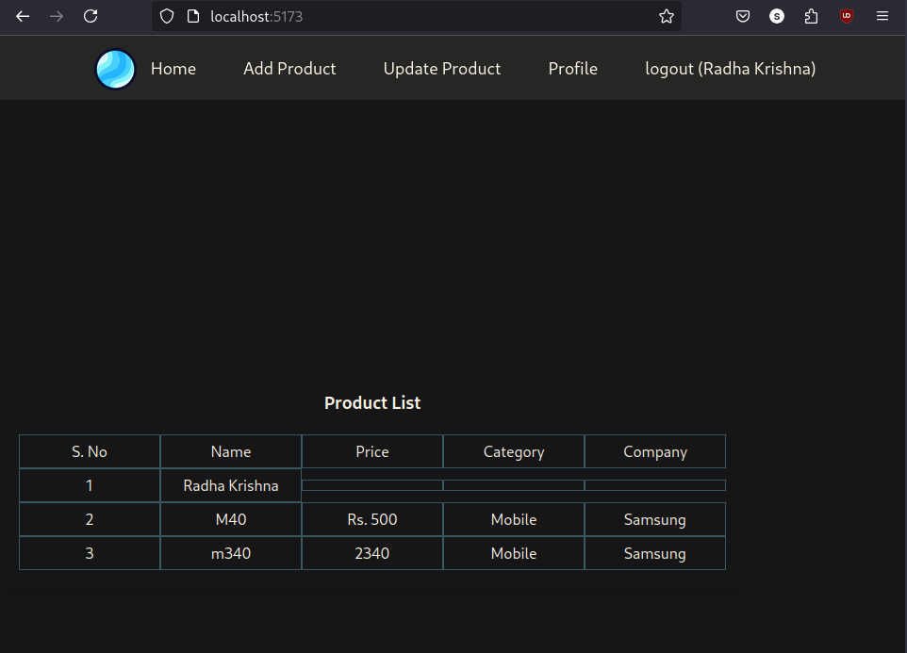

Delete Product API:
- Now, go to an index.js file:
app.delete("/products/:id", async (req, resp) => {
// resp.send("workingg")
const result = await Product.deleteOne({ _id: req.params.id })
resp.send(result)
})
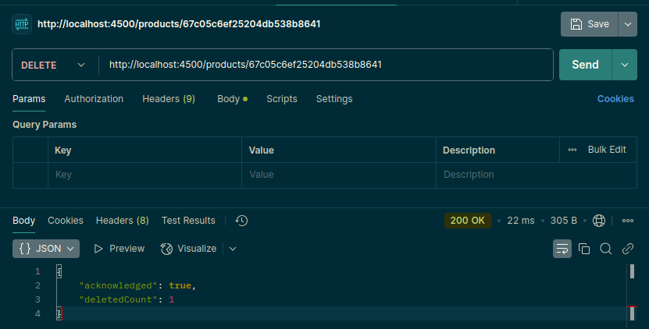
- Now, we are integrating this API in field of the product removing:

Integrate Delete Product API:

StaticProduct.jsx code:
import React, { useEffect, useState } from "react";
import "./CSS File/products.css";
function StaticProduct() {
const [products, setProducts] = useState([]);

useEffect(() => {
getProducts();
}, []);

// This is for the API calling
const getProducts = async () => {
try {
let result = await fetch("http://localhost:4500/products");
result = await result.json();
setProducts(result);
} catch (error) {
console.error("Error fetching products:", error);
}
};
const deleteProduct = async (id) => {
try {
let result = await fetch(`http://localhost:4500/products/${id}`, {
method: "DELETE"
});
result = await result.json();
if (result) {
getProducts();
} else {
alert("Not deleted");
}
} catch (error) {
console.error("Error deleting product:", error);
}
};
return (
<div className="sunny">
<div className="products">
<h3>Product List</h3>
<ul className="product-header">
<li>S. No</li>
<li>Name</li>
<li>Price</li>
<li>Category</li>
<li>Company</li>
<li>Operation</li>
</ul>
{
products.map((product) => (
<ul key={product._id} className="product-item">
<li>{products.indexOf(product) + 1}</li>
<li>{product.name}</li>
<li>{product.price}</li>
<li>{product.category}</li>
<li>{product.company}</li>
<li><button onClick={() => deleteProduct(product._id)}>Delete</button></li>
</ul>
))
}
</div>
</div>
);
}
export default StaticProduct;
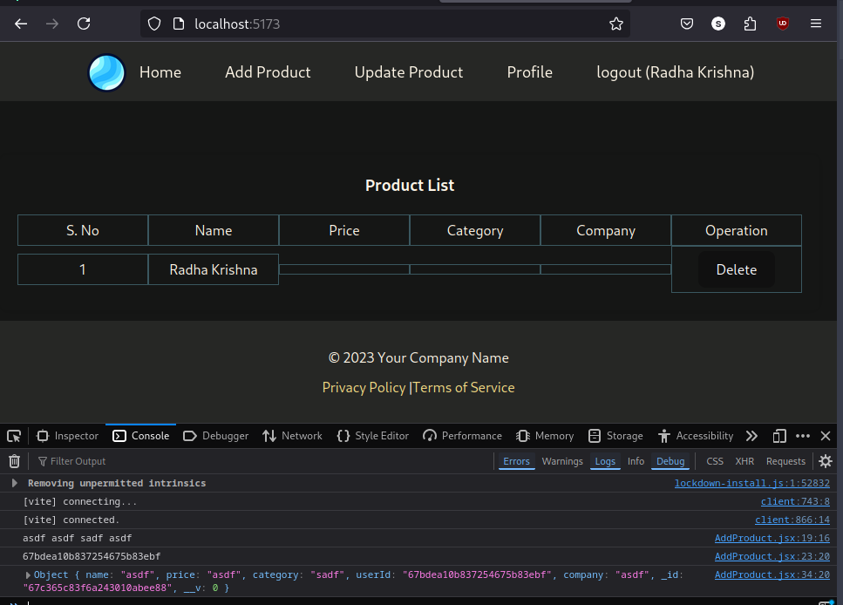
- Here, you can see that we have deleted some data. And even removed the entry of that data.

