UpdateProduct.jsx’s code:
import React, { useState } from "react";
function UpdateProduct() {
const [name, setName] = useState('');
const [price, setPrice] = useState('');
const [category, setCategory] = useState('');
const [company, setCompany] = useState('');
const [error, setError] = useState(false);
const updateProduct = async () => {
console.log(name, price, category, company, error);
};
return (
<div className="products">
<h1>Update Product</h1>
<input
className="InputBoxs"
type="text"
onChange={(e) => setName(e.target.value)}
value={name}
placeholder="Enter product name"
/>
<input
className="InputBoxs"
type="text"
onChange={(e) => setPrice(e.target.value)}
value={price}
placeholder="Enter product price"
/>
<input
className="InputBoxs"
type="text"
onChange={(e) => setCategory(e.target.value)}
value={category}
placeholder="Enter product category"
/>
<input
className="InputBoxs"
type="text"
onChange={(e) => setCompany(e.target.value)}
value={company}
placeholder="Enter product company"
/>
<button className="appButtons" type="button" onClick={updateProduct}>
Update Product
</button>
</div>
);
}
export default UpdateProduct;

App.jsx’s code:
import Nav from "./Components/navbar"
import Footer from "./Components/footer"
import Signup from "./Components/signup"
import PrivateComponent from "./Components/PrivateComponent"
import Login from "./Components/Login"
import StaticProduct from "./Components/StaticProduct"
import UpdateProduct from "./Components/updateProcut"
import './App.css'

import Product from "./Components/AddProduct"

import { BrowserRouter, Routes, Route } from "react-router-dom"
function App() {

return (
<>
<BrowserRouter>
<Nav />
<Routes>
{/* Here, we don't wanna to give an access to the other components unles or untill the user gets login */}
<Route element={<PrivateComponent />}>
<Route path="/" element={<StaticProduct />} />
<Route path="/add" element={<Product />} />
<Route path="/update/:id" element={<UpdateProduct />} />
<Route path="/logout" element={<h1>Here, we are adding Logout Components</h1>} />
<Route path="/logout" element={<h1>Here, we are adding Logout Components</h1>} />
<Route path="/profile" element={<h1>Here, we are adding Profile Components</h1>} />
</Route>
<Route path="/*" element={<h1>Here, we are adding ErrorPage Components</h1>} />
<Route path="/signup" element={<Signup />} />
<Route path="/login" element={<Login />} />
</Routes>
</BrowserRouter >
<Footer />
</>
)
}
export default App
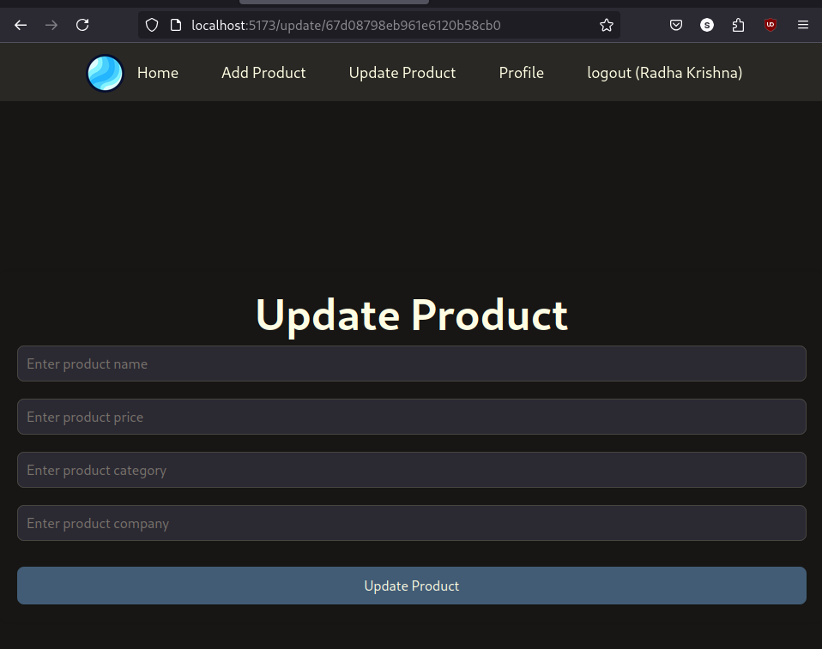

- Here, we are updating the Product. And, now we are working on the API for handling the Data. And, conditions to solve that condition.

- Now, working on the API’s of the Update Field: But, before getting into that we are working on the:

API for get Single Product:

Index.js’s code:

// Now, we are checking that, whatever the ID's product customer chooses. We are
// trying to filter out that only. And, showing them the result
app.get("/products/:id", async (req, resp) => {
let result = await Product.findOne({ _id: req.params.id })
if (result) {
resp.send(result)
}
else {
resp.send({ result: "No record found" })
}
})

- Run on the POSTMAN:
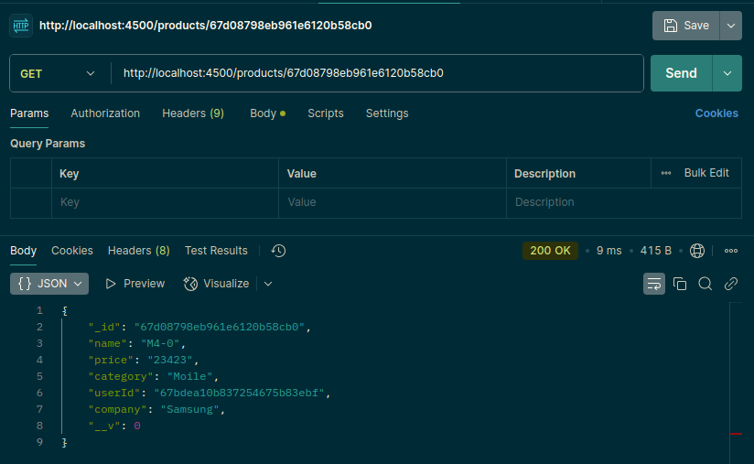

- If the ID is not available, then:
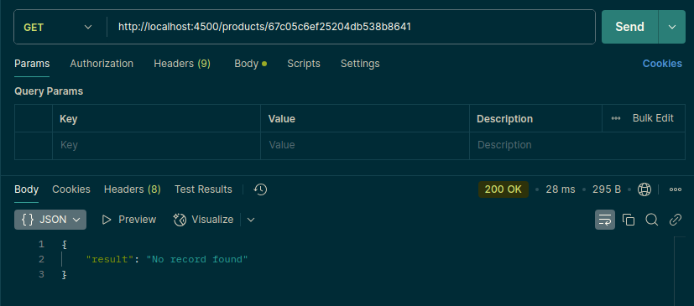

Prefill Update Product form

UpdateProduct.jsx’s code:
import React, { useEffect, useState } from "react";
import { useParams } from "react-router-dom";
function UpdateProduct() {
const [name, setName] = useState('');
const [price, setPrice] = useState('');
const [category, setCategory] = useState('');
const [company, setCompany] = useState('');
const [error, setError] = useState(false);
// This is for API calling:
const getProductDetails = async () => {
// Here, we are fetching the "Dynamic" ID's
let result = await fetch(`http://localhost:4500/products/${params.id}`)
result = await result.json()
// console.log(result)
setName(result.name)
setPrice(result.price)
setCategory(result.category)
setCompany(result.company)
}
const params = useParams()
// We want to just call this atmost once. So, we are using the useEffect
useEffect(() => {
console.log(params)
getProductDetails()
}, [])
const updateProduct = async () => {
};
return (
<div className="products">
<h1>Update Product</h1>
<input
className="InputBoxs"
type="text"
onChange={(e) => setName(e.target.value)}
value={name}
placeholder="Enter product name"
/>
<input
className="InputBoxs"
type="text"
onChange={(e) => setPrice(e.target.value)}
value={price}
placeholder="Enter product price"
/>
<input
className="InputBoxs"
type="text"
onChange={(e) => setCategory(e.target.value)}
value={category}
placeholder="Enter product category"
/>
<input
className="InputBoxs"
type="text"
onChange={(e) => setCompany(e.target.value)}
value={company}
placeholder="Enter product company"
/>
<button className="appButtons" type="button" onClick={updateProduct}>
Update Product
</button>
</div>
);
}
export default UpdateProduct;
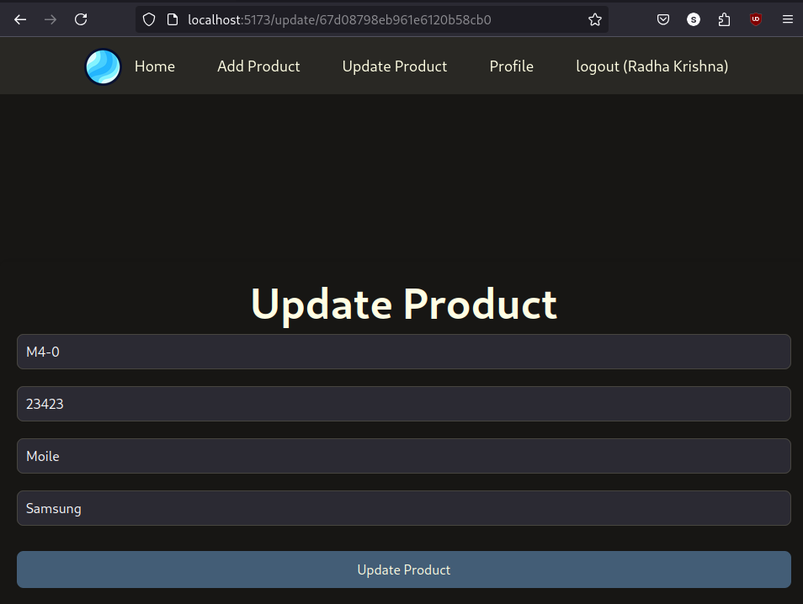

- Now, we fetched the Data from the API. Now, we working on the Updating Data.
Index.js’s PUT API:
// Here, we are updating the Product's list:
app.put("/products/:id", async (req, resp) => {
let result = await Product.updateOne(
{ id: req.params.id }, { $set: req.body })
resp.send(result)
})

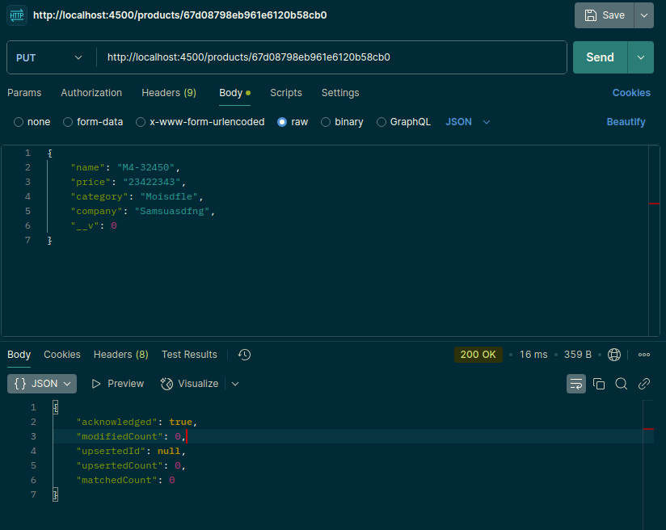

Integrate API for Update Product:
import React, { useEffect, useState } from "react";
import { Navigate, useNavigate, useParams } from "react-router-dom";
function UpdateProduct() {
const [name, setName] = useState('');
const [price, setPrice] = useState('');
const [category, setCategory] = useState('');
const [company, setCompany] = useState('');
const [error, setError] = useState(false);
const navigate = useNavigate()

// This is for API calling:
const getProductDetails = async () => {
// Here, we are fetching the "Dynamic" ID's
let result = await fetch(`http://localhost:4500/products/${params.id}`)
result = await result.json()
// console.log(result)
setName(result.name)
setPrice(result.price)
setCategory(result.category)
setCompany(result.company)
}

const params = useParams()
// We want to just call this atmost once. So, we are using the useEffect
useEffect(() => {
console.log(params)
getProductDetails()
}, [])

const updateProduct = async () => {
let result = await fetch(`http://localhost:4500/products/${params.id}`, {
method: 'put',
body: JSON.stringify({ name, price, category, company }),
headers: {
'Content-Type': "application/json"

}
})
result = await result.json()
console.warn(result)
navigate("/")
};

return (
<div className="products">
<h1>Update Product</h1>
<input
className="InputBoxs"
type="text"
onChange={(e) => setName(e.target.value)}
value={name}
placeholder="Enter product name"
/>
<input
className="InputBoxs"
type="text"
onChange={(e) => setPrice(e.target.value)}
value={price}
placeholder="Enter product price"
/>
<input
className="InputBoxs"
type="text"
onChange={(e) => setCategory(e.target.value)}
value={category}
placeholder="Enter product category"
/>
<input
className="InputBoxs"
type="text"
onChange={(e) => setCompany(e.target.value)}
value={company}
placeholder="Enter product company"
/>
<button className="appButtons" type="button" onClick={updateProduct}>
Update Product
</button>
</div>
);
}
export default UpdateProduct;

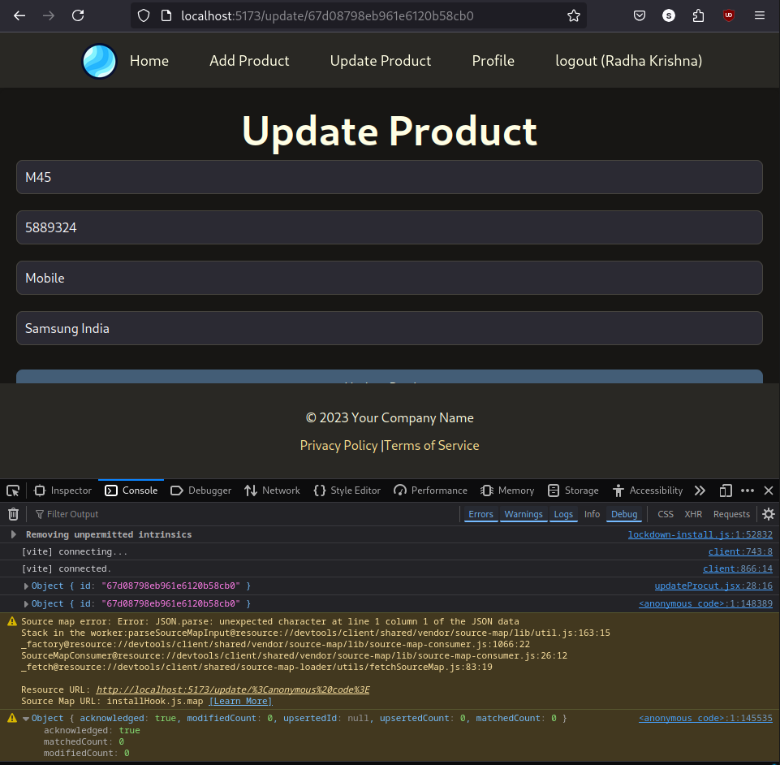
- Here, we have updated all the things.

Search API for Product:

Index.js’s Code:
app.get("/search/:key", async (req, resp) => {
try {
let result = await Product.find({
"$or": [
{ name: { $regex: req.params.key } },
{ company: { $regex: req.params.key } },
{ category: { $regex: req.params.key } },
{ price: { $regex: req.params.key } }
]
});
resp.send(result);
} catch (error) {
resp.status(500).send({ error: "Internal Server Error" });
}
});
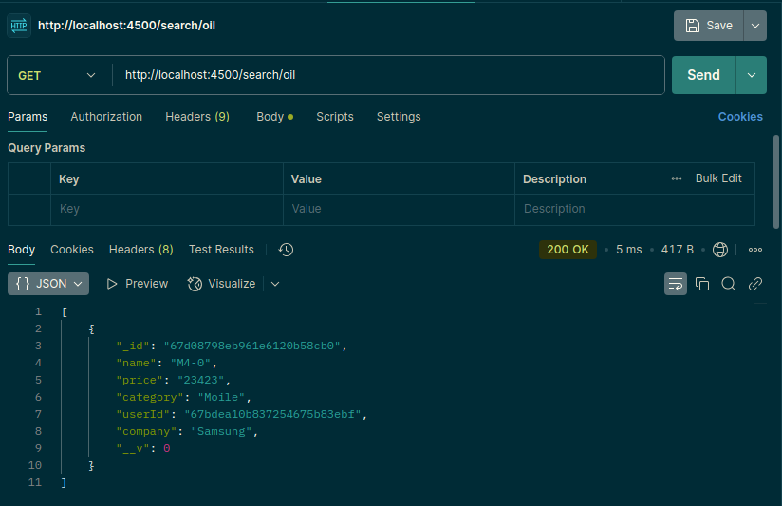

Integrate Search API:
- Make input box for Search
- Make search Handle function
- Call API for Search Product
- Update List on Search

staticProduct.jsx’s Code:
import React, { useEffect, useState } from "react";
import "./CSS File/products.css";
import { Link } from "react-router-dom";

function StaticProduct() {
const [products, setProducts] = useState([]);

useEffect(() => {
getProducts();
}, []);

// This is for the API calling
const getProducts = async () => {
try {
let result = await fetch("http://localhost:4500/products");
result = await result.json();
setProducts(result);
} catch (error) {
console.error("Error fetching products:", error);
}
};

const deleteProduct = async (id) => {
try {
let result = await fetch(`http://localhost:4500/products/${id}`, {
method: "DELETE"
});
result = await result.json();
if (result) {
getProducts();
} else {
alert("Not deleted");
}
} catch (error) {
console.error("Error deleting product:", error);
}
};

const searchHandle = async (event) => {
// console.log(event.target.value)
let key = event.target.value
// If there is no value in the "key" then we will call our main function
if (key) {
let result = await fetch(`http://localhost:4500/search/${key}`)
result = await result.json()
if (result) {
setProducts(result)
}
} else {
getProducts()
}
}

return (
<div className="sunny">
<div className="products">
<h3>Product List</h3>
<div className="search-container">
<div className="search">
<input type="text" placeholder="Search Product" onChange={searchHandle} />
{/* <button onClick={searchHandle}>Search</button> */}
</div>
</div>
<ul className="product-header">
<li>S. No</li>
<li>Name</li>
<li>Price</li>
<li>Category</li>
<li>Company</li>
<li>Operation</li>
</ul>
{
products.length > 0 ? products.map((product) => (
<ul key={product._id} className="product-item">
<li>{products.indexOf(product) + 1}</li>
<li>{product.name}</li>
<li>{product.price}</li>
<li>{product.category}</li>
<li>{product.company}</li>
<li>
<button onClick={() => deleteProduct(product._id)}>Delete</button>
<Link to={`/update/${product._id}`}>Update</Link>
</li>
</ul>
))
: <h1>No result found</h1>
}
</div>
</div >
);
}
export default StaticProduct;

- CSS’s code for Search:
/* Now for the Search Box's styling */
/* Container to center the search elements */
.search-container {
display: flex;
justify-content: center;
align-items: center;
height: 30vh;
}
.search {
display: flex;
gap: 10px; /* Space between input and button */
}

.search input {
padding: 10px;
font-size: 16px;
border: 1px solid #ccc;
border-radius: 4px;
}
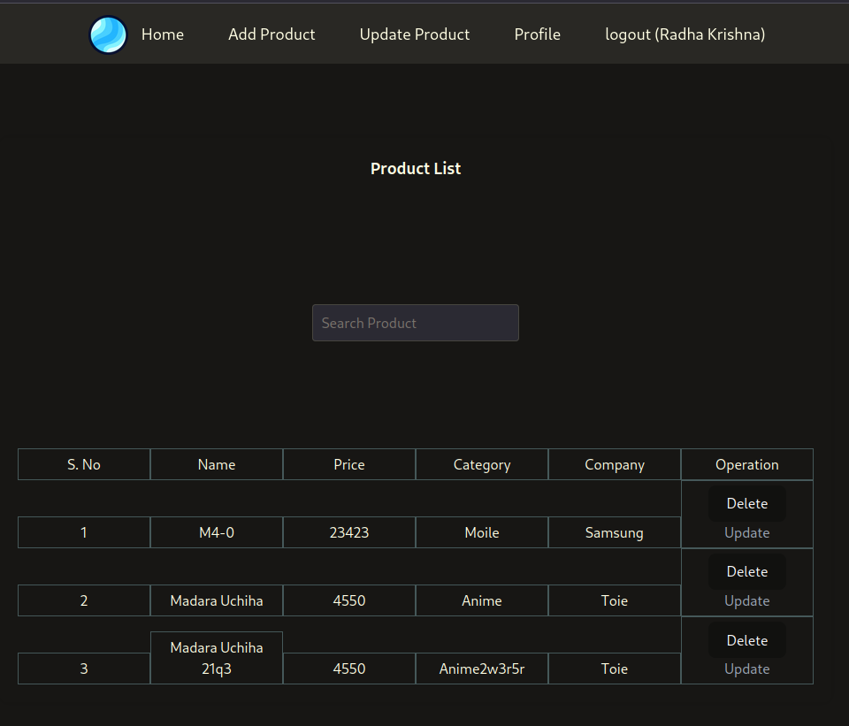

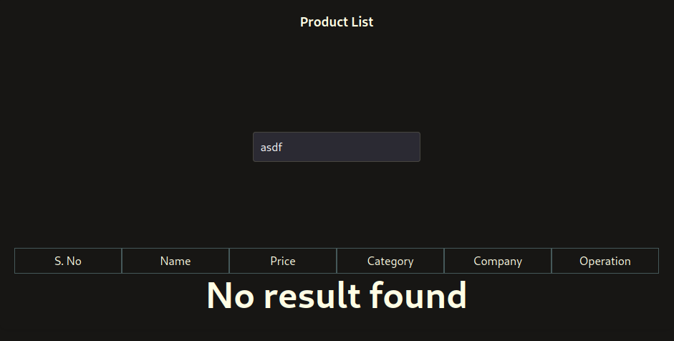

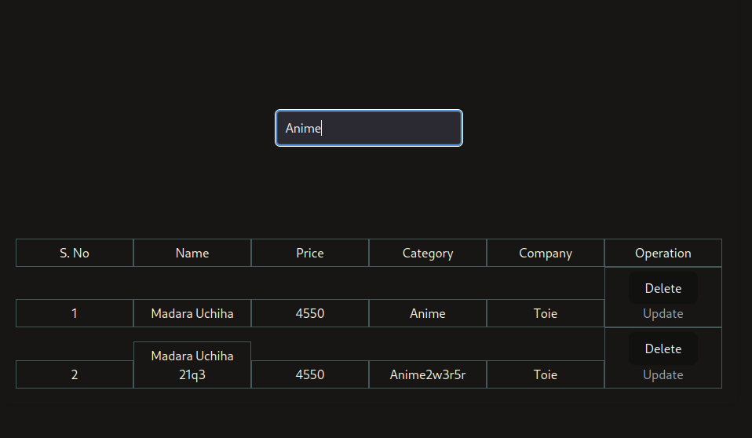

JWT Authentication: (JSON Web Token)
- Add JWT packages
- Define the key for token
- Add token with login and register API
- Test token with API in postman
- Install the dependent Packages:
- yarn add jsonwebtoken

Index.js’s code:
const jwt = require('jsonwebtoken')
const jwtKey = 'e-comm'
app.post("/login", async (req, resp) => {
try {
if (req.body.password && req.body.email) {
let user = await Users.findOne(req.body).select("-password");
if (user) {
jwt.sign({ user }, jwtKey, { expiresIn: "2h" }, (err, token) => {
if (err) {
resp.send({ result: "Somthing went wrong" })
} else {
resp.send({ user, auth: token });
}
})
} else {
resp.send({ result: 'No user found' });
}
} else {
resp.send({ result: "No user found" });
}
} catch (error) {
resp.status(500).send({ error: "Internal Server Error" });
}
});
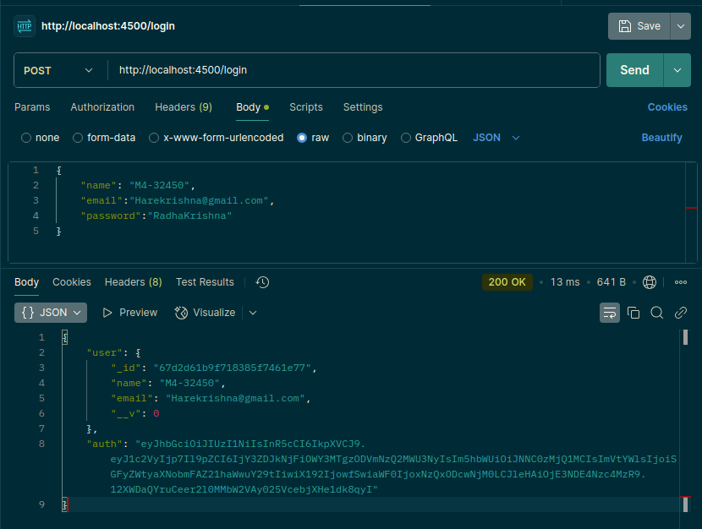

- Here, at the end you can see the “auth” token is generated after login. Just copy the authentication. And, paste it in the

Code:
app.post("/register", async (req, resp) => {
try {
let user = new Users(req.body);
let result = await user.save();
result = result.toObject();
delete result.password;
if (result) {
jwt.sign({ result }, jwtKey, { expiresIn: "2h" }, (err, token) => {
if (err) {
resp.send({ result: "Somthing went wrong" })
} else {
resp.send({ result, auth: token });
// resp.send(result);
}
})
} else {
resp.send({ result: 'No user found' });
}
} catch (error) {
resp.status(500).send({ error: "Internal Server Error" });
}

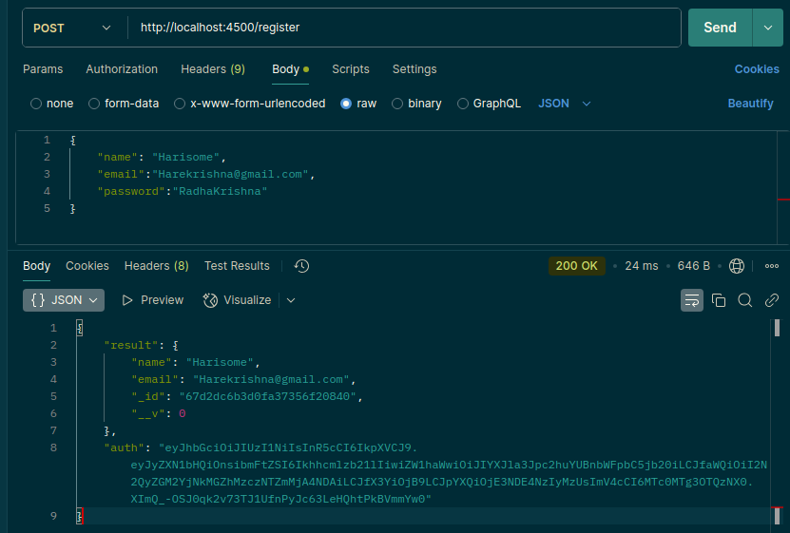
- Now, we are facing an issue. While, log in. Like – even if our details are correct. But, it doesn’t open the home pages.
- To solve this we are using a JWT Authentication.
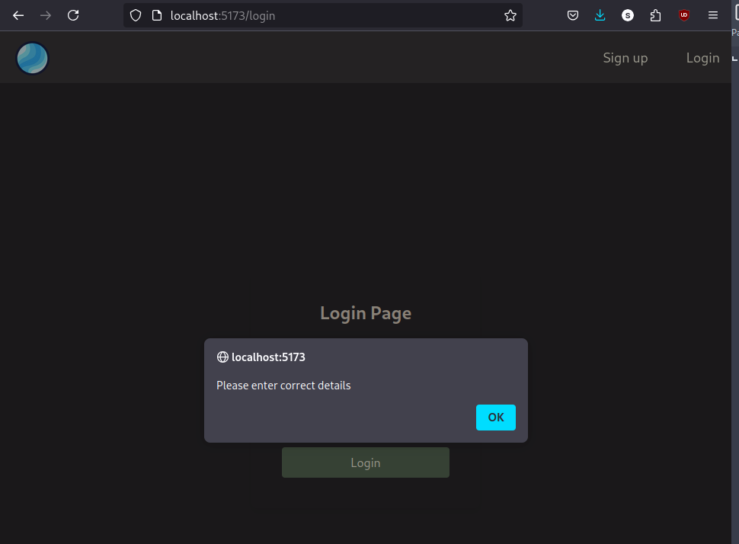

JWT Authentication:

Login.jsx’s file code:
const handleLogin = async () => {
console.log(email, password)
// Here, we are integrating an API for the working model
let result = await fetch('http://localhost:4500/login', {
method: 'post',
body: JSON.stringify({ email, password }),
headers: {
'Content-Type': "application/json"
}
})
result = await result.json()
console.log(result)
if (result.auth) {
// For storing the data in the Local storage
localStorage.setItem('user', JSON.stringify(result.user))
localStorage.setItem('token', JSON.stringify(result.auth))
naviage("/")
}
else {
alert("Please enter correct details")
}
}
- Only the Highlighted Part is changed.

- Now, it will login after that.
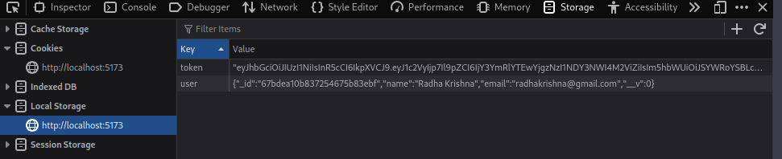
- Here, you can see that. Auth token is also saved.
Now, do same for the Register user.

Register.jsx’s code:
const collectData = async () => {
try {
console.log(name, email, password);
let result = await fetch('http://localhost:4500/register', {
method: 'post',
body: JSON.stringify({ name, email, password }),
headers: {
'Content-type': 'application/json'
}
});
result = await result.json();
localStorage.setItem("user", JSON.stringify(result.result));
localStorage.setItem("token", JSON.stringify(result.auth));
console.log(result);
if (result) {
navigate("/");
}
} catch (error) {
console.error("Error during registration:", error);
}
};
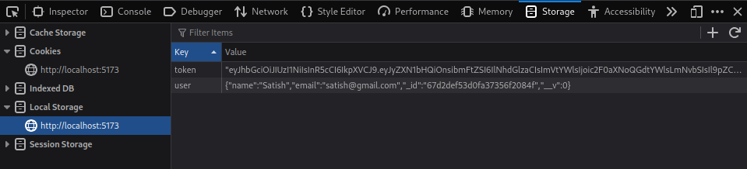
- Now, we are sending this token in the Product List for individual involvement.

StaticProduct.jsx’s code:
// This is for the API calling
const getProducts = async () => {
try {
let result = await fetch("http://localhost:4500/products", {
headers: {
authorization: JSON.parse(localStorage.getItem('token'))
}
});
result = await result.json();
setProducts(result);
} catch (error) {
console.error("Error fetching products:", error);
}
};
- After adding that Highlighted. We will get a token inside the Product’s list.

Verify Auth Token in Node Js
- Send Token with Postman
- Make Middleware for verifying Token
- Verify Token and send response

Middleware’s Authentication:
app.get("/search/:key", verifyToken, async (req, resp) => {
try {
let result = await Product.find({
"$or": [
{ name: { $regex: req.params.key } },
{ company: { $regex: req.params.key } },
{ category: { $regex: req.params.key } },
{ price: { $regex: req.params.key } }
]
});
resp.send(result);
} catch (error) {
resp.status(500).send({ error: "Internal Server Error" });
}
});
// Here, we are using a middleware. For the Authentication. And it takes the 3 Parameters
function verifyToken(req, resp, next) {
console.log("Middleware called")
next()
}

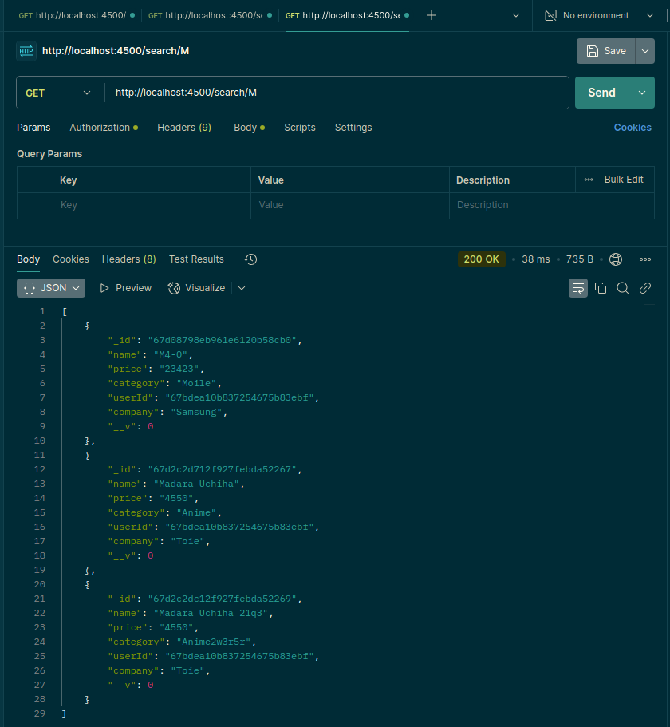

- Here, you can see an output.
Now, we are taking an input as a token from the Login’s session.
function verifyToken(req, resp, next) {
const token = req.headers['authorization']
console.log("Middleware called", token)
next()
}

- Here, you can see that an output
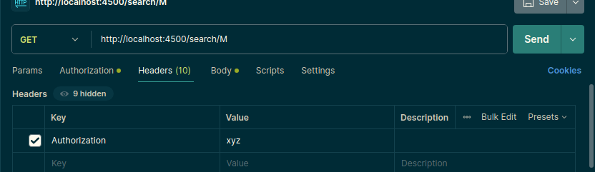
- And, you can see the “value” as an output in the console’s field.
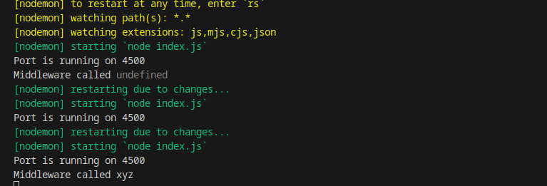
- Here, you can see that “xyz”. We got.
- Now, we are taking the static token from our browser’s section. And adding the “bearer” at the start.
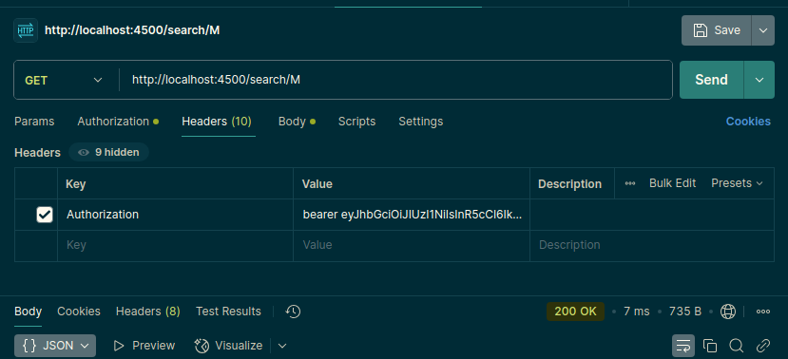
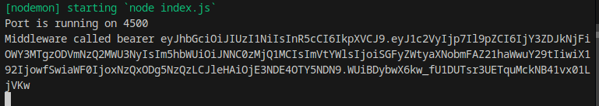
- Here, you can see that “bearer” as a word. Now, we are separating the word “bearer” from the token. And verify with the data.
function verifyToken(req, resp, next) {
let token = req.headers['authorization']
next()
if (token) {
// Now, separating the keyword "bearer"
token = token.split(' ')
console.log("Middleware called", token)
}
}

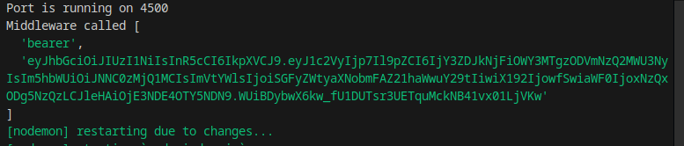
- Here, you can see that the “String” is converted into an Array.
- Now, we got two keys.
0th: bearer
1st: ‘token’

- Now, verify the token and handle an errors with the Status:
function verifyToken(req, resp, next) {
let token = req.headers['authorization']
// next()
if (token) {
// Now, separating the keyword "bearer"
token = token.split(' ')[1]
// console.log("Middleware called", token)
jwt.verify(token, jwtKey, (err, valid) => {
if (err) {
resp.status(401).send("Please provide valid token")
} else {
next()
}
})
} else {
resp.status(403).send({ result: "Please add token with header" })
}
}
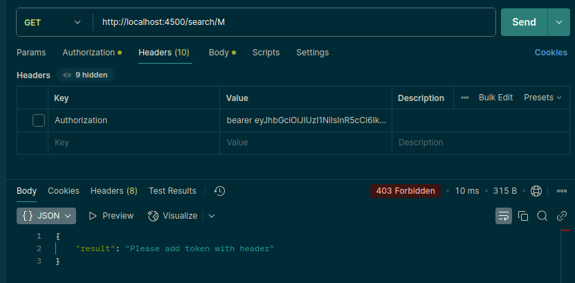
- If I don’t provide the token. It will give me an error.

- If I provide the token but it’s not valid.
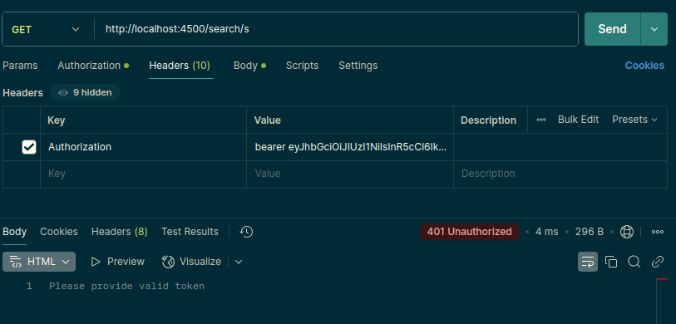
- Here, you can see that. If it’s invalid then it will give me an error of the 401 and if it’s not available then it will give me an error of the 403’s.
- Now, just add the “verify” function

- final code of the Index.js’s
const express = require('express');
const app = express();
require("./Components/DB_Config");
const cors = require('cors');

const Users = require("./Components/users");
const Product = require('./Components/Product');

app.use(express.json());
app.use(cors());

// Here, we are adding the JWT authorization

const jwt = require('jsonwebtoken')
const jwtKey = 'e-comm'

app.post("/register", async (req, resp) => {
try {
let user = new Users(req.body);
let result = await user.save();
result = result.toObject();
delete result.password;
if (result) {
jwt.sign({ result }, jwtKey, { expiresIn: "2h" }, (err, token) => {
if (err) {
resp.send({ result: "Somthing went wrong" })
} else {
resp.send({ result, auth: token });
// resp.send(result);
}
})
} else {
resp.send({ result: 'No user found' });
}
} catch (error) {
resp.status(500).send({ error: "Internal Server Error" });
}
});

app.post("/login", async (req, resp) => {
try {
if (req.body.password && req.body.email) {
let user = await Users.findOne(req.body).select("-password");
if (user) {
jwt.sign({ user }, jwtKey, { expiresIn: "2h" }, (err, token) => {
if (err) {
resp.send({ result: "Somthing went wrong" })
} else {
resp.send({ user, auth: token });
}
})
} else {
resp.send({ result: 'No user found' });
}
} else {
resp.send({ result: "No user found" });
}
} catch (error) {
resp.status(500).send({ error: "Internal Server Error" });
}
});

app.post("/add", verifyToken, async (req, resp) => {
try {
let product = new Product(req.body);
let result = await product.save();
resp.send(result);
} catch (error) {
resp.status(500).send({ error: "Internal Server Error" });
}
});

app.get("/products", verifyToken, async (req, resp) => {
try {
let products = await Product.find();
if (products.length > 0) {
resp.send(products);
} else {
resp.send({ result: "No products found" });
}
} catch (error) {
resp.status(500).send({ error: "Internal Server Error" });
}
});

app.delete("/products/:id", verifyToken, async (req, resp) => {
try {
const result = await Product.deleteOne({ _id: req.params.id });
resp.send(result);
} catch (error) {
resp.status(500).send({ error: "Internal Server Error" });
}
});

app.get("/products/:id", verifyToken, async (req, resp) => {
try {
let result = await Product.findOne({ _id: req.params.id });
if (result) {
resp.send(result);
} else {
resp.send({ result: "No record found" });
}
} catch (error) {
resp.status(500).send({ error: "Internal Server Error" });
}
});

app.put("/products/:id", async (req, resp) => {
try {
let result = await Product.updateOne(
{ _id: req.params.id }, { $set: req.body }
);
resp.send(result);
} catch (error) {
resp.status(500).send({ error: "Internal Server Error" });
}
});

app.get("/search/:key", verifyToken, async (req, resp) => {
try {
let result = await Product.find({
"$or": [
{ name: { $regex: req.params.key } },
{ company: { $regex: req.params.key } },
{ category: { $regex: req.params.key } },
{ price: { $regex: req.params.key } }
]
});
resp.send(result);
} catch (error) {
resp.status(500).send({ error: "Internal Server Error" });
}
});

function verifyToken(req, resp, next) {
let token = req.headers['authorization']
// next()
if (token) {
// Now, separating the keyword "bearer"
token = token.split(' ')[1]
// console.log("Middleware called", token)
jwt.verify(token, jwtKey, (err, valid) => {
if (err) {
resp.status(401).send("Please provide valid token")
} else {
next()
}
})
} else {
resp.status(403).send({ result: "Please add token with header" })
}
}

app.listen(4500, (err) => {
if (err) {
console.error("Error found ", err);
} else {
console.log("Port is running on 4500");
}
});

Send Auth Token from React js
- Here, we are working for the Frontend.
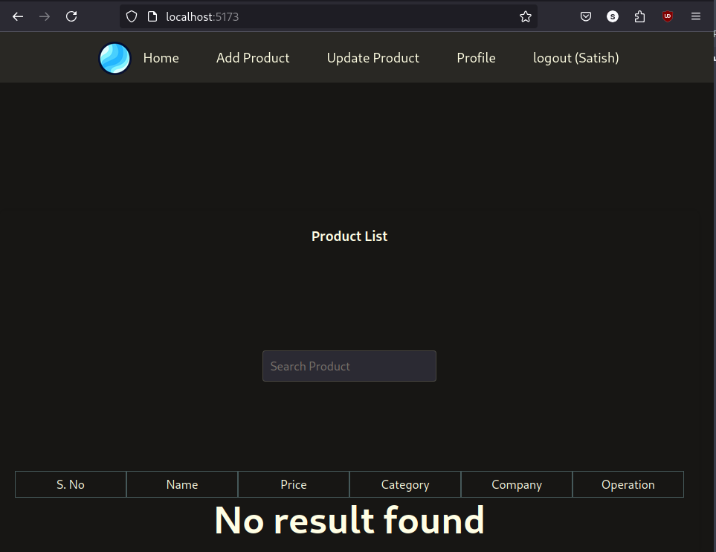
- This is the Result we are getting before adding the Tokens. Now, we are adding the Tokens.

Points to Remember:
- Whenever you are making an API, then always try to use the "try – catch" method for an error handling.
- Try to make the different database’s file for better the optimization of the Code
- Try to make the different Database’s Schema with try and error method
- Whenever you are working with the “Database” then try to use the Asynchronous method for the better optimization (async and await)

