
TRIBHUVAN UNIVERSITY
Faculty of Humanities and Social Sciences
ChatterWave – Real Time Chat App
A PROJECT PROPOSAL
In the partial fulfillment of the requirement for the Bachelors degree in Computer
Applications
Submitted to
Department of Computer Applications
JANAMAITRI MULTIPLE CAMPUS
Kuleshwar, Kathmandu
Submitted by
Abishek Pandeya (TU Reg No.6-2-263-02-2021)
Chandreswar Rawal (TU Reg No. 6-2-263-13-2021)
Under the Supervision of
Kamal Tamrakar
JANAMAITRI MULTIPLE CAMPUS
Kuleshwar, Kathmandu


TRIBHUVANUNIVERSITY
Faculty of Humanities and Social Sciences
Supervisor’s Recommendation
I hereby recommend that this project prepared under my supervision by Abishek
Pandeya(TU Reg. No. 6-2-263-02-2021) and Chandreswar Rawal(TU Reg. No: 6-2-263-07-2021) entitled “Chatterwave” in partial fulfillment of the requirements for the Bachelors degree in Computer Applications(BCA) is recommended for the final evaluation.
….………………………
Mr. Kamal Tamrakar
Supervisor
HOD, Faculty of Computer Applications
JANAMAITRI MULTIPLE CAMPUS
Kuleshwar, Kathmandu, Nepal

TRIBHUVAN UNIVERSITY
Faculty of Humanities and Social Sciences
LETTER OFAPPROVAL
This is to certify that this project, prepared by Abishek Pandeya (TU Reg. No: 6-2-263-
02-2021) and Chandreswar Rawal (TU Reg. No: 6-2-263-13-2021) entitled “Chatter- wave” in partial fulfillment of the requirements for the Bachelor's degree in Computer Application, is recommended for the final evaluation. In our opinion, it is satisfactory in scope and quality as a project for the required degree.
Signature of Supervisor  …………………………  Kamal Tarmrakar  Supervisor  Janamaitri Multiple Campus kuleshwor,kathmandu | Signature of HOD/ Coordinator  …………………………  Kamal Tamrakar  HOD, Faculty of Computer  Janamaitri Multiple Campus kuleshwor,kathmandu
…………………………  Signature of Internal Examiner  Internal Examiner | …………………………  Signature of External Examiner  External Examiner

ACKNOWLEDGEMENT
The report on project entitled “CHATTERWAVE – REAL TIME CHAT APP” is made as a partial fulfillment of the requirements for the degree of Bachelor of Science in Computer Science and Information Technology. We hope that this project will be beneficial to the bodies concerned.
We would like to express our sincere gratitude to Mrs. Sristi Khatiwada, our program coordinator and Ms. Susan Sunuwar, our project supervisor for their invaluable guidance, unwavering support and mentorship throughout the duration of project. Their valuable and timely suggestions at crucial stages, along with their constant encouragement have made it possible for us to accomplish this work. Lastly, we extend our heartfelt thanks to everyone who has contributed to this project, directly or indirectly, and helped in its completion.

Thanking you,
Abishek Pandeya
Chandreswar Rawal

ABSTRACT
ChatterWave is a real-time chat application developed using modern web technologies, including React, Tailwind, Node.js, Socket.io, and Prisma with SQL. The application is designed to provide an intuitive, responsive, and secure communication platform for users. It leverages React for a dynamic front-end, while Tailwind CSS ensures a customizable and visually appealing design. The backend is powered by Node.js and Socket.io, enabling realtime, bi-directional communication. Prisma, paired with SQL, handles efficient database interactions, ensuring data consistency.
To safeguard user data, the application employs the RSA algorithm for secure message encryption and decryption. ChatterWave is built to be cross-device compatible, ensuring users remain connected wherever they are. With features such as encrypted data transmission, secure authentication, and scalable architecture, the application guarantees privacy and reliability. The development process involved comprehensive testing and user feedback, ensuring a high-performance product that meets modern user expectations. Future plans include the integration of media sharing, group chats, and message history management, positioning ChatterWave as a versatile tool for both personal and professional communication.
Keywords: Real-time chat, React, Tailwind, Node.js, Socket.io, Prisma ORM, SQL, RSA
Encryption, Password Hashing

TABLE OF CONTENT
SUPERVISOR RECOMMENDATION Error! Bookmark not defined.
LETTER OF APPROVAL Error! Bookmark not defined.
ACKNOWLEDGEMENT iii
ABSTRACT iv
LIST OF FIGURES vii
LIST OF TABLES viii
LIST OF ABBREVIATION ix
Chapter 1: Introduction 1
1.1 Introduction 1
1.2 Problem Statement 2
1.3 Objectives 2
1.4 Scope and Limitations 3
1.4.1 Scope 3
1.4.2 Limitation 3
1.5 Development Methodology 4
1.6 Report Organization 5
Chapter 2: Background Study and Literature Review 6
2.1 Background Study 6
2.2 Literature Review 7
Chapter 3: System Analysis 8
3.1 Requirement Analysis 8
3.1.1 Functional Requirements 8
3.1.2 Non-Functional Requirements 9
3.2 Feasibility Analysis 9
3.2.1 Economic Feasibility 9
3.2.2 Technical Feasibility 9
3.2.3 Operational Feasibility 9
3.2.4 Schedule Feasibility 9
3.3 Analysis (Structured Approach) 10
3.3.1 DFD 10
3.3.2 ER Diagram 12
3.3.3 Flow Chart 13
Chapter 4: System Design 14
4.1 Database Design 14
4.2 Forms and Report Design 15
4.3 Interface Design 15
Chapter 5: Implementation and Testing 18
5.1 Implementation 18
5.1.1 Tools Used 18
5.1.2 Implementation Details of Modules 19
5.2 Testing 25
5.2.1 Unit Testing 25
5.2.2 System Testing 27
Chapter 6: Conclusion and Future Recommendations 32
6.1 Conclusion 32
6.2 Future Recommendations 32
REFERENCES 34
Appendix 35

LIST OF FIGURES
Figure 1.1 Agile Methodology [2] ....................................................................................... 3
Figure 3.1 Use Case Diagram of ChatterWave .................................................................... 7
Figure 3.2 Gantt Chart (Working Schedule of ChatterWave) .............................................. 9
Figure 3.3 DFD level 0 of ChatterWave .............................................................................. 9
Figure 3.4 DFD level 1 of ChatterWave ............................................................................ 10
Figure 3.5 ER Diagram of ChatterWave ............................................................................ 11
Figure 3.6 Flow Chart of ChatterWave .............................................................................. 12
Figure 4.1 Database design for ChatterWave..................................................................... 13
Figure 4.2 Form and Report Design .................................................................................. 14
Figure 4.3 Interface for Login Page ................................................................................... 15
Figure 4.4 Interface for Chat Page ..................................................................................... 15
Figure 4.5 Interface for User Profile Page ......................................................................... 16 Figure 4.6 Interface for Home Page ................................................................................... 16
Figure 5.1 Working of RSA Algorithm [6] ........................................................................ 18

LIST OF TABLES
Table 5.1 User Login/Signup ............................................................................................. 22
Table 5.2 Bad Word Filter .................................................................................................. 23
Table 5.3 RSA Encryption in Chat ..................................................................................... 24
Table 5.4 Socket.IO Connection ........................................................................................ 24
Table 5.5 User Registration and Login .............................................................................. 25
Table 5.6 Chat Functionality .............................................................................................. 25
Table 5.7 RSA Encryption and Decryption ........................................................................ 26
Table 5.8 Socket.IO Connection ........................................................................................ 26
Table 5.9 System Non-Functional Testing ......................................................................... 27

LIST OF ABBREVIATION
CSS Cascading Style Sheets DFD Data Flow Diagram
ER Entity Relationship
JS JavaScript
ORM Object Relational Mapping
RSA Rivest, Shamir, and Adleman
SQL Structured Query Language
UI User Interface
UX User Experience

Chapter 1: Introduction

1.1 Introduction
In today’s digital age, the security of online communication is paramount. Despite advancements in cybersecurity, no system can claim to be completely impervious to breaches. As cyber-attacks become increasingly sophisticated, it is crucial not only to secure user passwords through hashing but also to ensure that the messages exchanged between users are encrypted. Encryption plays a vital role in safeguarding sensitive information, ensuring that even if an attacker gains unauthorized access to a user’s account, they cannot decipher the contents of the communication.
Our project addresses these concerns by developing a real-time chat application that integrates RSA encryption to protect message exchanges. RSA, a widely recognized encryption algorithm, is employed to secure communication channels, thereby enhancing the confidentiality and integrity of user messages. This approach ensures that messages remain protected from potential breaches, mitigating risks associated with unauthorized data access.
Additionally, the application employs Socket.io to provide real-time messaging without the need for constant page refreshes or polling, enhancing user experience and efficiency. This technology ensures that users receive messages in real-time, enhancing the overall efficiency and responsiveness of the chat application.

1.2 Problem Statement
Many existing chat applications lack adequate security measures for message encryption, leaving user communications vulnerable to breaches . Messages sent without proper encryption can be intercepted during transmission, exposing sensitive user data to potential attackers. This lack of security can lead to data theft, unauthorized access to personal conversations, and a general breach of user privacy. Inadequate encryption methods or reliance on outdated security protocols further exacerbate the risk, making it easier for malicious actors to exploit vulnerabilities. As user expectations for privacy and data security continue to rise, the failure to implement robust encryption mechanisms not only compromises user trust but also places these applications at a competitive disadvantage in an increasingly security-conscious market.
Additionally, traditional methods for real-time updates, such as polling or periodic refreshing, can degrade user experience and application performance. Our project aims to address these issues by implementing robust message encryption and efficient real-time communication.

1.3 Objectives
i. Create a functional chat application with real-time messaging using Socket.io.
ii. Secure messages with RSA encryption to ensure the confidentiality of
conversations.
iii. Design a responsive user interface that allows smooth communication.
This project aims to address both security and performance challenges in real-time communication, creating a secure and efficient platform for users to interact and exchange information.

1.4 Scope and Limitations

1.4.1 Scope
- ChatterWave provides instant real-time messaging using Socket.IO, including features like real-time presence updates.
- ChatterWave ensures secure communication with end-to-end RSA encryption, secure key exchange mechanism, and protection of sensitive data such as chat histories.
- ChatterWave enhances user experience and promotes a healthy communication environment by incorporating text filtering to detect and block toxic or inappropriate words in messages.
- ChatterWave fosters meaningful connections by allowing users to send and accept friend requests, enabling them to build a trusted network for real-time conversations.

1.4.2 Limitation
- User verification is limited to email-based OTP verification, with no support for mobile number verification.
- The platform does not support sending images, videos, or audio files, restricting communication to text-only messages.
- Long conversational texts are not supported, allowing only short conversational text messages to be sent.

1.5 Development Methodology
The Agile methodology is applied throughout the project to facilitate flexibility and responsiveness to change. Agile focuses on iterative development, where the project is broken down into smaller, manageable units of work called sprints, typically lasting one to two weeks. Each sprint will result in a functional piece of the application that can be tested, reviewed, and refined based on user feedback.
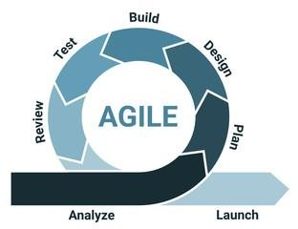

Figure 1.1 Agile Methodology [2]
This iterative process allows for continuous improvements and ensures that the development stays aligned with user needs and project goals. Regular sprint reviews and retrospectives will provide opportunities for the team to assess progress, identify any challenges, and make necessary adjustments. Agile emphasis on collaboration and communication among team members and stakeholders ensures that the project remains on track and any issues are addressed promptly.
In this project, Agile enables the rapid incorporation of changes, particularly as the development involves integrating complex features like real-time messaging and encryption. By following Agile, the project team ensures that the final product meets user expectations while delivering high-quality software that is both functional and secure.

1.6 Report Organization
The project is broken up into six isolated chapters, each of which describes a different stage of development. The following is a summary of the chapters:
Chapter 1 is the overview of the project including the introduction, problem statement, objectives, scope, limitations, and development methodology.
Chapter 2 focuses on the background study and literature review related to the project for reference in project development.
Chapter 3 involves system analysis, including requirement analysis and feasibility analysis.
Chapter 4 includes the project design and modeling.
Chapter 5 focuses on the implementation and testing of the system.
Chapter 6 is the conclusion of the report and includes future recommendations.
Furthermore, the reference section includes a list of all the sources cited in the report.

Chapter 2: Background Study and Literature Review

2.1 Background Study
ChatterWave, a real-time chat application, is grounded in key concepts and technologies that ensure robust functionality and an exceptional user experience. Socket.io plays a critical role in enabling real-time, bidirectional communication, allowing users to exchange messages instantly with minimal latency. To secure these interactions, RSA encryption is employed, ensuring end-to-end data protection by encrypting messages during transmission and allowing only authorized users to decrypt them. Furthermore, ChatterWave incorporates text filtering to detect and block toxic or inappropriate content, fostering a safe and respectful communication environment. The application also supports essential social networking features, such as sending and accepting friend requests, enabling users to build meaningful connections within the platform.
From a technological perspective, ChatterWave leverages a modern stack for both the frontend and back-end. The front-end is built with React.js, delivering a dynamic and interactive user interface, styled efficiently using TailwindCSS. State management is streamlined with Redux Toolkit, ensuring efficient data flow and predictable application state. The back-end, powered by Node.js and Express, provides a scalable and high-performance server infrastructure. Prisma, used as the ORM, simplifies database interactions and ensures consistency in managing relational data. This blend of advanced technologies and fundamental concepts forms the backbone of ChatterWave, ensuring a secure, scalable, and user-friendly platform that meets the demands of a modern real-time communication application.

2.2 Literature Review
Applied Cryptography: Protocols, Algorithms, and Source Code in C by Bruce Schneier is a foundational text that provides a comprehensive introduction to cryptography, covering both theoretical concepts and practical implementations. The book details various cryptographic algorithms, including symmetric and public-key encryption, hash functions, and cryptographic protocols. It also includes C source code for many algorithms, making it a practical guide for developers. Schneier emphasizes the correct application of cryptography in real-world scenarios, discussing potential vulnerabilities and security considerations.
Enhancing Real-Time Messaging Applications Using WebSocket and Socket.io is the journal posted in Journal of Web Engineering and Technology. This article examines the use of WebSocket and Socket.io to optimize the functionality of real-time messaging applications. It explains how WebSocket provides a full-duplex communication channel that allows for persistent connections between clients and servers, significantly reducing latency and improving message delivery speed. The article further explores how Socket.io, an abstraction layer over WebSocket, simplifies the development process by offering builtin features like automatic reconnection, broadcasting, and room-based communication, which are essential for creating interactive and scalable messaging systems..
Secure and Efficient End-to-End Encrypted Messaging Framework for Real-Time Communication is the journal posted in IEEE Transactions on Information Forensics and Security. This article presents a framework designed to ensure both security and efficiency in real-time messaging systems. The study focuses on implementing end-to-end encryption to protect messages from unauthorized access, ensuring that only the communicating parties can decrypt the content. The proposed framework also addresses the challenge of maintaining low latency and high performance in encrypted communication by optimizing encryption algorithms and key management processes. The findings suggest that the framework successfully balances strong security with the need for real-time responsiveness, making it suitable for applications requiring secure and fast communication, such as in healthcare, finance, and private messaging services.

Chapter 3: System Analysis

3.1 Requirement Analysis

3.1.1 Functional Requirements
- The system must allow users to register and log in securely using an email and password.
- The application must support real-time messaging between users, ensuring instant delivery and receipt of messages.
- All messages must be encrypted using RSA encryption to ensure secure communication between users.
- The system should store chat histories for users, allowing them to view previous messages.
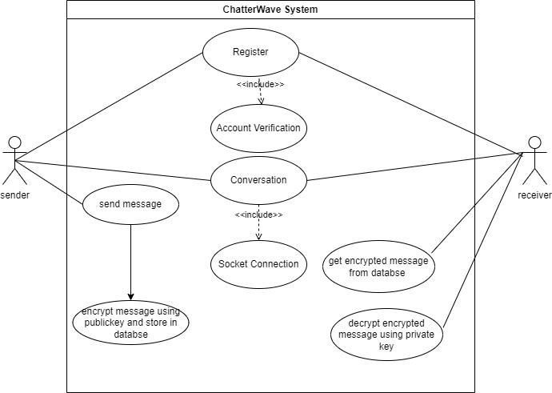
Figure 3.1 Use Case Diagram of ChatterWave

3.1.2 Non-Functional Requirements
- The application must be able to handle real-time message delivery with minimal latency, ensuring a smooth user experience.
- The application should support a light and dark mode switcher, allowing users to toggle between themes based on their preference.

3.2 Feasibility Analysis

3.2.1 Economic Feasibility
All the resources are available to do the project thus further expenses is not required.

3.2.2 Technical Feasibility
The necessary technologies and expertise, including Socket.io and RSA, are available to successfully implement in the project.

3.2.3 Operational Feasibility
The project aligns with user requirements and can be smoothly integrated into existing systems for real-time communication.

3.2.4 Schedule Feasibility
The project can be completed within the allotted time frame according to the proposed Gantt chart.

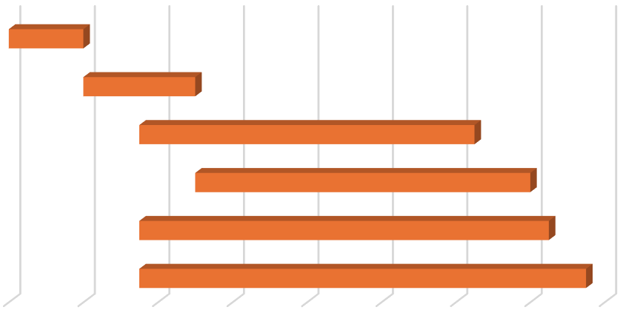

26-
Aug
15-
Sep
5-
Oct
25-
Oct
14-
Nov
4-
Dec
24-
Dec
13-
Jan
2-
Feb
Study and analysis
UI design
Frontend Development
Backend Development
Testing
Documentation
ChatterWave Development Schedule
Figure 2.2 Gantt Chart (Working Schedule of ChatterWave)

3.3 Analysis (Structured Approach)

3.3.1 DFD
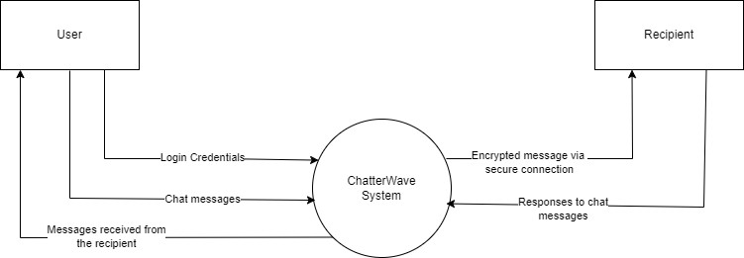

Figure 3.3 DFD level 0 of ChatterWave
The Level 0 Data Flow Diagram (DFD) for the ChatterWave system provides an overview of the key processes and data flows in the system. It illustrates how users interact with the ChatterWave system by sending login credentials for authentication. Once authenticated, users can exchange chat messages, which are processed by the system and securely transmitted to recipients as encrypted messages. The system ensures that responses from recipients are received, decrypted, and delivered back to the original sender. The diagram emphasizes secure communication through encrypted messages and seamless handling of chat interactions, ensuring privacy and efficient messaging between users.

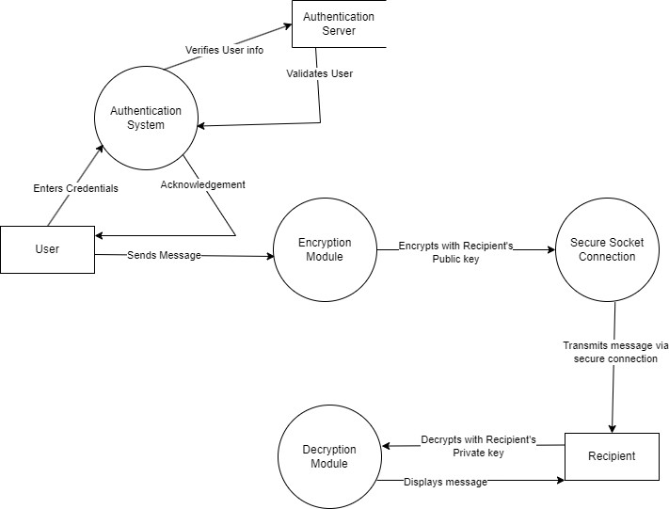

Figure 3.4 DFD level 1 of ChatterWave
The Level 1 Data Flow Diagram (DFD) for the ChatterWave system elaborates on the processes involved in secure communication. Initially, the user enters their credentials into the Authentication System, which verifies the information with the Authentication Server. Once validated, the system acknowledges the user and grants access. The user then sends a message, which is passed to the Encryption Module. This module encrypts the message using the recipient's public key to ensure security. The encrypted message is transmitted through a Secure Socket Connection to the recipient. Upon receipt, the Decryption Module decrypts the message using the recipient's private key, ensuring that only the intended recipient can read it. The decrypted message is then displayed to the recipient, completing the secure communication flow. This diagram emphasizes secure user authentication, message encryption, and decryption to safeguard data integrity and privacy.

3.3.2 ER Diagram
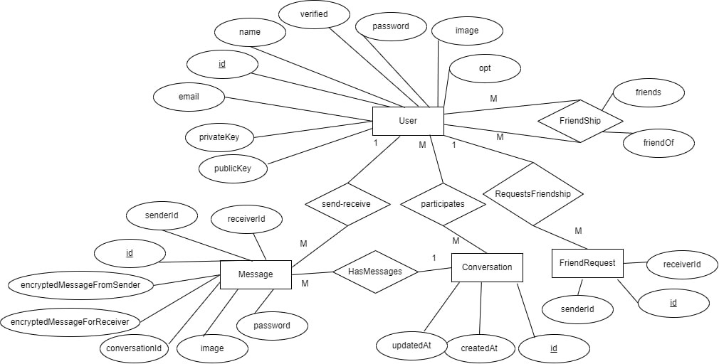

Figure 3.5 ER Diagram of ChatterWave
The ER diagram for ChatterWave models a real-time chat application's database structure. The User entity stores essential details like id, name, email, password, image, and encryption keys (privateKey, publicKey). Users can send and receive Messages, which are encrypted and linked to Conversations. Users also engage in Friendships (M:M relationship) and can send Friend Requests. The Conversation entity organizes messages and tracks createdAt and updatedAt timestamps. Overall, the diagram captures the relationships between users, messages, conversations, and friendships to enable secure and efficient real-time communication.

3.3.3 Flow Chart
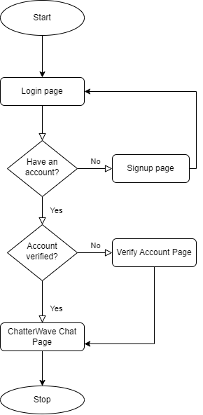

Figure 3.6 Flow Chart of ChatterWave
The flowchart of ChatterWave outlines the user journey from starting the application to accessing the chat page. It begins at the Start point, where users are directed to the Login Page. If the user does not have an account, they are redirected to the Signup Page to create one. For existing users, the system checks if the account is verified. If the account is not verified, the user is directed to the Verify Account Page to complete the verification process. Once the account is verified, the user can access the ChatterWave Chat Page to begin communication. The process ends at the Stop point. This flowchart ensures a logical sequence for user authentication, registration, and verification to access the chat functionalities.

Chapter 4: System Design

4.1 Database Design

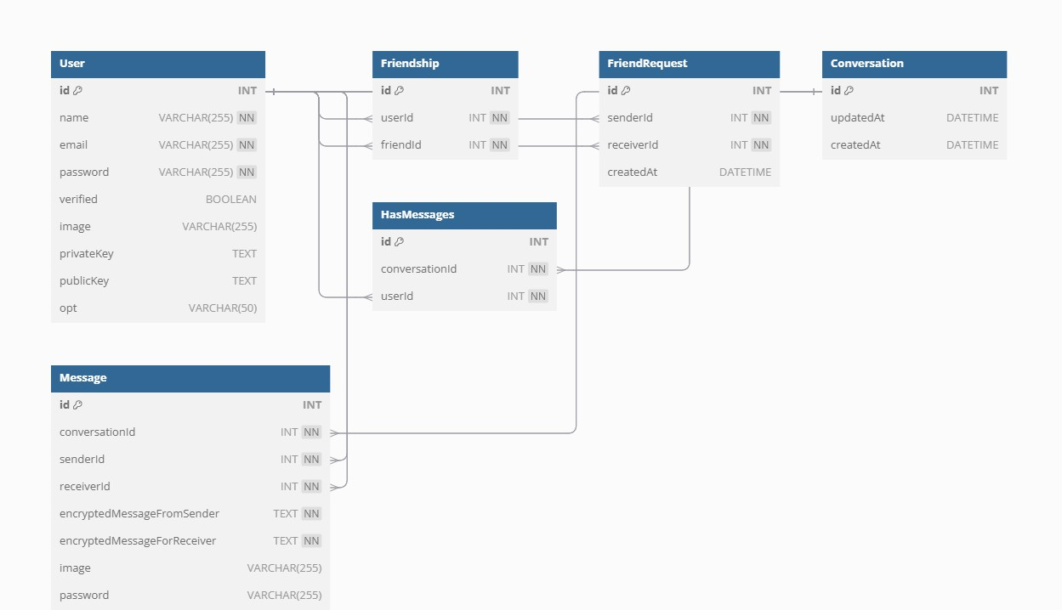

Figure 4.1 Database design for ChatterWave
The database design for ChatterWave defines the structure for managing users, messages, conversations, and friendships. The User table stores essential user details, including authentication data and encryption keys. The Message table records encrypted messages exchanged between users, linking each message to a Conversation. The Conversation table tracks chat sessions with timestamps. The Friendship table manages relationships between users, while the FriendRequest table records pending connection requests. The HasMessages table establishes a many-to-many relationship between users and conversations. This design ensures secure, structured communication with encryption and user verification.

4.2 Forms and Report Design
Forms are an important part of a system as they are used to get data from the users. The different forms that will be required for the system are login and registration for admin and user.

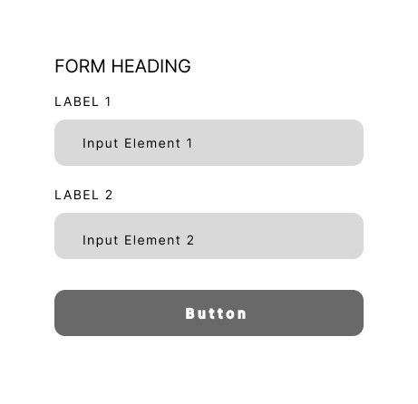
Figure 4.2 Form and Report Design

4.3 Interface Design
The User Interface (UI) and the User Experience (UX) plays a crucial role in the system, as it directly affects how easily new users can comprehend the various components and navigate them to accomplish their desired objectives. The system's interface will be displayed using the following representations:


Figure 4.3 Interface for Login Page

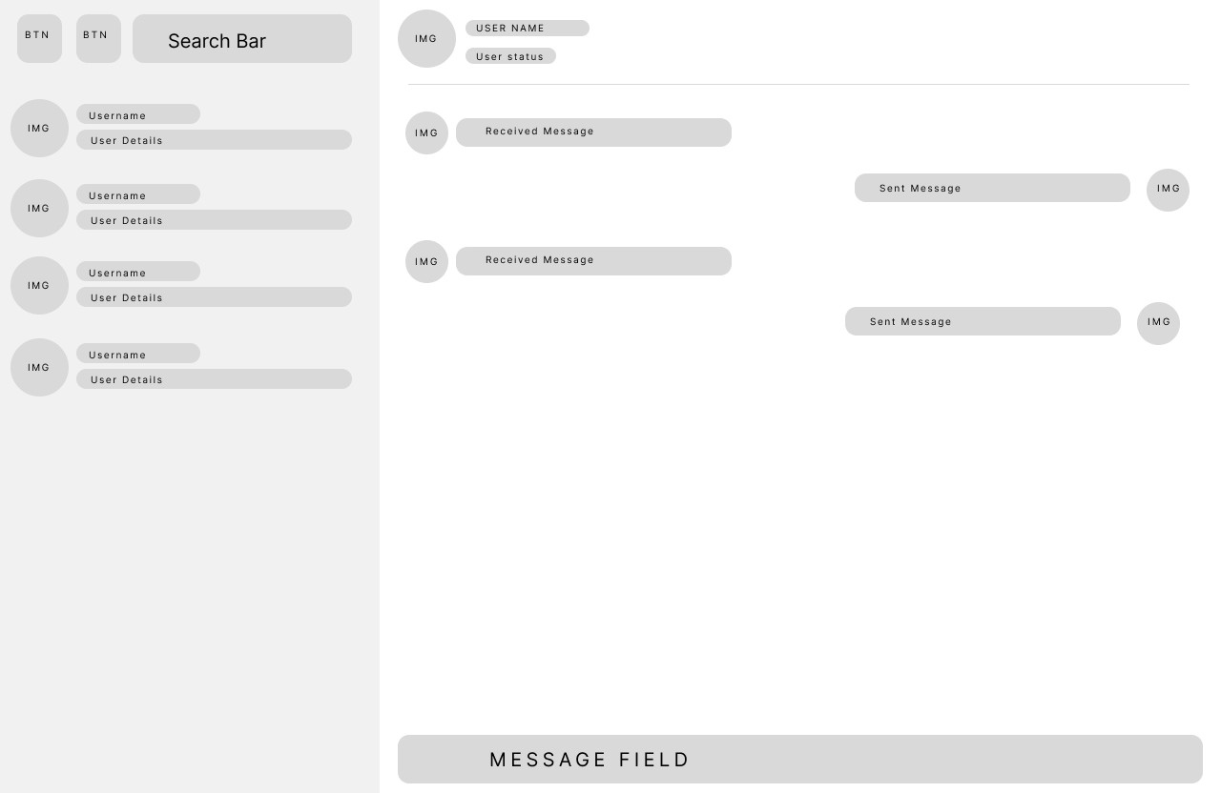

Figure 4.4 Interface for Chat Page
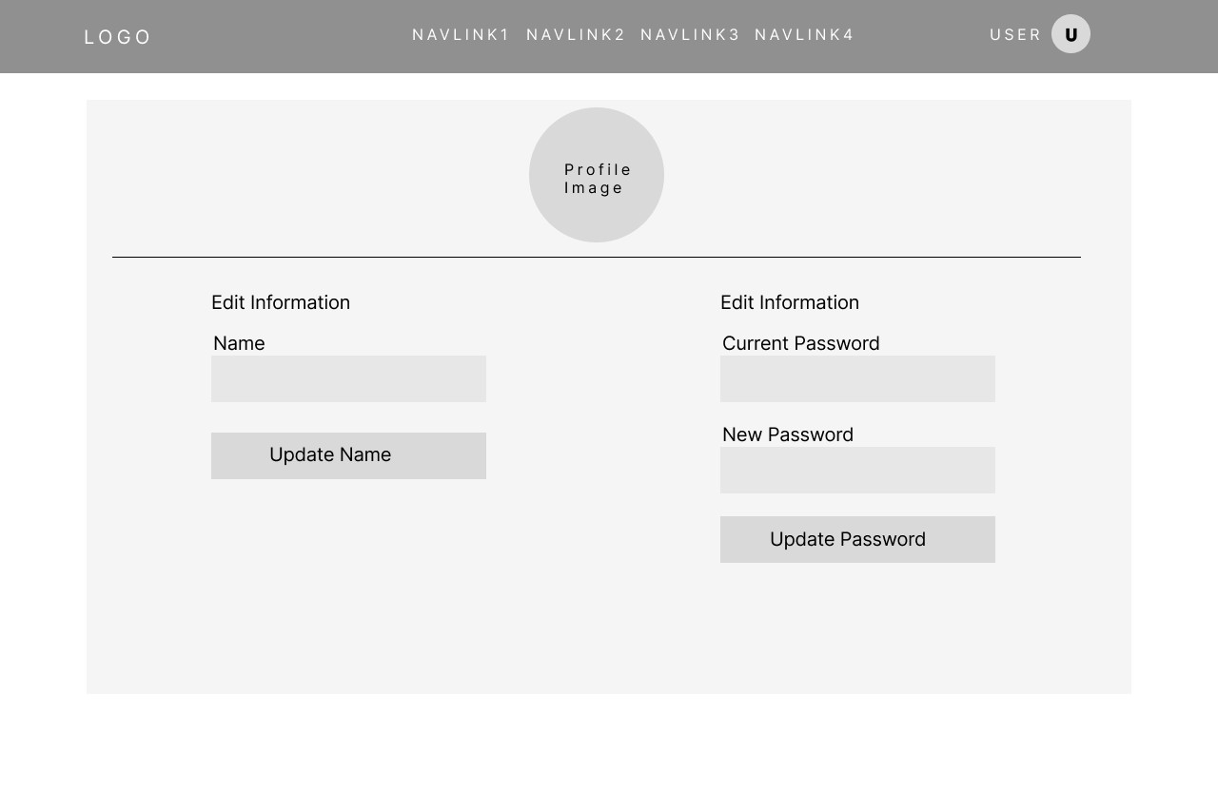

Figure 4.5 Interface for User Profile Page


Figure 4.6 Interface for Home Page

Chapter 5: Implementation and Testing

5.1 Implementation
The implementation phase involves executing the plan and deploying the system. For ChatterWave, this phase includes the development and deployment of a software system to manage real-time messaging, user authentication, secure communication, and chat data handling.

5.1.1 Tools Used
Various tools were used while making this ChatterWave App. Some of them are discussed below:
- Front-End: The front-end of the application is built using React.js for efficient UI rendering, Redux Toolkit for state management, and Tailwind CSS for responsive and modern styling.
- Back-End: The back-end utilizes Node.js and Express for handling server-side logic, with Socket.io for enabling real-time communication. Prisma will be used as the ORM for interacting with an SQL-based database, ensuring efficient and structured data management.
- Git: For version control and change tracking, we used git along with GitHub. This ensures coordination among the programming members during app development.

5.1.2 Implementation Details of Modules
Socket.io:
For the real-time messaging component, we use Socket.io, a powerful library that enables real-time, bidirectional communication between web clients and servers. Unlike traditional methods such as polling or periodic refreshing, Socket.io ensures that messages are delivered instantly, providing a seamless and responsive user experience. This technology is chosen specifically to enhance the efficiency and performance of real-time communication in our chat application.

RSA Encryption:
The RSA (Rivest–Shamir–Adleman) algorithm is utilized as the core encryption technique in the project to ensure the security of user communications. RSA is a public-key cryptography algorithm that relies on the mathematical properties of prime numbers to generate secure keys. In the context of this chat application, RSA is used to encrypt messages before they are transmitted over the network, ensuring that only the intended recipient can decrypt and read the messages.
RSA encryption involves two keys: a public key for encryption and a private key for decryption. When a user sends a message, the application will encrypt the message using the recipient's public key. The recipient will then use their private key to decrypt the message. This approach ensures that even if an attacker intercepts the encrypted message, they will not be able to decrypt it without the corresponding private key.
The choice of RSA is driven by its strong security guarantees and widespread use in secure communication protocols. RSA is well-suited for applications where confidentiality and integrity of data are paramount, making it an ideal choice for this real-time chat application. Additionally, the implementation of RSA in the project provides a robust layer of security, ensuring that user messages remain private and protected from unauthorized access.

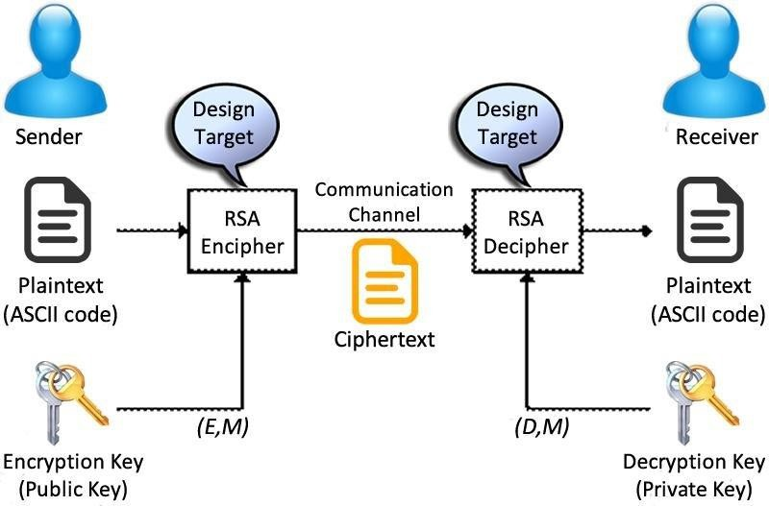

Figure 5.1 Working of RSA Algorithm [6]

RSA key generation:
- Choose two distinct large prime numbers p and q.
- Compute n = pq, n is used as modulus for both public and private keys.
- Compute the totient: ϕ (n) = (p-1)(q − 1). iv. Choose an integer e such that 1 <e< ϕ(n) and e and ϕ(n) are co-prime.
- Compute d to satisfy ed ≡ 1(mod ϕ (n)).
- Public key is {e, n}. vii. Private key is {d, n}.
Encryption: c = m^{e} mod n Decryption: m = c^{d} mod n

Key Generation
Steps:
i. Generate two distinct prime numbers (p and q). ii. Compute n = p × q.
- Calculate Euler's Totient Function: ϕ(n) = (p−1) × (q−1).
- Select a public exponent e such that 1<e<ϕ(n) and gcd(e,ϕ(n)) = 1.
- Calculate the private exponent d such that (e x d) ≡ 1 (mod ϕ(n)). vi. Public key is {e, n}. vii. Private key is {d, n}.
Code Snippet:
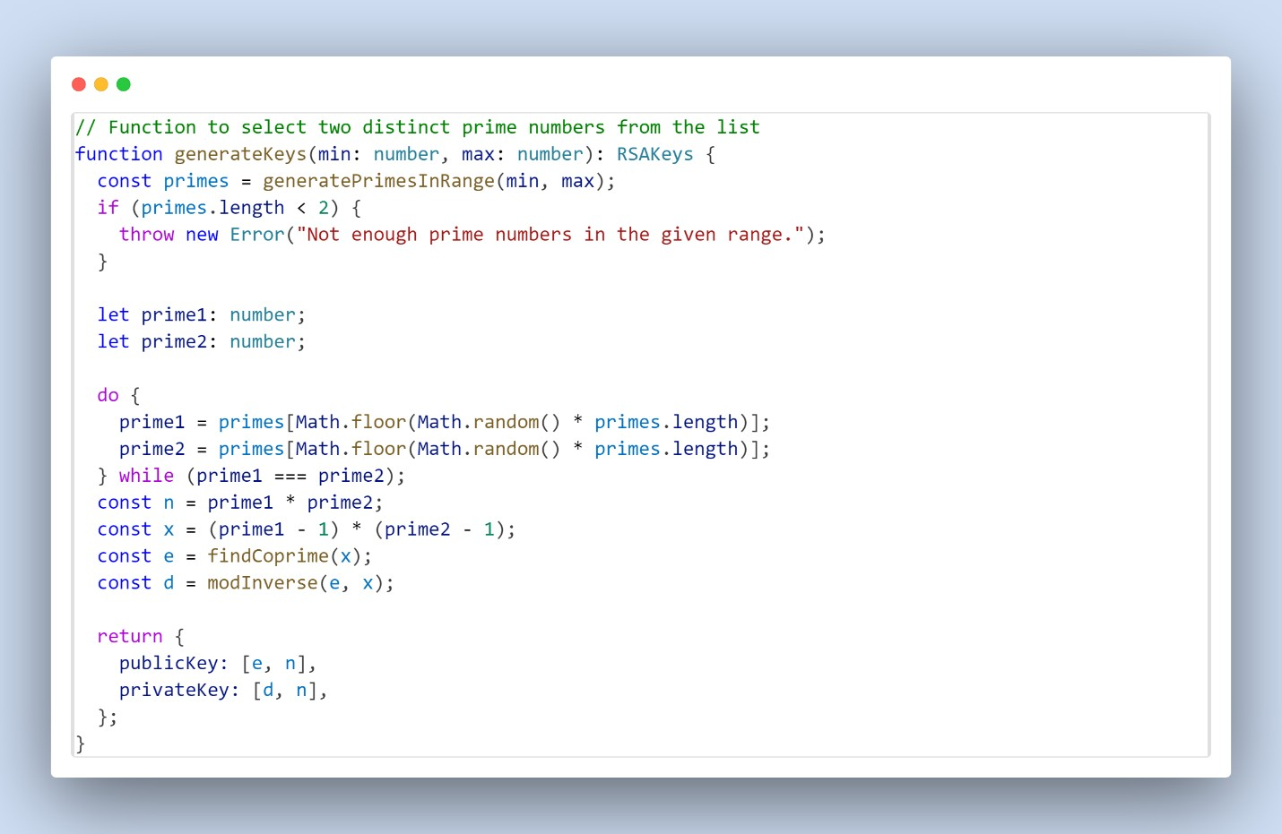
Tracing:
- Primes: p=61, q=53
- n=61×53=3233
- ϕ(n)= (61−1) × (53−1) =3120
- e=17, d=2753

Encryption
Steps:
- Convert each character in the plaintext to its ASCII value.
- Encrypt each ASCII value using modular exponentiation:
cipherChar=(charCode^{e}) mod n

Code Snippet:
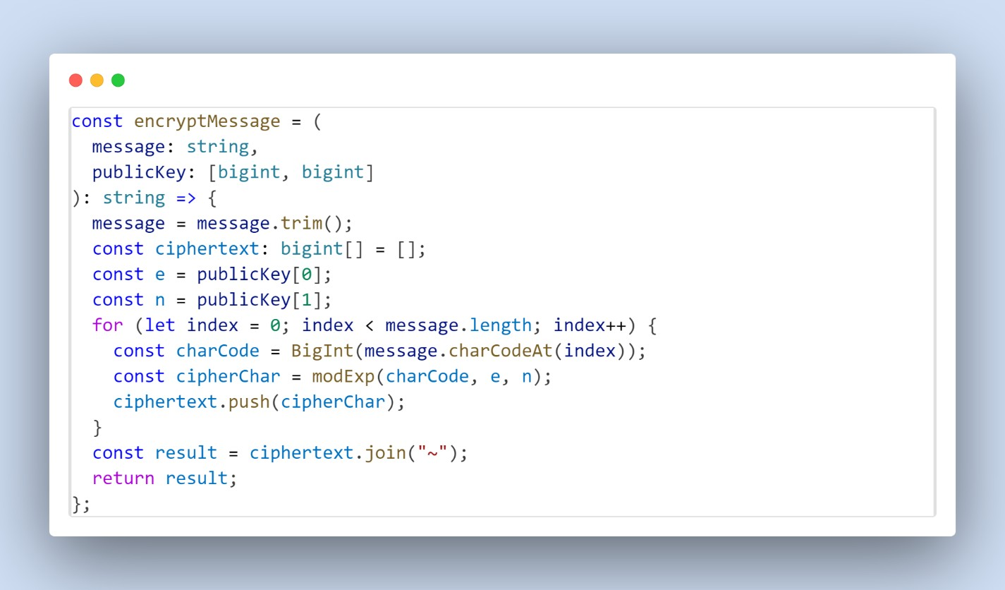
Tracing:
- Message: "Hello world"
- ASCII values: 72, 101, 108, 108, 111, 32, 119, 111, 114, 108, 100
- Ciphertext: 3000~1313~745~745~2183~32~1687~2183~1140~745~100

Decryption
Steps:
- Split the ciphertext into individual numbers.
- Decrypt each number using modular exponentiation:
plainChar=(cipherChar^{d}) mod n
- Convert each decrypted number back to its ASCII character.

Code Snippet:
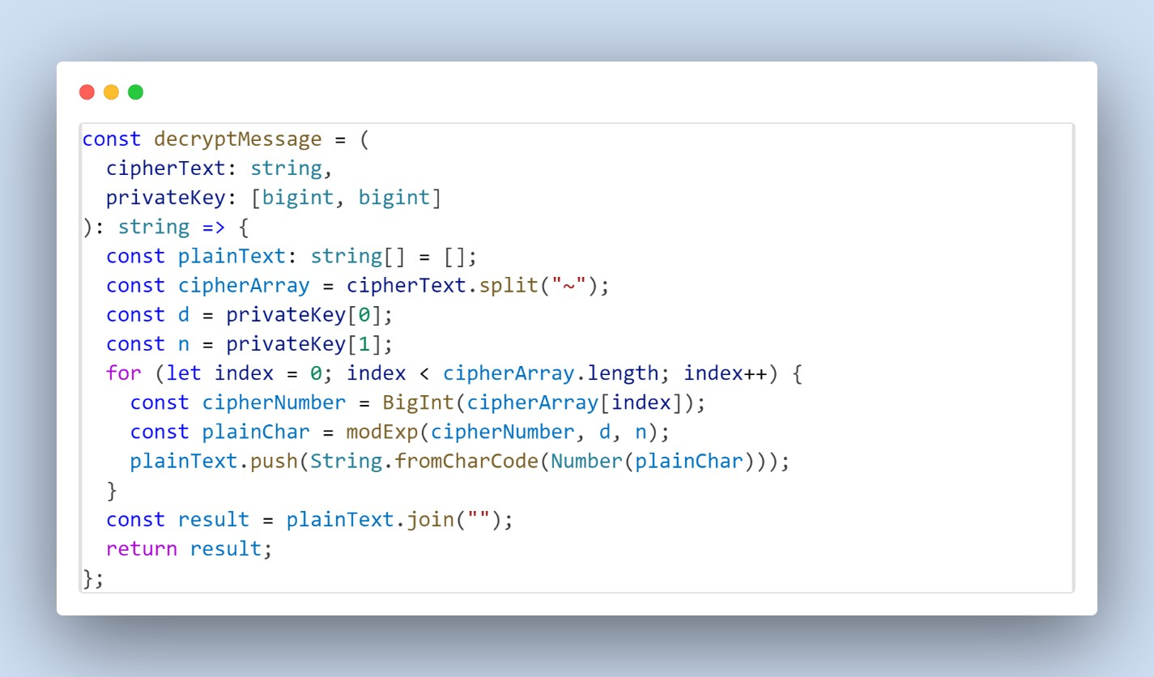
Tracing:
- Ciphertext: “3000~1313~745~745~2183~32~1687~2183~1140~745~100”
- Decrypted ASCII values: 72, 101, 108, 108, 111, 32, 119, 111, 114, 108, 100
- Decrypted Message: "Hello world”

5.2 Testing

5.2.1 Unit Testing

Table 5.1 User Login/Signup
ID | Description | Input Data | Expected Result | Actual Result | Pass/Fail
1.1 | Signup with invalid email | Name:Abishek Pandeya  Email: abin@.com  Password: Pass@123 | Signup should fail with an error message: "Invalid email address." | Shows  error message and fails the signup. | Pass
1.2 | Signup with valid data | Name:Abishek Pandeya  Email: abin@gmail.com Password: Pass@123 | User should be successfully registered in the system. | Signup success | Pass
1.3 | Login with incorrect password | Email:  abin@gmail.com  Password: Pass@ | Login should fail with an error message: "Invalid credentials." | Login failed | Pass
1.4 | Login with correct credentials | Email:  abin@gmail.com Password: Pass@123 | User should be successfully logged in and redirected to the homepage. | Login Success and redirected to  homepage | Pass

Table 5.2 Bad Word Filter
ID | Description | Input Data | Expected Result | Actual Result | Pass/Fail
2.1 | Send message without bad words | Message: "Hello, how are you?" | Message should be sent without any modifications. | Message: "Hello, how are you?" | Pass
2.2 | Send message with one bad word | Message: "You are a  fool!" | Message should be sent as: "You are a ****!" | Message: "You are a  fool!" | Fail
2.3 | Send message with multiple bad words | Message: "This is a bad and  stupid app!" | Message should be sent as: "This is a ***  and *** app!" | Message:  "This is a *** and *** app!" | Pass
2.4 | Send empty message | Message: "" | Message should not be sent, and an error message should display: "Message cannot be empty." | Did not allow empty message to empty. | Pass
2.5 | Send message with only bad words | Message:  "Idiot, dumb,  stupid!" | Message should be sent as: "***, ***, ***!" | Message: "***, ***,  stupid!" | Fail

Table 5.3 RSA Encryption in Chat
ID | Description | Input Data | Expected Result | Actual Result | Pass/Fail
3.1 | Encrypt and decrypt message | Message: "Hello, secure chat!" | The encrypted message should be successfully decrypted to its original form. | Message: "Hello, secure chat!" | Pass
3.2 | Send encrypted message over  Socket.IO | Message:  "RSA is  working!" | The message should be encrypted, sent via  Socket.IO, and decrypted on the receiver's end to match the original message. | Message:  "RSA is  working!" | Pass

Table 5.4 Socket.IO Connection
ID | Description | Input Data | Expected Result | Actual Result | Pass/Fail
4.1 | Establish socket connection | - | A connection should be successfully established with the server. | Connection Stablished | Pass
4.2 | Receive realtime messages | Sender sends: "Hi there!" | The receiver should immediately receive the message: "Hi  there!" | Receiver receives: "Hi  there!" | Pass

5.2.2 System Testing
Table 5.5 User Registration and Login
Test Case ID | Scenario | Steps | Expected Result
ST-01 | User  Registration with valid data | 1. Open the app. 2. Go to the "Sign Up" page.  - Enter valid details: Name, Email, Password and Confirm Password.  - Submit the form. | User should be successfully registered and redirected to the login page.
ST-02 | User  Registration with invalid email | 1. Open the app. 2. Go to the "Sign Up" page.  - Enter valid Name, and Password, but an invalid email.  - Submit the form. | An error message should display: "Invalid email address."
ST-03 | User Login with valid credentials | 1. Open the app. 2. Go to the "Login" page.  - Enter a registered email and password.  - Submit the form. | User should be successfully logged in and redirected to the dashboard if verified else go to opt verification page.
ST-04 | User Login with invalid credentials | 1. Open the app. 2. Go to the "Login" page.  - Enter an unregistered email or incorrect password.  - Submit the form. | An error message should display: "Invalid credentials."

Table 5.6 Chat Functionality
Test Case ID | Scenario | Steps | Expected Result
ST-05 | Send a valid  message | 1. Log in to the app. 2. Navigate to a chat window.  - Enter a valid message: "Hello!".  - Click "Send". | The message should be sent and appear in the chat window.
ST-06 | Send a message with bad words | 1. Log in to the app. 2. Navigate to a chat window.  - Enter a message: "You are a fool!".  - Click "Send". | The message should appear in the chat window with bad words replaced: "You are a ***!".
ST-07 | Receive a realtime message | 1. Open a chat window with another user. 2. Have the other user send a message:  "Hi there!". | The message "Hi there!" should immediately appear in the chat window.
ST-08 | Online indicator functionality | - Open a chat window.  - Observe the other user's chat window. | The other user should see a online indicator in real-time.

Table 5.7 RSA Encryption and Decryption
Test Case ID | Scenario | Steps | Expected Result
ST-09 | Encrypt and decrypt message | - Log in and navigate to a chat window.  - Send a message: "Hello!". | The message should be encrypted before transmission and decrypted on the receiver’s end.

Table 5.8 Socket.IO Connection
Test Case ID | Scenario |  | Steps | Expected Result
ST-10 | Establish socket connection | a | 1. Open the app. 2. Log in with valid credentials.  3. Check the console or logs for a successful Socket.IO connection. | A socket connection should be successfully established.
ST-11 | Reconnect after disconnect |  | 1. Open the app. 2. Log in with valid credentials.  - Simulate a network disconnect.  - Restore the network connection. | The app should automatically reconnect to the server.
ST-12 | Handle a serverside socket event |  | 1. Log in to the app. 2. Trigger a server event, such as receiving a new message.  3. Observe the client-side response. | The client should handle the event and display the new message.

Table 5.9 System Non-Functional Testing
Test Case ID | Scenario | Steps | Expected Result
ST-13 | Light and dark mode functionality | 1. Navigate to menu. 2. Toggle between light and dark mode.  3. Check the UI for consistency in both modes. | The UI should update correctly based on the selected mode.

Chapter 6: Conclusion and Future Recommendations

6.1 Conclusion
ChatterWave successfully addresses the critical challenges of real-time communication and data security by integrating advanced technologies like Socket.IO for seamless, low-latency messaging and RSA encryption for robust end-to-end security. By incorporating features such as toxic word filtering and friend request management, the platform ensures a safe, user-friendly environment that fosters meaningful connections. Leveraging a modern tech stack, including React.js, Redux Toolkit, Node.js, and Prisma, ChatterWave delivers a scalable, high-performing application tailored to meet the needs of today’s users. This project not only emphasizes secure and efficient communication but also sets a strong foundation for future enhancements, establishing ChatterWave as a reliable and innovative real-time chat solution.

6.2 Future Recommendations
To improve the functionality and overall user experience of ChatterWave, several enhancements are recommended to address current limitations and expand its capabilities. The following future recommendations are proposed to make the platform more versatile, accessible, and feature-rich for a broader audience:
- Support for Media Files: Enable the sharing of images, audio, and video files to enrich conversations and improve user engagement.
- Mobile Application Development: Create a dedicated mobile app to extend accessibility and convenience for users on the go.
- Support for Long-Form Text: Enable users to send extended text messages, accommodating scenarios that require more detailed and comprehensive communications.
- Phone Number-Based OTP Verification: Implement OTP verification via phone numbers to provide users with more versatile and secure authentication option.
- Admin Dashboard: Develop an admin dashboard to monitor and analyze user activity, system performance, and overall application health.
- Integration with External Websites: Enable ChatterWave’s chat system to be embedded into external websites, expanding its utility and reach across various platforms.

REFERENCES

- Kathmandu Post, "Vianet suffers data breach, leaking personal customer details online," 8 April 2020. [Online]. Available: https://atlastek.com.np/news/view/5.
- "Vector Stock," [Online]. Available: https://www.vectorstock.com/royalty-freevector/agile-lifecycle-development-process-diagram-vector-31188796.
- B. Schneier, "Comprehensive exploration of cryptographic protocols and algorithms, including RSA.," in Bruce Schneier, New York, 1996.
- M. A. D. Laura T. Brown, "Enhancing Real-Time Messaging Applications Using WebSocket and Socket.io," Journal of Web Engineering and Technology, 2024.
- E. R. J. John D. Smith, "Secure and Efficient End-to-End Encrypted Messaging Framework for Real-Time Communication," IEEE Transactions on Information Forensics and Security, 2023.
- H. Bodur, "ResearchGate," [Online]. Available: https://www.researchgate.net/figure/RSA-algorithm-structure_fig2_298298027.

Appendix
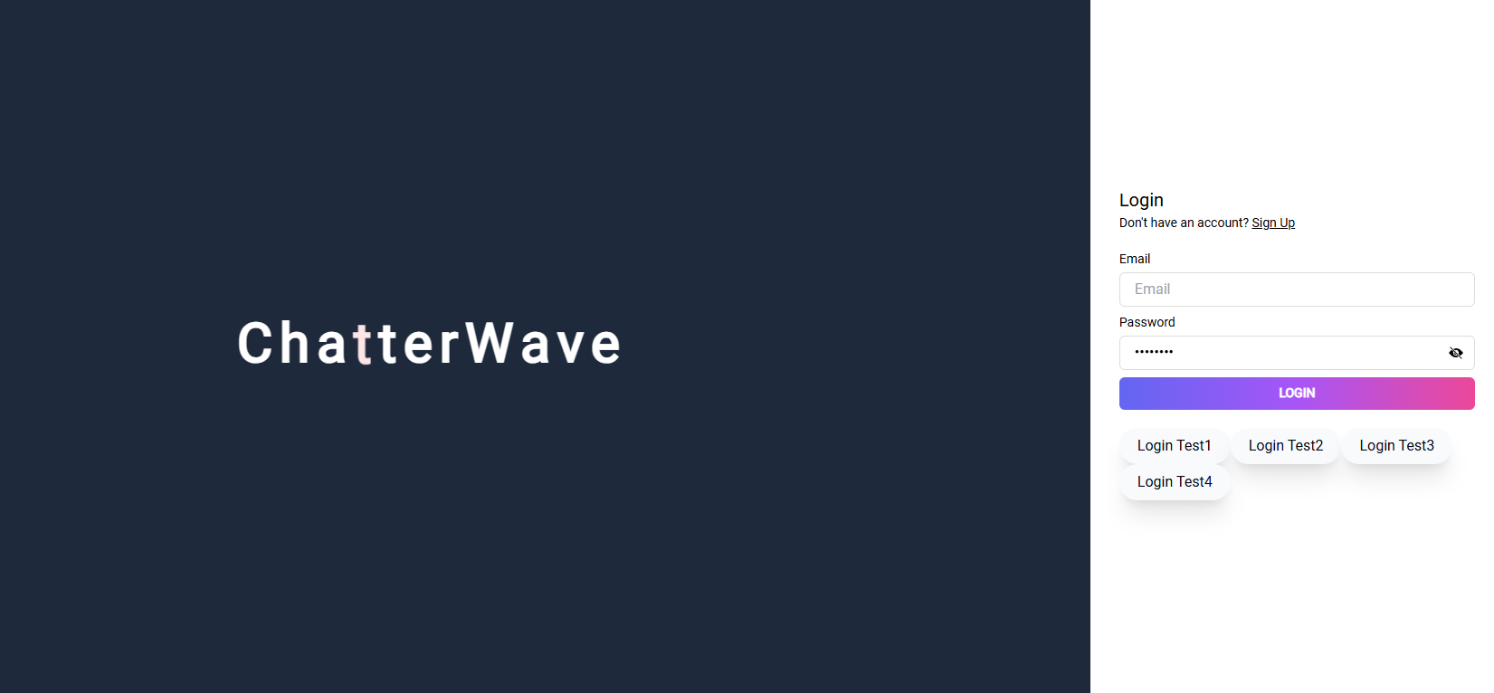
Login Page

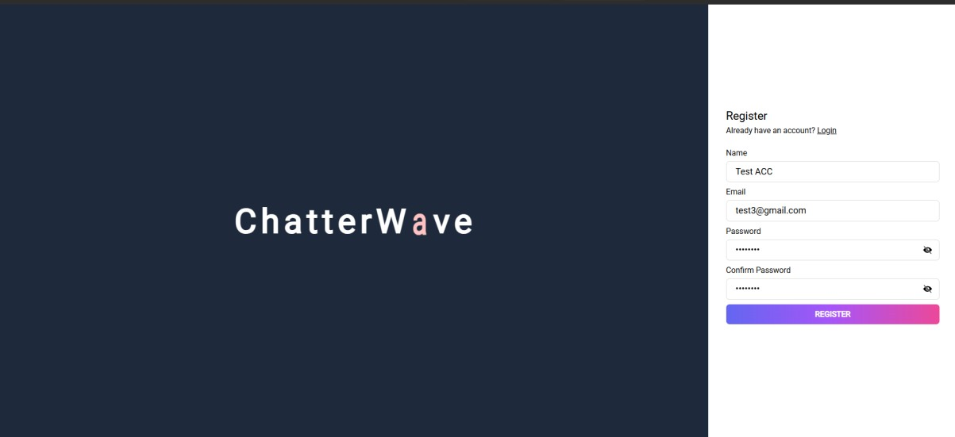
Sign up Page

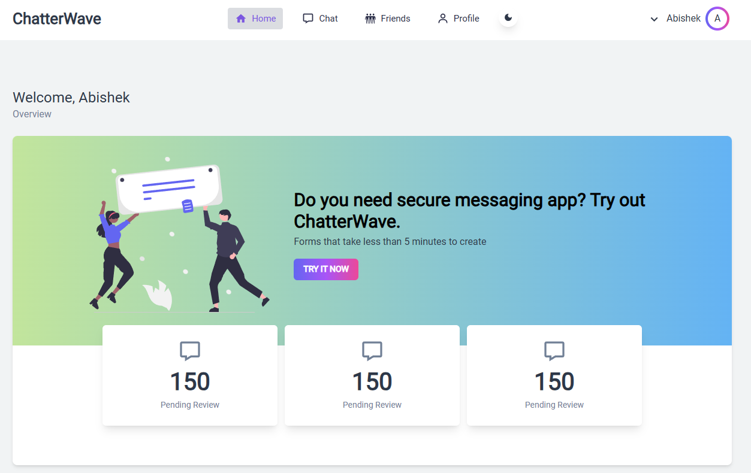
Home Screen in Light Mode

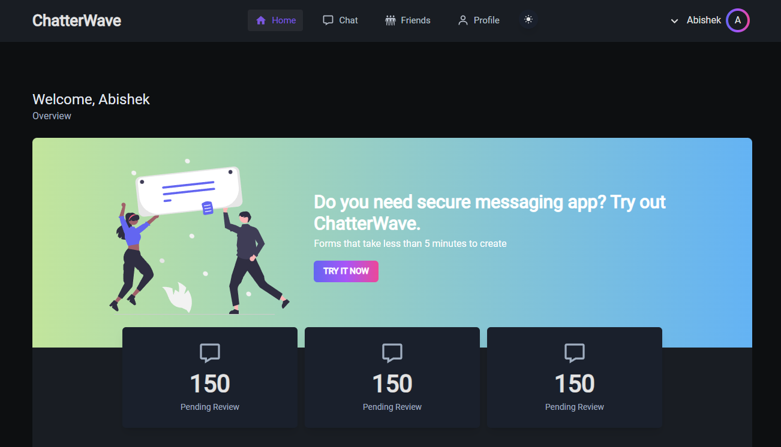
Home Screen in Dark Mode

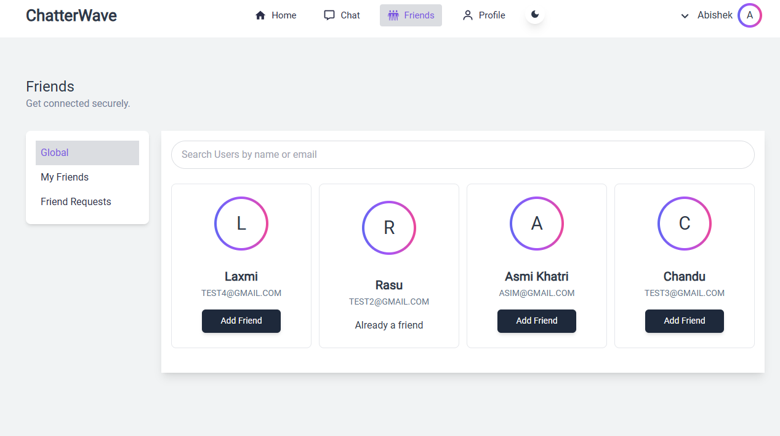
All Verified Users of App

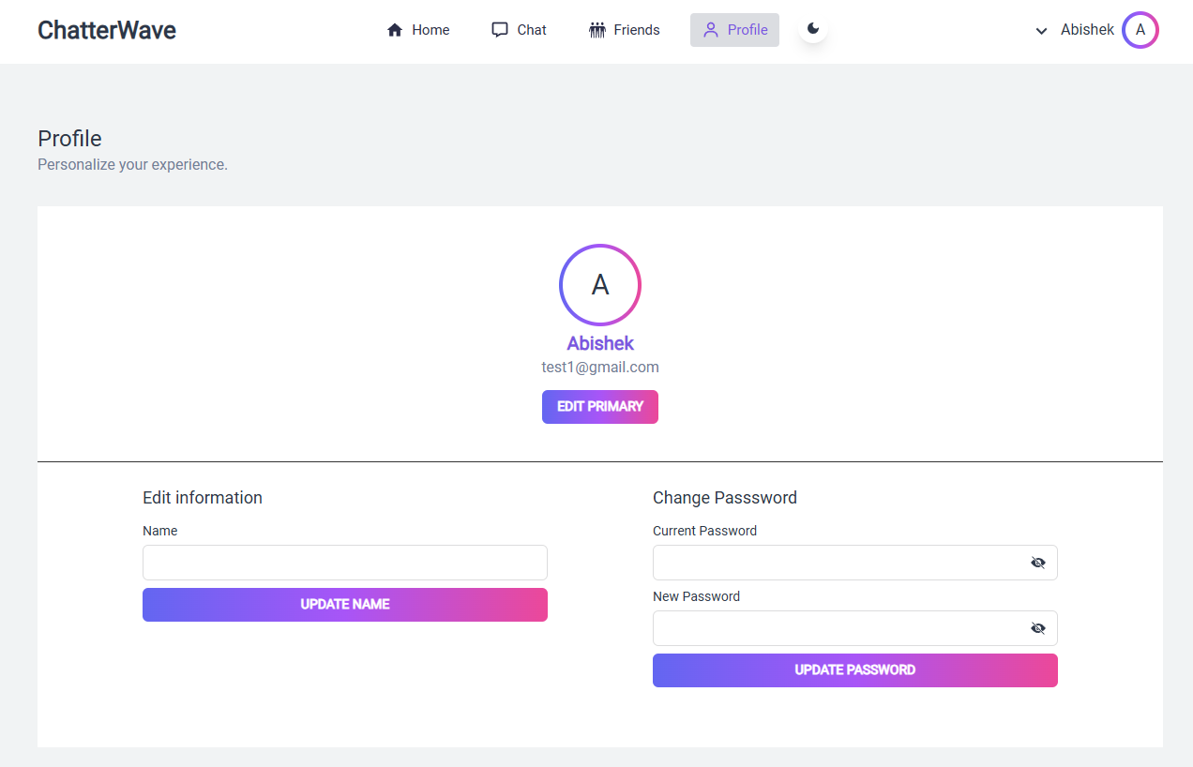
User Profile Page

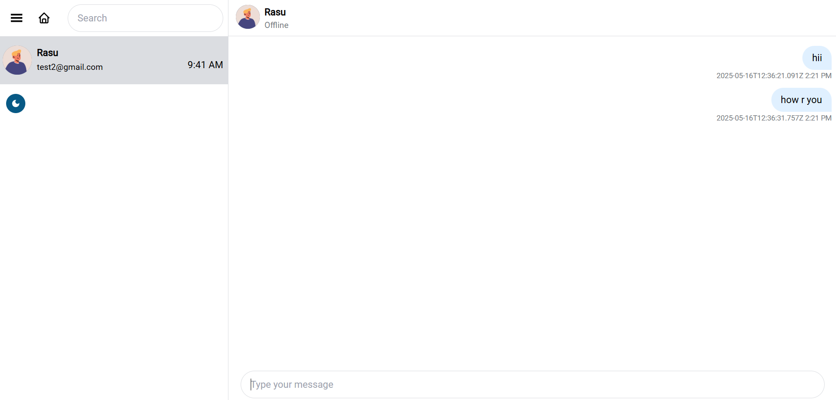
Friends Chat window

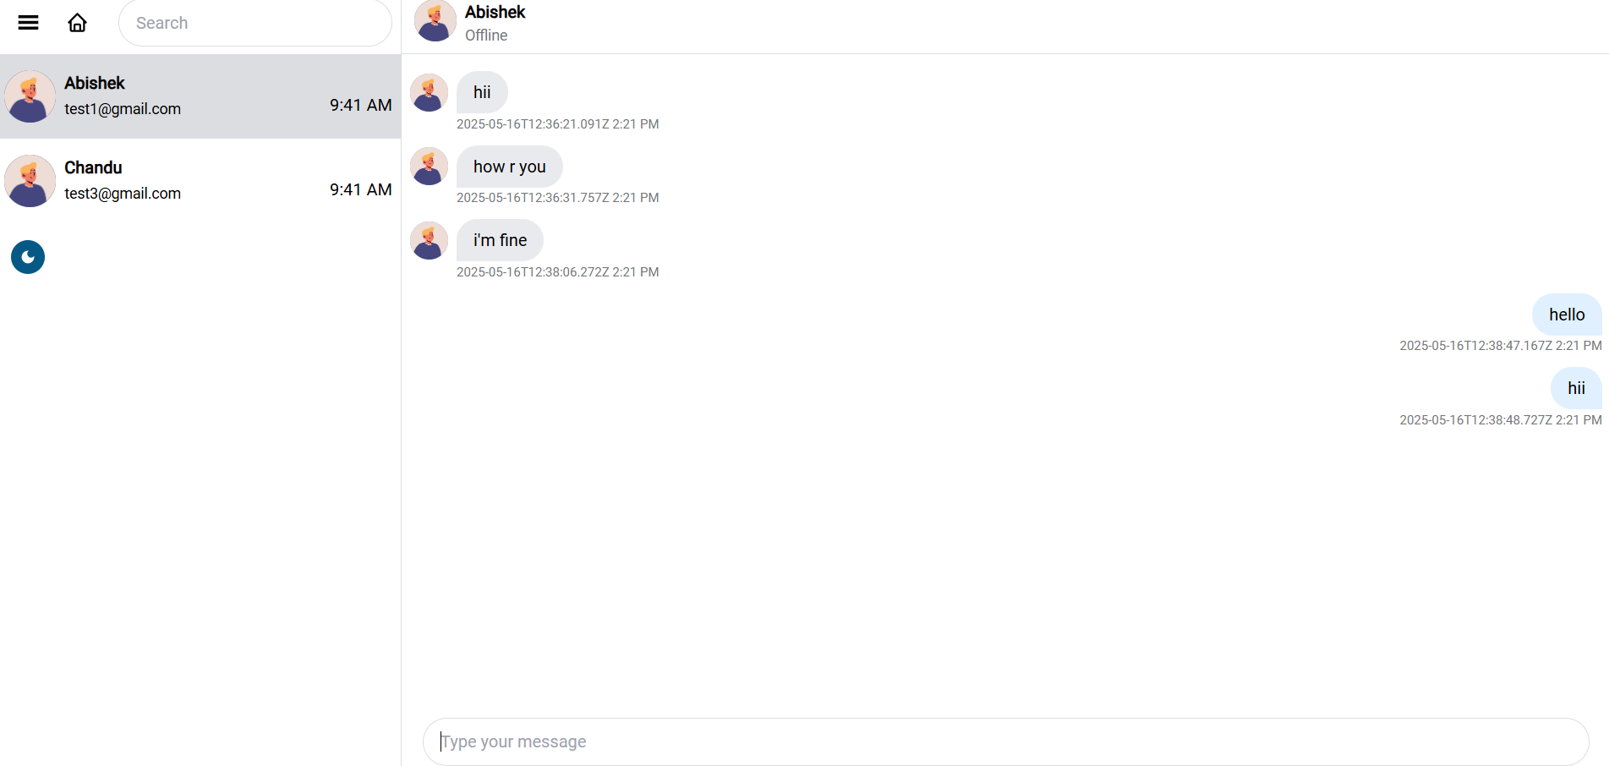
Chat Window with Explicit Word Filtering

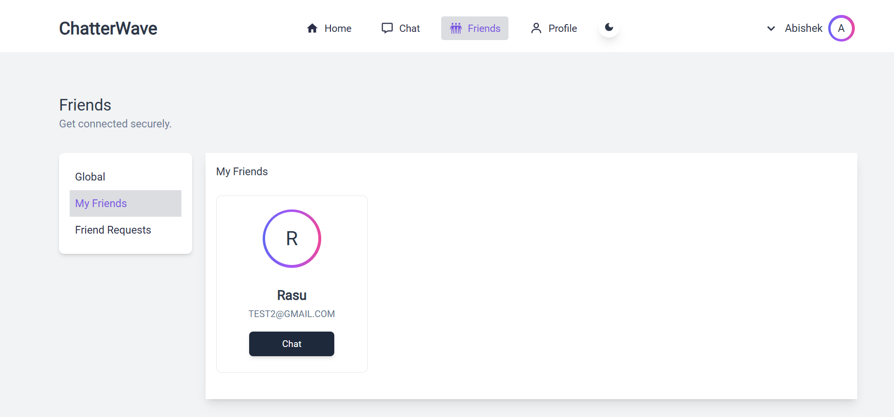
User Friend Page

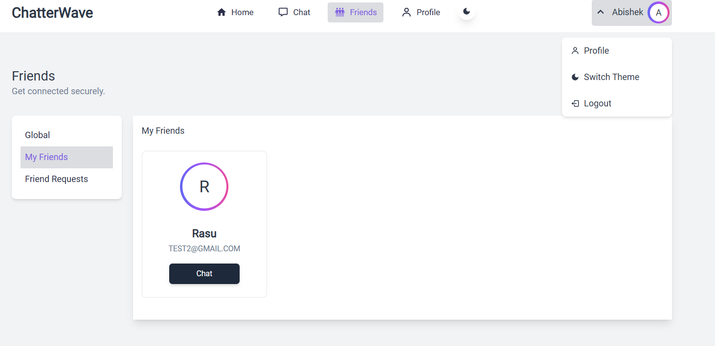
User Menu Items

