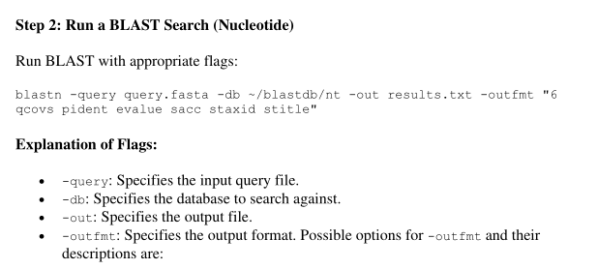
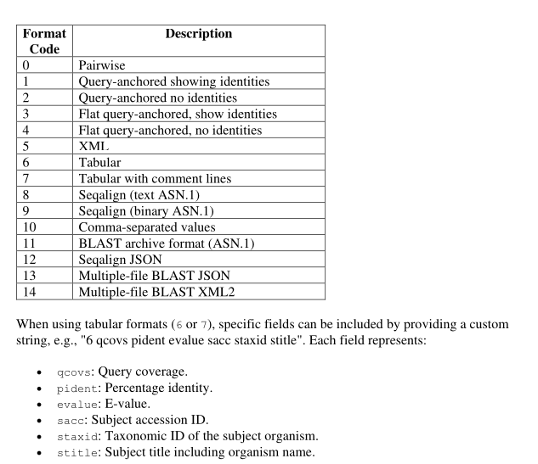
Filtering BLAST Output

Step 1: Filter Based on Sequence Identity
Use awk or a similar tool to extract matches with a sequence identity threshold (e.g., 90%):
awk '$2 >= 90' results.txt > filtered_results.txt

Step 2: Filter Based on Organism Name
Use grep to filter matches from a specific organism (e.g., Homo sapiens):
grep "Homo sapiens" results.txt > filtered_human_results.txt

Step 2: Use BLAST Against Online Databases
Run the following command:
blastn -query query.fasta -db nt -remote -out results_online.txt -outfmt "6
qcovs pident evalue sacc staxid stitle”

Here’s a breakdown of your questions with detailed explanations:
- How does the E-value relate to the quality of a match? What do lower E-values indicate?
  - The E-value (Expectation value) represents the number of hits one would expect to see by chance in a database search. It accounts for the size of the database and the length of the query sequence.
  - Lower E-values indicate higher confidence in the match. A very low E-value (close to zero) suggests that the alignment is highly significant and unlikely to have occurred by chance.
- Compare the query coverage and percentage identity values. What do they tell you about the alignment?
  - Query coverage refers to the proportion of the query sequence that is aligned to the subject sequence. Higher coverage means that a larger portion of the sequence is included in the alignment.
  - Percentage identity measures how similar the aligned regions are, based on the number of identical residues/nucleotides. A high percentage identity indicates a close evolutionary or functional relationship.
  - Together, these values help assess alignment quality:
    - High query coverage + high identity → strong match, likely homologous.
    - High coverage + low identity → possibly a distantly related homolog.
    - Low coverage + high identity → a small conserved region but not necessarily a strong overall match.
- How do the results from the local database search differ from those obtained using the online database?
  - A local database search is limited to a specific dataset, meaning it may return fewer results but be more tailored to the research focus.
  - An online database search (e.g., NCBI BLAST) searches a much larger and frequently updated dataset, potentially finding more diverse homologs but also increasing noise (more low-confidence hits).
  - Differences may arise due to:
    - Database size and diversity
    - Update frequency (online databases are updated regularly)
    - Computational resources (local searches may be faster but less comprehensive)
- What might cause differences in the output when searching different databases?
  - Database composition: Some databases focus on specific organisms (e.g., RefSeq for curated sequences, nr for non-redundant proteins).
  - Sequence curation: Some databases contain raw, unverified sequences, while others include only curated or annotated entries.
  - Taxonomic diversity: Different databases emphasize different groups (e.g., microbial genomes vs. vertebrate genomes).
  - Algorithm differences: Some databases use different scoring matrices, filtering parameters, or heuristics.
- What insights can you gain about the biological significance of hits based on organism names?
  - Identifying the source organism helps infer evolutionary relationships and functional conservation.
  - If hits come from closely related species, it suggests functional conservation.
  - If hits are found across diverse taxa, it may indicate a highly conserved and functionally important sequence (e.g., housekeeping genes).
  - Hits in pathogens or model organisms may provide insights for medical or biotechnological applications.
- Why might filtering based on sequence identity or organism name be useful for specific research questions?
  - For evolutionary studies, filtering by high identity helps focus on close homologs, while lower identity may indicate distant relationships.
  - For functional genomics, selecting specific taxa can refine searches to relevant model organisms or pathogens.
  - For metagenomic studies, filtering helps exclude contaminants or non-target species.
  - For biomedical applications, filtering ensures hits are from clinically relevant organisms.
Would you like any of these points expanded with examples?
grep -c "^>" Ecoli.faa how many sequences are present in file counts number of occurences

Look for Tfs grep -i "transcription factor" Ecoli.faa makes search case insensitive

makeblastdb -in Ecoli.faa -dbtype prot -out ECDB to make databases

If you want to get only one top hit in the target database for each query protein, modify the
command as:
>blastp -db ECDB -query StaphAur.faa -evalue 1e-04 -outfmt 6 -max_target_seqs 1 -out SProt-to-ECDB_Max1

top 10 hits: head -10 blast.out

BlastN: Blast genome with genome
>makeblastdb -in Ecoli.fna -dbtype nucl -out ECDB

>psiblast -query HBB.fasta -db HP -num_iterations=1 -evalue=0.01 -out HBB-to-HP_psiblast-1 -out_pssm=PSSM1
>psiblast -query HBB.fasta -db HP -num_iterations=2 -evalue=0.01 -out HBB-to-HP_psiblast-2 -out_pssm=PSSM2
>psiblast -query HBB.fasta -db HP -num_iterations=3 -evalue=0.01 -out HBB-to-HP_psiblast-3 -out_pssm=PSSM3
>psiblast -query HBB.fasta -db HP -num_iterations=4 -evalue=0.01 -out HBB-to-HP_psiblast-4 -out_pssm=PSSM4

BLAST outfmt 6 Column Format
In BLAST (Basic Local Alignment Search Tool), the tabular output format (outfmt 6) provides structured, easy-to-parse results.
It contains 12 default columns, but can be customized with additional fields.

Default Columns in outfmt 6
When running BLAST with:
blastn -query input.fasta -db nt -out results.txt -outfmt 6
The output contains the following 12 columns:
Column # | Description
1 | Query ID (Sequence name from input)
2 | Subject ID (Matched sequence ID from database)
3 | % Identity (Similarity between query and subject)
4 | Alignment Length (Total aligned bases/amino acids)
5 | Mismatches (Number of differing positions)
6 | Gap Openings (Number of gaps introduced)
7 | Query Start (Start position of alignment in query)
8 | Query End (End position of alignment in query)
9 | Subject Start (Start position in subject sequence)
10 | Subject End (End position in subject sequence)
11 | E-value (Statistical significance of the match)
12 | Bit Score (Alignment score; higher is better)

Example BLAST outfmt 6 Output
query1 subject1 98.5 250 3 0 1 250 5 254 1e-50 200
query1 subject2 95.3 230 5 1 10 239 50 279 2e-45 180
query2 subject3 92.7 300 8 2 5 304 20 319 5e-40 175
🔹 Each row represents one alignment hit.

Customizing BLAST outfmt 6
BLAST allows you to add extra fields using a customized format string:
blastn -query input.fasta -db nt -out results.txt -outfmt "6 qseqid sseqid pident length qstart qend sstart send evalue bitscore staxids sscinames scomnames"

Additional Columns You Can Use
Field Name | Description
qseqid | Query sequence ID
sseqid | Subject sequence ID
pident | % Identity
length | Alignment length
qstart, qend | Query start and end position
sstart, send | Subject start and end position
evalue | Expect value
bitscore | Bit score
staxids | Subject Taxonomy ID
sscinames | Scientific name of subject
scomnames | Common name of subject
sstrand | Strand of subject sequence

Parsing outfmt 6 with awk or cut

1. Extract Best Hit (Top Bit Score)
sort -k12,12nr results.txt | head -n 1
🔹 Sorts results by bit score (column 12) in descending order.

2. Extract Query and % Identity
awk '{print $1, $3}' results.txt
🔹 Extracts query ID and % identity.

3. Get Top 5 Hits Per Query
awk '!seen[$1]++ && ++count[$1]<=5' results.txt
🔹 Keeps only the first 5 hits per query.

Conclusion
✅ outfmt 6 is a compact, tabular format ideal for further analysis.
✅ It contains 12 default columns, but can be customized.
✅ Easy to process with awk, cut, sort, and Python.
Would you like help with parsing or visualizing BLAST results? 🚀

