makeblastdb -in HSA_Proteins.fasta -dbtype prot -out HSA_DB

blastp -query ThiQ.fasta -db HSA_DB -out blast.out -outfmt 6 -evalue 1e-04

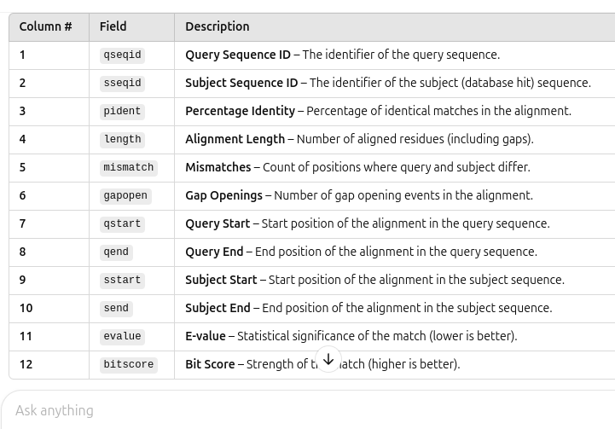

awk '{print $2}' results.txt | sort | uniq -c | awk '$1 > 1'

awk '{print $2}' results.txt | sort | uniq -c | awk '$1 > 1' | wc -l

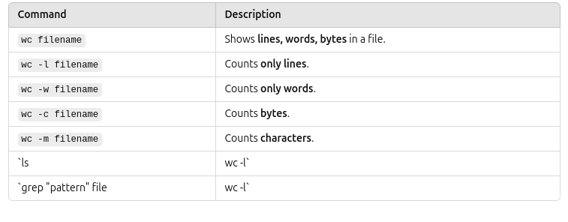
awk '{print $2}' blast.out | sort | uniq -c | awk '$1>1' > output.txt

psiblast -query SRY.fasta -db HSA_DB -num_iterations 3 -evalue 1e-04 -outfmt 6 -out pssm3.out -comp_based_stats 0

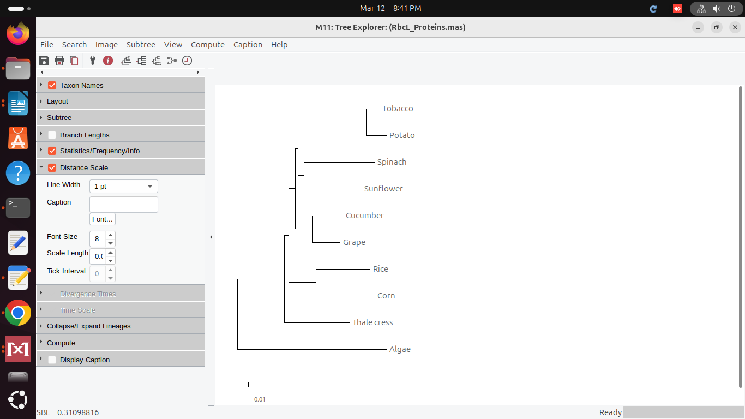
Your phylogenetic tree constructed using the Neighbor-Joining method and p-distance model in MEGA suggests evolutionary relationships among the RbcL protein sequences from different plant species.

Inference from the Tree:
- Algae is the outgroup
  - Algae is placed at the base of the tree, indicating it is the most distantly related organism compared to the other land plants.
  - This supports the idea that land plants evolved from an algal ancestor.
- Grouping of Monocots and Dicots
  - Rice and Corn are closely related, suggesting they share a common monocot ancestor.
  - Tobacco, Potato, Spinach, Sunflower, Cucumber, and Grape are grouped together, representing dicots.
- Closer relationships
  - Tobacco and Potato form a close clade, likely due to their shared Solanaceae family.
  - Spinach and Sunflower are more closely related to each other than to other species.
  - Cucumber and Grape form another subgroup, possibly indicating some evolutionary similarity.
- Thale Cress (Arabidopsis) as an Intermediate
  - Arabidopsis (Thale cress) appears to be diverging earlier from other dicots, which aligns with its evolutionary placement as a model plant.

Overall Conclusion:
- The tree correctly reflects plant evolutionary history, with monocots and dicots forming separate branches.
- The relationships among species are consistent with their taxonomic classifications and evolutionary divergence.
Would you like any additional insights or modifications to the tree? 😊
wget "https://rest.uniprot.org/uniprotkb/Q9NP78.fasta" -O Q9NP78.fasta

psiblast -query SRY.fasta -db swissprot -num_iterations 3 -out q7.out -outfmt 6

filter.sh

awk '$3 >= 60 && $3 < 70 {print $0}' SRY_psiblast.out | head -n 5 > SRY_60_69.txt
awk '$3 >= 70 && $3 < 80 {print $0}' SRY_psiblast.out | head -n 5 > SRY_70_79.txt
awk '$3 >= 80 && $3 < 90 {print $0}' SRY_psiblast.out | head -n 5 > SRY_80_89.txt
awk '$3 >= 90 && $3 <= 100 {print $0}' SRY_psiblast.out | head -n 5 > SRY_90_100.txt

awk '$3 >= 60 && $3 < 70 {print $0}' SRY_psiblast.out'
- $3 represents % identity.
- Filters rows where % identity is between 60 and 69.
- Prints the entire line ($0) when the condition is met.
- | head -n 5
- Limits output to first 5 matches.
- > SRY_60_69.txt
- Saves results to SRY_60_69.txt.
Download.sh
for id in `cut -c11-18 forMSA.out`
do
wget https://rest.uniprot.org/uniprotkb/$id.fasta
done
once all seqs are downloaded make sure only the downloaded seqs are in folder and not others after that give this command: cat *fasta > seq.fasta
tblastn -query seq.fasta -db nt -remote -evalue 1e-04 -outfmt 6 -out tblastn_results.txt
awk '{print $2}' tblastn_results.txt | sort | uniq > dna_ids.txt

