Part C – Core Java

- Transaction validation: an amount above 0 is VALID; an amount of 0 or less is INVALID. Read transaction ID and amount with Scanner and print the result.
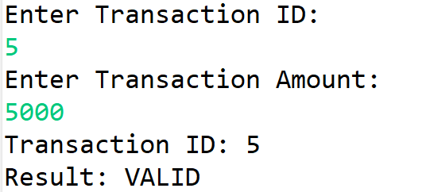

- Create validateTransaction(double amount) and return VALID or INVALID. Call the method from your program.

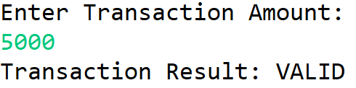

- Write 5000, -2500, 8000 and 0 to transaction.txt. Read them with Scanner and print the validation result for each value.
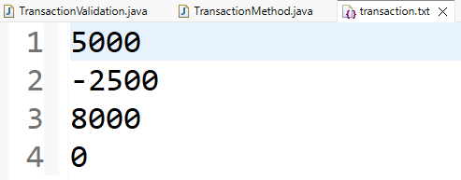
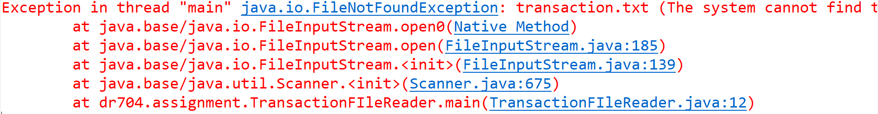

- Create transactions.csv with a transaction_id,amount header and at least three records. Read each record and print the ID with VALID or INVALID.
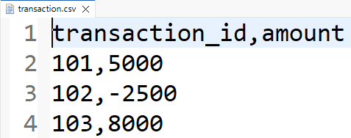

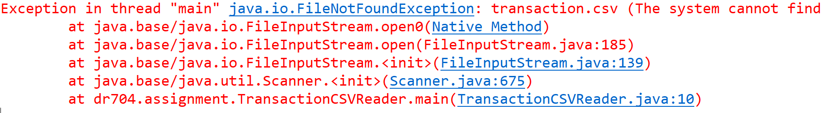

Core Java

- Array
- Store five numbers in an array and print them.
- Find the largest number in the array.

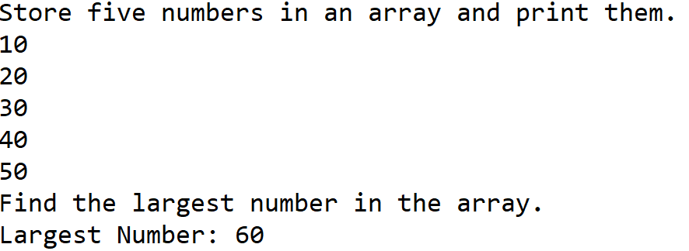
- String
- Print the length of a full name.
- Check whether a string contains Java

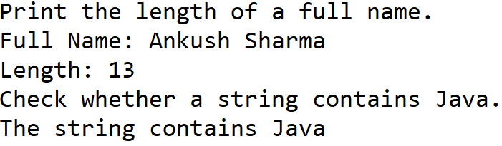

- ArrayList
- Add and print five students’ name.
- Remove one name and print the updated list.

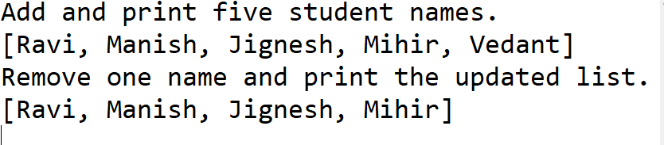

- HashSet
- Add and print five cities.
- Add a duplicate city and print the set again.

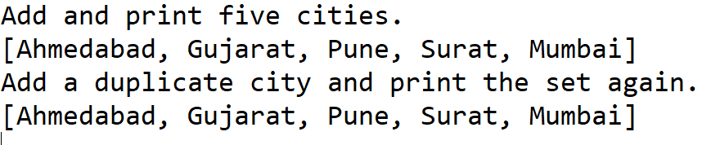

- HashMap
- Store five student IDs with names.
- Look up and print the name for a given ID.

