PART A – SQL Employee Management System

- Create both tables and insert the required records.
// DEPARTMENTS TABLE AND RECORDS
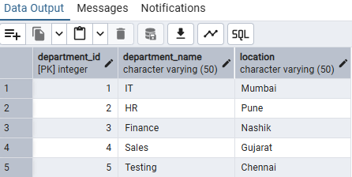

// EMPLOYEES TABLE AND RECORDS

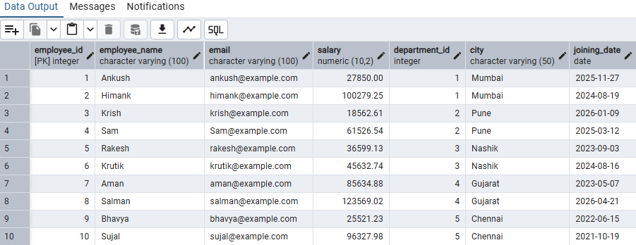

- Display all employees ; then display only employee names and salaries

// DISPLAY ALL EMPLOYEES

// DISPLAY ONLY EMPLOYEE NAMES AND SALARIES

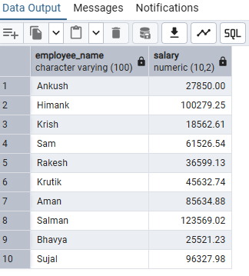

- Find salaries above 50000; employees in Mumbai; salaries between 30,000 and 70,000; employees in Mumbai or Pune

// FIND SALARIES ABOVE 50000

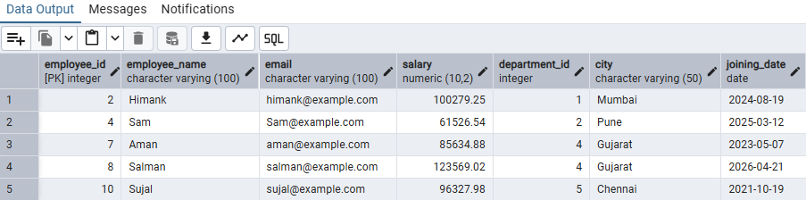

// EMPLOYEES IN MUMBAI

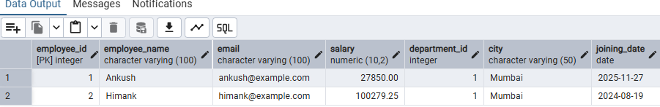

// SALARIES BETWEEN 30000 AND 70000

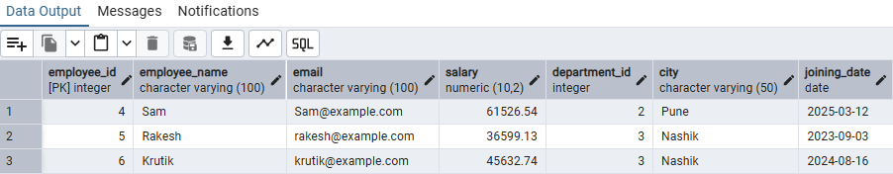

// EMPLOYEES IN MUMBAI OR PUNE

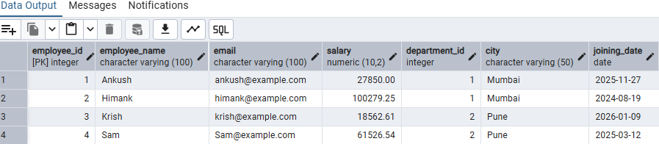

- Display distinct cities; update one salary; delete one employee; sort employees by salary from highest to lowest.

// DISPLAY DISTINCT CITIES

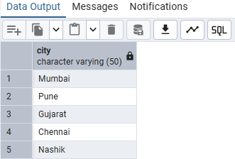

// UPDATE ONE SALARY

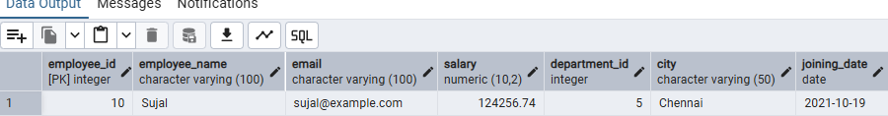

// DELETE ONE EMPLOYEE

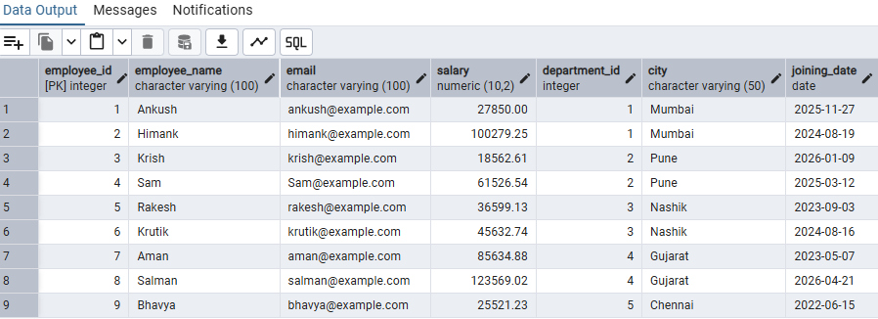

// SORT EMPLOYEES BY SALARY FROM HIGHEST TO LOWEST

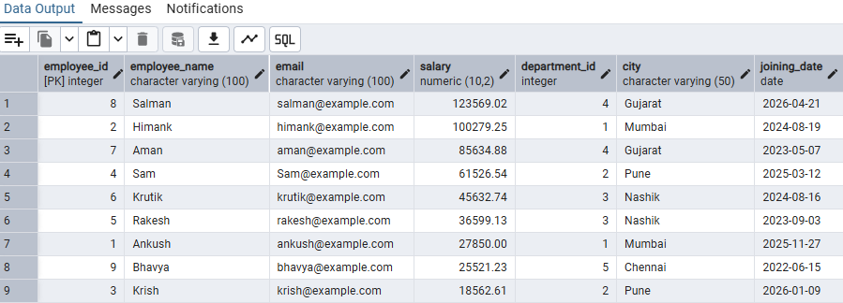

- Count employees by department; show departments having more than two employees.

// COUNT EMPLOYEES BY DEPARTMENT

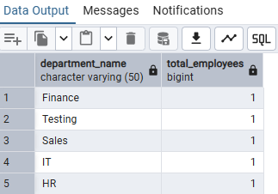

// SHOW DEPARTMENTS HAVING MORE THAN TWO EMPLOYEE

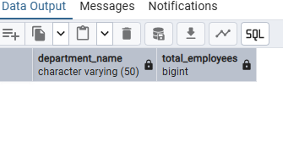

- Find the total, average, minimum, and maximum salary.

// FIND THE TOTAL

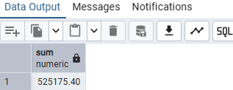

// FIND THE AVERAGE

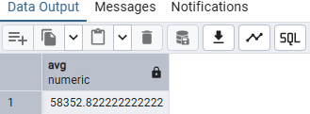

// FIND THE MINIMUM

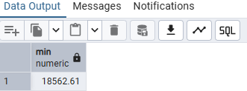

// FIND THE MAXIMUM

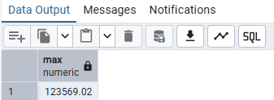

- Use INNER JOIN to show employee name, salary and department; use LEFT JOIN to show all departments and matching employees.

// USE INNER JOIN TO SHOW EMPLOYEE NAME, SALARY AND DEPARTMENT

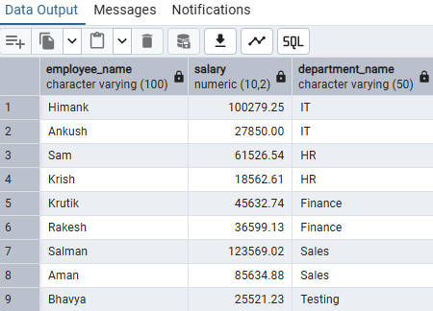

// USE LEFT JOIN TO SHOW ALL DEPARTMENTS AND MATCHING EMPLOYEES

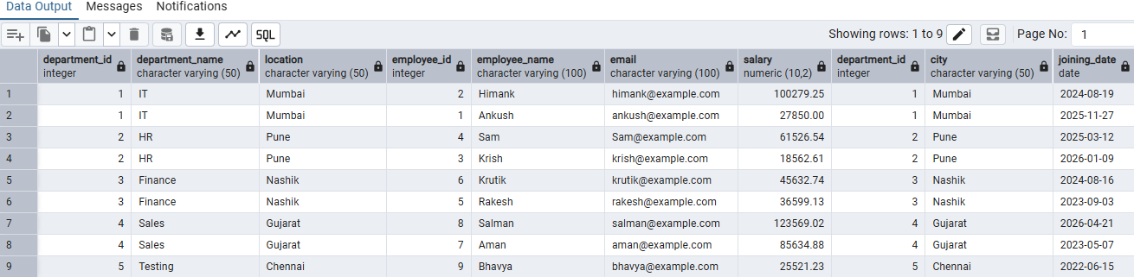

- Demonstrate COMMIT, ROLLBACK and SAVEPOINT using suitable statements.

// DEMONSTRATE COMMIT, ROLL BACK AND SAVEPOINT

