PRACTICAL 10
Automation Testing and Regression Analysis
SauceDemo / Swag Labs – Screenshot Evidence
Application Under Test | SauceDemo / Swag Labs
Testing Focus | Automation Testing and Regression Testing
Automation Tool | Selenium WebDriver with Python
Evidence Provided | 7 screenshots captured during practical execution

Aim
To identify suitable modules for automation testing and perform regression-oriented testing on the SauceDemo / Swag Labs application using Selenium WebDriver with Python.

Screenshot Evidence Mapping
Screenshot | Activity | Evidence
10.1 | Login page | Application available and login controls visible
10.2 | Credentials | Standard test username entered
10.3 | Automation execution | Selenium script and execution console visible
10.4 | Inventory | Products page opened successfully
10.5 | Shopping Cart | Selected product visible in cart
10.6 | Checkout | Checkout information form displayed
10.7 | Checkout data | Test information entered in checkout form

Captured Screenshots with Suitable Captions

Figure 10.1: Swag Labs Login Page
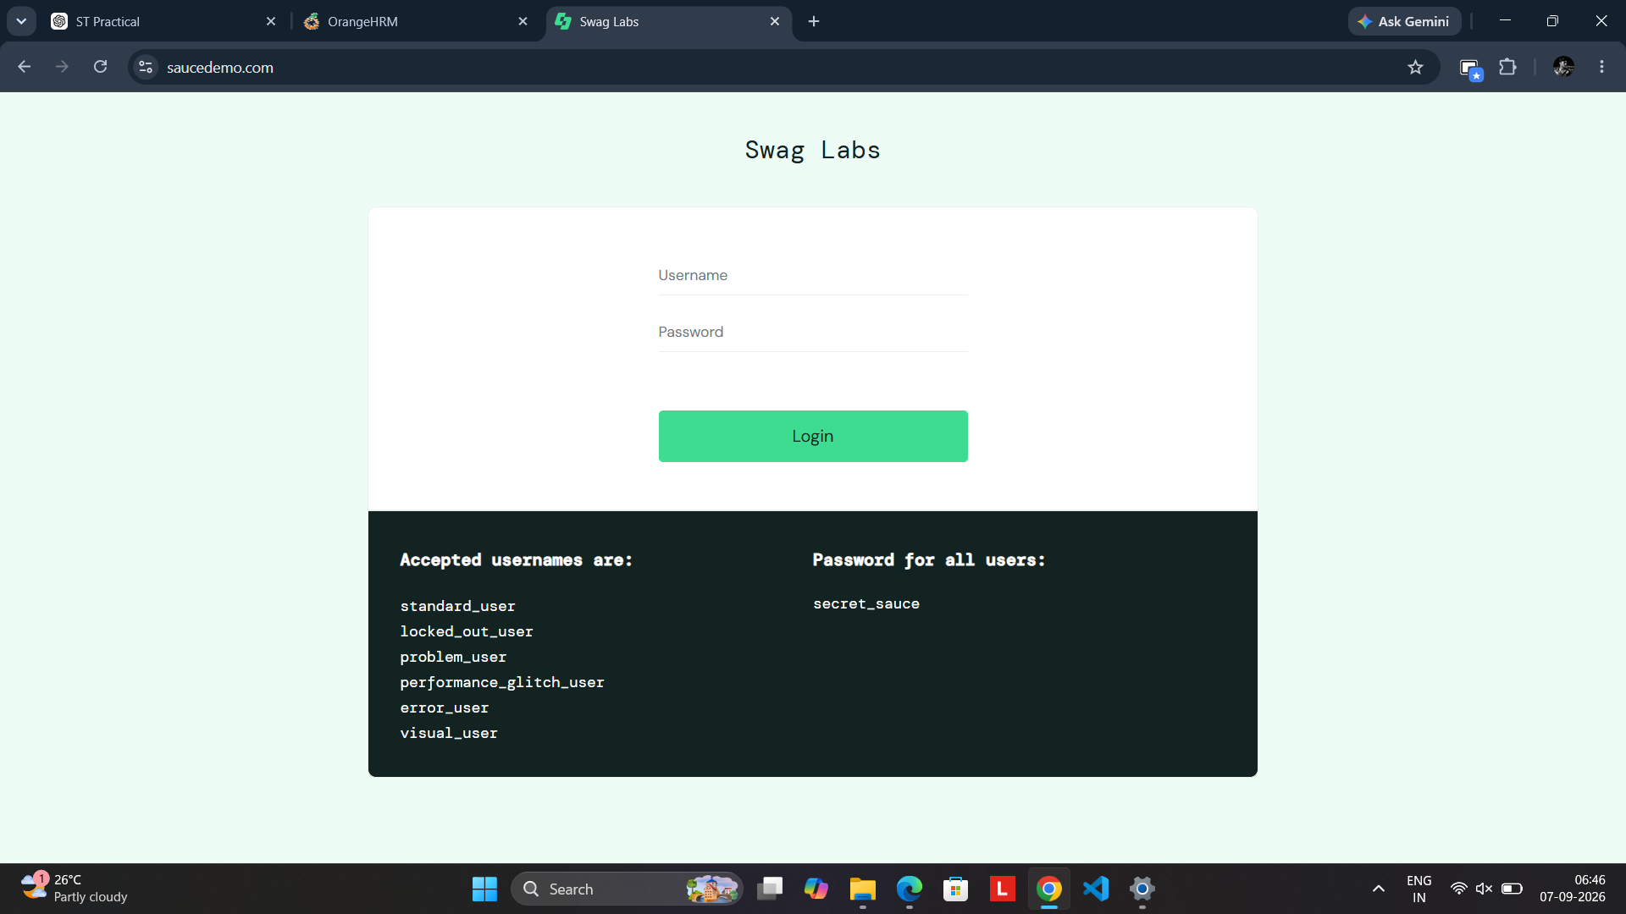
Initial Swag Labs login page showing the Username and Password fields, Login button, and the list of accepted test usernames.

Figure 10.2: Valid Credentials Entered
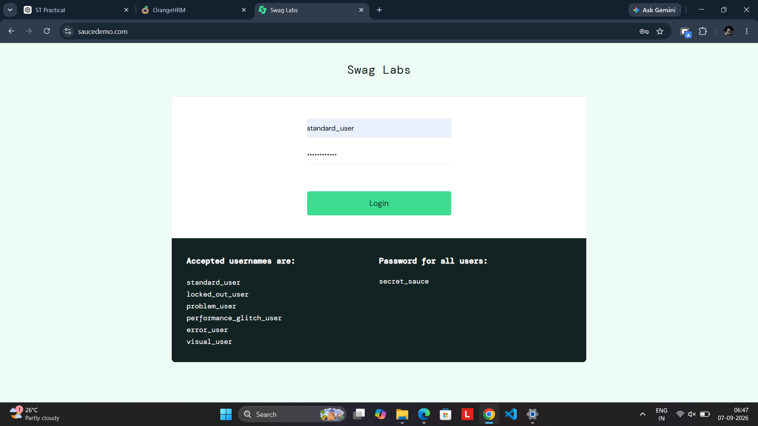
Standard test credentials entered in the Swag Labs login form before submitting the login request.

Figure 10.3: Selenium Automation Execution Attempt
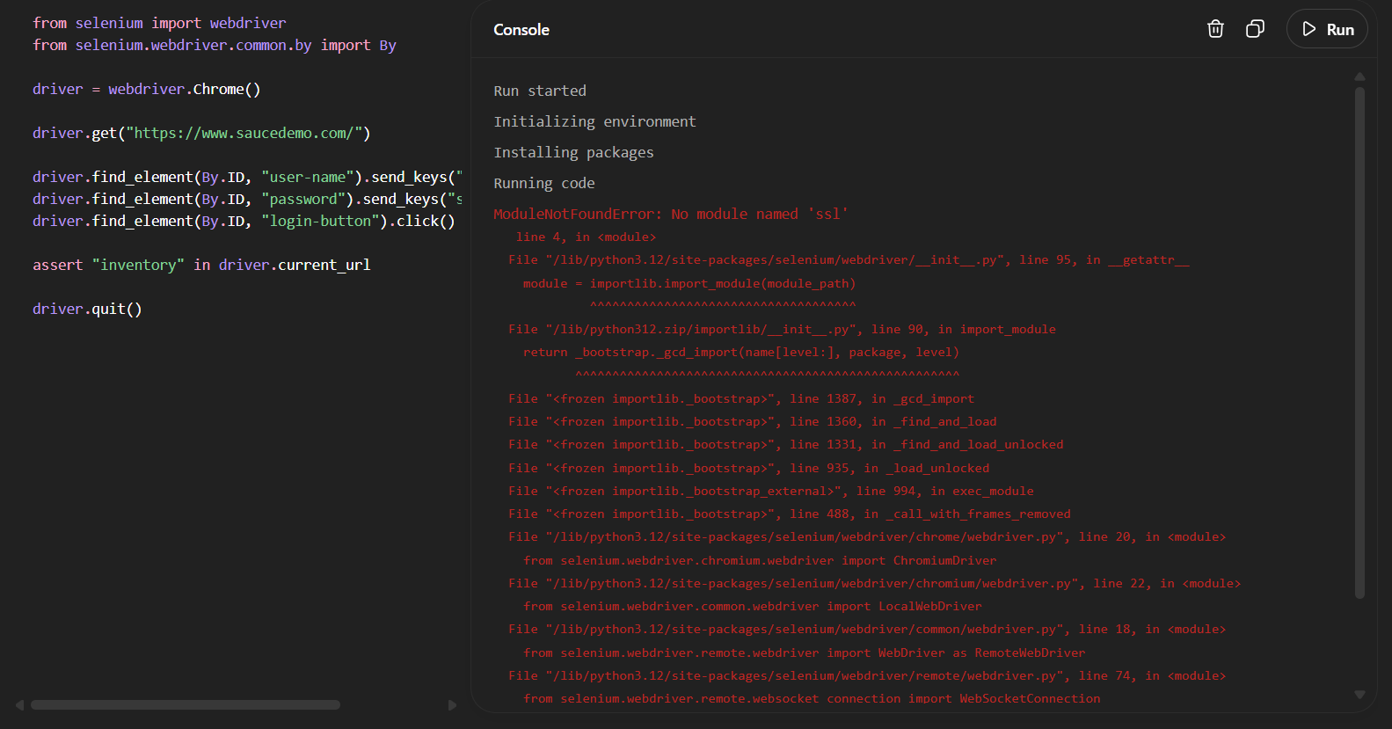
Selenium Python automation code shown with the execution console; the run stopped because the execution environment reported a missing Python SSL module.

Figure 10.4: Swag Labs Inventory Page
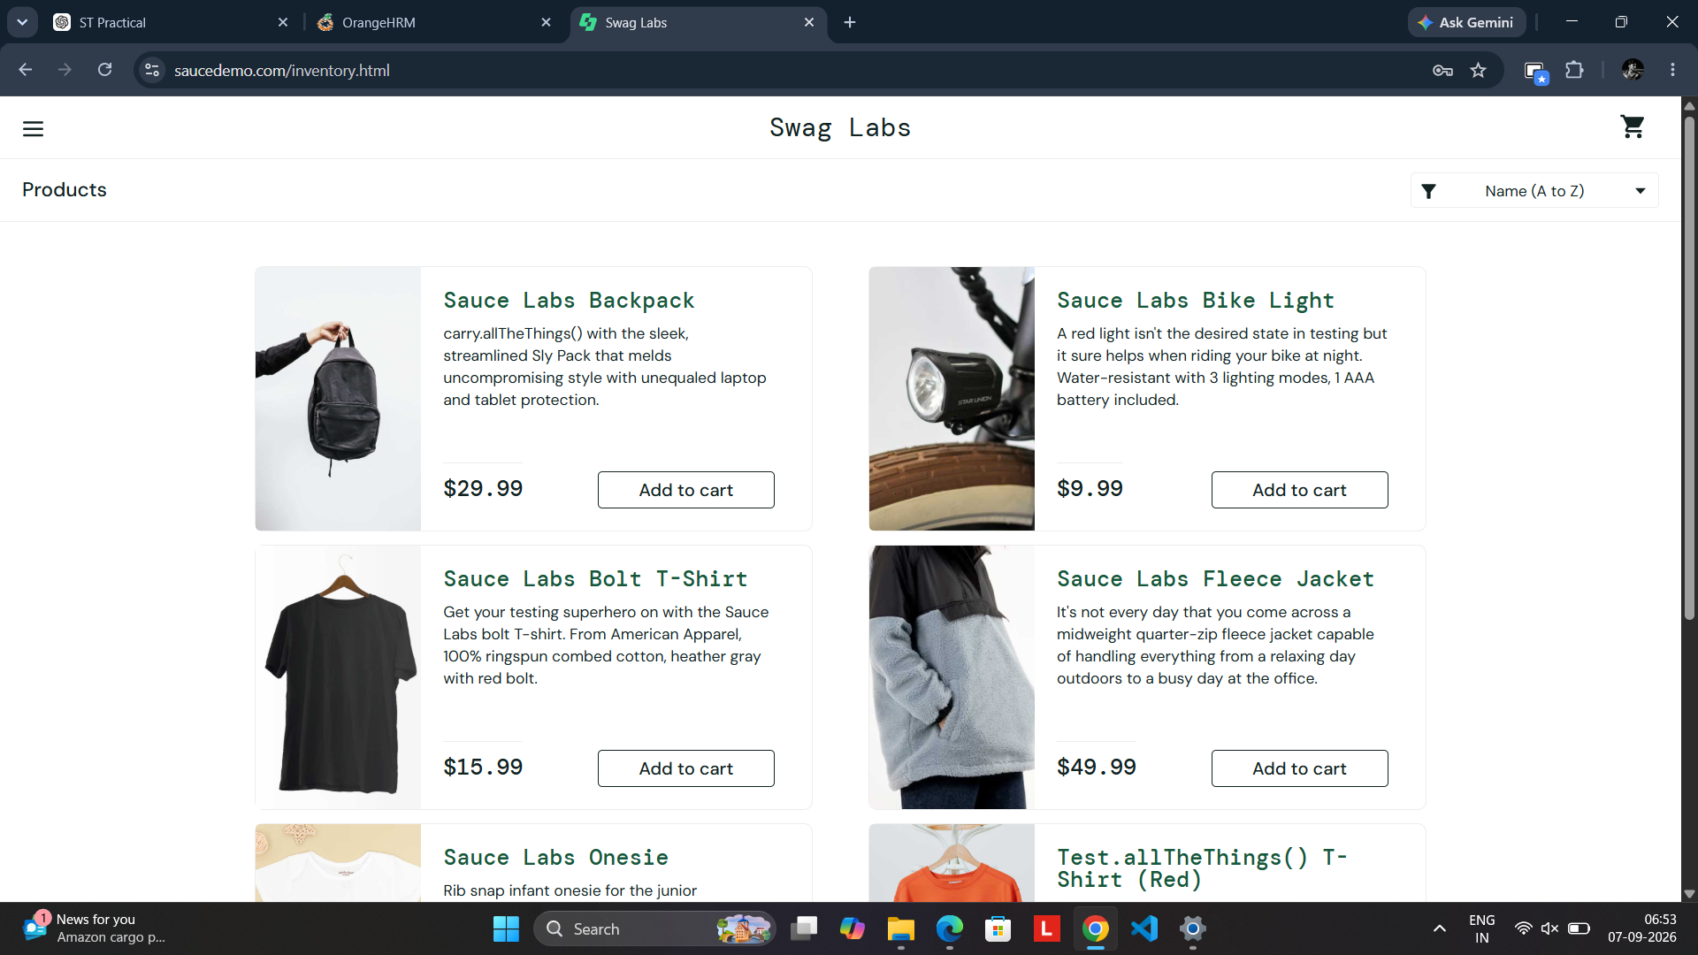
Successful navigation to the Swag Labs Inventory page, showing the Products listing and Add to cart controls.

Figure 10.5: Shopping Cart
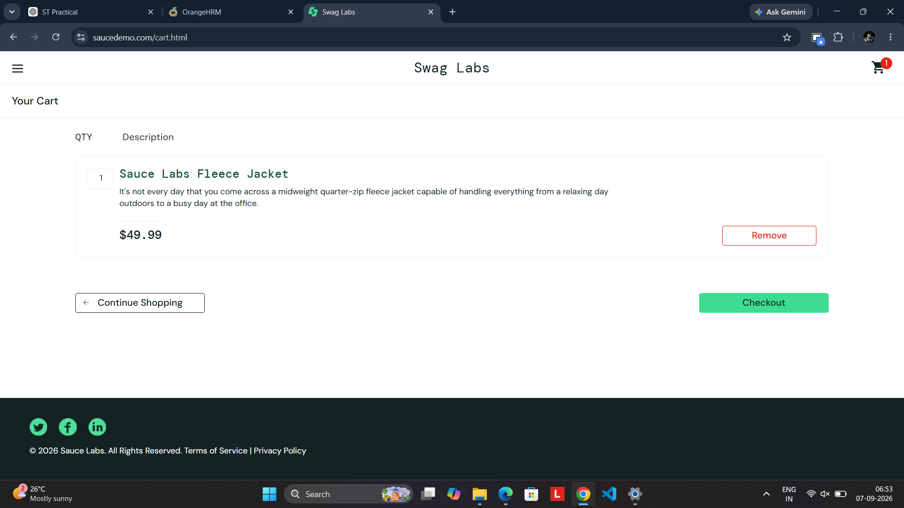
Shopping Cart page showing one selected product and the Checkout button.

Figure 10.6: Checkout – Your Information
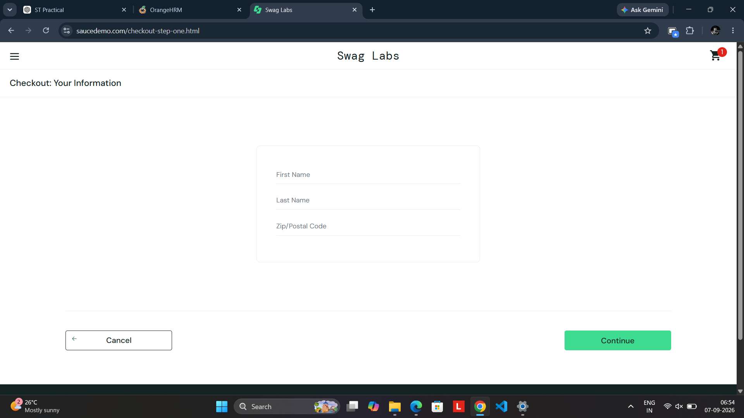
Checkout information page displaying First Name, Last Name, and Zip/Postal Code fields.

Figure 10.7: Checkout Information Entered
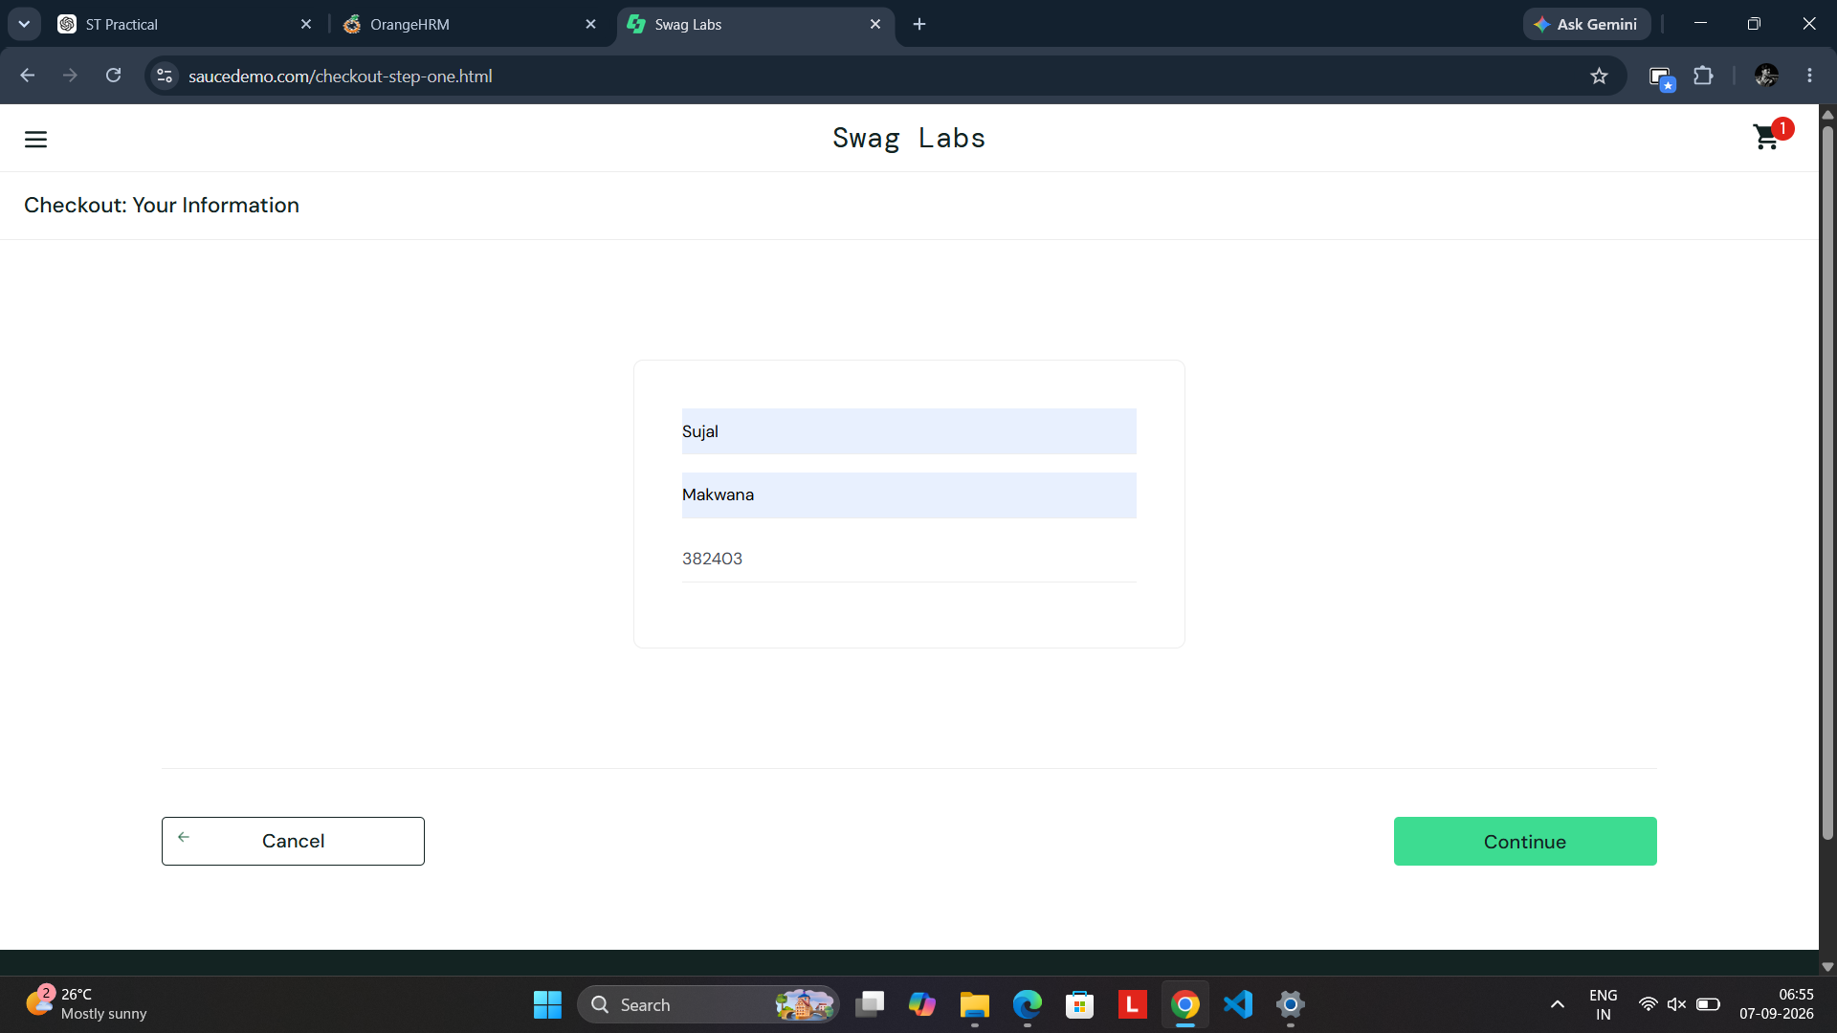
Checkout information fields populated with test data and ready to continue to the next checkout step.

Observations
- The Swag Labs login interface is available with dedicated Username, Password, and Login controls.
- The standard_user test account is shown as an accepted username on the login page.
- The Selenium automation script was prepared to open SauceDemo, enter credentials, click Login, verify the inventory URL, and close the browser.
- The supplied automation execution screenshot records a ModuleNotFoundError for the Python 'ssl' module. Therefore, that particular automation run did not complete in the shown environment.
- The Inventory page was successfully reached during the manual/application flow.
- A product was added to the Shopping Cart and the Checkout page was opened.
- Checkout information was entered, providing evidence for the checkout workflow.

Regression Testing Note
The screenshots support the tested login, inventory, cart, and checkout workflow. The automation execution evidence specifically shows an environment error ('No module named ssl'), so the screenshot evidence should not be described as a successful automated execution. After correcting the Python/Selenium execution environment, the same automation test should be rerun before claiming a successful automated regression result.

Final Result
The supplied screenshots provide visual evidence for the SauceDemo automation and regression practical. The application workflow progressed through login, inventory, cart, and checkout screens. The recorded Selenium run encountered an environment dependency error, which should be resolved before finalizing the automation execution result.

