SOFTWARE TESTING PRACTICAL
Practice Test Automation – Login Module Testing
1. Aim
To perform functional testing of a simple web login page by executing positive and negative login scenarios and recording the observed results.
2. Application Under Test
- Website: Practice Test Automation
- Page: Practice Test Login
- URL: practicetestautomation.com/practice-test-login/
- Test type: Functional / Login testing
- Browser: Google Chrome
3. Test Credentials
- Username: student
- Password: Password123
4. Test Scenarios
- TC001 – Verify login with valid username and valid password.
- TC002 – Verify login with invalid username.
- TC003 – Verify login with invalid password.
- TC004 – Verify login with blank username.
- TC005 – Verify login with blank password.
- TC006 – Verify login with both fields blank.
5. Evidence Note
The screenshots in this document are the screenshots supplied for this practical. Additional negative-case screenshots should be captured during execution if the instructor requires evidence for every test case.

6. Screenshot 1 – Initial Login Page
The login page is opened before execution. The page provides the Username and Password fields and a Submit button. The page also displays the credentials intended for practice.
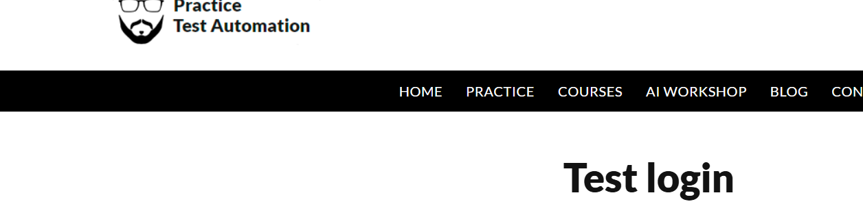
Screenshot 1: Initial Practice Test Automation login page with Username, Password and Submit controls.

7. TC001 – Enter Valid Credentials
Enter the supplied credentials: Username = student and Password = Password123. The screenshot shows both values entered in the login form immediately before submission.
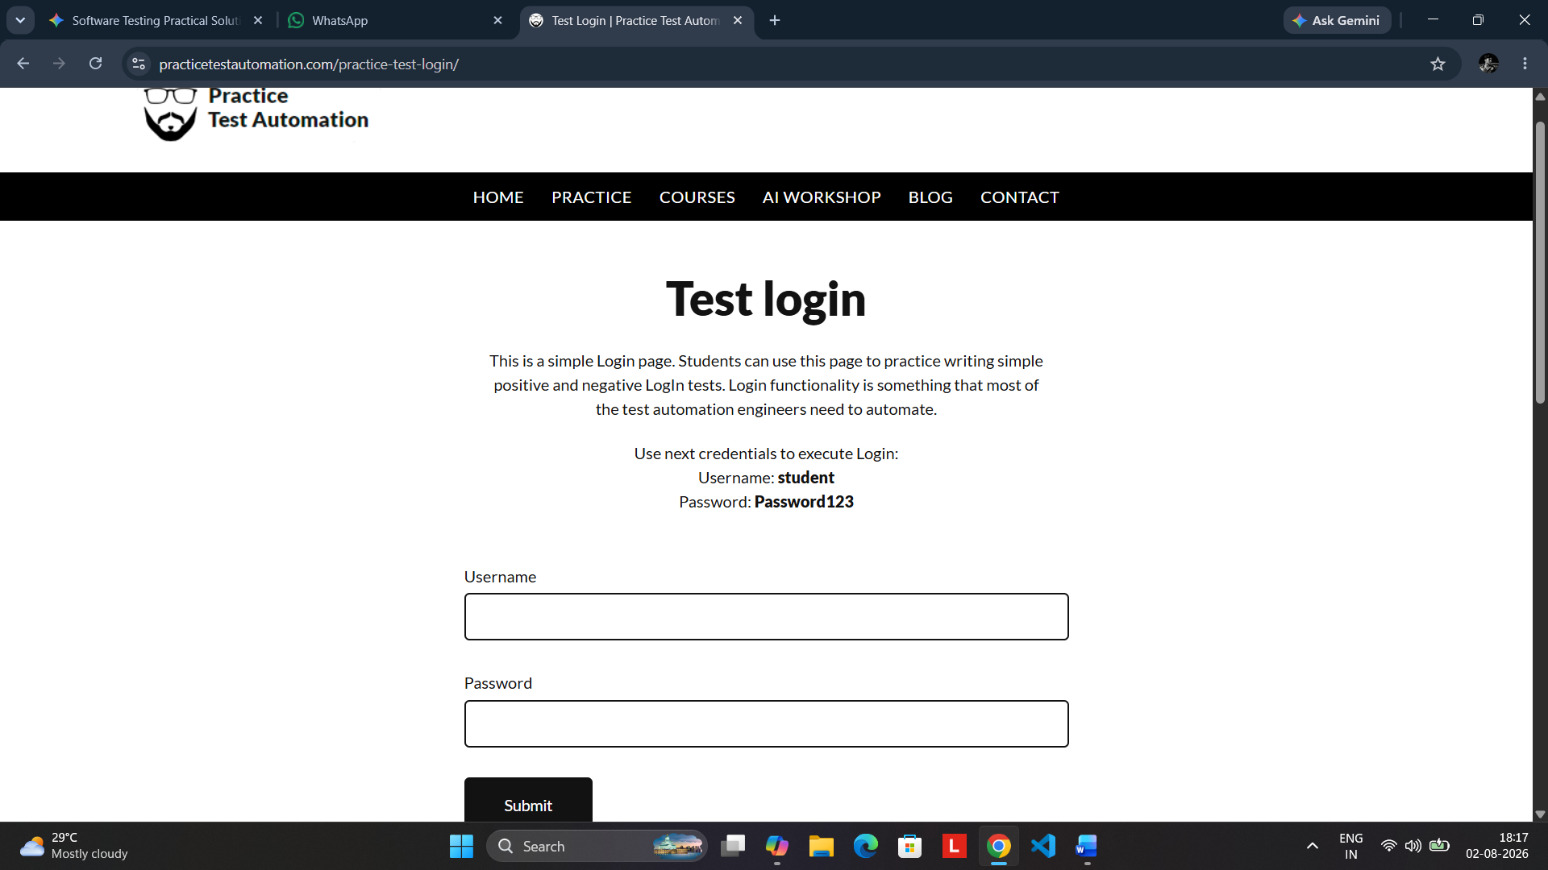
Screenshot 2: TC001 – Valid username and password entered and ready for submission.
Expected Result
The application should authenticate the user and redirect to the successful-login page.

8. TC001 – Successful Login
After submitting the valid credentials, the application displays the successful-login page and confirms that the student user has logged in successfully.
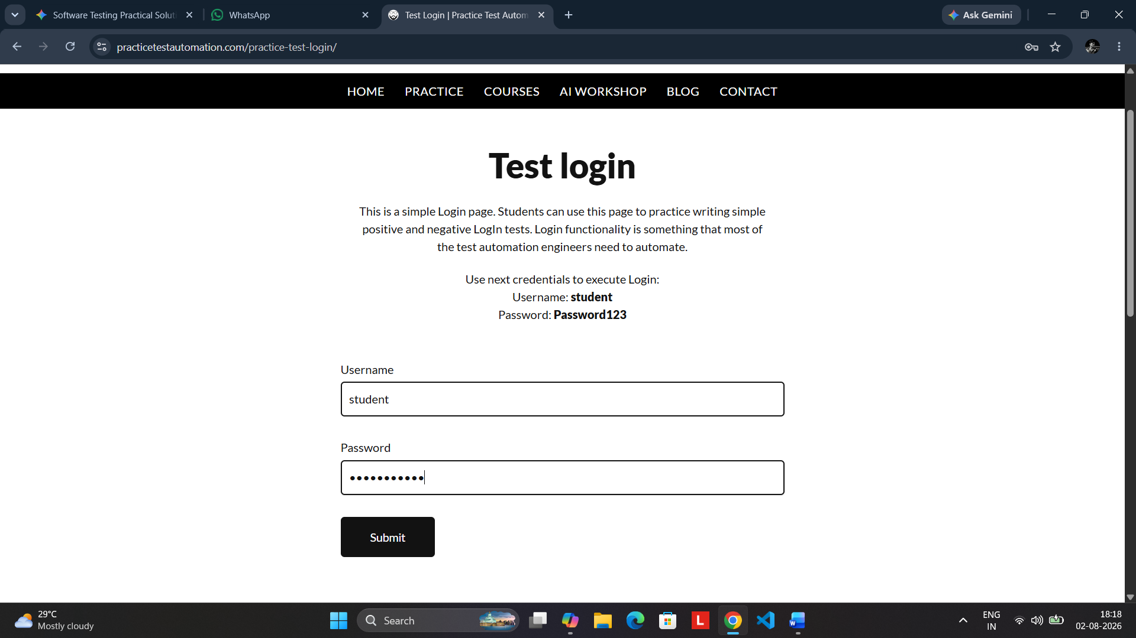
Screenshot 3: TC001 – Successful authentication; the “Logged In Successfully” page is displayed.
Actual Result
The supplied credentials were accepted and the successful-login confirmation page was displayed.

9. Additional Negative Login Tests
The following test cases should be executed after returning to the login page. These cases are included to complete functional coverage of the login module.
TC ID | Username | Password | Expected Result | Status
TC002 | Invalid | Password123 | Login rejected / error displayed | To be executed
TC003 | student | Invalid password | Login rejected / error displayed | To be executed
TC004 | Blank | Password123 | Username validation displayed | To be executed
TC005 | student | Blank | Password validation displayed | To be executed
TC006 | Blank | Blank | Required-field validation displayed | To be executed

10. Test Execution Summary
The following table records the observed execution available from the supplied screenshots. TC001 is supported by the provided successful-login evidence; the remaining negative cases require their corresponding execution screenshots.
TC | Scenario | Test Data | Expected | Actual | Status
TC001 | Valid login | student / Password123 | Successful login | Successful-login page displayed | PASS
TC002 | Invalid username | Invalid / Password123 | Login rejected | Capture actual error | Pending
TC003 | Invalid password | student / Invalid | Login rejected | Capture actual error | Pending
TC004 | Blank username | Blank / Password123 | Username validation | Capture actual message | Pending
TC005 | Blank password | student / Blank | Password validation | Capture actual message | Pending
TC006 | Both blank | Blank / Blank | Required validation | Capture actual message | Pending

11. Final Evidence – Successful Login
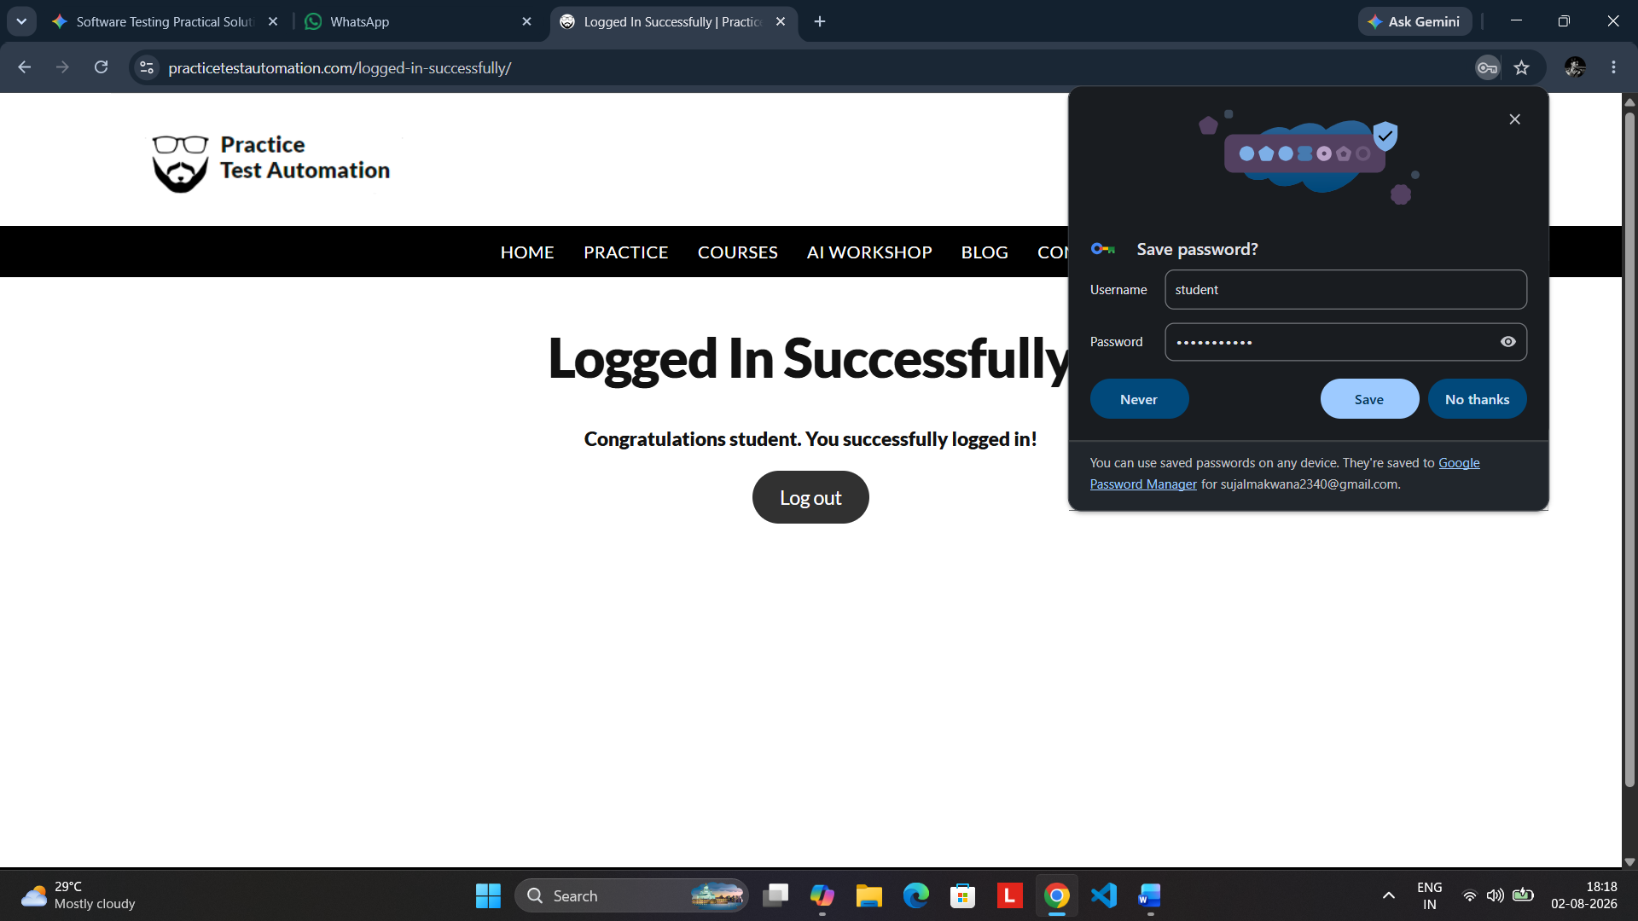
Screenshot 4: Additional supplied capture of the successful-login state for learning and execution documentation.
12. Observations
- The Practice Test Automation login page provides a dedicated form for positive and negative login testing.
- The supplied credentials are student / Password123.
- TC001 was successfully demonstrated in the supplied screenshots.
- Negative test cases should be executed separately and their exact error/validation messages recorded.
13. Conclusion
The login module was tested using a valid authentication scenario and a planned set of negative scenarios. The supplied evidence demonstrates successful authentication, while the remaining cases can be completed by executing the corresponding invalid or blank-input conditions.

