SOFTWARE TESTING PRACTICAL
Alibaba.com Login Module Testing
1. Aim
To perform functional testing of the Alibaba.com login module using positive and negative authentication scenarios, and to document the actual results observed during browser-based execution.
2. Application Under Test
- Application: Alibaba.com
- Module: Sign in / Authentication
- Browser: Google Chrome
- Test type: Functional testing
- Test environment: Alibaba.com web application
3. Test Scenarios Covered
- TC001 – Verify successful login with valid account credentials.
- TC002 – Verify login rejection when an incorrect password is entered.
- TC003 – Verify validation when the password field is blank.
- TC004 – Verify account/password validation for an incorrect credential combination.
- TC005 – Verify successful access to the Alibaba account page after authentication.
- TC006 – Verify that incorrect or incomplete authentication data is not accepted.
4. Evidence Note
The screenshots in this document are the user-provided execution captures. Sensitive account information visible in the screenshots has been kept as supplied; for formal submission, redact any personal email address or account identifier if required by your institution.

5. Alibaba.com – Initial Application State
The first supplied screenshot shows Alibaba.com before entering the authentication flow. The Products area, search field, navigation controls and account Sign in option are visible.
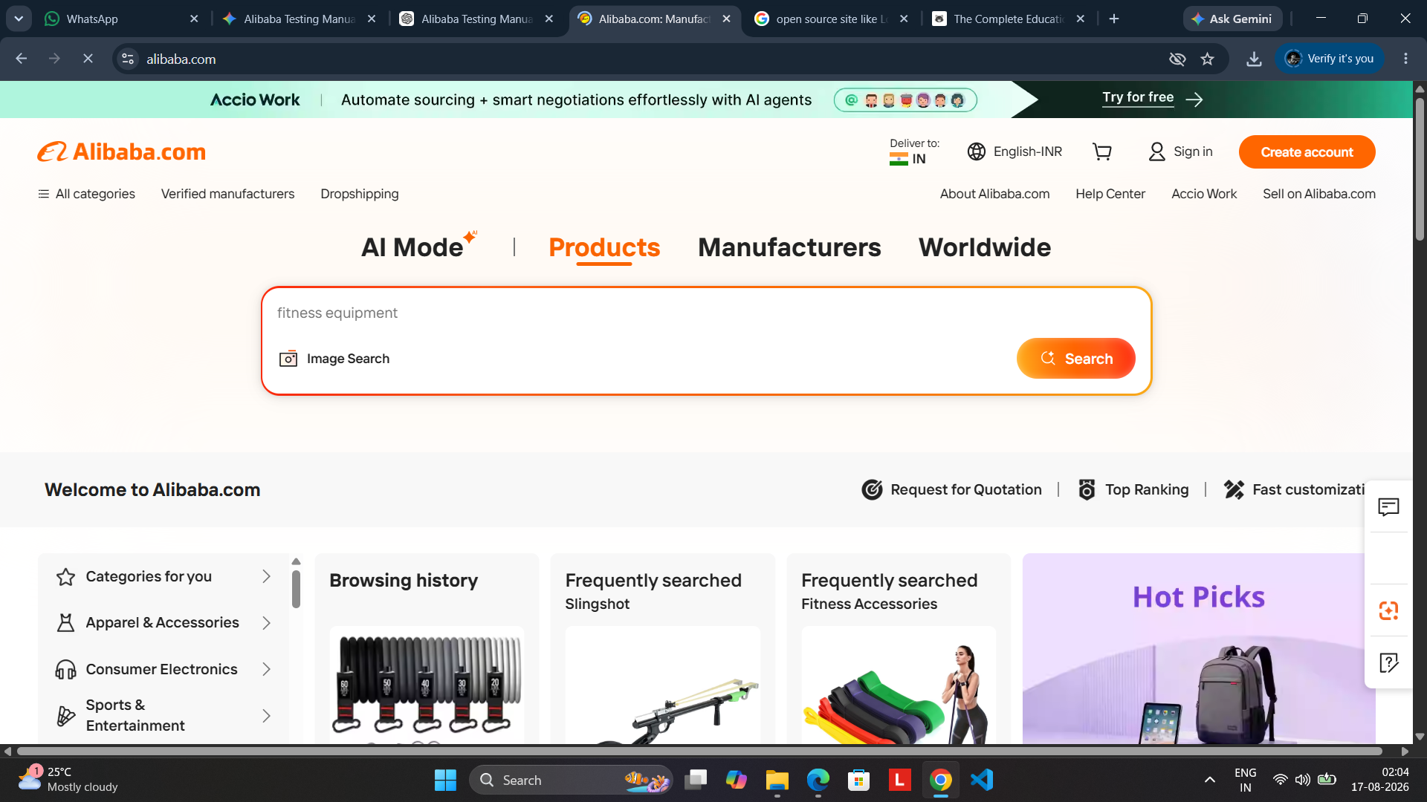
Screenshot 1: Alibaba.com initial page showing the Products interface and Sign in control.

6. TC001 – Valid Credentials Entered
The Alibaba sign-in form is opened and the supplied account email and password are entered. The Continue button is available for authentication.
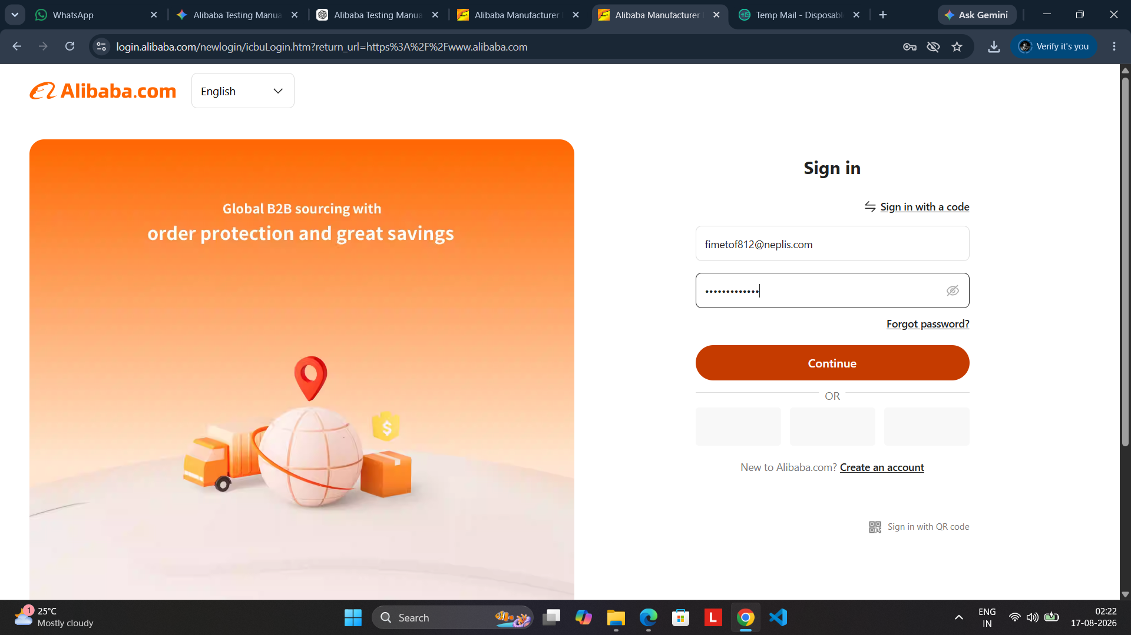
Screenshot 2: TC001 – Valid account credentials entered on the Alibaba sign-in form.
Expected Result
The application should authenticate the account and return the user to the Alibaba.com account/home experience.

7. TC001 – Successful Authentication
After authentication, Alibaba.com returns the user to the main site and displays the account name in the welcome area, indicating that the session is authenticated.
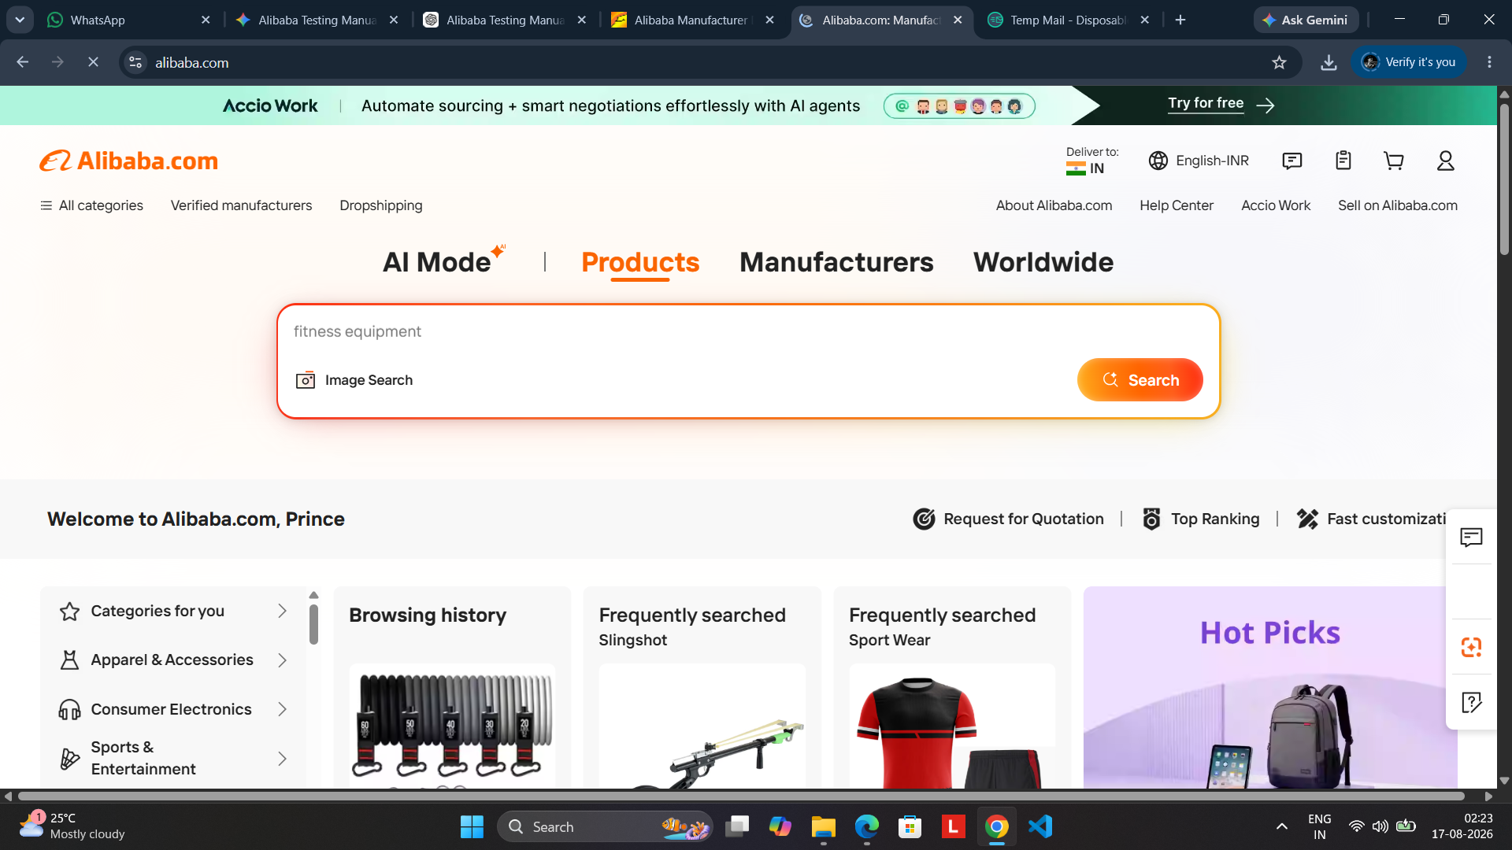
Screenshot 3: TC001 – Successful authentication; the Alibaba homepage displays the signed-in account.

8. TC002 / TC005 – Authenticated Account Area
The supplied capture shows the My Alibaba account settings page. Account information, account security, preferences, and the Sign out control are available, confirming access to the authenticated account area.
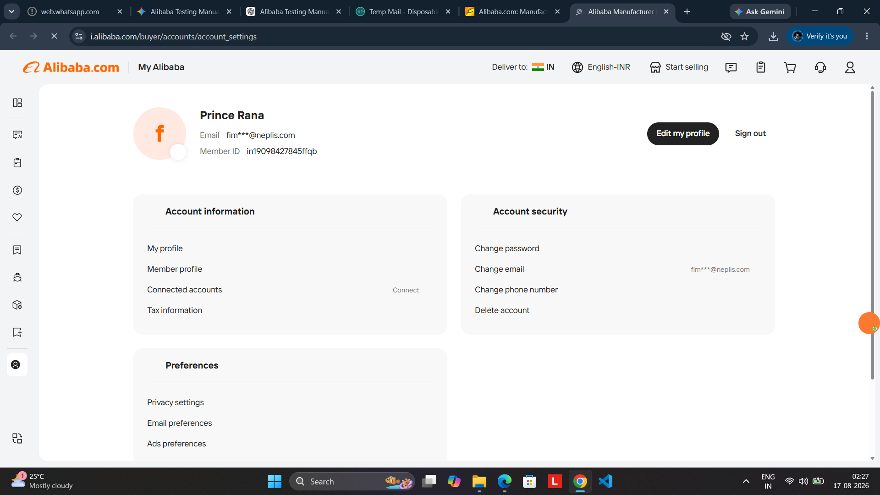
Screenshot 4: Authenticated My Alibaba account settings page with account and security controls.

9. Negative Authentication Tests
The next supplied screenshots demonstrate unsuccessful authentication and required-field validation. These observations should be recorded exactly as displayed by the Alibaba login instance.
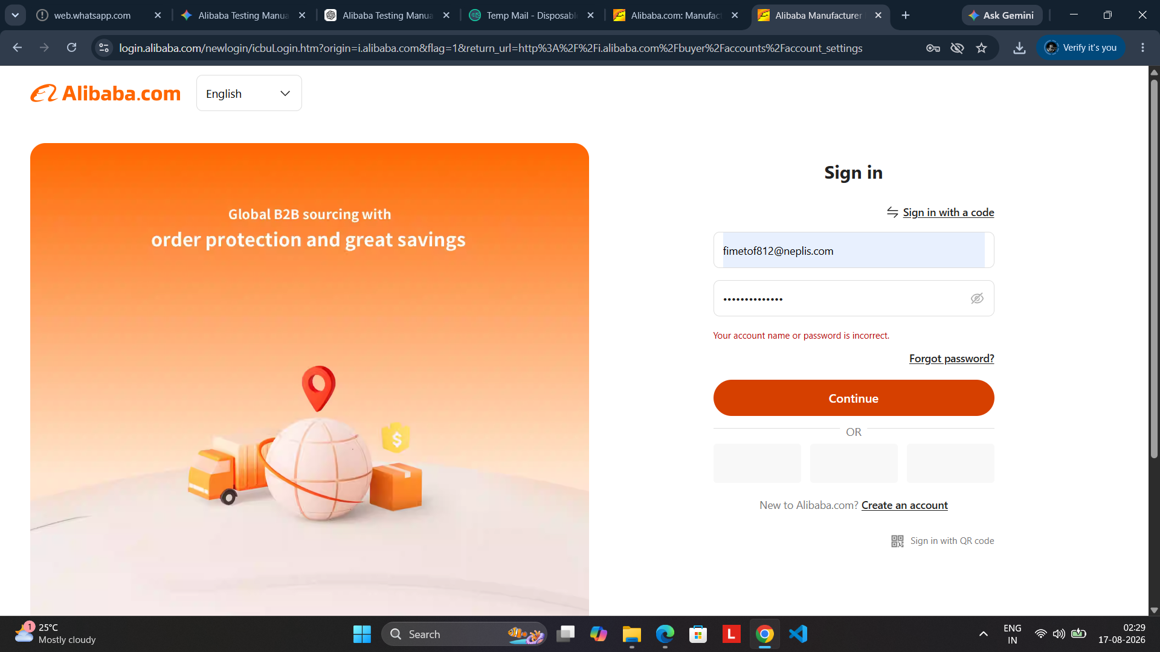
Screenshot 5: Invalid credential combination; Alibaba displays “Your account name or password is incorrect.”
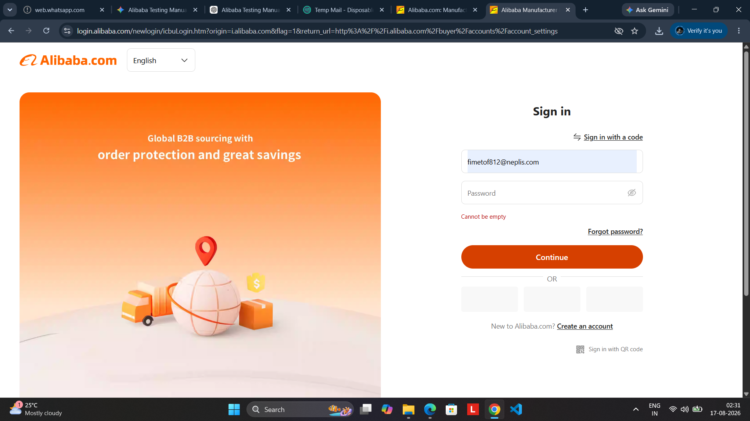
Screenshot 6: Blank password validation; Alibaba displays “Cannot be empty.”

10. Test Execution Summary
The following summary is based on the supplied screenshots. Where a screenshot demonstrates a result directly, the status is recorded as PASS. Cases that require a different input combination should be executed separately before final submission.
TC ID | Scenario | Input / Condition | Expected Result | Observed Result | Status
TC001 | Valid login | Valid account credentials | Authentication succeeds | Signed-in Alibaba page displayed | PASS
TC002 | Incorrect password | Valid account + wrong password | Login rejected | “Account name or password is incorrect.” | PASS
TC003 | Blank password | Valid account + blank password | Required validation | “Cannot be empty” displayed | PASS
TC004 | Invalid credential combination | Incorrect authentication data | Login rejected | Authentication error displayed | PASS
TC005 | Authenticated account access | Signed-in session | Account area accessible | My Alibaba account settings displayed | PASS
TC006 | Additional negative case | To be executed | Invalid/incomplete input rejected | Capture actual message | Pending
11. Observations
- Alibaba provides a dedicated Sign in interface with account credentials and a Continue button.
- Valid authentication leads to an authenticated Alibaba session and account area.
- An incorrect password is rejected with a visible authentication error.
- A blank password is rejected with a required-field validation message.
- The exact error text should be retained in the test report because it represents the observed behavior of the tested instance.
12. Conclusion
The Alibaba.com login module was evaluated using positive and negative functional scenarios. The supplied evidence demonstrates successful authentication, incorrect-credential rejection, blank-password validation, and access to the authenticated account area.

