SOFTWARE TESTING PRACTICAL
Samsung Account Login & Authentication Testing
1. Aim
To perform functional testing of the Samsung website and Samsung Account authentication flow by executing positive, validation, navigation, and account-access scenarios and recording the observed results.
2. Application Under Test
- Application: Samsung India website / Samsung Account
- Module: Account Sign in and authenticated account access
- Browser: Google Chrome
- Test type: Functional and UI validation testing
- Environment: Web application
3. Test Scenarios
- TC001 – Verify that the Samsung website opens correctly and the account control is available.
- TC002 – Verify that the Samsung Account sign-in form displays the required login controls.
- TC003 – Verify the authentication flow reaches the “Stay signed in?” confirmation.
- TC004 – Verify authenticated access returns the user to the Samsung website.
- TC005 – Verify the signed-in account panel displays account-specific options.
- TC006 – Verify the account recovery/support path is available.
- TC007 – Inspect the login page structure using browser developer tools for learning purposes.
4. Evidence Note
The screenshots in this practical are the screenshots supplied for the learning exercise. They document the actual browser states shown in the supplied captures. Any personal account information should be redacted before academic submission if required.

5. TC001 – Samsung Website Initial State
The Samsung India homepage is opened in Chrome. The screenshot shows the Samsung branding, navigation controls, search, cart and account icons, together with the current promotional content.
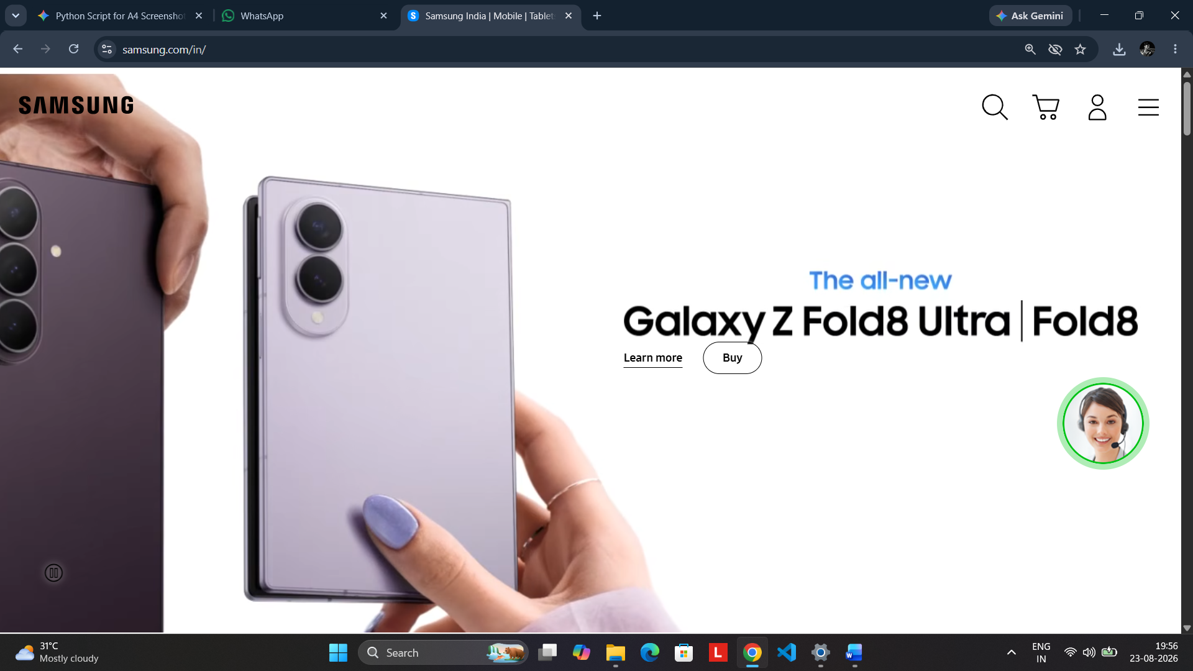
Screenshot 1: Samsung India homepage before authentication, showing the account icon and main navigation controls.

6. TC002 – Samsung Account Sign-in Page
Selecting the account/sign-in control opens the Samsung Account authentication page. The form provides a Phone number or email field, Remember my ID, Next, Find ID, Create account, Google sign-in and QR-code sign-in options.
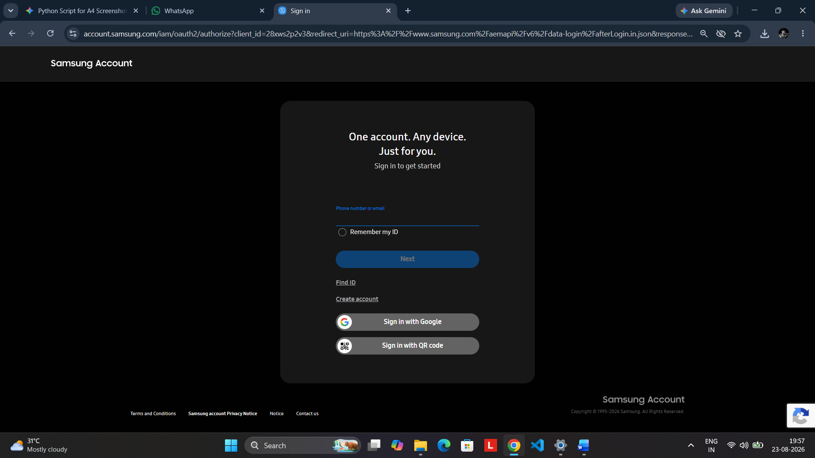
Screenshot 2: Samsung Account sign-in form with Phone number or email field and authentication options.
Expected Result
The sign-in page should load correctly and provide the controls necessary to begin authentication.

7. TC003 – Stay Signed In Confirmation
After progressing through the Samsung Account authentication flow, the application displays a “Stay signed in?” confirmation. The page explains the security consideration and provides Stay signed in and Not now controls.
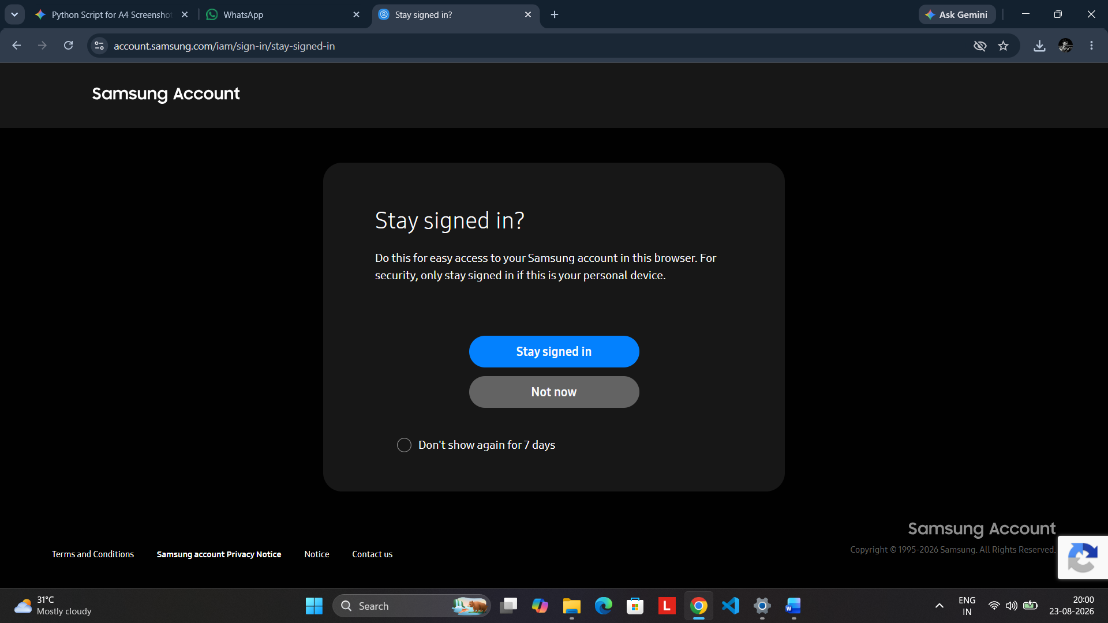
Screenshot 3: Samsung Account “Stay signed in?” confirmation displayed during the authentication flow.
Observed Result
The authentication flow successfully reached the stay-signed-in confirmation screen.

8. TC004 – Authenticated Samsung Website
The supplied screenshot shows the Samsung India website after authentication. The account panel is opened and displays the signed-in account name along with account-specific options such as My Rewards, My Page, Orders, Wishlist, Vouchers and Saved Address.
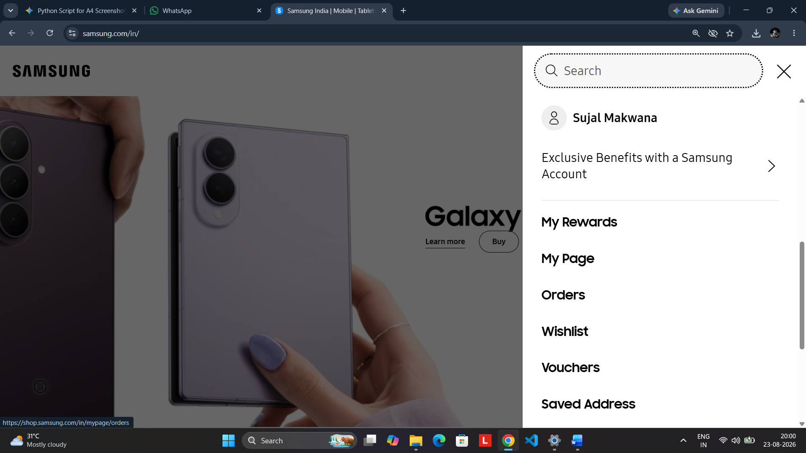
Screenshot 4: Authenticated Samsung website with the account panel and account-specific navigation options.
Expected Result
After successful authentication, the account control should identify the signed-in user and provide access to account-related services.

9. TC005 – Login Page Inspection
The supplied developer-tools screenshot shows the Samsung Account sign-in page alongside Chrome DevTools. This can be used as a learning exercise to inspect the HTML structure, DOM elements and embedded authentication components.
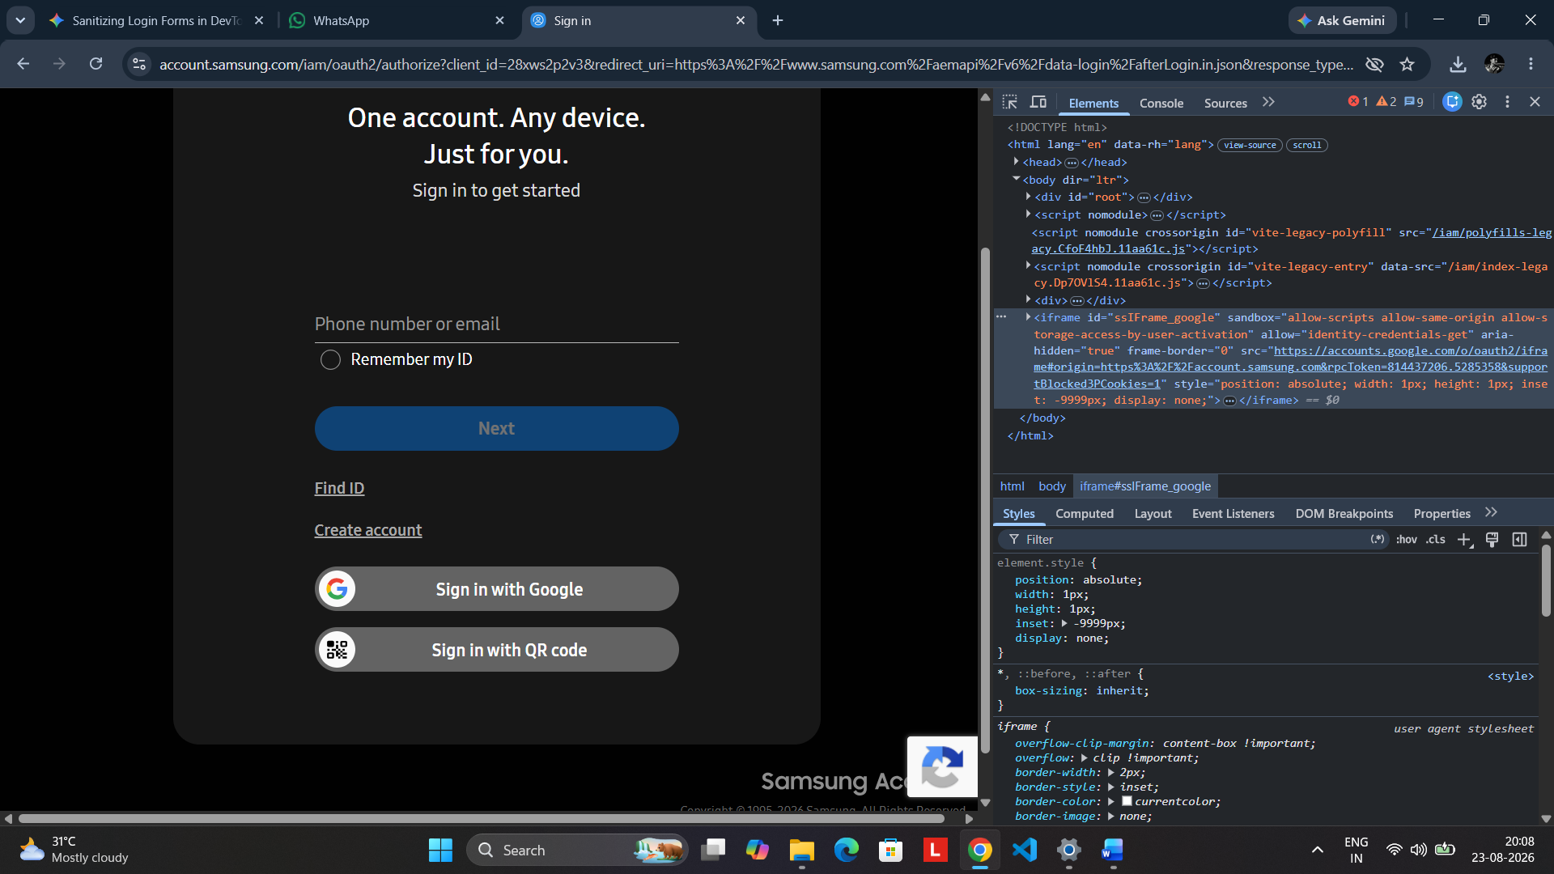
Screenshot 5: Samsung Account sign-in page inspected with Chrome Developer Tools for educational UI/DOM analysis.
10. TC006 – Account Recovery / Support Path
The supplied recovery-page screenshot demonstrates a Samsung support page for recovering a Samsung Account ID or resetting a password. A cookie-consent dialog is visible over the page.
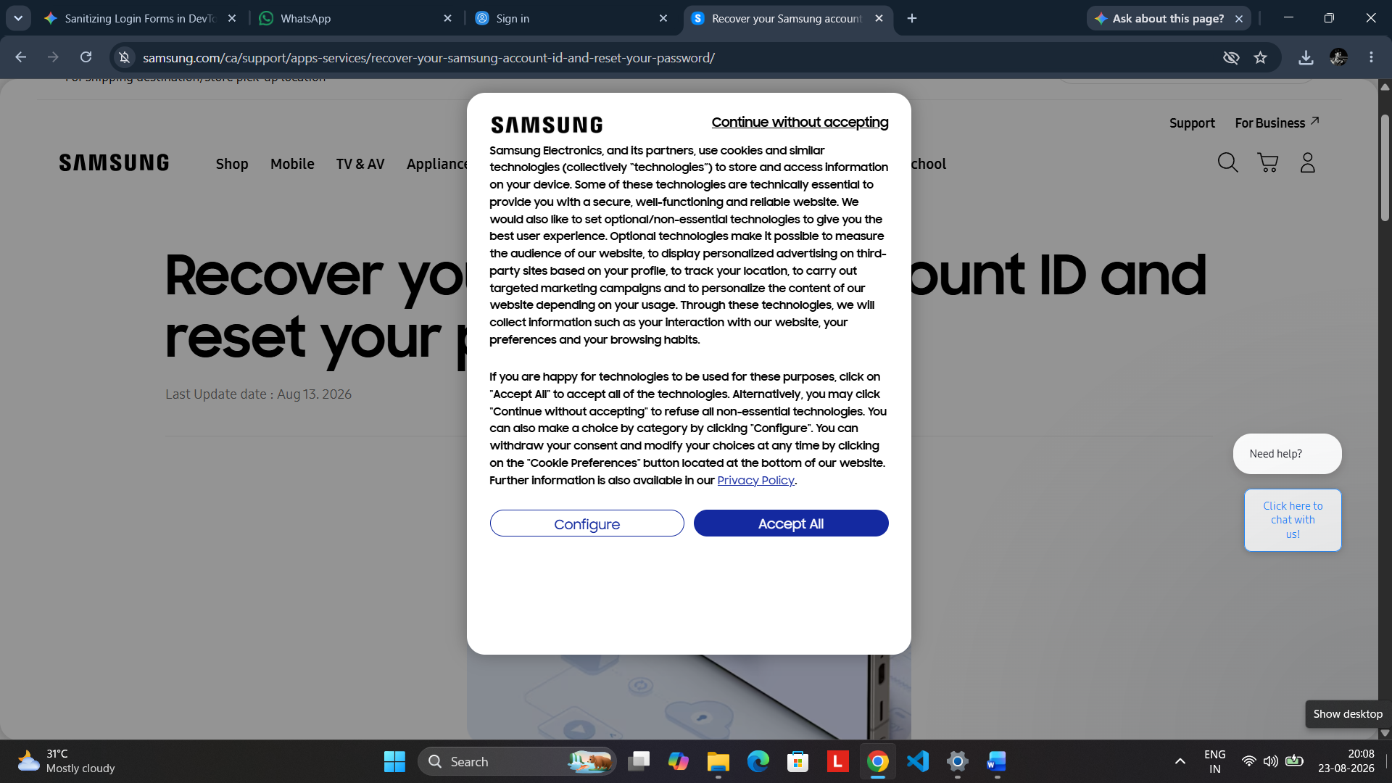
Screenshot 6: Samsung Account recovery/support page with cookie-consent dialog displayed.

11. Test Execution Summary
The following table summarizes the scenarios demonstrated by the supplied screenshots. It records only outcomes supported by the provided evidence.
TC ID | Scenario | Expected Result | Observed Result | Status | Evidence
TC001 | Samsung homepage | Homepage loads correctly | Samsung India homepage displayed | PASS | SS1
TC002 | Open sign-in | Login controls displayed | Samsung Account sign-in page displayed | PASS | SS2
TC003 | Authentication flow | Stay-signed-in option displayed | Stay signed in? page displayed | PASS | SS3
TC004 | Authenticated access | Signed-in account options available | Account panel displayed | PASS | SS4
TC005 | UI/DOM inspection | Page structure can be inspected | Chrome DevTools displayed | PASS | SS5
TC006 | Recovery path | Recovery/support page available | Recovery page displayed | PASS | SS6
12. Observations
- The Samsung India website provides a clearly accessible account/sign-in control.
- The Samsung Account page provides multiple authentication and account-recovery options.
- The authentication flow reaches a stay-signed-in confirmation.
- After authentication, account-specific navigation becomes available.
- The login page can be inspected with browser developer tools for software-testing and DOM-learning purposes.
- The recovery/support page provides a route for account ID recovery and password reset.
13. Conclusion
The Samsung Account authentication workflow was evaluated using the supplied browser evidence. The practical demonstrates initial navigation, sign-in UI verification, authentication-flow confirmation, authenticated account access, basic DOM inspection, and account-recovery navigation.

