SOFTWARE TESTING PRACTICAL
Canva Web Application — Authentication, Validation,
Functionality & Compatibility Testing
Screenshot Evidence & Execution Record

Application Tested | Canva Web Application
Testing Type | Manual Functional, Validation, Authentication & Compatibility Testing
Browser / Platform | Google Chrome / Windows 11
Evidence | 7 screenshots
Overall Outcome | Core authentication and workspace flow successfully demonstrated
Prepared as practical learning evidence for Software Testing

Screenshot 1 — Canva Login Interface
Test Evidence 1 of 7
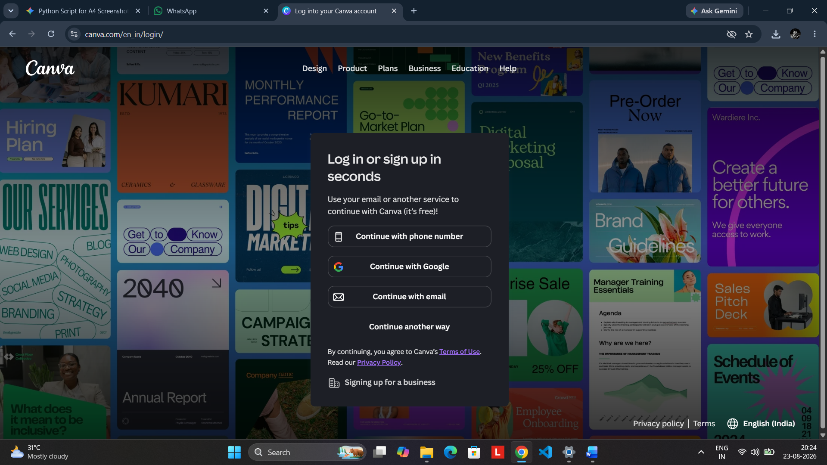
Caption: The Canva authentication interface is displayed with available sign-in methods such as phone number, Google, and email. This verifies that the login page and its primary authentication controls are accessible.
Test objective: Verify login-page availability and authentication controls.
Expected/Observed: Login interface loads successfully with multiple authentication options.
Status: PASS

Screenshot 2 — Invalid/Unsupported Email Response
Test Evidence 2 of 7
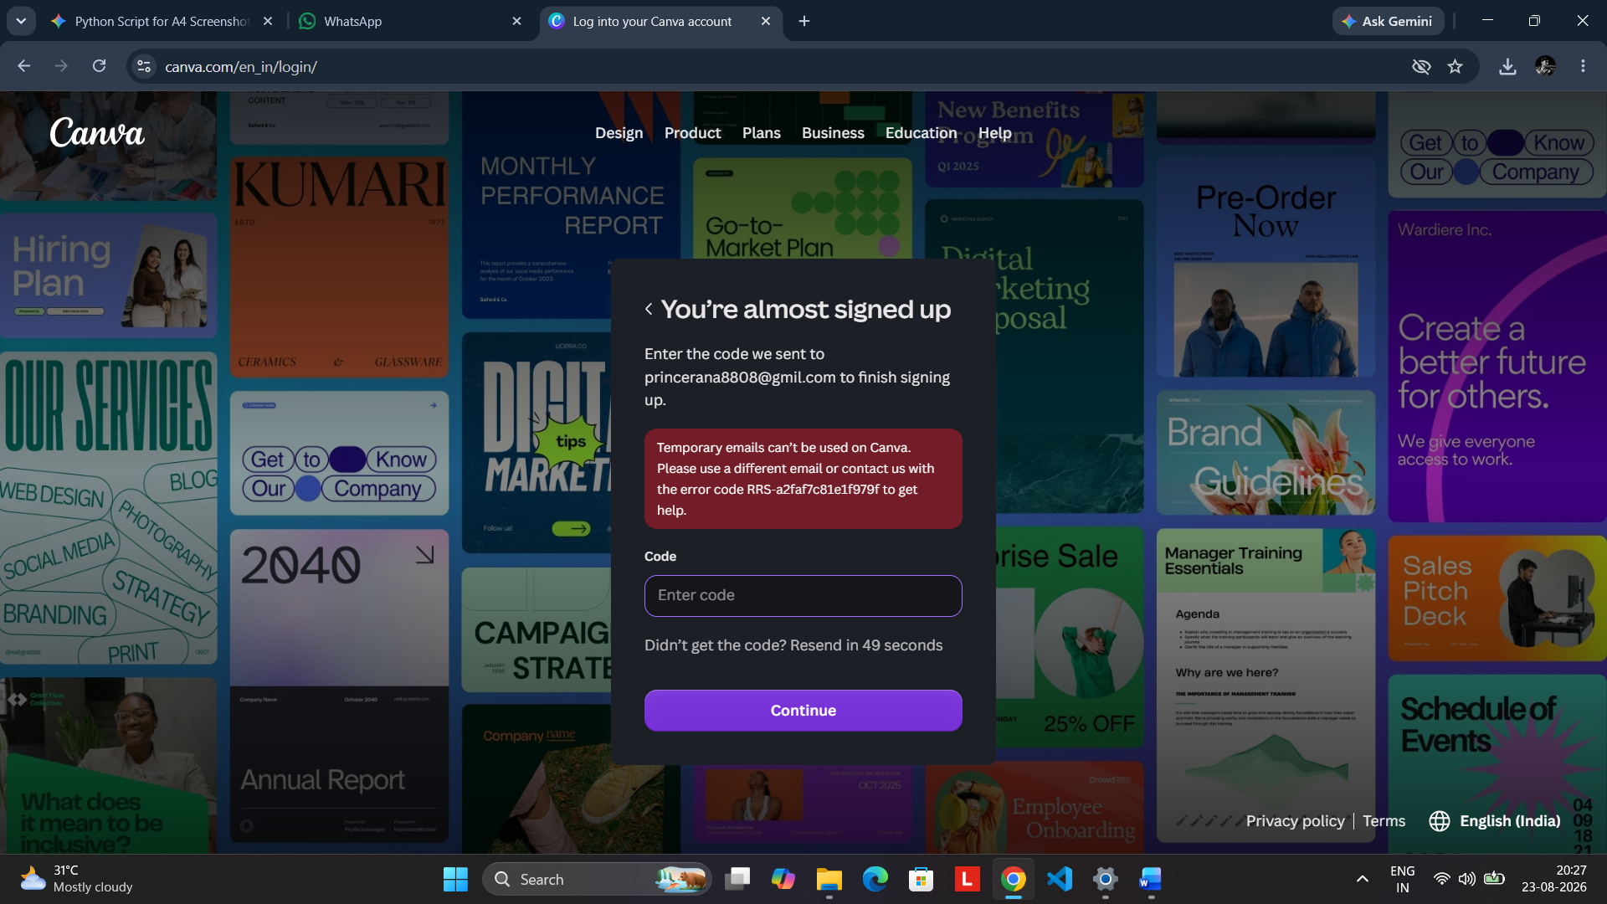
Caption: An authentication attempt using a temporary email address produces an appropriate response explaining that temporary emails are not supported. This demonstrates negative-input handling and user guidance.
Test objective: Verify the system response to an unsupported email identifier.
Expected/Observed: A clear validation/error message is displayed and directs the user toward an acceptable email address.
Status: PASS

Screenshot 3 — Required Field Validation
Test Evidence 3 of 7
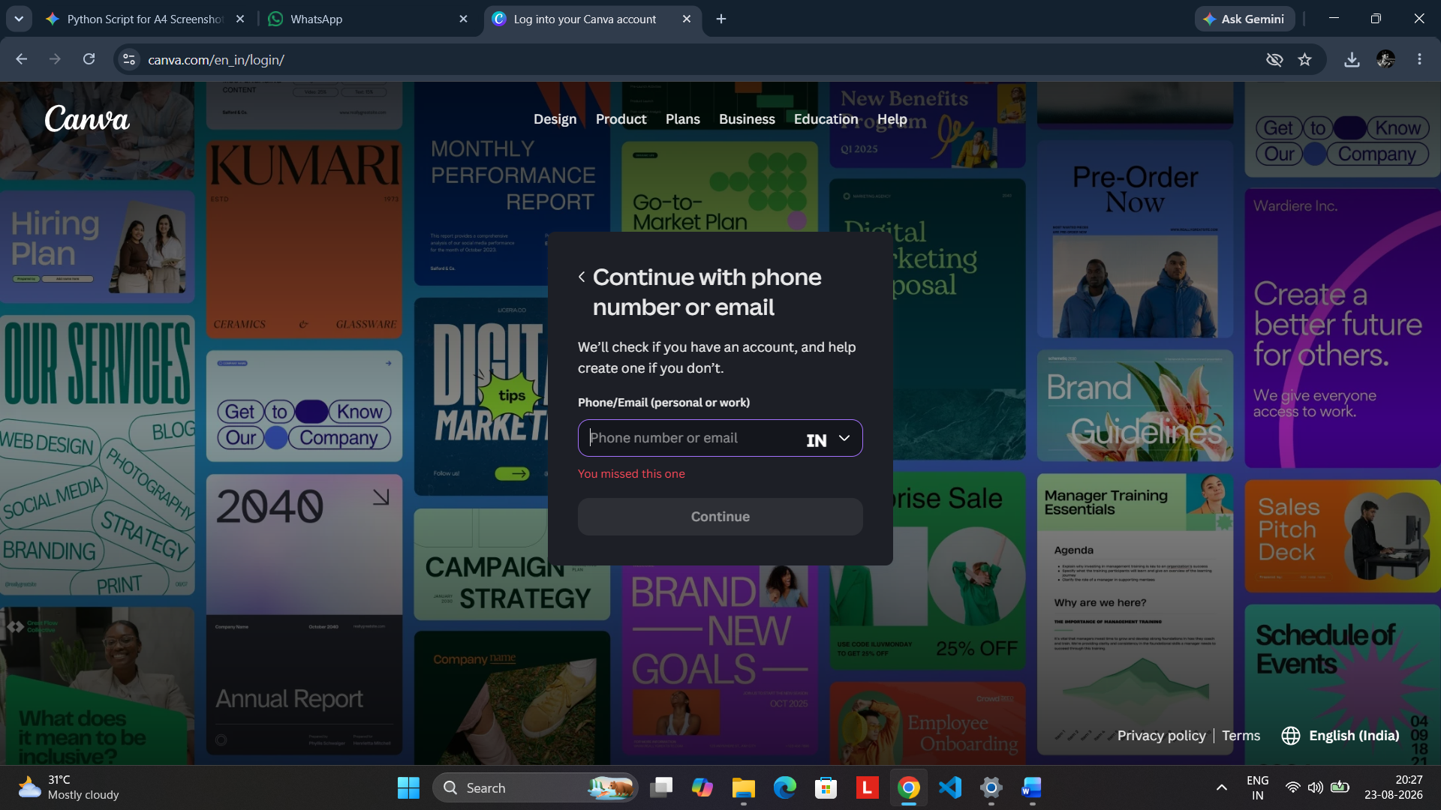
Caption: The phone number/email field is left empty and the form prevents progression. The validation state demonstrates that required authentication input is checked before continuing.
Test objective: Verify mandatory-field validation.
Expected/Observed: The Continue action remains unavailable until valid input is supplied.
Status: PASS

Screenshot 4 — Verification Code Authentication Step
Test Evidence 4 of 7
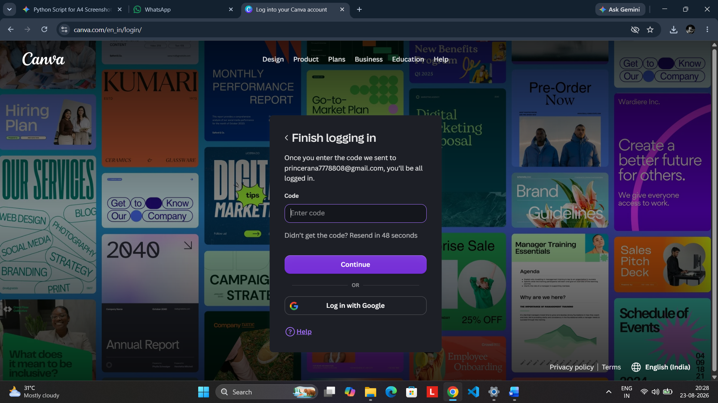
Caption: After the authentication flow proceeds, Canva displays a verification-code screen. This confirms the transition from identifier entry to the secondary verification stage.
Test objective: Verify the multi-step authentication workflow.
Expected/Observed: The system requests a verification code before completing authentication.
Status: PASS

Screenshot 5 — Successful Authentication / Canva Workspace
Test Evidence 5 of 7
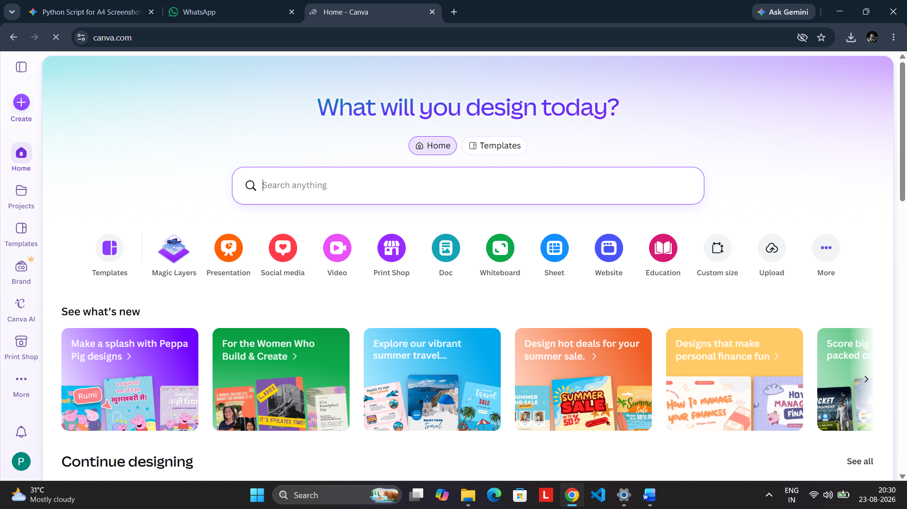
Caption: The Canva home workspace is displayed after authentication, showing the search interface, templates, design categories, projects, and workspace navigation. This provides positive evidence that login successfully reaches the application.
Test objective: Verify successful authentication and workspace access.
Expected/Observed: Canva workspace loads successfully and core dashboard controls are available.
Status: PASS

Screenshot 6 — Basic Design Editor Functionality
Test Evidence 6 of 7
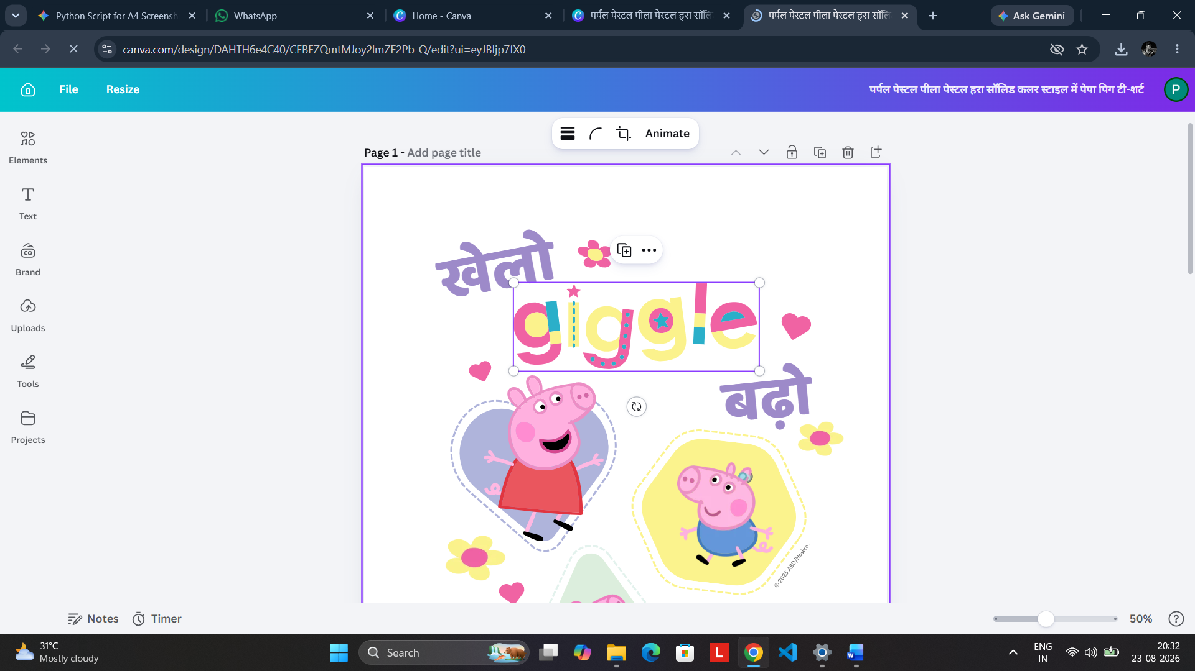
Caption: The Canva editor is open with a simple design and a text element selected/added. This verifies that authenticated users can enter the editor and perform a basic content-editing operation.
Test objective: Verify basic post-login application functionality.
Expected/Observed: Design editor loads and the text element can be added or modified.
Status: PASS

Screenshot 7 — Chrome/Windows 11 & DevTools Evidence
Test Evidence 7 of 7
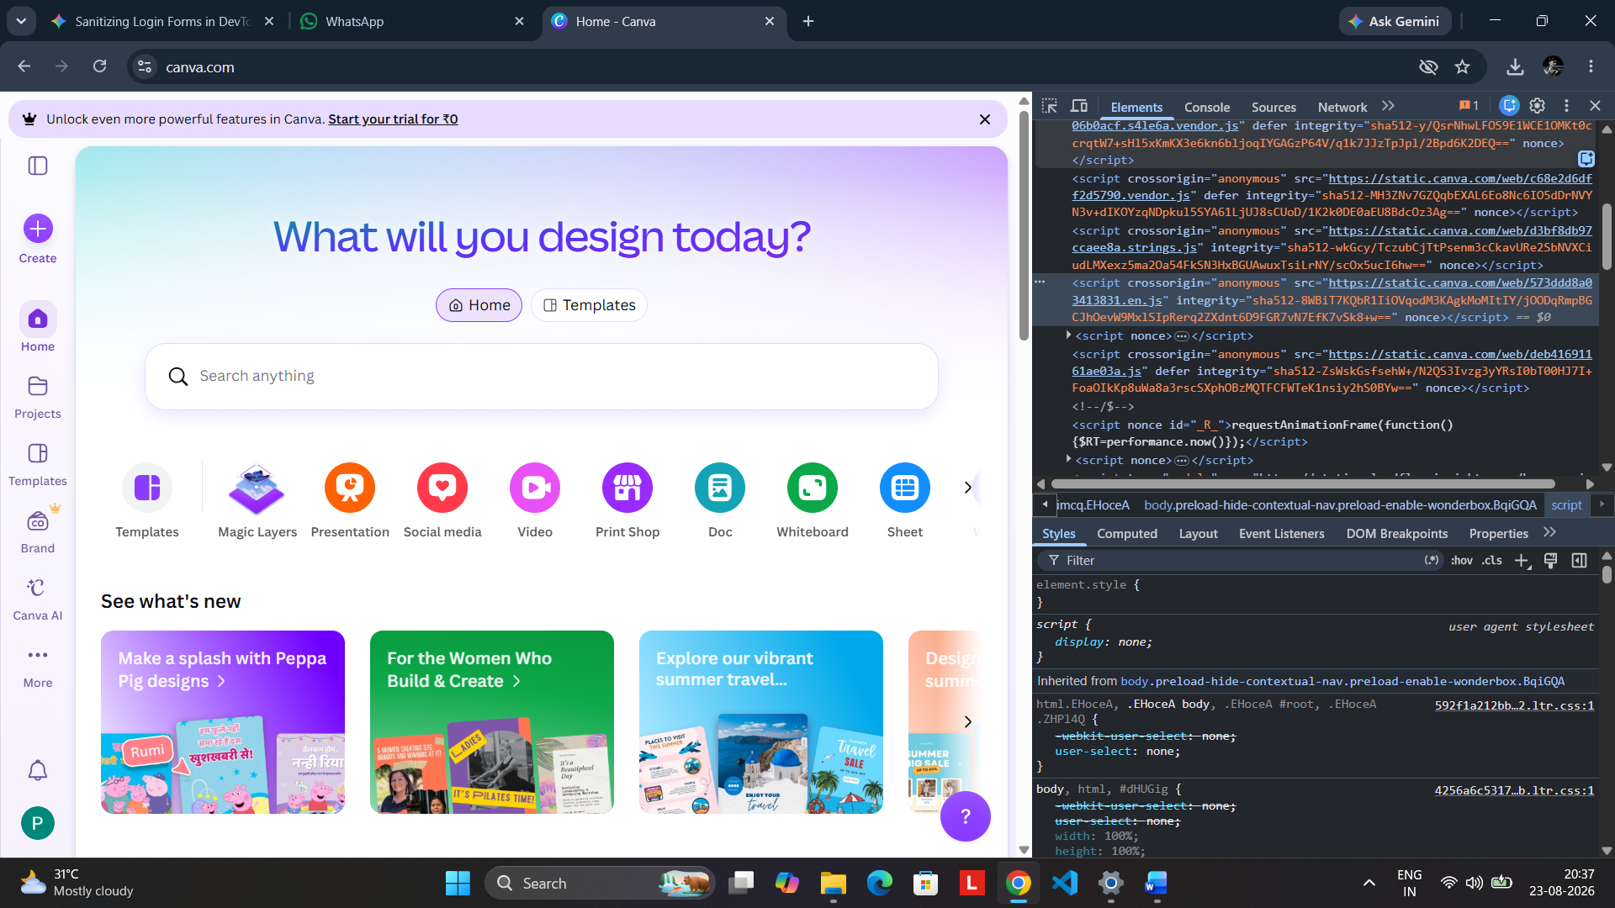
Caption: Canva is rendered in Google Chrome on Windows 11 while Chrome Developer Tools are open. This provides browser-compatibility evidence and a practical view for inspecting page behavior and performance-related information.
Test objective: Verify browser compatibility and support basic performance inspection.
Expected/Observed: Canva renders correctly in Chrome on Windows 11 and DevTools can inspect the page.
Status: PASS

