SOFTWARE TESTING PRACTICAL
Defect Reporting — The Internet: Broken Images
Screenshot Evidence & Final Practical Output

Application | The Internet — Broken Images module
Defect ID | BUG-001
Defect Type | Broken / Missing Image Rendering
Environment | Windows 11 / Google Chrome
Severity / Priority | Medium / Medium
Evidence | 3 screenshots + final practical output

Purpose: To demonstrate defect identification, reproduction, technical inspection, formal defect reporting, and final evidence documentation for a broken-image issue.

Screenshot 1 — Broken Images Page
Evidence 1 of 3
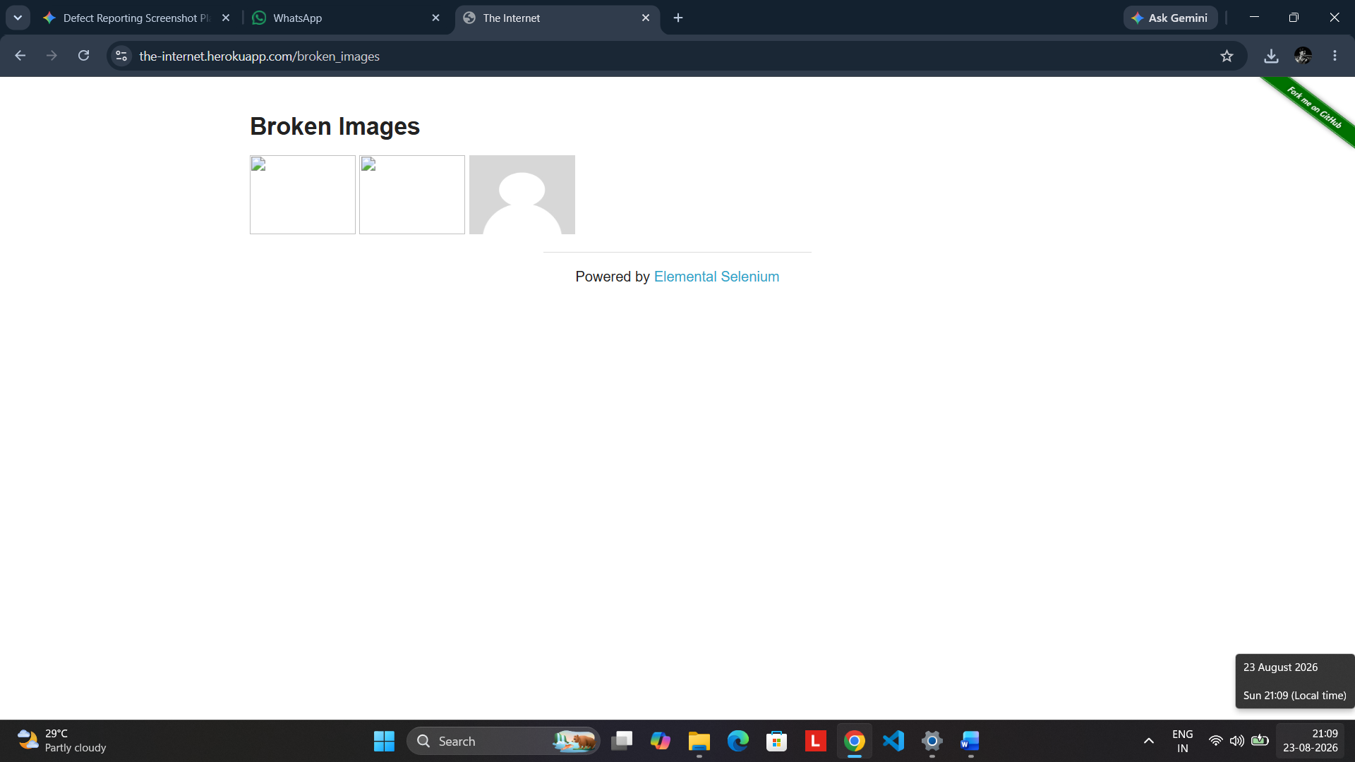
Caption: The Internet application's “Broken Images” module is opened in Google Chrome. The complete page is captured with the address bar visible, and the image area clearly shows missing/broken image indicators. This screenshot establishes the initial test condition and confirms that the defect can be observed directly in the application.
Test/Defect Detail: Test Objective: Verify whether image resources on the Broken Images page are rendered correctly.
Actual Observation: Observed Result: Multiple image elements display broken/missing-image indicators instead of the intended image content.
Evidence: Evidence Type: Functional UI / Defect Reproduction

Screenshot 2 — Broken Image Inspection / DevTools Evidence
Evidence 2 of 3
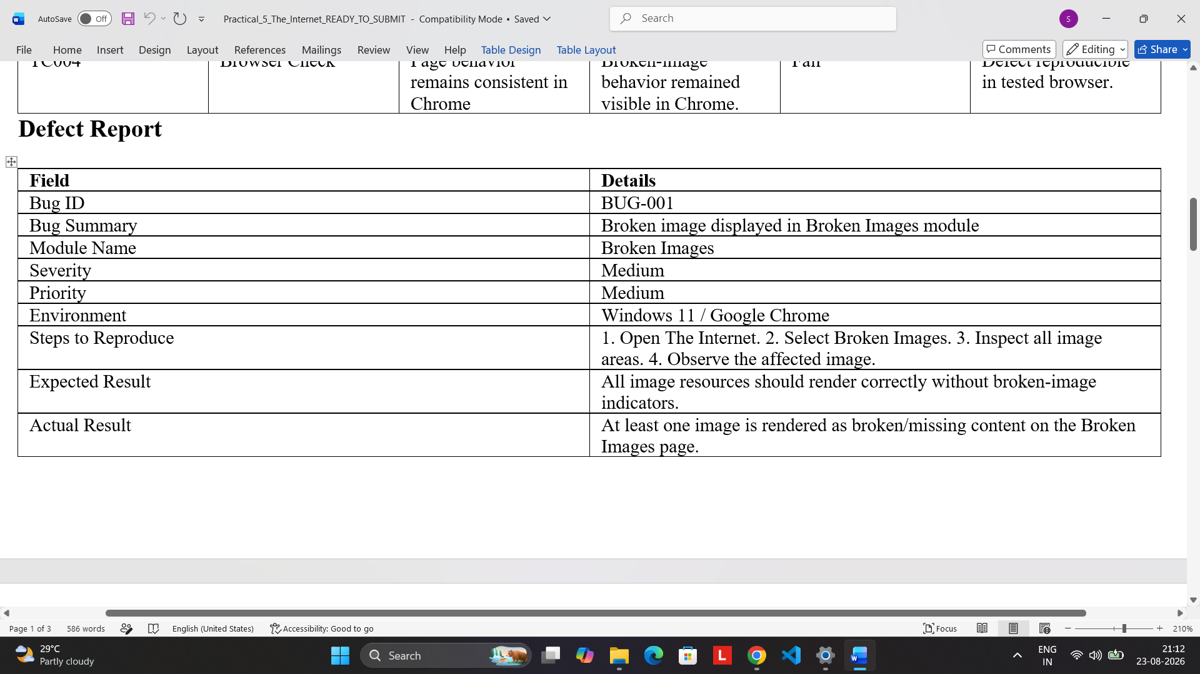
Caption: The affected image area is inspected closely while Chrome Developer Tools are open. The screenshot provides technical evidence of the affected page element and confirms that the broken-image behavior is visible during inspection.
Test/Defect Detail: Test Objective: Examine the affected image element and provide supporting technical evidence for the reported defect.
Actual Observation: Observed Result: The affected image region remains visibly broken, providing clear evidence of the rendering failure.
Evidence: Evidence Type: Defect Verification / Technical Inspection

Screenshot 3 — BUG-001 Defect Report
Evidence 3 of 3
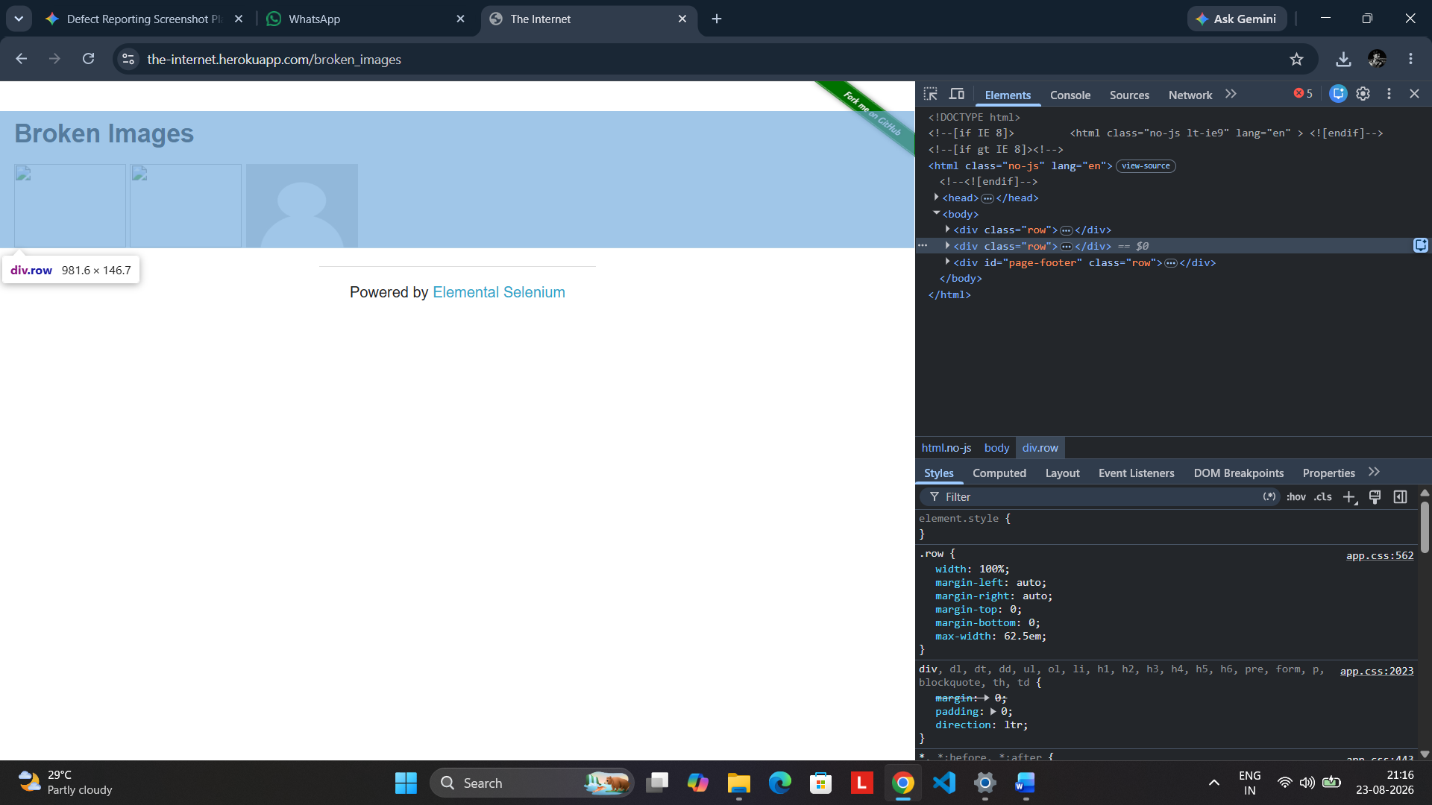
Caption: The completed BUG-001 defect report records the defect summary, module, severity, priority, environment, reproduction steps, expected result, and actual result. The report provides the formal documentation required to communicate the defect clearly.
Test/Defect Detail: Defect ID: BUG-001 | Summary: Broken image displayed in Broken Images module | Severity: Medium | Priority: Medium
Actual Observation: Environment: Windows 11 / Google Chrome. Actual Result: At least one image is rendered as broken/missing content on the Broken Images page.
Evidence: Evidence Type: Defect Documentation / Reporting

Final Practical Output
Defect Summary: BUG-001 — Broken image displayed in the Broken Images module.
Module | Broken Images
Severity | Medium
Priority | Medium
Environment | Windows 11 / Google Chrome
Steps to Reproduce | 1. Open The Internet. 2. Select Broken Images. 3. Inspect the image areas. 4. Observe the affected image.
Expected Result | All image resources should render correctly without broken-image indicators.
Actual Result | At least one image is rendered as broken/missing content on the Broken Images page.
Final Status | FAIL — Defect successfully reproduced and documented.
Final Outcome: The broken-image defect was successfully reproduced in the tested environment, technically inspected, documented as BUG-001, and supported with screenshot evidence. The defect should be assigned for correction and retested after the image resources are fixed.
Conclusion: Defect Identified → Reproduced → Inspected → Reported → Ready for Retesting

