SOFTWARE TESTING PRACTICAL
SauceDemo Login Functionality — Test Case Execution
Screenshot Evidence & Execution Summary
Application | SauceDemo / Swag Labs
Module | Login / Authentication
Test Cases | TC001–TC006
Environment | Windows 11 / Google Chrome
Test Type | Functional + Negative + Validation Testing
Evidence | 6 captured screenshots
Objective: Verify successful authentication, rejection of invalid credentials, and required-field validation on the SauceDemo login page.

Test Case Execution Summary
ID | Scenario | Test Data | Expected / Observed Result | Status
TC001 | Valid Login | standard_user / secret_sauce | Products page /inventory.html | PASS
TC002 | Invalid Password | standard_user / 12345 | Invalid-credentials error | PASS
TC003 | Invalid Username | student / secret_sauce | Invalid-credentials error | PASS
TC004 | Blank Username | blank / secret_sauce | Username is required | PASS
TC005 | Blank Password | standard_user / blank | Password is required | PASS
TC006 | Both Fields Blank | blank / blank | Username is required | Not captured
Note on TC006: The supplied evidence contains six screenshots and does not include a separate TC006 screenshot with both fields blank. The documented expected behavior is that the application should show “Epic sadface: Username is required.” No screenshot evidence has been invented.

Screenshot 1 — SauceDemo Login Page
Evidence 1 of 6
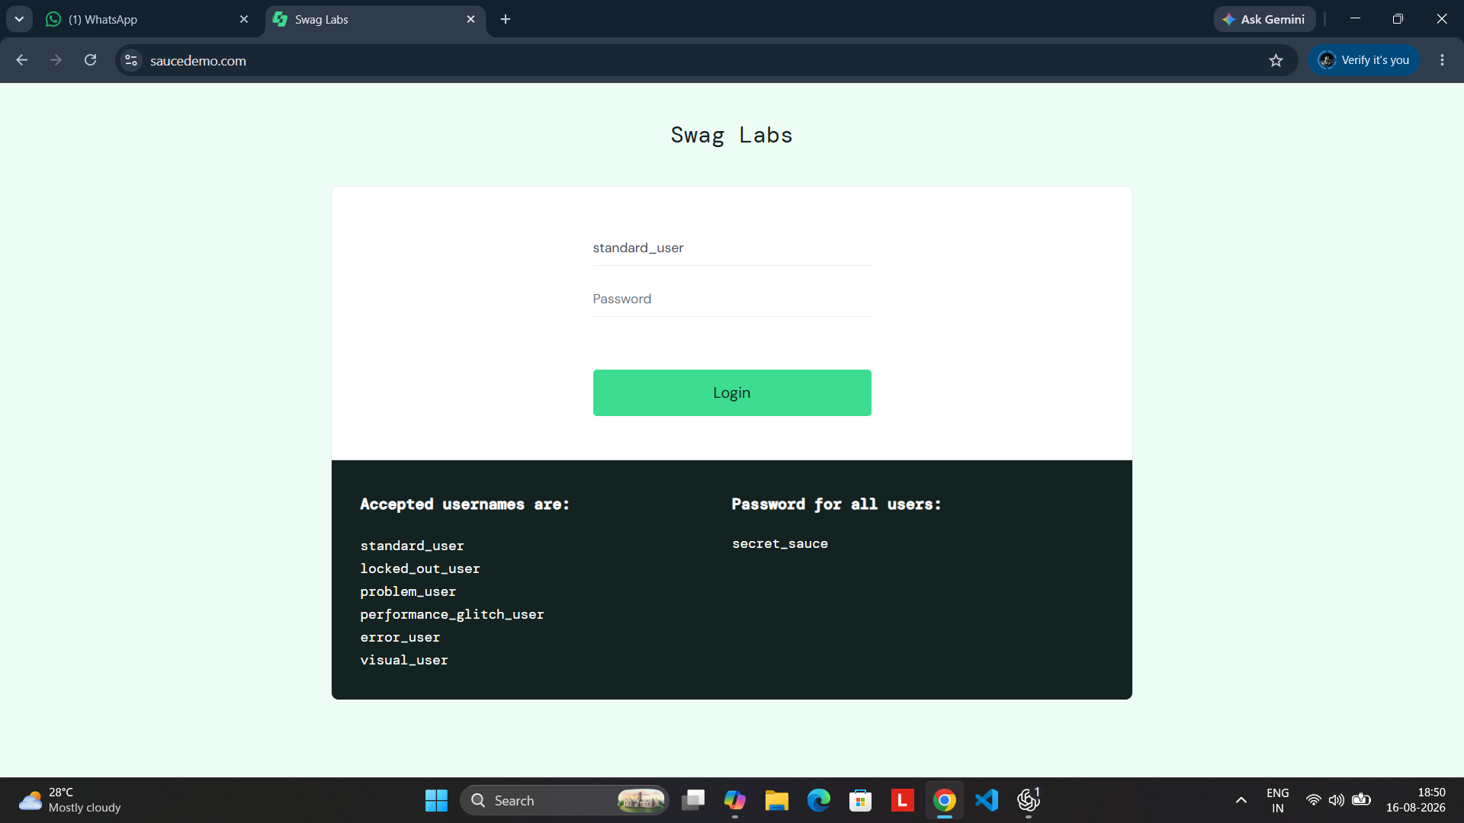
Caption: Initial state before test execution. The SauceDemo login interface is displayed with the Username field, Password field, Login button and browser address bar visible.
Test Detail: Purpose: Establish the baseline login screen before executing the authentication test cases.

Screenshot 2 — TC001 Successful Login
Evidence 2 of 6
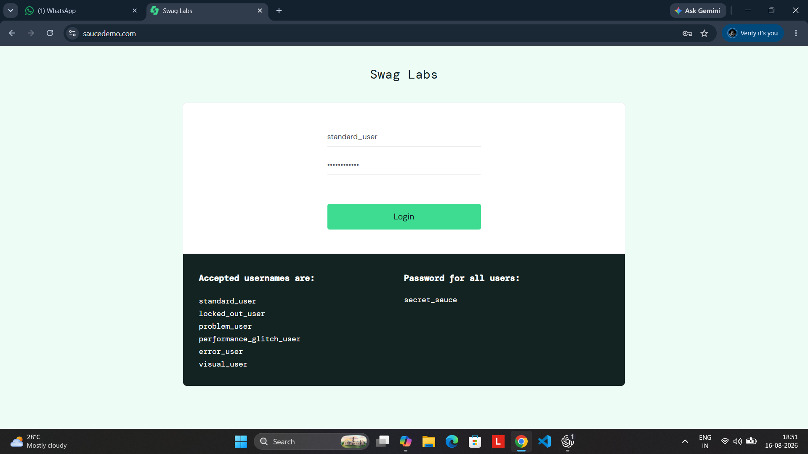
Caption: The valid credentials standard_user and secret_sauce are accepted and the application navigates to the Products/Inventory page. The browser URL shows /inventory.html.
Test Detail: Expected Result: Valid credentials should authenticate the user and open the Products page. Actual Result: Authentication succeeded and the inventory page was displayed. Status: PASS.

Screenshot 3 — TC002 Invalid Password
Evidence 3 of 6
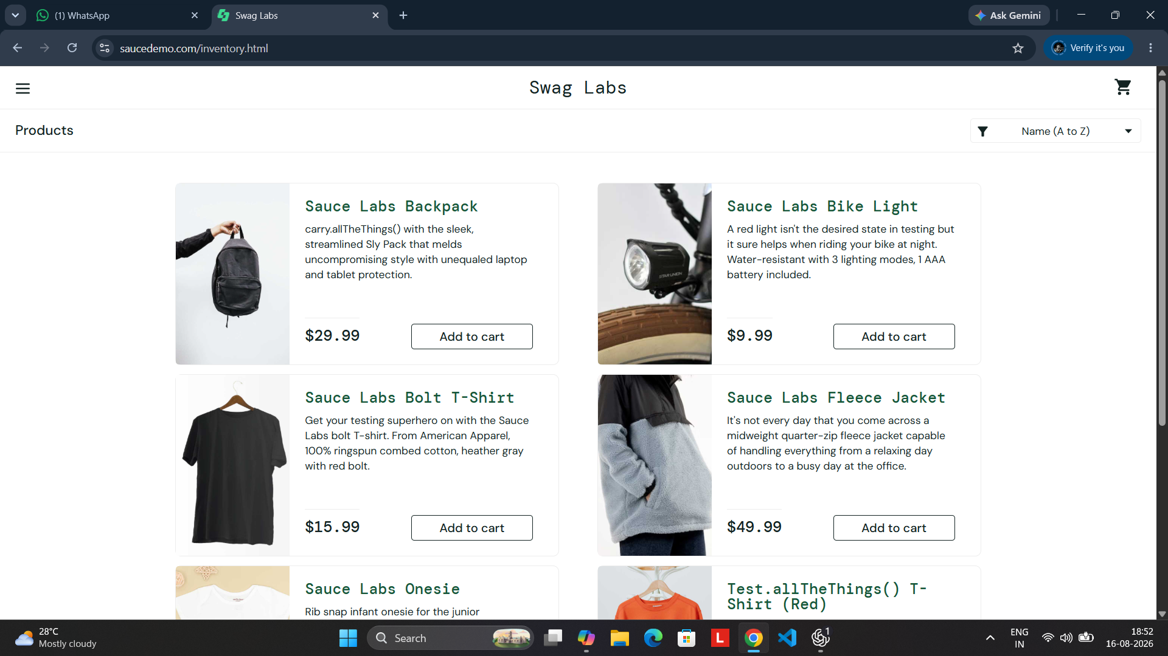
Caption: An invalid password is entered for standard_user. The application remains on the login page and displays the red invalid-credentials error message.
Test Detail: Test Data: Username = standard_user; Password = 12345. Expected Result: Login should be rejected with a clear error. Actual Result: Invalid-credentials message displayed. Status: PASS.

Screenshot 4 — TC003 Invalid Username
Evidence 4 of 6
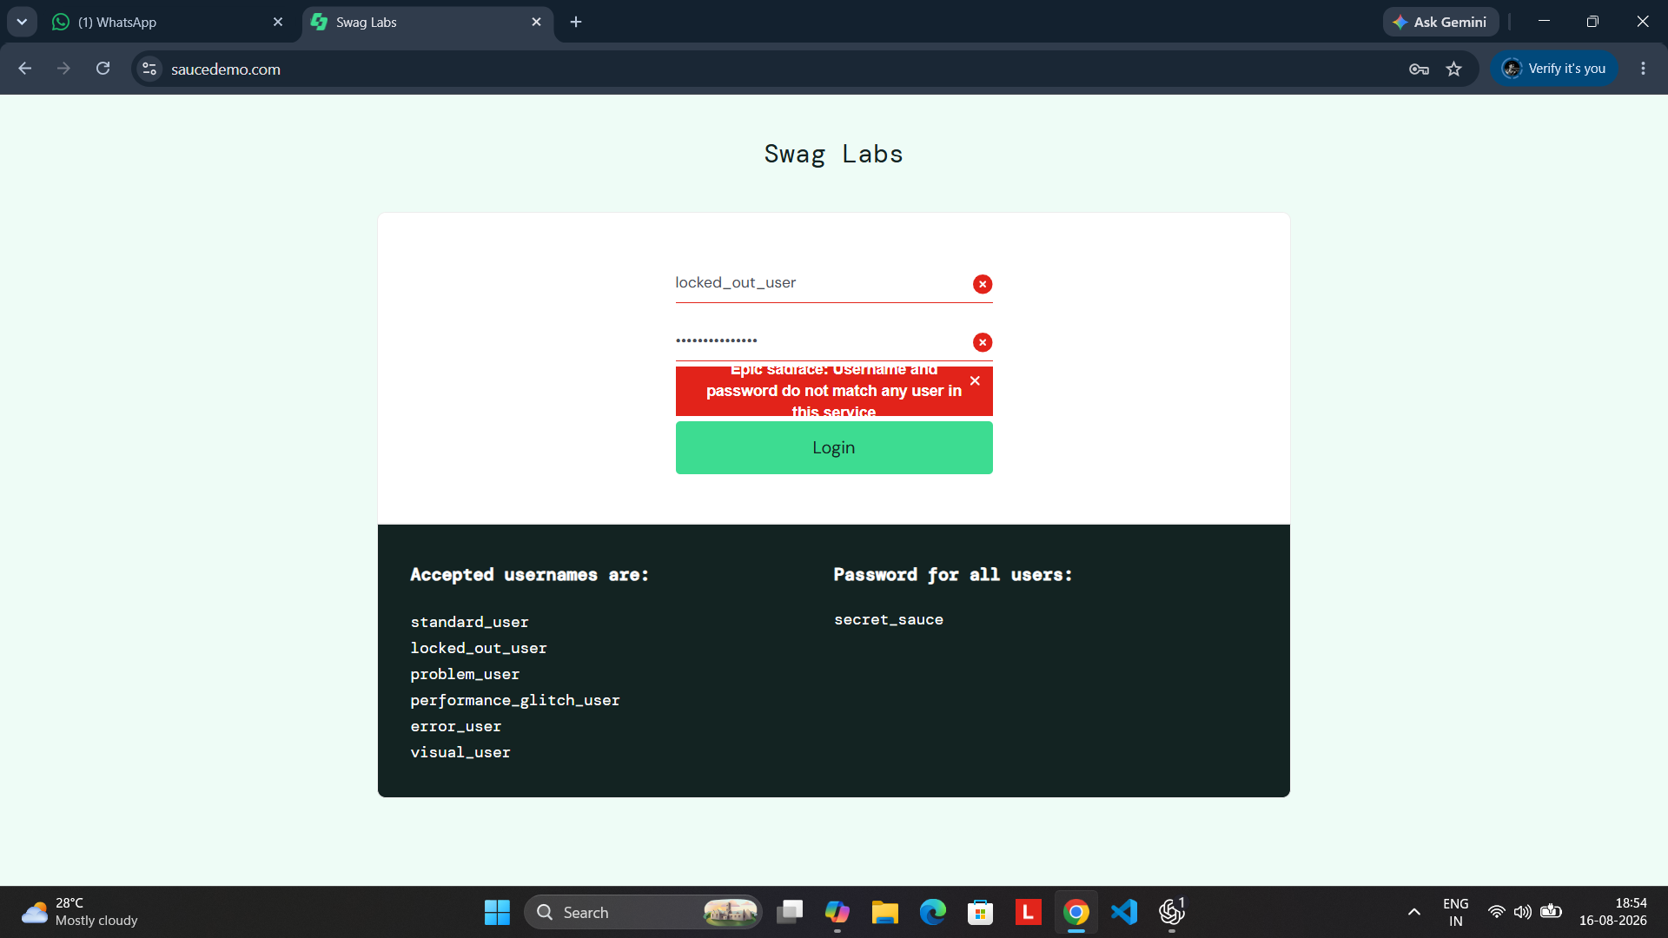
Caption: An unregistered username is tested with the valid SauceDemo password. The login page displays the red invalid-credentials message.
Test Detail: Test Data: Username = student; Password = secret_sauce. Expected Result: Login should be rejected. Actual Result: Invalid-credentials message displayed. Status: PASS.

Screenshot 5 — TC004 Blank Username Validation
Evidence 5 of 6
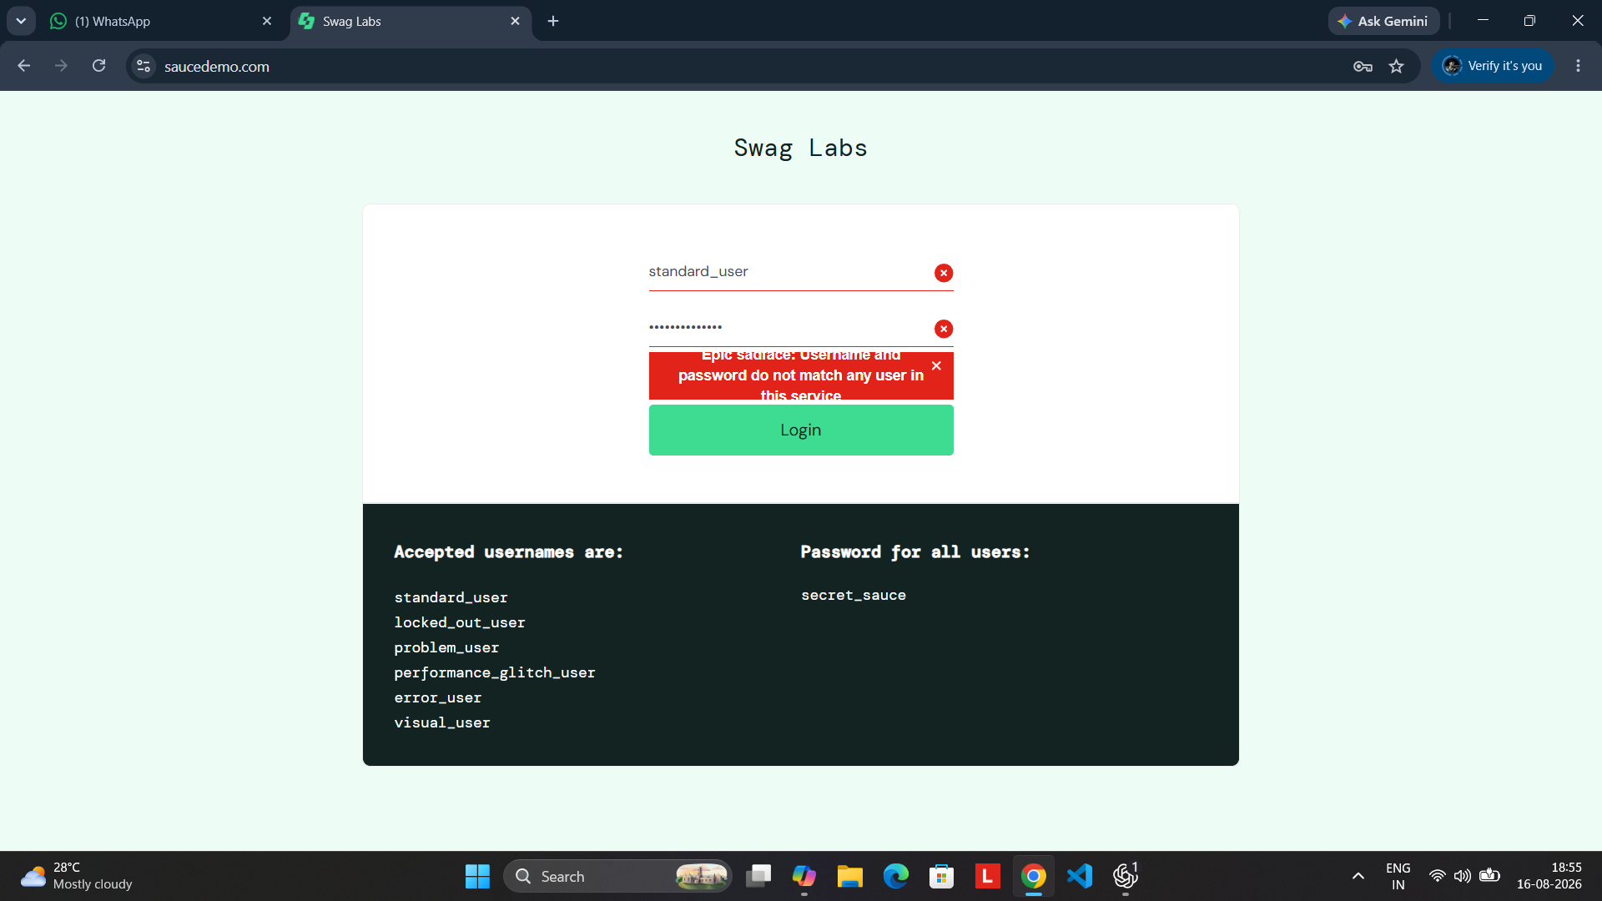
Caption: The username field is left blank while a password is entered. The application displays the red validation message indicating that the username is required.
Test Detail: Test Data: Username = blank; Password = secret_sauce. Expected Result: Required-field validation should appear. Actual Result: “Epic sadface: Username is required” is displayed. Status: PASS.

Screenshot 6 — TC005 Blank Password Validation
Evidence 6 of 6
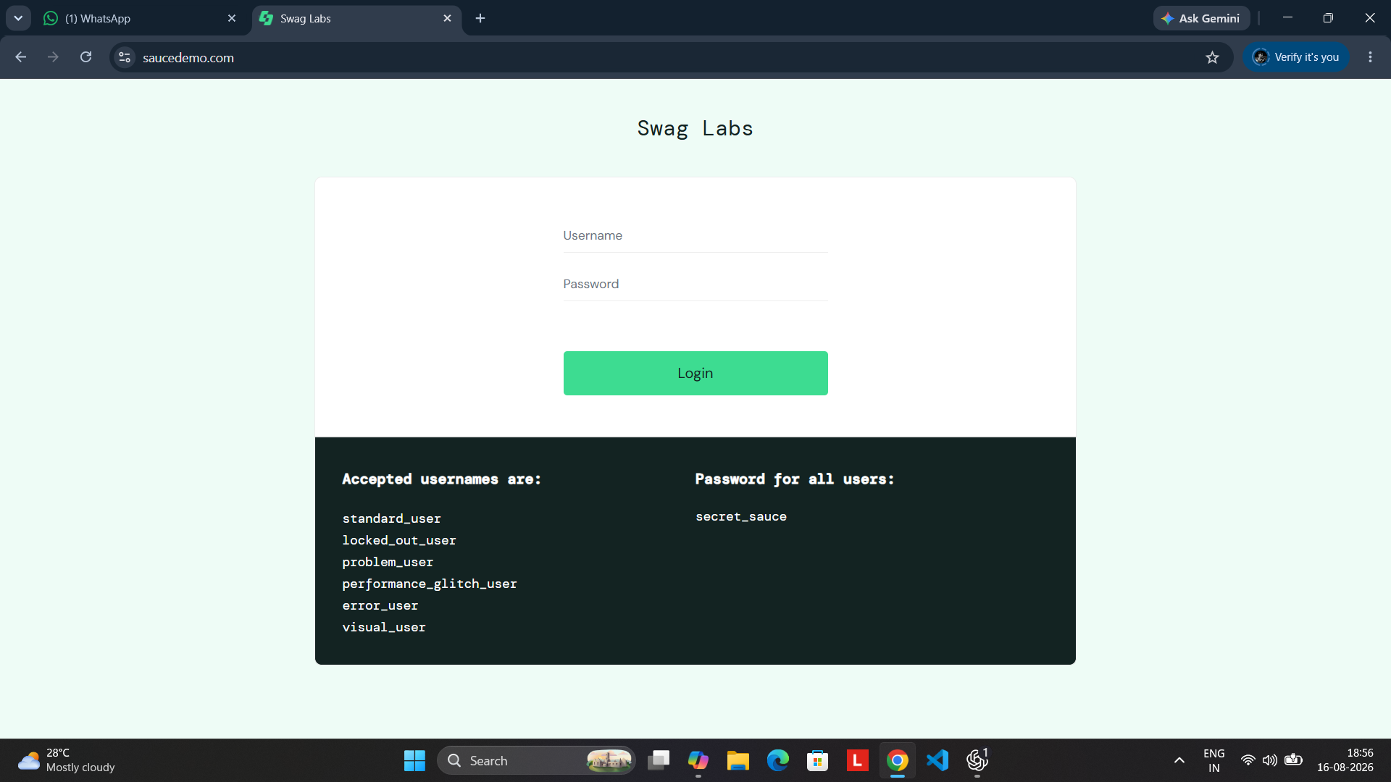
Caption: The valid username is entered while the password is left blank. The application displays the red validation message indicating that the password is required.
Test Detail: Test Data: Username = standard_user; Password = blank. Expected Result: Required-field validation should appear. Actual Result: “Epic sadface: Password is required” is displayed. Status: PASS.

Final Practical Output
Overall Objective | Validate SauceDemo login authentication and input validation.
Positive Test | TC001 successfully opened the Products/Inventory page.
Negative Tests | TC002 and TC003 correctly rejected invalid credentials.
Validation Tests | TC004 and TC005 correctly displayed required-field errors.
TC006 | Both fields blank: expected Username-required validation; separate screenshot not supplied.
Overall Evidence | 6 screenshots captured and documented with captions.
Final Outcome | PASS for all executed/evidenced test cases; TC006 remains to be captured separately.
Conclusion: The SauceDemo login module was tested using positive, negative and boundary/required-field scenarios. The supplied screenshots provide clear evidence for TC001–TC005. TC006 is documented without fabricated evidence and can be completed by capturing one additional screenshot with both fields blank.

