SOFTWARE TESTING PRACTICAL
Boundary Value Analysis (BVA) & Equivalence Partitioning (EP)
CodePen Login & Sign Up Form — Username Validation
Screenshot Evidence • Test Execution • Final Results
Application / Module | CodePen Login & Sign Up Form — Username field
Testing Techniques | Boundary Value Analysis (BVA) and Equivalence Partitioning (EP)
Valid Input Range | 5–15 characters; lowercase letters and digits
Invalid Classes | Below minimum (<5) and above maximum (>15)
Test Cases | TC01–TC06
Environment | Google Chrome / Windows desktop
Overall Result | 6/6 test cases PASS

Testing Objective
Objective: Verify that the Username field correctly accepts values within the defined 5–15 character range and rejects values outside the range. The selected test cases cover the lower invalid partition, lower boundary, valid interior values, upper boundary, and upper invalid partition.
BVA / EP Test Design
Equivalence partitions: Invalid below 5 characters; valid 5–15 characters; invalid above 15 characters.
Boundary values: 4, 5, 6, 14, 15 and 16 characters were selected to demonstrate the behavior around both boundaries.

Final BVA / EP Execution Table
TC ID | Technique | Test Input | Expected Result | Actual Result | Status
TC01 | EP / BVA | abcd (4 chars) | Username rejected (does not meet minimum pattern) | Validation indicates pattern/length requirement | PASS
TC02 | BVA | abcde (5 chars) | Username accepted (minimum boundary) | 5-character value accepted | PASS
TC03 | BVA | abcdef (6 chars) | Username accepted | 6-character value accepted | PASS
TC04 | BVA | abcdefghijknmn (14 chars) | Username accepted | 14-character value accepted | PASS
TC05 | BVA | abcdefghijklmno (15 chars) | Username accepted (maximum boundary) | 15-character value accepted | PASS
TC06 | BVA | abcdefghijklmnop (16 chars) | 16th character rejected (maximum 15 allowed) | Field retains maximum 15 characters | PASS
Execution summary: All six supplied test cases passed. The evidence confirms rejection below the minimum, acceptance at and within the valid range, and enforcement of the 15-character maximum.

Screenshot Evidence
Screenshot 1 — Initial CodePen Login & Sign Up Form
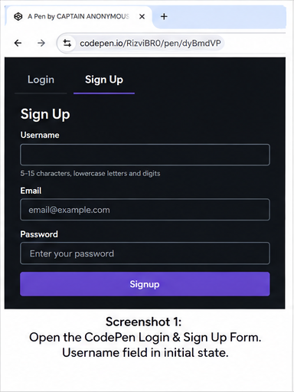
Details: Initial state of the CodePen Login & Sign Up form. The Username field is visible with the surrounding form and browser address bar, establishing the baseline for username validation testing.
Screenshot 2 — Below-Minimum Username Validation
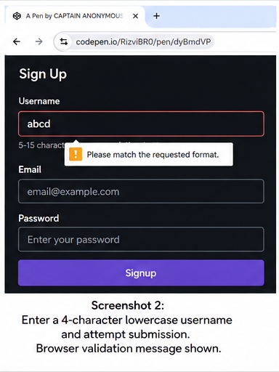
Details: A 4-character lowercase username is submitted. Browser validation indicates that the value does not satisfy the required pattern/length, confirming rejection below the minimum boundary.
Screenshot 3 — Minimum Boundary: 5 Characters
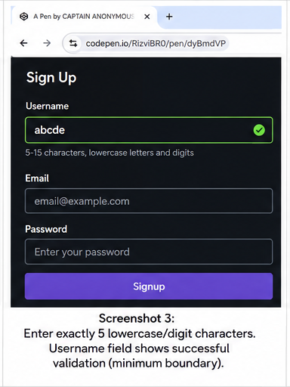
Details: Exactly 5 lowercase/digit characters are entered. The Username field shows a successful validation state, confirming acceptance at the minimum boundary.
Screenshot 4 — 6-Character Accepted Input
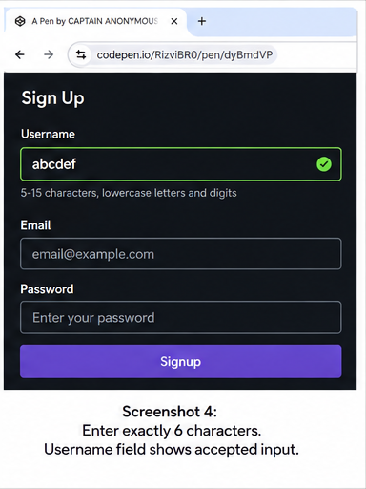
Details: Exactly 6 characters are entered. The Username field remains in a successful validation state, confirming acceptance for a valid value above the minimum.

Screenshot Evidence
Screenshot 5 — 14-Character Accepted Input
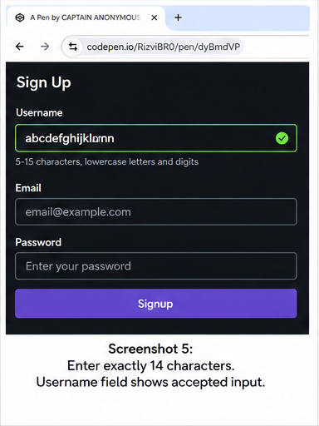
Details: Exactly 14 characters are entered. The Username field shows accepted input, confirming that values well inside the valid range are permitted.
Screenshot 6 — Maximum Boundary: 15 Characters
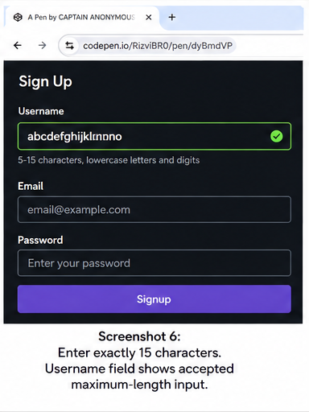
Details: Exactly 15 characters are entered. The Username field shows the accepted maximum-length input, confirming the upper boundary of the allowed range.
Screenshot 7 — Above-Maximum Input Rejected
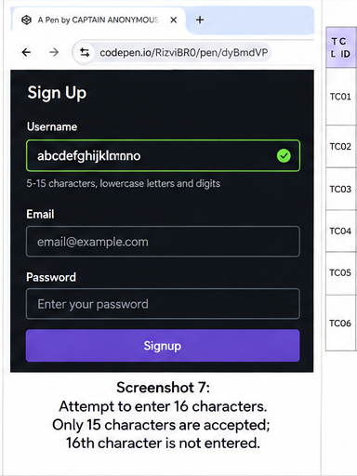
Details: An attempt is made to enter 16 characters. The field accepts only the first 15 characters, demonstrating that the maximum-length constraint prevents the 16th character from being entered.
Screenshot 8 — Completed BVA/EP Execution Table
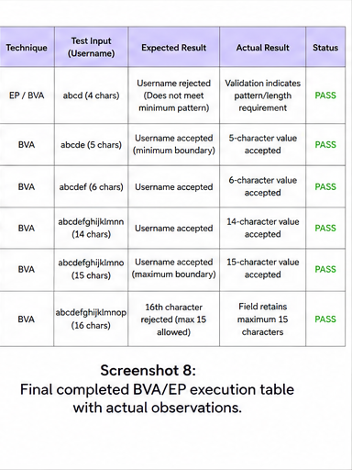
Details: The completed BVA/EP execution table records the test input, expected result, actual observation and PASS status for all six boundary/equivalence cases.

Final Practical Output & Conclusion
Result: PASS — all 6 BVA/EP test cases were executed successfully according to the supplied evidence.
TC01 — The 4-character value is rejected because it is below the minimum length.
TC02 — The 5-character value is accepted at the minimum boundary.
TC03 — The 6-character value is accepted as a valid near-boundary input.
TC04 — The 14-character value is accepted within the valid range.
TC05 — The 15-character value is accepted at the maximum boundary.
TC06 — The 16th character is not accepted, enforcing the 15-character maximum.
Conclusion: The username validation behaves correctly across the selected equivalence classes and boundary values. The test evidence demonstrates that the field rejects 4 characters, accepts 5–15 characters, and prevents entry beyond 15 characters. Therefore, the tested validation requirement is verified.

