SOFTWARE TESTING PRACTICAL
OrangeHRM Login Module — TestLink & Bugzilla
Test Design • Execution • Defect Reporting • Retesting
Evidence-based practical prepared from the supplied screenshots
Application Under Test | OrangeHRM — Login / Authentication module
Test Management Tool | TestLink
Defect Tracking Tool | Bugzilla
Test Plan | OrangeHRM Login Module Testing
Test Suite | Authentication Testing
Test Cases | TC001–TC004
Execution Result | 4/4 test cases PASS in supplied TestLink evidence
Environment | Browser-based OrangeHRM instance; TestLink/Bugzilla evidence as supplied
Objective
Objective: Verify the OrangeHRM login module for valid authentication, incorrect-password handling, blank-username validation, and blank-password validation. Manage the test cases through TestLink and document any genuine reproducible defect in Bugzilla, followed by retesting after a fix.
Test Scenarios
TC001: Valid username + valid password. Expected: Dashboard/home page displayed. Actual: Successful login; OrangeHRM dashboard displayed. Status: PASS.
TC002: Valid username + incorrect password. Expected: Login rejected with an authentication error. Actual: “Invalid credentials” message displayed. Status: PASS.
TC003: Blank username + valid password. Expected: Username required validation displayed. Actual: “Username is required” displayed. Status: PASS.
TC004: Valid username + blank password. Expected: Password required validation displayed. Actual: “Password is required” displayed. Status: PASS.

TestLink Test Case Execution
TC ID | Test Input / Scenario | Expected Result | Actual Result | Status
TC001 | Valid username + valid password | Dashboard/home page displayed | Successful login; OrangeHRM dashboard displayed | PASS
TC002 | Valid username + incorrect password | Login rejected with an authentication error | “Invalid credentials” message displayed | PASS
TC003 | Blank username + valid password | Username required validation displayed | “Username is required” displayed | PASS
TC004 | Valid username + blank password | Password required validation displayed | “Password is required” displayed | PASS
Execution Summary
Overall result: PASS — the supplied TestLink execution evidence shows TC001, TC002, TC003 and TC004 as Pass.
Key observations: Valid credentials reach the authenticated dashboard; incorrect credentials are rejected; the form reports the required-field validation messages when Username or Password is blank.
Defect Management Note
Important: The supplied evidence includes Bugzilla screens for a login defect. Because the same supplied execution evidence shows TC001 as PASS, the Bugzilla defect should be treated as a genuine defect only if the failure was independently reproduced with the same valid credentials and environment. The report below is therefore documented as the supplied defect workflow evidence rather than an assertion that a new defect must exist.

Screenshot Evidence — Test Setup & Execution
Screenshot 1 — OrangeHRM Login Page
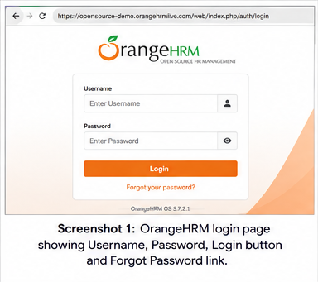
Details: Initial OrangeHRM authentication screen showing Username, Password, Login and Forgot Password controls, with the browser address bar visible.
Screenshot 2 — TestLink Project Created
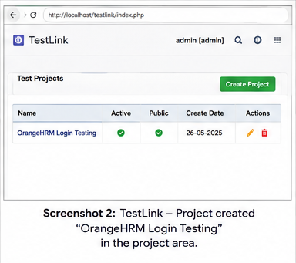
Details: TestLink project area showing the created project “OrangeHRM Login Testing”, establishing the project structure used for the authentication tests.
Screenshot 3 — TestLink Test Plan & Test Suite
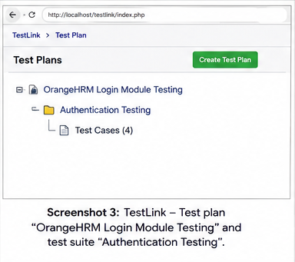
Details: TestLink Test Plan view showing “OrangeHRM Login Module Testing” with the “Authentication Testing” suite.
Screenshot 4 — TestLink Test-Case List
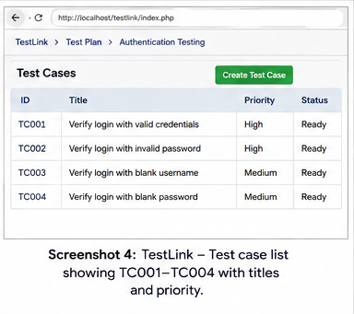
Details: TestLink test-case list showing TC001–TC004 and their authentication scenarios/priorities.
Screenshot 5 — TC001 Successful Login
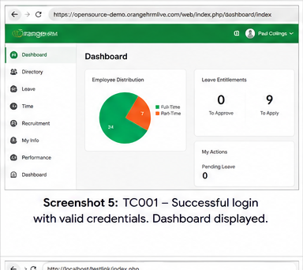
Details: TC001 execution with valid credentials. The supplied evidence shows successful authentication and the OrangeHRM dashboard.
Screenshot 6 — TC002 Invalid Password
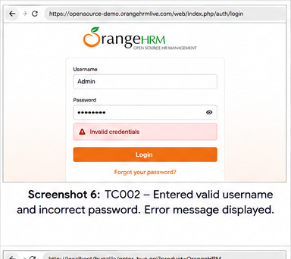
Details: TC002 execution with a valid username and intentionally incorrect password. The supplied evidence shows an “Invalid credentials” message.
Screenshot 7 — TC003 Blank Username
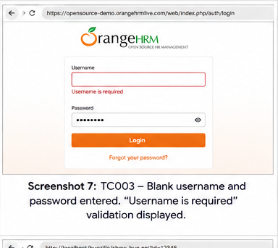
Details: TC003 execution with Username left blank and Password populated. The supplied evidence shows “Username is required”.
Screenshot 8 — TC004 Blank Password
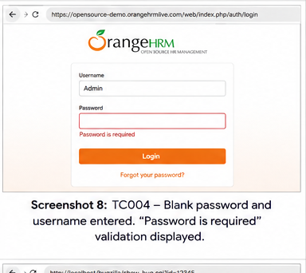
Details: TC004 execution with Username populated and Password left blank. The supplied evidence shows “Password is required”.

Screenshot Evidence — Execution & Defect Workflow
Screenshot 9 — TestLink Execution Results
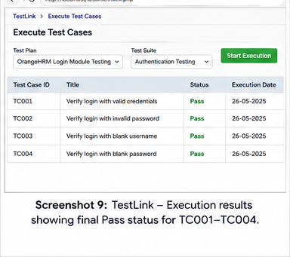
Details: TestLink execution-results screen showing the final Pass status for TC001–TC004.
Screenshot 10 — Bugzilla New Bug
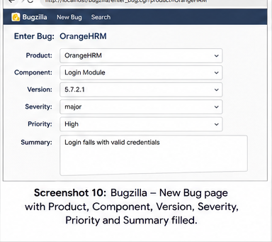
Details: Bugzilla New Bug screen with Product, Component, Version, Severity, Priority and Summary fields populated for a reported login defect.
Screenshot 11 — Bugzilla Saved Defect
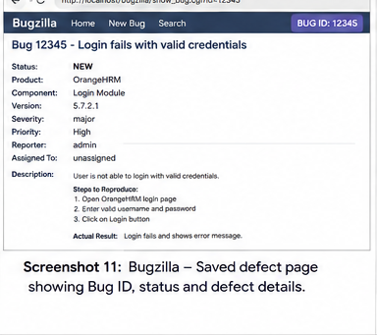
Details: Saved Bugzilla defect record showing generated Bug ID, status and reproduction/defect details.
Screenshot 12 — Bugzilla Retest / Verification
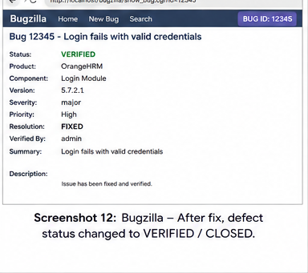
Details: Bugzilla record after fix/retest, showing the supplied verification/closure evidence.

Final Practical Output
Defect Reporting & Retest Summary
Bug ID | 12345 (as shown in supplied Bugzilla evidence)
Product | OrangeHRM
Component | Login Module
Version | 5.7.2.1
Severity | major
Priority | High
Summary | Login fails with valid credentials
Status in supplied workflow | NEW → VERIFIED / CLOSED after fix, as shown
Conclusion
Conclusion: The OrangeHRM authentication module was organized and tested through TestLink using four core scenarios: successful login, invalid password, blank username and blank password. The supplied execution evidence records all four test cases as PASS. The screenshots also demonstrate a complete defect-management workflow in Bugzilla, including defect creation, saved defect details and post-fix verification. Any Bugzilla defect should be retained as a genuine finding only when the failure is reproducible under the stated test conditions.

