PRACTICAL 9
Black-Box and White-Box Testing
OrangeHRM – Login Module Screenshot Evidence
Application Under Test | OrangeHRM Open Source Demo
Module Tested | Login Module
Testing Focus | Black-Box functional validation and supporting source/structure inspection
Evidence Provided | 6 screenshots captured during practical execution

Aim
To perform Black-Box and White-Box testing activities on the OrangeHRM Login Module, including valid-login, invalid-login, blank-field validation, and source/structure inspection.

Screenshot Evidence Mapping
Screenshot | Testing Activity | Evidence
9.1 | Initial login screen | Login form available for testing
9.2 | Positive / valid login | Dashboard opened successfully
9.3 | Negative / invalid login | Invalid credentials message displayed
9.4 | Boundary / validation check | Username marked Required
9.5 | Boundary / validation check | Password marked Required
9.6 | White-Box supporting inspection | Login-page source visible in DevTools

Captured Screenshots with Suitable Captions
Figure 9.1: OrangeHRM Login Page
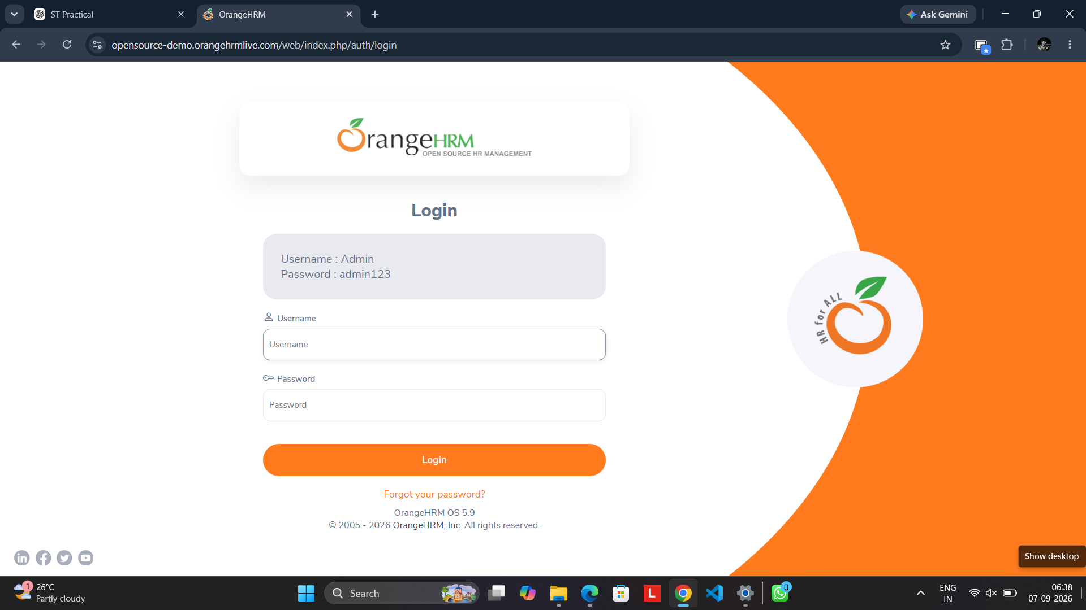
Initial OrangeHRM login screen showing the Username and Password fields and Login button before test credentials are entered.

Figure 9.2: Successful Login and Dashboard
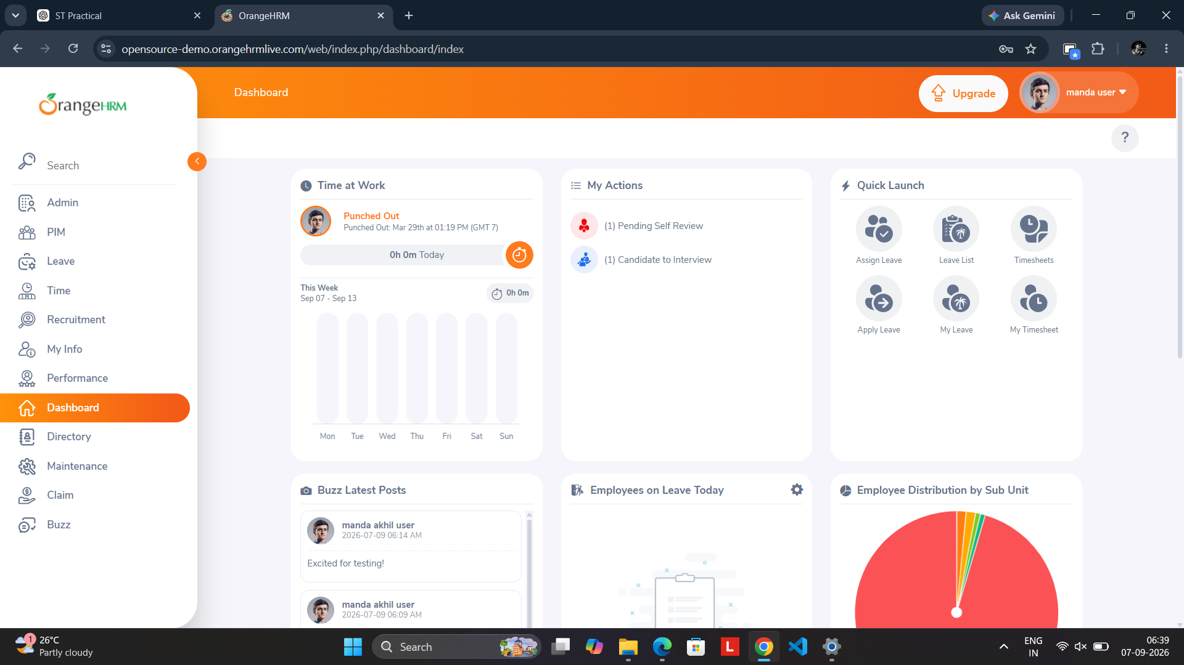
Successful login result showing the OrangeHRM Dashboard, confirming that valid credentials allow access to the application.

Figure 9.3: Invalid Credentials Validation
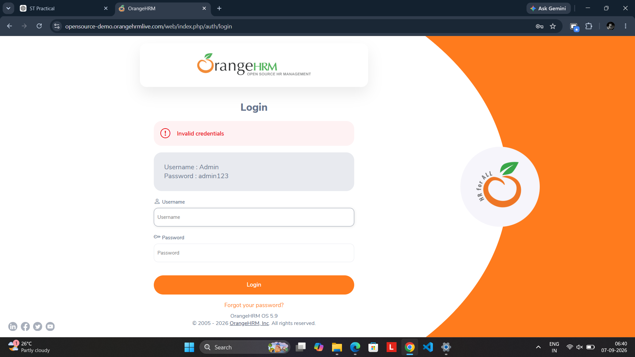
Negative test result showing the “Invalid credentials” message after an unsuccessful login attempt.

Figure 9.4: Blank Username Validation
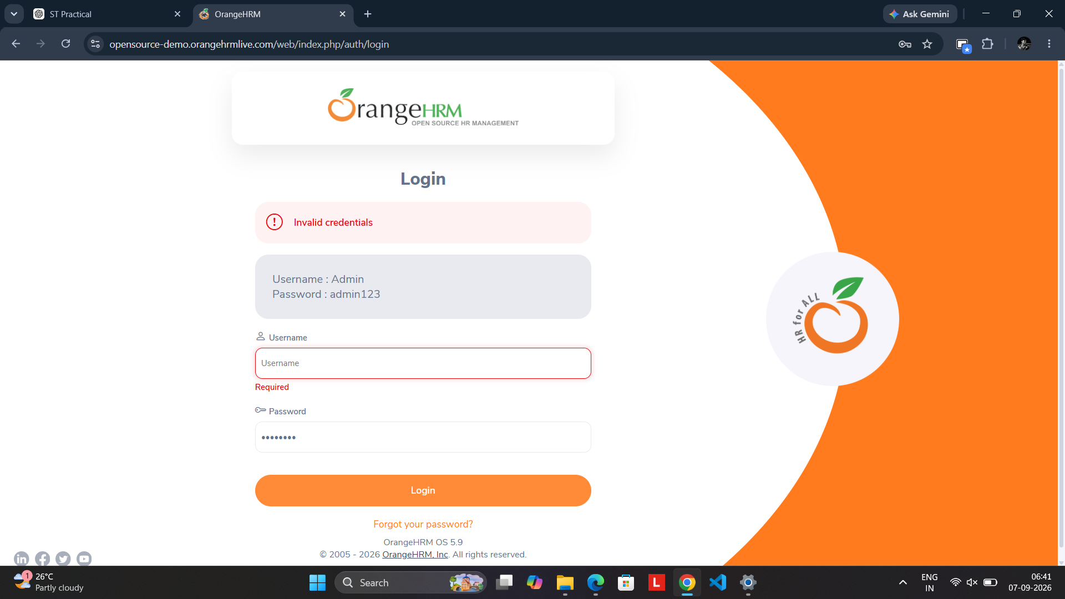
Negative test result showing the Username field highlighted with the “Required” validation message when the username is left blank.

Figure 9.5: Blank Password Validation
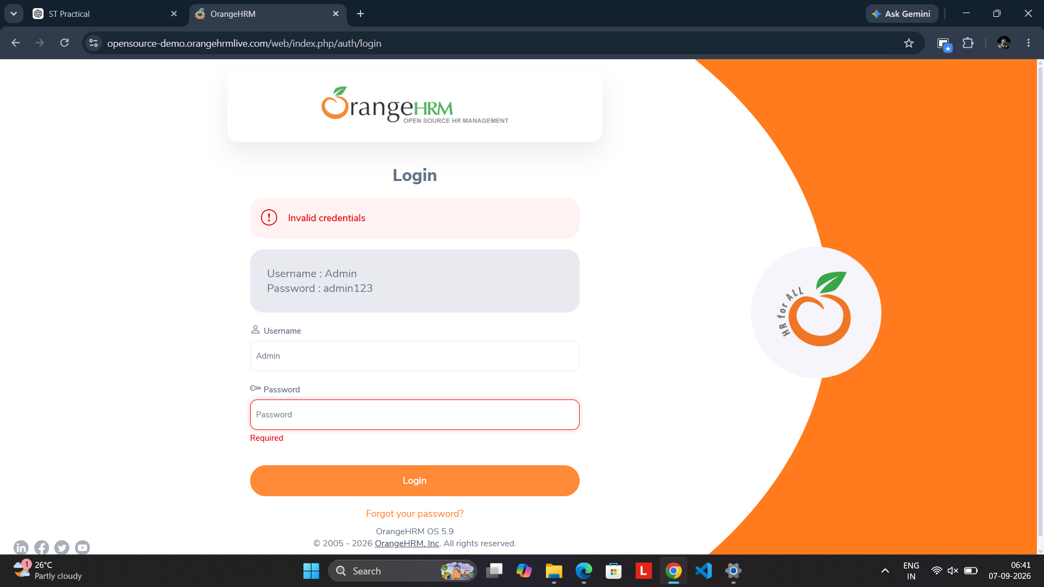
Negative test result showing the Password field highlighted with the “Required” validation message when the password is left blank.

Figure 9.6: Browser Source Inspection for Login Page
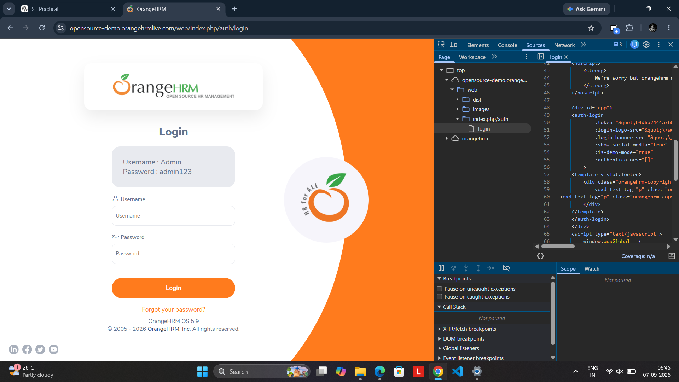
Chrome DevTools Sources panel displaying the loaded OrangeHRM login-page source, used as supporting evidence for structural/code inspection.

Observations
- The OrangeHRM login page provides Username and Password fields with a Login button.
- A valid login attempt reaches the OrangeHRM Dashboard.
- An invalid credential attempt is rejected with an “Invalid credentials” message.
- Leaving the Username field blank triggers a “Required” validation message.
- Leaving the Password field blank triggers a “Required” validation message.
- The Chrome DevTools Sources screenshot provides supporting evidence that the login-page client-side source/structure was inspected.

Final Result
The captured screenshots provide visual evidence for the executed OrangeHRM Login Module tests. The positive and negative login validations behaved as expected in the supplied evidence.
Note: Screenshot 9.6 is supporting source/structure inspection evidence from the browser. A complete White-Box test based on application source code requires access to the application's source code in a self-hosted/test environment; the browser DevTools view alone should not be presented as proof of full server-side white-box coverage.

