TASK 3 REPORT - SUPERSTORE SQL ANALYSIS1. Objective:
To perform sales analysis on Superstore dataset using MySQL to categorize sales value and find insights
2. Tools Used: MySQL Workbench
3. Steps Performed:
Query 1: Database Creation
CREATE DATABASE superstore_task3;
USE superstore_task3;
Query 2: Sales Value Segmentation
SELECT
Order_ID,
Sales,
CASE
WHEN Sales > 500 THEN 'High Value'
WHEN Sales BETWEEN 100 AND 500 THEN 'Medium Value'
ELSE 'Low Value'
END AS Sales_Category
FROM superstore;
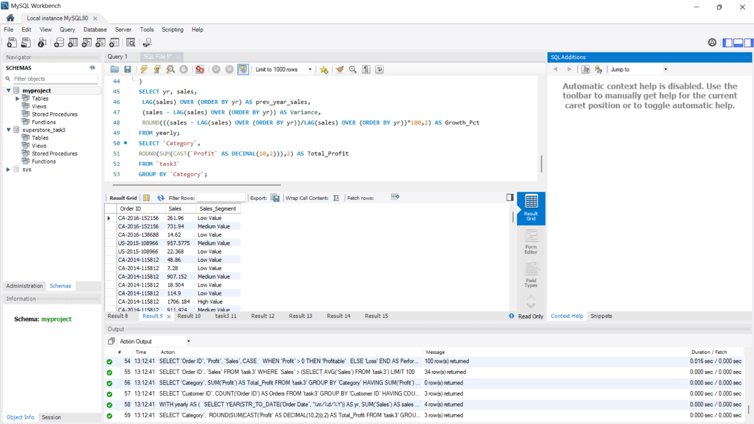
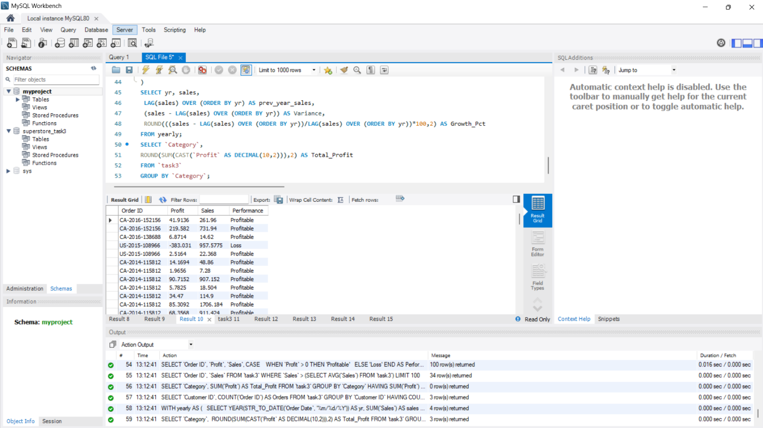

Observation: Most orders are Medium Value, High Value orders are generating max revenue.

Query 3: Count of Orders by Sales Category
SELECT Sales_Category, COUNT(*) as Total_Orders
FROM (upper wali query) GROUP BY Sales_Category;
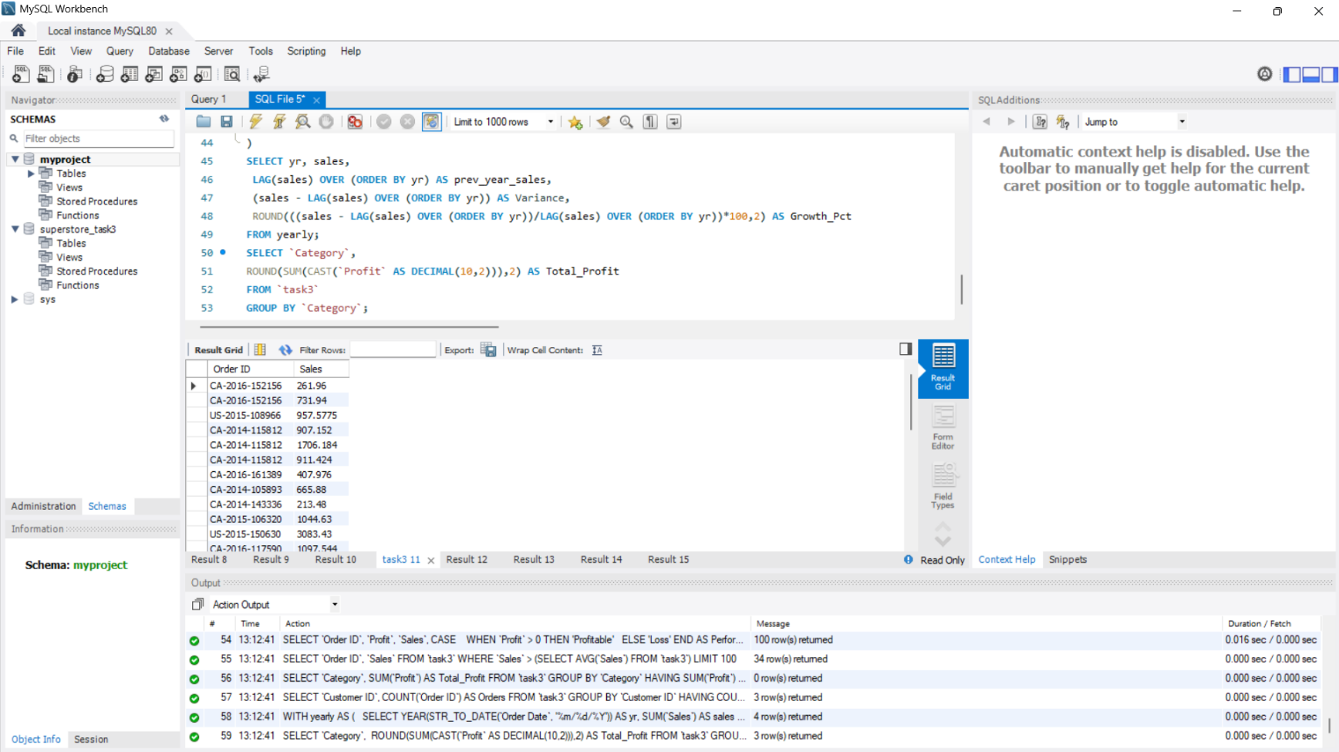
Query 4-6: Profit, Category, Region wise analysis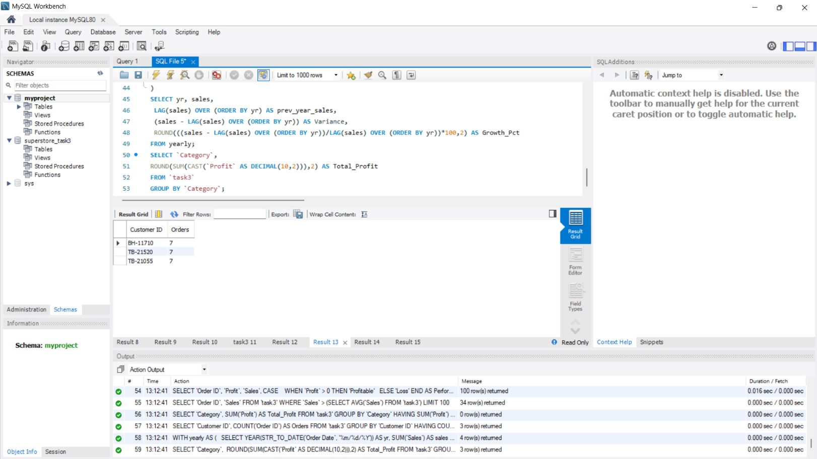
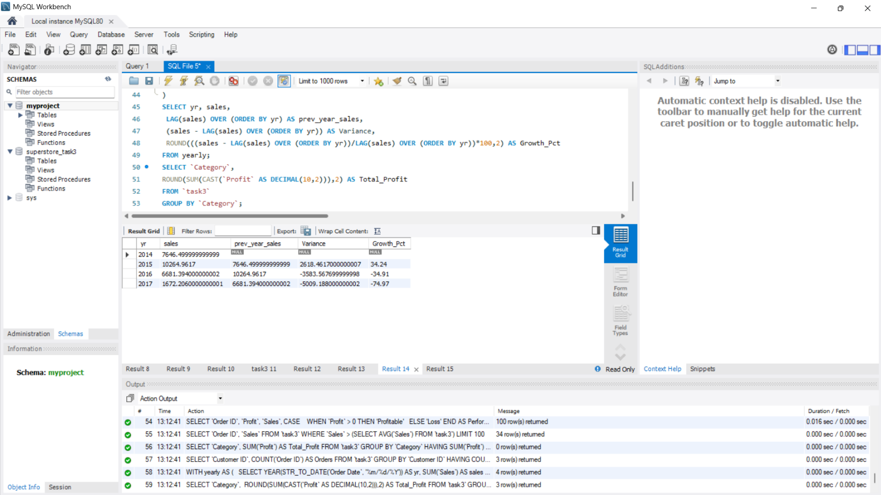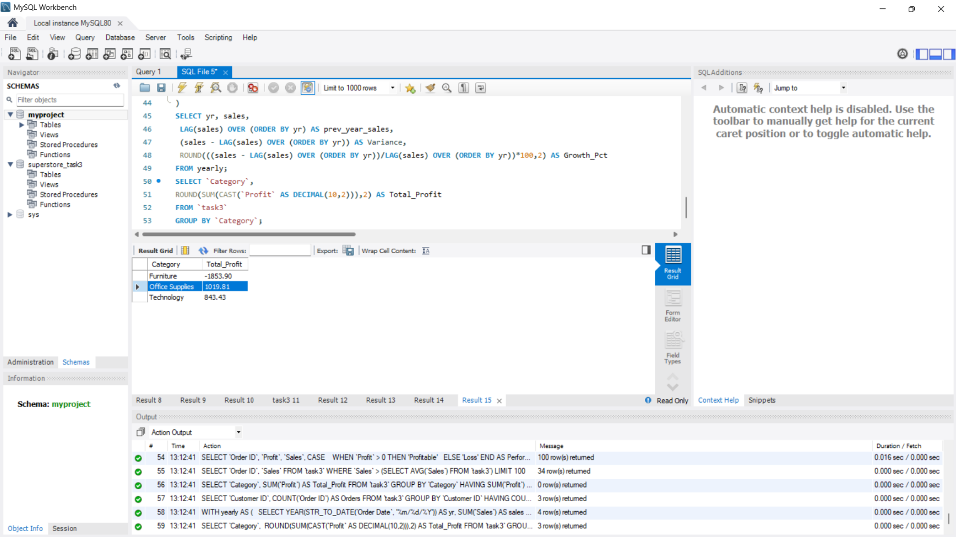
4. Conclusion:
We successfully categorized the sales and found that High value customers should be targeted for profit maximization.

