1a) i. Define variables & constants
In Java, variables are containers that store data in memory.
A constant is a value that does not change. It stays the same throughout a problem, experiment, or program.
a)ii. Define multidimensional arrays with example.
A multidimensional array in Java is an array of arrays. The most common type is the two-dimensional array, which you can think of as a table with rows and columns.
Syntax: datatype[][] arrayName; // 2D array
datatype[][][] arrayName; // 3D array
example:
public class MultiDimensionalArrayExample {
public static void main(String[] args) {
// Declaring and initializing a 2D array (3 rows, 3 columns)
int[][] matrix = {
{1, 2, 3},
{4, 5, 6},
{7, 8, 9}
};
a) iii) Explain in detail about java development environment.
1. Java Development Kit (JDK)
What it is:
The JDK is a software development kit that provides everything needed to develop Java applications.
Includes:
Java Compiler (javac) – converts Java code to bytecode
Java Runtime Environment (JRE)
Java Debugger (jdb)
JavaDoc tool – generates documentation
Tools for packaging (jar) and monitoring performance
🔸 2. Java Runtime Environment (JRE)
What it is:
The JRE is part of the JDK and allows you to run Java programs (but not develop or compile them).
Includes:
Java Virtual Machine (JVM)
Core Java class libraries
Supporting files

🔸 3. Java Virtual Machine (JVM)
What it is:
The JVM interprets or compiles Java bytecode (.class files) into machine code specific to the host operating system.
Key Features:
Platform independence
Memory management (garbage collection)
Security

🔸 4. Integrated Development Environment (IDE)
What it is:
A software application that provides an interface for writing, debugging, and running Java code.
Popular Java IDEs:
Eclipse – powerful and extensible
IntelliJ IDEA – intelligent code completion, preferred by professionals
NetBeans – Oracle-supported, easy for beginners
BlueJ / JGrasp – ideal for students
Features in an IDE:
Code editor with syntax highlighting
Autocomplete and suggestions
Debugger
GUI designers
Integration with build tools and version control

✅ 2. Java Development Workflow
Here’s how Java development typically flows:
Write Code – in a .java file using an IDE or text editor.
Compile Code – using the javac compiler to turn .java into .class (bytecode).
Run Code – using the java command or the IDE’s run feature to execute bytecode on the JVM.

✅ 3. Setting Up Java Development Environment (Step-by-Step)
Install JDK – from Oracle or OpenJDK website
Set Environment Variables:
Set JAVA_HOME to JDK path
Add JAVA_HOME/bin to your system PATH
Install an IDE – such as IntelliJ, Eclipse, or NetBeans
Create Your First Program – write, compile, and run HelloWorld.java

OR
1 b) i) What are the different types of data types?
byte
short
int
long
float
double
char
boolean

✅ 2. Non-Primitive (Reference) Data Types
String
Array
Class
Interface
Enum
Object
b) ii) Brief any two features of Java.
1. Platform Independence
Java code is compiled into bytecode which runs on the Java Virtual Machine (JVM).
This allows the same Java program to run on any operating system (Windows, Linux, Mac) without modification.
Known as: "Write Once, Run Anywhere" (WORA)

🔹 2. Object-Oriented
Java follows the object-oriented programming (OOP) paradigm.
Concepts like classes, objects, inheritance, encapsulation, polymorphism, and abstraction help in modular and reusable code.
b) iii) Explain in detail about control statements.
Control Statements in Java (Explanation)
Control statements in Java are instructions that determine the flow of control in a program. They allow Java programs to make decisions, repeat actions, or jump to different parts of code, depending on specific conditions or logic.
There are three main types of control statements in Java:

🔹 1. Conditional (Decision-Making) Statements
These statements allow the program to choose between different paths based on conditions.
if statement:
Executes a block of code if the given condition is true.
if-else statement:
Executes one block if the condition is true, and another block if false.
if-else if-else ladder:
Used for multiple conditions. It checks each condition one by one and executes the block of the first true condition.
switch statement:
Used as an alternative to multiple if-else statements when checking a variable against many constant values.

🔹 2. Looping (Iteration) Statements
These statements are used to execute a block of code multiple times.
for loop:
Used when the number of iterations is known. It repeats the block of code for a fixed number of times.
while loop:
Used when the number of iterations is not known and depends on a condition being true. It checks the condition before executing the loop.
do-while loop:
Similar to the while loop, but the condition is checked after executing the block, so the loop executes at least once.

🔹 3. Jump (Branching) Statements
These statements are used to transfer control to other parts of the program.
break:
Used to exit from a loop or switch statement before it naturally finishes.
continue:
Skips the current iteration of a loop and continues with the next one.
return:
Exits from the current method and optionally returns a value to the calling method.

Control statements are essential in Java to:
Make decisions (using if, switch)
Repeat tasks (using loops like for, while)
Control the flow (using break, continue, return)
They make programs dynamic, flexible, and responsive to various conditions.

✅ Control Statements in Java – With Syntax
Control statements help manage the flow of execution in a Java program. They are divided into:

🔹 1. Conditional (Decision-Making) Statements
These statements allow decision making based on conditions.
🔸 a) if Statement
Syntax:
if (condition) {
// code block if condition is true
}
🔸 b) if-else Statement
Syntax:
if (condition) {
// code if true
} else {
// code if false
}
🔸 c) if-else if-else Ladder
Syntax:
if (condition1) {
// code block 1
} else if (condition2) {
// code block 2
} else {
// default block
}
🔸 d) switch Statement
Syntax:
switch (expression) {
case value1:
// block of code
break;
case value2:
// block of code
break;
default:
// default block
}

🔹 2. Looping (Iteration) Statements
Used to repeat code multiple times.
🔸 a) for Loop
Syntax:
for (initialization; condition; update) {
// repeated code
}
🔸 b) while Loop
Syntax:
while (condition) {
// code block
}
🔸 c) do-while Loop
Syntax:
java
CopyEdit
do {
// code block
} while (condition);

🔹 3. Jump (Branching) Statements
Used to alter the flow of the loop or method.
🔸 a) break Statement
Syntax:
break;
Used to exit a loop or switch case.
🔸 b) continue Statement
Syntax:

continue;
Skips the current iteration and moves to the next.
🔸 c) return Statement
Syntax:
return; // exits method
return value; // returns value from method

2a) i) Define class and objects.
A class in Java is a blueprint or template that defines the properties (fields) and behaviors (methods) of an object. It serves as the foundation for creating objects.
Syntax:
class ClassName {
// Fields (variables)
dataType field1;
dataType field2;
An object is an instance of a class. It is a real-world entity created based on the structure defined by the class. When a class is defined, no memory is allocated until an object of that class is created.
Syntax:
ClassName objectName = new ClassName();

Method Overriding in Java is a feature of Object-Oriented Programming (OOP) where a subclass (child class) provides its own specific implementation of a method that is already defined in its superclass (parent class). The purpose of overriding is to provide a specific behavior of the method that is more suitable for the subclass.

2a)ii) What is overriding methods?
Syntax for Method Overriding:
class Superclass {
// Method in the superclass
void display() {
System.out.println("Superclass method");
}
}

class Subclass extends Superclass {
// Overriding the display() method in subclass
@Override
void display() {
System.out.println("Subclass method");
}
}
Example:

class Animal {
// Method in the superclass
void sound() {
System.out.println("Animal makes a sound");
}
}

class Dog extends Animal {
// Overriding the sound() method in subclass
@Override
void sound() {
System.out.println("Dog barks");
}
}

public class Main {
public static void main(String[] args) {
// Creating an object of Dog (Subclass)
Animal myDog = new Dog();

// Calling the overridden method
myDog.sound(); // Output: Dog barks
}
}

2 a)iii) Explain in detail about single inheritance.
Single Inheritance in Java
Single inheritance is a concept in Object-Oriented Programming (OOP) where a subclass (child class) inherits properties and behaviors (fields and methods) from only one superclass (parent class). This allows the subclass to reuse the code of the parent class and also extend or modify it as necessary.
Java supports single inheritance, meaning that a class can inherit from only one direct superclass.

🔹 Concept of Single Inheritance
In single inheritance, a child class inherits features from only one parent class. It is the most basic form of inheritance in Java.
Key Features:
Code Reusability: The child class can reuse the fields and methods from the parent class without writing the same code again.
Extension: The child class can add new methods and fields or modify inherited methods.
Hierarchy: It helps to create a class hierarchy where the child class inherits and extends the behavior of the parent class.

🔹 Syntax of Single Inheritance
class Parent {
// Parent class (Superclass)
void display() {
System.out.println("Parent class method");
}
}

class Child extends Parent {
// Child class (Subclass) inherits from Parent
void show() {
System.out.println("Child class method");
}
}

public class Main {
public static void main(String[] args) {
// Creating an object of Child class
Child obj = new Child();

// Calling methods from both Parent and Child class
obj.display(); // Inherited from Parent class
obj.show(); // Defined in Child class
}
}

Explanation:
The Child class extends the Parent class.
The Child class inherits the display() method from the Parent class.
The Child class also defines its own method, show().
The object obj of type Child can call both the display() method (inherited) and the show() method (defined in the child).

🔹 Advantages of Single Inheritance
Code Reusability:
The subclass inherits the properties and methods from the parent class, so you don't have to rewrite the same code in multiple places.
Simplicity:
Single inheritance keeps the hierarchy simple, as there is only one parent class to inherit from.
Maintainability:
Since you can reuse code from the parent class, maintaining and updating code becomes easier. Changes made to the parent class automatically propagate to all child classes, reducing code duplication.
Flexibility:
A child class can override methods from the parent class and provide its own implementation while still using the parent class functionality.

🔹 Example of Single Inheritance
class Animal {
// Parent class
void eat() {
System.out.println("This animal eats food");
}
}

class Dog extends Animal {
// Child class inherits from Animal class
void bark() {
System.out.println("The dog barks");
}
}

public class Main {
public static void main(String[] args) {
// Creating an object of Dog class
Dog myDog = new Dog();

// Calling inherited method from Animal class
myDog.eat(); // Inherited method

// Calling method from Dog class
myDog.bark(); // Defined in Dog class
}
}
Output:
nginx
CopyEdit
This animal eats food
The dog barks

OR
2b) i) Define errors and types of errors.
In Java, errors are abnormal conditions that occur during the execution of a program, causing it to behave unexpectedly or terminate unexpectedly. Errors are usually caused by issues such as incorrect code logic, system limitations, or environmental issues.
Errors in Java are categorized into two main types:
Compile-time errors
Runtime errors

2b) ii) Write note on Arithmetic Exception.
In Java, ArithmeticException is a runtime exception that occurs during arithmetic operations, such as division by zero or other mathematical errors. It is a subclass of RuntimeException, meaning it is unchecked and does not need to be explicitly declared or caught (although it can be caught if desired).

The ArithmeticException typically occurs in the following scenarios:
Division by Zero:
When you attempt to divide an integer by zero, Java throws an ArithmeticException.
Overflow or Underflow (less common in modern implementations):
Some operations may cause an overflow (the result exceeds the maximum value that can be stored) or underflow (result is below the minimum value that can be stored).

Here are some common cases where an ArithmeticException is thrown:
Integer Division by Zero:
int a = 10;
int b = 0;
int result = a / b; // ArithmeticException: / by zero
Overflow/Underflow (less common): This occurs when a calculation exceeds the data type’s range, although ArithmeticException is more likely to be thrown in the context of certain older systems or libraries.

2b)iii) Explain in detail about packages with example.
A package in Java is a namespace that groups related classes, interfaces, and sub-packages. It helps organize the code, prevent naming conflicts, and manage access control. A package in Java is a way of grouping related classes and interfaces, making it easier to maintain and navigate large applications.
🔹 Types of Packages in Java
There are two types of packages in Java:
Built-in Packages: These are the packages that come pre-defined in the Java Development Kit (JDK). They include the standard libraries and APIs that Java provides, such as java.util, java.io, and java.lang.
User-defined Packages: These are packages that developers create to organize their own classes and interfaces. These are custom packages created by the programmer to fit the needs of the application.

🔹 Benefits of Using Packages
Namespace Management:
Packages help to organize classes and avoid naming conflicts. For example, you can have two classes with the same name in different packages.
Access Control:
Java packages provide access control. Classes within the same package can access each other’s default members (i.e., without public, private, or protected modifiers).
Code Reusability:
By organizing code into packages, you can reuse packages across multiple programs.
Maintainability:
Packages make your code more readable and maintainable by logically grouping related classes and interfaces.

Syntax:
package package_name;
Example:
com.example.myapp:
package com.example.myapp;

public class MyClass {
public void display() {
System.out.println("Hello from MyClass inside com.example.myapp package!");
}
}
Here, package com.example.myapp; defines the package in which the MyClass class resides.
🔹 Creating a User-Defined Package with an Example
Step 1: Define a Class in a Package
Let's create a simple class Person inside a package called com.example:
// File: Person.java
package com.example;

public class Person {
String name;

public Person(String name) {
this.name = name;
}

public void greet() {
System.out.println("Hello, " + name + "!");
}
}
This class Person is inside the com.example package.
It has a constructor to set the name and a method greet() to display a greeting.
Step 2: Compile the Class
To compile a class with a package, navigate to the root directory where the folder structure of the package exists (e.g., com/example), and use the following command:
javac com/example/Person.java
This will create a Person.class file inside the com/example directory.
Step 3: Use the Class from the Package
Now, create another class in a different file, say Main.java, that will use the Person class from the com.example package.
// File: Main.java
import com.example.Person; // Importing the Person class

public class Main {
public static void main(String[] args) {
Person person = new Person("Alice");
person.greet();
}
}
Step 4: Compile and Run the Program
Now, compile both files:
javac com/example/Person.java Main.java
Finally, run the program:
java Main
Output:
Hello, Alice!
The import com.example.Person; statement allows us to use the Person class from the com.example package in the Main class.

🔹 Using Built-in Packages in Java
Java has many built-in packages, and you can use them by importing them into your program. The java.util package is commonly used for classes like ArrayList, HashMap, Date, etc.
For example, using ArrayList from the java.util package:
import java.util.ArrayList;

public class Main {
public static void main(String[] args) {
ArrayList<String> list = new ArrayList<>();
list.add("Apple");
list.add("Banana");
list.add("Cherry");

for (String fruit : list) {
System.out.println(fruit);
}
}
}
Output:
nginx
CopyEdit
Apple
Banana
Cherry
Here, the import java.util.ArrayList; statement imports the ArrayList class from the java.util package, and we use it to store and display a list of fruits.

🔹 Access Modifiers in Packages
Java packages also work in conjunction with access modifiers (like public, private, protected, and default). Here’s how they work with packages:
public: A class, method, or variable marked public can be accessed from any other class, whether it is in the same package or a different package.
protected: A protected member can be accessed within its own package and by subclasses.
private: A private member can only be accessed within the class it is declared.
Default (no modifier): If no access modifier is specified, the member is accessible only within classes in the same package.
Example:
package com.example;

public class MyClass {
public String name = "Java";
private int age = 25;

public void display() {
System.out.println("Name: " + name);
System.out.println("Age: " + age);
}
}

3 a) i) Define thread.
A thread in Java is a lightweight process, which is a small unit of execution within a program. A thread allows Java programs to perform multitasking, where multiple tasks can be executed concurrently. Java provides built-in support for multithreading, enabling developers to write programs that can execute multiple threads at the same time.
3 ii) What is Thread Priority?
Thread Priority in Java
In Java, thread priority determines the order in which threads are scheduled for execution by the thread scheduler. The thread scheduler is responsible for deciding which thread will run at any given time. Threads with higher priority are generally executed before threads with lower priority, but the exact scheduling depends on the thread scheduler's algorithm and the underlying operating system.
🔹 Thread Priority Concept
Java allows you to assign a priority to each thread to influence the scheduling behavior of threads. This priority is represented by an integer value between Thread.MIN_PRIORITY (1) and Thread.MAX_PRIORITY (10). The default priority is Thread.NORM_PRIORITY (5).
Higher priority threads are more likely to be executed before lower priority threads, but the actual behavior can vary depending on the operating system and JVM.
Low priority threads may get less CPU time or may even have to wait until higher priority threads finish.
🔹 Thread Priority Values
Java provides three predefined constants for thread priorities:
Thread.MIN_PRIORITY:
The minimum priority a thread can have. Its value is 1.
Thread.NORM_PRIORITY:
The default priority for threads. Its value is 5.
Thread.MAX_PRIORITY:
The maximum priority a thread can have. Its value is 10.
🔹 Setting Thread Priority
To set the priority of a thread, you can use the setPriority(int priority) method, which takes an integer value between 1 and 10 (inclusive). The value of 1 represents the lowest priority, while 10 represents the highest priority.
3 iii) Explain in detail about life cycle of a thread.
Life Cycle of a Thread in Java (with Diagram and Explanation)
The life cycle of a thread in Java involves a series of states a thread undergoes during its existence. The thread can transition between these states based on various actions like calling the start(), sleep(), wait(), notify(), or join() methods, or completing its execution.
🔹 Thread Life Cycle States
New (Born State)
Runnable (Ready to Run State)
Blocked (Waiting for Resource)
Waiting (Waiting for Another Thread's Action)
Terminated (Dead State)

🔸 Diagram of Thread Life Cycle
Here's a diagram representing the thread life cycle in Java:
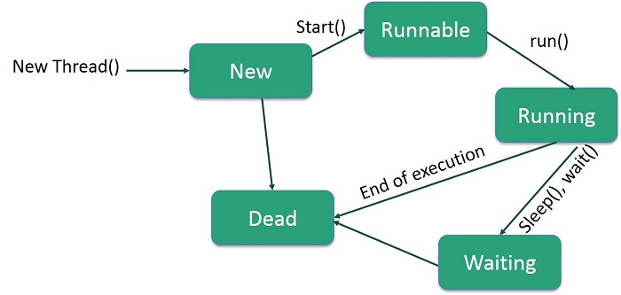

🔹 Detailed Explanation of Each State
.

1. New (Born State)
A new thread is created but has not yet started. This is the initial state of a thread when it is instantiated but the start() method has not been called yet.
The thread remains in this state until the start() method is invoked.
Transition:
From New, the thread transitions to Runnable when the start() method is called.

2. Runnable (Ready to Run State)
A thread enters the Runnable state after the start() method is called.
Once in the Runnable state, the thread is ready for execution, but it may not be running immediately. The operating system's thread scheduler will decide when the thread will actually run.
The Runnable state does not guarantee that the thread is currently executing; it only means that the thread is ready to run.
Transition:
From New, the thread enters the Runnable state when start() is called.
From Runnable, the thread can either be executed (entering the Running state) or be blocked (entering Blocked state).

3. Running
A thread in the Running state is currently executing its run() method.
Once the thread is assigned CPU time by the thread scheduler, it enters the Running state from Runnable.
Transition:
The thread moves from Runnable to Running once the scheduler assigns CPU time to it.

4. Blocked (Waiting for Resource)
A thread enters the Blocked state when it is trying to acquire a resource (e.g., a lock on an object) but cannot proceed because the resource is being used by another thread.
Threads can also enter the Blocked state when they are waiting to perform I/O operations or access a shared resource.
After the resource becomes available, the thread moves back to the Runnable state and resumes its execution.
Transition:
A thread enters the Blocked state when it is waiting to access a resource or performing I/O and cannot continue until the resource is available.

5. Waiting (Waiting for Another Thread's Action)
A thread enters the Waiting state when it is waiting for another thread to perform a specific action, such as notifying it or completing a task.
This can happen if a thread calls wait(), join(), or sleep() on another thread.
wait(): The thread waits indefinitely for a notification (notify() or notifyAll()) from another thread.
join(): The thread waits until another thread has finished execution.
sleep(): The thread is temporarily paused for a specific amount of time, which is a form of waiting.
Transition:
From Runnable, a thread enters the Waiting state if it calls wait(), join(), or sleep().
The thread will remain in the Waiting state until the condition it’s waiting for is met (e.g., another thread calls notify())

6. Terminated (Dead State)
A thread enters the Terminated (Dead) state once it has finished executing its run() method or has been terminated due to an exception.
A thread cannot be started again after it has reached the Terminated state.
Transition:
A thread enters the Terminated state once its run() method completes execution.
A thread can also enter the Terminated state if it encounters an unhandled exception or is forcibly stopped.

OR
3 b) i) How to create thread by extending thread class.
Steps to Create a Thread by Extending Thread Class
Create a class that extends Thread.
Override the run() method to define the task to be executed.
Create an object of your thread class.
Call the start() method to begin the thread execution.
// Step 1: Extend the Thread class
class MyThread extends Thread {
}

3b ii) Define Thread Exception.
A Thread Exception in Java refers to any error or exception that occurs within a thread during its execution. These exceptions can happen when the thread is running its run() method and can be caused by programming mistakes, interrupted operations, or invalid actions.

Common Causes of Thread Exceptions
InterruptedException
Occurs when a thread that is sleeping, waiting, or joining is interrupted.
try {
Thread.sleep(1000);
} catch (InterruptedException e) {
System.out.println("Thread was interrupted!");
}
3 b)iii) Explain in detail about thread methods.
Thread Methods in Java – Detailed Explanation
Java provides a number of built-in methods in the Thread class (in java.lang package) to create, control, and manage threads. These methods help in starting, pausing, stopping, and inspecting threads during execution.

🔹 Commonly Used Thread Methods
Method | Description
start() | Starts a new thread and invokes the run() method.
run() | Defines the code to be executed in the thread.
sleep(long millis) | Makes the thread pause for a specified time.
join() | Waits for the thread to die (finish execution).
getName() / setName() | Gets or sets the thread’s name.
getId() | Returns the thread's unique ID.
getPriority() / setPriority() | Gets or sets the thread's priority.
isAlive() | Returns true if the thread is still running.
yield() | Pauses the current thread and gives chance to others of same priority.
interrupt() | Interrupts a sleeping or waiting thread.
isInterrupted() | Checks if the thread has been interrupted.
currentThread() | Static method that returns a reference to the currently executing thread.

🔸 1. start()
Purpose: Starts a new thread by calling the run() method in a separate call stack.
Syntax:
threadObject.start();
Note: Do not call run() directly, as it won’t create a new thread.

🔸 2. run()
Purpose: Defines the code that the thread will execute.
Syntax:
public void run() {
// code to be executed by thread
}
Note: This method is automatically called when start() is invoked.

🔸 3. sleep(long millis)
Purpose: Pauses the thread for a given number of milliseconds.
Syntax:
Thread.sleep(1000); // Sleep for 1 second
Throws: InterruptedException

🔸 4. join()
Purpose: Waits for another thread to finish before continuing.
Syntax:
thread.join();
Example:
t1.join(); // Waits for t1 to finish

🔸 5. getName() / setName()
Purpose: Used to get or set a thread’s name.
Syntax:
thread.setName("MyThread");
String name = thread.getName();

🔸 6. getPriority() / setPriority()
Purpose: Gets or sets a thread's priority (range: 1 to 10).
Syntax:
thread.setPriority(Thread.MAX_PRIORITY);
int p = thread.getPriority();

🔸 7. isAlive()
Purpose: Returns true if the thread is still running.
Syntax:
if (thread.isAlive()) {
// thread is still running
}

🔸 8. yield()
Purpose: Causes the currently running thread to pause and allow other threads of equal priority to run.
Syntax:
Thread.yield();

🔸 9. interrupt()
Purpose: Interrupts a sleeping or waiting thread.
Syntax:
thread.interrupt();
Note: Works with sleep(), join(), and wait() methods.

🔸 10. isInterrupted()
Purpose: Checks whether the thread has been interrupted.
Syntax:
if (thread.isInterrupted()) {
// thread was interrupted
}

🔸 11. currentThread()
Purpose: Returns a reference to the currently executing thread.
Syntax:
Thread t = Thread.currentThread();
Example
class MyThread extends Thread {
public void run() {
System.out.println("Thread started: " + Thread.currentThread().getName());
try {
Thread.sleep(2000); // Pause for 2 seconds
} catch (InterruptedException e) {
System.out.println("Thread interrupted");
}
System.out.println("Thread ending: " + Thread.currentThread().getName());
}
}

public class Main {
public static void main(String[] args) throws InterruptedException {
MyThread t1 = new MyThread();
t1.setName("Worker-1");
t1.start();

t1.join(); // Main thread waits for t1 to finish
System.out.println("Main thread ends");
}
}

4 a) i) Define JTextField.
TextField is a GUI component in Java used to create a single-line text box that allows the user to enter or edit text. It is part of the Swing package and inherits from the javax.swing.JTextComponent class.
Syntax:
JTextField textField = new JTextField();

4a)ii) Write about key events.
Key Events in Java refer to events that occur when a user presses, releases, or types a key on the keyboard. Java provides a mechanism to handle these events through the KeyListener interface.
Key events are a part of AWT (Abstract Window Toolkit) and are defined in the java.awt.event package.

🔹 Types of Key Events
Java defines three types of key events:
Event Method | Triggered When…
keyPressed(KeyEvent e) | A key is pressed down
keyReleased(KeyEvent e) | A key is released
keyTyped(KeyEvent e) | A character is typed (pressed & released)

4 iii)Explain in detail about event handlers.

In Java, an event handler is a block of code (usually a method) that executes in response to an event (such as a button click, key press, or mouse movement). Java provides a robust event handling mechanism as part of its AWT (Abstract Window Toolkit) and Swing libraries to build interactive GUI applications.

An event is an object that describes a change in the state of a source object. Events are generated when a user interacts with GUI components like:
Clicking a button
Typing a key
Selecting a menu item
Moving the mouse

Java uses the Event Delegation Model, which includes three main components:
Component | Description
Event Source | The GUI component that generates the event (e.g., a button, text field).
Event Object | Contains information about the event (e.g., ActionEvent, KeyEvent).
Event Listener | Interface that defines methods to handle the event (e.g., ActionListener).

🔸 Steps for Event Handling
Implement the appropriate listener interface (like ActionListener, KeyListener, etc.).
Override the listener method(s) to define what happens when the event occurs.
Register the listener with the event source using methods like addActionListener().

🔹 Common Event Listener Interfaces in Java
Interface | Event Type | Listener Method
ActionListener | Button click | actionPerformed()
KeyListener | Keyboard input | keyPressed(), etc.
MouseListener | Mouse click, entry | mouseClicked(), etc.
ItemListener | Checkbox, combo box | itemStateChanged()
WindowListener | Window events | windowClosing(), etc.

🔸 Example: Handling a Button Click with ActionListener
import javax.swing.*;
import java.awt.event.*;

public class EventExample implements ActionListener {

JButton button;

EventExample() {
JFrame frame = new JFrame("Event Handling Example");
button = new JButton("Click Me");
button.setBounds(100, 100, 100, 40);

// Register ActionListener
button.addActionListener(this);

frame.add(button);
frame.setSize(300, 250);
frame.setLayout(null);
frame.setDefaultCloseOperation(JFrame.EXIT_ON_CLOSE);
frame.setVisible(true);
}

// Event handler method
public void actionPerformed(ActionEvent e) {
JOptionPane.showMessageDialog(null, "Button Clicked!");
}

public static void main(String[] args) {
new EventExample();
}
}

🔹 Explanation of the Example:
button.addActionListener(this) registers the current class as the listener for button click events.
actionPerformed() is executed automatically when the button is clicked.
A message dialog is displayed as a response to the event.

🔹 Advantages of Java’s Event Handling:
Separation of concerns – Keeps UI code separate from business logic.
Reusability – One listener can handle events from multiple components.
Flexibility – Allows for inner classes, anonymous classes.

4b) i) Write the constructor of JCheckBox.
The JCheckBox class in Java is part of the Swing package (javax.swing) and is used to create check box buttons, which allow users to make multiple selections independently.
Constructor
JCheckBox()
JCheckBox(String text)
JCheckBox(String text, boolean state)
JCheckBox(Icon icon)
JCheckBox(Icon icon, boolean state)
JCheckBox(String text, Icon icon)
JCheckBox(String text, Icon icon, boolean state)
ii) What are the controls available to generate item events?
Controls That Generate Item Events in Java
In Java, Item Events are triggered when an item is selected or deselected in a GUI component. These events are handled using the ItemListener interface and are represented by the ItemEvent class in the java.awt.event package.

🔹 Controls (Components) That Generate Item Events:
Control Component | Description
Checkbox (AWT) | A basic checkbox for selecting/deselecting options.
Choice (AWT) | A dropdown list for single selection.
List (AWT) | A list that may allow single or multiple selections.
JCheckBox (Swing) | Swing version of a checkbox.
JRadioButton (Swing) | Swing radio button for single selection in a group.
JComboBox (Swing) | A drop-down combo box (like Choice but Swing-based).

4b iii) Explain in detail about Event listeners.
Event Listeners in Java – Detailed Explanation
In Java, Event Listeners are interfaces used to handle various types of events such as mouse clicks, key presses, or button actions. They are a central part of Java’s Event Delegation Model, which is used in GUI programming (AWT and Swing) to respond to user interactions.

🔹 What Is an Event Listener?
An event listener is an interface that contains one or more methods which are called automatically when an event occurs.
When a user performs an action (e.g., clicks a button), the component generates an event object.
This object is passed to the listener, which has been registered with the component.

🔹 Java's Event Delegation Model
It consists of three main components:
Component | Description
Event Source | The component that generates events (e.g., JButton, JTextField)
Event Object | Contains details about the event (e.g., ActionEvent, MouseEvent)
Event Listener | Interface with methods to handle the event (e.g., ActionListener)

🔹 Common Event Listener Interfaces
Listener Interface | Event Type | Example Components
ActionListener | Action (e.g., button) | JButton, JMenuItem
ItemListener | Item selection | JCheckBox, JRadioButton
KeyListener | Keyboard actions | Any component
MouseListener | Mouse click, enter | JButton, JPanel, etc.
MouseMotionListener | Mouse movement | JPanel, Canvas
WindowListener | Window events | JFrame, JDialog
FocusListener | Focus gained/lost | Text fields, input fields
ComponentListener | Resizing, moving | JComponent

🔹 How to Use an Event Listener
Steps:
Implement the listener interface in your class.
Override the required method(s).
Register the listener with the component using addXXXListener().

🔸 Example: Using ActionListener with JButton
java
CopyEdit
import javax.swing.*;
import java.awt.event.*;

public class EventListenerExample implements ActionListener {
JButton button;

public EventListenerExample() {
JFrame frame = new JFrame("Event Listener Example");

button = new JButton("Click Me");
button.setBounds(100, 100, 100, 40);
button.addActionListener(this); // Register listener

frame.add(button);
frame.setSize(300, 250);
frame.setLayout(null);
frame.setDefaultCloseOperation(JFrame.EXIT_ON_CLOSE);
frame.setVisible(true);
}

public void actionPerformed(ActionEvent e) {
JOptionPane.showMessageDialog(null, "Button clicked!");
}

public static void main(String[] args) {
new EventListenerExample();
}
}

5 a) i) Define JDBC.
JDBC (Java Database Connectivity) is an API (Application Programming Interface) in Java that allows Java applications to connect to and interact with databases.

ii) Draw the architecture of IDBC. 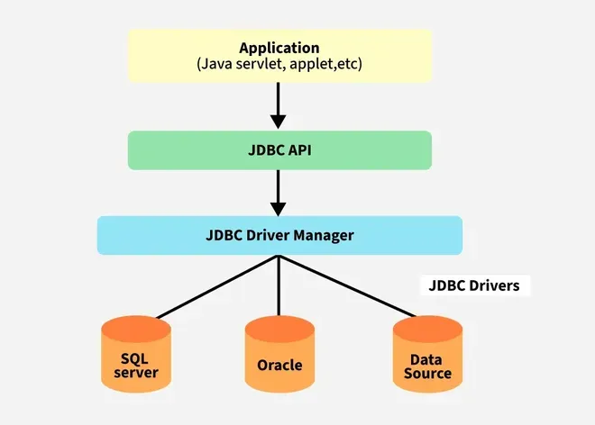

iii) Explain in detail about server steps to connect JDBC.
What is JDBC?
JDBC stands for Java Database Connectivity. JDBC is a Standard API that enables Java applications to interact with databases like MYSQL, PostgreSQL, etc. This API consists of classes and interfaces written in Java. In other words, we can also say that JDBC acts as a bridge between your Java application (frontend) and the database (backend), allowing you to send and retrieve data between the two systems.
The diagram below demonstrates the workings of JDBC by correlating its steps to real-world examples.

We can think JDBC as a middleman that builds communication between Java application and database.
Steps to Establish a JDBC Connection
Below are the steps that explains how to connect to Database in Java:
Step 1: Import the Packages
Step 2: Load the drivers using the forName() method
Step 3: Register the drivers using DriverManager
Step 4: Establish a connection using the Connection class object
Step 5: Create a statement
Step 6: Execute the query
Step 7: Close the connections
Java Database Connectivity

Let us discuss these steps in brief before implementing by writing suitable code to illustrate connectivity steps for JDBC.
Step 1: Import the JDBC Package
First, we need to import the packages.
Step 2: Load or Register the Driver
In order to begin with, you first need to load the driver or register it before using it in the program. Registration is to be done once in your program. You can register a driver in one of two ways mentioned below as follows:
Class.forName()
Here, we load the driver’s class file into memory at the runtime. No need of using new or create objects. The following example uses Class.forName() to load the Oracle driver as shown below as follows:
Class.forName(“oracle.jdbc.driver.OracleDriver”);

DriverManager.registerDriver()
DriverManager is a Java inbuilt class with a static member register. Here we call the constructor of the driver class at compile time. The following example uses DriverManager.registerDriver() to register the Oracle driver as shown below:
DriverManager.registerDriver(new oracle.jdbc.driver.OracleDriver())
Note: From JDBC 4.0 (Java 6 or later), driver loading is done automatically, it means we don not have to manually load or register the driver using Class.forName() or DriverManager.registerDriver().
Step 3: Establish a Connection
After loading the driver, establish connections as shown below as follows:
Connection con = DriverManager.getConnection(url,user,password)
user: Username from which your SQL command prompt can be accessed.
password: password from which the SQL command prompt can be accessed.
con: It is a reference to the Connection interface.
Url: Uniform Resource Locator which is created as shown below:
String url = “ jdbc:oracle:thin:@localhost:1521:xe”
Where,
oracle is the database used, thin is the driver used
@localhost is the IP Address where a database is stored
1521 is the port number and xe is the service provider.
All 3 parameters above are of String type and are to be declared by the programmer before calling the function. Use of this can be referred to form the final code.
Step 4: Create a Statement
Once a connection is established you can interact with the database. The JDBCStatement, CallableStatement, and PreparedStatement interfaces define the methods that enable you to send SQL commands and receive data from your database.
Use of JDBC Statement is as follows:
Statement st = con.createStatement();
vNote: In real-world application, it is recommended to use PreparedStatement or CallableStatement instead of Statement for executing SQL queries.
Step 5: Execute SQL Query
Now comes the most important part i.e. executing the query. The query here is an SQL Query. Now, we know we can have multiple types of queries. Some of them are as follows:
The query for updating/inserting a table in a database.
The query for retrieving data.
The executeQuery() method of the Statement interface is used to execute queries of retrieving values from the database. This method returns the object of ResultSet that can be used to get all the records of a table.
The executeUpdate(sql query) method of the Statement interface is used to execute queries of updating/inserting.
Pseudo Code:
int m = st.executeUpdate(sql);
if (m==1)
System.out.println(“inserted successfully : “+sql);
else
System.out.println(“insertion failed”);
on
Example: The below Java program demonstrates how to connect to a MYSQL database, execute a Query, retrieve data and display it.
Note: Here, sql is SQL query of the type String.
// This code is for establishing connection with MySQL
// database and retrieving data
// from db Java Database connectivity

/*
*1. import --->java.sql
*2. load and register the driver ---> com.jdbc.
*3. create connection
*4. create a statement
*5. execute the query
*6. process the results
*7. close
*/

import java.sql.*;

class Geeks {
public static void main(String[] args) throws Exception {
String url = "jdbc:mysql://localhost:3306/database_name"; // Database details
String username = "rootgfg"; // MySQL credentials
String password = "gfg123";
String query = "select * from students"; // Query to be run

// Load and register the driver
Class.forName("com.mysql.cj.jdbc.Driver");

// Establish connection
Connection con = DriverManager.getConnection(url, username, password);
System.out.println("Connection Established successfully");

// Create a statement
Statement st = con.createStatement();

// Execute the query
ResultSet rs = st.executeQuery(query);

// Process the results
while (rs.next()) {
String name = rs.getString("name"); // Retrieve name from db
System.out.println(name); // Print result on console
}

// Close the statement and connection
st.close();
con.close();
System.out.println("Connection Closed....");
}
}
Output:
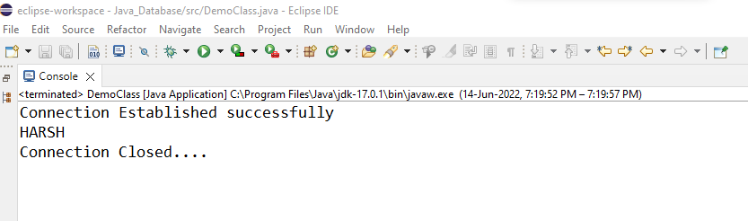
Step 6: Close the Connections
So, finally we have sent the data to the specified location and now we are on the verge of completing our task. By closing the connection, objects of Statement and ResultSet will be closed automatically. The close() method of the Connection interface is used to close the connection. It is shown below as follows:
con.close();
Note: It is recommended to use try-with-resources to automatically close resource like Connection, Statement and ResultSet.
Java Program for MySQL JDBC Connection
Example:
import java.sql.*;

public class MySQLConnect {
public static void main(String[] args) throws Exception {
String url = "jdbc:mysql://localhost:3306/testdb";
String user = "yourusername";
String password = "yourpassword";

// Load MySQL JDBC driver
Class.forName("com.mysql.cj.jdbc.Driver");

// Connect to database
try (Connection con = DriverManager.getConnection(url, user, password);
Statement stmt = con.createStatement();
ResultSet rs = stmt.executeQuery("SELECT * FROM students")) {

System.out.println("Connection Successful!");

while (rs.next()) {
System.out.println(rs.getString("name"));
}

} catch (SQLException e) {
e.printStackTrace();
}
}
}

Note: Never hardcode database credentials in your production code.
Java Program for Oracle Database Connection
Example: The below Java program demonstrates how to establish a JDBC Connection with an Oracle database.
// Java Program to Establish Connection
// in JDBC with Oracle Database

// Importing database
import java.sql.*;

// Importing required classes
import java.util.*;

// Main class
class Main {
public static void main(String a[]) {

String url = "jdbc:oracle:thin:@localhost:1521:xe"; // Database details

// Username and password to access DB
String user = "system";
String pass = "12345";

// Entering the data
Scanner k = new Scanner(System.in);
System.out.println("Enter name:");
String name = k.next();
System.out.println("Enter roll no:");
int roll = k.nextInt();
System.out.println("Enter class:");
String cls = k.next();

// Inserting data using SQL query
String sql = "insert into student1 values('" + name + "'," + roll + ",'" + cls + "')";

// Connection class object
Connection con = null;

try {
// Registering drivers
DriverManager.registerDriver(new oracle.jdbc.OracleDriver());

// Establish connection
con = DriverManager.getConnection(url, user, pass);

// Create a statement
Statement st = con.createStatement();

// Execute the query
int m = st.executeUpdate(sql);
if (m == 1)
System.out.println("Inserted successfully: " + sql);
else
System.out.println("Insertion failed");

// Close the connection
con.close();
} catch (Exception ex) {

// Handle exceptions
System.err.println(ex);
}
}
}
}

b) i Define prepared statement.
A PreparedStatement in Java is a precompiled SQL statement used in JDBC to execute parameterized queries safely and efficiently.
Syntax:
PreparedStatement ps = con.prepareStatement("INSERT INTO students(name, age) VALUES (?, ?)");
ps.setString(1, "Alice");
ps.setInt(2, 20);
ps.executeUpdate();

5aii) How to create a statement?
In Java, you create a Statement object to send SQL commands (like SELECT, INSERT, UPDATE, DELETE) to a relational database using JDBC.
Steps to Create a Statement
Establish a database connection using DriverManager.
Call createStatement() method on the Connection object.
Syntax
Connection con = DriverManager.getConnection("jdbc:mysql://localhost:3306/dbname", "user", "password");
Statement stmt = con.createStatement();

5biii)Explain in detail about JDBC drivers
JDBC Drivers
JDBC drivers are client-side adapters (installed on the client machine rather than the server) that translate requests from Java programs into a protocol understood by the DBMS. These drivers are software components that implement the interfaces in the JDBC API, allowing Java applications to interact with a database. Sun Microsystems (now Oracle) defines four types of JDBC drivers, which are outlined below:
Type-1 driver or JDBC-ODBC bridge driver
Type-2 driver or Native-API driver
Type-3 driver or Network Protocol driver
Type-4 driver or Thin driver
1. JDBC-ODBC Bridge Driver – Type 1 Driver
Type-1 driver or JDBC-ODBC bridge driver uses ODBC driver to connect to the database. The JDBC-ODBC bridge driver converts JDBC method calls into the ODBC function calls. Type-1 driver is also called Universal driver because it can be used to connect to any of the databases.
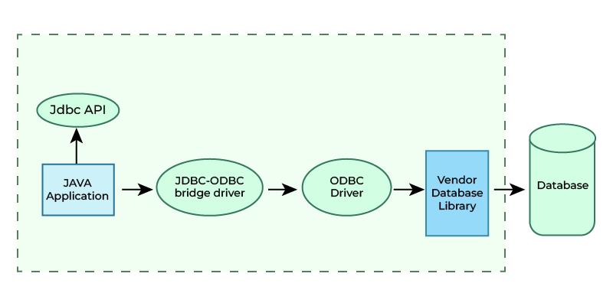
Advantages
This driver software is built-in with JDK so no need to install separately.
It is a database independent driver.
Disadvantages
As a common driver is used in order to interact with different databases, the data transferred through this driver is not so secured.
The ODBC bridge driver is needed to be installed in individual client machines.
Type-1 driver isn’t written in java, that’s why it isn’t a portable driver.
2. Native-API Driver – Type 2 Driver ( Partially Java Driver)
The Native API driver uses the client -side libraries of the database. This driver converts JDBC method calls into native calls of the database API. In order to interact with different database, this driver needs their local API, that’s why data transfer is much more secure as compared to type-1 driver. This driver is not fully written in Java that is why it is also called Partially Java driver.
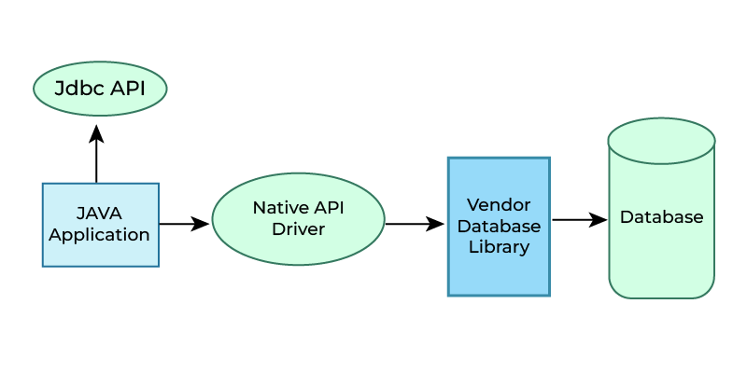
Advantage
Native-API driver gives better performance than JDBC-ODBC bridge driver.
More secure compared to the type-1 driver.
Disadvantages
Driver needs to be installed separately in individual client machines
The Vendor client library needs to be installed on client machine.
Type-2 driver isn’t written in java, that’s why it isn’t a portable driver
It is a database dependent driver.
3. Network Protocol Driver – Type 3 Driver (Fully Java Driver)
The Network Protocol driver uses middleware (application server) that converts JDBC calls directly or indirectly into the vendor-specific database protocol. Here all the database connectivity drivers are present in a single server, hence no need of individual client-side installation.
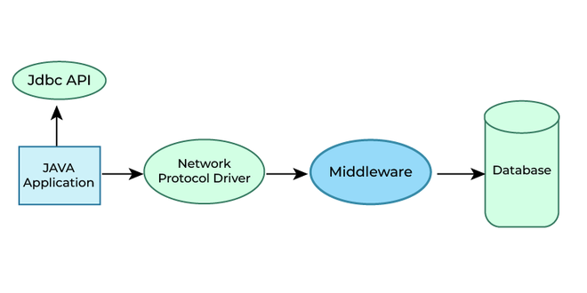
Advantages
Type-3 drivers are fully written in Java, hence they are portable drivers.
No client side library is required because of application server that can perform many tasks like auditing, load balancing, logging etc.
Switch facility to switch over from one database to another database.
Disadvantages
Network support is required on client machine.
Maintenance of Network Protocol driver becomes costly because it requires database-specific coding to be done in the middle tier.
4. Thin Driver – Type 4 Driver (Fully Java Driver)
Type-4 driver is also called native protocol driver. This driver interact directly with database. It does not require any native database library, that is why it is also known as Thin Driver.
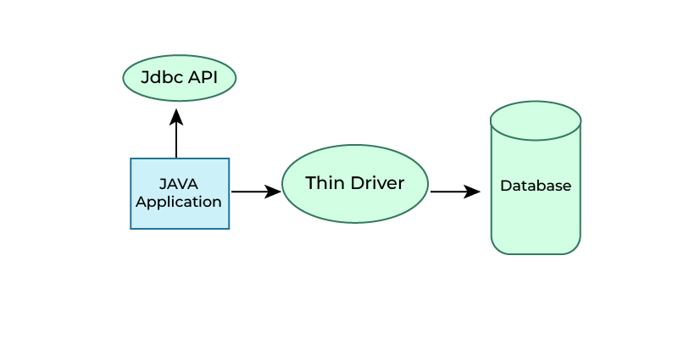
Advantages
Does not require any native library and Middleware server, so no client-side or server-side installation.
It is fully written in Java language, hence they are portable drivers.
Disadvantage
If the database changes, a new driver may be needed.

