

**Institute of Engineering Pulchowk Campus**

**Computer Network**

**MINI PROJECT**

**Submitted By:**

Sujan Koirala

**Submitted To:**

Department of Electronics and

Computer Engineering

Pulchowk Campus

Pulchowk, Lalitpur

AUGUST, 2024

1. NETWORK TOPOLOGY

Organization : SaptaGandaki Private Hospital

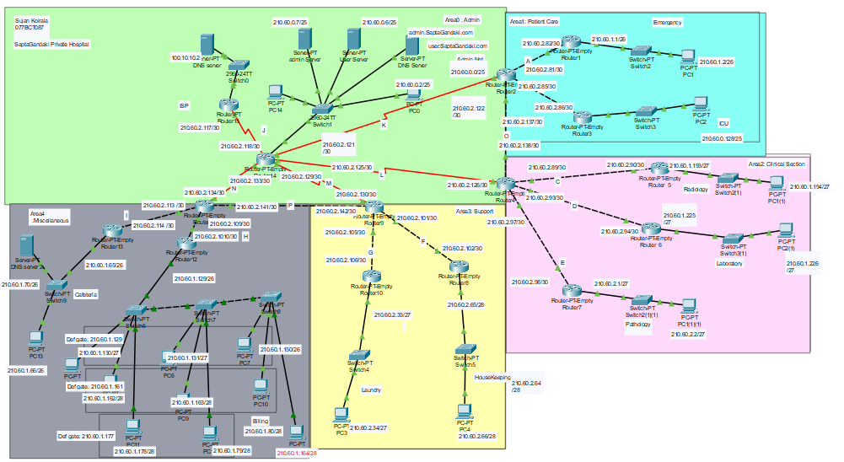

1. NETWORK ADDRESS BLOCK : 210.60.0.0/21
2. NETWORK DESCRIPTION:

The SaptaGandaki Private Hospital’s network consists of five areas in total. The areas 1,2,3 and 4 are connected to the backbone network in area 0.

i. **Area 0:**

Area 0 is the backbone area where all the area border routers are connected. Area 0 contains the Admin router and public DNS server and web server for user.SaptaGandaki.com and admin.SaptaGandaki.com. The DNS server resolves the domain doece.edu.np after receiving the request from the local DNS server in the area 4.

ii. **Area 1:**

Area 1 is divided into 2 networks for the Emergency and ICU.

iii. Area 2: Area 2 is divided into 3 networks for Clinical Section, Laboratory and Pathology.

VLAN1: 192.168.9.0/24

VLAN2: 192.168.10.0/24

VLAN3: 192.168.11.0/24

iv. Area 3:Area 3 is divided into 2 networks for HouseKeeping and Laundry.

v. Area 4: Area 4 consists of Billing and Cafeteria. VLAN is setup for Billing Area. VLANS are:

vlan2 : 210.60.1.128/27

vlan10: 210.60.1.160/28

vlan100: 210.60.1.176/28

Inter-VLan Routing is done using Router-On-Stick.

1. IP ADDRESS ASSIGNMENT

|  |  |  |  |  |  |  |
| --- | --- | --- | --- | --- | --- | --- |
| S.N | Name | Hosts | Network Id | Broadcast Id | Subnet Mask | Slash |
| 1 | AdminNet | 100 | 210.60.0.0 | 210.60.0.127 | 255.255.255.128 | 25 |
| 2 | ICU | 70 | 210.60.0.128 | 210.60.0.255 | 255.255.255.128 | 25 |
| 3 | Emergency | 60 | 210.60.1.0 | 210.60.1.63 | 255.255.255.192 | 26 |
| 4 | Cafeteria | 58 | 210.60.1.64 | 210.60.1.127 | 255.255.255.192 | 26 |
| 5 | Billing | 50 | 210.60.1.128 | 210.60.1.191 | 255.255.255.192 | 26 |
| 6 | Radiology | 30 | 210.60.1.192 | 210.60.1.223 | 255.255.255.224 | 27 |
| 7 | Laboratory | 30 | 210.60.1.224 | 210.60.1.255 | 255.255.255.224 | 27 |
| 8 | Pathology | 30 | 210.60.2.0 | 210.60.2.31 | 255.255.255.224 | 27 |
| 9 | Laundry | 24 | 210.60.2.32 | 210.60.2.63 | 255.255.255.224 | 27 |
| 10 | HouseKeeping | 14 | 210.60.2.64 | 210.60.2.79 | 255.255.255.240 | 28 |
| 11 | A | 2 | 210.60.2.80 | 210.60.2.83 | 255.255.255.252 | 30 |
| 12 | B | 2 | 210.60.2.84 | 210.60.2.87 | 255.255.255.252 | 30 |
| 13 | C | 2 | 210.60.2.88 | 210.60.2.91 | 255.255.255.252 | 30 |
| 14 | D | 2 | 210.60.2.92 | 210.60.2.97 | 255.255.255.252 | 30 |
| 15 | E | 2 | 210.60.2.96 | 210.60.2.99 | 255.255.255.252 | 30 |
| 16 | F | 2 | 210.60.2.100 | 210.60.2.103 | 255.255.255.252 | 30 |
| 18 | G | 2 | 210.60.2.104 | 210.60.2.107 | 255.255.255.252 | 30 |
| 19 | H | 2 | 210.60.2.108 | 210.60.2.111 | 255.255.255.252 | 30 |
| 20 | I | 2 | 210.60.2.112 | 210.60.2.115 | 255.255.255.252 | 30 |
| 21 | J | 2 | 210.60.2.116 | 210.60.2.119 | 255.255.255.252 | 30 |
| 22 | K | 2 | 210.60.2.120 | 210.60.2.123 | 255.255.255.252 | 30 |
| 23 | L | 2 | 210.60.2.124 | 210.60.2.127 | 255.255.255.252 | 30 |
| 24 | M | 2 | 210.60.2.128 | 210.60.2.131 | 255.255.255.252 | 30 |
| 25 | N | 2 | 210.60.2.132 | 210.60.2.135 | 255.255.255.252 | 30 |
| 26 | O | 2 | 210.60.2.136 | 210.60.2.139 | 255.255.255.252 | 30 |
| 27 | P | 2 | 210.60.2.140 | 210.60.2.143 | 255.255.255.252 | 30 |

1. DNS RESOLUTION

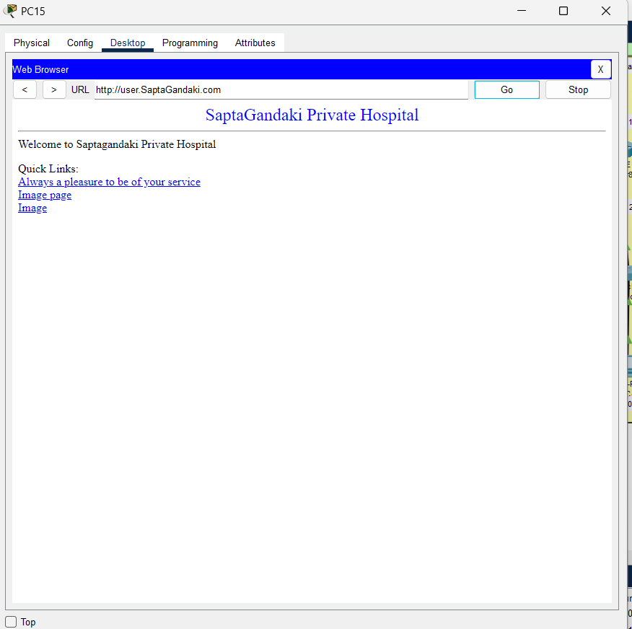

1. CREDENTIALS

* Password for console : cisco
* Password for telnet : network
* Password for privileged access mode : class

1. CONCLUSION

In summary, the network design for a hypothetical Hospital has been crafted with a focus on efficient network segmentation and robust connectivity. The design strategically divides the network into multiple areas, each managed independently to optimize performance and reduce complexity. The use of Area Border Routers (ABRs) to interconnect these areas ensures seamless communication across different segments of the network. A key feature of this design is the incorporation of redundant paths. These redundant links are crucial for enhancing the network's reliability and resilience, as they provide alternative routes for data transmission in case of a link failure. This redundancy minimizes the risk of communication disruption and ensures continuous network availability.

The OSPF (Open Shortest Path First) routing protocol has been implemented within each area to facilitate efficient routing and fast convergence. OSPF's ability to dynamically adapt to network changes and its scalability make it well-suited for this design, ensuring that routing information is accurately and promptly disseminated across the network.

Although the current design effectively meets the requirements of the typical hospital network, it is important to note that it is adaptable for future growth. The design's modularity and scalability mean that it can be extended to accommodate larger networks or additional areas as needed.

Overall, this network design provides a solid foundation for reliable and efficient communication within the hospital, while also offering the flexibility to evolve with future demands.