# **What Is the Metaverse?**

With the recent explosion of [NFTs](https://chain.link/education/nfts) (non-fungible tokens) in the blockchain ecosystem and Facebook’s head-turning rebrand to “Meta,” the metaverse has entered into mainstream public consciousness.

Though the concept might seem new and cutting-edge, the idea of the metaverse has been well-established in pop culture for decades. The term was first coined in 1992 by Neal Stephenson in his science fiction novel Snow Crash to refer to an all-encompassing 3D virtual world that mimics, augments, enhances, and connects with physical reality. Since then, the metaverse has brushed with the mainstream, with versions of the concept appearing in Ready Player One, Tron*,* and The Matrix. But what is the metaverse in actuality?

## **Metaverse Explained**

Simply put, the metaverse is a parallel digital universe that exists alongside the real world. Given its emergent nature, there are many different visions of how the metaverse will manifest itself, and even debates about whether the metaverse already exists today.

In the most idealistic depictions, the metaverse is a virtual world that offers parallel experiences to the real world, with the potential for enhanced abilities—much like the robot-manufactured world of The Matrix. In more realistic renderings, metaverse visitors use complex motion-tracking machinery and virtual reality headsets to physically interact in a virtual world, where they take the form of virtual avatars, play games, and live pseudo-anonymous lives. Sometimes, the current existence of user-owned digital goods that have traditionally real-world qualities of rarity, value, and history is referred to as evidence that the metaverse is already with us. Some argue that the metaverse exists in the human interactions, feelings, and experiences that make up the digital lives we live on individual social platforms, video games, and more.

Yet despite these disparate visions, the core concept behind the metaverse is clear. Telepresence—defined as an immersive state that allows a person to feel present in a virtual space—is key to facilitating metaverse experiences. Whether through a combination of immersive AR and VR technologies, user-owned digital goods powered by blockchains, or simply through an addicting massively multiplayer online role-playing game (MMORPG), the metaverse manifests from our ability to build virtual spaces that make us feel present—perhaps even tangible—in a digital environment.

## **Entering the Metaverse**

The metaverse exists all around us in a very real way. Early experiments in MMORPGs such as Second Life and World of Warcraft introduced the concept of gamified social platforms that immersed players to the point where digital items, from weapons and clothing to in-game houses, held immense real-world value. Existing social networking platforms such as Facebook, Instagram, and Twitter have allowed for the creation of pseudo-anonymous Internet avatar identities and interactive virtual rooms where users go to share news, discuss information, and chat with friends.

Whether at a Twitter Spaces hangout, a Zoom call with co-workers, or in multiplayer games, people are no strangers to complete digital immersion through an external screen. However, there are emerging technologies that have the potential to give more importance, permanence, and presence to the digital world.

A large factor in facilitating the increased telepresence that will power metaverse development will be our ability to replicate the human experience. In this, virtual reality (VR) headsets and movement-tracking devices can play a pivotal role, with increasingly realistic portrayals that create a state of complete sensory immersion. Some examples of early innovations include SuperHot*,* a Matrix-esque game where time moves only as fast as the player, and VR Chat, a social platform where players create 3D avatars to interact in communal virtual rooms.

While VR aims to build an immersive virtual world separate from physical spaces, Augmented Reality (AR) adds virtual displays to physical reality. One compelling example that exists right now is Microsoft’s Hololens, an AR headset that tracks both what we’re looking at and our body movements to superimpose virtual images and icons, allowing for compelling use cases that can help us navigate, identify objects, and interact with the physical world in a virtual manner.

Imagine a world where you can put on AR glasses to see which virtual shoes a person chose to wear that day, or play games on a completely virtual screen that exists on your desk. AR glasses could update in real time based on sensors, providing information and accentuating everyday experiences. This is the goal of AR—a seamless blend of the virtual and physical to enhance everyday life in exciting, functional, and genuine ways.

AR and VR are inspirational technologies that are playing a part in developing the experiences that define the future vision of the metaverse. However, interactive and immersive experiences are just a piece of the puzzle; the metaverse will require a value layer underpinned by decentralized infrastructure such as blockchains to empower users as much as platform developers in building up the metaverse. Ultimately, this will help metaverse users define the shape of the metaverse, giving more substance to the digital universe through verifiable digital items and helping users feel substance in an intangible, digitized space.

## **Problems With the Current State of the Metaverse**

There are aspects of current metaverse experience that inhibit the immersive experience. Players and users are constantly reminded that the current version of the metaverse is not theirs to grow and build upon, but owned by those creating the experiences for them. For example, players can’t take their rare World of Warcraft sword, sell it, and then buy a house on Second Life, and activities are restricted by centralized platform owners. Twitter is separate from Instagram; while there are social avenues to connect them, there is no formal transfer of information or value between the two as they are built by separate companies. Instead, these experiences exist in limited silos that represent a meta-room more than a complete metaverse.

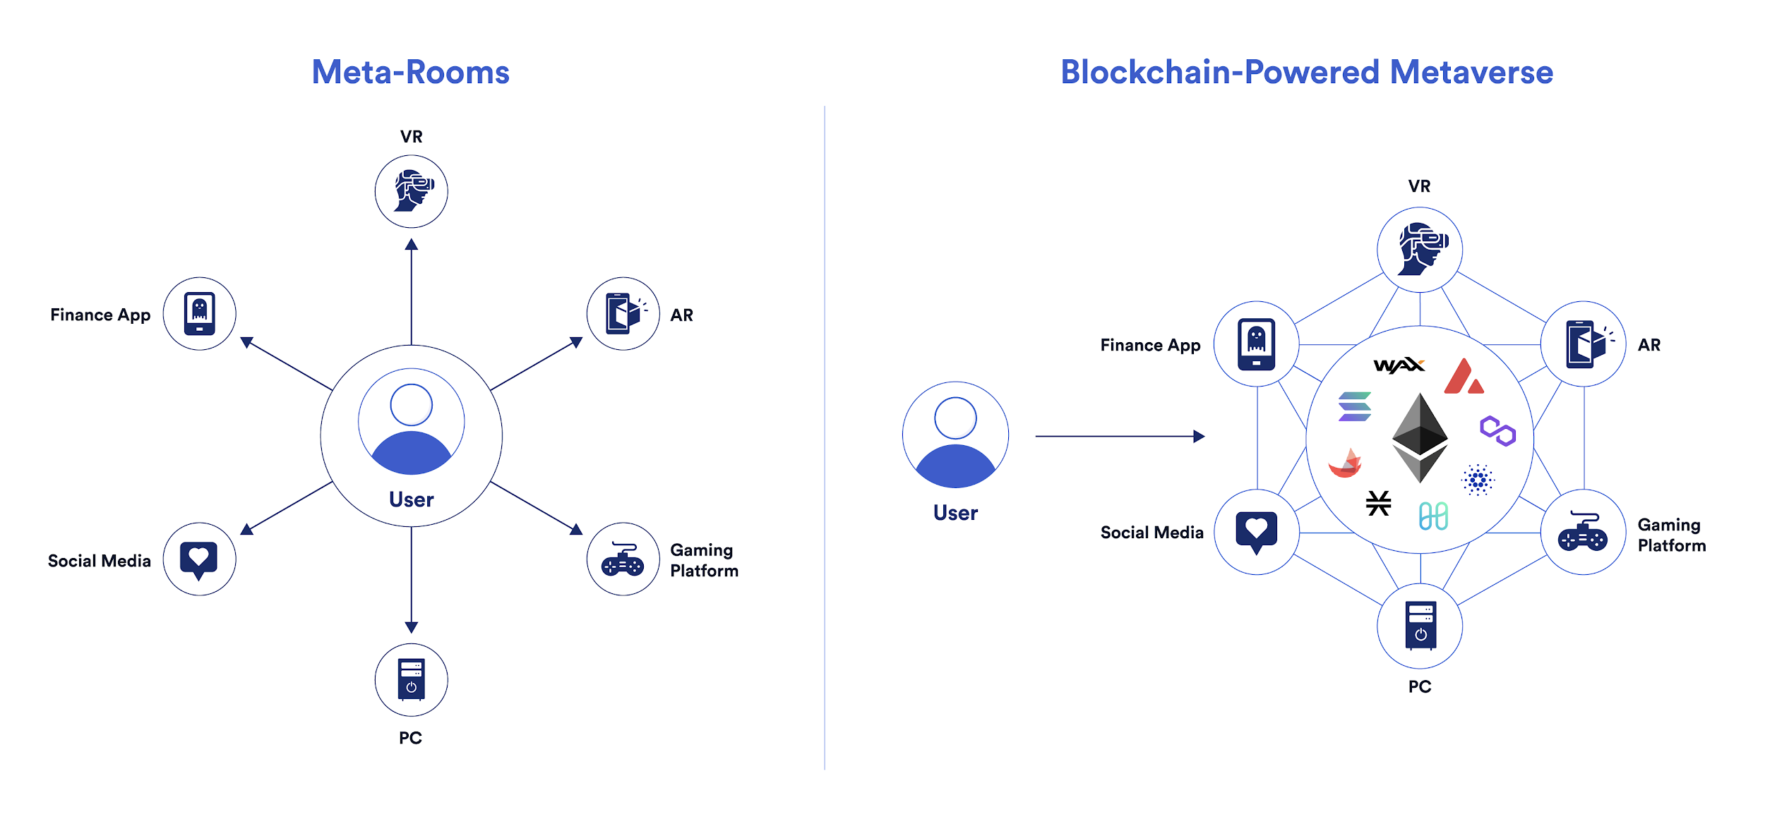Meta-rooms are siloed experiences, while blockchains and oracles offer interconnection

Ideally, further metaverse developments would bridge all of the fragmented ecosystems that hold independent value and combine them into one holistic virtual environment, defined by seamless interoperation between each individual aspect to build a sum that is greater than its parts: an open world where people can co-exist in a shared virtual network rather than a fragmented ecosystem where individual networks are disconnected from one another by disparate hardware and software, differing geographical locations, and borders built up by competing entities.

A system that works in this way would present a true parallel reality built through a virtual space. You can own goods, manifest as an identifiable avatar, and traverse the virtual world, much like you can in the physical world. The vision of an interconnected system of metaverse applications, experiences, and digital goods is already being realized, and it is being built through a combination of blockchain technology and [decentralized oracles](https://chain.link/education/blockchain-oracles).

## **Problems With the Current State of the Metaverse**

There are aspects of current metaverse experience that inhibit the immersive experience. Players and users are constantly reminded that the current version of the metaverse is not theirs to grow and build upon, but owned by those creating the experiences for them. For example, players can’t take their rare World of Warcraft sword, sell it, and then buy a house on Second Life, and activities are restricted by centralized platform owners. Twitter is separate from Instagram; while there are social avenues to connect them, there is no formal transfer of information or value between the two as they are built by separate companies. Instead, these experiences exist in limited silos that represent a meta-room more than a complete metaverse.

Meta-rooms are siloed experiences, while blockchains and oracles offer interconnection

Ideally, further metaverse developments would bridge all of the fragmented ecosystems that hold independent value and combine them into one holistic virtual environment, defined by seamless interoperation between each individual aspect to build a sum that is greater than its parts: an open world where people can co-exist in a shared virtual network rather than a fragmented ecosystem where individual networks are disconnected from one another by disparate hardware and software, differing geographical locations, and borders built up by competing entities.

A system that works in this way would present a true parallel reality built through a virtual space. You can own goods, manifest as an identifiable avatar, and traverse the virtual world, much like you can in the physical world. The vision of an interconnected system of metaverse applications, experiences, and digital goods is already being realized, and it is being built through a combination of blockchain technology and [decentralized oracles](https://chain.link/education/blockchain-oracles).

## **The Role of Decentralized Oracle Networks in the Metaverse**

While blockchains offer greater interconnectivity than the current meta-room alternative, they are unable to solve the problem of fragmented ecosystems by themselves because they function as highly secure yet disconnected environments—leading to the need for secure oracles to bridge the gap.

Decentralized oracle networks such as [Chainlink](https://blog.chain.link/what-is-chainlink/) enable blockchains and the [smart contracts](https://chain.link/education/smart-contracts) built on top of them to securely interact with real-world data and services that exist outside of blockchain networks. Through Chainlink, blockchains can communicate with each other and with traditional systems that power metaverse experiences in a transparent, secure, and efficient manner.

Intrinsically blockchain-agnostic, Chainlink currently serves as a universal framework for sourcing off-chain data and decentralized off-chain computation for leading blockchains across the industry. These are mission-critical services for blockchain interoperability and the metaverse, providing functionality such as:

* **Decentralized Data Feeds** —The metaverse economy will facilitate user-owned value transfers and host financial tools such as lending, borrowing, insurance, and more. [Chainlink Price Feeds](http://data.chain.link/) give blockchain-based projects access to robust and secure price data that helps the entire metaverse economy build on each others’ success, while Chainlink Data Feeds can deliver important outcomes to be cemented on underlying blockchains, such as establishing transfers of in-game metaverse items, rewards, and more to the user’s desired blockchain.
* **Off-Chain Computation** — [Chainlink VRF](https://chain.link/solutions/chainlink-vrf) offers metaverse applications a provably fair, trust-minimized random number generator for play-to-earn games, raffles, and giveaways. [Chainlink Keepers](https://chain.link/solutions/keepers) help blockchain projects automate critical services and build truly autonomous processes between all systems, centralized or decentralized.
* **Cross-Chain Connectivity** — The [Cross-Chain Interoperability Protocol](https://chain.link/cross-chain) (CCIP) is a global standard that enables any blockchain-based project to easily connect with other chains. With secure cross-chain connectivity, the metaverse can span multiple blockchains that are optimized for different use cases, offering an efficient multi-chain ecosystem that is easily traversable for any user.

If the metaverse looked like the world we live in today, individual companies and centralized metaverse environments would be cities, blockchains would be countries, and Chainlink would be the infrastructure that connects them all in a secure, reliable, and decentralized manner.

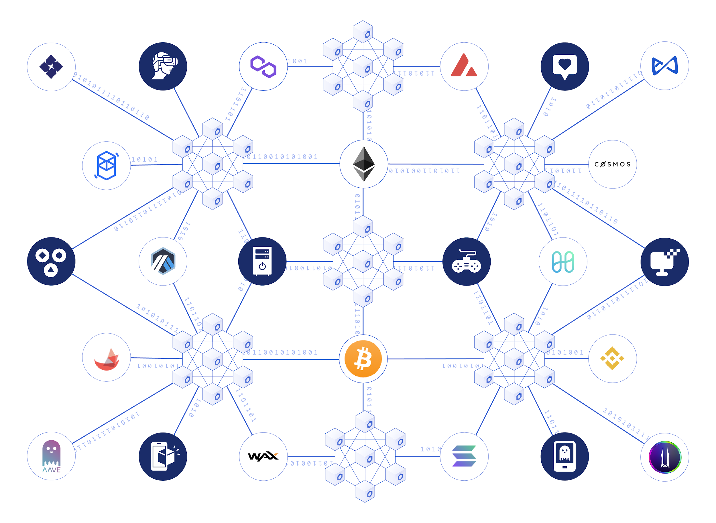Chainlink connects blockchains and centralized metaverse platforms in a secure, reliable manner.

For example, consider a future metaverse where the main players are Meta’s VR headset and Microsoft’s HoloLens for entering the metaverse both in the real-world and online, while blockchains serve as an underlying decentralized structure that secure user-owned digital goods and power unified virtual environments. Chainlink can serve as a secure connection point for all three technologies, securely facilitating value and information transfers in a trust-minimized manner between [IoT devices](https://blog.chain.link/how-chainlink-enables-blockchain-iot-integrations/), blockchains, and centralized metaverse applications. From real-world data such as sports results and weather readings to metaverse-related events, Chainlink acts as a trust-minimized infrastructure for connecting real-world and online experiences, resulting in immersive metaverse encounters.

As the metaverse develops, Chainlink’s ability to provide trust-minimized connections between off-chain entities and blockchains will help further an interoperable and fully integrated metaverse that seamlessly incorporates all metaverse-related platforms, real-world experiences, and more.

## **The Metaverse Is Coming**

In the past few years, the Metaverse has transitioned from a fantastical future envisioned in various pieces of fiction to a tangible reality that truly exists, albeit in a nascent stage of development. The stage has been set for the next set of immersive metaverse applications to come to life, and the core technologies behind them are steadily advancing.

It’s impossible to say whether we’ll see a dystopian reality such as those depicted in Snow Crash and the Matrix or a gamified virtual world full of retro references like Ready Player One. Perhaps the metaverse will take shape in a way we’ve yet to imagine. With the future state of the metaverse still in flux, it’s up to builders, creators, users, and visionaries to build a user-owned digital universe that is defined by decentralization, immersion, and connectivity.