Sorting: Bubble Sort & Selection Sort
Report
Type:Mini-Project.
To:
Rajani Ma’am
DOCSE
By:
Sujan Nepal

Description
Sorting refers to arranging the given set of data in an order. It arranges all the input data in ascending or descending order. There are multiple types/ways of sorting. Here, we are going to talk about bubble sort and insertion sort. If input data is in ascending order but the sorting to be done is in descending order it will be the worst case.
In this file there are programs of two sorting algorithms

BUBBLE SORT
The program of the sorts are given below:

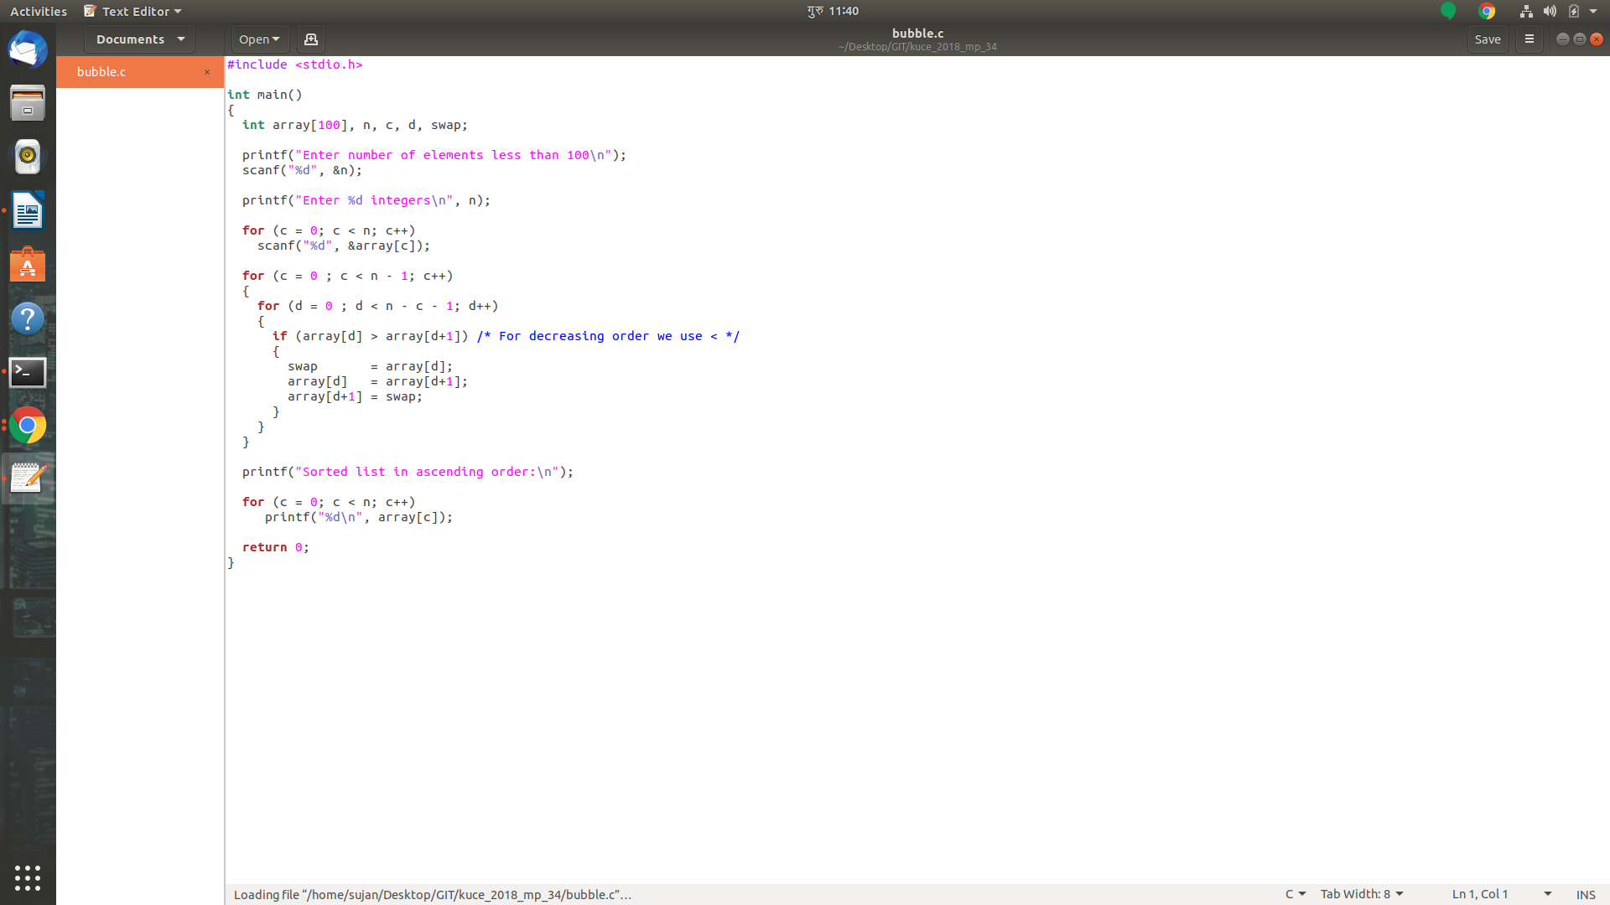

SELECTION SORT
The program of the sorts are given below:
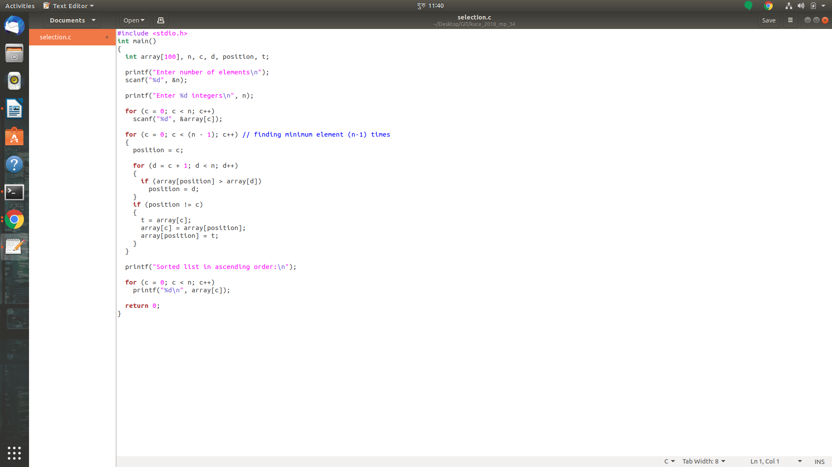

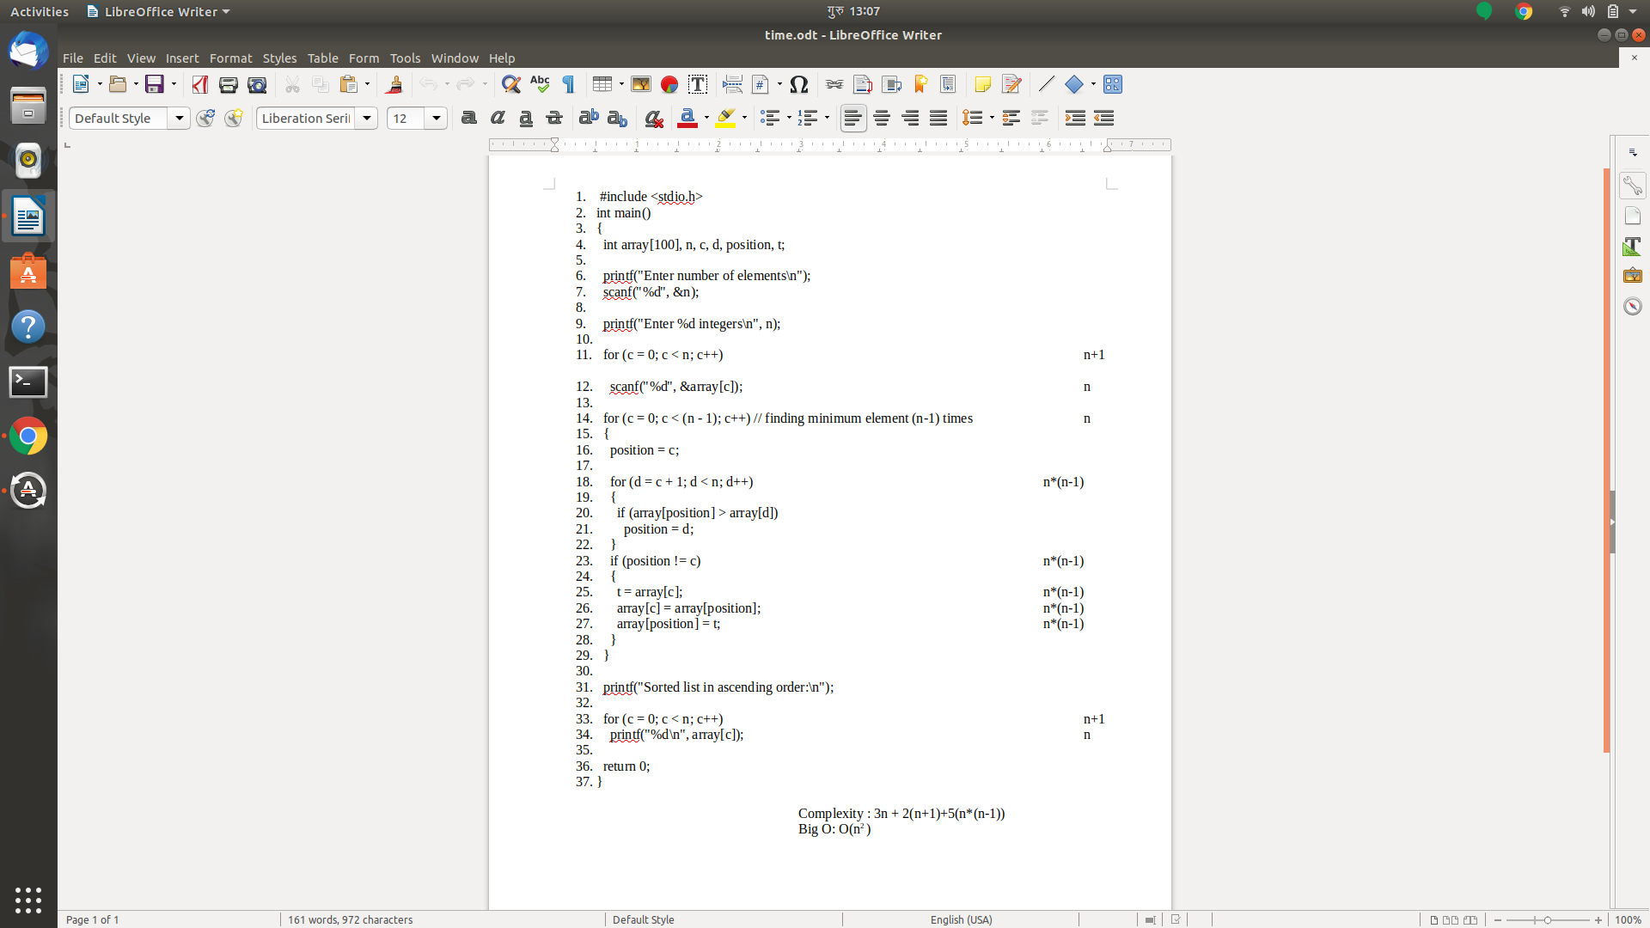
Time Complexity Calculation for Worst Case Scenario ::
For selection Sort:

Complexity : 3n + 2(n+1)+5(n*(n-1))
Big O: O(n² )

FOR :: Bubble Sort

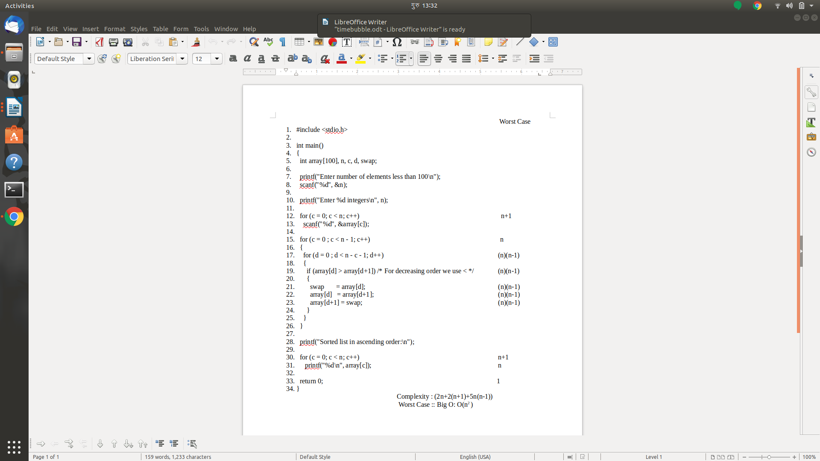
Complexity : (2n+2(n+1)+5n(n-1))
Worst Case :: Big O: O(n² )

Time Complexity Comparision :

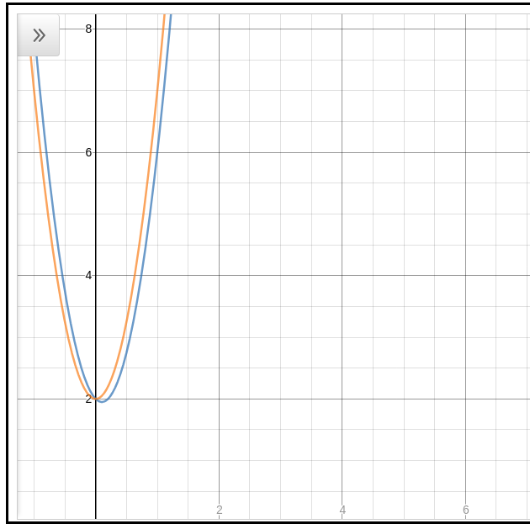

For large data too, It is similar.
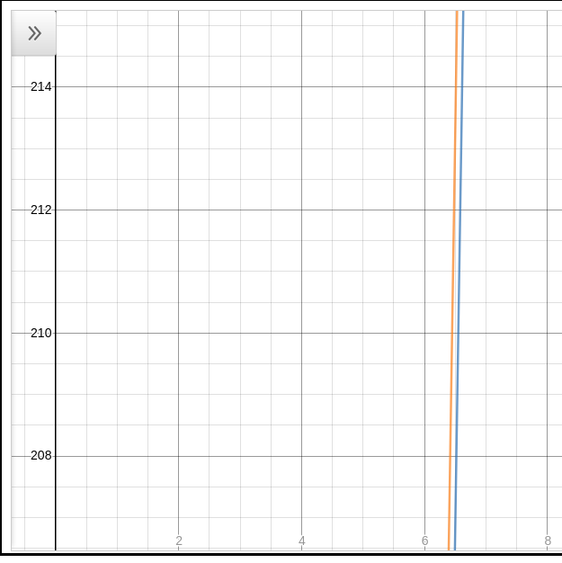

Conclusion
Bubble sorting and Selection sorting are only two of the many types of sorting. Bubble sorting and selection sorting one of the basic concepts of sorting.
It was seen that the time complexity of bubble sort was little better then selection sort.

