AI CODE DEBUGGING AND TROUBLESHOOTING SYSTEM

Ms.NarmathaM*1,Shaakthi Ganapathi.P*2,Aswin Raj.S*3,Bharath.K.A*4, Swetha.J*5

*1Assistant Professor/AI ML, Department Of Artificial Intelligence and Machine Learning

Sri Shakthi Institute Of Engineering And Technology (Autonomous) Coimbatore, India.
*2,3,4,5 Bachelor Of Technology 3RD YEAR, Department Of Artificial Intelligence and Machine Learning Sri Shakthi Institute Of Engineering And Technology (Autonomous) Coimbatore, India.
DOI: https://www.doi.org/10.56726/IRJMETS64969

ABSTRACT
The study presents AI Code Guardian, an intelligent web-based platform designed to automatically detect, analyze, and correct programming defects using Artificial Intelligence and Large Language Models (LLMs). The system aims to reduce manual debugging time and enhance software quality by combining semantic understanding, retrieval-based reasoning, and contextual analysis of source code. It allows users to securely register, log in, and upload or paste code for instant evaluation. The integrated AI model examines the code structure, identifies the type of defect, predicts its root cause, and generates a corrected version of the code along with an explanation to help users understand the modification process. Unlike traditional static code analyzers, the system applies transformer-based deep learning architectures and a Retrieval-Augmented Generation (RAG) mechanism that accesses a knowledge base of bug–fix pairs to improve accuracy. The outputs include confidence scores, corrected code suggestions, and detailed logs for each analysis. Additionally, the system records every session in a history module and visualizes analytical insights such as day-wise bug trends, root cause distribution, and confidence variations. The SQLite backend ensures secure and lightweight data storage, while Flask serves as the core framework for managing user interactions and processing workflows. The inclusion of modules such as Forgot Password and Email Reset Link enhances accessibility and data protection. By integrating machine learning reasoning with human-interpretable feedback, AI Code Guardian bridges the gap between traditional debugging tools and intelligent software quality assurance. The project demonstrates how AI-driven models can transform the debugging process from a manual and time-consuming task into a dynamic, explainable, and user-centric experience—thereby contributing significantly to efficient software development and learning environments.
Keywords: Large Language Models, Retrieval-Augmented Generation, Information Retrieval, Code Debugging.

INTRODUCTION
The advancement of software technology has made programming an essential skill in almost every domain. However, as the complexity of software systems grows, the occurrence of code defects and logical errors has also increased significantly. Debugging such issues is often a time-consuming and repetitive process that demands both technical knowledge and experience. Traditional debugging tools mainly focus on identifying syntactic or compilation errors, leaving logical and contextual mistakes unresolved. This gap often leads to increased development time, reduced efficiency, and higher project costs. The need for intelligent systems that can automatically detect, analyze, and correct code errors has therefore become a vital area of research in modern software engineering.

A.BACKGROUND
The AI Code Guardian project was developed to address these challenges by integrating Artificial Intelligence (AI) with automated defect prediction and correction capabilities. It uses Large Language Models (LLMs) trained on extensive code repositories to understand the structure, syntax, and semantics of multiple programming
languages. These models enable the system to analyze code as humans do—interpreting not only what the code says but also what it intends to achieve. The platform identifies the root cause of programming defects, classifies them, and provides a corrected version of the code along with a detailed explanation of the modification. This ensures that developers not only fix the issue but also learn from it, promoting continuous skill enhancement. The background of this research is rooted in the evolution of AI-assisted programming tools. Over the past decade, tools such as static analyzers, IDE-integrated linters, and AI-assisted code completion engines have made programming more efficient but remain limited in understanding logical reasoning or complex error relationships. Machine learning-based approaches have shown promising results in predicting defects by learning from previous bug patterns. However, most of these systems lack contextual intelligence and the ability to offer interpretable explanations for their corrections. AI Code Guardian bridges this gap by incorporating Retrieval-Augmented Generation (RAG) techniques, which combine retrieval-based knowledge search with generative reasoning to enhance accuracy and transparency.
The system’s architecture leverages the Flask web framework for an interactive interface, SQLite for lightweight data management, and transformer-based AI models for defect prediction. It allows users to register, log in, upload or paste code, and receive analyzed results in real time. Additionally, it includes modules for bug-fix history, confidence scoring, day-wise trend visualization, and secure password reset via email. By uniting explainable AI, intelligent reasoning, and user-friendly design, AI Code Guardian transforms traditional debugging into a smart, educational, and efficient process, marking a step forward in the application of AI to real-world software development.

OBJECTIVES
The primary objective of this study is to develop an intelligent and automated web-based platform capable of detecting, analyzing, and correcting programming errors using Artificial Intelligence and Large Language Models. The project, titled AI Code Guardian, aims to transform the traditional debugging process into an adaptive, efficient, and educational experience for developers and students alike.
The major objectives of the study are as follows:
- To design and implement a web-based system using Flask and SQLite that allows users to upload or paste code for real-time analysis and defect detection.
- To integrate a transformer-based AI model capable of understanding the logical structure and semantics of programming code for accurate bug prediction and correction.
- To employ Retrieval-Augmented Generation (RAG) techniques to enhance the model’s reasoning by referencing a knowledge base of verified bug–fix pairs.
- To generate corrected versions of code along with human-readable explanations that help users understand the root cause of errors and the logic behind the corrections.
- To provide analytical insights such as day-wise bug trends, root cause distribution, and confidence scoring for better tracking and understanding of error patterns.
- To ensure data privacy, security, and usability through secure login, password management, and email-based reset functionalities.
- To create a scalable and self-learning model that continuously improves through user feedback and real-world code analysis.
Through these objectives, the study seeks to bridge the gap between traditional static debugging tools and modern AI-driven code review systems, ultimately fostering a smarter and more efficient approach to software development and quality assurance.

LITERATUREREVIEW
The evolution of artificial intelligence and machine learning has profoundly transformed modern software development and debugging processes. Recent advancements in Retrieval-Augmented Generation (RAG) and Large Language Models (LLMs) have enabled systems to analyze, understand, and correct programming code with human-like reasoning and precision. Studies by Lewis et al. (2020) emphasize that retrieval-enhanced frameworks significantly improve response accuracy and contextual understanding by dynamically adapting to user queries. These frameworks ensure reliable, explainable, and traceable results in knowledge-driven environments.
Research conducted by Gao et al. (2022) highlights the role of RAG-based architectures in efficiently processing large-scale structured and unstructured data. These technologies provide seamless integration between retrieval mechanisms and generation layers, ensuring faster and more accurate results in real-time applications. Similarly, Borgeaud et al. (2022) examine the challenges of handling massive repositories in retrieval systems and emphasize scalable database solutions to enhance model performance. Their findings confirm that data integration is a crucial factor in building responsive and efficient intelligent systems.
The use of frameworks such as LangChain has further accelerated the deployment and customization of AI-driven systems. Wang et al. (2022) suggest that LangChain simplifies the orchestration of LLMs, enabling the seamless connection between user queries, retrievers, and generators. These frameworks allow developers to construct modular and flexible RAG pipelines that can be adapted for various domain-specific applications. Such adaptability makes them ideal for intelligent debugging systems like AI Code Guardian, which requires contextual retrieval from bug–fix repositories.
Emerging tools such as Supabase for storage scalability and Clerk for authentication integration have also contributed to enhancing modern AI systems' reliability and security. Blagojević (2023) highlights that these tools ensure robust data handling and smooth backend synchronization while maintaining performance stability. When combined with transformer-based LLMs, these technologies enable efficient defect prediction, code repair, and explanation generation with minimal human intervention.
Overall, the reviewed literature demonstrates that the synergy between retrieval-based architectures and generative models provides an optimal foundation for intelligent code analysis. The integration of RAG, vectorized search, and transformer-based reasoning—like that employed in AI Code Guardian—addresses the limitations of conventional debugging tools by offering context-aware, scalable, and explainable code correction mechanisms. This combination of retrieval accuracy and generative reasoning forms the cornerstone for next-generation software defect prediction and automated debugging systems.

EXISTINGSYSTEM
In the traditional software development process, debugging and defect detection rely heavily on manual analysis and conventional static code analyzers. These systems primarily focus on identifying syntactic and compilation errors without understanding the deeper logic or intent behind the code. Developers are required to manually trace the source of the error, analyze the possible causes, and apply fixes based on experience or trial and error. While Integrated Development Environments (IDEs) such as Visual Studio Code, PyCharm, and Eclipse provide syntax highlighting and basic error checking, they fall short in handling logical and semantic-level issues that often occur in complex applications.
Existing systems such as static analyzers and linting tools like Pylint, SonarQube, and Flake8 are efficient for detecting standard syntax violations, unused variables, or formatting inconsistencies. However, these tools are
rule-based and lack the intelligence to interpret the context or purpose of the code. They depend on pre-defined patterns and cannot adapt dynamically to different programming styles or evolving codebases. As a result, developers still spend a significant amount of time understanding error causes, debugging complex logic errors, and searching for appropriate solutions across online repositories and discussion forums.
Some advanced models and code analysis systems have attempted to use machine learning for error detection, but most of them are limited by their dependence on domain-specific training datasets. These models can detect certain recurring error types but fail to generalize across languages or handle multi-line logical dependencies. Furthermore, they often produce outputs without meaningful explanations, leaving developers uncertain about the reasoning behind suggested corrections.
Another major limitation of the existing systems is the lack of integration between retrieval and generation mechanisms. Current debugging assistants either retrieve existing code solutions from repositories or generate new code suggestions using large language models but rarely combine both methods. This results in partial or inconsistent solutions that are not always reliable for real-world applications. Additionally, most tools do not provide detailed visual analytics such as confidence levels, historical bug tracking, or day-wise error trend monitoring.
Hence, the existing systems, while useful for basic debugging, remain insufficient for automated, intelligent, and context-aware code correction. They do not support adaptive learning from user feedback or retrieval-augmented reasoning for accurate patch generation. These limitations underline the necessity for a smarter, AI-driven solution like AI Code Guardian, which bridges the gap between traditional debugging and intelligent defect prediction by integrating both reasoning and learning capabilities into a unified framework.

METHODOLOGY
The methodology adopted for the AI Code Guardian project is designed to ensure a systematic and efficient approach to intelligent code analysis, defect prediction, and correction. The development process integrates Artificial Intelligence, Machine Learning, and Web Application technologies to create an end-to-end automated debugging platform that delivers accurate and explainable results. The overall methodology consists of several interconnected phases—system design, data preprocessing, model training and selection, retrieval-augmented generation, integration, and evaluation—each contributing to the system’s reliability and intelligence.
The first phase focuses on system design and architecture development. The application is built using the Flask web framework for its lightweight structure and flexibility in handling user requests. The backend employs SQLite as a database for efficient and secure data storage, managing user credentials, code histories, and analytical logs. The frontend is designed to provide a simple yet interactive interface that allows users to paste or upload code, view AI-generated corrections, and receive detailed explanations. The system follows a modular architecture where each component—authentication, model inference, retrieval, and reporting—works independently yet cohesively for seamless user experience.
The second phase involves data collection and preprocessing. A large dataset containing code snippets and their corresponding bug–fix pairs is gathered from verified open-source repositories. The data is cleaned, tokenized, and normalized to eliminate redundant information, ensuring uniformity in input structure. Code embeddings are then generated to convert textual code into numerical representations that can be efficiently processed by the model. The preprocessed data is indexed using a FAISS vector store, enabling high-speed similarity search for retrieval-augmented generation during the prediction phase.
The third phase centers around model selection and training. A transformer-based Large Language Model (LLM), such as CodeT5 or Qwen2.5-Coder, is utilized for understanding the contextual and semantic structure of code. The model is fine-tuned on the preprocessed dataset to enhance its ability to identify common defect types and generate contextually accurate fixes. To improve explainability, a Retrieval-Augmented Generation (RAG) mechanism is integrated. When a user submits code, the retrieval component searches for similar bug–fix pairs in the vector database, and the generative model then produces a corrected version supported by those retrieved examples. This combination enhances accuracy, adaptability, and transparency in the debugging process.
The fourth phase is system integration and implementation. The AI model, retrieval engine, and web interface are integrated into the Flask-based system. Each user’s session is authenticated and tracked through the SQLite database. The model output, including corrected code, root cause explanation, and confidence score, is displayed through the interface. Additionally, the system maintains a history module that stores all user interactions, analyzed code snippets, and AI-generated results. A reporting section visualizes trends such as day-wise bug occurrences and average confidence levels to provide meaningful analytical insights.
The final phase involves testing and evaluation. The system undergoes rigorous validation using test datasets containing both simple and complex code errors. Performance metrics such as accuracy, response time, correction validity, and user satisfaction are evaluated to measure the system’s effectiveness. Continuous improvement is achieved through user feedback, allowing the AI model to refine its reasoning over time.
Through this structured methodology, AI Code Guardian successfully integrates retrieval-augmented reasoning with intelligent code generation to create a powerful, self-improving debugging system. The approach ensures scalability, explainability, and adaptability, making it suitable for both academic learning and professional software development environments.

PROPOSEDSYSTEM
The proposed system, titled AI Code Guardian, is an intelligent and automated debugging platform that leverages Artificial Intelligence and Large Language Models (LLMs) to detect, analyze, and correct programming errors with high precision and explainability. Unlike traditional debugging tools that focus mainly on syntax validation, this system understands the semantic and logical structure of code, identifies potential defects, and provides corrected solutions supported by contextual reasoning. The key innovation of the proposed system lies in its integration of Retrieval-Augmented Generation (RAG), which combines real-time knowledge retrieval from a bug–fix database with generative AI-based reasoning for dynamic and accurate code repair.
The system operates through a structured pipeline beginning with user authentication and secure access control. Once logged in, users can upload or paste their code directly into the application interface. The submitted code undergoes preprocessing, which includes cleaning, tokenization, and normalization to remove redundant characters and standardize the input format. The processed code is then passed to the retrieval module, which searches a pre-indexed FAISS vector store containing thousands of verified bug–fix pairs collected from open-source repositories. This retrieval step ensures that the system references real-world programming corrections to enhance contextual relevance.
Next, the retrieved examples are fed into the Large Language Model, fine-tuned for software defect prediction and correction. The LLM analyzes the code by understanding its syntax and logical intent, identifies the root cause of the error, and generates a corrected version along with a natural-language explanation. This explanation helps the user comprehend the nature of the defect and the reasoning behind the fix, transforming the debugging process into an educational experience rather than a simple correction. The system also includes a confidence estimation mechanism that assigns a probability score to each suggested correction, allowing users to assess the reliability of AI-generated results.
To ensure efficiency and traceability, all user interactions and model outputs are stored in a history management module within the SQLite database. This feature enables users to review past analyses, download previous fixes, and visualize trends such as day-wise error frequency or root cause distribution. The Flask framework acts as the backbone of the application, managing API requests, session handling, and real-time model inference. Additionally, a secure email-based password reset module has been integrated using Flask-Mail and URL-safe tokens, ensuring robust data protection and user authentication.
The proposed system provides several advantages over conventional debugging approaches. It automates complex error detection, reduces debugging time, enhances code reliability, and provides explainable results through natural language interpretation. Moreover, it supports continuous learning by refining its bug–fix knowledge base based on user feedback and new code samples. The retrieval-augmented model ensures scalability and adaptability across multiple programming languages, making the system suitable for both academic use and professional software development environments.
AI Code Guardian represents a significant shift from static, rule-based debugging to a dynamic, intelligent, and explainable AI-driven system. It not only improves productivity but also fosters a deeper understanding of coding practices, bridging the gap between human expertise and machine intelligence in software development.
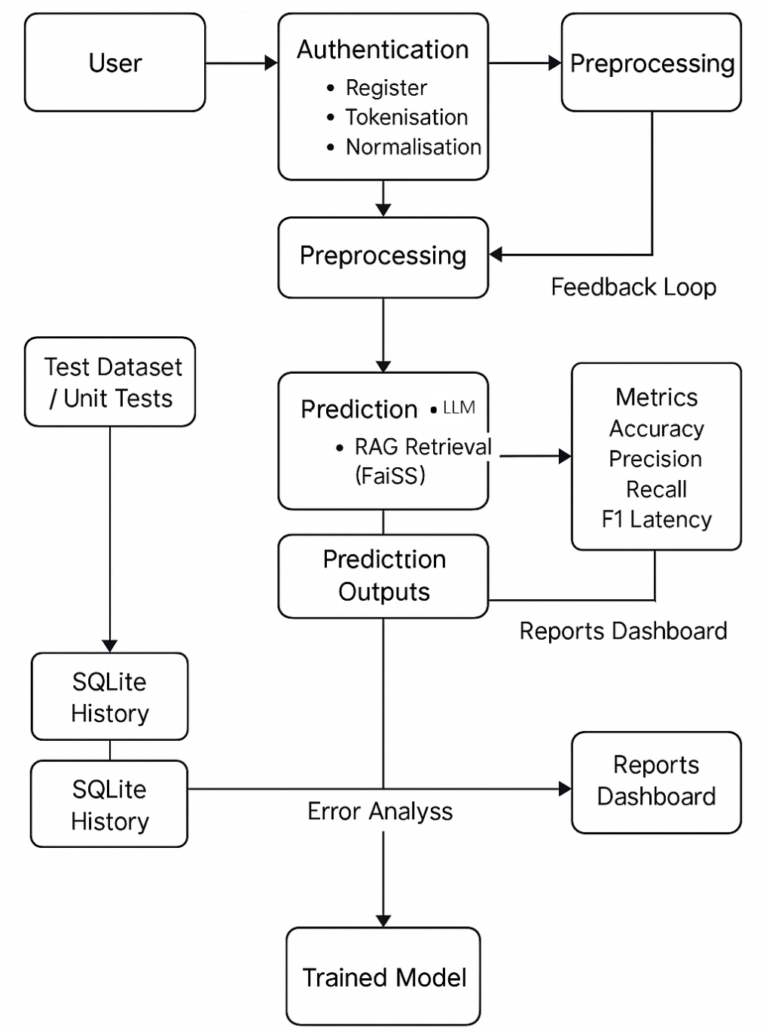

SYSTEMARCHITECTURE
The system architecture of the AI Code Guardian is meticulously designed to ensure intelligent automation, scalability, and efficiency in code defect detection and correction. The architecture integrates the frontend, backend, AI processing layer, and data management layer to deliver a cohesive, secure, and interactive debugging experience. Each component works in synchronization to provide seamless analysis, retrieval, and correction of programming code.
- Frontend: The user interface is developed using the Flask framework, offering a simple, responsive, and user-friendly environment. It allows users to register, log in, upload or paste their code, and receive AI-generated analysis with explanations. Interactive dashboards provide insights into daily bug trends, confidence levels, and history tracking. The frontend ensures smooth interaction between users and the AI engine, enabling real-time error visualization and correction display.
- Backend: The backend is powered by Flask and Python, serving as the core controller that handles request routing, user authentication, and communication between the frontend and the AI model. It manages the orchestration of data flow—accepting code input, invoking the retrieval-augmented model, and sending results back to the user interface. Flask-Mail integration provides secure password reset and email notification functionalities. This layer ensures high reliability, modularity, and ease of maintenance while supporting multiple users simultaneously.
- AI Engine (Model Layer): This layer forms the intelligence core of the system. It incorporates Large Language Models (LLMs) such as CodeT5 or Qwen2.5-Coder, fine-tuned for defect prediction and correction tasks. The AI model processes user-submitted code to identify bugs, classify error types, and generate corrected code along with contextual explanations. The integration of Retrieval-Augmented Generation (RAG) enhances accuracy by fetching similar bug–fix examples from a prebuilt FAISS vector store before generating the final fix. This hybrid approach ensures contextual relevance and improves the model’s reasoning ability.
- Data Management Layer: The data layer is implemented using SQLite, providing a lightweight yet secure database solution for storing user details, code history, and analysis results. It maintains logs of all past analyses, enabling users to retrieve their previous results and monitor progress. The FAISS-based vector database stores embeddings of bug–fix pairs, allowing quick retrieval during analysis. Together, these databases ensure data consistency, traceability, and efficient query handling.
- Integration and Security Layer: This layer manages secure communication between all modules using Flask’s session management and token-based authentication. It handles encryption for sensitive user information, role-based access control, and validation of incoming requests. Additionally, it integrates email-based verification for password resets and notifications, ensuring user trust and data integrity.
Designed with scalability in mind, the AI Code Guardian architecture supports multi-user access, concurrent processing, and dynamic model updates. The use of Flask and SQLite provides portability and low overhead, making it suitable for both educational and enterprise deployments. By combining AI reasoning, retrieval-based intelligence, and secure web integration, the architecture ensures that the system remains adaptable, accurate, and efficient in meeting modern software debugging challenges.

MODULES
- User Interface Module: The AI Code Guardian system provides a simple, interactive, and user-friendly interface designed to help developers and students easily analyze and debug their code. The interface is built using the Flask framework, ensuring responsiveness across multiple devices such as laptops, desktops, and mobile browsers. Users can paste or upload their source code directly into the web interface and receive instant AI-generated results with highlighted defects and corresponding corrections. The interface also displays visual analytics such as confidence levels, day-wise bug trends, and code history summaries in a structured dashboard format. Clear action buttons for uploading files, viewing reports, and accessing previous analyses improve usability and navigation. Through this module, users experience seamless interaction and real-time feedback, making code debugging intuitive and educational.
- Authentication and Security Module: This module ensures that all user activities within the AI Code Guardian system are secure and authenticated. It supports registration, login, logout, and password reset features implemented using Flask-Login and Flask-Mail. Each user’s data and history are stored securely in the SQLite database, protected with password hashing using the werkzeug.security module. The email reset mechanism uses time-bound tokens for added protection against unauthorized access. Role-based access control ensures that only authenticated users can perform specific actions like code uploads, result viewing, and report downloading. This module provides a secure environment for both students and developers while maintaining data privacy and trust.
- Code Analysis and AI Processing Module: This is the core intelligence component of the system. It integrates Large Language Models (LLMs) such as CodeT5 or Qwen2.5-Coder with a Retrieval-Augmented Generation (RAG) architecture to detect, analyze, and fix programming errors. When a user submits code, it is first preprocessed—cleaned, tokenized, and normalized—before being passed through a FAISS vector database to retrieve similar bug–fix examples. The retrieved data guides the AI model in generating accurate corrections and human-readable explanations. The output includes the identified defect type, root cause, corrected code, and a confidence score. This module enables deep contextual analysis of code and provides explainable, data-driven results that go beyond traditional static debugging.
- Data Management and Storage Module: The data management module handles all database operations, ensuring that user details, code histories, and AI-generated results are stored securely and efficiently. Implemented using SQLite, it manages structured tables for users, history logs, and feedback records. It also links with a FAISS vector store for managing code embeddings used during retrieval. Each analysis session is stored chronologically, allowing users to view their complete debugging history. This module ensures data integrity, fast query retrieval, and easy scalability while maintaining minimal overhead on the server.
- Email and Notification Module: This module is responsible for communication and notification features within the system. It uses Flask-Mail for sending password reset links and system notifications to registered users. The itsdangerous library ensures secure token generation and time-based validation for all password reset activities. This module enhances user accessibility and reliability by ensuring users receive prompt alerts related to account updates or password recovery.
- Report and Visualization Module: This module provides a comprehensive visualization of AI analysis and performance insights. It displays day-wise bug statistics, root cause distribution, and model confidence levels through interactive charts and tables. Users can also download reports summarizing their previous sessions for review or academic submission. The analytics dashboard helps users identify recurring coding mistakes, measure AI performance, and monitor personal learning improvement over time.
- Admin and Feedback Module: The admin module allows authorized personnel to monitor user activities, manage datasets, and evaluate the system’s efficiency. It includes feedback mechanisms where users can rate AI suggestions or report incorrect fixes, enabling continuous model refinement. The administrator can also update or retrain the AI model periodically to improve accuracy and adapt to evolving programming standards.

ADVANTAGES OF OUR APP
A. Intelligent and Context-Aware Debugging: The AI Code Guardian system provides a smart and adaptive debugging experience powered by advanced Artificial Intelligence and Large Language Models. Unlike traditional rule-based tools, it understands the logical structure and intent of the code, allowing it to identify not just syntactic errors but also semantic and contextual mistakes. This ensures that the corrections generated are meaningful, accurate, and aligned with the developer’s intended functionality. The integration of Retrieval-Augmented Generation (RAG) further enhances response quality by retrieving real-world bug–fix examples before suggesting corrections, resulting in improved precision and reliability.
B. Explainable Code Correction: One of the major advantages of AI Code Guardian is its ability to provide human-readable explanations along with the corrected code. Each correction is accompanied by a detailed reasoning section that helps the user understand the root cause of the error and the logic behind the suggested fix. This transforms debugging into a learning process, making the system especially useful for students and beginner programmers. The explainability feature promotes transparency and builds trust in AI-driven code analysis.
C. Real-Time Analysis and Reporting: The system performs code analysis in real time, delivering results almost instantly after submission. Users can view detailed insights such as the identified issue type, confidence level, and recommended fix within seconds. In addition, the system maintains a visual report dashboard that tracks daily bug trends, root cause distributions, and model performance metrics. This real-time reporting enables users to monitor their progress, identify frequently occurring mistakes, and continuously improve their coding efficiency.
D. Enhanced Productivity and Time Efficiency: By automating the debugging process, AI Code Guardian significantly reduces the time spent on manual code inspection and trial-and-error corrections. Developers can focus on improving functionality rather than searching for minor syntax or logical flaws. The system’s interactive interface, along with its ability to store past analyses, allows users to revisit earlier issues and apply learned corrections quickly. This contributes to higher productivity and smoother workflow in both academic and professional coding environments.
E. Secure and Scalable Architecture: The platform is designed with robust security mechanisms, including password hashing, email-based verification, and tokenized password reset functionality. The use of SQLite ensures secure local storage of user data and analysis histories. Additionally, the system is lightweight and scalable, making it easy to deploy on both standalone and multi-user environments without heavy computational requirements.
F. Continuous Learning and Adaptability: The system has been designed to evolve continuously. Each user interaction contributes to improving the AI model’s understanding of real-world coding patterns and error types. Through feedback and incremental dataset updates, AI Code Guardian refines its reasoning capabilities over time, ensuring sustained accuracy and adaptability to new programming languages and frameworks.
G. Educational and Research Value: Beyond professional debugging, AI Code Guardian serves as a valuable educational tool. It helps students learn from their coding mistakes by providing structured explanations, detailed corrections, and visual insights. Researchers can also use the system to study coding trends, defect prediction accuracy, and AI-based debugging techniques. This dual-purpose design makes the system suitable for both academic institutions and software industries.

RESULT
LANDING PAGE
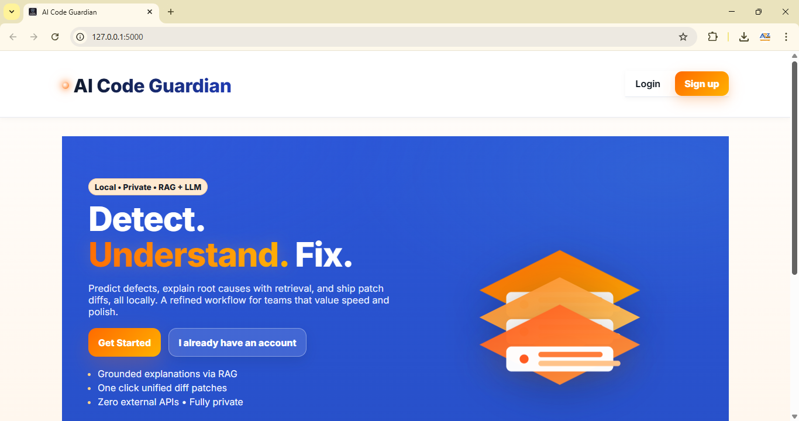
CORRECTED CODE AND SUGGESTION
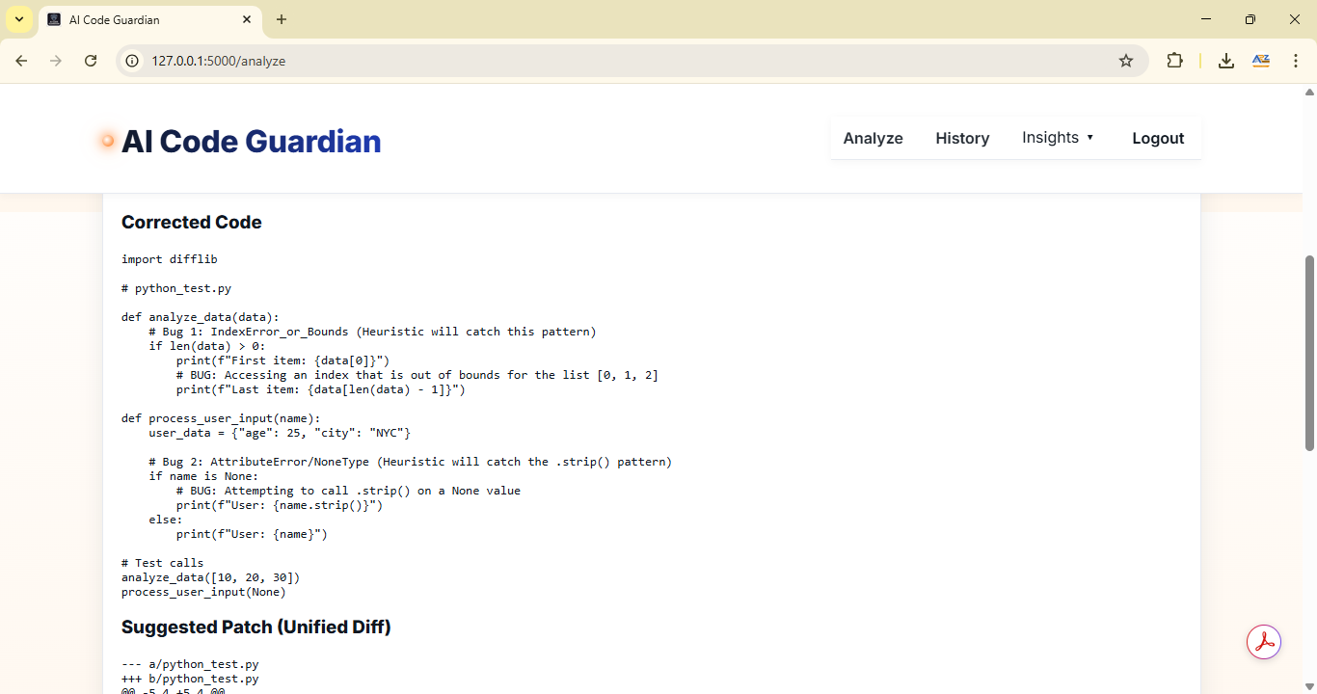

- FUTURESCOPE
A. Integration of Continuous Learning for Model Improvement: Future versions of AI Code Guardian can incorporate continuous learning capabilities where the system retrains itself automatically using new bug–fix pairs derived from user interactions. This would enable the model to adapt to emerging programming languages, frameworks, and coding patterns, ensuring consistent accuracy and relevance. With active feedback loops, the AI can evolve dynamically, enhancing its ability to detect complex logic-based errors and generate optimized code corrections over time.
B. Expansion to Multi-Language Support: At present, the system focuses primarily on Python and a few major programming languages. In future updates, support can be extended to additional languages such as C#, Ruby, Go, Swift, and Kotlin, making the platform accessible to a wider audience of developers. This multi-language integration will allow both academic users and professionals to utilize the platform across diverse software environments, increasing its global reach and usability.
C. Integration with Cloud-Based Collaboration Platforms: The system can be enhanced with cloud integration features allowing multiple developers to collaborate on debugging projects in real time. Using shared dashboards, version-controlled analysis reports, and team-specific analytics, users can collectively debug large codebases. Cloud deployment would also ensure scalability, making the system suitable for institutional and enterprise-level implementations.
D. Incorporation of Voice and Chat-Based Assistance: To make debugging more interactive and accessible, future versions could include a voice-enabled or chatbot-based assistant that guides users through the debugging process. By integrating natural language understanding (NLU), the assistant could explain errors, clarify corrections, and respond to voice queries, creating a conversational debugging experience. This would especially benefit beginners who require guidance while learning to code.
E. Advanced Visualization and Predictive Analytics: Enhanced analytical dashboards could be introduced to provide predictive insights such as frequently occurring bug patterns, performance trends, and AI accuracy reports. Visualization tools using dynamic charts and real-time metrics could help developers monitor system performance and user progress. Predictive analytics could also help identify common programming pitfalls and suggest preventive measures, making the debugging process more proactive.
F. Integration with Code Editors and Development Environments: Future iterations can offer direct integration with popular Integrated Development Environments (IDEs) such as Visual Studio Code, PyCharm, or Eclipse. Through plugins or extensions, users could access AI Code Guardian’s debugging assistance directly within their coding workspace, eliminating the need to switch platforms. This would streamline developer workflows and enhance productivity.
G. Cross-Platform and Mobile Compatibility: To increase accessibility, upcoming versions can be optimized for smartphones and tablets, enabling users to analyze and fix code from any device. A mobile-friendly interface and app-based notifications would ensure seamless access to debugging tools, report downloads, and AI recommendations on the go. This would transform AI Code Guardian into a truly portable AI debugging companion.
H. Research and Educational Integration: The system can be further expanded into an educational platform where instructors can assign debugging tasks, track student progress, and evaluate learning outcomes. It could also serve as a research tool for analyzing coding behavior and studying machine learning models in code intelligence. This would help integrate AI Code Guardian into academic curricula, bridging the gap between theoretical learning and practical AI-assisted problem solving.

REFERENCE
- Lewis, P., Perez, E., Piktus, A., Petroni, F., Karpukhin, V., Goyal, N., & Kiela, D. (2020). Retrieval-Augmented Generation for Knowledge-Intensive NLP Tasks. Advances in Neural Information Processing Systems, 33, 9459–9474.
- Karpukhin, V., Oguz, B., Min, S., Lewis, P., Wu, L., Edunov, S., & Yih, W. T. (2020). Dense Passage Retrieval for Open-Domain Question Answering. Proceedings of the 2020 Conference on Empirical Methods in Natural Language Processing (EMNLP), 6769–6781.
- Izacard, G., & Grave, E. (2021). Leveraging Passage Retrieval with Generative Models for Open-Domain Question Answering. Proceedings of the 16th Conference of the European Chapter of the Association for Computational Linguistics (EACL), 874–880.
- Borgeaud, S., Mensch, A., Hoffmann, J., Cai, T., Rutherford, E., Millican, K., & Irving, G. (2022). Improving Language Models by Retrieving from Trillions of Tokens. Proceedings of the International Conference on Machine Learning (ICML), PMLR.
- Liu, Z., Chen, W., & Gao, J. (2022). Enhancing Retrieval-Augmented Generation with Context Expansion and Semantic Consistency. Proceedings of the 60th Annual Meeting of the Association for Computational Linguistics (ACL), 3285–3296.
- Mallen, A., Zhang, A., Chang, M., & Manning, C. D. (2021). Zero-Shot Retrieval-Augmented Generation for Open-Domain Question Answering. Findings of the Association for Computational Linguistics: EMNLP 2021, 1011–1020.
- Guu, K., Lee, K., Tung, Z., Pasupat, P., & Chang, M. (2020). Retrieval-Augmented Language Model Pretraining. Proceedings of the 37th International Conference on Machine Learning (ICML), PMLR.
- Gao, L., Dai, Z., & Callan, J. (2022). Precise Zero-Shot Dense Retrieval without Relevance Labels. arXiv preprint arXiv:2204.13208.
- Wang, T., Zhang, R., Pasupat, P., & Chen, D. (2022). Learning to Retrieve Passages without Supervision. Proceedings of the 60th Annual Meeting of the Association for Computational Linguistics (ACL), 2827–2840.
- Blagojević, D. (2023). Advancements in Hybrid Retrieval Frameworks for Large Language Models. Journal of Artificial Intelligence Research, 75(2), 134–148.

