

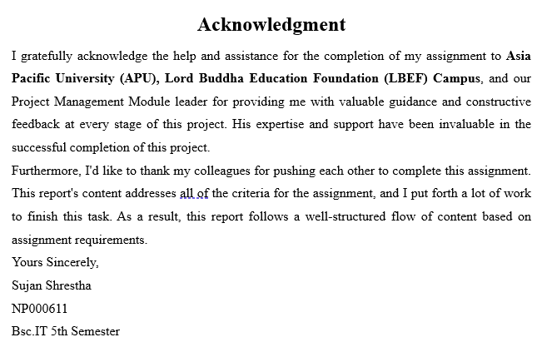

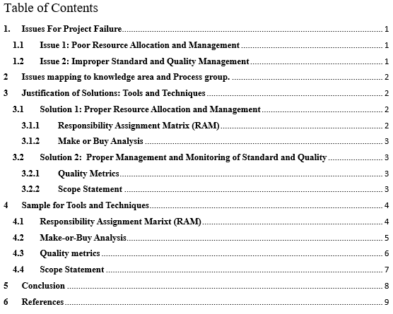

# **Issues For Project Failure**

## **Issue 1: Poor Resource Allocation and Management**

A major issue in the HRMS project arises due to inefficient resource allocation and distribution. Problems in identifying suitable personnel due to competing goals and scarcity of Subject Matter Experts (SMEs) can cause problems for organization. As a result, the project team lacks critical knowledge that can certainly lead to delays in projects, overruns in cost and poor quality of service. An efficient and adequate resource management plan can easily handle this situation. Proactively identifying capable resource limits, collaboration with leaders of department to recruit individuals with required qualifications and forming cross-functional team comprised of members of other departments can all help to reduce the risk of knowledge gaps. These steps are intended to guarantee that the project team has a diversified skill set, therefore improving overall competency and addressing resource-related issues (Wood, 2003).

## **Issue 2: Improper Standard and Quality Management**

Another significant issue in the case of the HRMS project is poor management of quality and low standards. The project involves the replacement of current systems throughout the region with an innovative HRMS, therefore proper planning, development, testing, and implementation is critical. Certain problems can occur if there are inadequacies in these areas such as system downtime, data loss and breaches in security which can affect the project’s overall success. A complete plan for quality management must be designed to deal with this issue where the plan should include techniques for the development, testing, design, and deployment, with a focus on quality at each stage. Furthermore, a good quality assurance approach that confirms regular reviews, regular inspections and regular testing throughout the project’s life cycle can be established to eradicate this issue. Furthermore, workshops and training for the team can increase the understanding of quality measures and standards of excellence, ensuring that the ongoing task is completed with greatest level of quality possible (Kim, 2012).

#



# 

## **Solution 1: Proper Resource Allocation and Management**

Tools and Techniques for issue of Poor Resource Allocation and Management

### **Responsibility Assignment Matrix (RAM)**

To solve the problem of inadequate resource handling and management, the choice of Responsibility Assignment Matrix (RAM) is a supported solution. By allocating project responsibilities and goals to separate roles or departments, the RAM can be a excellent tool for injecting transparency as well as responsibility in to the project structure. The redundancy of support frameworks and raised IT expenses caused by inefficient resource management can be eradicated with RAM as it can be critical. It facilitates resource allocation by clearly defining which division or individual oversees whatever task in the HRMS project. As a result, there is no duplication of work, ensuring effective resource usage (Shrahily, 2020).

### **Make or Buy Analysis**

The utilization of Make or Buy Analysis is a well-chosen strategy to deal with the problem of insufficient resource management in the HRMS project, notably in the knowledge area of Project Procurement Management. The cooperation of subject matter experts (SMEs) from different divisions is essential for the achievement of the HRMS project within the given case study. However, due to inaccuracies in the management of resource, this resource becomes a difficult undertaking, potentially creating delays and additional costs. Implementation of this Analysis provides the project lead with strategic techniques to determine whether project parts need to be manufactured in-house or can be bought from external vendors (Ruffo, 2007).

## **Solution 2: Proper Management and Monitoring of Standard and Quality**

Tools and Techniques for issue of Improper Standard and Quality Management

### **Quality Metrics**

The utilization of Quality Metrics as a means of standard and quality control is a wise decision in order to deal with the prevalent quality challenges in the HRMS project, especially in the realm of Project Quality Management. The product can have different problem like inconsistent and inaccurate data inputs and erroneous reporting, which can lead to unsatisfaction of stakeholders. With the use of Quality Metrics, the management department can easily measure the quality of project deliverables and processes. This tool will help the project team with information they need to confirm informed decision making about the required quality and standard improvements (A Review of Quality, 2015).

### **Scope Statement**

The inclusion of the Scope Statement as a tool for better project quality management is a well-founded approach, particularly within the realm of Project Scope Management that will contribute to maintain the quality standards of the project. The scope statement tool will properly delineate the project limits, explaining the objectives, requirements, and deliverables of the project in brief. A lack of clear scope statements decreases the quality of the project as project leads will be lost about the project’s objectives, requirements, and deliverables. The absence of a clear scope statement in the instance of Systemware Sdn's HRMS project, in which the overall objective is to improve human capital management activities through centralized support and reducing costs, might end up in ambiguity regarding the needs of the project, which could lead to a failure to meet stakeholders' expectations (Walker, 2016).

# **Sample for Tools and Techniques**

## **Responsibility Assignment Marixt (RAM)**

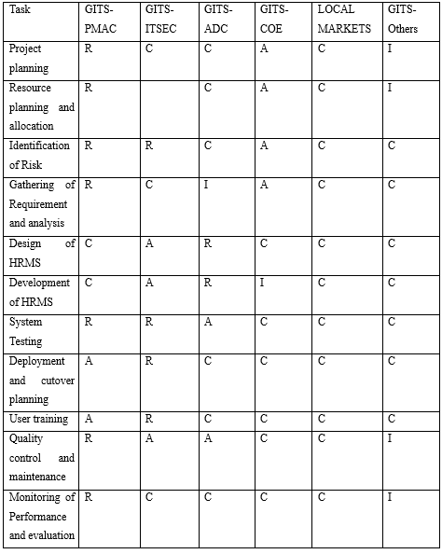

Figure 2 : Responsibility Assignment Marix (RAM)

Index

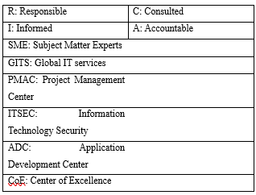

Figure 3: Index of RAM

## **Make-or-Buy Analysis**

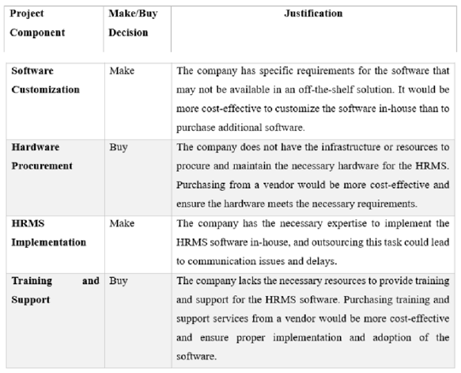

Figure 4: Make or Buy Analysis

## **Quality metrics**

Figure 5: Quality metrics

## **A white document with black text Description automatically generatedScope Statement**

Figure 6: Scope Statement

# **Conclusion**

The careful selection of tools and techniques to deal with the arising issues and deployment of them is critical for solving the specific difficulties outlined in Systemware Sdn Bhd's HRMS project. The tools and techniques such as Responsibility Assignment Matrix (RAM) and Make-or-Buy analyses provide strategic way to eradicate resource allocation and procurement problems to mitigate Poor Resource Allocation and Management. These tools help to uplift the utilization of resources and provide clarity and efficiency. Along with these tools, implementation of Quality Metrics and the Scope Statement is critical for addressing quality issues. These tools work together in order to improve the outcomes of a project, its efficiency and accountability while also aligning with the organization's objectives and project management.

# **References**

A Review of Quality. (2015). Arkal Vittal Hegde. doi:https://doi.org/10.1016/j.aqpro.2015.02.019

Kim, D.-Y. (2012, February). Relationship between quality management practices and innovation. Journal of Operations Management. doi:https://doi.org/10.1016/j.jom.2012.02.003

Ruffo, M. (2007, January 23). Make or buy analysis for rapid manufacturing. Rapid Prototyping Journal. Retrieved November 13, 2023, from https://emerald.com/insight/content/doi/10.1108/13552540710719181/full/html?queryID=62%2F5414906&utm_source=TrendMD&utm_medium=cpc&utm_campaign=Rapid_Prototyping_Journal_TrendMD_0&WT.mc_id=Emerald_TrendMD_0

Shrahily, R. (2020, October 29). The responsibility assignment matrix (RAM) system. International Journal of Construction Management. doi:https://doi.org/10.1080/15623599.2020.1837717

Walker, H. A. (2016). Scope Statements: Imperatives for Evaluating Theory. doi:https://doi.org/10.2307/2095540

Wood, S. (2003, May 21). Human resource management and performance. doi:https://doi.org/10.1111/1468-2370.00020