**

**

# **Introduction**

In the world of Java programming, RMI stands for Remote Method Invocation which is referred as an important application programming interface which allows one computer or JVM which stands from Java Virtual Machine to connect with objects on another JVM via a distributed network. RMI serves as a conduit for creating distributed Java applications through simplicity of method calls. RMI is also considered to be matched effectively with the concept of a Java Remote Procedure Call (RPC) but extends its capabilities by allowing the delivery of one or more objects alongside request. This complex system mainly uses two basic components to facilitate smooth remote interactions between application: the ’stub’ and the ’skeleton’ (Awati, 2019).

## **Background and Context of RMI application development project**

The RMI application development project began in broader concept of distributed computing, an approach that is used when expanding program capabilities by distributing components over multiple machines. Java perfectly aligns with RMI, making it a popular alternative for designing distributed systems as the synergy between java and RMI, multiple components of the application can communicate continuously, with servers and clients engaging coherently. RMI takes advantage of Java objects' ability to communicate openly over a network, which contributes to the project's robust and versatile architecture (MAASSEN, 2001).

Utilization of RMI can be done for a variety of activities like developing client-server applications, the creation of distributed databases, and the creation of remote administration and control systems. The RMI technique was developed on the basis of an object-oriented paradigm, which enables seamless functionality in a distributed computing context. This object-oriented paradigm forms the base of Remote Machine Interface (RMI), enables objects separated across a network to access their methods. This simplifies the design and concept of distributed computing and enhances the application's overall efficiency and coherence.

The security of any distributed systems is crucial and RMI addresses such concerns by executing comprehensive security standards. Specific use cases must be defined within the context of the RMI project to tailor the development process to the CKF Group Malaysia's particular goals and objectives. Given the project's distributed nature, maintaining safe interactions between components is critical. To protect RMI interactions and the overall system's integrity, the project will need to investigate and implement best practices.

## **RMI Framework and its Role in Distributed Systems**

Remote Method Invocation (RMI) is a key Java technology for the construction of distributed systems, allowing for seamless communication between Java objects. This technology allows objects to interact with one another and invoke methods remotely, even if they are on different Virtual Machines or environments. The essence of RMI is its ability to remotely activate methods or objects, allowing dispersed systems to run more efficiently. RMI becomes the backbone of programs that demand collaboration between diverse components spread across different computer systems by facilitating communication among objects across different machines (Sharp, 2006).

RMI's critical role in distributed systems can be summarized as follows:

* Method Invocation and Object Communication: RMI acts as a conduit for objects to communicate with one another and invoke methods on remote machines. This functionality is important in instances when application components run on separate machines.
* Bridge between Components and Servers: RMI acts as a bridge to connect components on the server to different machines. This link enables the invocation of methods, allowing for the cohesive and integrated operation of distributed components.
* Handling Network Communication Details: Handling RMI abstracts and managing sophisticated network communication elements, facilitating the design and deployment of distributed systems. This layer hides developers from the complexity of low-level network connection, resulting in a simpler and more efficient development process.
* Rapid create and Deployment: RMI's features make it easier to create and deploy distributed systems. Its architecture allows developers to concentrate on the logic and functionality of the program while RMI handles the underlying communication issues, resulting in a more efficient and rapid development process.

## **Cloud Computing and Virtualization**

Virtualization refers to a transformational technology that enables the concept of numerous virtual machines (VMs) to work on a single physical system with creation of various virtual instances over the network. It allows effective utilization of resources through pooling, isolating VMs for increased security, and supports backup and scalability capabilities such as snapshots and cloning (Gopalakrishnan, 2015).

To abstract and efficiently utilize real infrastructure, virtual instances of computer resources like servers or storage are created. Its significance in distributed systems includes the following:

Cloud computing represents a paradigm shift towards the delivery and consumption of computing services as it provides on-demand services via internet connectivity to a shared pool of adjusting computing resources. Users can access services required, offering a cost-effective service. Cloud computing provides widespread network access, allowing for ubiquitous connectivity from a variety of devices. Because of its resource pooling and quick flexibility, it allows for dynamic scaling to suit shifting workloads. Cloud services are classified as Infrastructure as a Service (IaaS), Platform as a Service (PaaS), and Software as a Service (SaaS), providing customers and companies with a variety of possibilities (Elsenpeter, 2010).

Cloud computing provides a scalable and adaptable architecture that enables distributed systems to respond to changing workloads. Its primary significance is found in:

## **Objective and Goals**

* Create a user-friendly and efficient Product Delivery System (PDS) with RMI and Java.
* Enable functionalities like user account registration, authentication, profile management, purchase management with necessary information.
* Create an effective order processing system that provides order confirmation, status updates, and thorough reports to customers.
* Use RMI technology for effective communication among distributed components.
* Quality requirements, such as usability, maintainability, and heterogeneity, should be used to evaluate the implemented application.

# **System design**

## **Overview of RMI application architecture and components**

In the RMI architecture, various distributed components contribute to the development of a distributed system that allows seamless communication between clients and servers. These components are important to the overall functionality of the Remote Method Invocation process.

Remote Interface:

The remote interface refers to a base element in the RMI architecture that determines the structure for remote methods that are required to be invoked across different Java Virtual Machines (JVMs). By extending the 'java.rmi.Remote' interface, it establishes a standardized blueprint for method signatures, ensuring consistency among the distributed components (Graba, 2007).

Remote Objects:

At the core of the RMI architecture are remote objects, Java entities which executes the specified remote interface. These objects are hosted on servers and play a vital role in implementing the actual logic of remote methods. When a client initiates an RMI call, it is these remote objects that handle execution of methods and provide the corresponding response.

Stubs and Skeletons:

Stubs and skeletons act as intermediaries facilitating the communication between clients and servers. On the client side, stubs serve as local proxies to the remote objects, serializing method calls and directing them to the server. On the server side, skeletons receive these calls, invoke the corresponding methods on the actual remote objects, and manage the serialization of results back to the client (Vecchio, 2002).

RMI Registry:

The RMI Registry refers to a a central directory registry, providing a mechanism for servers to register their names or URLs. Clients can then validate specific remote objects using these identifiers, obtaining references that are essential for creating method calls. This centralized registry streamlines the process of object identification and retrieval.

RMI API:

The RMI API, residing in the 'java.rmi' package, is a comprehensive set of interfaces and classes that equip developers with the tools needed to implement and manage RMI applications. It encompasses functionalities related to remote object management, naming, and registry interactions, forming the backbone of RMI application development.

Java Virtual Machine:

The Java Virtual Machine (JVM) is a crucial component responsible for executing Java code on both the client and server sides. It ensures the proper functioning of remote objects and the execution of RMI method calls in a distributed environment. The JVM creates and manages the runtime environment for RMI applications, playing a fundamental role in their seamless operation.

## **Interaction of RMI Application Components**

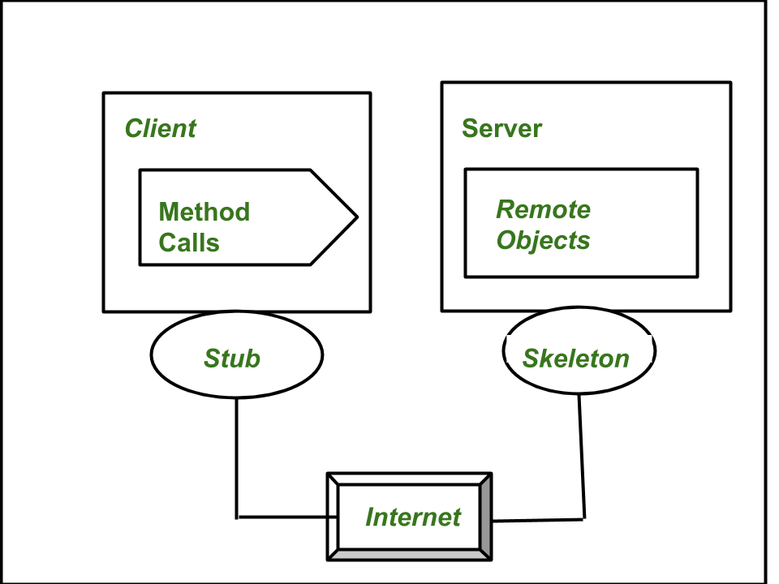

Figure 1: Interaction of RMI Application Components

i) Stub:

ii) Skeleton:

On the server side, the skeleton play a role of a receiver of incoming requests sent towards the server-side object. Once an inbound request is received, the skeleton performs critical tasks. It extracts the arguments of the remote method, invokes the actual method on the true remote object, captures the result, and marshals it back to the caller. The skeleton serves as the intermediary on the server side, orchestrating the execution of remote methods and handling the communication flow between the server and the client.

The interaction between the stub and skeleton is a vital aspect of the RMI architecture. The stub on the client side marshals parameters and sends requests to the skeleton on the server side. The skeleton, in turn, extracts arguments, invokes the actual method on the remote object, captures the result, and marshals it back to the stub. This interaction ensures the seamless execution of remote methods and the exchange of data between the client and server components.

iii) Transport Layer:

The transport layer plays a pivotal role in controlling the references called by clients for remote objects within the RMI architecture. It handles the transmission of data between components, ensuring the integrity and efficiency of communication.

iv) Remote Reference Layer (RRL):

In charge of establishing and maintaining connections between the client and server, the Remote Reference Layer (RRL) is an important component in the RMI architecture which oversees all existing and currently active connections, ensuring a robust and reliable linkage between the client and server for seamless remote method invocations (Tejera, 2005).

Data Flow and Communication Protocols in RMI

Figure 2: Data Flow in RMI

The above figure depicts the data flow process visualization, which visualized the flowing phases of the communication between the client and server components in a Java RMI application environment.

JRMP (Java Remote Method Protocol):

The Java Remote Method Protocol (JRMP) is used in the context Java RMI for secure transmission of data between Java Virtual Machines. JRMP is a combination of rules that control the serialized transmission of data between clients and servers. This communication protocol enables the smooth and continuous invocation of methods on remote objects, making sure that a continuous network connection within the RMI framework. Java RMI achieves a standardized and secure communication route by conforming to JRMP, which is required for the reliable operation of distributed applications.

# **Implementation**

In the online shopping application development, the following are the implementations done from my side in our group project. The user authentication and entire User management including profile management, login, signup was part of components done by me where I have executed the principles of an RMI environment as explained below:

## **4.1 RMI Application Development Process with Code Snippets**

An RMI application system is developed by the following process:

1. Definition of Remote Interface

The first thing done was to define the remote interfaces required for communication between the client and the server in the RMI application.

Figure 3: Defining Remote Interface I

Figure 4: Defining Remote Interface II

Here, the above two figures shows interfaces created fir Login and User management component of the application.

1. Implementation of remote methods

After the definition of remote interfaces, next this to be done is implementing the remote interfaces to create remote object. This Java interface includes method declarations for remote invocation by clients. The contents for the methods declared in the remote interface is developed in this part of the code.

Figure 5: Extending Implementation class with Interface.

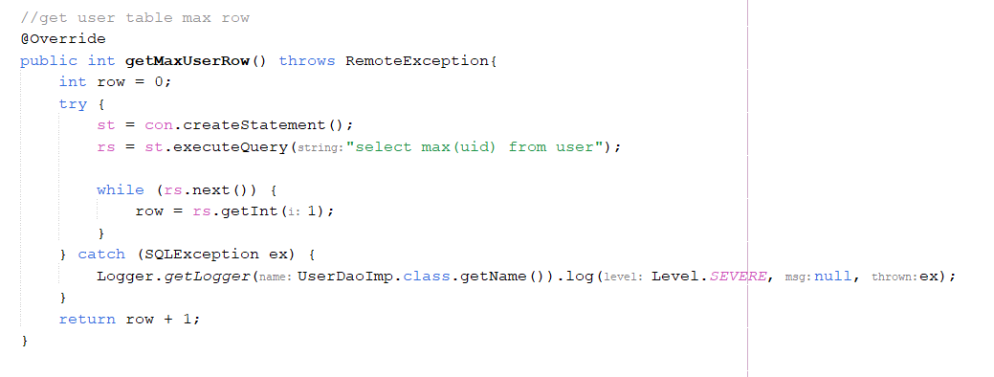

Figure 6: RMI Method Implementation class 1

Figure 7: RMI Method Implementation II

Figure 8: RMI Method Implementation III

Figure 9: RMI Method Implementation IV

Figure 10: RMI Method Implementation V

Figure 11: RMI Method Implementation VI

Figure 12: RMI Method Implementation VII

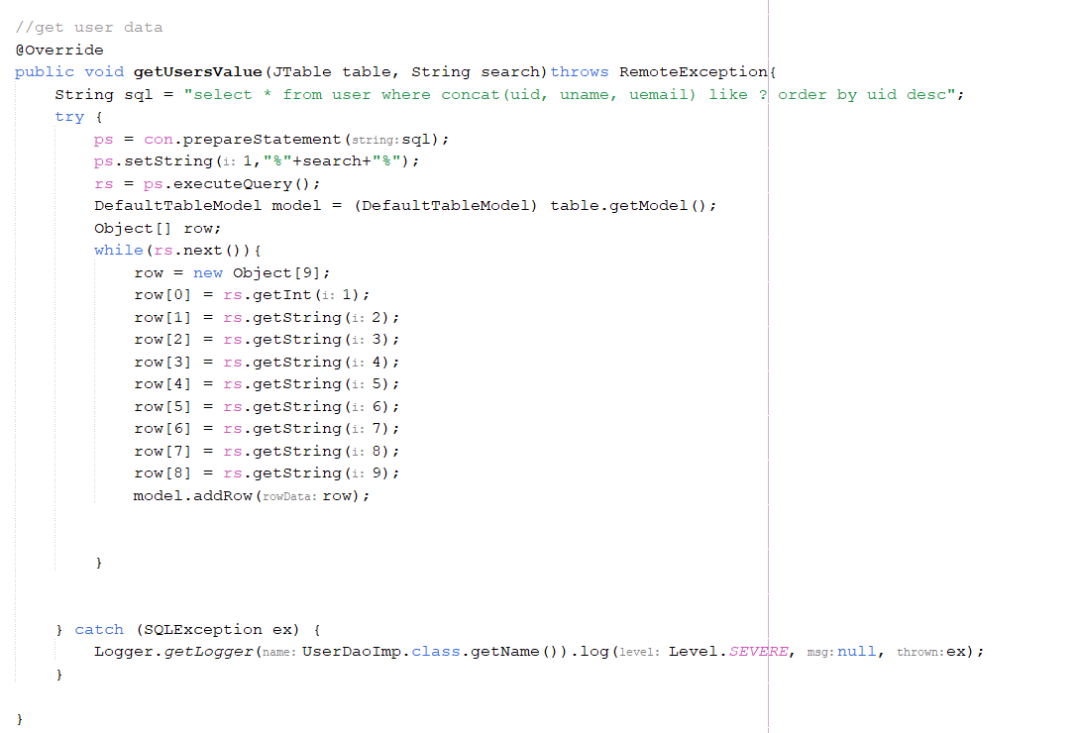

Figure 13: RMI Method Implementation VIII

Figure 14: RMI Method Implementation IX

Figure 15: RMI Method Implementation X

Figure 16: RMI Method Implementation XI

Figure 17: RMI Method Implementation XII

These are various methods required for my part of user management. These methods are called via RMI through UI part of the client program.

1. Developing the UI for my parts

Here are some snippets of the UI of my components from the RMI application. The figures below include UI of components created with Swing like Login interface, signup interface, forget password interface, user management and profile management interface.

Figure 18: Login UI

Figure 19: Sign Up UI

Figure 20: Forgot Password UI

Figure 21: User Profile Update UI

Figure 22: Admin User Management UI I

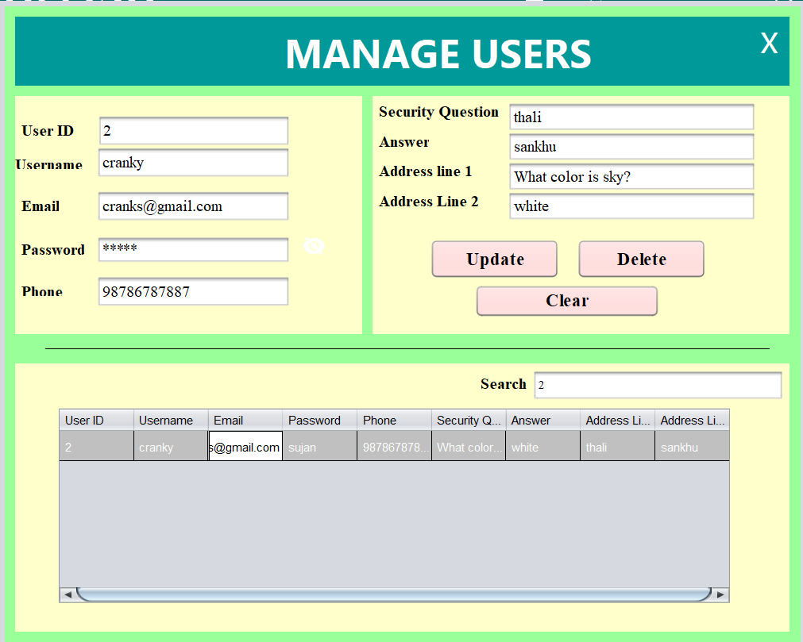

Figure 23: Admin User Management UI II

1. Developing the client program

A client-side program is created once the remote object and interface have been established. This software interfaces the client with the remote object, allowing users to create and interact with it.

Figure 24: Client-Side Implementation I

Figure 25: Client-Side Implementation I

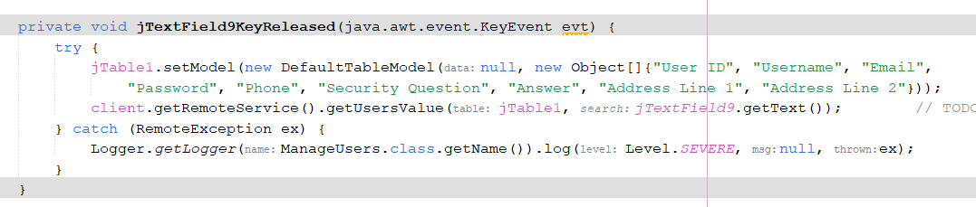

Figure 26: Client-Side Implementation II

Figure 27: Client-Side Implementation III

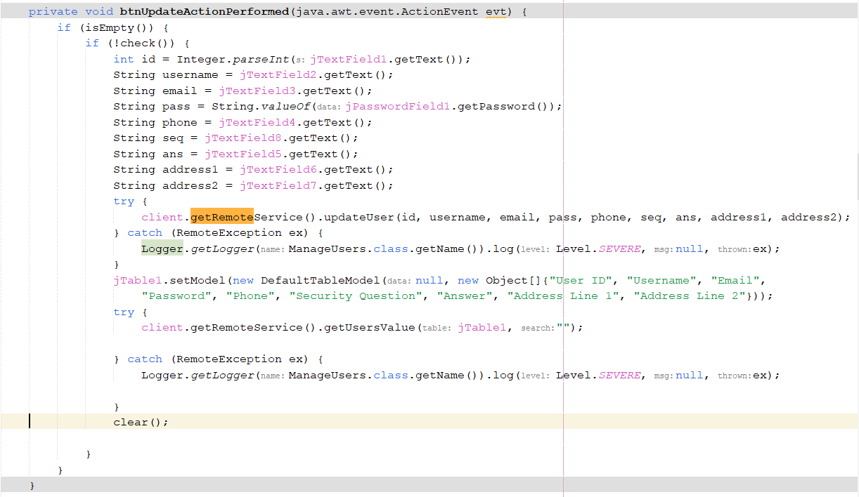

Figure 28: Client-Side Implementation IV

Figure 29: Client-Side Implementation V

Figure 30: Client-Side Implementation VI

1. Compiling the source files and client stubs and server skeletons generation:

The next step is to compile Java source files to build skeletons and stubs for both the remote object class and the client software. This is accomplished by utilizing the javac or Java compiler, which produces class files.

1. Starting the RMI Registry: The RMI registry was created to allow users to look for remote objects by name. It's in the same folder as the classes.

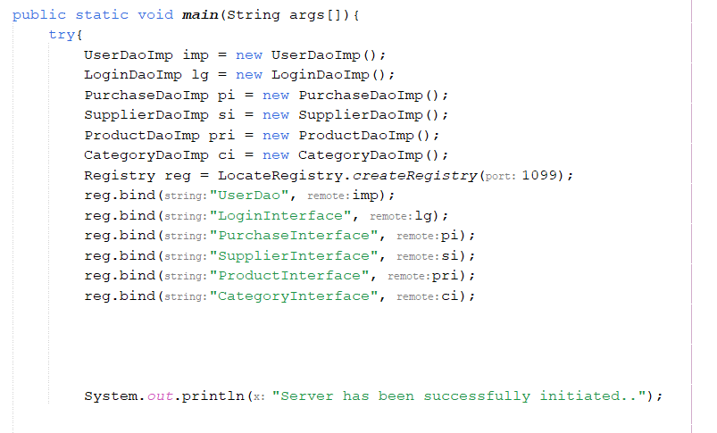

Figure 31: RMI Registry

1. Starting the remote object and running the client:

The server is launched after the registry has been started, allowing it to hold server information. The client software is run with the necessary configurations. Implementing the RMI registry to look for remote objects and enable method invocation is required.

Figure 32: Server Setup

**Figure 33: Client Setup**

## **Use Case Diagram**

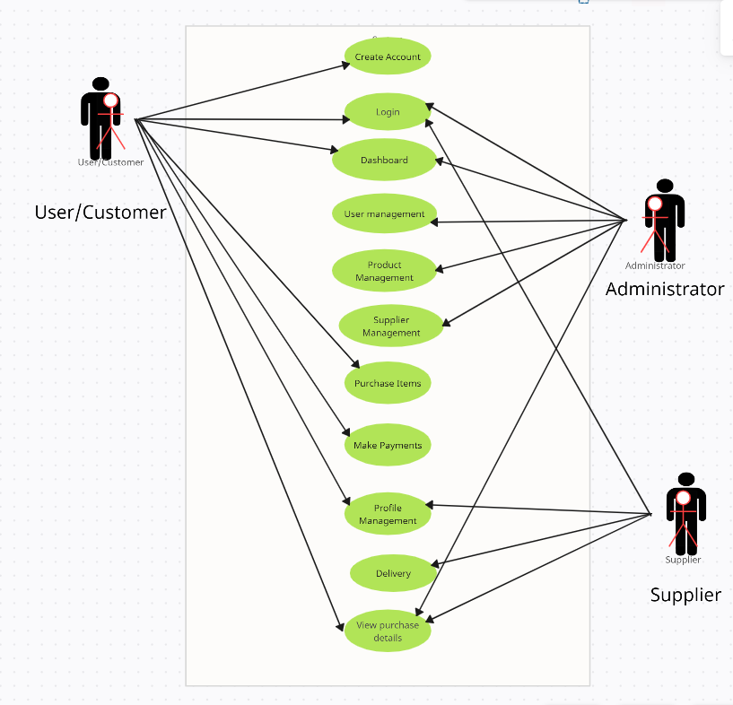

Figure 34: Use Case Diagram

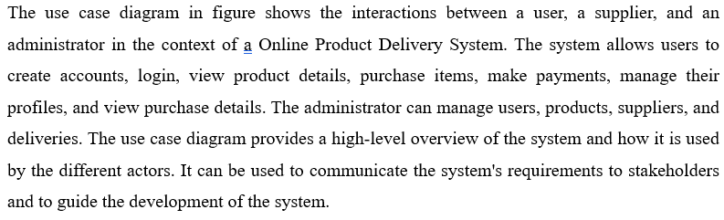

# **Testing**

To ensure the development of Online Product Delivery System was done properly, my team had carried out certain tests. Since I have implemented the purchasing or the ordering part of the application, I have performed certain tests regarding this part of application. Here, proper brief regarding the testing of my component is given below:

## **Integration Testing**

As there were different components for each member in our team, I have chosen integration testing as a method of testing my component as it will ensure the specific area of the application is good to integrate with the main application (A study of integration testing and software regression at the integration level, 2002). This testing provided me with brief results of tests performed in the user management and login/signup area of the application. In the following table brief results of the test Is provided.

Figure 35: Integration Testing

This testing ensures that users can effectively view their profile details and also admins can view accurate user and supplier details, search and add suppliers to the system and search for users’ profile along with functionality of adding and deleting users.

# **Deployment in the Cloud:**

Deployment of the RMI application in environment of cloud computing depends deciding on a cloud service provider, such as AWS or Azure, and then also a suitable architecture plays vital role in this. The utilization of the cloud enhances worldwide accessibility, scalability, and flexibility along with the Configuration of networks, implementation of load balancing, and ensuring security are all valuable stages. Potential network latency and security concerns are among the challenges that may arise while deploying such RMI applications over the cloud. Overall, cloud deployment improves the overall resource utilization and enables dynamic scaling in response to application demand (Buyya, 2013).

## **Benefits and Challenges of Cloud-Based Deployment:**

Various benefits such as Scalability, flexibility, cost effectiveness, and worldwide accessibility come with the deployment of such RMI application over the cloud. Organizations can efficiently lower the cost by utilization of a pay-as-you-go model. However, certain difficulties can occur during this implementation which may include network latency and security concerns, particularly when storing and sending data. There can be potential issue of vendor lock-in, underlining the significance of implementing cloud-agnostic methods. Regulation compliance is critical, and careful consideration of these elements assures effective cloud adoption.

## **Future Enhancements:**

Furthermore, exploring developing cloud computing and virtualization technologies can create the pathway for future enhancements. Integrating enhancements such as serverless computing, virtualization improvements, and support for AI and IoT are all promising areas of investigation which seems difficult but can be developed in the sense to improve the currently existing services in cloud. Furthermore, the application could benefit from blockchain for increased security. By listening to these trends, the RMI application may remain inventive and flexible to changing technology landscapes.

# **Conclusion**

The RMI application development project successfully applies over CKF's Product Delivery System issues. Utilization of RMI and deployment of the application over the cloud enhances the efficiency and scalability of the application system. The system's reliability is furthermore confirmed by using different testing methodologies, and future developments are in line with new technology. The project displays the groundwork for developments that can be enhanced in future through cloud computing and virtualization, finally achieving its goals and objectives of enhancing the Product Delivery System.

# **References**

A study of integration testing and software regression at the integration level. (2002, August). doi:https://doi.org/10.1109/ICSM.1990.131377

Ahuhed, S. (2020). Performance evaluation of Java RMI: a distributed object architecture for Internet based applications. *IEEE Xplore Journal of Computer Science*.

Awati, R. (2019). Remote Method Invocation (RMI). *Front-end, back-end and middle-tier frameworks*. Retrieved November 2, 2023, from https://www.theserverside.com/definition/Remote-Method-Invocation-RMI#:~:text=Remote%20Method%20Invocation%20(RMI)%20is,JVM%20in%20a%20distributed%20network.

Borner, D. (2021). More efficient serialization and RMI for Java. *Wiley Online Journal for Computing*.

Buyya, R. (2013). Mastering Cloud Computing. Retrieved November 19, 2023, from https://www.sciencedirect.com/topics/computer-science/remote-method-invocation

Elsenpeter, R. (2010). *Cloud Computing: A Practical Approach.* Retrieved November 19, 2023, from https://ds.amu.edu.et/xmlui/bitstream/handle/123456789/9207/CloudComputing.pdf?sequence=1&isAllowed=y

Gopalakrishnan, V. (2015, February). Network function virtualization. *Challenges and opportunities for innovations*. doi:https://doi.org/10.1109/MCOM.2015.7045396

Graba, J. (2007). *An Introduction to Network Programming with Java.* London: Springer. doi:https://doi.org/10.1007/978-1-84628-630-8_5

Hagimont, D., & Boyer, F. (2021). A configurable RMI mechanism for sharing distributed Java objects. *Computer Science Journal for Advanced Computing*.

MAASSEN, J. (2001). Efficient Java RMI for Parallel Programming. Retrieved November 19, 2023, from https://scholar.google.com/scholar?hl=en&as_sdt=0%2C5&q=RMI&btnG=

Sharp, M. (2006, September). Static Analysis of Object References in RMI-Based Java Software. 664 - 681. doi:https://doi.org/10.1109/TSE.2006.93

Tejera, D. (2005, June 6). Two alternative RMI models for real-time distributed applications. doi:https://doi.org/10.1109/ISORC.2005.62

Vecchio, A. (2002, August 6). Embedding remote object mobility in Java RMI. doi:https://doi.org/10.1109/FTDCS.2001.969628