Rashiv

Purchase and Order Mangement

Remote interface

Remote Objects

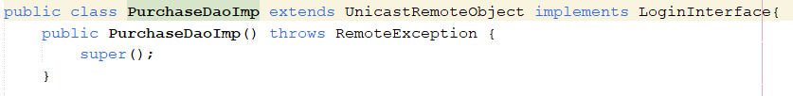

Client Program

Server snippet

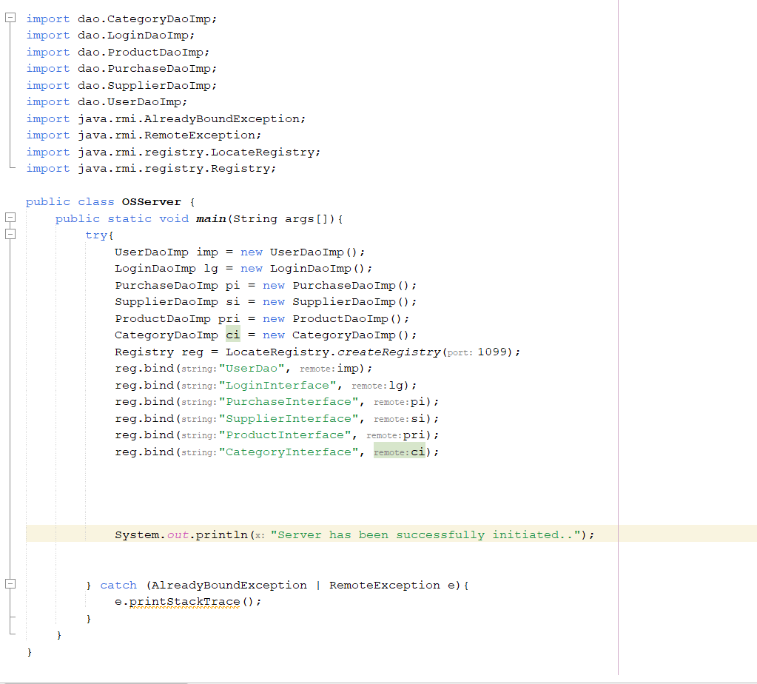

Client Snippet

**UI**



